Computer forensics
Synthesize a solution to a potential real-life scenario
ACCD5000
Carlos Yanez | 2413875
BSc: Computing (Computer Networks & Cybersecurity)

Table of Contents
Introduction 3
Acronyms 4
The Computer Hacking Forensic Investigator (CHFI) Methodology 5
Phase 1: Identification and First Response 5
Phase 2: Preservation and Data Acquisition (Imaging) 5
Phase 3: Examination and Deep Analysis 6
Mobile Device and Cloud Forensics 6
Phase 4: Documentation, Reporting and Presentation 7
Evaluation of Forensic Suites 7
Exterro Forensic Toolkit (FTK) 7
Architectural Paradigm and Processing Capabilities 7
Supported File Systems and Evidence Types 8
Advanced Analytical Features 8
Cost and Licensing Structure 8
Reporting Capabilities 8
Magnet AXIOM 9
The Artifact-First Architectural Approach 9
Cross-Platform Capabilities 9
Advanced Analytical Features 10
Cost and Licensing Structure 10
Reporting Capabilities 10
Cellebrite UFED 10
Hardware-Driven Exploitation and Device Access 10
Bypassing Modern Mobile Security Architectures 11
Extraction Methodologies 11
Cost and Licensing Structure 11
Reporting Capabilities 11
Autopsy 12
Open-Source Philosophy and Algorithmic Transparency 12
Modular Ingest Pipeline Architecture 12
Supported File Systems and Evidence Types 12
Cost, Accessibility, and Academic Value 13
Reporting Capabilities 13
Comparative Analysis of Modern Digital Forensic Tools 13
Table 1: Comparative Analysis of Digital Forensic Tools 13
Table 2: File System and Data Source Compatibility 14
Table 3: Strategic Alignment of Forensic Tools Across CHFI Phases 14
Case study: Sabotage at Cyfusion Mobile Manufacturing Company (CMMC) 15
Forensics Methodology & Investigation Plan 15
Acquiring the Encrypted Drive Forensically 15
Proving Anti-Forensic Activity (Use of Wiping Tools) 16
Strategies for File Carving 16
Extracting Cloud Synchronisation Evidence 16
Forensic Report 17
EXECUTIVE SUMMARY 17
INVESTIGATION STEPS 17
FINDINGS 23
CONCLUSION 23
APPENDIX: HASH LOG 24
INVOICE 26
Conclusion 28
References 29

Introduction

The discipline of digital forensics represents the highly critical intersection of advanced computer science and rigorous legal jurisdiction. As global reliance on digital infrastructure accelerates, so too does the frequency and complexity of cybercriminal activity, corporate espionage, intellectual property theft, and insider sabotage. In this perpetually evolving landscape, a foundational axiom dictates that while the underlying investigative concepts remain immutable, and the methodologies undergo only gradual procedural shifts, the technological tools utilised to execute these investigations exist in a state of constant, rapid flux.

To navigate this dynamic environment effectively, investigators must adhere to standardised, vendor-neutral frameworks that ensure the absolute integrity, reliability, and court admissibility of their findings. The purpose of this report is two-fold. Part one conducts an exhaustive research analysis of modern digital forensic tools, systematically comparing both commercial enterprise solutions and open-source alternatives. It specifically analyses Exterro’s Forensic Toolkit (FTK), Magnet AXIOM, Cellebrite’s Universal Forensic Extraction Device (UFED), and the open-source Autopsy platform against key operational parameters and the Computer Hacking Forensic Investigator (CHFI) methodology.

Part two transitions from theoretical evaluation to practical application, presenting a case study of suspected sabotage and intellectual property theft at Cyfusion Mobile Manufacturing Company (CMMC). By applying the researched tools and CHFI/ACPO principles to a real-world scenario involving, full-disk encryption, anti-forensics wiping, and cloud exfiltration, this report demonstrates the execution of a legally defensible digital investigation.

Acronyms

- ACPO: Association of Chief Police Officers
- AD: Active Directory
- AFU: After First Unlock
- APFS: Apple File System
- API: Application Programming Interface
- BFU: Before First Unlock
- CHFI: Computer Hacking Forensic Investigator
- EDL: Emergency Download Mode
- ESI: Electronically Stored Information
- Ext4: Fourth Extended Filesystem
- FBE: File-Based Encryption
- FDE: Full Disk Encryption
- FFS: Full File System
- FTK: Forensic Toolkit
- GUI: Graphical User Interface
- IoC: Indicator of Compromise
- IoT: Internet of Things
- MFT: Master File Table
- NTFS: New Technology File System
- RAM: Random Access Memory
- SIEM: Security Information and Event Management
- TSK: The Sleuth Kit
- UFDR: Universal Forensic Extraction Device Report
- UFED: Universal Forensic Extraction Device

The Computer Hacking Forensic Investigator (CHFI) Methodology

The Computer Hacking Forensic Investigator (CHFI) methodology, promulgated by the EC-Council, establishes a globally recognised, highly comprehensive framework for conducting digital investigations. The CHFI program prepares cybersecurity professionals with the requisite technical knowledge to perform effective digital forensics investigations and bring their respective organisations into a state of continuous forensic readiness [1].

This readiness is absolutely crucial, as it constitutes the primary differentiator between a rapidly contained minor security incident and a catastrophic cyber-attack that severely compromises organisational continuity. The CHFI methodology insists on a highly structured approach to searching, seizing, acquiring, preserving, analysing, and reporting digital evidence. Understanding the technical and procedural requirements of each operational phase is paramount for evaluating the efficacy of modern forensic software and hardware suites.

Phase 1: Identification and First Response

The inception of any digital investigation is the identification phase, which involves the recognition of an incident, the determination of its scope, and the rapid deployment of a first response strategy. During this phase, investigators must identify all potential sources of digital evidence, which may range from traditional desktop workstations and on-premise servers to mobile devices, Internet of Things (IoT) appliances, and remote cloud infrastructure [2], [3]. The primary objective of the first responder is to secure the scene and halt any ongoing malicious activity without inadvertently modifying the state of the compromised systems. This phase requires strict adherence to legal guidelines, such as the Association of Chief Police Officers (ACPO) principles in the United Kingdom [4], which mandate that no action taken by investigators should change data held on a computer or storage media that may subsequently be relied upon in court.

Phase 2: Preservation and Data Acquisition (Imaging)

The preservation phase is arguably the most legally sensitive stage of the CHFI methodology, governed by the absolute necessity of maintaining data integrity. The primary mechanism for achieving this preservation is forensic imaging, which is the process of creating a perfect, sector-by-sector, bit-stream physical or logical copy of a storage medium. To ensure that the original evidence remains completely unaltered, investigators must utilise hardware or software write-blocking technology, which intercepts and denies any write commands directed at the target drive [5].
Forensic imaging tools must be capable of generating cryptographic hashes—such as MD5, SHA-1, or SHA-256 algorithms—concurrently with the imaging process. These hash values serve as digital fingerprints; by calculating the hash of the original drive and comparing it to the hash of the forensic image, the investigator provides mathematical proof that the duplicate is an exact replica, thereby satisfying the chain of custody requirements necessary for legal admissibility [6]. Furthermore, modern data acquisition has expanded beyond “dead-box” forensics to include “live” acquisition, which involves capturing volatile data, primarily from Random Access Memory (RAM), while the system remains powered on to recover decrypted keys and active network states [7].

Phase 3: Examination and Deep Analysis

Following the secure acquisition of data, the examination and analysis phase requires investigators to deploy sophisticated software suites capable of parsing complex file systems, recovering deleted data, and reconstructing user activity timelines. This phase transforms raw, unstructured hexadecimal data into human-readable, actionable intelligence.

A cornerstone technique within this phase is file carving. File carving is the process of recovering deleted or highly fragmented files based on their known internal data signatures (headers and footers), rather than relying on the file system’s allocation tables or metadata. This technique is particularly vital for extracting files from areas of the disk where file system structures are damaged, missing, or deliberately obfuscated by anti-forensic wiping tools [8]. Advanced analysis also requires the exhaustive parsing of operating system artifacts, including the Windows Registry, prefetch files, jump lists, and event logs, to prove program execution, file access, and network traversal [9].

Mobile Device and Cloud Forensics

Mobile forensics presents one of the most formidable technical challenges in the modern investigative landscape, necessitating a specialised sub-discipline within the CHFI framework. Unlike traditional hard drives, mobile devices are inherently active, constantly communicating with cellular towers, Wi-Fi networks, and cloud synchronisation services. Extracting and analysing data from modern smartphones requires tools capable of navigating incredibly complex security boundaries [10].

The adoption of cloud computing has fundamentally altered the paradigm of digital investigations. Evidence no longer resides solely on localised, physical disks; instead, it is distributed across remote, multi-tenant infrastructures hosted by providers such as Amazon Web Services (AWS), Google Workspace, and Microsoft Azure. Cloud forensics introduces severe jurisdictional and legal complications, as Electronically Stored Information (ESI) may be physically located in foreign territories subject to conflicting regulatory frameworks. Furthermore, traditional concepts of physical isolation and dead-box imaging are obsolete in cloud environments, as investigators cannot seize physical servers that support thousands of unrelated customers. Instead, investigators must rely on targeted data collections techniques to extract synchronisation data, audit logs, and account activity [11].

Phase 4: Documentation, Reporting and Presentation

The culmination of the CHFI process is the documentation and presentation phase. Forensic reports must translate highly complex, technical findings into clear, unambiguous narratives suitable for specialised legal counsel, judges, and non-specialist juries. A well-organised forensic report strictly adheres to structural standards, presenting the materials and methods used, the raw data observations without subjective interpretation, and a separate analysis section highlighting patterns or anomalies. Tools must provide robust reporting capabilities that support customisable templates and the explicit linkage of every finding to its underlying data source via cryptographic hash values and exact file paths to maintain the unbroken chain of custody necessary to satisfy stringent legal requirements [12].

Evaluation of Forensic Suites

Exterro Forensic Toolkit (FTK)

Exterro Forensic Toolkit (FTK) stands as a foundational pillar in the commercial digital forensics market. Engineered to handle enterprise-scale datasets and complex corporate litigation, FTK is utilised extensively by federal law enforcement, corporate security teams, and intelligence agencies globally. Operating primarily on Windows-based infrastructure, FTK provides a comprehensive suite of parsers designed to dissect an exhaustive array of cross-platform evidence while maintaining strict adherence to legal defensibility [12].

Architectural Paradigm and Processing Capabilities

The defining architectural advantage of FTK is its distributed processing engine combined with its indexing methodology. Unlike many forensic tools that parse data sequentially or rely on live searching, FTK systematically indexes every byte of data, metadata, and text immediately upon initial ingestion. With this approach, investigators can execute highly complex grep queries, regular expressions, and keyword searches with virtually instantaneous results. While this approach requires a more substantial upfront cost in processing time and significant database storage capacity (estimated at 4-5GB of metadata space per one million processed objects), it fundamentally transforms the subsequent analysis phase [13], [14].

Supported File Systems and Evidence Types

FTK demonstrates exceptional proficiency in deep-dive host and disk forensics, supporting a massive array of global file systems. Its parsing capabilities natively include Microsoft’s NTFS, FAT, and exFAT, Linux-centric systems such as Ext4, and Apple’s APFS [15]. Beyond static disk images (such as E01 or DD formats), FTK natively ingests raw physical images, volatile memory dumps (RAM), and mobile device extractions imported from specialised third-party tools.

Advanced Analytical Features

To navigate the overwhelming volume of moder data, FTK integrates “Exterro Intelligence”, an advanced, privacy-first artificial intelligence engine. This AI facilitates semantic search, automated summarisation, and anomaly detection, allowing investigators to cut through digital noise and prioritise relevant artifacts [16].

Cost and Licensing Structure

As a premium enterprise-tier solution, FTK requires a significant financial commitment. The core FTK software license is priced at approximately £3,800 to £6,900 annually, depending on specific module bundles, concurrent virtual licensing needs, and required on-demand training. While this cost structure places FTK outside the typical budget of independent, freelance investigators or small academic departments, it is highly justifiable for mid to large organisations and law enforcement agencies that require the ability to rapidly process massive datasets without sacrificing forensic rigor.

Reporting Capabilities

FTK’s reporting infrastructure is meticulously designed for courtroom defensibility. The platform allows investigators to seamlessly embed decrypted files, parsed chat databases, multimedia files, and visual timelines directly into standard reporting formats. A highly regarded feature is the “Portable Case”. This capability allows investigators to export a fully interactive subset of the case data into a standalone, offline reviewer. Legal counsel, external auditors, or non-technical stakeholders can navigate the Portable Case, apply labels and bookmarks, and subsequently sync those annotations back to the primary FTK database, creating a highly efficient, collaborative review process [17].

Magnet AXIOM

Magnet AXIOM, developed by Magnet Forensics, has rapidly ascended to prominence as one of the most comprehensive, all-in-one digital investigation platforms available. While legacy tools often focus primarily on recreating the physical layout of a hard drive, AXIOM differentiates itself by prioritising the rapid surfacing of high-value digital artifacts across a multi-domain landscape.

The Artifact-First Architectural Approach

Magnet AXIOM diverges from the traditional full-disk indexing paradigm utilised by FTK, employing instead an “artifact-first” approach. The software is engineered with a vast, continuously updated database of applications signatures and behavioural patterns. This allows AXIOM’s Evidence Analyser to automatically parse, reconstruct, and present highly relevant data—such as SQLite database fragments, active chat histories, browser caches, and registry jump lists—that might otherwise remain deeply buried in unallocated space of fragmented across the file system. By focusing on the artifacts that prove intent and reconstruct user activity, AXIOM significantly accelerates the analysis phase [18].

Cross-Platform Capabilities

AXIOM is uniquely positioned in its ability to seamlessly ingest, process, and correlate evidence across computers, mobile devices, IoT hardware, and cloud platforms within a single, unified case file.
- Computer Forensics: AXIOM supports major file systems, including NTFS, FAT, APFS, and Ext4. Recent updates have heavily bolstered its Linus support, providing dedicated parsing for ext2/3/4 file systems, bash histories, SSH activity logs, network interfaces, and system logs.
- Cloud Forensics: AXIOM is an industry leader in cloud evidence extraction. It supports targeted data acquisition via APIs from over 50 cloud services. Crucially, AXIOM can leverage authentication tokens (OAuth) recovered during the physical analysis of a suspect’s mobile device or computer to bypass two-factor authentication (2FA) and directly retrieve synchronised cloud data [18].
- Mobile Forensics: While AXIOM’s mobile artifact carving is phenomenal, it relies on external, specialised hardware (such as Cellebrite UFED) to initially bypass hardware locks and perform the physical extraction of an encrypted device.

Advanced Analytical Features

To synthesize complex, multi-source investigations, AXIOM features powerful analytical visualisation tools. The “Connections” module is a proprietary visualiser that maps the complex relationships between specific files, user accounts, geolocation data, and disparate devices. This visual link analysis is critical for proving user intent, demonstrating the origin of a malicious file, or tracking the exfiltration path of stolen intellectual property. Furthermore, “Magnet.AI” is integrated natively into the platform to scan incoming multimedia and text artifacts, automatically flagging illicit images, weapons, or potential indicators of compromise (IoC) [19].

Cost and Licensing Structure

Magnet AXIOM is positioned as a premium commercial product. Its corporate edition, AXIOM Cyber, which included remote endpoint collection agents and integrations with Security Information and Event Management (SIEM) tools, carries an annual licensing fee of approximately £8,800 (not including training bundles). Despite the high cost of ownership, the sheer breadth of its cross-platform capabilities makes it a highly efficient investment.

Reporting Capabilities

AXIOM generates highly intuitive, customisable, and court-admissible reports. The reporting engine allows investigators to filter exactly which artifacts and metadata column are exported to HTML, PDF, or JSON formats. Similar to FTK, AXIOM offers a robust “Portable Case” export that includes an integrated artifact reference guide, allowing non-technical stakeholders to navigate gigabytes of data and view chat threads in a native “mobile view” format.

Cellebrite UFED

While tools like FTK and Magnet AXIOM are comprehensive generalist platforms for disk and artifact analysis, Cellebrite’s Universal Forensic Extraction Device (UFED) is the undisputed global leader and highly specialised industry standard specifically for mobile device forensics.

Hardware-Driven Exploitation and Device Access

The primary bottleneck in modern mobile forensics is device access. Moder smartphones utilise hardware-backed Secure Enclaves (SE) and File-Based Encryption (FBE), which render traditional dead-box extraction techniques entirely useless without the user’s PIN. Cellebrite UFED solves this bottleneck through proprietary, hardware-driven exploitation. The UFED ecosystem utilises a constantly updated arsenal of proprietary bootloaders, Emergency Download Mode (EDL) exploits for Qualcomm chipsets, and advanced vulnerability research to bypass patter locks, PINs, and complex encryption barriers [20].

Bypassing Modern Mobile Security Architectures

Cellebrite’s efficacy is dependent on the specific state of the seized device. A device in a “Before First Unlock” (BFU) state has its decryption keys securely stored in the hardware, making extraction exceptionally difficult. A device in an “After First Unlock” (AFU) state contains cryptographic keys actively stored in volatile memory. UFED is engineered to execute specialised RAM exploits to extract these keys from AFU devices, allowing for the subsequent decryption of the user partition [20].

Extraction Methodologies

Cellebrite UFED physically interfaces with an unparalleled database of over 30,000 distinct device profiles. UFED executes data acquisition across three primary methodologies:
- Logical Extractions: Interacting directly with the operating system’s API to extract active, user-facing data.
- Full File System (FFS) Extractions: The gold standard for modern mobile forensics. UFED bypasses operating system restrictions to pull the complete, decrypted directory structure of the device, providing access to SQLite databases crucial for recovering deleted messages.
- Physical Extractions: Bypassing the operating system entirely to create a bit-to-bit clone of the flash memory [20].

Cost and Licensing Structure

The Cellebrite UFED ecosystem is exceptionally expensive, reflecting the massive operational overhead required to maintain continuous vulnerability research. Annual licensing for basic UFED software ranges heavily based on deployment, but premium access suites can exceed £11,800 to £25,800 annually. This positions the tool primarily within the budgets of well-funded law enforcement agencies and federal intelligence sectors.

Reporting Capabilities

Data extracted via UFED is parsed by the Cellebrite Physical Analyser (PA) application, which translates fragmented databases into readable chat bubbles and visual timelines. Reports are natively exported as Universal Forensic Extraction Device Reports (UFDR), a standardised format that can be easily shared with prosecutors and external investigators.

Autopsy

While commercial suites dominate enterprise incident response due to their automation capabilities, open-source tools provide vital, highly capable, and legally defensible alternatives. Autopsy represents the premier end-to-end, open-source digital forensics platform globally.

Open-Source Philosophy and Algorithmic Transparency

Maintained by Basis Technology, Autopsy serves as an intuitive Graphical User Interface (GUI) wrapper for “The Sleuth Kit” (TSK), a powerful library of forensic utilities. The open-source nature of Autopsy provides a profound legal advantage. Under the Daubert Standard, scientific evidence must be derived from methodologies that are testable and peer-reviewed. While commercial tools rely on proprietary, “black-box” algorithms, Autopsy’s underlying code is transparent and constantly peer-reviewed by the global academic community, ensuring the absolute mathematical integrity of its findings [21], [22].

Modular Ingest Pipeline Architecture

Autopsy is engineered around a highly flexible, modular ingest pipeline. When an investigator loads a forensic image, they select specific ingest modules tailored to the precise parameters of the case. Key modules include:
- File Type Identification: Categorises files by their internal hexadecimal signatures (magic numbers) and flags files where the user has deliberately altered the extension.
- Hash Filtering: Automatically calculates file hashes and compares them against known databases, drastically reducing the analytical workload.
- Malware Scanning: Integrates the Cyber Triage malware scanner, utilising ReversingLabs to cross-reference executables via hash lookups without broadcasting the actual file to public repositories.
- File Carving: Utilises integrated tools like PhotoRec to reconstruct deleted multimedia directly from raw data markers [22].

Supported File Systems and Evidence Types

Driven by The Sleuth Kit, Autopsy natively parses a comprehensive array of raw file systems. It supports Microsoft’s NTFS, FAT12/16/32, and exFAT; Apple’s HFS+ and APFS; and Linux environments utilising Ext2/3/4 and YAFFS2. While Autopsy excels in deep-disk analysis and host forensics, its native mobile forensics capabilities are limited to ingesting logical data dumps generated by other tools, as it lacks hardware-level exploitation capabilities.

Cost, Accessibility, and Academic Value

Autopsy is released under the Apache 2.0 open-source license, meaning it is completely free to download, utilise, modify, and deploy. This cost-effectiveness makes it an indispensable tool for academic institutions teaching digital forensics, resource-constrained municipal law enforcement agencies, and independent forensic consultants.

Reporting Capabilities

Autopsy provides a highly extensible and customisable reporting infrastructure. Investigators can generate comprehensive reports in HTML, PDF, Excel (XLS), and CSV formats. These reports dynamically include specific files tagged by the investigator, analytical notes, and the automated results of the ingest pipeline.

Comparative Analysis of Modern Digital Forensic Tools

To synthesize the technical specifications, capabilities, and market positioning of the evaluated forensic suites, the following tables provide comparative analysis.

Table 1: Comparative Analysis of Digital Forensic Tools
Feature / Criteria | Exterro FTK | Magnet AXIOM (Cyber) | Cellebrite UFED | Autopsy (The Sleuth Kit)
Tool Classification | Commercial, Enterprise Host/Disk Forensics | Commercial, All-in-One (Disk, Cloud, Mobile) | Commercial, Specialised Mobile Forensics | Open-Source, Host/Disk Forensics
Estimated Cost | ~£3,800 - £6,900 (Annual) | ~£8,800 (Annual) | ~£11,800 - £25,800 (Annual) | Free (Apache 2.0 License)
Primary Architectural Strength | Distributed processing; Upfront indexing | Artifact-first parsing; Cross-source correlation | Hardware-level exploitation; Bootloader bypass | Modular ingest pipeline; Algorithmic transparency
Cloud Forensics Capabilities | Moderate (Requires external/agent collection tools) | Exceptional (50+ Cloud APIs, OAuth bypass) | Moderate (Via UFED Cloud add-on module) | Limited (Focuses primarily on local cache files)
Reporting & Export Formats | PDF, HTML, XML, Portable Case | PDF, HTML, JSON, Portable Case | UFDR, PDF, HTML, XML | HTML, PDF, XLS, Body File

Table 2: File System and Data Source Compatibility
File System / Data Source | Exterro FTK | Magnet AXIOM | Cellebrite UFED | Autopsy
NTFS / FAT / exFAT (Windows) | Native Support | Native Support | N/A (Focus on Mobile) | Native Support
APFS / HFS+ (Apple macOS) | Native Support | Native Support | N/A (Focus on Mobile) | Native Support
Ext2/3/4 (Linux/Android) | Native Support | Native Support | Native Support | Native Support
FBE / FDE Mobile Decryption | N/A (Requires Dump) | N/A (Requires Dump) | Exceptional (Hardware Bypass) | N/A (Requires Dump)
Volatile Memory (RAM) | Native Support | Native Support | Limited (AFU Key Extraction) | Native Support

Table 3: Strategic Alignment of Forensic Tools Across CHFI Phases

CHFI Investigation Phase | Optimal Tool Deployment | Justification for Tool Selection
Phase 1 & 2: Imaging & Acquisition | Exterro FTK (Imager) | Industry standard for generating physical disk images and volatile RAM captures with instantaneous cryptographic hash verification.
Phase 3: Host & Disk Analysis | Exterro FTK & Autopsy | FTK distributed processing for massive corporate server datasets. Autopsy provides excellent, cost-effective deep disk analysis for standard workstations.
Phase 3: Host & Disk Analysis (Mobile Forensics) | Cellebrite UFED -> Magnet AXIOM | UFED is mandatory for breaching FBE/FDE encryption for physical extractions. AXIOM is subsequently used to ingest the dump for correlating mobile chat artifacts.
Phase 3: Host & Disk Analysis (Cloud Forensics) | Magnet AXIOM (Cyber) | AXIOM leads the industry in cloud forensics, leveraging recovered OAuth tokens to seamlessly bypass 2FA and extract remote cloud data.
Phase 4: Documentation, Reporting & Presentation | Exterro FTK; Magnet AXIOM; Cellebrite UFED; Autopsy | All tools present great documentation and reporting capabilities.

Case study: Sabotage at Cyfusion Mobile Manufacturing Company (CMMC)

Forensics Methodology & Investigation Plan

The investigation into the suspected sabotage and intellectual property theft by Rich Daley will strictly adhere to the internationally recognised CHFI and the ACPO guidelines.

The ACPO principles dictate that no action should change the data held on a digital device, the examiner must be fully competent, a meticulous audit trail must be maintained, and the lead investigator has overall responsibility for ensuring these standards are met. To ensure the legal admissibility of the findings, the following investigation plan outlines the procedural and technical steps to be executed on Daley’s seized Windows 11 workstation.

Acquiring the Encrypted Drive Forensically

The presence of Full-Disk Encryption (BitLocker) presents a significant acquisition challenge. The acquisition strategy depends on the state of the machine at the time of seizure:
- Live Acquisition (If Powered On): If the computer is found powered on and unlocked, an immediate live acquisition of the volatile Random Access Memory (RAM) will be executed to capture the decrypted BitLocker Volume Master Key (VMK). FTK Imager can be deployed to capture the RAM and create a live logical image of the decrypted storage.

- Dead-Box Acquisition (If Powered Off): If the machine is powered off, the physical storage drive will be removed and attached to a forensic workstation using a hardware write-blocker to satisfy ACPO Principle 1 (No action taken by law enforcement agencies, persons employed within those agencies or their agents should change data which may subsequently be relied upon in court) [23]. FTK Imager will be utilised to create a bit-to-bit physical image in the E01 (EnCase) format, which concurrently generates and embeds MD5 and SHA-1 cryptographic hashes to prove evidence integrity. Decryption will subsequently require the BitLocker Recovery Key, which must be subpoenaed or obtained directly from CMMC’s IT department via their Active Directory (AD) or Azure AD environment.

Proving Anti-Forensic Activity (Use of Wiping Tools)

To prove that Rich Daley deliberately destroyed the Autodesk Maya project files, the investigation will focus on identifying the execution artifacts of the wiping tool (e.g., Eraser). Exterro FTK will be utilised to parse the Windows 11 Master File Table (MFT) and operating system artifacts. We will analyse the Windows Prefetch (.pf) files, which record the execution history of applications, to prove exactly when the wiping executable was launched. Additionally, FTK will be used to review the MFT for files exhibiting randomised, alphanumeric renaming patterns—a hallmark signature of secure wiping utilities attempting to overwrite metadata.

Strategies for File Carving

Because the file system allocation tables for the Maya designs were deliberately wiped, we must attempt to recover the files from unallocated space using data carving. Data carving ignores the logical file system and searches the raw binary data for specific hexadecimal headers and footers (magic numbers) [24]. FTK will be used to carve specific file formats (i.e., .png, .ma)

Extracting Cloud Synchronisation Evidence

To prove that intellectual property was exfiltrated to a personal Google Drive account, the investigation will target web browser artifacts. Magnet AXIOM would be deployed due to its superior “artifact-first” parsing capabilities but it’s not available for the investigator. FTK will be used instead to parse as much as possible.

Forensic Report

PRIVILEGED AND CONFIDENTIAL
PREPARED FOR THE PURPOSE OF LITIGATION

FORENSIC INVESTIGATION REPORT

Case Reference: CMMC-RD-01
Matter: Suspected Intellectual Property Theft
Prepared for: Ms Ker Walters, CEO
Prepared by: Troy Simpson, CHFI | CEH
Date of Report: 29/04/2026

EXECUTIVE SUMMARY

Troy Simpson was retained by Cyfusion Mobile Manufacturing Company (CMMC) to investigate suspected intellectual property theft by a former employee, Rich Daley. Examination of Daley’s corporate-issued Windows 11 workstation revealed conclusive evidence that Daley deliberately utilised a secure file-wiping utility to destroy proprietary design related to the Samsung Galaxy Z Flip 6 project. Furthermore, forensic artifacts demonstrate that prior to the destruction of the files, Daley synchronised and uploaded these proprietary designs to a personal Google Drive account.

INVESTIGATION STEPS

- Preservation: Acquired a forensically sound, bit-stream E01 image of the workstation’s hard drive using software write-blocker (FTK Imager). Cryptographic hashes (MD5/SHA-1) were verified to ensure zero data alteration.
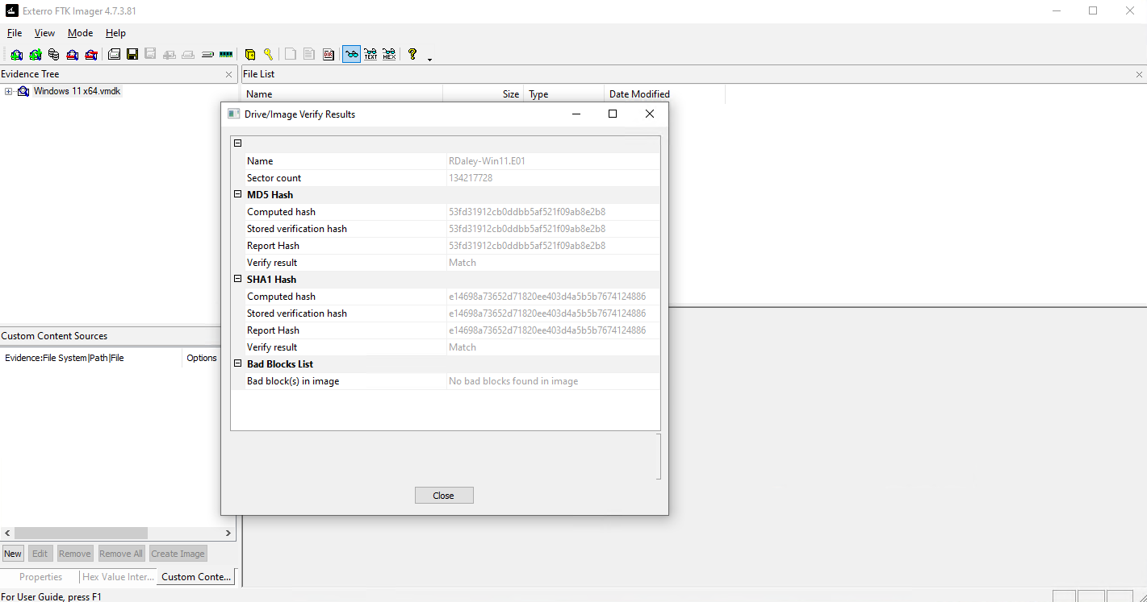
Fig. 1. Exterro FTK Imager’s Image Verify Results

- Decryption: Unlocked the BitLocker-encrypted volume using the recovery key provided by CMMC’s IT department.
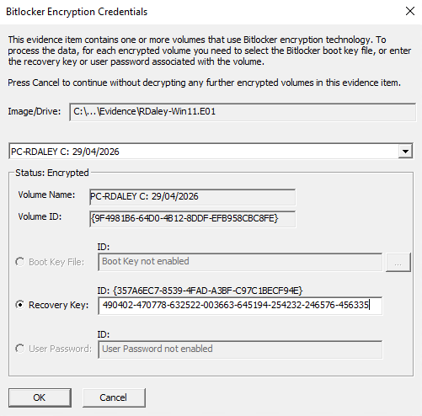
Fig. 2. Upload of Evidence Image and BitLocker Recovery Key
- System Analysis: Parsed Windows 11 Prefetch files and the Master File Table (MFT) using Exterro FTK to identify the execution of anti-forensic software alongside Registry Viewer and Windows Events correlations.
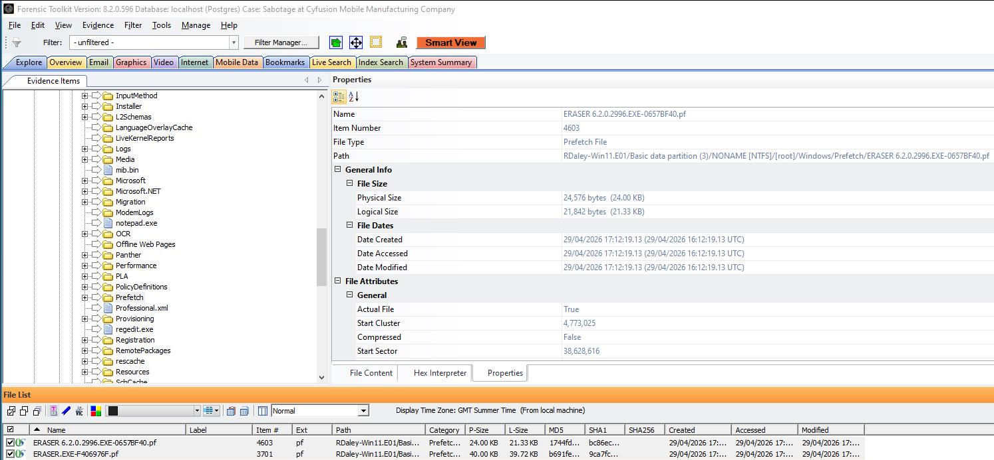
Fig. 3. Eraser.exe Prefetch files found in \Windows\Prefetch\

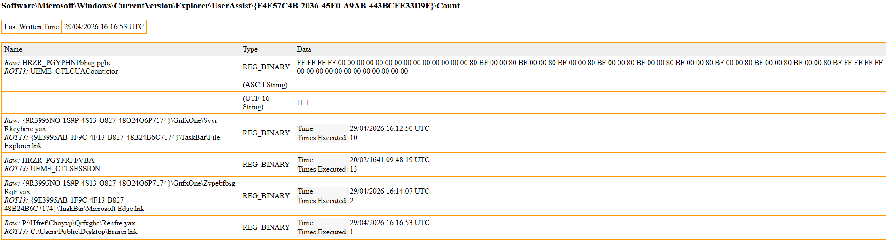
Fig. 4. Eraser.lnk Registry found in Windows Registry

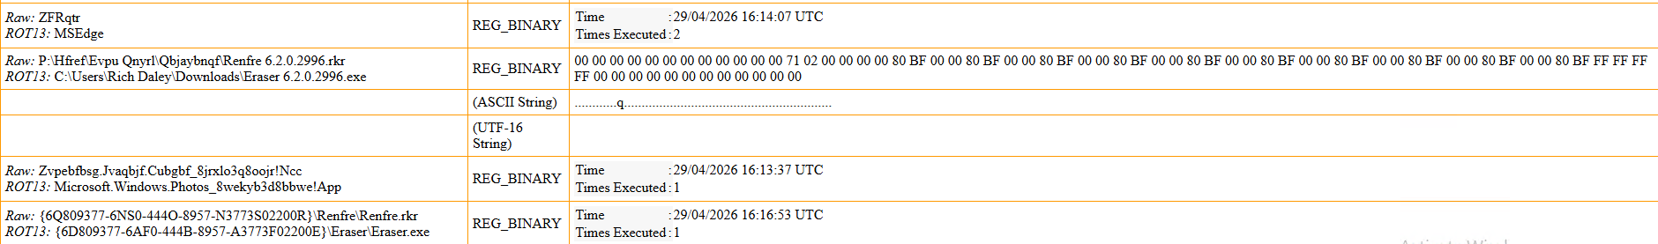
Fig. 5. Eraser 6.2.0.2996.exe Registry found in Windows Registry

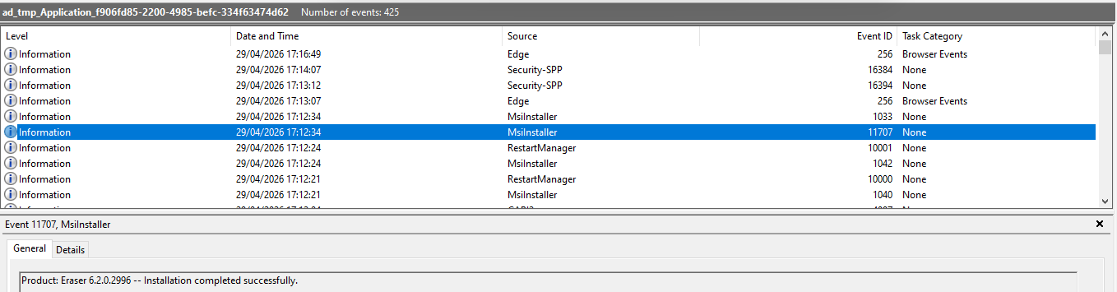Fig. 6. Windows Event of Eraser 6.2.0.2996 installation

- Data Recovery: Conducted data carving across unallocated disk space using Exterro FTK, targeting specific file signatures to recover destroyed assets.
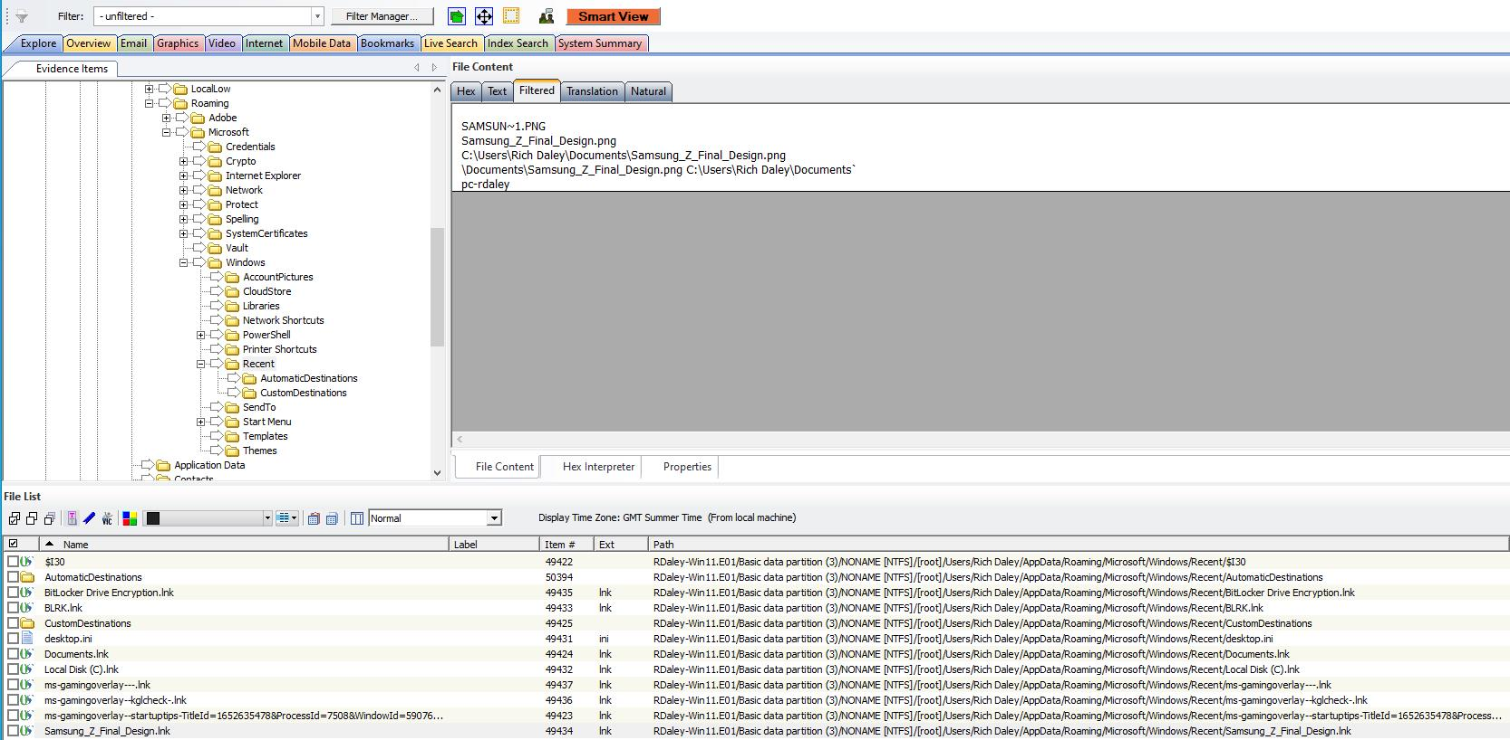Fig. 7. Samsung_Z_Final_Design.lnk found in \Users\Rich Daley\AppData\Roaming\Windows\Recent\

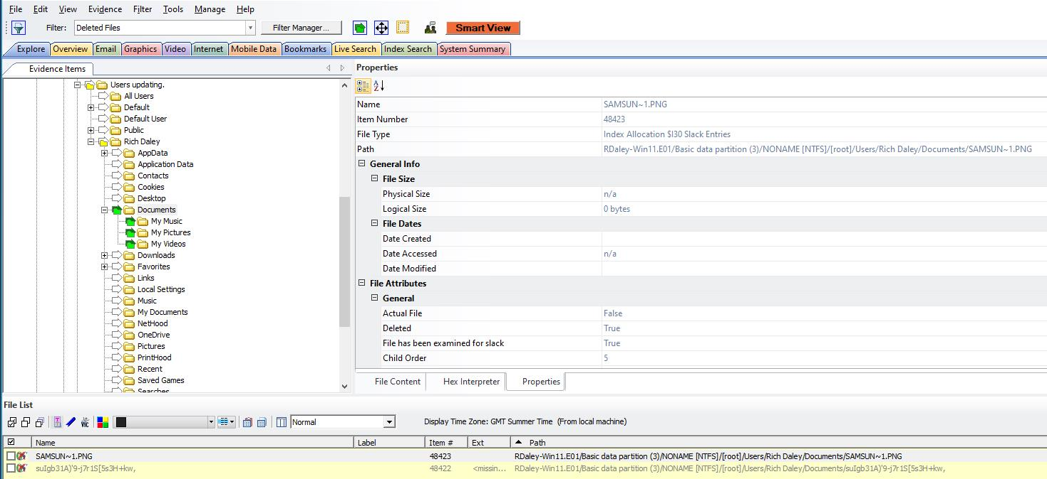Fig. 8. Index allocation of .png file deleted from \Users\Rich Daley\Documents\

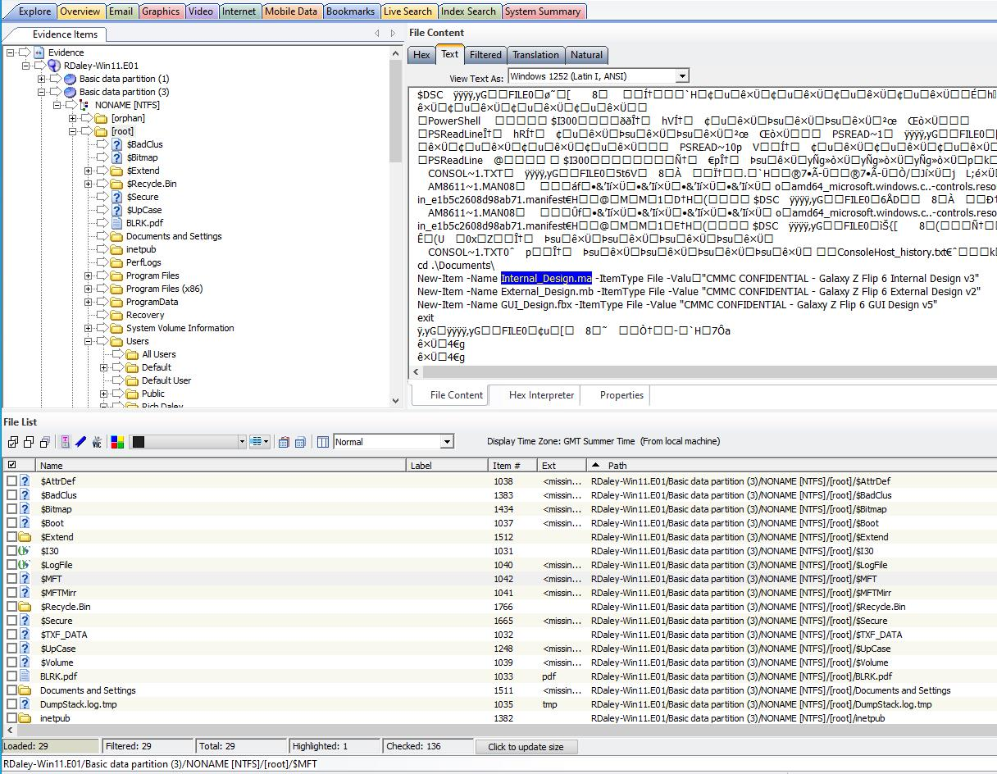Fig. 9. Powershell commands to create confidential files found in MFT

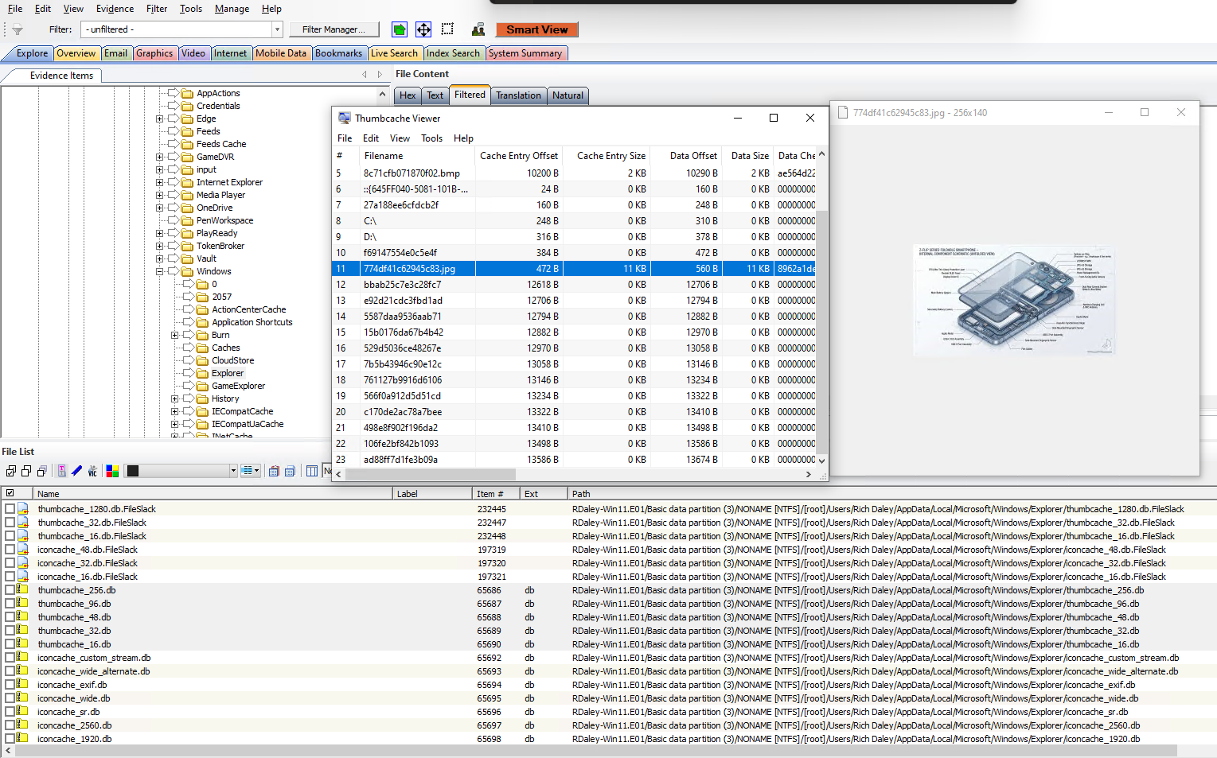Fig. 10. File carving in Windows Thumbnail Cache and parsed them with thumbcacheviewer

- Exfiltration Analysis: Parsed web browser SQLite databases using Exterro FTK to reconstruct cloud synchronisation timelines.
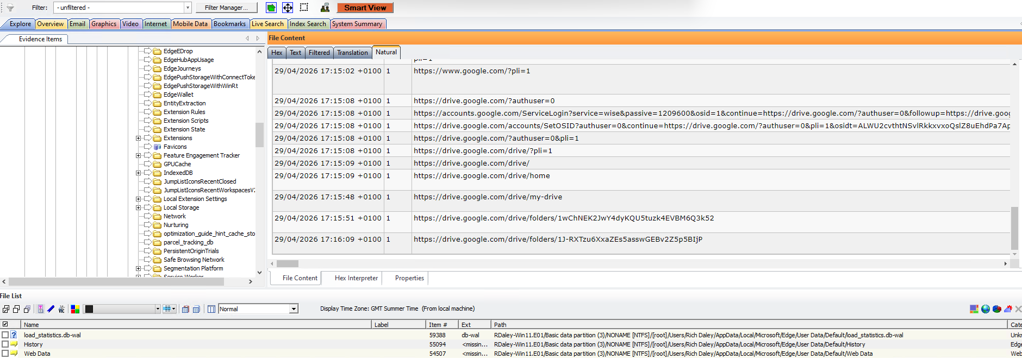Fig. 11. Google Drive accessed
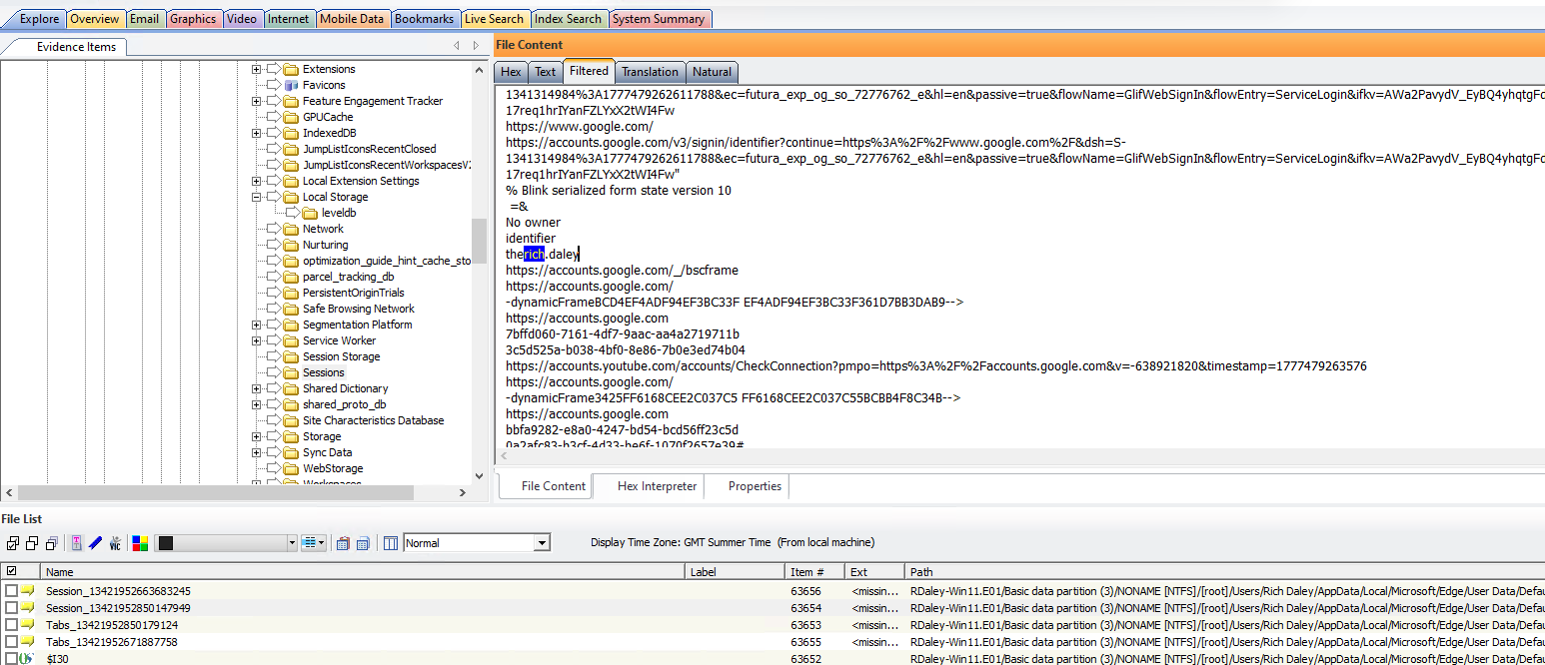Fig. 12. Personal account found (therich.daley)

FINDINGS

- Evidence of Anti-Forensic Activity: FTK software analysis identified the presence of Eraser.exe. Analysis of the Windows Prefetch directory (C:\Windows\Prefetch) confirmed that Eraser.exe was executed by the user Rich Daley prior his resignation. The MFT revealed at least 3 files being created using PowerShell commands and consequently not found anywhere in the system, confirming deletion of said files.

- Recovered File Fragments: Utilising custom hexadecimal carving in Exterro FTK didn’t bring positive results, however, searching in common places where files leave traces, one design file containing schematics of Samsung Galaxy Z Flip 6 was found.

- Cloud Synchronisation Evidence: The browser artefact evidence found with Exterro FTK demonstrates that Rich Daley transferred CMMC proprietary design files to a personal Google Drive account prior to destroying the local copies.

CONCLUSION

Based on the forensic evidence extracted from the seized device, it is the expert opinion’s that Rich Daley engaged in deliberate, premeditated sabotage. The evidence proves that Daley exfiltrated highly confidential corporate assets to a personal cloud storage environment and subsequently deployed specialised anti-forensic software to destroy the original files on the host system in an attempt to conceal the theft.

APPENDIX: HASH LOG

Exterro FTK Imager 4.7.3.81 – Image Verification Log

Created by: Troy Simpson
Case Number: CMMC-RD-01
Drive Information:
Image Name: Windows 11 x64.vmdk
Sector Count: 134,217,728
MD5 Checksum: 53fd31912cb0ddbb5af521f09ab8e2b8
SHA-1 Checksum: e14698a73652d71820ee403d4a5b5b7674124886
Bad Blocks: No bad blocks found in image

FORENSIC IMAGE CREATION ENCASE FORMAT
Image Information:
Image Name: RDaley-Win11.E01
Sector Count: 134,217,728
MD5 Checksum:
Computed Hash: 53fd31912cb0ddbb5af521f09ab8e2b8
Stored Verification Hash: 53fd31912cb0ddbb5af521f09ab8e2b8
Report Hash: 53fd31912cb0ddbb5af521f09ab8e2b8
Verify Result: Match
SHA-1 Checksum:
Computed Hash: e14698a73652d71820ee403d4a5b5b7674124886
Stored Verification Hash: e14698a73652d71820ee403d4a5b5b7674124886
Report Hash: e14698a73652d71820ee403d4a5b5b7674124886
Verify Result: Match
Bad Blocks: No bad blocks found in image

IMAGE VERIFICATION RESULTS AFTER FORENSIC INVESTIGATION
Exterro FTK 8.2.0.596 – Image Verification Results
Image Information:
Image Name: RDaley-Win11.E01
MD5 Checksum:
Stored: 53fd31912cb0ddbb5af521f09ab8e2b8
Calculated: 53fd31912cb0ddbb5af521f09ab8e2b8
Reported: 53fd31912cb0ddbb5af521f09ab8e2b8
Verify Result: Verified
SHA-1 Checksum:
Stored: e14698a73652d71820ee403d4a5b5b7674124886
Calculated: e14698a73652d71820ee403d4a5b5b7674124886
Reported: e14698a73652d71820ee403d4a5b5b7674124886
Verify Result: Verified
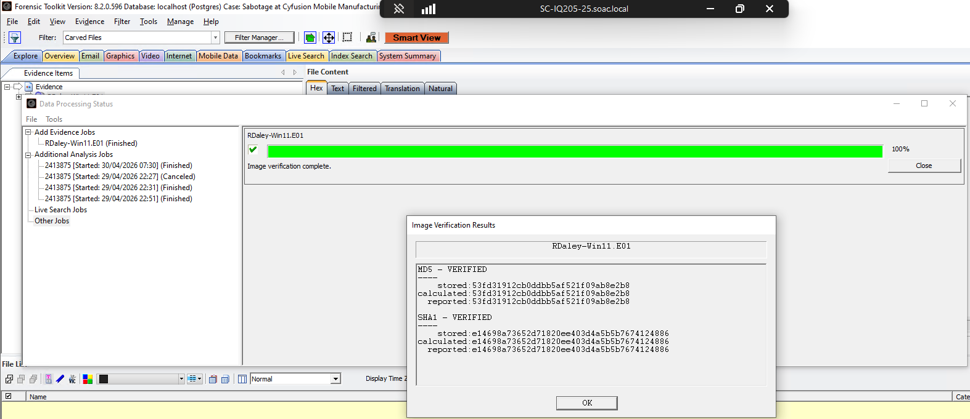
Fig. 13. Exterro FTK Image Verification Results after investigation

INVOICE

═════════════════════════════════════════════════════════
TROY SIMPSON
═════════════════════════════════════════════════════════
Invoice No: TS-2026-0001
Date: 30/04/2026
Client: Cyfusion Mobile Manufacturing Company
Attn: Ms. Ker Walters, CEO
Case Ref: CMMC-RD-01

SERVICE DESCRIPTION | HRS | RATE | TOTAL
Initial consultation & case briefing with Ms. K. Walters | 2.0 | £175/hr | £350.00
Evidence seizure, documentation & chain of custody preparation | 3.0 | £150/hr | £450.00
Forensic acquisition (BitLocker decryption, FTK imaging, hash verification) | 4.0 | £150/hr | £600.00
Anti-forensic artefact analysis (Prefetch, Registry, Event Logs, LNK files, MFT examination) | 5.0 | £150/hr | £750.00
File carving & recovery (unallocated space, thumbnail cache, secondary locations) | 4.0 | £150/hr | £600.00
Browser & cloud artefact analysis (Chrome History, Cookies, Preferences, Cache, Drive evidence) | 5.0 | £150/hr | £750.00
Report writing & production | 6.0 | £150/hr | £900.00
Expert testimony preparation & legal counsel briefing | 4.0 | £175/hr | £700.00
──────────────────────────────────────────────────────────────────────────────────
SUBTOTAL: £5,100.00
VAT (20%): £1,020.00
──────────────────────────────────────────────────────────────────────────────────
TOTAL DUE: £6,120.00
═════════════════════════════════════════════════════════
Payment Terms: 30 days. Bank transfer to:
Account Name: Troy Simpson
Sort Code: [12-23-43] | Account: [01100111]

Queries: [info@troysimpson.co.uk]
═════════════════════════════════════════════════════════

Conclusion

The modern digital forensic investigator navigates a labyrinthine technological environment characterised by ubiquitous encryption, highly fragmented cloud architectures, and an overwhelmingly massive volume of data. The EC-Council’s CHFI methodology provides the requisite procedural discipline and legal framework to conduct investigations in this environment, but the ultimate success of an investigation relies heavily on the strategic, educated deployment of specialised forensic tools.

As demonstrated through this exhaustive evaluation, Exterro FTK remains the premier powerhouse for large-scale, deep-disk imaging and processing. Cellebrite UFED serves as the indispensable key for breaching the formidable security layers of modern mobile devices, facilitating critical extractions that would otherwise remain inaccessible. Magnet AXIOM elegantly bridges the investigative gap across domains, offering unparalleled artifact correlation across disk, mobile, and cloud environments. Finally, Autopsy proves that the open=source community continues to provide highly capable, legally defensible, and absolutely essential alternatives that democratise access to sophisticated forensic analysis. Forensic readiness demands not a reliance on a single application, but the mastery of a diversified, multi-tool ecosystem.

The practical application of these principles in the Case Study further emphasises their critical importance. In the case, the successful resolution of the incident required a layered forensic approach. By utilising Exterro FTK for all phases of the investigation, it successfully proved the intent of the suspect.

References

[1] EC-Council, “CHFI Candidate Handbook V5”, May 2021. [Online]. Accessed: Apr 28, 2026. Available at: https://cert.eccouncil.org/images/doc/CHFI-Handbook-v5.pdf.
[2] A. Dimitriadis, N. Ivezic, B. Kulvatunyou and I. Mavridis, "D4I - Digital forensics framework for reviewing and investigating cyber attacks," Array. vol. 5, pp.100015, -03-01 2020, doi: 10.1016/j.array.2019.100015. Accessed: Apr 28, 2026. Available at: https://www.sciencedirect.com/science/article/pii/S2590005619300153.
[3] E. Salfati and M. Pease, "Digital Forensics and Incident Response (DFIR) Framework for Operational Technology (OT)," Jun 2022, doi: 10.6028/NIST.IR.8428. Accessed: Apr 28, 2026. Available at: https://nvlpubs.nist.gov/nistpubs/ir/2022/NIST.IR.8428.pdf.
[4] G. Kessler, "View of Are mobile device examinations practiced like ‘forensics’?" 2015, doi: 10.14296/deeslr.v12i0.2237. Accessed: Apr 28, 2026. Available at: https://journals.sas.ac.uk/deeslr/article/view/2237/2170.
[5] K. Kent, S. Chevalier, T. Grance and H. Dang, "Guide to Integrating Forensic
Techniques into Incident
Response," Aug 2026, doi: 10.6028/NIST.SP.800-86. Accessed: Apr 28, 2026. Available at: https://nvlpubs.nist.gov/nistpubs/Legacy/SP/nistspecialpublication800-86.pdf.
[6] E. Casey, Digital evidence and computer crime : forensic science, computers and the internet, 3rd Ed. Burlington, MA: Academic Press, 2011.
[7] A. Case and G. G. Richard, "Memory forensics: The path forward," vol. 20, pp.23–33, 2017, doi: 10.1016/j.diin.2016.12.004.
[8] S. L. Garfinkel, "Carving contiguous and fragmented files with fast object validation," vol. 4, pp.2–12, 2007, doi: 10.1016/j.diin.2007.06.017.
[9] R. M. Saidi, et al., "Windows registry analysis for forensic investigation", pp. 132–136. [Online].doi: 10.1109/TAEECE.2013.6557209.
[10] W. Jansen and R. Ayers, "Guidelines on cell phone forensics," vol. 800, no. 101, pp.800–101, 2007,
[11] D. Tidmarsh."What do you need to know about cloud forensics?" Cybersecurity Exchange. (Sep 22022). Accessed: Apr 28, 20262026, [Blog]. Available at: https://www.eccouncil.org/cybersecurity-exchange/computer-forensics/what-is-cloud-forensics/
[12] J. Sammons, The basics of digital forensics : the primer for getting started in digital forensics, 2nd Ed. Waltham, MA: Elsevier, 2014.
[13] F. Ninos, K. Karalas, D. Dechouniotis and M. Polemis, "On Microservice-Based Architecture for Digital Forensics Applications: A Competition Policy Perspective," vol. 17, no. 4, pp.137, 2025, doi: 10.3390/fi17040137.
[14] Exterro Inc. “FTK SYSTEM SPECIFICATION GUIDE”, Sep 2023. [Online]. Accessed: Apr 28, 2026. Available: https://d1kpmuwb7gvu1i.cloudfront.net/8.x/8.0.0/Doc/Exterro_FTK-System_Specification_Guide.pdf
[15] B. Carrier, File system forensic analysis, Portland: Copyright Clearance Center, Inc, 2005. [Online]. Available: https://klikitscripts.com/toddbooks/files/File%20System%20Forensic%20Analysis%20(%20PDFDrive%20).pdf
[16] Exterro Inc. "Exterro Intelligence." https://www.exterro.com. [Online]. Available: https://www.exterro.com/exterro-intelligence
[17] Exterro Inc. "Exterro FTK Forensic Toolkit: Product Overview." https://www.exterro.com. Accessed: Apr 28 2026. [Online]. Available: https://www.exterro.com/digital-forensics-software/ftk-forensic-toolkit
[18] "Magnet Axiom | Digital Forensic Software." Magnet Forensics. Accessed: Apr 28 2026. [Online]. Available: https://www.magnetforensics.com/products/magnet-axiom/
[19] "Magnet AI | Built for justice. Designed for truth." Magnet Forensics. Accessed: Apr 28 2026. [Online]. Available: https://www.magnetforensics.com/magnet-ai/
[20] J. E. James, "Foundations of mobile forensics: an academic approach." vol. 25, no. 3, 2024,
[21] B. Carrier, "Open Source Digital Forensic Tools: The Legal Argument," 2002,
[22] M. Farnan, et al., "Digital Forensic Tools: Comparison of Autopsy TSK and Forensic Explorer", pp. 1–5. [Online].doi: 10.1109/ICITEICS61368.2024.10625076.Available: https://ieeexplore.ieee.org/xpls/abs_all.jsp
[23] G. Horsman, "ACPO principles for digital evidence: Time for an update?" vol. 2, pp.100076, 2020, doi: 10.1016/j.fsir.2020.100076. Available at: https://www.sciencedirect.com/science/article/pii/S2665910720300220.
[24] M. Yip, "Signature Analysis and computer forensics," pp.1–11, 2008,

