Implementing sustainable practices in the hotel and hospitability sector to achieve eco-certification.
Sustainable Hospitality & Tourism Management BMIH5006
Andreea Loredana Mirica 2028692
Ruth Taylor Davies
word count:2187
Contents
Executive Summery 2
Introduction 3
Main body 5
Sustainable Accreditation in Hotels 5
The benefits and challenges of incorporating green in the hospitality industry 10
How does the future look for hotels and hospitality? 12
Conclusion 14
References 15

Executive Summery

This paper investigates the increasing popularity of environmentally friendly procedures in the hotel and hospitality business, focusing on the pursuit of eco-certifications such as the Green Key accreditation. It covers the steps required to achieve sustainable accreditation, examines the benefits as well as challenges of integrating sustainability into daily operations, and considers future trends. The research also dives into sustainability ideas and models, such as the Green Key Initiative and business Social Responsibility (CSR), critically examining the influence of green tourism and comparing it to successful business practices to show the need for improvement.

Introduction

This report focuses on the rising trend of hotels implementing environmentally friendly initiatives to acquire eco-certifications like the Green Key accreditation, which addresses environmental challenges. It explores into the methods necessary to meet sustainable accreditation standards, as well as the benefits and challenges associated with sustainability in the sector. It also focuses on the industry's future sustainable direction.

According to Inkson(2022), tourism is a dynamic industry driven by societal and external influences. It is an intrinsic part of our life and cannot be isolated from the larger external world. Furthermore, she emphasises that successful tourist enterprises must adapt and adjust quickly to current economic and operating conditions. These dynamics are critical for globalisation, sustainability, and advancements in information and communication technology.
The hotel business is a significant source of revenue and opportunity in nations that are developing, impacting communities worldwide. Tourism, an important driver to global GDP, produced over 10% in 2020, producing one in ten employment and growing its scale prior to the epidemic, according to WTTC (2020), with one in four new jobs in the previous five years.
Wolfgang M. Neumann, Chair of the Sustainable hotel Alliance, stated that the United Nations and the hotel sector are working together to achieve sustainability, with an emphasis on the Paris Agreement (United Nations, 2015) and the UN Sustainable Development Goals (SDG, 2024). He furthermore said that partnership between governments, the public and private sectors is critical for speeding transformation and preparing future hotel staff and leaders (SHA, 2020).
According to The Sustainable Hospitality Alliance (2024), the hospitality sector accounts for 1% of worldwide carbon emissions and must decrease emission levels per room by 66% and 90% by 2030 and 2050, respectively, to avoid further expansion, highlighting the increasing significance of sustainability in this sector in order to minimise its environmental impact.
Sustainability is now an essential priority in the tourism and hospitality sector. Sustainable hospitality, as defined by Legrand (2023), entails effectively handling resources while considering economic, social, and environmental costs in order to fulfil current requirements while safeguarding and improving prospects for the next generation.

Main body

Sustainable Accreditation in Hotels
According to Travel Agent Central (2023), how interested people are in sustainability has grown dramatically in the past few years, with 69% of all travellers now looking for environmentally conscious travel alternatives.
Hotels must adopt several environmentally friendly practices to acquire sustainable accreditation, such as the Green Key designation, which is listed below:
To reduce water use, hotels should prioritise waste reduction, take minor precautions, explore cost-cutting alternatives, and involve customers, such as:
- Educate people.
- Utilise water-saving washing technologies.
- Set up showerheads with reduced flow and faucets.
- Setting up greywater reuse systems.
- Utilise immune to drought plants. (Water Offsets, 2024)

Hotels consume considerable amounts of water, with a single room consuming between 60,000 and 220,000 litres per year, resulting in expensive costs. 54% of total usage of water comes from rooms and shared bathrooms as shows in figure 1(IDRAL, 2022).
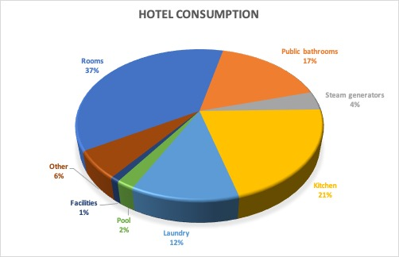
(Figure 1, WHAT IS THE WATER CONSUMPTION OF A HOTEL)

Hotel rooms use an average of 0.55 kWh per day, with typical rooms using around 50,000 kWh. Restaurants, pubs, and gyms also use energy, based on Pinnington (2023).
- the use of LED lamps is essential to enhance energy efficiency.
- employ efficient HVAC systems,
- invest in alternative energy sources such as solar panels or geothermal systems. (Wood, 2024)
Employing energy-efficient measures can help companies save money on their electrical consumption while also reducing their carbon footprint.
Waste management in the hotel business is critical for long-term operations, decreasing environmental impact, saving money, and improving customer happiness.
Initiatives include:
- source separation and recycling,
- food waste management,
- single-use plastic reduction,
- staff education and involvement. (HPG Consulting ,2024)
According to Wayne and Steinfeld (2017) food waste in the hotel industry accounts for 50% of total spending, with more than $218 billion allocated to non-edible foods. Hotels like Fairmont Jasper Park Lodge implement ecological measures such as utilising vegetable oil to run the track and farm generators.
Another effort in responsible sourcing entails purchasing items and services at the greatest possible value and of the highest quality while considering criteria for sustainability. Hotels should mitigate environmental and social implications by obtaining sustainable goods and influencing suppliers and customers (SustinableHospitalityAlliance, 2021).
As reported by Sarfas (2024), European firms Unilever, Aldi Sud, Aldi Nord, Barilla, Nestlé, and Gategroup are aiming to be completely cage-free by 2025. In addition, Marriott International (2019) is aggressively promoting sustainable seafood purchases, prohibiting specific species such as bluefin tuna, sea bass, marine mammals, orange roughly, sea turtles, and sharks, with the goal of sourcing 95% of its top categories before 2025.
Hotels are also encouraging sustainability by educating tourists, offering rewards, recognising successes, and granting loyalty points for sustainable behaviours such as reusing towels, saving electricity, and not providing daily room service (LinkedIn, 2024; Travel Places, 2023).
Each of the above strategies, once followed and maintained, will have a positive impact on the sustainability of any hotel.

Green travel has resulted in greenwashing, which is a false marketing approach in which an organisation pretends to be environmentally friendly but fails to deliver on its promises, hurting tourist sustainability initiatives and creating a hostile environment (Sustainable Travel International, 2024).
The hotel's sustainability strategy may be called into question because of variations in green measures such as the as the presence of a green sign, neglecting to incorporate green practices such as linen reuse, discarding of disposable products, and even membership in a non-inspected sustainable accreditation system. Nowadays, the rise of "greenwashing" requires travellers to distinguish between true green hotels and those that only pretend to be such.
The Booking.com sustainable Report (2021) indicates the increased need for confirmation of sustainable policies among travellers and travel provider customers.

Accredited Certification Body is a third-party review of a company's policies and assures that tourist goods fulfil environmentally friendly standards and GSTC criteria. This certifying authority gives credibility and confidence while maintaining openness and neutrality. Businesses that meet GSTC Criteria exhibit distinctive GSTC logos as seen in figure 2, reflecting strong management and forward-thinking operations GSTC, 2022).

(Figure2, Logo for businesses certified to the GSTC Criteria)

Hotels are approved by reliable environmental certification agencies such as Green Key, Earth Check, LEED, Green Globe, Trip Advisor Green Leaders, Green Seal, and Travelife, assuring long-term sustainability and excellent guest experiences (Event Temple, 2023).
Green Key accreditation, a leading benchmark in environmental responsibility, guarantees that businesses follow stringent requirements, supporting sustainable operations in the tourism industry, with over 5,000 recognised facilities in 60+ countries (Green Key, 2023).

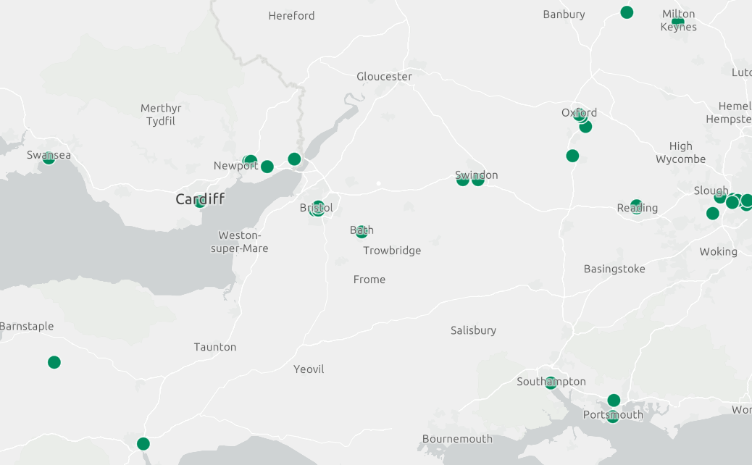

(Figure3, MAP OF ALL THE GREEN KEY SITES IN THE WORLD)
As shown above in the figure 3, the Parkgate Hotel, Delta Hotels by Marriott Swansea, Coldra Court Hotel, and Celtic Manor Resort are just a handful of the hotels in Wales that have a Green Key certification which encourages the use of environmentally friendly and sustainable ways of operation.

The benefits and challenges of incorporating green in the hospitality industry.

The travel sector is progressively adopting green methods, which help both the environment and the traveller.
Sustainable hospitality focuses on saving energy and water while minimising prices. SaltLine Hotele's energy management system saved 56,000 kWh per year, cutting energy consumption by 40 kWh per day (Energy Trust, 2023).
According to ABRAMOVICH (2023), a Wunderman survey found that 88% of US customers choose businesses that establish new standards, and 89% are devoted to brands that adhere to their values. Integrating sustainable ideals into a business has the potential to draw in and keep loyal customers who return for further visits and suggest the accommodation to friends and family.
Brand awareness is crucial for businesses to gain a competitive advantage in the burgeoning market. Sustainable brands in the travel and tourism industries can enhance their brand by emphasizing eco-friendly practices, community engagement, and biodiversity conservation (Bolder, 2023). Furthermore, Green travel, accompanied by awards and recognitions, can significantly boost brand awareness.
Operational efficiency is a key strategy for successful hotel operations, ensuring staff satisfaction and maximizing profitability. In accordance with Kaur (2023) by streamlining operations, automating repetitive tasks, and listening to customer demands, hotels can implement a comprehensive strategy that boosts overall performance.
Green hotels provide a healthier environment by utilising environmentally friendly cleaning products and organic, locally produced meals, appealing to health-conscious travellers' tastes.
As noted by Grant Thornton (2023), keeping up with worldwide environmental tax incentives is critical for organisations to consider tax rate reductions, loans, and special discounts for enterprises embracing green measures, delivering financial benefits to their properties.
Another benefit of sustainable hotels is that they promote compassion and sustainable growth by buying locally, creating jobs, and contributing to local sustainability programmes within the community.
Sustainability in the hotel business has various benefits, but it also raises obstacles.
The hospitality sector faces a significant energy consumption increase. According to the IEA's (2023) CO2 Emissions in 2022 report, estimate that energy consumption climbed by less than 1% in 2022, despite increases in solar, wind, and energy efficiency. To minimise emissions and increase efficiency, the business should use renewable energy, energy-efficient equipment, smart metering, and educate visitors on power-saving habits.
The hotel business has water management and conservation challenges, particularly in desert and coastal areas. Water conservation, recycling, and collaboration with local governments are among the strategies employed. Furthermore, the sector creates a large amount of waste, which may be reduced using circular economy concepts.
Another challenge for green hotels and the planet is the carbon footprint, which is measured by the Global Warming Potential, a climatic change induced by human activity that affects the atmosphere via greenhouse gas emissions. Reducing it requires responsible consumption, the use of local products, energy-efficient equipment, and sustainable transportation (REPSOL,2024a).
Another impediment to green hotels and the environment is climate change. In keeping with that, the Paris Agreement seeks to limit global warming to 1.5 degrees Celsius by tackling climate change, which is principally produced by the greenhouse effect. Circular economies, renewable energy, reforestation, and effective CO2 collection are all examples of sustainable solutions. Companies are dedicated to long-term climate solutions, while everyone participates by buying local, recycling, and decreasing waste (REPSOL, 2024b).

How does the future look for hotels and hospitality?

The future of sustainable hospitality looks bright, with an emphasis on environmental preservation, social responsibility, and economic sustainability, shaped by key trends, as follows above.
Green hotels are a category of hospitality facility that focuses on lowering its environmental effect through sustainable and eco-friendly activities (RAW, 2024).
Sustainable hotels foster carbon neutrality by lowering waste and reusing resources, such as HVAC systems, to reach no waste and encourage sustainable sourcing stated Weber (2024).
The future of sustainable hospitality will prioritise responsible tourist practices that benefit local economies, preserve cultural heritage, and promote biodiversity protection. The industry is using sustainability certifications like as Green Key and Earth Check (Earth Check, 2023) as proof of its concern for the environment and society.
Technologies is important for improving sustainable hospitality; the future will witness improved resource efficiency and environmental performance through new solutions like as smart building management systems and IoT sensors. Mathe (2023) said that IoT is transforming building management by increasing energy conservation, lowering operational costs, and boosting comfort through data gathering and connection with management systems.
Sustainable hospitality supports circular economy concepts by minimising waste and maximising reuse, recycling, and repurposing of resources, resulting in lowering carbon dioxide emissions and pollution, leading to a sustainable future. (Circular&Co, 2024)
Sustainable hospitality is a fundamental approach that prioritises community participation, training, and socially beneficial projects. It entails investment in sustainability education and environmentally friendly experiences for tourists. Partnerships cooperation among hotels, authorities, non-governmental organisations (NGOs), and industry players are also critical for moving forward with sustainable projects while encouraging solidarity.
Climate change is a significant environmental problem that affects tourism and the hotel sector. According to Booking.com's Sustainable Travel Report 2022, 81% of global travellers prioritise sustainable travel, with half identifying climate change as a major factor influencing ecologically aware decisions. It is becoming increasingly necessary for hospitality companies to include more environmentally conscious methods into their operations in the future.

Conclusion

The hotel and hospitality businesses are integrating sustainability into their daily activities, which presents benefits and challenges. While the initial expenses may be significant, the rewards in the future include the preservation of resources, decreased pollution, and increased competitiveness. The future will witness growing use of new technology and innovation, greener hotels, carbon offsets and zero waste, accreditation as Green Key, and a stronger emphasis on circular economy concepts. Also, community participation and collaboration among hotels and governments support sustainability projects. Hotels must embrace sustainability and strong CSR practices to stay competitive while also contributing positively to environmental and social health.

References

ABRAMOVICH, G. (2023) Study: Majority Of People More Loyal To Brands That Care About Them. Available at:https://business.adobe.com/uk/blog/perspectives/people-more-loyal-to-brands-that-care-about them#:~:text=Additionally%2C%2089%25%20are%20loyal%20to,in%20making%20their%20lives%20easier. (Accessed:31.06.2024)

Bolder (2023) 0 Real Ways to Increase Brand Awareness for Sustainable Businesses Available at:https://www.bolderagency.com/journal/10-real-ways-to-increase-brand-awareness-for-sustainable-businesses(Accessed:31.06.2024)

Booking.com 2021 Sustainable Travel Report (2021) Booking.com 2021 Sustainable Travel Report reveals how the ‘pandemic effect’ could finally tip sustainable travel intent into impactful action. Available at:https://www.gstcouncil.org/booking-com-2021-sustainable-travel-report/(Accessed:02.06.2024)

Booking.com (2022) Sustainability travel report 2022 Available at:
https://globalnews.booking.com/download/1161485/booking.comsustainabletravelreport2022final.pdf(Accessed:31.06.2024)

Circular&Co (2024) Our mission: Circular Design Available at:https://circularandco.com/circular-mission?gad_source=1&gclid=Cj0KCQjw0_WyBhDMARIsAL1Vz8tMecVxwC3lsVByE-QLkX8ZAD3kOfO-d2zSwSuRmHd9XbfGHPR77yUaAgdrEALw_wcB (Accessed:30.06.2024)

Earth Check (2023) CERTIFICATION Available at: https://earthcheck.org/what-we-do/certification/(Accessed:30.06.2024)

Energy Trust (2023) Oregon Coast’s SaltLine Hotel has built in energy efficiency from day one. Available at:https://blog.energytrust.org/oregon-coasts-saltline-hotel-has-built-in-energy-efficiency-from-day-one/(Accessed:31.06.2024)

Event Temple (2023) Sustainability in hotels: 5 Ways to Recognize a Sustainable Hotel Available at:https://www.eventtemple.com/blog/sustainability-in-hotels-5-ways-to-recognize-a-sustainable-hotel(Accessed:01.06.2024)

Global Sustainable Tourism Council (GSTC) (2022) Becoming Certified as a Sustainable Hotel/Accommodation Available at:https://www.gstcouncil.org/certification/become-certified-hotel/(Accessed:02.06.2024)

Grant Thornton (2023) Engaging with incentives to drive your ESG goals. Available at:
https://www.grantthornton.global/en/insights/articles/esg-tax-2023---reliefs-and-incentives/(Accessed:01.06.2024)

Green Key (2023) Unlocking sustainability in the hospitality industry. Join Green Key Available at: https://www.greenkey.global/(Accessed:02.06.2024)

HPG Consulting (2024) Waste Reduction Strategies in Hotel Facilities Available at:
https://hpgconsulting.com/uncategorized/waste-reduction-strategies-in-hotel-facilities/#:~:text=One%20of%20the%20most%20fundamental,their%20waste%20stream%20from%20landfills. (Accessed:29.06.2024)

IDRAL (2022) WHAT IS THE WATER CONSUMPTION OF A HOTEL? Available at:https://www.idral.it/en/hotel-water-consumption/#:~:text=Water%20consumption%20in%20the%20rooms,represents%2054%25%20of%20total%20consumption. (Accessed:28.06.2024)

IEA (2023) CO2 Emissions in 2022 Available at:https://www.iea.org/reports/co2-emissions-in-2022(Accessed:01.06.2024)

Inkson, C. (2022) Tourism management: an introduction. 3rd edition. London:, SAGE.

Kaur, G. (2023) How can hotels improve operational efficiency? Available at:
https://botshot.ai/resources/blog/hotel-improve-operational-efficiency(Accessed:30.06.2024)

Legrand, W. (2023) Sustainability in the hospitality industry: principles of sustainable operations. Fourth edition. London; New York, New York; London ; New York, New York :, Routledge. Available at:https://read.kortext.com/reader/pdf/2040028/31(Accessed:27.06.2024)

LinkedIn (2024) How can you involve guests in your hotel's sustainability efforts? Available at:https://www.linkedin.com/advice/0/how-can-you-involve-guests-your-hotels-sustainability-aa1ge#:~:text=Involving%20guests%20in%20hotel%20sustainability,sustainable%20behavior%2C%20showcasing%20green%20initiatives%2C(Accessed:31.06.2024)

Mariott International (2019) RESPONSIBLE SEAFOOD POSITION STATEMENT Available at:https://serve360.marriott.com/wp-content/uploads/2019/05/Responsible-Seafood-Position-Statement2.pdf(Accessed:29.06.2024)

Mathe (2023) IoT in Smart Buildings: Benefits, Use Cases, and Tips Available at:
https://www.wattsense.com/blog/building-management/iot-in-smart-buildings-benefits-use-cases-and-tips/(Accessed:30.06.2024)

Mollie Pinnington (2023) Why do hotels have a high energy demand? Available at:https://www.resolveenergy.co.uk/blog/article/business-energy-guide-for-hotels#:~:text=If%20you%20have%20a%20standard,use%20a%20lot%20of%20energy. (Accessed:29.06.2024)

RAW (2024) Environmental Rating Systems for Hotels: Sustainability in Hospitality Available at:
https://rawcharging.com/environmental-rating-systems-for-hotels-sustainability-in-hospitality/(Accessed:31.06.2024)

REPSOL (2024,a) What is a carbon footprint and why is it important? All about the carbon footprint Available at:https://www.repsol.com/en/sustainability/sustainability-pillars/climate-change/reducing-carbon-footprint/index.cshtml(Accessed:01.06.2024)

REPSOL (2024,b) What is climate change? Causes and solutions The great challenge of our time. Available at: https://www.repsol.com/en/energy-and-the-future/future-of-the-world/what-is-climate-change/index.cshtml(Accessed:01.06.2024)

Sarfas, A. (2024) WHAT DOES CAGE-FREE PROGRESS LOOK LIKE AROUND THE WORLD? Available at:https://thehumaneleague.org/article/cage-free-progress-worldwide#:~:text=Cage%2Dfree%20in%20Europe&text=Companies%20across%20Europe%20are%20ditching,cage%2Dfree%20globally%20by%202025. (Accessed:28.06.2024)

SDG (2024) THE 17 GOALS Available at :https://sdgs.un.org/goals(Accessed:27.06.2024)

SustinableHospitalityAlliance (2021) Responsible procurement Available at:https://sustainablehospitalityalliance.org/wp-content/uploads/2021/05/Responsible-procurement-factsheet.pdf(Accessed:30.06.2024)

Sustainable Travel International (2024) How To Spot and Avoid Greenwashing in Tourism Available at: https://sustainabletravel.org/how-to-spot-avoid-greenwashing-tourism/(Accessed:29.06.2024)

The Sustainable Hospitality Alliance (2024) Climate change and the hospitality industry Available at:https://sustainablehospitalityalliance.org/our-work/climate-action/#:~:text=The%20hotel%20sector%20accounts%20for,its%20impact%20on%20our%20planet. (Accessed:28.06.2024)

Travel Agent Central (2023) Stats: 69% of Travelers Actively Seeking Sustainable Travel Options Available at:https://www.travelagentcentral.com/your-business/bookingcom-releases-2024-sustainable-travel-report(Accessed:28.06.2024)

Travel Places (2023) HOW HOTELS ARE INCENTIVISING GREEN CHOICES FOR GUESTS Available at:https://travelplaces.co.uk/how-hotels-are-incentivising-guests-to-make-green-choices/#:~:text=Reward%20Programs%3A%20Many%20hotels%20are,their%20room%20serviced%20every%20day. (Accessed:31.06.2024)

United Nation (2015) The Paris Agreement Available at:https://unfccc.int/process-and-meetings/the-paris-agreement(Accessed:27.06.2024)

Water Offsets (2024) 5 Simple Ways to Save Water & Recycle Water With Hydraloop Grey Water System Available at:https://www.wateroffsets.co.uk/post/5-simple-ways-to-save-water-recycle-water-with-hydraloop-grey-water-system(Accessed:28.06.2024)

Wayne,S., Steinfeld, D. (2017)How hotels are becoming smarter about waste Available at:https://www.hotelmanagement.net/operate/how-hotels-are-becoming-smarter-about-waste(Accessed:30.06.2024)

Weber, E. (2024) Sustainability Trends in Hotel Management for 2024 Available at:https://verdant.copeland.com/sustainability-trends-in-hotel-management/(Accessed:30.06.2024)

Wood, J. (2024) 3 Tips for Saving Energy in Hospitality For A Sustainable World Available at:https://business.getonbloc.com/saving-energy-in-hospitality/(Accessed:29.06.2024)

WTTC (2020) THE FUTURE OF TRAVEL & TOURISM IN THE WAKE OF COVID-19 Available at:
https://wttc.org/Portals/0/Documents/Reports/2020/To%20Recovery%20and%20Beyond-The%20Future%20of%20Travel%20Tourism%20in%20the%20Wake%20of%20COVID-19.pdf(Accessed:027.06.2024)

