Creating a Simple Database for The City Book Store

This documentation will cover the design and implementation of a database for the use of a local bookstore. It will allow the staff of the book store to search through the database for the books that are in stock, the customers information, order information, suppliers that are currently being used by the City Book Store. As well as add onto their existing database with new customers information, books coming into the store, suppliers and so on.

Content

Production of the Database

Relationship Diagram of tables

Forms and Reports

Database Production

A database was produced using MS Access in order for the City Book Store to handle and navigate the information that the Store’s are using currently to help with identifying orders, customer and suppliers. As well as monitoring the prices of orders that are coming into the stores and from which suppliers, and who the order was for and the staff member that ordered the book.

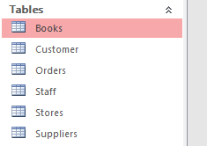
Firstly, suitable tables were to be created within access that will be used to create relationships that connect the different components of the City Book store together, and ready for data from the City Book store to be entering into them. These tables included the likes of:
- Books – this allows the staff members to search for books in store, prices of them and stock.
- Customers – Information from the customers to allow for the staff to contact them about orders that have been placed for within the store.
- Orders – This is to show which supplier the order is coming from, the date it was ordered, prices of the order, about the book that was ordered, and the ID of who ordered this item.
- Staff – Identified staff members by ID, position in store, their names and contacts.
- Store – Helps identify which store is being referenced to with ordered or stock take for monitoring books among the stores. And which staff work at each location.
- Suppliers – Identifies which supplier is being referred to a certain order, their contact details and the suppliers company name.

Once the suitable tables had been created, columns were added into the tables. These columns within the tables held information that would help to fill out and explain each table or help connect the relationship between that table and another.

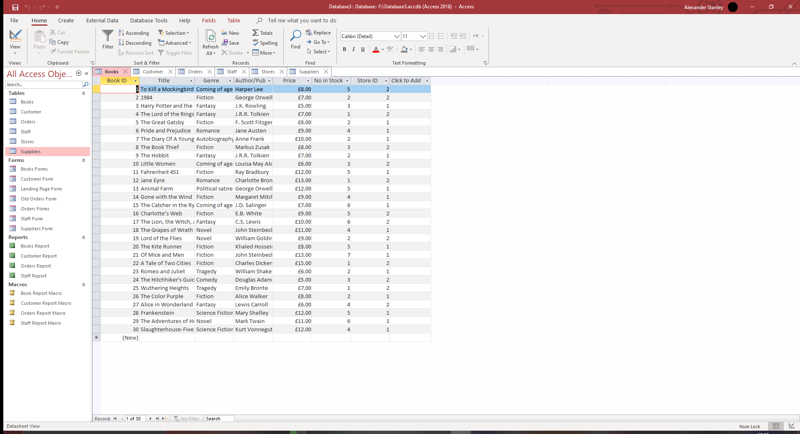
Above are the columns within the Books tables. With this information staff are able to narrow down books within the store for customers that are searching for a specific book based on the title, Author or publisher or genre of that book. The price will also be key for the staff member to relay to the customer is they are curious of the amount either their single purchase will be, or if they are looking for multiple books based on the prices they find. The number of books of that title are also displayed for stock take, and the store in which you are able to find that book.

The tables were then filled with information from the City Book store and this is a sample of the information as it would appear in the table within access.

This was repeated for the other tables within the database. Once completed with the information that is required for the tables, relationships between the tables were linked and highlighted to help understand how these tables are connected through the information that they held within them.
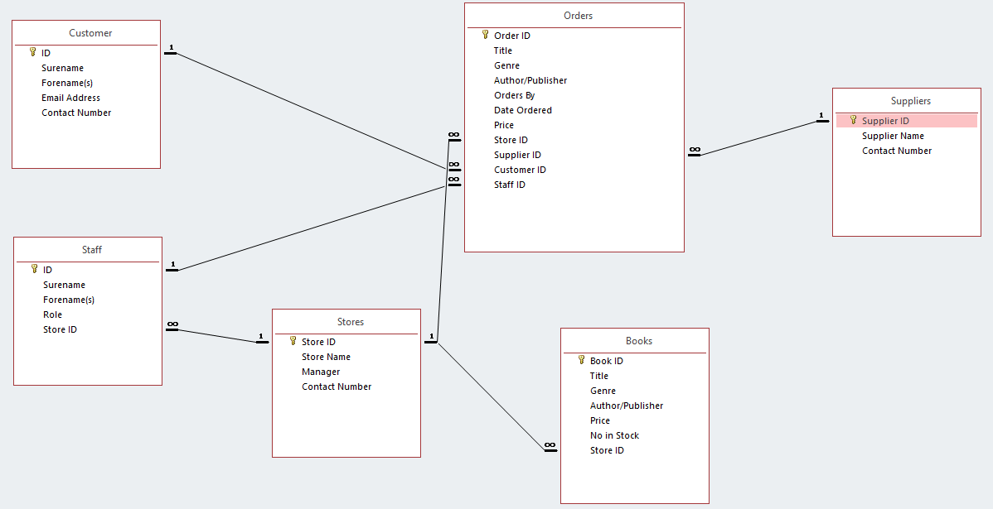
The Relationship Diagram that was created is below.

This diagram shows how these tables are connected with one-to-many connections throughout most of the diagram. For example, Staff and Stores are connected through the Store ID. This is because multiple members of staff work specifically within a single store. Orders and suppliers in another example, showing us that there could be many orders that come from a single supplier.
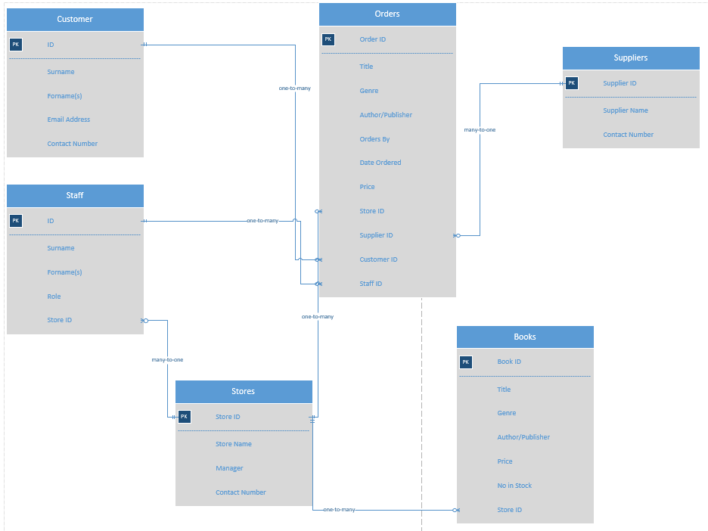

This is the ERD produced via Visio. Showing the relationships between the tables annotated with the type of connection that they fit into. These relationships can be expanded upon if and when more tables are added, or tables are expanded upon.

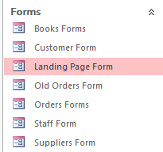
Following the creation and completion of information within the tables, forms are created that display the contents of the table in an interactive format allowing the staff member to interact with the data within each of the tables, provided, add new contents to those tables and from these forms create reports that can be printed off or stored for reference if needed.

The books form allows the staff member to view the books that are within the store as stock, traverse through this stock and view information regarding each individual book title within the store.
This also displays the price and the stock level of the title in question.
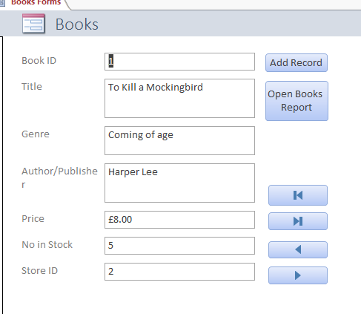
A book ID is also provided for an easer way of searching for that book.
A button “Add Record” is used for adding another record is available, this is what a staff member will want to press in order to add a new book to the stock inventory within the books table in the database. Pressing the “Open Books Report” will open a report of all the books in the store, their prices with a total at the bottom and their stock level.

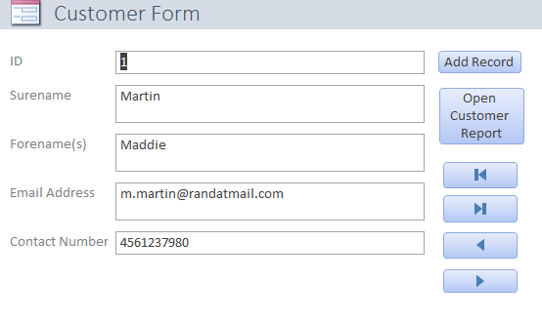
Similar to the books form, the customer form gives the “Add Record” button for adding a new customers information to the database, “Open Customer Report” for opening the report detailing all information about the stores customers stored within the customers table. There are also buttons for navigating through the table.

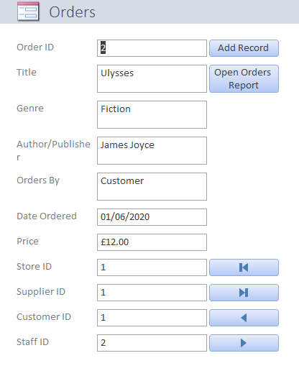
The orders form has an “Add Record” button for adding a new order to the stock that can then be followed through. “Open Orders Report” button to open a report of all the current orders that are being processed, the date that order was placed and the title of the book also.
The price of the order also appears on this form, along with the customer, staff, store and supplier IDs. This can help to narrow down where an order was placed, who the order was for, who placed the order and which supplier was to complete this order.

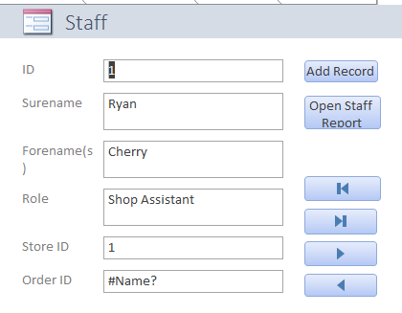
The staff from has an “Add Records” button and “Open Staff Report” buttons to add a new member of staff and display all current staff members in a report.
The form also has navigational buttons for the staff members to navigate through the data, and also displays the names of staff members and their store and staff IDs

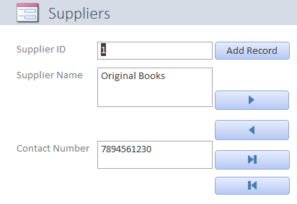
The Suppliers form has a button “Add Records” for adding information for a new supplier to be entered. Buttons for navigating through the data also.
The form displays the Supplier name and their contact number.

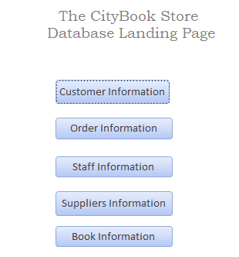

The last form created is a landing page with a way of navigating to any of the other forms. The buttons are named in a way to allow the staff to know which button will take them to which form. This will allow them to then view, search for or add to the database of the chosen form.

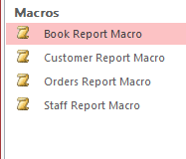
The buttons that were created to populate the reports that can be viewed are populated using a macro that has been set into them. A macro is a way of adding a functionality to a form or report within the access database.

The next to be created are the reports for the database that will be generated from the macro that has been set into some of the Books, Customers, Orders and Staff forms. These will give the reports of the chosen fields on that table that has been selected from the database.
Below is the report that is produced from the macro within the books form. This report details the title of the books in store, their genre, the Author of Publisher of that book, the price that it is being sold for in the City Book store, the number of that title book that is in stock for City Books and which store ID they are currently located at.
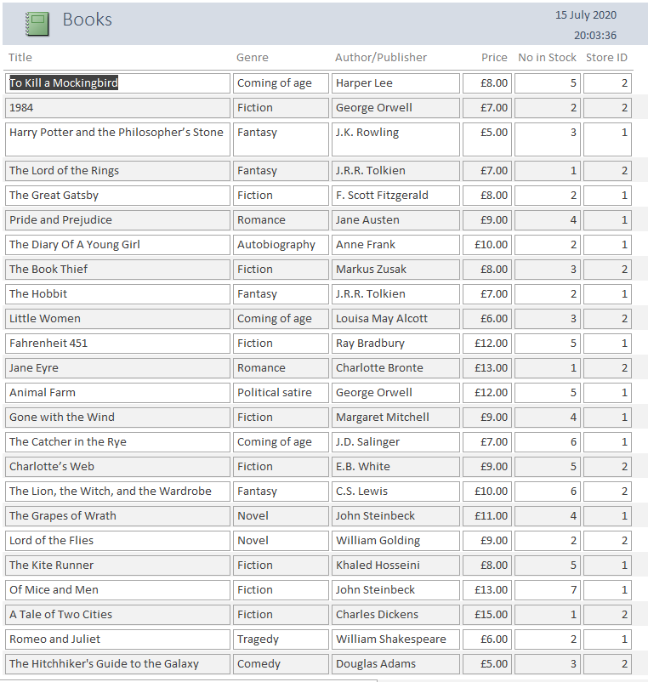

At the bottom of this report it will display a number of pages, (if multiple pages are appearing from the amount of data in that table) and a time stamp at the top of when the report was generated.
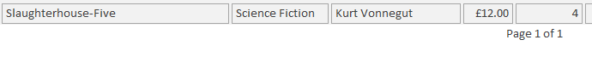

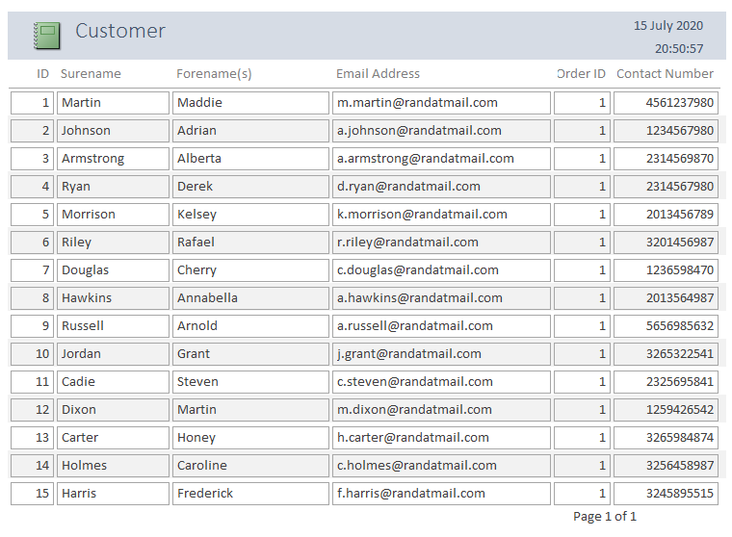
The report that is generated using the macro from the Customer form provides the staff with the report that is displayed below. This report displays the customers ID that can be used for the purpose of tracking an order, the customers name and surname, their email address for contacting them when an order is on the way, or in store and their contact number too.
This report also displays the page number, and time and date stamp for reference.

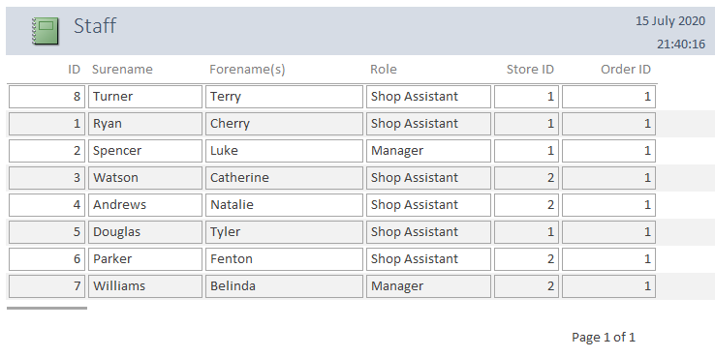
Below is the report that is generated from the macro on the Staff form. This will display the staffs ID number and name and surname, their role or position such as manager or shop assistant, the store ID that they normally would work, and their order ID number to help the staff track who is placing an order for a book to come into store.

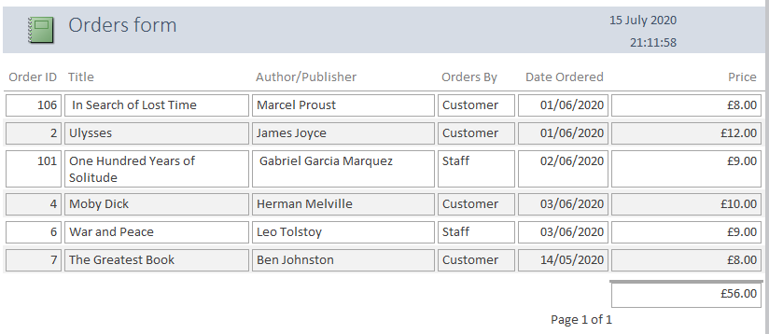
Below is the report that is generated from the macro on the Orders form. This report when generated will provide the staff of City Books with the order ID number and the ordered by statement which will relate to if a staff member or a customer has ordered a book to the store, the name of the Author of Publisher of the ordered book, the title of the book that was ordered, that date of the day that book was ordered and the price of the book that was ordered.

On this Orders report, like the other reports there is a page number at the bottom and a time and date stamp at the top of the page. This also gives the total amount that all the books on order come to at the bottom of the report, this could be used for staff to monitor the income for that week or month of that period, and for also seeing the outstanding amount of the orders to come in.

With the store and staff having the ability to make additions to their database and manage their systems orders and inventory, they’re in a position to improve on the MS access database where they require it to be changed or improved.

