Operating Systems
Module Name: Computer Architecture and Operating Systems
Module Code: ACCA4022
Student Name: Viorica-Mihaela Posirca
Student ID: 2512924
Lecturer Name: Dr. Md Shantanu Islam

Submission date:

Contents
Introduction 4
Key Functions of General Operating Systems (OS) 4
Task Management 4
App/Application/Program Management 5
File & Directory Management 5
Device Management 6
Security Management 6
Use of Windows OS CLI commands 7
Example 1: File & Directory Management (DIR Command) 7
Example 2: Directory Navigation (CD Command) 8
Example 3: Create Directory (MKDIR Command) 8
Example 4: Remove Directory (RMDIR Command) 9
Example 5: Display Text (ECHO Command) 9
Example 6: Process Management (TASKLIST Command) 10
Example 7: System Information (SYSTEMINFO Command) 10
Example 8: Network Monitoring (IPCONFIG Command) 11
Example 9: Network Testing (PING Command) 11
Example 10: Network Path Tracking (TRACERT Command) 12
Use of Linux OS CLI Commands 12
Example 1: ls Command 13
Example 2: cd Command 13
Example 3: mkdir Command 14
Example 4: rmdir Command 14
Example 5: ps aux Command 15
Example 6: top Command 15
Example 7: ipaddr 16
Example 8: ping Command 16
Example 9: sudo adduser Command 17
Example 10: crontab Command 17
Use of Windows OS Scripts 18
Example 1: Batch Script for Simple Backup Automation 18
Example 2: Batch Script for Simple Calculator with a Loop 20
Use of Linux OS Scripts 21
Example 1: Bash Script for Simple User Input 21
Example 2: Bash Script for Number Iteration through For Loop 22
Conclusion 24
References 25
Appendices 26

Introduction
After completing the module coursework related to the "Computer Architecture and Operating Systems”, the present report is devised to reflect upon the key operating systems (OS) through some practical examples using relevant commands and/or command-line interface (CLI). Primarily, the current report aims to develop knowledge about working in different operating systems and the basic level of automation. For this purpose, the report has been structured into five core sections, including "key functions of general operating systems", mainly the Microsoft Windows and its numerous features, "Use of Windows OS CLI commands", "Use of Linux OS CLI commands", "Use of Windows OS scripts", and "Use of Linux OS scripts.”

Key Functions of General Operating Systems (OS)
In the history of computers, one of the most central, widely used, and general operating systems (OS) is Microsoft Windows. Its first version (Windows 1.0) was initially released on 20th November 1985 with the efforts of Microsoft [1]. Over time, this OS became a powerful graphical OS and was used in numerous personal as well as professional settings. Its key purpose was to provide users with a friendly Graphical User Interface (GUI), ensure accessibility of PCs to a massive population, revolutionise computing operations in different ways, like text commands' replacement with icons, windows, menus, etc, and manage all computer resources (hardware and software resources) efficiently. Core functions of this general OS are process and memory management, device and file/directory system management, task and application/program management, GUI management, and security [1,2].

Task Management
In Windows OS, one of the core functions is task management, which is commonly used by users for numerous purposes, including monitoring applications and processes and controlling them. This is mainly a kind of tool known as "Task Manager" that is used by users to focus on background working (i.e. processes, usage rate of CPU/memory/network/disk), find out active applications/programs, and monitor system performance [3]. This feature allows users to stop unresponsive tasks and restart any application to lower the system load. Similarly, it enables users to efficiently allocate time for key system resources (including processor and RAM). This feature is crucial for improving system stability alongside performance if managed properly because it helps prevent resource overload. This function of Windows OS also supports multitasking and smooth operations because it works on process scheduling techniques that allow users to handle multiple tasks simultaneously [3].
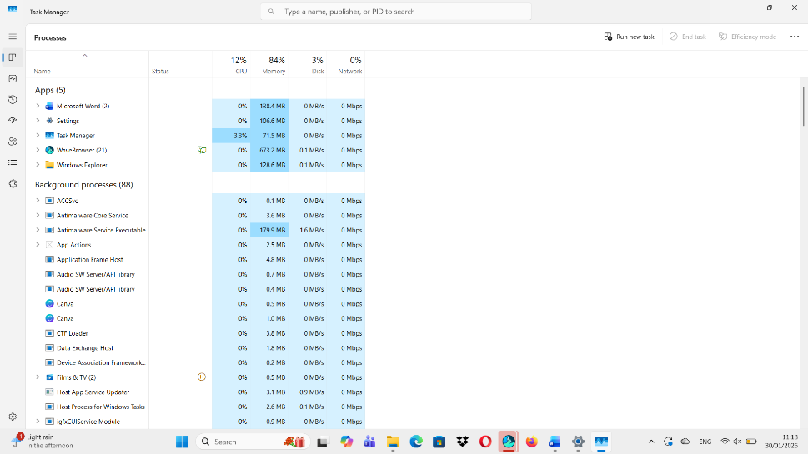
Figure 1: Task Manager Function of Windows OS-Screenshot Showing Usage Status

App/Application/Program Management
Application management (app management) is another function of Windows OS, which is used to install, uninstall, or change/manage software programs [2]. In other words, this feature can be used to modify and/or remove previously set up applications, which provides control over programs through system boot that not only reduces the unneeded resource usage, but also improves system performance and ensures efficient running of different programs without any security threat or conflicts.
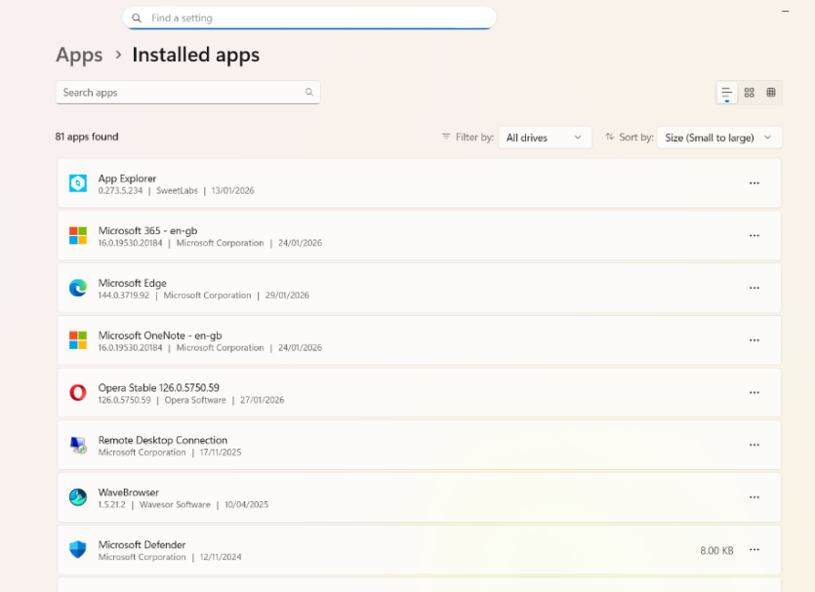
Figure 2: Application/Program Management Function of Windows OS-Screenshot Showing Installed Programs

File & Directory Management
This function of Windows OS is useful for creating a new file or folder, removing an older one, deleting/replacing an already existing one, and moving or renaming it when needed. It is mainly managed through the File Explorer option, and since the concerned OS organises information with the help of hierarchical directory structures and file systems like NTFS, it assists in easily storing as well as retrieving or compressing any kind of data/file with security permissions for protection [3].
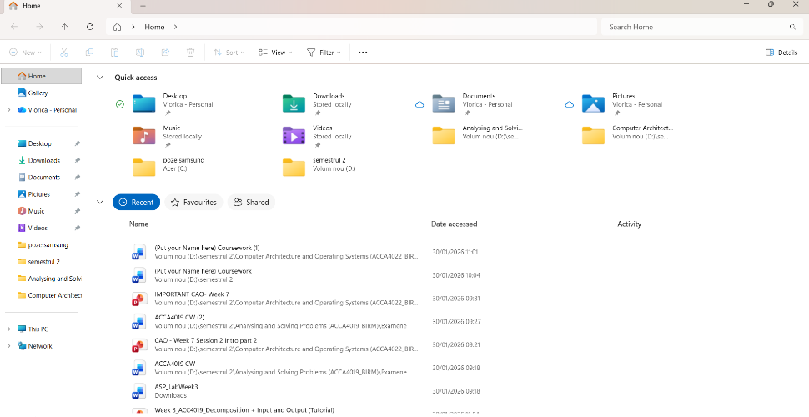
Figure 3: File/Directory Management Function of Windows OS-Screenshot Showing Quick Access to File/Folder

Device Management
The device management function of Windows OS highlights the communication between the OS and hardware components or a variety of input/output (I/O) devices (i.e. keyboard, printer, mouse, and storage devices, etc) via their respective drivers. It ultimately supports device (hardware) compatibility and system performance consistency [2]. This is fundamentally a tool called “Device Manager”, which not only shows installed hardware devices along with relevant drivers, but also serves in finding existing device malfunctions (through automatic detection and configurations) that can be managed by the users promptly through different options, including disable, update, or reinstall. Proper device management ensures hardware compatibility and system stability [2].
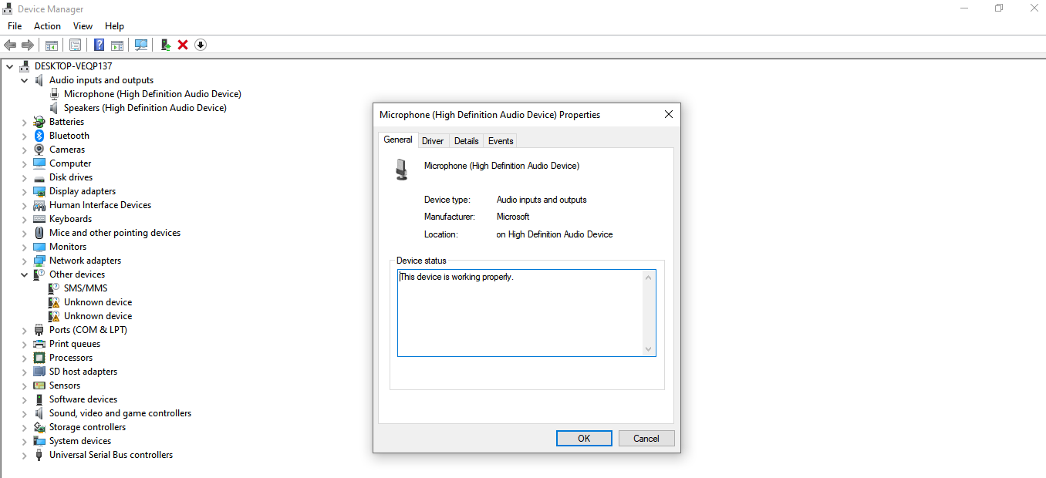
Figure 4: Device Management Function of Windows OS-Screenshot Displaying Installed Hardware Devices

Security Management
Another significant function of Windows OS is security management. Typically, Windows offers several built-in security tools (including firewall protection, Windows Defender, user account control (UAC), and password-centred authentication) to protect the entire system from risks like unauthorised access from third parties, malware, and network risks. Security management function also works on file permissions and encryption options in NTFS that are imperative to avoid leakages of sensitive information and secure it. Windows OS is also functioning in the form of regular security updates that serve to fix possible vulnerabilities and ensure data protection with integrity and confidentiality [3].
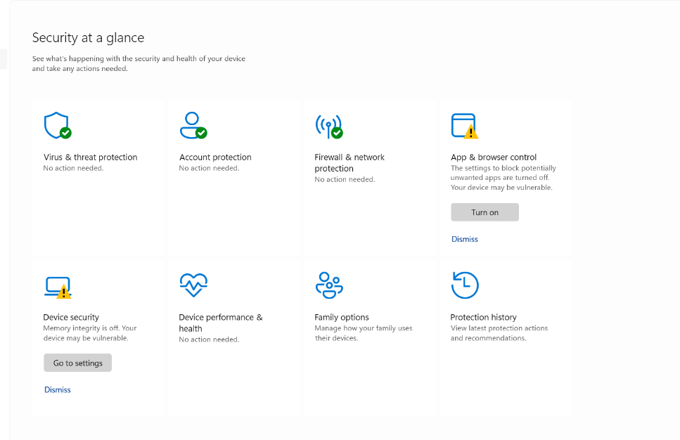
Figure 5: Security Management Function of Windows OS-Screenshot Depicting Threat and Virus Protection

Use of Windows OS CLI commands
The Windows CLI refers to a text-oriented interface that can be used by users for command input/typing to interact with the OS of the computer instead of clicking on icons/buttons. Typically, Windows CLI operates based on the default PowerShell and Command Prompt/Command shell between the OS and the user for automation and faster control through managing different processes, handling and creating or removing files, monitoring system operations, and troubleshooting the network [4].

Example 1: File & Directory Management (DIR Command)
Under the file & directory management area, the DIR command is highly important, which helps in listing all files/folders in the existing directory, which is essential for verifying stored files and navigating system directories significantly. The output below highlights the file names along with their sizes as well as the last dates of modifications [4].
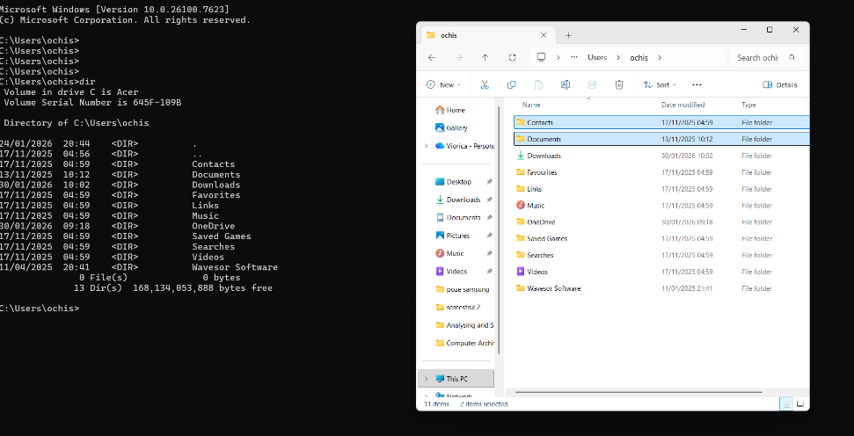
Figure 6: DIR Command and Output of Directory Contents

Example 2: Directory Navigation (CD Command)
The next command, CD (Change Directory), is often used to move between and among folders and navigate file structures in the OS. The screenshot of the output below reflects changing the directory path through working [4].
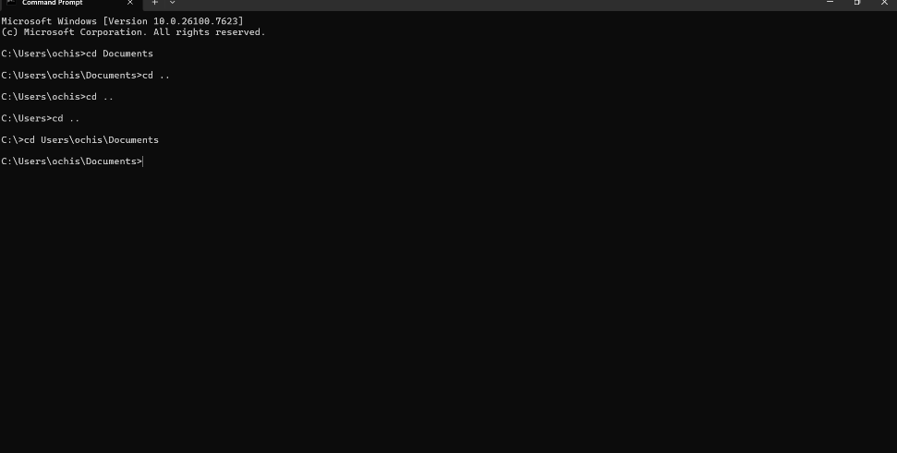
Figure 7: CD Command and Output of Change in Directory Path

Example 3: Create Directory (MKDIR Command)
This is also known as an MD command, which leads users to create new folders in some specific locations, which further appear in the directory listing [4].
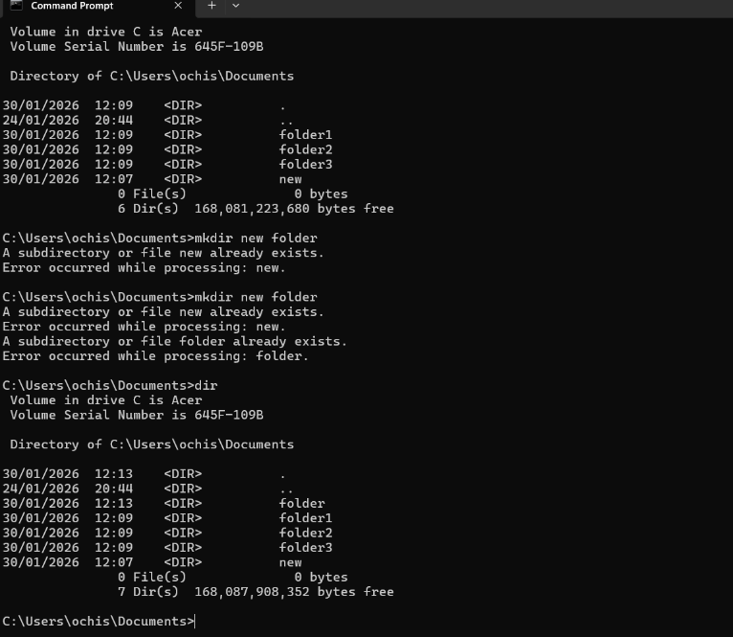
Figure 8: MKDIR/MD Command and Output of Creating New Folders

Example 4: Remove Directory (RMDIR Command)
This is also known as an RD command, which assists in deleting existing directories. The following output shows that the /s option deletes all the content in a folder containing specific files [4].
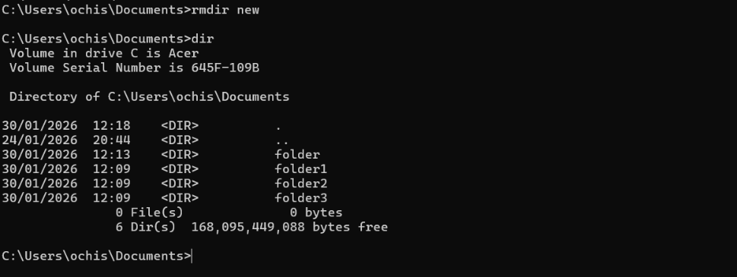
Figure 9: RMDIR/RD Command and Output of Deleting/Removing a Directory

Example 5: Display Text (ECHO Command)
This command is used to display/print any entered text/message immediately, particularly on the command screen (as shown below). Its use is common in batch scripts for communication between users [4].
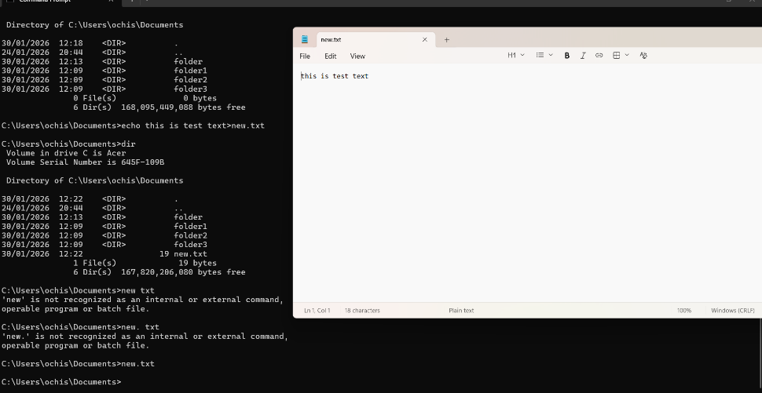
Figure 10: ECHO Command and Output of Displaying Customer Text/Message

Example 6: Process Management (TASKLIST Command)
This command shows all the running processes with memory usage and process Ids, which is crucial for monitoring system performance alongside active applications [4].
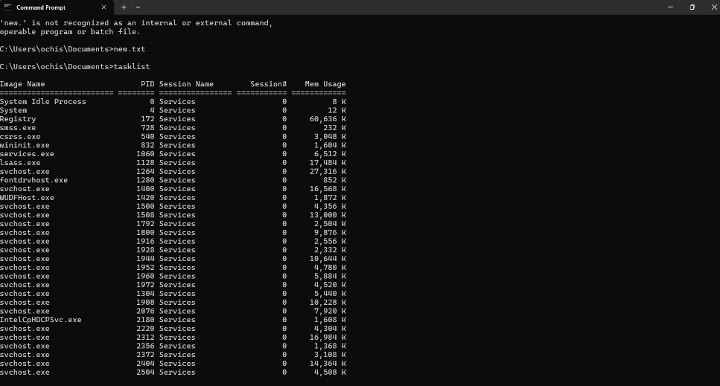
Figure 11: TASKLIST Command and Output of Displaying Running Processes

Example 7: System Information (SYSTEMINFO Command)
In Windows OS, the SYSTEMINFO command is required for providing detailed information about the entire system (i.e. its installed memory, OS version, processor info, etc) to diagnose its configuration [4].
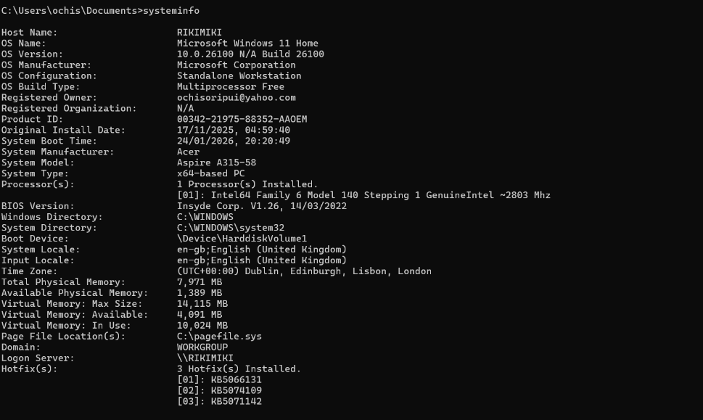
Figure 12: SYSTEMINFO Command and Output of Showing System Configuration/Specs

Example 8: Network Monitoring (IPCONFIG Command)
This command is used to know about the network configuration by getting information about the system's IP address, subnet mask and default gateway, which is imperative to understand and troubleshoot connectivity problems [4].
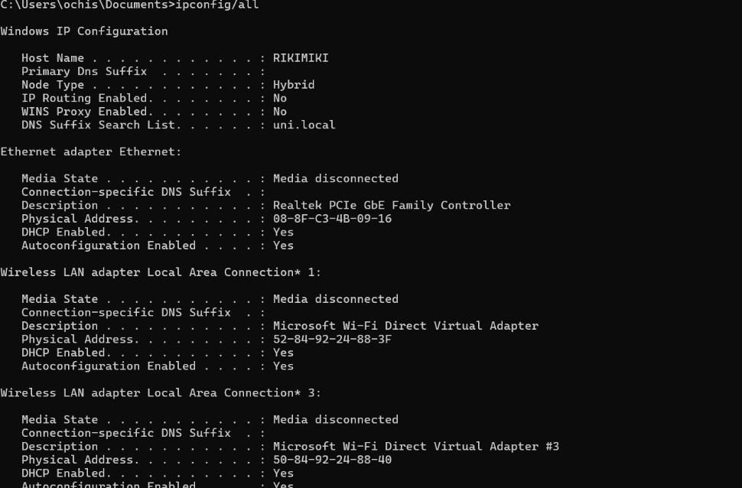
Figure 13: IPCONFIG Command and Output of Displaying Network Information

Example 9: Network Testing (PING Command)
One of the Windows OS CLI commands is the PING, which assists in testing connectivity between/among devices by sending packets to a virtual host and showing response time with data on packet loss [4].

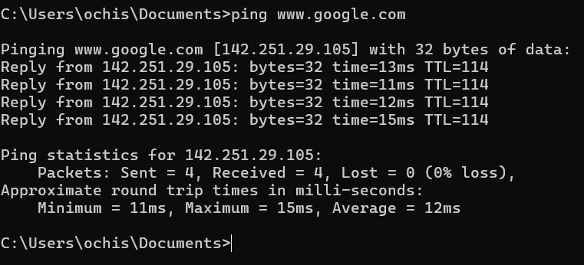
Figure 14: PING Command and Output of Showing Testing Network Connectivity

Example 10: Network Path Tracking (TRACERT Command)
This diagnostic command tool allows users to trace the route paths (intermediate routers and response) time that data packets take to travel and reach the destination on an IP network to avoid network delays [4].
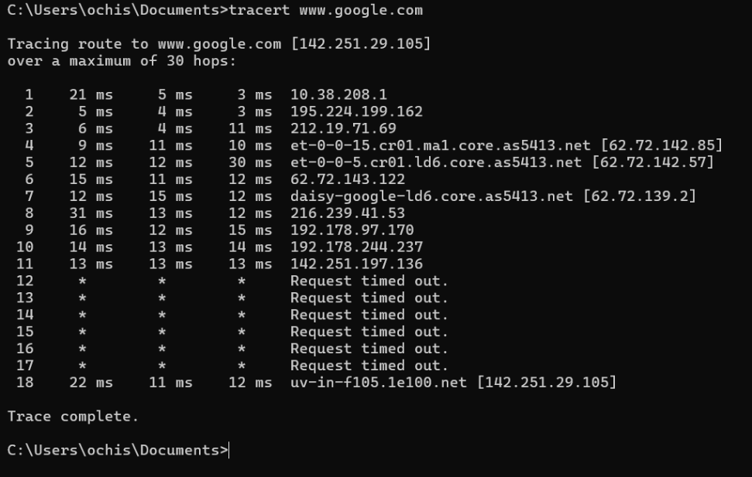
Figure 15: TRACERT Command and Output of Showing Network Path

Use of Linux OS CLI Commands
The Linux OS CLI is defined as a text-centric interface to the computer to ensure controlling the OS by accessing through a shell program (such as Zsh or Bash). Linux command is also known as Terminal, Command Prompts, Shell, etc [5]. Key functions of Linux OS CLI are related to text commands interpretation for program execution, file operations, process management, task scheduling, and system configuration settings efficiently [6].

Example 1: ls Command
The command ls -1 in Linux OS CLI allows users to list the files and/or directories using a comprehensive format, which consists of different displays such as size, modification dates, owner, elevated permissions, etc., and it is important for efficient data management and storing verification [5,6].
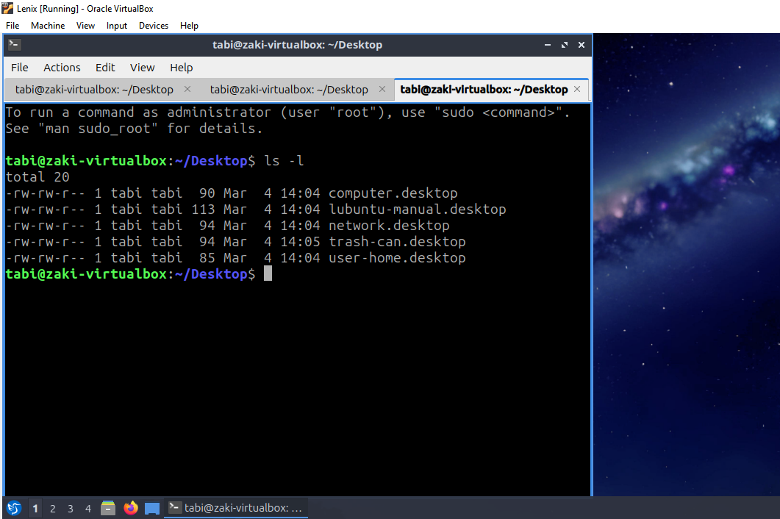
Figure 16: ls –l Command and Output of Showing Detailed Files/Directory Listing

Example 2: cd Command
Linux CLI command cd is helpful in changing the already existing working directory, where the new location is revealed through terminal prompt updates to navigate the file system structure [6].
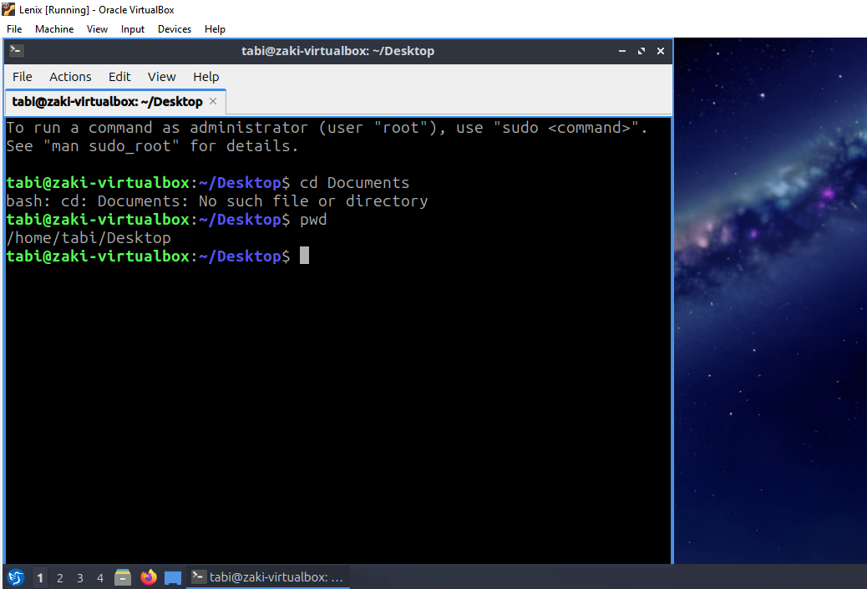
Figure 17: cd Command and Output of Showing Changing Directory to Documents and Verifying Path

Example 3: mkdir Command
This command in Linux OS is mainly used for new directory creation, and once it is done, the folder appears via the ls command [6].
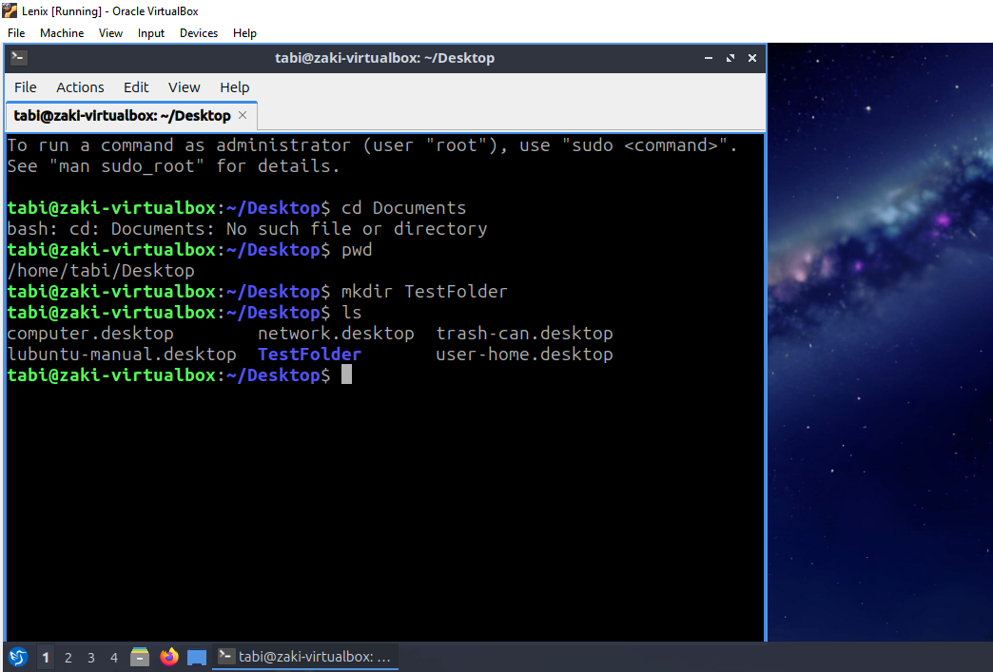
Figure 18: mkdir Command and Output of Showing New Directory Creation and Verification

Example 4: rmdir Command
Through this command on Linux OS, users are allowed to remove/delete any empty directory that instantly disappears from the list [6].
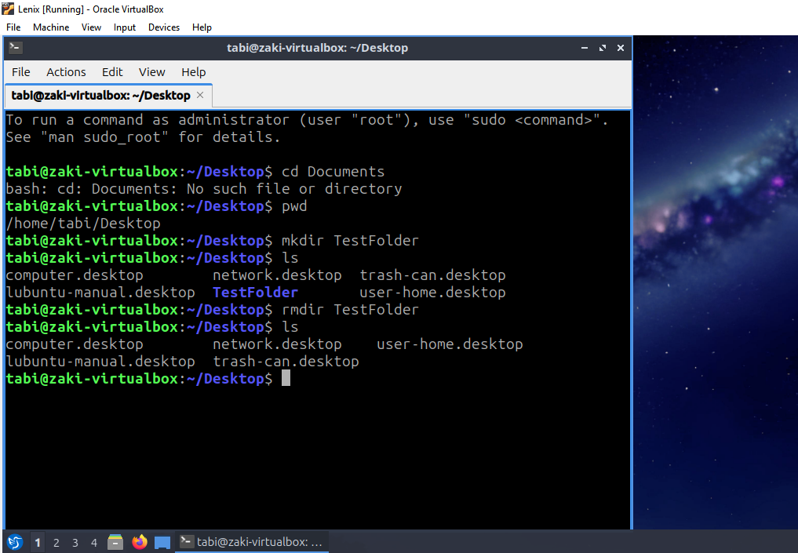
Figure 19: rmdir Command and Output of Showing Directory Removal and Confirming Deletion

Example 5: ps aux Command
One of the core commands of Linux OS CLI is the ps aux, which is run to find and monitor active processes, alongside highlighting the usage rate of CPU, memory, and PID. This is vital for managing different running processes/tasks simultaneously [6].
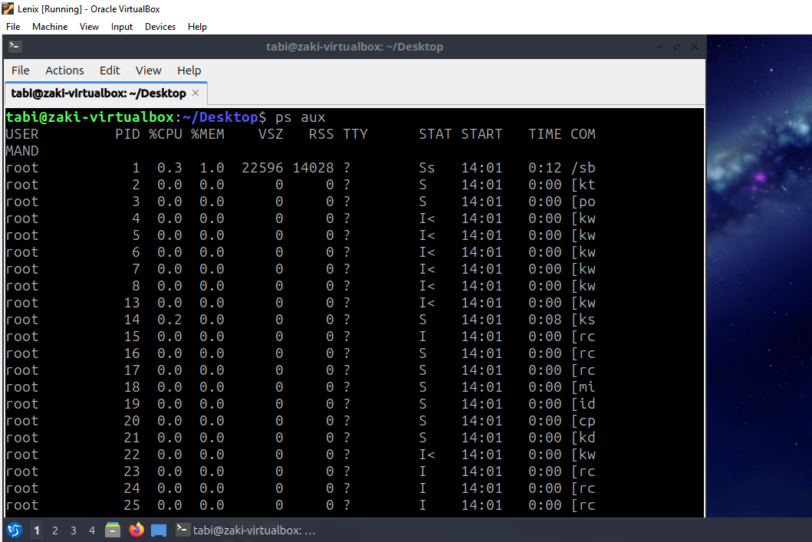
Figure 20: ps aux Command and Output Displaying Active Running Processes

Example 6: top Command
This command is also essential within the concerned OS to illustrate real-time system performance in the form of popping out the memory consumption and CPU usage [6].
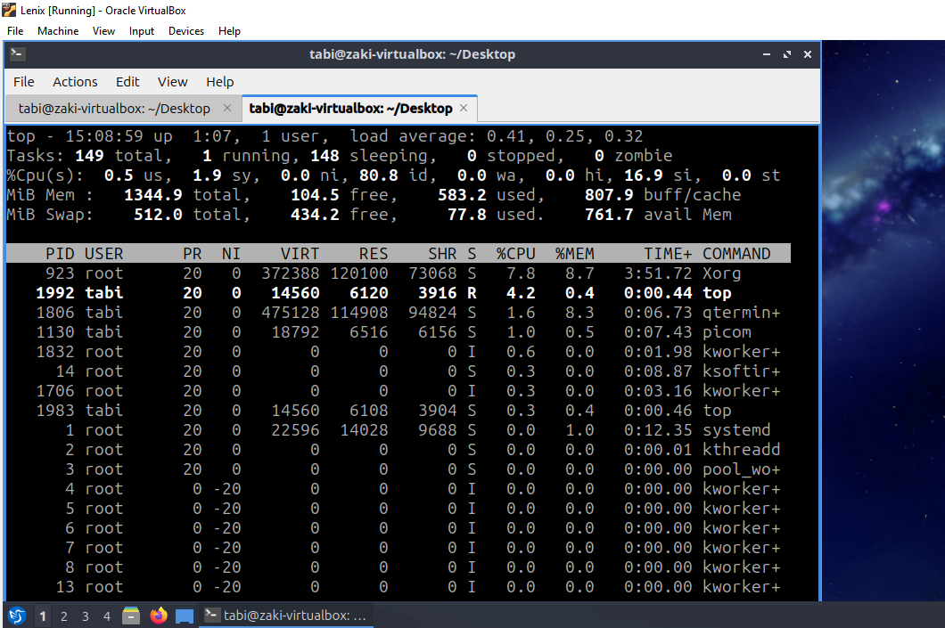
Figure 21: top Command and Output Highlighting Real-Time System Monitoring

Example 7: ipaddr
In the Linux OS CLI, the ipaddr shows key network interfaces along with IP configuration information that not only helps in monitoring the network but also focuses on troubleshooting [5,6].
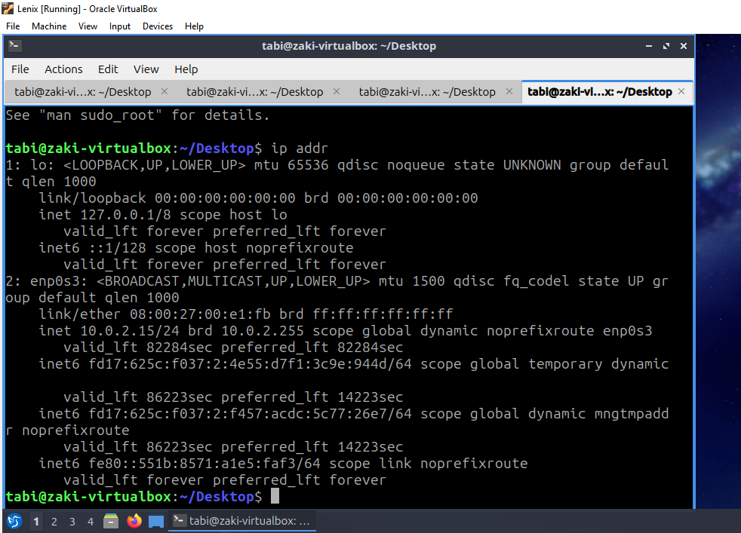
Figure 22: ipaddr Command and Output Displaying Network Interface Information

Example 8: ping Command
One of the Linux OS CLI commands is the ping that allows testing system connectivity through a specific mechanism that sends packets, measures response time, and calculates the packet loss [5].
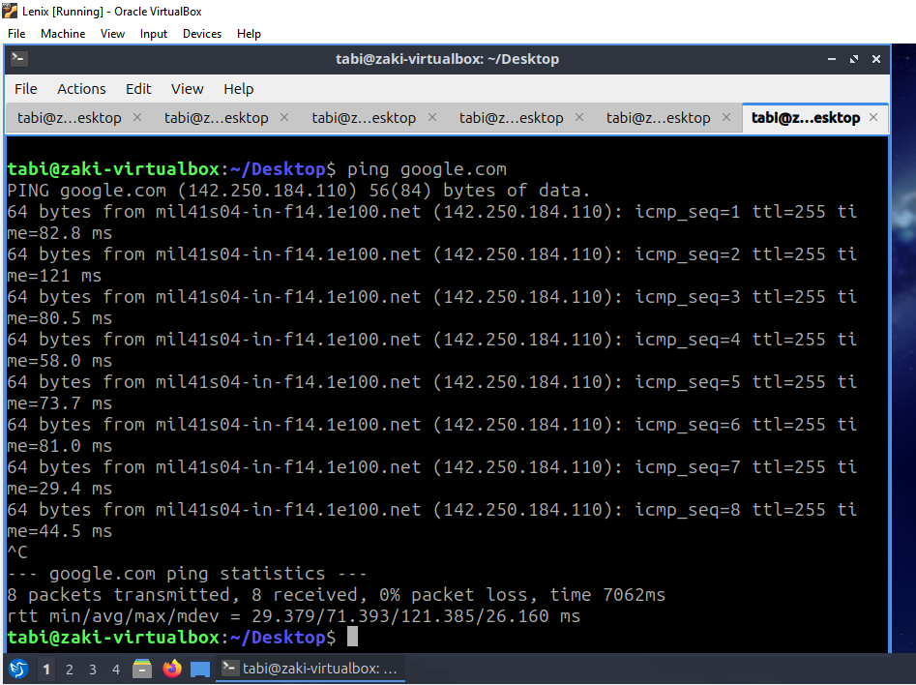
Figure 23: ping Command and Output of Showing System Connectivity Testing

Example 9: sudo adduser Command
The key use of this command is to generate new user account(s), supported by the password during setup [6].
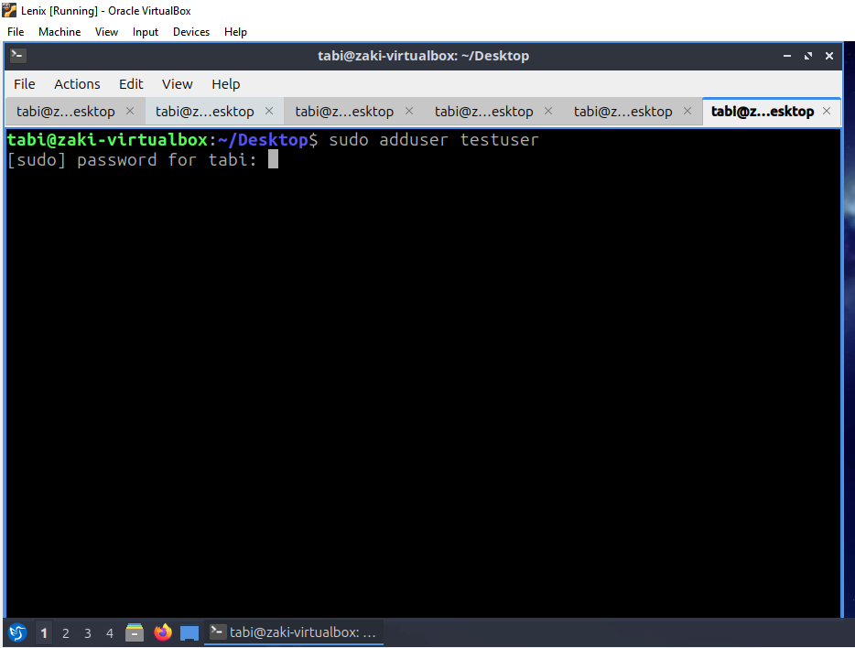
Figure 24: sudo adduser Command and Output Showing Adding a New User

Example 10: crontab Command
One of the important commands in the concerned OS is the crontab –1, which highlights scheduled tasks, helps in task automation and job arrangement [6].
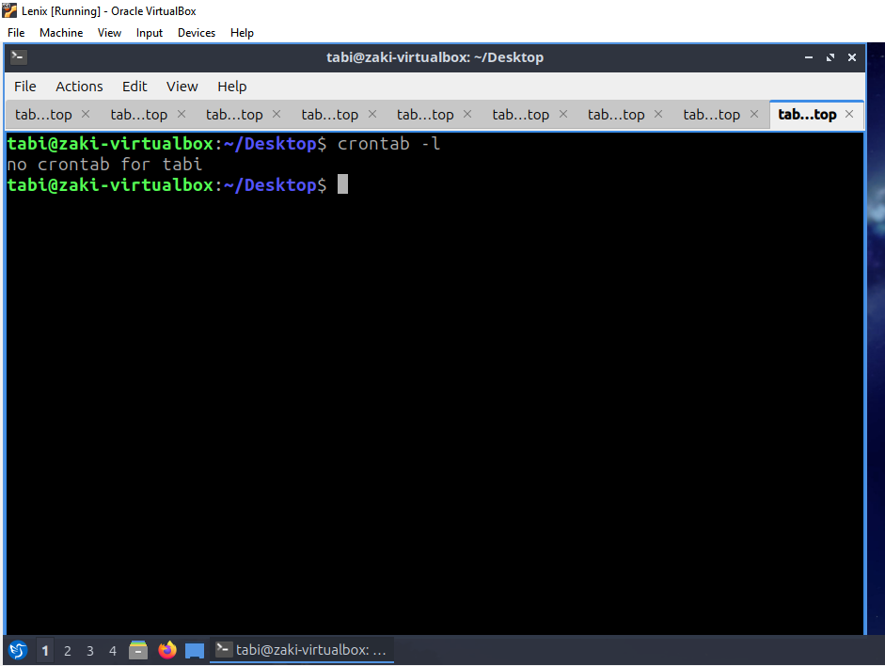
Figure 25: crontab Command and Output Showing to View Scheduled Tasks

Use of Windows OS Scripts
In Windows OS, batch scripting refers to the language used by system administrators for program creation that can be executed using the CLI. Batch scripting is more common, which automates the repetitive tasks through the Command Prompt commands always seen in the.bat files, saving [7]. This kind of scripting not only advocates variables and loops but also works for the conditional statements as well as user interaction that eventually favours file management, administrative tasks automation, and system maintenance [7,8].

Example 1: Batch Script for Simple Backup Automation
The presented batch script (backup_script.bat) is required for the automation of the process of backing up a specified folder. Initially, there is a prompt used by the users to name the folder via the set /p command with the help of the Windows Command Prompt. Before that, a sample folder “TestData” comprising a specific file named file1.txt was created on the Desktop for script testing and demonstration. In the next step, the "if not exist" conditional statement is checked, and in case of absence, an error message is displayed along with stopping/terminating the execution. However, the existence of the folder “TestData” supports the creation of a new backup folder by adding _backup to the initial folder name through the mkdir command. Later, the xcopy command is appended to copy every single file and/or subfolder into the backup directory with the help of the /s, /e, and /i switches. Consequently, the success message is put on view while there is a pause in the script before the end. Briefly, this entire script depicts the simple backup automation, variables with conditionals, and file management.
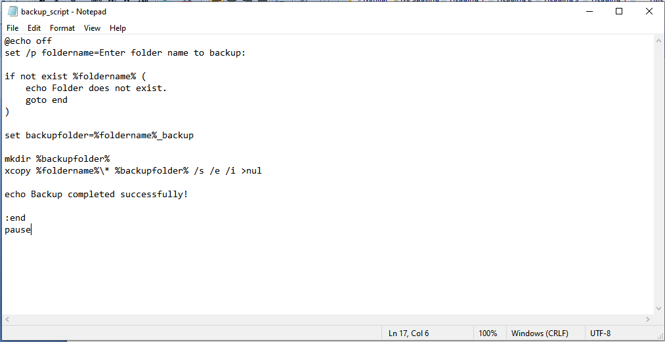
Figure 26: Batch Script Code for Simple Backup Automation
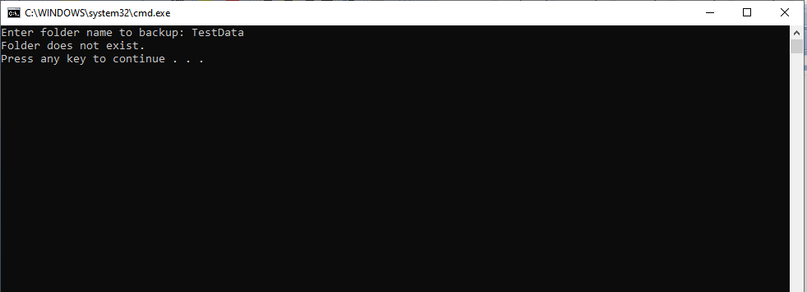
Figure 27: Script running and Output Showing Folder does not Exist
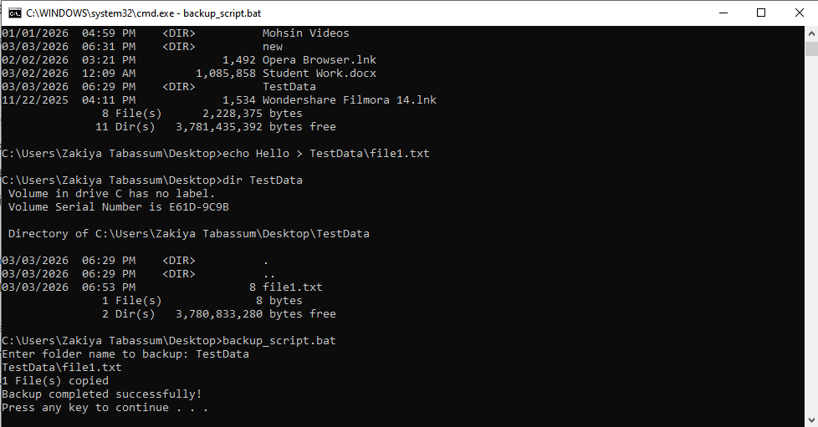
Figure 28: Output Showing Execution of Backup Automation Batch Script with Successful Completion

Example 2: Batch Script for Simple Calculator with a Loop
The second example presented here is the batch script that is used for performing a simple arithmetic operation related to a calculator to showcase user interaction as well as looping. This script works on the set /p command for collecting two key numbers from the user. After that, a set /a command is run for arithmetic addition, as well as storing the results in a variable named result. In this way, the output is demonstrated via the echo command, while a label:start is followed for loop creation. Once the output/results are displayed, the users are asked through the script whether they need recalculation or not. Users’ decisions are checked through the if /i statement in case the user selects “Y” for entry. If this is true, the script redirects execution back to the beginning with the help of goto. Ultimately, a loop structure is created. Conversely, if any other value is entered by the users, the program finishes abruptly at this stage. Overall, the presented batch script reflects variables, arithmetic operations, conditional statements and finally the looping.
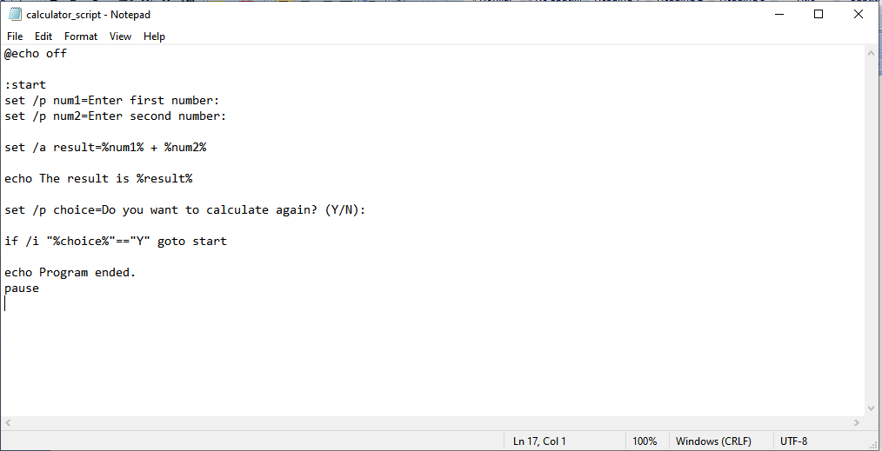
Figure 29: Batch Script Code for Calculator Batch Script
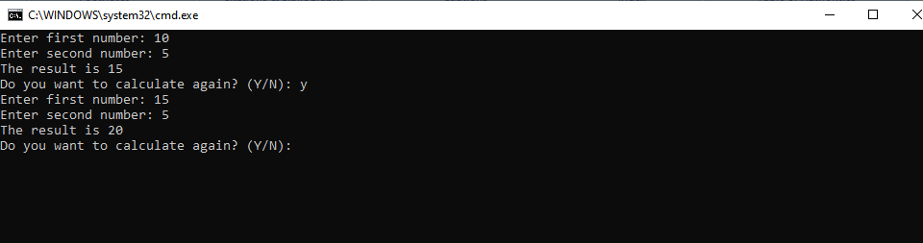
Figure 30: Output Showing Execution of Calculator Batch Script

Use of Linux OS Scripts
In Linux OS, bash scripting is typically the equivalent of batch language used on Windows OS and ends in .bat. Bash scripting is important to automate the command-line tasks where different and multiple commands are combined into a specified yet executable script file. Similar to batch script in Windows OS, bash script in Linux OS favours loops, variables, conditionals and arithmetic aspects for system management, file administration and process automation [6].

Example 1: Bash Script for Simple User Input
The concerned bash script allows basic interaction of users, particularly while using different variables for operations as well as conditional statements. Herein, the script starts with the shebang line #!/bin/bash to specify the interpreter, while another command called read leads users to input own name (as a user name), which is used for operation by storing it in a variable called name. Next, the echo command is used for the demonstration of a personalised greeting message through $name. The given example clearly demonstrates how bash scripting helps in automating the input process and generating instant, yet dynamic results (output) in any simple condition. This bash scripting shows fundamental components of scripting (i.e. user input, variables, useful and simple input operations, and control flow) for Linux system administration/management tasks.
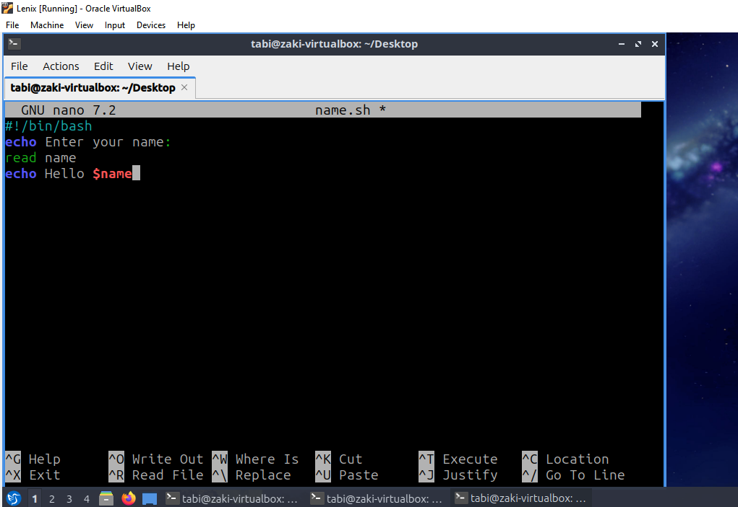
Figure 31: Bash Script Code Showing User Input
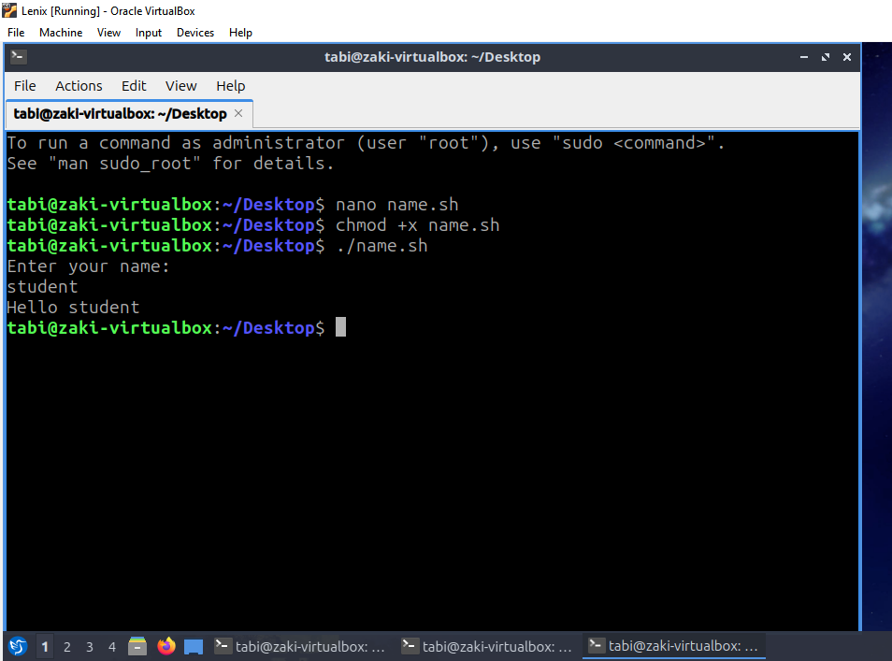
Figure 32: Bash Script running and Output Demonstrating User Input (as Hello Student)

Example 2: Bash Script for Number Iteration through For Loop
The second example of a bash script works on a loop operation. Herein, primarily, the script begins with a specific option “for” loop for number iteration to focus on specific numbers starting from 1 and ending at 5. This is called the iteration step, where every single iteration, there is the “i” variable, which helps in storing the current variable value. Next, the echo command is used to display it, and finally, the loop operation is observed on the screen. The process constantly works until the last number value is reached by the loop. This kind of bash script ensures loops that can easily automate repetitive tasks. Similarly, it highlights that these are the essential aspects of Bash scripting for automation in Linux OS.
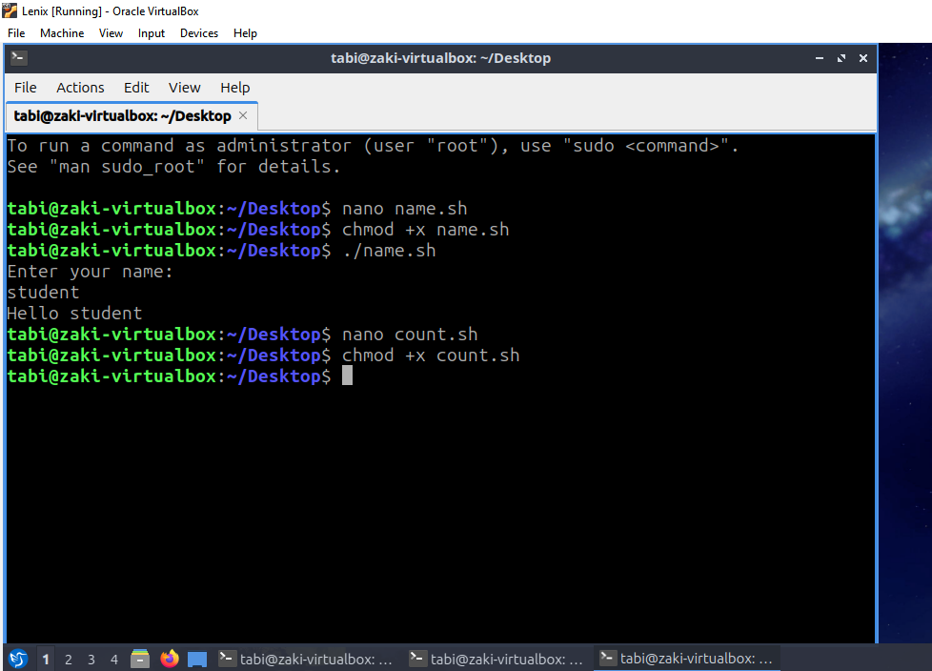
Figure 33: Bash Script Code for Loop Operation
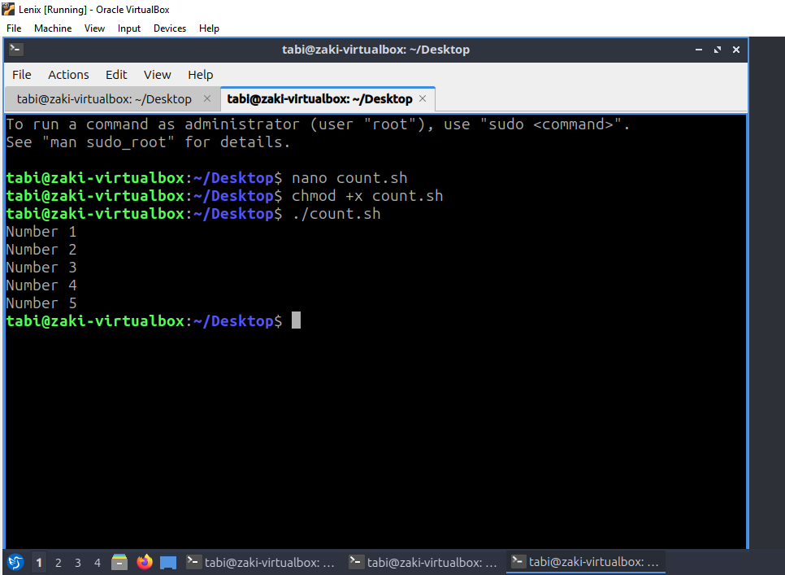
Figure 34: Bash Script running and Output Demonstrating Loop Operation

Conclusion
The devised report developed an in-depth understanding of two different types of operating systems (Windows and Linux). With practical examples of Windows CLI and Linux CLI, the report highlighted that they are used for process and network management and automation. Their functions also work on the same concepts, but the techniques and automation processes vary.

References

[1] | Ravikant Tiwari and Mr Shadab Siddique, "Analytical survey of windows operating system and comparison of windows, linux and android operating system," International Journal of Engineering Applied Sciences and Technology, vol. 6, no. 2, 2021. [Online]. https://www.researchgate.net/profile/Dr-Shadab-Siddiqui/publication/354633401_ANALYTICAL_SURVEY_OF_WINDOWS_OPERATING_SYSTEM_AND_COMPARISON_OF_WINDOWS_LINUX_AND_ANDROID_OPERATING_SYSTEM/links/61441ddfd5f4292c01fe7e85/ANALYTICAL-SURVEY-OF-WINDOWS-OPERATING-
[2] | Abraham Silberschatz, Peter B. Galvin, and Greg Gagne, Operating system concepts.: John Wiley & Sons, 2019. [Online]. https://books.google.com.pk/books?hl=en&lr=&id=2vC1EQAAQBAJ&oi=fnd&pg=PA3&dq=A.+Silberschatz,+P.+B.+Galvin+and+G.+Gagne,+Operating+System+Concepts,+10th+ed.+Hoboken,+NJ,+USA:+Wiley,+2018.&ots=o9UphIyOBL&sig=VdDOvkNumOP0h-G75rJmYTwhjlE&redir_esc=y#v=onepag
[3] | Rajkumar Banoth and Aruna Kranthi Godishala, The Windows Operating System, Linux Overview.: Springer Nature Switzerland, 2026. [Online]. https://doi.org/10.1007/978-3-032-06439-4_2
[4] | Microsoft. (2026) Windows Commands. [Online]. https://learn.microsoft.com/en-us/windows-server/administration/windows-commands/windows-commands
[5] | Canonical Ltd. (2026) https://ubuntu.com/tutorials/command-line-for-beginners#1-overview. [Online]. https://ubuntu.com/tutorials/command-line-for-beginners#1-overview
[6] | Canonical Ltd. (2026) Ubuntu Server. [Online]. https://documentation.ubuntu.com/_/downloads/server/en/latest/pdf/
[7] | Sharon Tentarelli, Rómulo Romero, and Michelle L. Lamb. (2022) Script-based automation of analytical instrument software tasks. [Online]. https://www.sciencedirect.com/science/article/pii/S2472630321000194
[8] | Microsoft. (2026) Using batch files. [Online]. https://learn.microsoft.com/en-us/windows-server/administration/windows-commands/cmd

Appendices
Online Course name:

Figure 35: Certificate of completion

