UWTSD
Rolling Road Assignment
Powertrain
William Wallace (1902566)
1902566


Figure 1 uwtsd logo

Figure 2 lightened and non-lightened fly wheelFigure 3 uwtsd logo
Contents
List of figures 1
Introduction 2
Research/literature review 2
Flywheel 2
Friction plate 2
Pressure plate 2
Gear box 3
Input shaft 3
Shifter fork 3
Synchroniser ring 3
Countershaft 3
prop shaft 3
differential 3
pinion gear 4
ring gear 4
spider gear and side gears 4
axles 4
Clutch 4
constant pressure theory 4
Constant wear theory 4
Methodology 5
Analysis 6
Conclusion 8
Recommendations for further study 8
References 8
Appendices 8

List of figures
Figure 1 uwtsd logo 0
Figure 2 lightened and non-lightened fly wheelFigure 3 uwtsd logo 0
Figure 4 lightened and non-lightened fly wheel 3
Figure 5 full face plate vs 6 puck pressure plate 3
Figure 6 gearbox 4
Figure 7 gearing terminology 4
Figure 8 differential 5
Figure 9 wheel torque 7
Figure 10 tractive effort 7
Figure 11 vehicle drag 8
Figure 12 tractive effort in each gear 8
Figure 13 speed in each gear 9

Introduction
This assignment will be to understand the how a vehicle delivers its power from the engine to the driven wheels and what all the parts functions are and how it uses mechanical advantage to produce torque to pull away and the speed for motorway use and how the dyno was used to collect data from the bike and then to analyses the data collected from the rolling road using excel to.

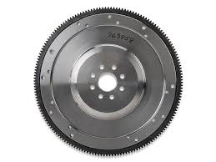
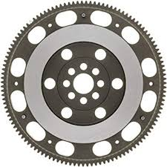
Research/literature review
Figure 4 lightened and non-lightened fly wheel

Flywheel
A flywheel’s main purpose is to store rotational energy ready for when the vehicle requires it like when engaging the clutch but is also a surface the clutch can uses to engage the wheels in performance vehicles the fly wheel will be lightened to help the engine rev with less rotational energy which means it can change speeds quicker, this is shown in figure 3 the difference between a lightened and non-lightened.

Friction plate
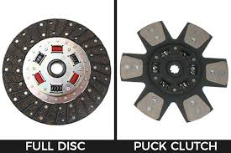
The friction plate is a part of the clutch it is the point that is in contact with the fly wheel and can be made out of fiberglass or silicon dioxide and many other materials and it made to grip the surface of the flywheel which will engage the wheels to the engine this can come with springs to help dampen the engagement of the friction plate it can also be shaped differently to change the way it engages by the surface area being in sections called a puck style clutch disk shown in figure 5 which has less surface area which causes the clutch to engage more abruptly which is why there are full face friction plates, (which is most common) 6 puck, 5 puck, 4 puck and 3 puck which all can be used for different applications like performance vehicles.
Figure 5 full face plate vs 6 puck pressure plate

Pressure plate
The pressure plate is attached to the flywheel and is used to engages and disengage the friction plate by using a diaphragm spring this is used to produce the pressure needed for the friction plate to operated.

Gear box
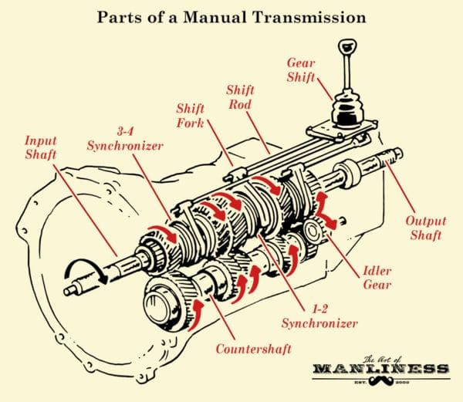
The gear box is used to change the gears which have different ratios which changes the torque output at the loss of speed this is controlled by the number of teeth there are on each gear to control the gear ratio.
Figure 6 gearbox

Input shaft
Impute shaft is what attaches to the clutch and provides drive to the gearbox.

Shifter fork
The shifter fork is the physical connection between the output shaft and each individual gear as it can slide between each gear.

Synchroniser ring
The Synchroniser ring or also known as the synchro ring or synchromesh. Its main purpose is to synchronise the speed of the gear to the speed of the selector fork.

Countershaft
The countershaft is in constant connection with the input and output shafts this is called a constant mesh transmission which means that the gears on the countershaft and the gears on the output shaft are constantly contacted and the selector fork has the control on which gear transfer power to the wheels.
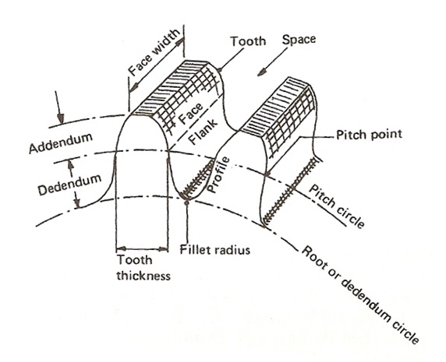
Figure 7 gearing terminology
A gear ratio is the drive from one shaft (the driving shaft) going through a set of gears that change the speed by using gears with different amounts of teeth then going into a different shaft (the output shaft) which has a different speed and a different mechanical advantage

prop shaft
The prop shaft takes the rotational movement from the gearbox and transfers it to the differential using a hollow shaft this is because a solid shaft wouldn’t provided much more strength for the weight. This is used in rear wheel drive vehicles.

differential
with a rear wheel drive vehicle, the differential transfers the direction of the rotation 90 degrees to the driven wheels and also allow the wheels to spin at different rates which is for when during cornering the outside wheel is able to spin faster.

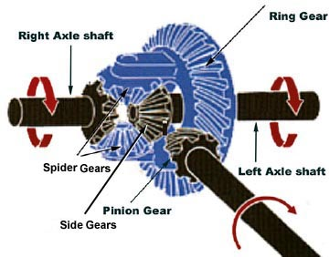
pinion gear
Figure 8 differential
the pinion gear is what changes the direction of rotation which is a big part of what a differential does.

ring gear
the ring gear has a big part in the final drive of the vehicle. It uses a crown and pinion gear

spider gear and side gears
these two gears are similar just mounted differently and what allow the differentials two wheels to spin at different rates.

axles
the axles take the rotation force from the differential and sends it to the driven wheels.

Clutch
a clutch is needed to allow the vehicle to stop and allow the engine to spin freely and also to aid in gear changes to help match the engine speed to the newly selected gear it must also allow slip as a it gives the driver more control of the vehicle.
There are two formulas used to calculate the torque that a clutch can transmit through a flat plate clutch.

constant pressure theory
The constant pressure theory is relying on the fact that the pressure is being applied constantly over the hole surface of the friction plate and that the clutch is new or unworn.
$$T=\frac{2}{3}µW\frac{\left({ro}^{3}-{ri}^{3}\right)}{({ro}^{2}-{ri}^{2})}$$

Constant wear theory
The constant wear theory relies on the fact that the clutch would wear equally over the surface of the pressure plate this theory works best with worn clutches.
$$T=µ\frac{W\left(ro+ri\right)}{2}$$
ro = outer radius (m)
ri = inner radius (m)

T = torque (Nm)
μ = coefficient of friction (no units)
W = axial load (N

Methodology
The data was collected using BMW S1000 RR on a rolling road dyno using a sweep test which is a sweep through the whole rev range which gives multiple data points to perform this test you must strap down the bike on the dyno bring the bike up to speed in 5th gear as this is close to a one to one ratio which help to see how the engine is performing without the gearbox. Then the test will be performed through the whole rev range, then ones its at the end of its rev range the clutch will be disengaged and the transmission efficiency will be recorded by how the bike slows the dyno down after the run, this give the transition efficiency which can be used to get the power output with out the gear box as the transition efficiency can be taken away.
At the end of the test the dyno gives the engine speed, engine power, engine Torque, Wheel power, drag power and the velocity in km/h which can be used to gain more info of how the bike is performing using excel by finding the.
tractive effort
$$TE=\frac{Tfƞn}{R}$$
Pdrag
$$Pdrag={\frac{1}{2}ρC_{d}A(V+V_{0})}^{2}.V$$
Gearbox efficiency
$$ƞ=\frac{P wheel}{P engine}$$
the road speed in each gear through the rev range
$$V=\frac{2πRN}{60fn}$$
the tractive effort in each gear through the rev range
$$TE=\frac{Tfnƞ}{R}$$
speed ratio
$$speed ratio=\frac{Max Torque engine speed}{Max Power engine speed}$$

Analysis
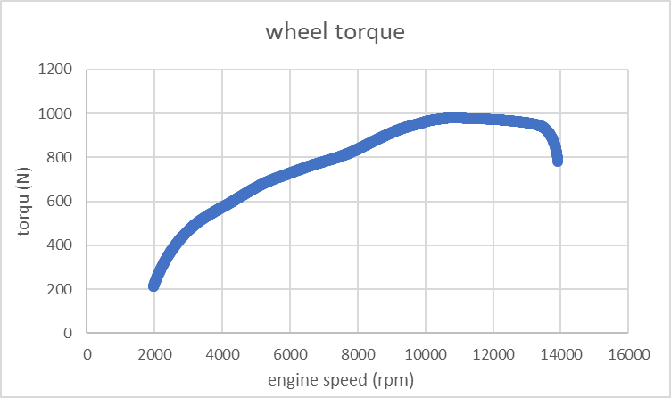
Figure 9 wheel torque

the torque of the bike has a very good torque graph as the torque doesn’t drop off too much at the higher rpm. This torque graph is the torque that is being delivered from the gearbox to the wheels.
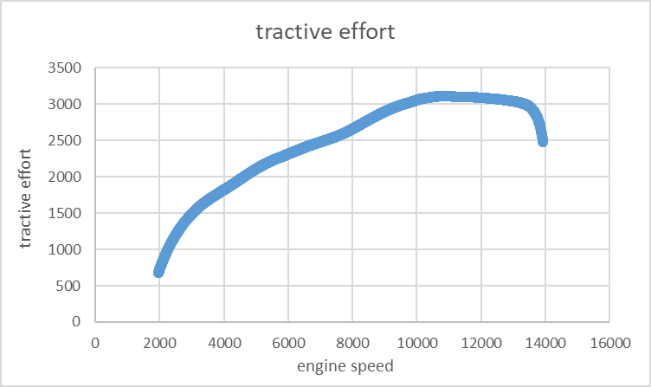
Figure 10 tractive effort

Tractive effort is the force provided by the engine through the transmission needed to overcome the rolling resistance that would be the rolling radius meaning the wheel/tyre the tractive resistance is the rolling resistance this being all the drag from the tyre/wheel, chain and the gearbox and the aero resistance and the gradient resistance as well but as this is on a rolling road there is no aero or gradient forces so this would be the torque at the wheels. Tractive effort can’t be compared to the torque output from the gear box as as the force is newtons and the gearbox torque is Nm, yet they both do follow the same pattern.

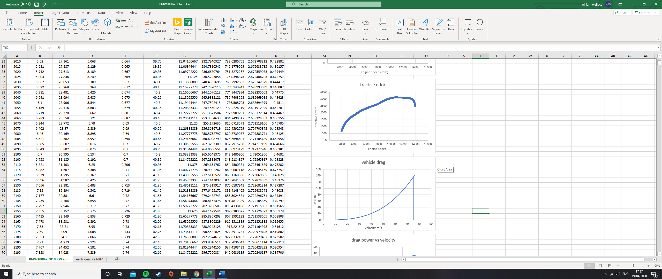
Figure 11 vehicle drag

The vehicle drag doesn’t have much impact at lower speeds but as the speed increases the drag increases at a higher rate but levels out at 65 m/s and appears to become liner from then onwards, but this would have to be tested to be true.
To get this graph data the air density is assumed to be 1.225 kg/m3 which is found by the International Standard Atmosphere “The density of air is 1.225 kg/m3 at sea level at 15 degrees C.”
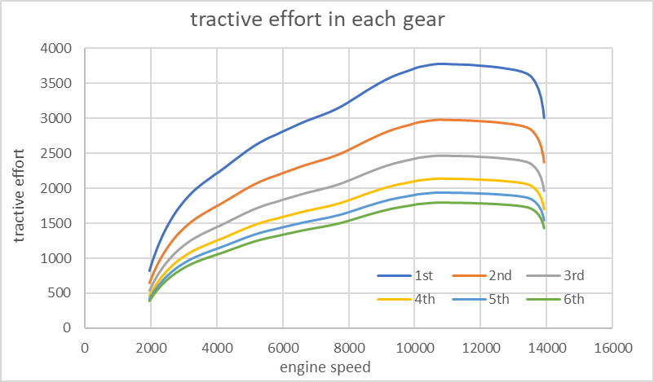
The marked-out line in figure 11 show where the max power at the wheels limits the top speed of the bike in 5th gear with the max power being 139kw shows that the theoretical top speed would be 76m/s which works out to be 273 km/h
Figure 12 tractive effort in each gear

In figure 12 the tractive effort increases the lower the gear is because of mechanical advantage the first gear has the highest mechanical advantage which means it can produce the most torque but at the loss of speed which can be seen in figure 13 this is 1st has the slowest road speed this trade off of loss of wheel speed for torque is proportional as the torque and speed will stay the same with a gear chosen gear ratio the only way to changes either is to improve the toque from the engine or increase the RPM limit.
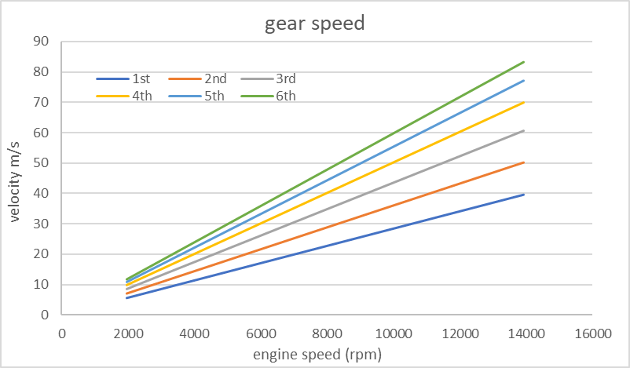
Figure 13 speed in each gear

Conclusion
In conclusion this report has found that all the data that can be extracted from a rolling road and to analysed and brake down what it means, what the main purposes of gears are used for and how they are used to maximise the engines power and torque for pulling away or motorway use. And many of the losses of energy there are in a drive train down to friction. and how to use the rolling road. And the equations used to give understanding to the mechanical process of a clutch.

References
https://www.thoughtco.com/density-of-air-at-stp-607546 By Anne Marie Helmenstine, Ph.D. Updated February 04, 2020

