

Module Name | Problem solving and decision making
Module Code | BMSW4004
Lecturer | Mary March
Assignment | Individual report
Student Number | 2009070
Student Name | Erika Mikolane Pinter
Deadline | 28 April 2021
Word Count | 3206 / 3500 words

Content page

1. Introduction | 3
2. Problem in health care | 3
3. Problem at my workplace | 4
4. Impact of the problem | 6
5. Analysis of decision-making process | 5
6. Recommendations and alternative solutions | 7
7. Conclusion | 8
8. References | 9
9. Appendices | 11

1. Introduction

The purpose of this paper is to discuss a problem with health and social care workers being underpaid, making them to feel underappreciated, and quitting their workplace, leaving health and social care understaffed. Some techniques will be used that can help solve the problem and offer recommendations and solutions that would help overcome these challenges.

According to the Cambridge English Dictionary (2019) problems could be people or situations that require immediate attention and have to be solved or taken care of as soon as possible. Problems are present everywhere from our personal life to our workplace and academic studies.

Kings fund (2012) states that one in ten people works in health care, 48% of the workers are professionally certified and there’s’ higher chance of assigning tasks to different roles. Social care has less qualified workers and roles depend on the type of work they do.

There are many issues in health and social care and it’s important to mention some of them before we analyse a single problem. The Government Office for Science (2016) stated an issue that healthcare is facing is that less people are having children, and many are living longer lives than before. Thompson (2015) reported that 3 million people of the population is aged over 80 and this shift in age causes the average age of the population to increase. Thompson (2015) also reported that with the change in ageing population the healthcare system is working on finding a solution. Another issue reported by The health Foundation (2019) is the declining health in the UK, where it would be important for the government to promote healthy lifestyle. Merrifield (2016) discussed another issue regarding the wages that healthcare workers get paid.

2. Problem in health and social care

The issue we will be discussing deeper is the problem that has been standing for years, which is low wages of health and social care workers. The National Health Forum (2020) revealed that 80% of the adults in England believe care workers are underappreciated and 81% believe that they should receive a pay rise.

Merrifield (2016) discussed after a survey were made that 39% of the healthcare assistants who replied felt they did not receive enough training but some of the requirements and tasks they needed training for were part of their daily duties. 44% of those who replied thought about leaving their workplace because of the amount of pressure they were under or because they felt their work was undervalued. Gorton explained to Merrifield (2016) that healthcare assistants are undervalued, overworked, and lack the support they need, but their responsibilities are increasing, and they also carry out tasks that nurses did before. Healthcare assistants are being employed on low budget which is a concern to them personally and the patients who could suffer because of short staffing.

Clarke (2020) reported that in the period of 2012/2013 care workers’ wage was higher than cleaners and kitchen workers, but the wage-increase since then switched it and as of 2019/2020 care workers’ wage dropped below cleaners and retail workers as it is shown in Appendix A. Clarke (2020) also said that Skills for Care reported that there was 30% turnover in adult social care which is approximately 430,000 people, but it is stated that those who left their job, still stayed in the sector. It is also important to mention that there are around 112,000 jobs still available, which means that the demand is higher than the available workers.

Underpaying health and social care workers and treating them unvalued can also result not only in understaffing in the healthcare system, but could include political, economic, social and many other issues. To analyse the problem, we can use PESTLE analysis, but it’s important to understand first what Pestle is.

Oxford College of Marketing (2018) wrote that Pestle analysis as a method that helps understanding external factors that has an impact on an organisation. Pestle analysis includes political, economic, social, technological, legal, and environmental factors as seen in Appendix B. If an organisation understands how to monitor these external changes successfully and they can make changes in the organisation, it can help them grow.

Political
Tallack said to Perry (2019) that according to a survey, the current political standstill in social care funding needs a change because last years’ funds decreased, whilst people in need of healthcare have increased. They also discussed that the staff shortages and high turnover damages the quality of healthcare as over a third of the health and social care workers and nurses leave their job because of being underpaid and undervalued.

Social and Economic
Unison (2018) states that many healthcare workers are required to work more, do some of the nurses’ jobs, but without the necessary training they need. According to the Care Quality commission (2014) Health and Social Care Act 2008 (Regulated Activities) Regulations 2014: Regulation 18: Staffing, employers must provide the necessary training, support, and career development for their workers to complete their tasks. But Unison (2018) reported that after a survey was done between 2000 healthcare assistants in the UK, it has revealed that many who replied felt they did not receive the correct training, they felt overworked, not being valued, and are underpaid. This causes their turnover to increase, causing shortages in staffing and difficulty in giving the right care. Some of the respondents said that the difference in staff and patient ratio is very high and there isn’t enough staff to offer the right care to patients and this causes stress for the staff.

Technological
Technology is improving in a quick pace and makes our life easier, but it is also very difficult to those that do not understand technology well or those who are not interested. According to Califf, Sarker and Sarker (2020) many nurses found technological help useful and quick, but many found it to be stressful. Some of the healthcare workers said they were worried about not understanding technology or understanding less than some of their colleagues and this left them concerned. Others said it was very tiring, they were updating patience charts even in their breaks because of the large amount of data they had to enter. Having less or more job, or initially finding technology useful, a study revealed that many finds it difficult to accept technological support, possibly because they do not know the technology and do not receive the necessary training.

According to Unison (2021) they have been working on getting a pay raise for health and social care workers and continue to do it even after Supreme Court’s decision that lost the case for pay rise. They said they will make extra effort to fight for the reform because in the current pandemic they can not self-isolate if they have symptoms and that is putting the public at risk and it is unfair to the workers.

3. Problem at my workplace

As The National Health Forum (2020) stated, health and social care workers are underpaid and unfortunately I have to agree with that because I have personal experience with this problem in my workplace where I work as a healthcare assistant. I work for a neurological centre that offers accommodation and treatment for up to 60 people over the age of 18. We provide a place for patients with long term neurological problems, brain and spinal injuries and offer respite care. We have patients with brain injury, spinal injury, tracheostomy, respiratory ventilator support and respiratory disorders as a cause of neurological conditions, also stroke and brain and spinal tumours. We also care for people with multiple sclerosis, Parkinson’s disease, cerebral palsy, motor neurone disease and neurological end of life care.

We work in 12 hours shift, in two periods, one from 8am to 8pm and then next shift from 8pm to 8am. Most of our residents need one on one care, which means they can not be left alone and that is why everyone is assigned to a patient who they are responsible for the whole shift. Some of our tasks include ventilator support, a machine that helps them breathe, tracheostomy care, blood pressure, pulse, oxygen level, blood sugar level and saturation checks. Also repositioning, peg feeding, pad change, body, and oral care, hosting and many other important tasks. Most of our patients have less mental capacity and unable to move, so they need complete support until the end of their life.

In my workplace we have 2 floors and for each floor only two-two nurses who are responsible for medication and pay attention to problems and emergency situations. If they can’t solve the problem, a doctor is being called.

We love our job, including me, but many of us feel that we do not get paid enough even though we have lots of responsibilities. If we do not pay attention for a second, it could cost the life of a patient. I have been working for my company in the private sector for 4 years and they give us a pay rise every year, last year twice because of the pandemic, but our wages are still as low as a supermarket worker’s. Unfortunately, the private care homes are not NHS and as Perry (2019) stated they do not get paid as much as the NHS workers which is unfair because we are responsible for people’s lives and I would also add that our work is dangerous to our health.

As an example, last year we had a young man who was capable of speaking and moving his hands and his head, but nothing below his chest. We needed to play with him all night, sometimes on video games. He had anger issues and it often caused problems. He pulled out his tracheostomy tube when he got upset, which is dangerous because his airways could close and die. We were next to him every hour and every minute, but he did not like it. He attacked carers with his special wheelchair on purpose, causing pain and injuries. I was lucky, I only had a few purple spots, but my colleague was taken to emergency with a taxi. We filled out many statements and risk assessments, photos were taken of the abuse the staff members received, but it took month to find him a new place. I do not understand why it took so long, but many of my colleagues, including me felt we did not have enough support against the physical abuse we received.

An example for mental abuse was when we had an older man whose mental capacity was fine but was paralysed from neck down. He was very discriminative against different races, religions, and nationalities. Only a very few people could give him care. He was shouting and screaming, some careers even left their shift crying. We filled out many reports and statements, but nothing happened. To solve this problem only those he accepted were allowed to care for him which was a very few people, and it was unfair because we still received emotional abuse from him, he just did not kick us out. Plus, we also received discrimination from other colleagues instead of supporting us for taking over their tasks, while they stayed with easier patients. And I think the emotional and physical abuse we suffer is not being paid enough.

4. Impact of the problem

As Merrifield (2016) reported, almost half of the healthcare assistants wanted to leave their jobs and as Perry (2019) stated over third of them did, causing a high turnover rate. Unfortunately, because health and social care workers feel unappreciated, underpaid and lacking the trainings needed, it could cause understaffing which can impact the care that workers can provide to their patients and it can impact the professionals who are working in the sector and also the government.

Patients
According to Mitchell (2019) US researchers found that understaffing of healthcare workers is a risk to patients’ lives. The research stated that the death rates and low nursing support level were connected. Because of low nursing staff and low nursing staff support, it is possible the nurses did not have enough time to monitor their assistants and pay attention to the needs of their patients which caused the number of deaths to increase. This also shows that it is an international problem.

Professionals
Understaffing impacts other professionals in the sector such as nurses and doctors. Mitchell (2019) stated in the report based on the US research, that the low level of nursing support caused nurses to complete tasks that their assistant care workers were responsible for. It means understaffing causes tasks and responsibilities to be passed onto others, giving them more job.

Government
Low level of nursing staff support has a big impact on the Government and vice versa. Georgiou and Oykener (2020) reported that at the beginning of the current pandemic the Government provided support to NHS staffing, but neglected non-NHS health and social care workers and homes. Addressing the issue, Prime Minister Boris Johnson announced to fix the problem, but some of the issues include a wide range of problems such as higher demand than workers that are available or low level of funding. The training and pay between care workers and key workers show a big difference which the government must address. Chappell (2020) also stated that after a survey conducted by Unison, 43% of those health workers who replied thought that the Government didn’t do enough.

5. Analysis of decision-making process

Before we can discuss solutions and recommendations to problems in the health care sector, it’s necessary to identify some key problems. As stated by Merrifield (2016) and Perry (2019) the health and social care sector is struggling with workers wanting to leave, already having issues with lack of staff, employees feel unappreciated and underpaid.

To be able to make a decision and find the right solution, we can understand this issue by using the Fish bone analysis which according to Deming (2019) is a tool that is built on cause and effect and helps analyse the problem, their causes and solve the issue. In the case of health and social care workers, the main problem is their wage. They are underpaid, underappreciated and they have less opportunity for career development, and many workers decide to leave their jobs, leaving the sector understaffed.

Cause
Causes that include health and social care workers’ problem include the Government’s lack of support. Unison (2018) reported that workers felt unappreciated, undervalued, and underpaid for years, but the Government did not get involved. Georgiou and Oykener (2020) stated the Government addressed the problems but it only happened last year, and they did not release a plan or future changes to solve the issue.

Effects
Unison (2018), Mitchell (2019) and Merrifield (2016) said that carers feel underpaid and unappreciated, and this caused understaffing in the health and social care sector, because they did not get higher wages and more support. As a result, reported by Clarke (2020) the vacancies grew and the demand for workers increased. According to Mitchell (2019) when nursing support experienced less staff, nurses had to take over the assistants’ job, leaving patients with less care and attention. It means that understaffing also causes patients to have less care.

6. Recommendations and alternative solutions

My recommendation would be to increase health and social care workers’ wage, offer more opportunity for career development and provide more support for the private sector. As Clarke (2020) described a care worker with five years of experience earns only 1% more than someone with less than a year of experience, which also means that building a career as a care worker is very hard. According to Rogers (2020) the Labour party has asked the Prime Minister to announce plans to changes for social care workers stating that the wage of care workers in the private sector is very low. As Gorton responded to Merrifield (2016) care workers could earn more by working for supermarkets. Rogers (2020) further discussed that the Government will not be able to publish a new plan until this year, but it could even take months.

Kings Fund (2020) reported that they believe the best way to reform the health and social care sector is to solve the wage problem first. It would solve the vacancy issues which was 112,000 in 2019 and it would solve the turnover rate which was 430,000 and that is 30% of the sector. They also said that the pay rise should come as specified for the sector, because most of the health and social care workers are employed by private organisations.

To analyse some of the impacts that a possible raise could have on the healthcare sector, SWOT analysis is a good way to start. According to Grant (2021) SWOT analysis consists of Strength, Weaknesses, Opportunities and Threats as shown in Appendix C, which are the 4 parts needed to analyse the internal and external factors affecting an organisation and help development.

Strength
I think a raise in wages and better career opportunity would increase the number of people choosing to work as a health and social care worker. As I said before Clarke (2020) mentioned that there is a high demand for staffing in the health and social care sector, but more opportunity for development, an increase in wages and more support would probably decrease vacancies that the sector has now, and it would motivate workers who are already in the sector.

Weakness
As a result of pay rise, it would cost more money to the government and probably they would not want to spend too much. It would also take more time to create new legislations and regulations.

Opportunities
A pay rise, career development and support would not just bring more workers into the sector, but the higher staffing would also decrease the death risk that Mitchell (2019) stated. As I have said before Mitchell (2019) reported that there was a link between understaffing and death rates and to decrease the number of deaths, higher number of staff are needed, which would possibly increase the reputation of health and social care workers.

Threats
The recommendations could also be affected by other sectors such as retail and other average wage sectors where workers would also ask for higher wage and support from the government which could cost more money.

7. Conclusion

In conclusion as I said before Merrifield (2016) reported, health and social care workers have been neglected not like NHS for years. Health and social care workers would need a pay rise, more training, and more support. Workers are not motivated, the demand for staffing is higher than the number of workers that are available now, they have less opportunity to build a career and because the wages are low, less people would like to be a health and social care worker. To solve this, health and social care workers’ wage have to be increased, they need more support, training and opportunity for career development. If the healthcare sector stays where it is now, it will get worse. Perry (2019) said before that the funds available for the sector are decreasing, but the population who need care are increasing. It means the Government needs to work to fix this problem as soon as possible.

8. References

Califf, C., B., Sarker, S. and Sarker, S. (2020) ‘Are healthcare workers stressed by information technology?’, LSE, 24 August. Available at: https://blogs.lse.ac.uk/businessreview/2020/08/24/are-healthcare-workers-stressed-by-information-technology/ (Accessed: 20 April 2021)

Cambridge English Dictionary (2019) Problem. Available at: https://dictionary.cambridge.org/dictionary/english/problem (Accessed: 20 April 2021)

Care Quality Commission (2014) Regulation 18: Staffing. Available at: https://www.cqc.org.uk/guidance-providers/regulations-enforcement/regulation-18-staffing (Accessed: 25 April 2021)

Chappell, E. (2020) ‘Care workers “undervalued and underpaid for too long”, says Labour’, Labour List, 7 November. Available at: https://labourlist.org/2020/11/care-workers-undervalued-and-underpaid-for-too-long-says-labour/ (Accessed: 24 April 2021)

Clarke, S. (2020) ‘Care worker pay drops below that of cleaners, Skills for Care report finds’, Home Care Insight, 21 October. Available at: https://www.homecareinsight.co.uk/care-worker-pay-drops-below-that-of-cleaners-skills-for-care-report-finds/ (Accessed: 20 April 2021)

Deming, D. W. (2019) Cause and Effect Diagram (Fish Bone). Available at: https://qi.elft.nhs.uk/resource/cause-and-effect-diagram-fish-bone/ (Accessed: 20 April 2021)

Frue, K. (2018) ‘PEST Analysis of The Healthcare Industry’, Pestle Analysis, 14 February. Available at: https://pestleanalysis.com/pest-analysis-of-healthcare-industry/ (Accessed: 20 April 2021)

Georgiou, A. and Oykener, A (2020) ‘The crisis in social care: who’d be a care worker?’, New Policy Institute, 13 October. Available at: https://www.npi.org.uk/blog/health/crisis-social-care-whod-be-care-worker/ (Accessed: 23 April 2021)

Government Office for Science (2016) Future of an aging populations. Available at: https://assets.publishing.service.gov.uk/government/uploads/system/uploads/attachment_data/file/816458/future-of-an-ageing-population.pdf (Accessed: 20 April 2021)

Grant, M. (2021) ‘Strength, Weakness, Opportunity, and Threat (SWOT) Analysis’, Investopedia, 30 March. Available at: https://www.investopedia.com/terms/s/swot.asp (Accessed: 20 April 2021)

Kings Fund (2012) Overview of the health and social care workforce. Available at: https://www.kingsfund.org.uk/projects/time-think-differently/trends-workforce-overview (Accessed: 25 April 2021)

Kings Fund (2020) Careworker pay: the national living wage is not enough. Available at: https://www.kingsfund.org.uk/blog/2020/12/careworker-pay-national-living-wage-not-enough (Accessed: 25 April 2021)

Merrifield, N. (2016) ‘Healthcare assistants used as ‘nurses on the cheap’’, Nursing Times, 23 September. Available at: https://www.nursingtimes.net/news/workforce/healthcare-assistants-used-as-nurses-on-the-cheap-23-09-2016/ (Accessed: 20 April 2021)

Mitchell, G. (2019) ‘Combined nurse and assistant staff shortages ‘increase patient death risk’’, Nursing Times, 22 August. Available at: https://www.nursingtimes.net/news/workforce/combined-nurse-assistant-staff-shortages-increase-patient-death-risk-22-08-2019/ (Accessed: 22 April 2021)

National Health Forum (2020) Care Workers are Undervalued and Underpaid, according to new research to mark Professional Care Worker's Week. Available at: https://www.nationalcareforum.org.uk/ncf-press-releases/care-workers-are-undervalued-and-underpaid-according-to-new-research-to-mark-professional-care-workers-week/ (Accessed: 24 April 2021)

Oxford College of Marketing (2018) What is a PESTEL analysis?. Available at: https://blog.oxfordcollegeofmarketing.com/2016/06/30/pestel-analysis/ (Accessed: 20 April 2021)

Perry, S. (2019) ‘The current political impasse around social care funding is having serious human consequences’, The Healthcare Foundation, 26 June. Available at: https://www.health.org.uk/news-and-comment/news/the-current-political-impasse-around-social-care-funding-is-having-serious-human-consequences (Accessed: 20 April 2021)

Rogers, S. (2020) ‘Publish your plan to fix social care crisis, Labour tells PM’, Labour list, 19 September. Available at: https://labourlist.org/2020/09/publish-your-plan-to-fix-social-care-crisis-labour-tells-pm/ (Accessed: 23 April 2021)

Unison (2018) Overworked healthcare assistants not given proper training or supervision. Available at: https://www.unison.org.uk/news/2018/04/overworked-healthcare-assistants-not-given-proper-training-supervision/ (Accessed: 20 April 2021)

Unison (2021) UNISON to step up campaigns on pay and social care reform. Available at: https://www.unison.org.uk/news/article/2021/04/unison-to-step-up-campaigns-on-pay-and-social-care-reform/ (Accessed: 26 April 2021)

The Health Foundation (2019) Top line facts on the big issues in health and social care. Available at: https://www.health.org.uk/news-and-comment/newsletter-features/top-line-facts-on-the-big-issues-in-health-and-social-care (Accessed: 22 April 2021)

Thompson, C. (2015) ‘Meeting the challenges of an ageing population’, NHS, 11 February. Available at: https://www.england.nhs.uk/blog/catherine-thompson/ (Accessed: 22 April 2021)

9. Appendices

Appendix B – Care worker’s wage in comparison

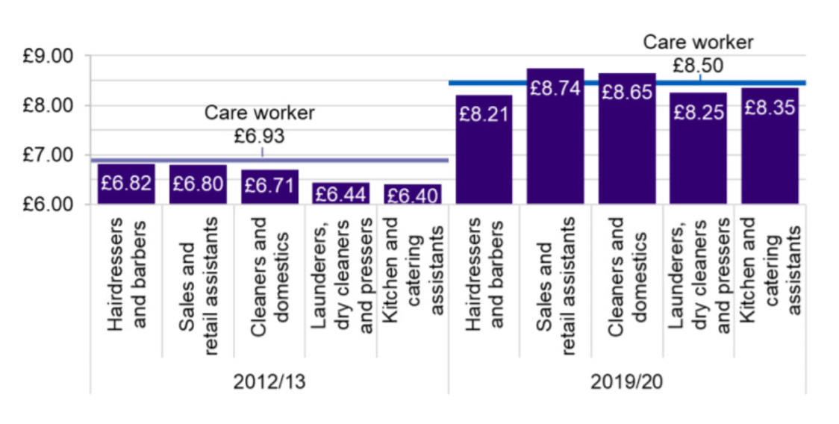

Source: Clarke, 2020

Appendix A – PESTEL Analysis diagram

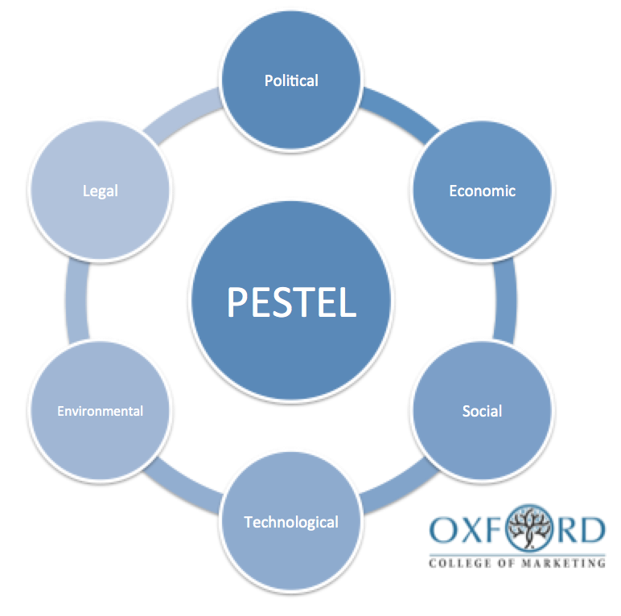

Source: Oxford College of Marketing, 2018

Appendix C – SWOT Analysis



Source: Bang, 2019 in Grant, 2021

