Assignment Title:
Case Study Analysis Report: Comparative report on COVID19 leadership responses

Module Title: Health Care System, Organization and Leadership
Module Code: LCHS7002

Lecturer’s Name: Dr Fahad Khan

Student Name
MD AKTARUJJAMAN
Student ID Number
2512989

Word Count: 5059

Executive Summary
This report compares how Spain, South Korea and Canada organized and led their COVID-19 responses in 2020–2021, focusing on systems design, leadership behavior and centralisation versus decentralisation. Spain’s highly decentralised National Health System entered the pandemic after a decade of austerity that had weakened public health and surge capacity. This contributed to a severe first wave, but Spain later delivered one of Europe’s highest vaccination rates through more collaborative co governance with regions. South Korea’s centralised Korea Disease Control and Prevention Agency, strengthened after the 2015 MERS outbreak, combined rapid digital contact tracing, testing and clear communication, although this raised significant privacy concerns. Canada’s tax funded Medicare system, administered by provinces, showed strong rhetorical unity but devastating failures in long term care, where fragmented governance and chronic underinvestment contributed to one of the highest shares of COVID 19 deaths in care homes among OECD countries.
Using systems thinking and complexity leadership theory, the analysis shows that neither centralisation nor decentralisation is inherently superior. What matters is whether leaders can rapidly reconfigure decision rights, information flows and relationships to match a highly volatile, uncertain, complex and ambiguous environment while sustaining trust, transparency and learning (Weberg, 2012; Uhl-Bien and Arena, 2018; Bennett and Lemoine, 2014).

Table of Contents
Executive Summary 2
1. Introduction 5
2. Conceptual and Analytical Framework 5
3. Organisation of Health Care Systems and Governance 6
3.1. Spain 7
3.2. South Korea 9
3.3. Canada 11
4. Leadership Approaches During COVID-19 13
4.1. Spain: from delayed response to vaccination champion 13
4.2. South Korea: transparent, networked and technology enabled leadership 14
4.3. Canada: empathetic federal leadership within a fragmented federal system 15
4.4. Cross case discussion 15
5. Centralisation, Decentralisation and Systems Performance 16
6. Comparative Discussion: Leadership Styles and Health System Shaping 18
7. Recommendations and Lessons for Future Health System Leadership 19
8. Conclusion 20
References 21

List of Figures
Figure 1: Rich picture of Spain’s COVID-19 leadership and health system response. 8
Figure 2: Rich picture of South Korea’s COVID-19 leadership and health system response. 10
Figure 3: Rich picture of Canada’s COVID-19 leadership and health system response. Source: Author. 12

Introduction
The COVID 19 pandemic created an extreme volatile, uncertain, complex and ambiguous environment for health systems worldwide. National responses varied markedly in speed, coordination, transparency and outcomes. Understanding why similar high income systems performed so differently is essential for designing more resilient and adaptive leadership and governance arrangements for future crises.
This report presents a comparative case study of Spain, South Korea and Canada during 2020–2021. All three are high income democracies with tax funded or social insurance based health systems, but they differ in how responsibility is distributed between central and subnational authorities, how public health institutions are structured, and how digital technologies are used in surveillance and contact tracing. Spain represents a strongly decentralised national health system with powerful Autonomous Communities. South Korea represents a centralised but learning oriented public health agency that reconfigured itself after the 2015 Middle East Respiratory Syndrome crisis. Canada represents a federal system where provinces run health services within a national framework, with a particularly fragmented long term care sector.
Visuals and diagrams are used to map key organisations, leadership roles, information flows and feedback loops in each case. These visual maps support systems thinking, highlighting how apparently local decisions, such as the configuration of contact tracing or the regulation of nursing homes, can generate reinforcing or balancing feedback loops that shape pandemic trajectories (Arminio et al., 2021).
The analysis is framed by complexity leadership theory, which views leadership not simply as the actions of heroic individuals but as a networked process that enables adaptation, learning and innovation in complex systems (Weberg, 2012; Uhl-Bien and Arena, 2018). The central question is not whether centralisation or decentralisation is better in the abstract, but how leaders at multiple levels mobilised and reconfigured their systems to cope with rapidly changing conditions while maintaining legitimacy and protecting vulnerable populations.

Conceptual and Analytical Framework
This assignment uses a comparative qualitative case study design based solely on secondary data, consistent with the module brief. The three countries were selected through purposive sampling to maximise variation on two dimensions. These are degree of centralisation of health system governance and performance across key pandemic indicators during 2020–2021, such as cases, deaths, long term care outcomes and vaccination coverage (OECD, 2021; Johns Hopkins University, 2021).
Data sources include peer reviewed journal articles, official reports from international organisations and national authorities, and reputable think tank and research institute publications. Examples include evaluations of Spain’s COVID 19 response (García-Basteiro et al., 2020; Henríquez et al., 2020), analyses of South Korea’s preparedness and digital contact tracing (Yoo et al., 2021; Yang et al., 2021; Park, Choi and Ko, 2020), and studies of Canada’s long term care crisis (Hsu et al., 2020; Estabrooks et al., 2020; Canadian Institute for Health Information, 2020).
For each country, key organisational actors, such as ministries of health, public health agencies, regional governments and care providers, decision making structures, and information flows related to surveillance, testing, clinical care and social measures are identified. These were informed by existing system descriptions and COVID 19 evaluations, and then interpreted through a systems thinking lens to identify reinforcing and balancing feedback loops, delays and leverage points (Arminio et al., 2021).
Leadership analysis draws on complexity leadership theory, which emphasises three intertwined leadership roles. These are administrative leadership, which covers formal authority, structures and policies, adaptive leadership, which covers emergent, networked problem solving, and enabling leadership, which covers the creation of conditions for learning and innovation across the system (Uhl-Bien and Arena, 2018; Weberg, 2012). The literature on healthcare leadership in crises and volatile, uncertain, complex and ambiguous environments further highlights the importance of sensemaking, transparent communication, psychological safety and distributed decision making (Crain et al., 2021; Singh et al., 2024).
The comparative discussion in Sections 4 and 5 links organisational features and leadership practices to observed outcomes. Rather than ranking countries, the analysis seeks to understand how specific configurations of centralisation, preparedness, digital infrastructure and leadership behaviours produced particular strengths and vulnerabilities, and what transferable lessons emerge for future health system leaders.

Organisation of Health Care Systems and Governance
Spain, South Korea and Canada differ in the way they finance health care, divide powers between national and sub national governments and integrate public health with clinical services. Figure 1, Figure 2 and Figure 3 present the main actors, information flows and feedback loops in each case. These structural features shape how leaders can act in a crisis, how quickly decisions are implemented and how consistently policies reach the population (Marchildon, 2008; Kwon et al., 2020; OECD and European Observatory on Health Systems and Policies, 2023).

Spain
Spain’s National Health System is tax funded, with universal coverage and a strong primary care orientation. Since the 1980s, responsibilities for healthcare planning, financing and delivery have been progressively devolved to 17 Autonomous Communities, while the Ministry of Health retains stewardship, strategic coordination and public health surveillance functions (García-Armesto et al., 2010). In principle this decentralised model allows policies to be tailored to local needs, but it also creates coordination challenges when rapid, uniform responses are required across the territory (Armenteros-Ruiz et al., 2024).
However, the capacity of this devolved system had been weakened by a decade of austerity following the 2008 financial crisis. Between 2009 and 2013, public health and hospital budgets were cut, staff were not replaced and investment in surveillance and emergency preparedness lagged behind need (Cervero-Liceras, McKee and Legido-Quigley, 2015; Legido-Quigley et al., 2013). Studies report perceptions among Spanish health professionals of chronic underfunding, increased workloads, precarious contracts and reduced surge capacity on the eve of the pandemic (Otero-García et al., 2023). Austerity also slowed the digital transformation of public health information systems, which limited real time data integration between regional and national authorities (García-Basteiro et al., 2020). From a systems perspective, these changes reduced slack resources and eroded adaptive capacity, so that when the first COVID 19 wave hit, the system had limited buffer to absorb the shock.
Figure 1 provides an overview of the organisational structure of Spain’s National Health System, highlighting the Ministry of Health at national level and the devolved responsibilities of the 17 Autonomous Communities. It depicts a dense network of actors, including the Ministry of Health at the centre of a relatively thin national public health hub, 17 regional health ministries and health services with strong autonomy, municipal public health agencies, and professional bodies and unions representing clinicians. Information flows include surveillance data from regional to national levels, clinical guidelines and legal decrees from the centre to the regions, and feedback from hospitals and primary care to regional and central authorities.
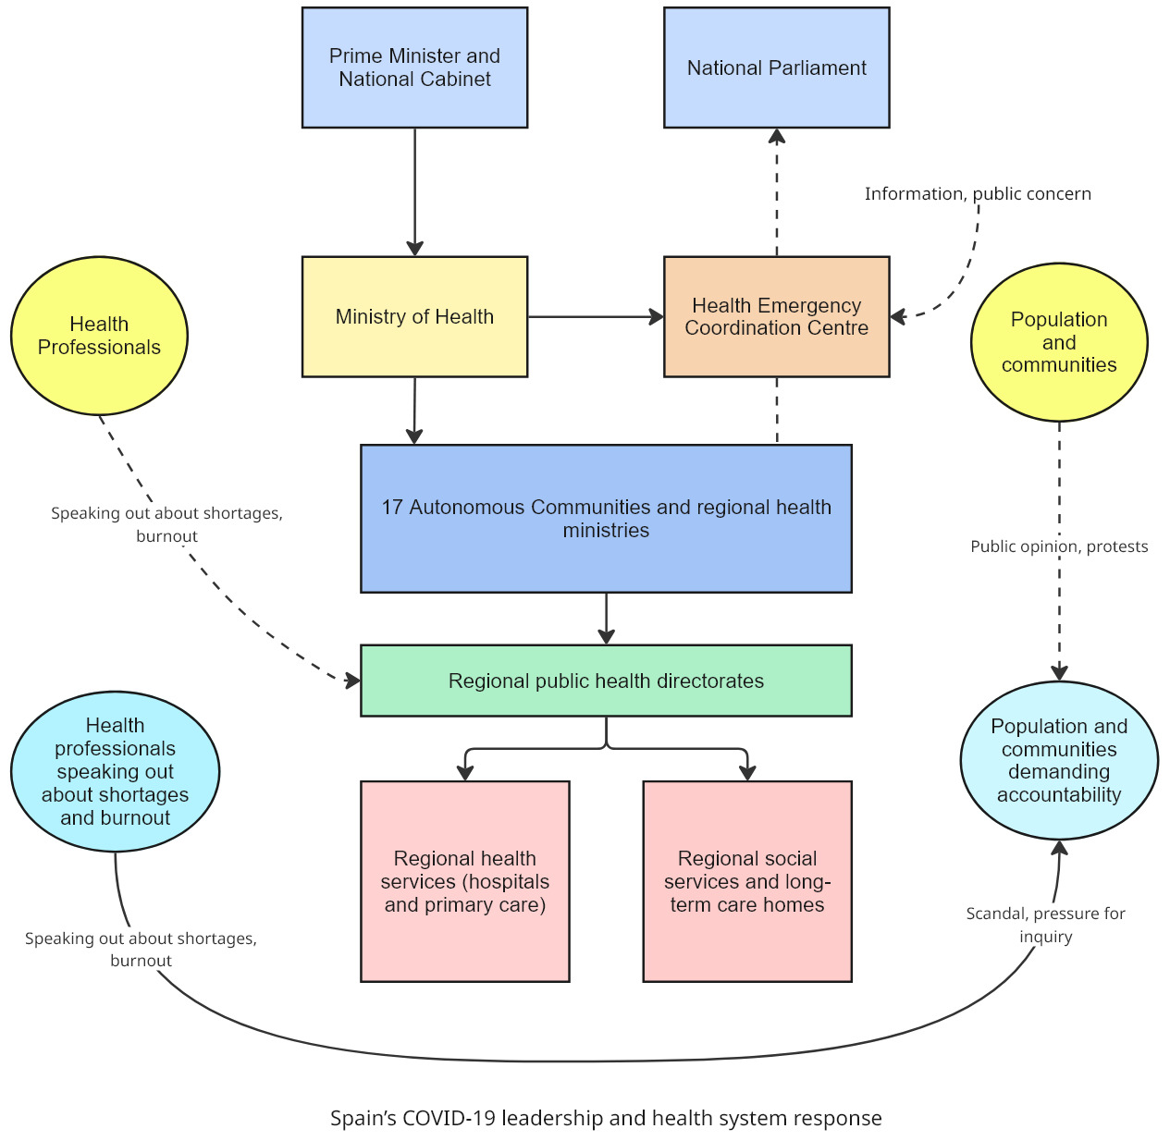
Figure 1: Rich picture of Spain’s COVID-19 leadership and health system response.
Source: Author.
As the first wave escalated in March 2020, the national government declared a State of Alarm that temporarily recentralised key powers, including control over regional health services, mobility restrictions and emergency procurement (García-Basteiro et al., 2020; Henríquez et al., 2020). National press conferences by the Prime Minister and the Health Emergency Coordination Centre became key communication channels. However, shortages of personal protective equipment, delays in scaling up testing and fragmented information systems meant that clinical teams often felt left to improvise, and mortality in hospitals and care homes was very high (García-Basteiro et al., 2020; Otero-García et al., 2023).
In the later vaccination phase, Spain’s decentralised system became more of an asset. The national government negotiated vaccine supply and set broad priority groups, while regional health services used well established primary care and public health networks to deliver vaccines at high speed and coverage. By mid 2021, Spain had one of the highest vaccination rates in Europe, especially among older people (OECD, 2021). This trajectory illustrates how the same structural features can be liabilities or strengths depending on how they are led and coordinated over time.

South Korea
South Korea has a mixed health system with compulsory National Health Insurance that covers almost the entire population. Service delivery is dominated by private hospitals and clinics, but public health functions, including infectious disease surveillance and response, are highly centralised in the Korea Disease Control and Prevention Agency under the Ministry of Health and Welfare (Yoo et al., 2021).
A crucial background factor is the 2015 Middle East Respiratory Syndrome outbreak, which exposed major weaknesses in hospital infection control, risk communication and legal frameworks for data sharing. The outbreak involved 186 cases and 38 deaths and led to widespread public criticism of the government’s opaque and slow response (Oh, 2018; Ki, 2015). In its aftermath, South Korea revised the Infectious Disease Control and Prevention Act to expand the agency’s authority, clarify reporting obligations, and allow the use of mobile phone location, credit card and CCTV data for contact tracing during epidemics, subject to safeguards (Yang et al., 2021; Kwon et al., 2021). Investments were made in laboratory capacity, stockpiles of personal protective equipment and a national emergency operations centre.
Figure 2 illustrates South Korea’s triage and care pathway for asymptomatic and mildly symptomatic COVID-19 patients, showing how screening clinics, testing, community treatment centres and hospitals are integrated into the national response. The agency appears as a central hub that coordinates surveillance, testing, contact tracing and risk communication. Regional public health centres and municipal governments feed case data into central databases and implement local quarantine orders. Private hospitals and laboratories are tightly integrated into national testing and reporting systems. Digital platforms link multiple databases to generate detailed movement logs of confirmed cases, which are used both for targeted contact tracing and to inform the public (Park, Choi and Ko, 2020; Park et al., 2020).
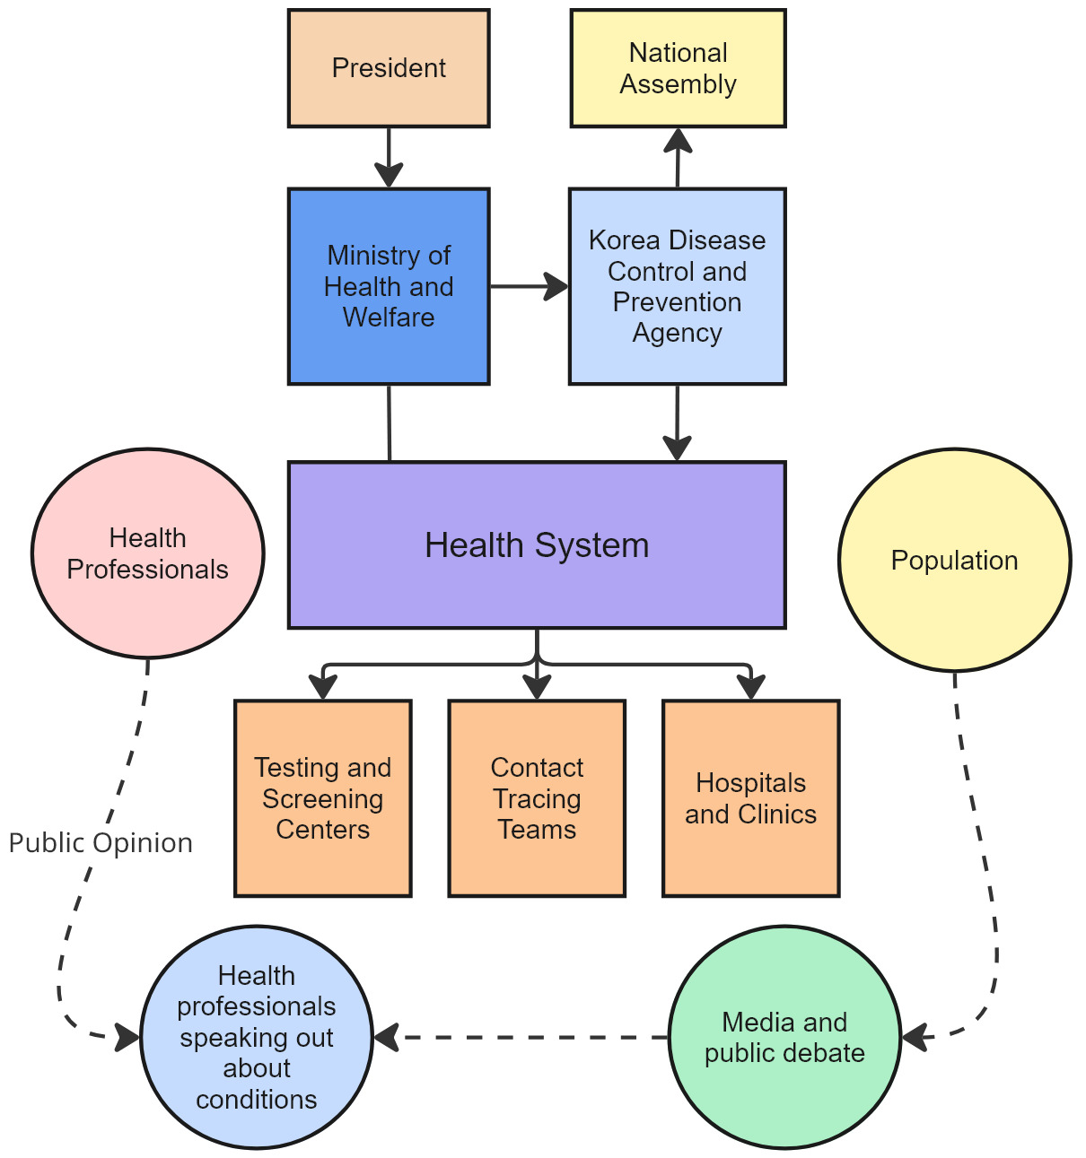
Figure 2: Rich picture of South Korea’s COVID-19 leadership and health system response.
Source: Author.
When COVID 19 arrived in early 2020, South Korea rapidly scaled up testing, contact tracing and isolation without imposing nationwide lockdowns. Drive through testing sites, government funded isolation facilities and SMS alerts about exposure locations were deployed within weeks (Yoo, 2020; Park et al., 2020). From a systems perspective, the country deliberately designed targeted centralisation in critical functions such as surveillance and data integration, while implementation remained distributed through local public health centres. This configuration enabled rapid, coordinated action and contributed to relatively low mortality in the first wave compared with many OECD peers (Yoo et al., 2021; Juneau et al., 2023).

Canada
Canada’s health system, often referred to as Medicare, is a publicly funded system where provincial and territorial governments plan, finance and deliver most health services within the national framework of the Canada Health Act. The federal government sets broad principles, provides funding transfers and leads on border control, procurement of some supplies and national guidance, but has limited direct authority over provincial health services (Marchildon, 2013). This creates a structurally decentralised system with significant interprovincial variation in organisation and performance.
A critical structural fault line lies in long term care. While hospital and physician services are covered under the Canada Health Act, long term care homes are governed by a patchwork of provincial regulations and funding arrangements, with a mix of public, non profit and for profit ownership. Numerous reviews before COVID 19 had documented chronic underfunding, staff shortages, reliance on part time workers who often worked in multiple facilities, and outdated infrastructure (Estabrooks et al., 2020; Hsu et al., 2020). These vulnerabilities created a highly fragile subsystem within an otherwise relatively robust acute care system.
Evidence from the first months of the pandemic shows how severe this fragility was. A report for the International Long Term Care Policy Network estimated that by May 2020, residents of long term care homes accounted for up to 82 percent of COVID 19 deaths in Canada, a much higher share than in many comparator countries (Hsu et al., 2020). Analyses by the Canadian Institute for Health Information similarly found that Canada had one of the highest proportions of COVID 19 deaths occurring in care homes among OECD countries (Canadian Institute for Health Information, 2020; 2021). Military personnel deployed to hard hit facilities in Ontario and Quebec documented serious deficiencies in infection control, staffing and basic care, which prompted public outcry and were described as a national disgrace (Halladay and Bélanger, 2020; Shepherd, 2021; Estabrooks et al., 2023).
Figure 3 summarises the division of responsibilities between the federal government and provincial and territorial governments in Canada’s health system. At the federal level, the Public Health Agency of Canada and Health Canada provide guidance, coordinate border measures and manage some stockpiles. Provincial ministries of health oversee regional health authorities and hospitals, and chief medical officers of health advise provincial governments. Long term care homes sit within this landscape but are regulated and funded mainly by provinces, with fragmented ownership and variable integration into regional health structures (Estabrooks et al., 2020).
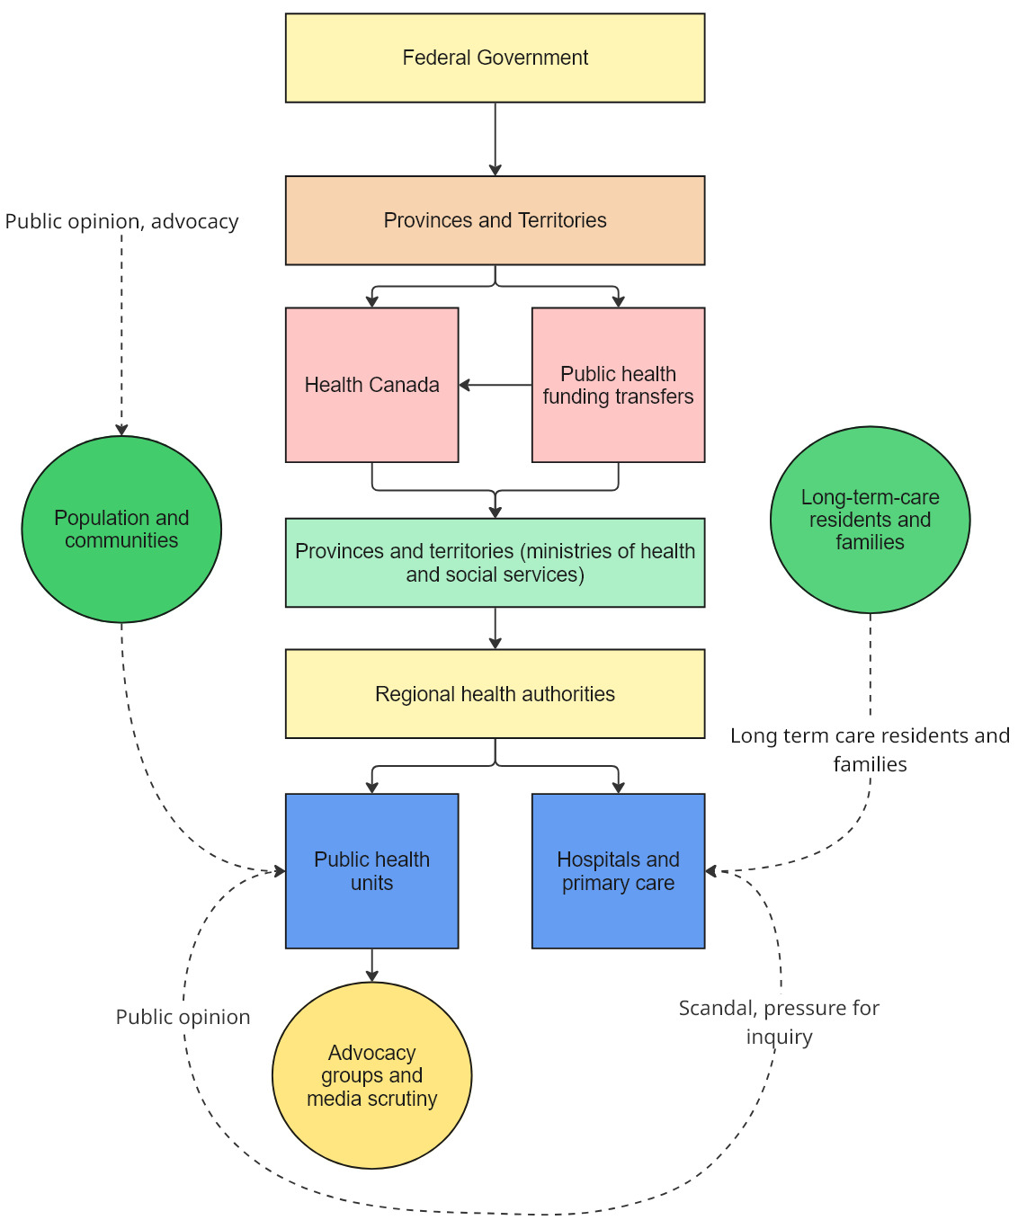
Figure 3: Rich picture of Canada’s COVID-19 leadership and health system response. Source: Author.
During COVID 19, provinces and territories determined most public health restrictions, such as school closures and gathering limits, while the federal government coordinated international measures and financial support schemes. This produced a patchwork of responses, with some provinces acting more quickly than others and with varying degrees of alignment with federal recommendations (Marchildon and Bossert, 2018; Estabrooks et al., 2023).

Leadership Approaches During COVID-19

Spain: from delayed response to vaccination champion
Spain’s political and health system leadership had to navigate intense uncertainty and high polarisation. In the early weeks of March 2020, the government hesitated to cancel large public events and apply strong distancing measures, partly due to concern about economic and social disruption and partly because of underestimation of community transmission (García-Basteiro et al., 2020). When hospitals in Madrid and other regions began to saturate, the Prime Minister declared a State of Alarm, centralising decision making and appearing frequently in national press conferences.
From a leadership lens, this early phase resembled classical command and control crisis leadership, with strong reliance on legal powers and centralised communication, but limited adaptive engagement with regional governments and professional communities (Uhl-Bien and Arena, 2018). The rapid centralisation, layered on top of pre-existing mistrust between the central government and some regions, especially Madrid and Catalonia, made it harder to co create solutions and share data (Henríquez et al., 2020). Healthcare workers reported frequent changes in guidelines and shortages of protective equipment, which contributed to stress and moral distress (Otero-García et al., 2023).
In the subsequent vaccination phase, leadership practices shifted. The Ministry of Health convened technical advisory groups with regional representatives and scientific experts to design priority groups and logistics, and communication emphasised solidarity and the protection of older people. Regional health services drew on primary care networks and local knowledge to organise mass vaccination centres and outreach to vulnerable groups. Spain achieved high levels of vaccine acceptance and coverage, with relatively low levels of politicisation of vaccines compared with some other European countries (Lazarus et al., 2021; OECD, 2021).
Viewed through complexity leadership theory, Spain’s story illustrates a transition from predominantly administrative leadership, focused on legal authority, towards more enabling leadership that created spaces for joint problem solving with regions and professionals. However, the legacy of austerity and politicised centre region relations limited the system’s agility during the critical early months.

South Korea: transparent, networked and technology enabled leadership
In South Korea, political leaders and public health experts drew consciously on lessons from Middle East Respiratory Syndrome. The central government moved quickly to frame COVID 19 as a national emergency that required transparent communication and strong coordination between ministries and levels of government (Yoo, 2020; Yang et al., 2021). Daily briefings by agency officials and the Minister of Health provided detailed epidemiological updates and rationales for interventions, which reinforced public trust in expert led decision making.
Leadership in South Korea can be characterised as a combination of strong administrative leadership from the central agency and government, and adaptive leadership through rapid experimentation with testing and tracing models. The government actively partnered with private laboratories to expand polymerase chain reaction testing capacity and developed standard operating procedures that regional public health centres could implement quickly (Yoo et al., 2021). This reflects complexity leadership principles of enabling networks and leveraging distributed capabilities rather than attempting to control all activity from the centre (Weberg, 2012).
At the same time, South Korea’s extensive use of digital contact tracing generated ethical and political controversy. Authorities used credit card transaction data, mobile phone location records and CCTV footage to reconstruct the movements of confirmed cases and publicly share anonymised but detailed itineraries (Park, Choi and Ko, 2020). This strategy was effective in identifying contacts and limiting large scale lockdowns, but it also led to instances where individuals were indirectly identifiable, resulting in stigma, harassment and concerns about a surveillance society (Zastrow, 2020; Kang et al., 2023).
Bioethicists and legal scholars argued that South Korea exemplified a broader risk of a pandemic panopticon, where technologies introduced for public health surveillance blur boundaries between legitimate emergency measures and invasive, long term monitoring (Couch, Robinson and Komesaroff, 2020; Park, Choi and Ko, 2020). In response, some local authorities adjusted the level of detail in public disclosures and reinforced data protection safeguards (Yang, 2022). From a leadership perspective, this highlights the challenge of balancing decisive action and innovation with protection of rights and social cohesion.

Canada: empathetic federal leadership within a fragmented federal system
Canadian leaders faced the dual task of coordinating a federated response and addressing long standing inequities in Indigenous communities and long term care. The Prime Minister and federal public health leaders emphasised unity and Team Canada messaging, holding regular national briefings and convening First Ministers’ meetings with provincial and territorial leaders. Early federal actions included border closures, economic support packages and guidance on public health measures (Marchildon and Bossert, 2018).
However, the most severe leadership and governance failures emerged in long term care. Many provincial leaders were slow to restrict staff from working in multiple care homes, to provide adequate protective equipment and to integrate long term care facilities into regional infection prevention and control structures, despite early warnings from outbreaks in Europe and the United States (Hsu et al., 2020; Estabrooks et al., 2020). The deployment of the Canadian Armed Forces to overwhelmed facilities in Ontario and Quebec, and the subsequent military reports documenting neglect, unsafe conditions and distress among residents, revealed deep systemic problems that had been repeatedly noted but not addressed (Halladay and Bélanger, 2020; Estabrooks et al., 2023).
From a complexity perspective, leaders struggled to adapt quickly in a subsystem that was characterised by fragmented ownership, weak data and low status within the broader health system. Administrative leadership reforms, such as changing regulations or issuing guidelines, did not automatically translate into better practice in understaffed homes. Where provincial and local leaders adopted more collaborative approaches, partnering with hospitals, public health units and community organisations to support long term care homes, outcomes tended to be better (Lavoie-Tremblay et al., 2022).
At the same time, leadership in acute care and public health in several provinces succeeded in rapidly reorganising services, scaling up testing and vaccination, and maintaining relatively high public trust in health professionals even when trust in politicians fluctuated (Estabrooks et al., 2023). The contrast between acute care and long term care illustrates how leadership effectiveness is shaped by underlying system design and power dynamics.

Cross case discussion
Across the three cases, leadership cannot be separated from system structures. Spain shows how austerity weakened the adaptive capacity of a decentralised system, which made early command and control leadership insufficient. South Korea illustrates how learning from previous crises and deliberate investment in central capabilities can support both administrative and adaptive leadership, although at the cost of new ethical trade offs around surveillance. Canada highlights how gaps in coverage and regulation in less visible sectors such as long term care can negate strengths elsewhere, and how rhetoric of unity must be matched by targeted support and integration for vulnerable services and populations.
Complexity leadership theory suggests that effective crisis leadership requires a dynamic interplay between administrative, adaptive and enabling roles (Uhl-Bien and Arena, 2018). In practice, this means leaders must be able to reconfigure decision rights between central and local levels as conditions change, create safe spaces for experimentation and learning, for example around testing strategies or long term care support models, and maintain transparent, empathetic communication that acknowledges uncertainty and explains how decisions are being made.
Spain’s shift from a legalistic State of Alarm towards co governance, South Korea’s adjustments to contact tracing transparency in response to privacy concerns, and Canadian provinces’ later reforms to staffing and integration in long term care all illustrate attempts to move in this direction. The degree to which these changes were institutionalised, however, remains variable.

Centralisation, Decentralisation and Systems Performance
The three cases underline that centralisation and decentralisation are not binary opposites but design choices that can be configured differently across functions. Surveillance and data integration, procurement, financing, service delivery and risk communication can each be organised at different levels, and these choices shape how systems respond to shocks (Yoo et al., 2021; OECD, 2021).
Spain shows that a highly decentralised system with strong regional autonomy can struggle in the initial crisis phase if coordination mechanisms, digital infrastructure and trust between levels are weak. The State of Alarm from March to June 2020 temporarily recentralised health powers and standardised restrictions, but once it ended Spain moved to a co governance model in which the central government and Autonomous Communities jointly decided risk levels and measures using a traffic light framework (Henríquez et al., 2020). While this was intended to combine national coherence with regional flexibility, frequent legal disputes and partisan conflicts, especially with Madrid, generated ambiguity about who was responsible for which decisions and contributed to public confusion (García-Basteiro et al., 2020; Henríquez et al., 2020). Over time, however, collaboration improved in the vaccination campaign, which suggests that decentralisation can support strong performance when roles are clearer and shared goals are salient.
South Korea demonstrates how targeted centralisation in public health functions can enable rapid, coordinated responses. The agency’s authority to collect and integrate data from multiple sources and to issue binding guidance to regional public health centres reduced delays and inconsistencies (Yoo et al., 2021; Kwon et al., 2021). At the same time, delivery of services, such as operating screening clinics and supporting quarantined households, remained largely decentralised. This hybrid model leveraged local implementation capacity within a centrally coordinated strategy. Yet the very tools that made centralisation effective for disease control also raised concerns about excessive surveillance and the risk that exceptional powers could become normalised (Park, Choi and Ko, 2020; Couch, Robinson and Komesaroff, 2020).
In Canada, decentralisation is deeply embedded in the constitutional division of powers. Provinces vary widely in how they organise regional health authorities, public health units and integration with social care. This diversity allowed some provinces to innovate and respond quickly, but it also meant that there was no single national system to mobilise (Marchildon and Bossert, 2018). Federal coordination and financial support were important, yet the limited legal authority of Ottawa over provincial health services constrained its ability to enforce consistent standards, particularly in long term care. The result was a patchwork of responses and outcomes, with shared national narratives of solidarity coexisting with stark interprovincial differences in mortality, especially in care homes (Canadian Institute for Health Information, 2020; Estabrooks et al., 2023).
From a systems thinking perspective, all three countries faced trade offs between tight and loose coupling. Highly centralised arrangements, as in South Korea’s surveillance system, can increase speed and coherence but risk over reliance on central capacities and underestimation of local knowledge and rights. Highly decentralised arrangements, as in Spain’s and Canada’s federated structures, can increase responsiveness to local contexts but create delays and coordination failures if shared information platforms, trust and conflict resolution mechanisms are weak (Arminio et al., 2021; Yoo et al., 2021).
The comparative analysis suggests that the key question for future crises is not whether to centralise or decentralise in the abstract, but how leaders can flexibly reconfigure the balance by function and over time. For example, this might include centralising data standards and emergency stockpiles while decentralising community engagement and service delivery, or using legal tools for time limited emergency centralisation with clear sunset clauses and accountability mechanisms.

Comparative Discussion: Leadership Styles and Health System Shaping
Across the three jurisdictions, different leadership styles interacted with institutional structures to shape pandemic trajectories.
First, the use of expertise and evidence varied. South Korea institutionalised expert leadership through the Korea Disease Control and Prevention Agency and visibly empowered scientific voices in public communication, reinforcing trust and compliance (KCDC/World Bank, 2020; Hong, 2024). Spain initially struggled with integrating epidemiological expertise into political decision making but later used scientific committees to guide vaccination strategy (García-Basteiro et al., 2020; Ministry of Health Spain, 2020). Canada relied on both federal and provincial chief medical officers. While expert advice was prominent, political decisions occasionally diverged from recommendations, particularly regarding reform of long term care and the timing of restrictions (Allin et al., 2021; Canadian Institute for Health Information, 2020).
Second, communication and trust building were central. South Korean leaders emphasised transparency, frequent updates and detailed case information, exemplifying transformational and relational leadership that treated citizens as partners (Ahn, 2022; Hong, 2024). Spanish communication improved over time but was initially hampered by mixed messages and underestimation of risk, which eroded trust during the first wave (García-Basteiro et al., 2020; Oliver et al., 2020). Trudeau’s empathetic communication and clear messaging around federal supports strengthened public trust, but provincial variation and politicisation at sub national level sometimes muddied the overall narrative (Allin et al., 2021; Lavoie, MacNaughton and Labonté, 2022).
Third, leaders differed in how they used the crisis to reshape their health systems. In Spain, the crisis exposed weaknesses in public health capacity and legal frameworks for emergency coordination, prompting debates on recentralising certain functions and investing in surveillance and primary care (OECD and European Observatory on Health Systems and Policies, 2023; Sameni, 2024). South Korea used the pandemic to reinforce its public health infrastructure, upgrade the Korea Disease Control and Prevention Agency to an independent agency and normalise digital tools in epidemic management, which is an example of leadership using crisis to deepen system capabilities (Kwon et al., 2020; Ahn, 2022). In Canada, reviews have called for stronger federal provincial coordination mechanisms, national standards in long term care and enhanced data systems. Progress has been uneven, illustrating how leadership windows for reform can close as political attention shifts (Canadian Institute for Health Information, 2020; OECD, 2021).
Finally, equity and vulnerable populations were a critical test of leadership. Spain’s later vaccination success did not fully eliminate inequalities, and early campaigns struggled to reach marginalised groups, which highlighted the need for targeted, community-based engagement (Lazarus et al., 2021). South Korea achieved relatively good overall control but faced criticism over privacy concerns and the burdens placed on certain groups, raising questions about how to balance collective safety and individual rights (Ahn, 2022; Hong, 2024). In Canada, disproportionate impacts on residents of long-term care, racialised communities and low-income workers reflected preexisting structural inequities that leadership responses only partially mitigated (Canadian Institute for Health Information, 2020; Rocard, Sillitti and Llena-Nozal, 2021).
Overall, transformational, distributed and complexity aware leadership, most visible in South Korea and in specific phases in Spain and Canada, appears better aligned with the demands of pandemic management than narrowly transactional or politicised approaches.

Recommendations and Lessons for Future Health System Leadership
Several cross-cutting lessons emerge for leaders who seek to strengthen health system preparedness and crisis response.
First, complexity and systems thinking should be embedded into governance. Permanent multi-level coordination bodies with clear mandates for shared decision making across central, regional and local levels can improve coherence. Investments in interoperable data systems that allow real time monitoring and feedback can enable adaptive policy adjustments (OECD, 2020; Manavgat and Audibert, 2024).
Second, public health institutions and authority need to be strengthened. Elevating national disease control agencies, as Korea did with the Korea Disease Control and Prevention Agency, with legal powers, secure funding and independence, while ensuring strong links to regional and local public health units, is essential (Kwon et al., 2020; KCDC/World Bank, 2020). Preparedness plans should be regularly stress tested through simulations and cross jurisdictional exercises (World Health Organization, 2020).
Third, transformational and distributed leadership capacities should be fostered. Political and health leaders require skills in communication, co-production with communities and inter professional collaboration, supported by institutional cultures that reward learning, transparency and error reporting rather than blame (Singh and Storey, 2024; Gunzel-Jensen et al., 2018).
Fourth, structural inequities must be treated as a core resilience issue. Equity indicators should be integrated into pandemic dashboards and leadership performance metrics, focusing on long term care, migrant communities and low-income groups (Canadian Institute for Health Information, 2020; Rocard, Sillitti and Llena-Nozal, 2021). Long term care and other neglected sectors should be reformed as part of mainstream health system strengthening, not as separate social policy add ons (OECD, 2021).
Finally, crises should be used to drive sustainable system transformation. As the acute phase of COVID-19 fades, there is a risk of complacency. Leadership should lock in gains from innovations such as telehealth, coordinated vaccination campaigns and improved data systems, rather than allowing reforms to dissipate once immediate pressures ease (Sameni, 2024; OECD, 2020).

Conclusion
Spain, South Korea and Canada illustrate how health system organisation, degree of centralisation and leadership styles interact to shape pandemic responses. Spain’s highly decentralised National Health System suffered from early coordination failures but evolved into one of Europe’s vaccination success stories through stronger national and regional alignment and a solidarity-based narrative. South Korea’s proactive, transparent and networked leadership, built on prior experience and robust public health institutions, enabled effective containment without prolonged nationwide lockdowns. Canada’s empathetic federal leadership operated within a fragmented federal context, producing both examples of innovation and troubling failures in long term care and inter provincial coherence.
Across all three jurisdictions, the pandemic underscored that effective leadership in public health is not simply about centralising power or issuing strict orders. It requires a blend of transformational vision, distributed authority, robust institutions and systems thinking that views health systems as complex adaptive networks. Leaders who can navigate this complexity, mobilise trust, align multiple levels of governance and embed learning into institutions are better positioned to protect populations in future health crises.

References
Armenteros-Ruiz, M., García-García, P., Peiró, S. and Bernal-Delgado, E., 2024. Decentralisation and performance of the Spanish National Health System in the COVID 19 pandemic. Health Policy, 138(1), pp.1-8.
Arminio, A., Boccia, S. and Ricciardi, W., 2021. Systems thinking for responding to the COVID 19 pandemic. European Journal of Public Health, 31(Supplement 4), pp.iv16-iv20.
Bennett, N. and Lemoine, G.J., 2014. What VUCA really means for you. Harvard Business Review, 92(1–2), pp.27-31.
Canadian Institute for Health Information, 2020. Long-term care and COVID-19: international comparisons. Ottawa: CIHI.
Canadian Institute for Health Information, 2021. The impact of COVID-19 on long-term care in Canada: focus on the first 6 months. Ottawa: CIHI.
Cervero-Liceras, F., McKee, M. and Legido-Quigley, H., 2015. The effects of the financial crisis and austerity measures on the Spanish health care system: a qualitative analysis of health professionals’ perceptions in the region of Valencia. Health Policy, 119(1), pp.100-106.
Couch, D.L., Robinson, P. and Komesaroff, P.A., 2020. COVID-19 extending surveillance and the panopticon. Journal of Bioethical Inquiry, 17(4), pp.809-814.
Crain, M.A., Cummings, C.L., Jones, D. and Niemeier, M., 2021. Healthcare leadership in the COVID-19 pandemic: from innovative preparation to crisis management. Journal of Healthcare Leadership, 13, pp.199-207.
Estabrooks, C.A., Straus, S., Flood, C.M., Keefe, J., Armstrong, P., Donner, G., Boscart, V., Ducharme, F., Silvius, J. and Wolfson, M., 2020. Restoring trust: COVID-19 and the future of long-term care in Canada. FACETS, 5(1), pp.651-691.
Estabrooks, C.A., Flood, C.M., Straus, S., Keefe, J., Armstrong, P. and Wolfson, M., 2023. The predictable crisis of COVID-19 in Canada’s long term care homes. BMJ, 382, e075148.
García-Armesto, S., Abadía-Taira, M.B., Durán, A., Hernández-Quevedo, C. and Bernal-Delgado, E., 2010. Spain: health system review. Health Systems in Transition, 12(4), pp.1-295.
García-Basteiro, A.L., Alvarez-Dardet, C., Arenas, A., Bengoa, R., Borrell, C., Del Llano, J., Franco, M., Gotsens, M., Luna, F. and Malmusi, D., 2020. The need for an independent evaluation of the COVID-19 response in Spain. The Lancet Public Health, 5(11), pp.e575-e576.
Halladay, J. and Bélanger, S.A.H., 2020. Fast facts on COVID-19 and the Canadian Armed Forces. Journal of Military, Veteran and Family Health, 6(S2), pp.7-8.
Henríquez, J., Gonzalo-Almorox, E., García-Goñi, M. and Paolucci, F., 2020. The first months of the COVID-19 pandemic in Spain: a view from the eye of the storm. Health Policy and Technology, 9(4), pp.560-574.
Hsu, A.T., Lane, N., Sinha, S.K., Dunning, J., Dhuper, M., Kahiel, Z. and Sveistrup, H., 2020. Impact of COVID-19 on residents of Canada’s long-term care homes: ongoing challenges and policy responses. London: International Long Term Care Policy Network.
Johns Hopkins University, 2021. COVID-19 dashboard by the Center for Systems Science and Engineering at Johns Hopkins University. Baltimore: JHU.
Kang, J., Lee, J., Choi, S. and Kim, S., 2023. COVID-19 survivors’ experiences of social stigma and discrimination in South Korea: a qualitative study. Frontiers in Psychiatry, 14, 1103572.
Ki, M., 2015. 2015 MERS outbreak in Korea: hospital-to-hospital transmission. Epidemiology and Health, 37, e2015033.
Kwon, S., Lee, T., Kim, C.Y., Lee, J.H. and Lee, S., 2021. Republic of Korea’s COVID-19 preparedness and response. Washington DC: World Bank Group.
Lazarus, J.V., Ratzan, S.C., Palayew, A., Gostin, L.O., Larson, H.J., Rabin, K., Kimball, S. and El-Mohandes, A., 2021. A global survey of potential acceptance of a COVID-19 vaccine. Nature Medicine, 27(2), pp.225-228.
Legido-Quigley, H., Otero, L., La Parra, D., Alvarez-Dardet, C., Martín-Moreno, J.M. and McKee, M., 2013. Will austerity cuts dismantle the Spanish healthcare system? BMJ, 346, f2363.
Lavoie-Tremblay, M., Richard, L., Aubry, M., Lavigne, G., Dallaire, C. and Pépin, J., 2022. Lessons from long-term care facilities without COVID-19 outbreaks. Geriatric Nursing, 45, pp.64-72.
Marchildon, G.P., 2013. Canada: health system review. Health Systems in Transition, 15(1), pp.1-179.
Marchildon, G.P. and Bossert, T., 2018. Federalism and decentralization in health care: a decision space approach. Social Science and Medicine, 196, pp.39-48.
OECD, 2021. Health at a glance 2021: OECD indicators. Paris: Organisation for Economic Co-operation and Development.
Oh, M.D., 2018. MERS in Korea: one year later. Osong Public Health and Research Perspectives, 9(6), pp.348-349.
Otero-García, L., Limón, R., Sánchez-Recio, R., Díaz-Méndez, C., Gutiérrez-Rojas, L. and Ruiz-Azarola, A., 2023. Austerity measures and underfunding of the Spanish health system during the COVID-19 pandemic: perceptions of healthcare staff in Spain. International Journal of Environmental Research and Public Health, 20(3), 2594.
Park, S., Choi, G.J. and Ko, H., 2020. Information technology based tracing strategy in response to COVID-19 in South Korea: privacy controversies. JAMA, 323(21), pp.2129-2130.
Park, Y.J., Choe, Y.J., Park, O., Park, S.Y., Kim, Y.M., Kim, J., Kweon, S., Woo, Y., Gwack, J. and Kim, S.S., 2020. Contact tracing during coronavirus disease outbreak, South Korea, 2020. Emerging Infectious Diseases, 26(10), pp.2465-2468.
Shepherd, R.P., 2021. A national disgrace: long-term care and COVID-19. Ottawa: Canadian Association of Programs in Public Administration.
Singh, P.K., Kumar, S., Verma, A. and Gupta, S., 2024. Navigating healthcare leadership: theories, challenges and practical insights for the future. Journal of Healthcare Leadership, 16, pp.1-15.
Uhl-Bien, M. and Arena, M., 2018. Leadership for organizational adaptability: a theoretical synthesis and integrative framework. The Leadership Quarterly, 29(1), pp.89-104.
Weberg, D., 2012. Complexity leadership: a healthcare imperative. Nursing Forum, 47(4), pp.268-277.
Yang, T.U., Jeong, S., Bae, S., Lee, Y.K., Kim, S.S. and Park, Y.J., 2021. How lessons learned from the 2015 Middle East respiratory syndrome outbreak affected the response to coronavirus disease 2019 in the Republic of Korea. Osong Public Health and Research Perspectives, 12(3), pp.141-149.
Yang, Y., 2022. Privacy protection in digital contact tracing for COVID-19 in South Korea. Asian Bioethics Review, 14(2), pp.129-143.
Yoo, J.H., 2020. The fight against the 2019-nCoV outbreak: an arduous march has just begun. Journal of Korean Medical Science, 35(4), e56.
Yoo, K.J., Kwon, S., Choi, Y. and Bishai, D.M., 2021. Systematic assessment of South Korea’s capabilities to control COVID-19. Health Policy, 125(5), pp.568-576.
Zastrow, M., 2020. South Korea is reporting intimate details of COVID-19 cases: has it helped? Nature, 579(7798), pp.18-19.

