
Applied Leadership and Management in the Workplace
Module Assignment Submission
Student Name: | Katie Marie Smith
Student Number: | 2307193
Module No: | BMSK5012
Module Title: | Understanding and Engaging in the customer experience

Table of Contents
Report on Understanding and Engaging 3
in the Customer Experience 3
Introduction 3
Customer Value 4
Understanding Patients Experience 6
Engaging in Patients Experience 9
Evidence of Critical Understanding of Quality Processes in the dental practice 10
Analysis of Patients Experience in the Dental Practice 12
• Strengths and Weaknesses: 14
Critical Evaluation of Developing and Maintaining Good Patient Relationships 15
Conclusion 17
Appendix 1 19
Appendix 2 20
References 21
Bibliography 23

Report on Understanding and Engaging

in the Customer Experience

Introduction

For the purpose of this report the customers are known as patients as the organisation discussed is dental care setting, focusing on mixed practice made up of NHS/Private patients. In today society there is a competitive market with understanding and engaging in the customer experience. This report takes an in depth look at patients experience within the dental care setting, discussing and critically evaluating the various aspects of patient value, experience, and engagement strategies. The report aims to provide comprehensive understanding of how dental practices can increase their dental services to meet and exceed patient expectations. The insights gained from the analysis will not only help improve patient satisfaction and loyalty but also contribute to the overall success and sustainability of the dental practice business. Taking a look at many frameworks models and tools that can help aid customer engagement and experience in a dental environment. The report emphasis how the importance of patient centred care is the heart of dentistry, how key statistics and trends have an impact on the patient’s oral health. The challenges that occur in dentistry regarding patient experiences, and how innovative technologies and CRM play a pivotal role when transforming the dental care environment.

Customer Value
Customer value is essential for the success and growth of any organisation. The value a customer perceives depends on the organisation's offerings, whether it's a specific product or service, and how it benefits the customer while factoring in cost, time, emotional investment, or effort. In the circumstances of a dental practice, patients often seek high standards of quality treatment, professionalism, and in general a positive experience.
As Henry et al. (2025) state, “Professionalism in health care serves as a cornerstone for building trust and confidence, ensuring the delivery of high-quality care.” Dentistry is a patient focused service, aiming to ensure patients leave with improved oral health. For others, this may involve cosmetic dental treatments or achieving a perfect smile which is known as a patient desired value. On the other hand, perceived value considers factors such as cost and service quality.

The costs of private dental treatment in the UK have risen over the years due to numerous factors, including regulatory requirements by governing bodies, higher operating expenses, and growth in materials and technology. Preshaw (2025) explains that dental inflation is estimated to have already increased by 9%, powered by rising lab fees, utility costs, wages, and expensive materials. These increasing costs often lead patients to seek treatment outside the UK. To secure patient satisfaction and meet their standards, both desired and perceived value must be carefully considered. Research by Doughty et al (2025) dental tourism is on the rise due to the affordability and easy accessibility of having treatment abroad, a lot led by this is a patient’s self-esteem or confidence, therefore receiving both desired value and perceived value will take place for the patient abroad. However, a patient may think this service is right for them without knowing the true consequences it possesses on the patient’s dental physiology. GDC (2025) stresses to patients that “any patient who receives illegal dental treatment is placing themselves at risk as they will not be protected by the rigorous regulatory system that we have in place in the UK”. Although a report conducted by Tickle et al (2015) finding suggested that patients find NHS dentistry poor value for money and average care provided “suboptimal care”. This seems to be the trend on why patients are seeking care elsewhere and how the terminology “Turkey Teeth” seems to be trending in present days.
In order for the patients to stay in the UK practices customer centrality needs to be applied to all of the NHS and private business decisions elaborating on this by understanding patient wants, needs, preferences, and overall experiences they have regarding the services provided by the business. Applying this approach can lead to patients feeling valued and satisfied, therefore continue to have increased customer revenue with new and existing customers allowing positive word of mouth recommendations to family and friends. Customer relationship management (CRM) can be used as a tool to help advance the dental environment. Andriana & Mardiani (2025) suggests CRM is a strategy that is continuously used by organisations to determine the direction of goals that business needs. See below CRM basic diagram.
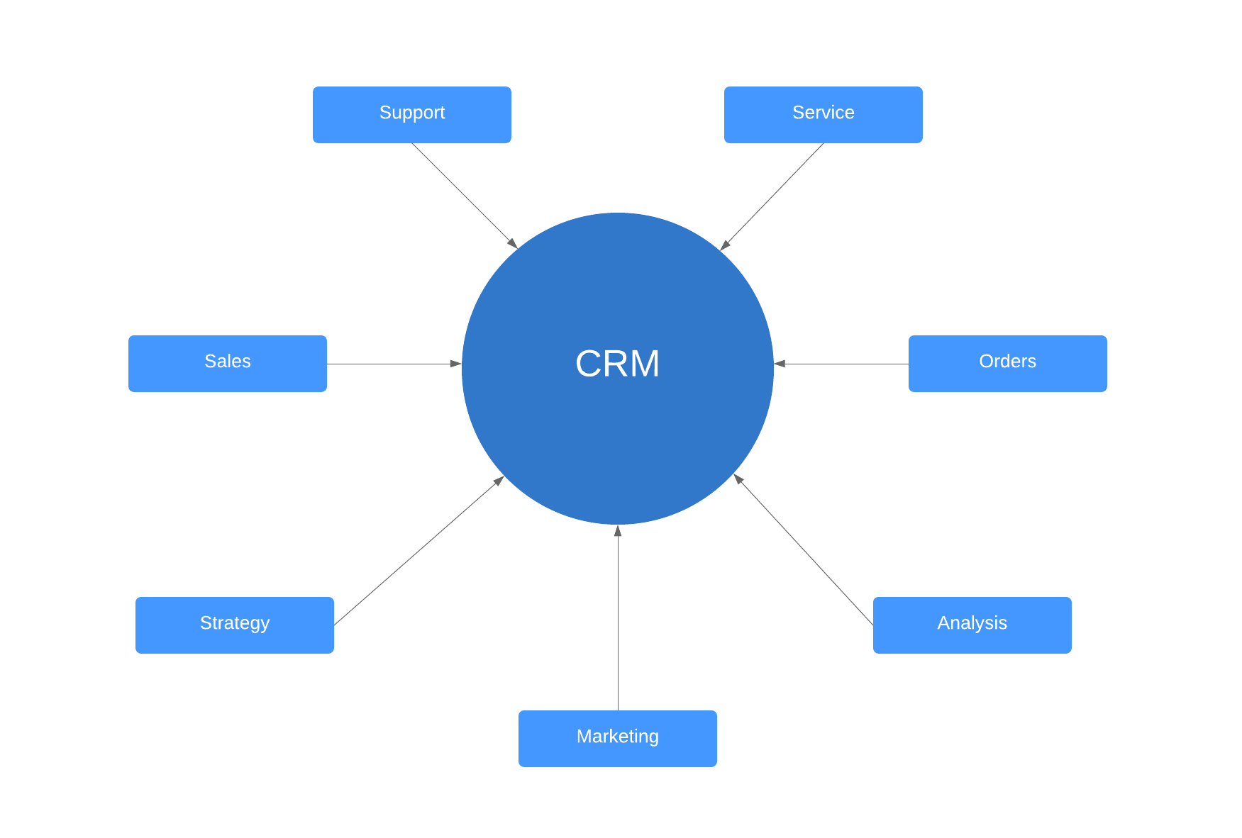
CRM value chain model created by Francis Buttle helps identify the activities needed to build and maintain customer relationships. When applied to a dental care setting the sub-branches would be tailored to that specific business.
Lucid chart (2025)

Francis & Maklan (2019) views on CRM not only happen to be about relationships with the customer, but about the active management of the process and resources a business needs to survive and prosper. The dental practice can look at many processes to help with the patient relationship such as personalised communication, patient feedback, appointment management, patient education, loyalty programmes, professionalism and empathy. If CRM was not in place the dental practice would likely see an increase in challenges when dealing with patient relationships leading to discrepancies, missed opportunities to less income revenue. Young (2016) states that the success of a dental practice requires a wide range of tools and techniques this is how CRM can be implemented and used to business advantage. Dyche (2002) suggest how CRM can form many categories to marketing, customer service, the business and the analytical approach. Therefore, covering all aspects of opportunities to gain throughout the business.

Understanding Patients Experience
Definition of Patient Experience: Patient experience entails the general perception and feelings a patient has regarding the care and services they received at their chosen practice. It reflects the patient's own personal journey with healthcare providers and the dental team. Factors included in the experience from the quality of care, the physical environment, and the emotional support provided by the practice, considerably influences this experience.
The British Dental Journal (BDNJ, 2024) supports the view that patient experience is multidimensional, involving social factors, excellent clinical guidance, and the physical environment all of which positively correlate with patient satisfaction and clinical outcomes. A positive patient experience can lead to better healthcare results while meeting the patient’s functional, emotional, life-altering, and social needs. For example, when a patient has a positive experience that addresses those needs, they may feel relieved and happy, reducing anxiety about dental appointments. This newfound confidence might encourage the patient to undergo cosmetic treatments, resulting in an improved smile. These specific treatments can be life-changing, encouraging the patient’s confidence and self-esteem and positively impacting both their personal and professional life.

Many dental practices pinpoint those success stories online via their own websites. For instance, a dental practice based in the UK called, Bamboo Dental (2025) showcases patient testimonials, such as: “I went years without having the confidence to smile. Now, my new smile has given me a new lease on life.” This example demonstrates how dental practices use (CRM) by utilising online platforms to market their full range of services, attracting more private patients. This strategy not only increases profits but also creates long-term customer retention, this is called continuous relationship marketing which co-insides with CRM.

- Importance of Patient Experience: The importance of a patient experience cannot be overlooked. It is vital for the business as it directly impacts whether business succussed or in fact fails. Firstly, a positive patient experience helps build trust and confidence, as a patient may feel valued and well cared for. The trust is key for ensuring the patients return and follow the instruction given by the dental team.
Patient satisfaction and loyalty can show by a positive experience which leads to higher levels of satisfaction therefore turns into patient loyalty. Loyal patients are more likely to continue using the services of the practice and initiates recommendations to other potential patients. This leads to increased patient retention and growth. Dalatony et al (2023) view on loyalty is for keeping the patient for as long as possible as loyalty refers to a patient commitment to the return to that particular service. Whereas patient satisfaction is how they think and feel Eriksen (1995) states “Patient satisfaction literature addresses the fulfilment of patients’ needs, desires, or expectations in relation to a healthcare service”. Ghanem et al (2023) expands on this view as explains patient satisfaction is an important metric for evaluating the quality of care given by dental professionals. Loyalty and satisfaction are two different needs, although you need adequate satisfaction in order to achieve loyalty, you cannot have one without the other.
There are many models and frameworks that can aid in the help to achieve customer satisfaction, the Kano model created by Professor Noriaki Kano which helps group product features into three main groups they are basic needs, performance needs and excitement needs which allows business to prioritise features and services based on their impact on customer satisfaction. Materla (2019) views on Kano model suggest it helps healthcare providers to figure out, sort and rank the complicated demands of their patients and produce long lasting success in quality of care. Although this model is useful, another model called Walkers model focuses on the customer experience journey and the emotional responses of a customer. The model suggests how the customer journey can be mapped by identifying, recognising, emotional factors that affect their experience, how to improve on those points by continuously measuring and monitoring customer satisfaction. See below figure 1 an example of what the Kano model looks like in business.

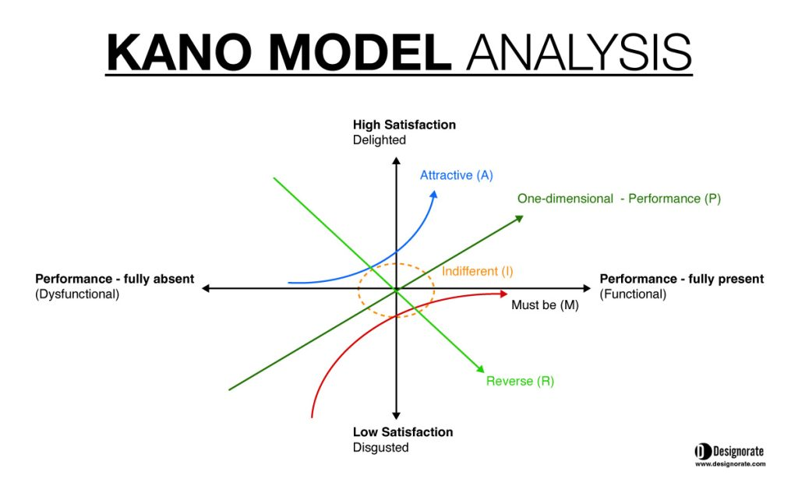Figure1. Desginorate (2025) Kano Model
When applied to a dental care environment several adjustments need to be made to address the specific needs of dental patients. The basic needs category would need to be changed to cover the essential aspects of dental care, such as cross infection, appointments, clear communication about treatment and costs. These are basic elements that if not met would lead to dissatisfaction. The performance needs would focus on improving patient satisfaction and transform the practice. Finally, the excitement category of the Kano model can be tailored to a dental practice by advancing services that go beyond the patient expectations such as teeth whitening composite bonding the so called “Turkey Teeth” look which briefly mentioned above. By using the Kano model, it allows the practice to continuously grow patient satisfaction and loyalty while meeting both functional and emotional patient needs.

Engaging in Patients Experience
- Strategies for Engagement: There are many ways you can engage a patient effectively communication is the main component when engaging a patient. Ho et al (2024) discusses many ways to engage the patient explaining how listening attentively to patients, using clear and simple language, asking open ended questions, using visual aids regarding the specific treatments , providing reassurance and empathy, allocating sufficient time patient for each appointment, taking a patient-centred approach by putting their needs before the business, showing positive body language, following up with patients post treatments, encouraging feedback, using information technology, and receiving continuing education and training. Furthermore, research by Duisebayev et al (2024) suggests that using good strategies to get people involved in dental services helps lower the costs of treating complicated dental problems, which is a way to get the most out of healthcare spending. This process therefore allows the business profits to increase as costs are lower in turn patients’ oral health is stabilised as they are engaged with active treatment. Overall engagement strategies not only help the business but the patients too.

- Tools and Techniques: The main tool which flows into other areas of the business starts with the foundation of CRM by managing patient relationships by personalising communication, collecting feedback, giving a patient centred approach and managing appointments. Information technology is another tool that can be useful to both customer and business as arranging appointments frequent reminders, follow ups allows the patient to be involved with the process of the service engaging the customer continuously by phone calls, emails, text reminders. Even though information technology can be a useful too, some patients depending on their preferences may prefer different methods of engagement. Asan et al (2013) survey on patient perceptions regarding information technology showed frustration and distraction leading up to their appointments. Producing negative experience before it has even begun why would that patient turn up for that first appointment, leading to unsatisfied customer, where loyalty will not even exist. Patient feedback is important tool to have as collecting and analysing the patient feedback allows continuous improvement. Techniques to undergo patient feedback can be regular surveys, feedback forms and follow up calls from the dental team. This allowing the business to grow and improve for patient satisfaction to be achieved along with loyal returning patients.
Continuous education and training for the dental team can improve their skills and the quality of care provided, leading to increasing engagement with the patient as present days technology advancements help engage the patient as many forms of different technology processes. Wood (2024) states that “the journey of patient education and engagement in dentistry has been marked by continuous evolution, shaped by technological advancements, changing societal norms, and a deeper understanding of patient psychology”.

Evidence of Critical Understanding of Quality Processes in the dental practice
- Quality Processes in the Workplace: In the dental practice there are wide range of processes to ensure patient safety and provide the best standard of care delivered. There are many governing bodies to which the practices have to adhere too such as the Care Quality Commission, The General Dental Council, Welsh Health Technical Memorandum each individual governing body seeks to protect both patients and business. GDC (2025) states “How their primary purpose is to protect patient safety and maintain public confidence in the dental profession”. Whereas if patients seek treatment outside the UK, they do not have the same standards and regulations as the UK do. If negligence occurred how would the patient report this where there are no regulating bodies or quality process to follow. It is highly important that all quality process is followed through as legal action can also occur, having a massive impact on the business revenue and customer retention. See below a table of quality process involved in a dental practice which governing bodies they belong to and the impact it has on a patient experience.
Quality process in a dental practice
Process | Description | Governing Body | Impact on Patient Experience
Patient Safety Standards | Ensuring all procedures are conducted with the highest safety measures to protect patients. | Care Quality Commission (CQC) | Builds trust and confidence, showing commitment to patient welfare.
Regulatory Compliance | Adherence to national standards and guidelines for quality assurance. | General Dental Council (GDC) | Maintains public trust and ensures a consistent standard of care.
Cross Infection Control | Implementing sterilisation and hygiene practices to prevent contamination. | Welsh Health Technical Memorandum (WHTM) | Enhances patient confidence in the clinic's cleanliness and professionalism.
Feedback Collection | Using surveys, follow-up calls, and forms to gather patient insights. | Internal Practice Protocols | Allows continuous improvement and addresses patient concerns for better experiences.
Quality Assurance Audits | Regularly reviewing processes to ensure compliance with regulatory standards. | CQC and GDC | Helps identify areas for improvement while assuring patients of high standards.
Technology Integration | Using IT for appointment scheduling, reminders, and engagement communication. | Practice Management Systems | Streamlines patient interactions and enhances convenience.

Analysis of Patients Experience in the Dental Practice
- Customer Feedback: Customer feedback is another component, that a business can increase patient satisfaction, loyalty and overall success. Many techniques are used to form feedback in a dental practice this can be patient feedback forms digital, written or verbal. Follow up calls from the dental team can contribute to improved success of treatments and experience delivered by the practice. Barrow et al (2025) implies that the importance of feedback helps ensure that the practice fosters professional growth while assessing care quality. By actively producing feedback in a business, you can create a positive working environment supporting not only the patients but staff members too. Policies are in place for patients to complain regarding the service, dentistry seems to be focused more on the negative feedback as policies of complaints procedure is a legal requirement stated by the GDC (2025) whereas positive feedback is not.

- Customer Journey Mapping: Customer journey mapping is useful tool that helps dental practice to understand the different stages that customer goes through, from the first stage which is awareness to post treatment follow ups. McKinsey model decision journey is useful framework to apply to any business organisation, the model describes how customers make or use the particular service involving elements that consist of different touchpoints, customer actions emotional responses allowing the dentistry business to act open opportunities that are presented through the model.
Please see below Figure 2 a patient journey mapping using elements of walker model tool and McKinsey model as a guideline.

Figure 2 Dental practice NHS/Private customer journey mapping
Stage | Touchpoints | Customer Actions | Emotional Responses | Opportunities for Improvement
Awareness | Advertisements, referrals, social media content | Searching for dental services within their area. | Curiosity, uncertainty  Indecisive  Unknown | Enhance online presence and clarity of information regarding the dental practice friendly environment
Consideration | Website, reviews, initial inquiry. Opinions from friends, colleagues’ family members | Comparing options, treatments prices range of dental professionals contacting different practices. | Interest, hesitation  Doubt | Provide transparent pricing and detailed service descriptions.  Reception friendly voice needed.
Appointment Booking | Phone call, online booking system | Booking a appointment | Convenience, satisfaction | Simplify online booking process. Take booking over the phone  Recall scheduled 6 months for returning patients.
Arrival | Reception, waiting area | Checking in | Comfort, anxiety | Improve waiting area ambiance and reduce waiting time
Treatment | Interaction with dental practitioners, dentist, dental nurse, hygienist, dental therapist receptionist | Undergoing dental procedures | Trust, fear, | Ensure clear communication and empathetic care
Follow-up | Post-treatment call, email, text message | Providing feedback, addressing concerns | Gratitude, excitement frustration (if unresolved) | Timely and personalised follow-ups
Retention | Newsletters, loyalty programs | Returning for future services | Loyalty, satisfaction | Offer incentives for repeat visits  Discount, freebies toothpaste toothbrushes monitoring charts.

- Strengths and Weaknesses:

Looking at the customer journey mapping there is an equal amount of strength and weakness to consider. Taking a look at strengths identified shows a clear view of a patient’s experience. It shows the effectiveness of key touchpoints where customers interact with the dental practice, allowing for specific improvements not wasting other potential resources. The map shows emotional responses at each stage showing the patients feelings and experiences leading onto opportunities based of this for improvement to increase the customer experience.

The weaknesses detected in the customer journey map shows how the journey touchpoints are a general feeling it may benefit from more specific scenarios that do occur in the dental practice by applying the emotional hierarchy pyramid can help categorize the patients emotional state to get a better understanding of patient’s emotions in specific areas of the dental practice experience. Please see appendix 2 for the emotional pyramid hierarchy applied to dental practice. Follow up and retention strategies can be more reliable with additional details on how to maintain the customer relationship. The journey map could include more visual elements such as diagrams or flowcharts to make it more engaging and easier to understand, as everyone learning needs are different so in cooperating this will lead to full understanding of the team.

Critical Evaluation of Developing and Maintaining Good Patient Relationships

- Benefits: There are numerous benefits when maintain good relationships and developing new ones. Firstly, patients will receive continuity of their dental professional which groups under the loyal and satisfied customer as they keep returning, allowing increased patient retention and growth of the practice. The satisfied customers are more likely to continue the service as they have a built a trusting relationship with their particular dental professional, therefore the patient can share their experiences with family and friends which produces the positive word of mouth. The higher the level of satisfaction is between patient and the practice they are more likely to follow treatment plans and engage in preventive care, leading to better healthcare results along with NHS targets being hit. While high levels of trust and confidence are being produced patients my want other extensive treatments such as teeth whitening, implants, composite bonding, crowns this will lead to an increased private profit sector. By collecting and analysing feedback from patient’s continuous improvement in the services provided by the practice will be at a high level. It can help address any concerns or issues therefore allowing different situations not to escalate or start in the first place. It helps the business practice professional growth and assessing care quality.

- Challenges: One of the biggest problems is living up to the high standards that patients have. The high standards regarding the quality of care and services provided and consistently trying to meet those expectations can be difficult. It can make the dental professional feel like you’re emotionally disappointing them for that reason it may affect the dental professionals’ confidence when carrying out extensive treatment. No patient is the same as everyone has different needs and preferences. A patient could have consulted with different dentists which may have different treatment plans and therefore complicates there existing expectations. Ozar (2017) clarifies this by expressing that the most essential ethical issue for dental professionals is still how to put patients' health first and create connections with them that are based on making ethical decisions, all while striving to run a successful business. Other challenges could be language barriers so effective communication could be insignificant leading to misunderstandings conflicts between patient and dental professional. Limited resources including time, staff, and budget can impact the ability to provide personalised care and attention to each patient, leading to dissatisfaction and weakened relationship complaints could occur from this. Following on from complaints increasing negative feedback can appear that can be challenging in itself. Technology can increase patient’s interactions with the business although it can create frustration and distraction if not implemented effectively. Patient segmentation should be applied when technology is needed. See appendix 1 for segmentation process.

Conclusion
To conclude the report understanding and engaging in the customer experience is at the highest importance for a dental practice to grow and succeed. This report has explored the complexity of customer experiences within a mixed practice which involves both NHS and private patients We have learnt a lot about how dental practices may enhance their offerings to meet and beyond patient expectations by examining many aspects of customer value, patient experience, and engagement tactics. One of the core components discussed is the importance of effective communication. How clear and empathetic communication guarantees the patient to be heard and understood which is key for building trust and confidence. Personalised care helps patients to feel valued as their specific needs have been met allowing a sense of satisfaction which can lead to loyalty.
The implementation of CRM systems and the use of information technology for appointment booking, reminders, and follow ups have been highlighted as a necessary strategy for improving patient interactions and convenience. Constant training and education for the dental team is also important for maintain high standards of care and ensuring that the team stays updated with the latest advancements and techniques. Customer feedback showed its importances as it was a tool for improvement and prevention identifying patients concerns urgently creating a positive and supportive environment.
The report also indulged into the concept of customer journey mapping which helped the dental practices understand what a patient goes through from initial treatment to post treatment follow up. This tool is useful for identifying touchpoints, customer actions, emotional responses, and opportunities for improvement. The frameworks of the McKinsey 7s and the Kano model were explored as ways to analyse and strengthen the practice effectiveness in order to focus on the demands and preferences of patients. These models help dental practices understand how different organisational elements get together to achieve their goals and identify the elements that will have the biggest impact on patient satisfaction.
Developing and maintaining good customer relationships offered a range of benefits which includes the following customer loyalty, positive word of mouth, higher levels of satisfaction, improves patient outcomes, increased trust and confidence, finally continuous improvement. Although, maintaining these relationships can be extremely challenging due to factors of high expectations, communication barriers, resource constraints, managing feedback, technological integration and ensuring consistent service delivery.
Overall, the report addressed these challenges by showing the effectiveness of engagement strategies. How quality process protect not only the patients but the business too. By applying CRM your guaranteed to see results in the healthcare environment, along with patient satisfaction and loyalty will ultimately contribute to the sustainability and growth of a dental practice.

Appendix 1
Patient segmentation is useful tool to use and apply to different challenges that a business occurs and to improve customer engagement. Segmentation uses grouping the patients such as age, sex, specific needs, to work for the business advantage. See below an example of what segmentation would be like in a dental care setting. See below the segmentation shows different grouping appointment frequency is useful group as you can figure out what patient to invest in rather than time wasters who do not attend their appointments.

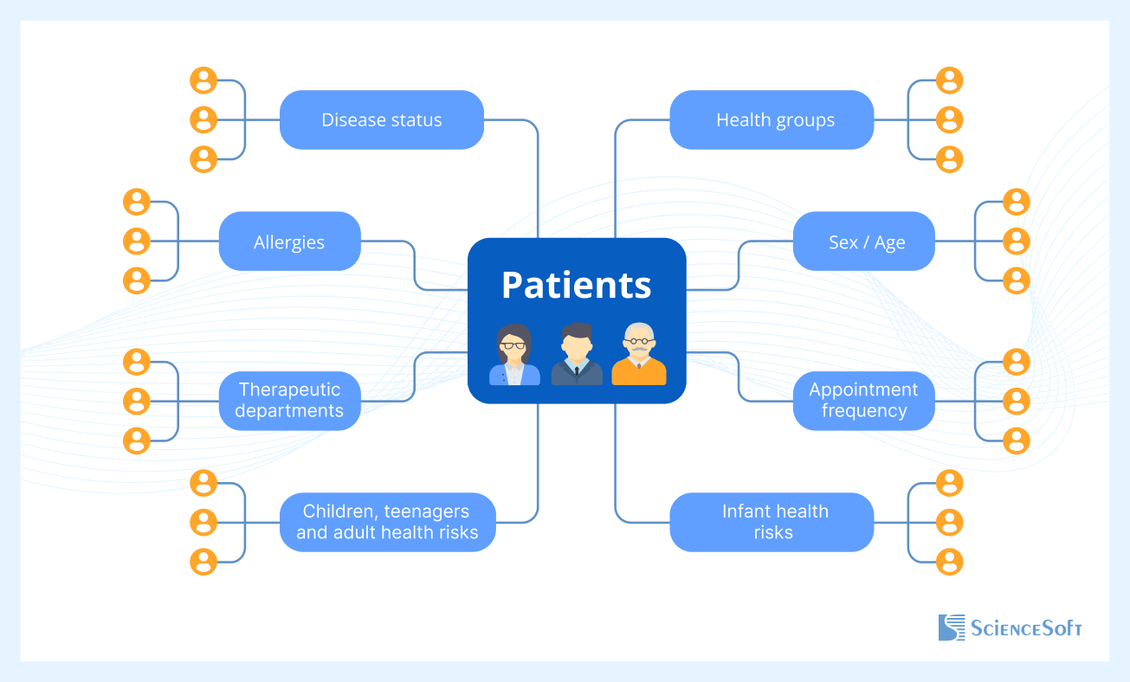

https://www.scnsoft.com/healthcare/patient-segmentation

Appendix 2
This appendix goes into more detail about how the emotional pyramid hierarchy can be used in dentistry clinics. 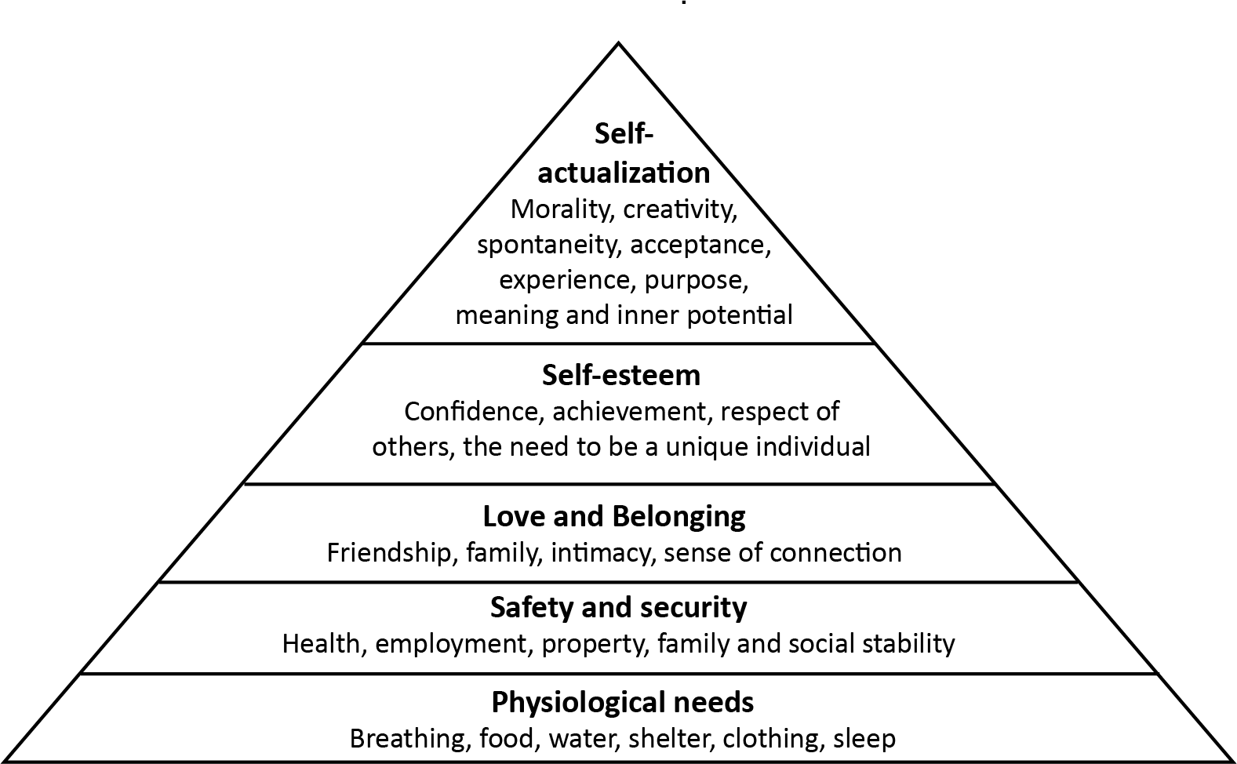
This Photo by Unknown Author is licensed under CC BY
Online images Microsoft 365 – Creative Commons
This pyramid would change into basic needs, performance needs, and excitement needs when applied to the dental practice. Firstly, the basic needs would indicate the core components such as feeling safe comfortable and understood. This can include clear communication between dental professional and patient discussing costs also what treatment entails, and ensuring cross infection is at high standard with clean environment. From this performance needs while take form on the pyramid seeking satisfaction with the quality of care and services provided. Personalised treatment plans being empathetic to their patients’ certain needs. Finally at the top of the pyramid higher level of emotions are developed excitement needs are met with expectations and advance services cosmetic treatment and loyalty programmes evolve. This model has many similarities to the kano model.

References
- Al Ghanem, E. J., AlGhanem, N. A., AlFaraj, Z. S., et al. (2023). Patient satisfaction with dental services. Cureus, 15(11), e49223. assets.cureus.com
- Andriana, A. D., & Mardiani, G. T. (2025). Customer segmentation analysis in CRM framework using RFM methods. *AIP Conference Proceedings*. pubs.aip.org
- Asan, O., Ye, Z., & Acharya, A. (2013). Dental care providers' and patients' perceptions of the effect of health information technology in the dental care setting. The Journal of the American Dental Association, 144(8), 958–965. Googlescholar.com
- Barrow, E., Mylonas, P., Pattinson, R., & Sadaghiani, L. (2025). Positive reinforcement: Balancing negative and positive feedback for comprehensive improvement. Journal of Dentistry. Elsevier.
- BDNJ (2024). A patient experience to be proud of – Dental design. https://bdnj.co.uk/2024/10/11/a-patient-experience-to-be-proud-of/
- Bamboo Dental (2025). Smile gallery. https://bamboodental.co.uk/smile-gallery/
- Buttle, F., & Maklan, S. (2019). Customer Relationship Management: Concepts and Technologies (4th ed.). Routledge. https://doi.org/10.4324/978135101
- Desginorate (2025). Template of the Kano model. https://www.designorate.com/what-is-kano-model-analysis-and-how-to-conduct-it/
- Doughty, J., Moore, D., & Ellis, M. (2025). Contemporary dental tourism: A review of reporting in the UK news media. *British Dental Journal, 238*(230-237). https://doi.org/10.1038/s41415-025-8330-2
- Dyche, J. (2002). The CRM handbook: A business guide to customer relationship management. Google Books. Googlescholar.com
- El Dalatony, M. M., Alshareef, R. I., Lakhani, A. R., et al. (2023). Patient satisfaction as a determinant of patient loyalty to the dentist in dental clinics. Journal of Patient Experience, 10. doi:10.1177/23743735231166506
- Eriksen, L. R. (1995). Patient satisfaction with nursing care: Concept clarification. Journal of Nursing Measurement, 3(1), 59–76. Googlescholar.com
- GDC (2025). About us – what we do. https://www.gdc-uk.org/about-us/what-we-do
- GDC (2025). Feedback and concerns. https://www.gdc-uk.org/standards-guidance/supporting-the-dental-team/dealing-with-feedback-and-concerns
- GDC (2025). Going abroad for dental treatment – Information, standards and guidance. https://www.gdc-uk.org/standards-guidance/information-for-patients-public/going-abroad-for-dental-treatment
- Hendry, C., Maayta, N., Nafea, L., Aranda, V., Oyoyo, U., & Kwon, S. R. (2025). Scrub Colour Affects Perceived Professionalism of Dental Hygienists: A Cross-sectional Study. *The Journal of Contemporary Dental Practice, 26*(3), 223-228.
- Ho, J. C. Y., Chai, H. H., Lo, E. C. M., Huang, M. Z., & Chu, C. H. (2024). Strategies for effective dentist-patient communication: A literature review. Patient Preference and Adherence, 18, 1385–1394. https://doi.org/10.2147/PPA.S465221
- Materla, T., Cudney, E. A., & Hopen, D. (2019). Evaluating factors affecting patient satisfaction using the Kano model. International Journal of Health Care Quality Assurance. emerald.com
- Ozar, D. (2017). Professionalism: Challenges for Dentistry in the Future. *The Journal of Forensic Odonto-Stomatology, 30*(1), 72–84. https://ojs.iofos.eu/index.php/Journal/article/view/118
- Preshaw, P. (2025). We need more dental professionals. *British Dental Journal, 238*(149). Googlescholar.com
- Wood, N. H. (2024). Empowering oral health: Navigating the future of patient education and engagement in dentistry. South African Dental Journal.scielo.org.za
- Young, M. R. (2016). Managing a dental practice the Genghis Khan way. Google Books. Googlescholar.com

Bibliography
- GDC (2025). Feedback and concerns. https://www.gdc-uk.org/standards-guidance/supporting-the-dental-team/dealing-with-feedback-and-concerns
- GDC (2025). Going abroad for dental treatment – Information, standards and guidance. https://www.gdc-uk.org/standards-guidance/information-for-patients-public/going-abroad-for-dental-treatment
- Hendry, C., Maayta, N., Nafea, L., Aranda, V., Oyoyo, U., & Kwon, S. R. (2025). Scrub Colour Affects Perceived Professionalism of Dental Hygienists: A Cross-sectional Study. The Journal of Contemporary Dental Practice, 26(3), 223-228.
- Ho, J. C. Y., Chai, H. H., Lo, E. C. M., Huang, M. Z., & Chu, C. H. (2024). Strategies for effective dentist-patient communication: A literature review. Patient Preference and Adherence, 18, 1385–1394. https://doi.org/10.2147/PPA.S465221
- Materla, T., Cudney, E. A., & Hopen, D. (2019). Evaluating factors affecting patient satisfaction using the Kano model. International Journal of Health Care Quality Assurance. emerald.com
- Ozar, D. (2017). Professionalism: Challenges for Dentistry in the Future. The Journal of Forensic Odonto-Stomatology, 30(1), 72–84. https://ojs.iofos.eu/index.php/Journal/article/view/118
- Preshaw, P. (2025). We need more dental professionals. British Dental Journal, 238(149). Googlescholar.com
- Wood, N. H. (2024). Empowering oral health: Navigating the future of patient education and engagement in dentistry. South African Dental Journal. scielo.org.za
- Young, M. R. (2016). Managing a dental practice the Genghis Khan way. Google Books. Googlescholar.com

