:ECEY4001/C Human Development – Maslow’s Hierarchy of Needs Portfolio
I confirm that I have not used any Al tools in the research and creation of this assignment. I confirm that I have not presented any Al generated materials as my own work. I confirm I have copies of my drafts, notes, and other resources I used, which 1 may be asked to provide in evidence.
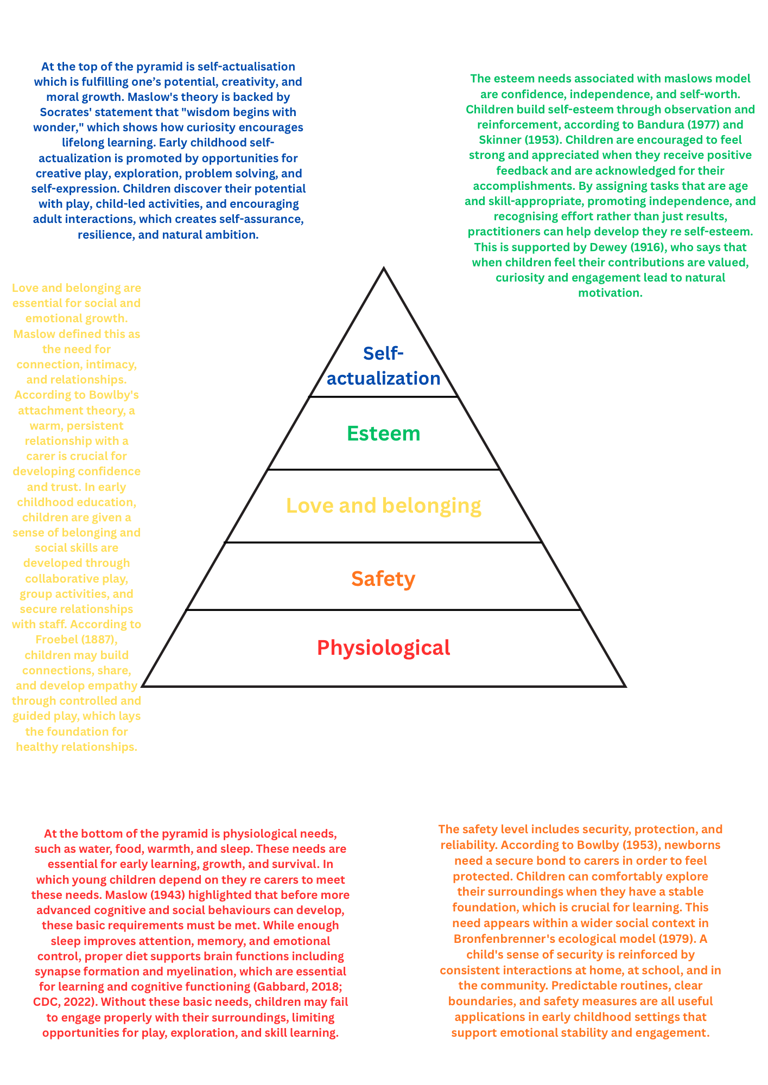

Explanation

Maslow's Hierarchy of Needs (1943) provides a structure to help with the understanding of child development and human motivation. The model is structured as a pyramid of five needs, ranging from the most basic needs for survival to the fulfilment of one's full potential. This hierarchy shows how unfulfilled basic needs may hinder development and shows the connection of physical, emotional, cognitive, and social requirements in early years education.
Maslow’s hierarchy can be viewed and used as both as a framework for motivation and as a reflection of the brain’s biological development Early childhood environments that are both nurturing and stimulating, such as ones that provide opportunities for exploration, secure attachment, and responsive caregiving, strengthen neural connections, and assist healthy brain development (Center on the Developing Child, 2004; Nelson & Gabard-Dalgliesh, 2010). It has been proven that environmental stimulation, such as exposure to a variety of sensory, social, and cognitive activities, increases synaptogenesis which is essential for learning and cognitive development (van Praag, Kempermann, & Gage, 2000). On the other hand, neglect or inconsistent affection could interfere with these processes, reducing synaptic formation and resulting in weaknesses in social functioning, emotional control, and thinking abilities (McLaughlin et al., 2014). Evidence also suggests that the quality of early attachment is linked to the development of areas of the brain involved in social cognition and self regulation, highlighting the long term impact of relationships on neurodevelopment (Gee et al. 2013). As a result, Maslow's hierarchy is more than just a motivation model; it reflects developmental results, showing that fulfilling basic physiological and safety requirements sets the foundation for advanced cognitive, social, and emotional development.
Finally, Maslow's Hierarchy of Needs gives a framework for early years educators to analyse and support children's motivation and development. Meeting children’s physiological and safety needs provides the foundation for them to climb up Maslows hierarchy of needs and make reaching love and belonging and esteem possible. By understanding Maslow’s hierarchy, practitioners can create environments and interactions that support holistic development, allowing children the ability to thrive across multiple areas.

References
Bandura, A. (1977). Social learning theory. Englewood Cliffs, NJ: Prentice Hall.
Bowlby, J. (1953). Child care and the growth of love. London: Penguin.
Bowlby, J. (1969). Attachment and loss: Vol. 1. Attachment. New York: Basic Books.
Bronfenbrenner, U. (1979). The ecology of human development: Experiments by nature and design. Cambridge, MA: Harvard University Press.
CDC (2022) Child development basics. Available at: https://www.cdc.gov/ncbddd/childdevelopment/facts.html (Accessed: 28 November 2025).
Dewey, J. (1916). Democracy and education. New York: Macmillan.
Froebel, F. (1887). The education of man. New York: D. Appleton and Company.
Gabbard, C. (2018). Lifespan motor development (7th ed.). Human Kinetics.
Maslow, A. H. (1943). A theory of human motivation. Psychological Review, 50(4), 370–396.
Skinner, B. F. (1953). Science and human behavior. New York: Macmillan.
Center on the Developing Child (2004) Early childhood program effectiveness: What a difference a window of opportunity makes. Harvard University. Available at: https://developingchild.harvard.edu (Accessed: 28 November 2025).
Gee, D.G. et al. (2013) ‘Early developmental emergence of human amygdala-prefrontal connectivity after maternal deprivation’, Proceedings of the National Academy of Sciences, 110(39), pp. 15638–15643. doi: 10.1073/pnas.1307893110.
McLaughlin, K. A., Sheridan, M. A., & Nelson, C. A. (2014). Neglect as a violation of species-expectant experience: Neurodevelopmental consequences. Biological Psychiatry, 75(5), 378–385.
Nelson, C. A., & Gabard-Dalgliesh, S. (2010). Early experience and brain development. Pediatric Clinics of North America, 57(3), 591–602.
van Praag, H., Kempermann, G., & Gage, F. H. (2000). Neural consequences of environmental enrichment. Nature Reviews Neuroscience, 1(3), 191–198.
Dunn, J. (2004) Children’s friendships: The beginnings of intimacy. Oxford: Blackwell Publishing.

Holistic Child Development with Links to Maslow’s Hierarchy of Needs

Holistic child development is based on early brain development, which begins before birth and continues to develop throughout the first few years of a child’s life. To provide food, warmth, and bodily regulation, newborns are born with basic survival instincts including rooting, sucking, and grasping. These reflexes correspond to Maslow's physiological needs (Maslow, 1943). Secure and stable connections promote Maslow's second level: safety needs, which allow the brain to focus on learning rather than survival, since children depend on carers for protection and emotional availability. As newborns use their senses to explore and make associations, early developmental processes such synaptogenesis, blooming, and pruning change brain pathways (Coulter, 1995). While plasticity enables the brain to rapidly adapt to new things, especially during the early years, myelination improves the efficiency of these connections.

An important part of this process is the environment. According to research, children from low income or working class households were more likely to have smaller vocabularies than children from college educated parents between the ages of 0 and 36 months. This is due to more privileged childhood experiences and exposure to language development (Hart & Risley, 1995). On the other hand, neglect or long term stress may damage brain growth, resulting in smaller, less active structures that limit advancement through Maslow's higher levels such as love/belonging, esteem, and self actualisation.

Children's development of motor and cognitive skills are strengthened by the way they engage with their environment and sensory experiences. Skinner (1953) found that reinforcement enhance learning, which can be seen in practice through praise and encouragement that improves children's self esteem, which aligns with Maslow's fourth stage of development. According to Bandura's (1977) theory of observational learning, children pick up skills by observing others. Good relationships and role modelling promote Maslow's desires for love and belonging. According to Dewey (1916), children learn most through hands on exploration, which leads to self actualisation which is the greatest level in Maslow's hierarchy of needs. According to Basho, "to learn about a tree, go to a tree" (cited in Kriesberg, 1999) reinforces the importance of hands on learning for holistic development. Together, these theories support Maslow's model by showing how children are more likely to interact, explore, and gain higher level learning skills when their basic needs are satisfied.

Transitions are an important part of early life and have an important impact on children's overall development, which includes their sense of identity, emotional health, social confidence, and cognitive abilities. According to Birth to 5 Matters (2021), transitions include both horizontal movements within a setting, like changing rooms or important staff members changing, as well as major vertical shifts, like going from nursery to school. The concept of childhood itself is acknowledged as a social construct, which means that cultural and historical contexts have different expectations for it (James & James, 2012). Transitions can be sudden and emotionally stressful, disrupting children's security and attachment, as proven by historical examples like the evacuation of children during World War II. Children's emotions, behaviours, and learning are also affected by current transitions, such as starting school, moving, or going through parental separation.

According to Vogler, Crivello, and Woodhead (2008), children's feeling of stability is affected by horizontal, vertical, and various other changes. These experiences are related to Maslow's Hierarchy of needs (1943), which says that before children can develop higher level learning, reach self actualisation, and self esteem, their basic physiological and safety requirements must be satisfied. Children may suffer from anxiety, uncertainty, or a loss of routine when transitions are poorly managed. This may damage their sense of security and belonging and decrease their motivation and learning ability. On the other hand, resilience, and confidence are two vital factors of holistic development and can be strengthened when transitions are properly supported by stable relationships, reliable routines, and emotional assurance.

The UNCRC supports this by emphasising children's independence and capacity to voice their points of view during times of transition (DfE, 2010). Children are recognised as capable participants in decisions that impact their life under Article 12. Children's emotional stability, independence, and self esteem are supported by having conversations with them, listening to their concerns, and preparing them for new experiences. This rights based approach improves children's overall welfare and holistic development by ensuring that changes become chances for growth rather than causes of distress.

Inclusion, partnerships, and an educational environment are essential for supporting holistic child development, which supports growth in the emotional, social, cognitive, and physical areas. Every child is different, capable, and knowledgeable, and inclusive education acknowledges this. According to Booth, Ainscow, and Kingston (2006), inclusion is the ongoing process of increasing participation and reducing barriers to ensure all children are given the opportunity to be able to thrive. This can be linked to the concept of equity, which recognises that children may require different levels of support to achieve identical outcomes, and equality, which ensures that all children are treated equally. According to Nutbrown (1996), truly inclusive practice requires recognising children's diverse identities, backgrounds, and learning paths to help them build a sense of self confidence, and self esteem.

These ideas support holistic development and correlate with Maslow's Hierarchy of Needs (1943), which argues that before children can engage in more advanced learning and self fulfilment, they must first work they re way up his hierarchy of needs. An inclusive environment involving predictable routines, trusting connections, and engaged people helps children achieve their physiological and emotional needs, allowing them to take part fully in learning. This is reinforced by the Welsh Government (2022), which says that children under seven need care and education that centres around reliable, positive relationships. Similarly, the Welsh Government (2008) states that "the significant adults in a child's life are called upon to accept responsibility to enable children to achieve the best outcomes," emphasising the key role that adults play in creating emotionally safe and nurturing environments.

This is further reinforced by solid relationships with families. Programs like Flying Start, Families First, and Crèche acknowledge that children's growth is influenced by the wider community in which they live in (Donaldson, 2015). In addition to keeping consistency between home and early years settings, collaborative connections between practitioners and parents further increase emotional security. When parents and professionals work together, children experience a sense of consistency and belonging, which are important components of holistic development and fundamental to Maslow's hierarchy.

References
Booth, T., Ainscow, M. and Kingston, D. (2006) Index for Inclusion: Developing Learning and Participation in Schools. Bristol: CSIE.
Donaldson, G. (2015) Successful Futures: Independent Review of Curriculum and Assessment Arrangements in Wales. Cardiff: Welsh Government.
Maslow, A.H. (1943) ‘A theory of human motivation’, Psychological Review, 50(4), pp. 370–396.
Nutbrown, C. (1996) Respectful Educators – Capable Learners. London: Paul Chapman Publishing.
Welsh Government (2008) Foundations for Success: Guidance on the Education of Children from 0–7 Years. Cardiff: Welsh Government.
Welsh Government (2022) Curriculum for Wales: Framework Guidance. Cardiff: Welsh Government.
Bandura, A. (1977) Social Learning Theory. Englewood Cliffs: Prentice Hall.
Coulter, R. (1995) Music and the Mind in Early Childhood. London: Early Education Press.
Dewey, J. (1916) Democracy and Education. New York: Macmillan.
Hart, B. & Risley, T. (1995) Meaningful Differences in the Everyday Experience of Young Children. Baltimore: Brookes.
Kriesberg, A. (1999) Experiencing the World in Early Childhood. Boston: Early Years Press.
Skinner, B.F. (1953) Science and Human Behavior. New York: Macmillan.
Birth to 5 Matters (2021) Birth to 5 Matters: Non-statutory guidance for the Early Years Foundation Stage. London: Early Education.
Department for Education (2010) United Nations Convention on the Rights of the Child: How legislation underpins implementation in England. London: DfE.
James, A. and James, A. (2012) Key Concepts in Childhood Studies. 2nd edn. London: Sage.
Vogler, P., Crivello, G. and Woodhead, M. (2008) Early Childhood Transitions Research: A Review of Concepts, Theory and Practice. The Open University/UNICEF.

Section 3 – Early Years Practice Examples

This section includes three real examples from my early years experience that show how Maslow's Hierarchy of Needs helps practice. I look at Gibbs' Reflective Cycle (1988) to think about what went wrong, how I felt, and what I could do better the next time.

Example 1: Supporting a Child Struggling With Drop Off (Safety & Belonging Needs)
One child in a nursery setting i worked in experienced regular distress at drop off, crying, clinging to their parent, and refusing to enter the room. This corresponds with the Welsh Government (2014) guidance, which highlights the need for emotionally secure transitions between home and childcare. This can also be linked to Maslow's needs for safety and belonging, which must be satisfied before social interaction, or learning can take place (Maslow, 1943). At the time of transition, the child lacked emotional stability. So, what I did to try overcome this Is I calmly greeted the child, reassured him, and used a transitional toy brought from home by the mother. To support the growth of a trustworthy relationship, I also kept physically close to the child until they felt safe. Bowlby (1953), drawing on attachment theory, states that children require responsive, ongoing attention to feel secure enough to leave a carer. To then Reflect on this experience I Used Gibbs' concept, I realised that at first, I was not sure how much comfort to offer without making the situation worse. Furthermore, I had time limits and pressure from parents. But I concluded that the child needed more predictable routines, not quicker separations. According to Bronfenbrenner (1979), the child's transfer from home to nursery required stronger overall collaboration. What I would do differently, I would set up a regular drop off routine with the parent, such as hug, then handover, then activity. To increase predictability, I would also put in a visual schedule that shows the parent will return later. In addition, I would use regular settling in sessions to help the child feel secure with me before beginning full time. Action points I have for future practice would be to reinforce transition plans with all families before starting. Make sure the same staff member greets the child each day to build secure attachment and build routine. Using Dweck’s (2006) growth mindset principles, I could use more specific praise phrases such as ‘You did really well coming in today,’ which focuses on effort and helps children build confidence during challenging moments. Provide transition visual display for the child whilst adding comforting photos and items.

Example 2: Supporting a Breastfed Infant Struggling to Feed in Nursery (Physiological Needs)
While I was watching a five month old child for a family member that has been strictly breast fed, the baby became very fussy. Bowlby (1953) says that feeding of a newborn is connected to attachment, so disruptions to a child’s usual feeding routine can understandably cause distress. The infant was normally calm with its parents, but soon after they left, they became upset, crying uncontrollably and refusing their bottle. The baby was due to be fed, but they only drank tiny sips before getting restless once more. They were clearly uncomfortable, whining, arching their back, and finding it difficult to relax in my arms. I tried rocking, singing softly, and providing comfort, but the baby did not stop being distressed until its parent came back. Maslow's physiological needs are highlighted in this situation since an infant cannot feel emotionally calm or prepared for any kind of interaction or enjoyment until their needs for food, comfort, and physical security are satisfied. To try overcome this I attempted to replicate the comfort of breastfeeding for the baby, I used controlled feeding, kept the baby close to my chest, and gave them more time to regulate. To understand the babies at home habits, including feeding cues and timings, I kept in regular contact with the parents. The Welsh Government (2014) emphasises the importance of acknowledging the child’s cues sensitively, especially around feeding. To prevent overstimulation, I also kept the surroundings peaceful and quiet. In reflection of this experience I used Gibbs' reflective module, I came to the realisation that I felt both responsible and worried because the baby's wellbeing depends on providing their basic needs. Additionally, I realised that the infant was already overwhelmed when I tried bottle feeding, which lowered the chances of success. According to research, emotional regulation is necessary for newborns to feed well (Schore, 2012). This suggests the baby's comfort and safety requirements were equally as crucial as the bottle itself. What I would do differently if I were faced with this scenario again would be that. I would ask for full feeding information before taking care of a child still being milk fed, including how often bottles have been offered at home. To increase emotional security, I would also give the child a blanket or muslin that smells like the parent each time I feed them. Because Gerhardt (2004) notes that newborns rely greatly on caregiver touch, scent and tone to feel safe enough to feed. Feeding should only take place when the infant shows early signs of hunger, not when they are upset.

Example 3: Supporting a Withdrawn Child’s Belonging, Esteem, and Self-Actualisation Needs
A four year old child played alone most of the time, avoided social situations, and hardly spoke during the day. Higher level needs like confidence, creativity, and independent learning were blocked by this behaviour, which showed unfulfilled needs for esteem and belonging. Gerhardt (2004) says that children’s emotional development is formed by warm and caring relationships, which supports the need to strengthen the child’s sense of belonging. What I did to try overcome this was help the child feel a sense of belonging, I encouraged them to take part in simple activities they enjoyed. Dewey (1916) states that engaging children in active, meaningful activities helps them learn socially and emotionally. Additionally, I emphasised effort above results, which is consistent with Maslow's esteem level and Skinner's reinforcement theory (1953). To make the child feel motivated and at ease, I promoted involvement through interest led activities. Using Gibbs' reflective approach, I saw that I first pushed the child too quickly towards group activities, which resulted in withdrawal. According to Bandura (1977), children often pick up information by watching their classmates, therefore indirect involvement can still be beneficial. I also realised that before I could help the child develop confidence, I needed to make the relationship between me and them stronger. What I would do differently if faced with this situation again would be that, instead of expecting the child to take part in whole group sessions, I would gradually introduce small group activities the next time because Bronfenbrenner (1979) says that a child’s social interactions are influenced by the environmental around them, so small groups may feel safer for them then compared to whole class activities.Kriesberg (1999) argues that discovery based learning encourages children to explore at their own pace, which supports children who are anxious in social situations, therefore I would ask the childs carer for more information about their children's hobbies and strengths so that I could organise activities that made them feel valued and included.

References
Bandura, A. (1977) Social Learning Theory. Englewood Cliffs, NJ: Prentice-Hall.
Bowlby, J. (1953) Child Care and the Growth of Love. London: Penguin.
Bronfenbrenner, U. (1979) The Ecology of Human Development: Experiments by Nature and Design. Cambridge, MA: Harvard University Press.

Dewey, J. (1916) Democracy and Education. New York: Macmillan.
Dweck, C. (2006) Mindset: The New Psychology of Success. New York: Random House.
Gerhardt, S. (2004) Why Love Matters: How Affection Shapes a Baby’s Brain. London: Routledge.
Gibbs, G. (1988) Learning by Doing: A Guide to Teaching and Learning Methods. Oxford: Oxford Polytechnic.
Kriesberg, D. (1999) Teaching Through Inquiry: A Guide for Teachers. Portsmouth, NH: Heinemann.
Maslow, A.H. (1943) ‘A Theory of Human Motivation’, Psychological Review, 50(4), pp. 370–396.
Schore, A.N. (2012) The Science of the Art of Psychotherapy. New York: W. W. Norton & Company.
Skinner, B.F. (1953) Science and Human Behavior. New York: Macmillan.
Welsh Government (2014) Early Years and Childcare Plan. Cardiff: Welsh Government.

