Jacek Traczewski (2022703)

E-portfolio
ACCA4025 Learning in the Digital Era

1a. Essential Skills for Academic Success and a Career in Data Analysis
Data analysis is a possible career path for Applied Computing graduates. This profession requires analytical thinking, technical knowledge and good communication skills. According to the National Careers Service [1], data analysts need to work accurately, solve problems and explain information clearly. Developing these skills during university studies can help students prepare for future employment.
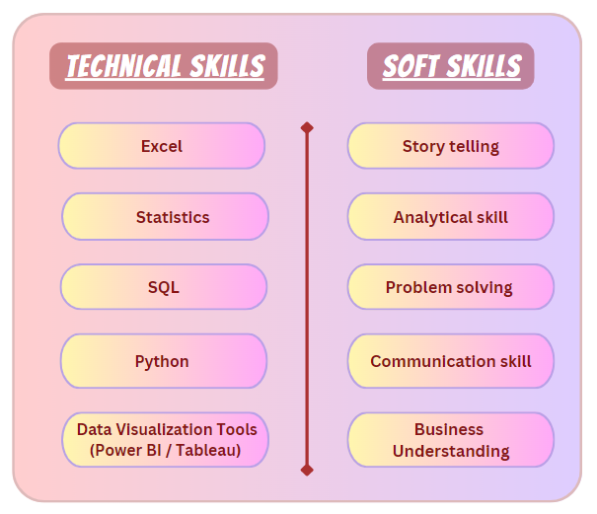
Figure 1 Technical and soft skills for data analysts. Source: [2]
Analytical thinking and attention to detail are essential when working with datasets. Analysts must identify patterns, recognise missing or incorrect information and interpret results carefully. Provost and Fawcett [3] explain how data-analytical thinking supports better decision-making. Students can develop these abilities by examining datasets, checking calculations and evaluating their findings. This can help improve accuracy and reduce mistakes in professional work.
Technical and programming skills are also valuable. Excel can be used to organise and examine data, while SQL allows users to retrieve information from databases. Python can support more complex analysis and automate repetitive tasks. Gould [4] highlights the importance of combining statistical and computational thinking when developing data-related skills. Although Applied Computing provides a foundation in computing, students interested in data analysis may benefit from learning these additional technologies through independent study and practical projects.
Problem-solving and communication skills help analysts turn data into useful information. According to the National Careers Service [1], analytical roles require problem-solving abilities and effective communication. For example, an analyst might identify changes in customer behaviour and present the findings using charts or reports. Clear communication allows colleagues to understand results and make informed decisions. University presentations and group assignments provide opportunities to practise these skills.
Overall, preparing for a career in data analysis involves more than learning software. Accuracy, critical thinking and the ability to communicate findings are equally important. Developing these skills through academic activities and independent learning can help graduates prepare for the expectations of the workplace.
1b. Evaluation and Practical Application of AI Assistants
Artificial intelligence (AI) assistants can support academic learning and professional tasks. ChatGPT is useful for analysing datasets and creating tables or charts [5]. Microsoft Copilot supports productivity, information organisation and data analysis [6], while Google Gemini's Deep Research feature can help investigate topics and summarise findings [7]. However, AI-generated information should be checked before use.
To explore a practical application, I used Microsoft Copilot to analyse fictional monthly household expenses. The dataset contained six categories: rent, groceries, electricity and gas, transport, internet and phone, and entertainment. I asked Copilot to calculate total expenditure, identify the three largest expenses and provide a percentage breakdown.
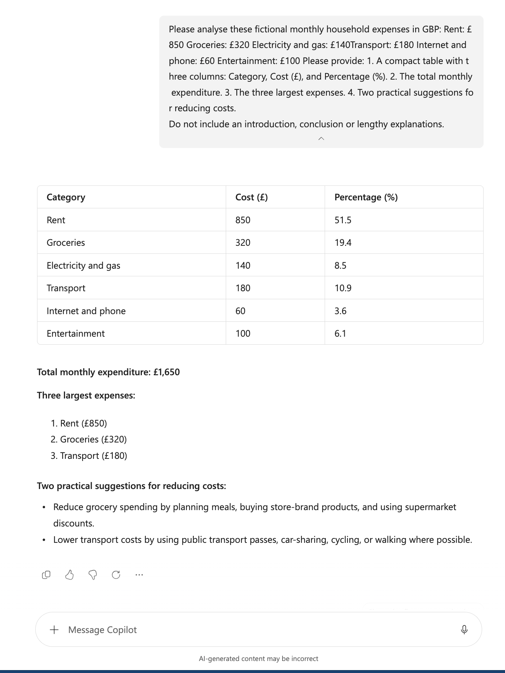
Figure 2 Microsoft Copilot analysis of fictional monthly household expenses. Source: Author's screenshot (2026).
As shown in Figure 2, Copilot calculated total monthly expenditure as £1,650. Rent accounted for 51.5% of spending, followed by groceries (19.4%) and transport (10.9%). I checked these results against the original amounts and found them accurate.
Although the calculations were correct, Copilot's suggestions for reducing expenditure were general and did not consider individual circumstances. This highlights the need to critically evaluate AI outputs [8]. The activity demonstrated how AI can assist with basic data analysis while human judgement remains important.

Reference:
[1] National Careers Service, “Data analyst-statistician,” UK Government. [Online]. Available: https://nationalcareers.service.gov.uk/job-profiles/data-analyst-statistician [Accessed: Oct. 17, 2026].
[2] H. Kumavat, “End to End Beginner’s Guide To Become Data Analyst,” Medium. [Online]. Available https://harshakumavat.medium.com/end-to-end-beginners-guide-to-become-data-analyst-8c9b1c0a060c [Accessed: Oct. 17, 2026].
[3] F. Provost and T. Fawcett, Data Science for Business: What You Need to Know About Data Mining and Data-Analytic Thinking. Sebastopol, CA, USA: O'Reilly Media, 2013.
[4] R. Gould, “Toward data-scientific thinking,” Teaching Statistics, vol. 43, no. S1, pp. S11–S22, 2021, doi: 10.1111/test.12267.
[5] OpenAI, “Data analysis with ChatGPT,” OpenAI Help Center. [Online]. Available: https://help.openai.com/en/articles/8437071. [Accessed: Oct. 19, 2026].
[6] Microsoft, “What Is a Copilot and How Does It Work?,” Microsoft Copilot. [Online]. Available: https://www.microsoft.com/en-gb/copilot/ai-knowledge/what-is-copilot. [Accessed: Oct. 19, 2026].
[7] Google, “Gemini Deep Research,” Google Gemini. [Online]. Available: https://gemini.google/gb/overview/deep-research/. [Accessed: Oct. 19, 2026].
[8] C. Autio et al., Artificial Intelligence Risk Management Framework: Generative Artificial Intelligence Profile, NIST AI 600-1. Gaithersburg, MD, USA: National Institute of Standards and Technology, 2024, doi: 10.6028/NIST.AI.600-1.

