

BA BUSINESS MANAGEMENT

Assignment 2

Module: Data Handling and Business Intelligence
Code: (LCBB5000)
Lecturer: Xavier Matieni
Name: Stefan Genchev
Student ID: 2131735

INTRODUCTION
Microsoft Excel is widely recognized as a powerful platform for conducting data analysis, giving its users the ability to turn raw data into actionable insights. Excel is a powerful program for analyzing data, and it has a friendly design that makes it accessible to users of all skill levels.
The dataset has been provided to find out if the average price (per room booked) has gone up or down from 2017-2021. To analyze the data here, I am using PIVOT TABLE. This will help us to extract the pattern. The relationship between the average price of hotel reservations and the number of years spanning from 2017 to 2021 is needed to be calculated.

PART 1
Pivot Table Analysis in Excel
The Pivot Table is a versatile and powerful analytical tool that allows users to condense large amounts of information into meaningful and practical findings (Field, 2023). This is a feature of Microsoft Excel. This feature has significant value inside the programmed. The tool in question demonstrates efficacy in the organization, summarization, and interpretation of data across diverse methodologies. The proposed software application facilitates data processing by allowing users to rearrange and condense information from a comprehensive dataset according to self-defined criteria. One of the key advantages of this technology is in its ability to efficiently convert unstructured data into a structured format. Consequently, this facilitates a heightened understanding of the fundamental inclinations, patterns, and connections. Pivot Tables may be efficiently generated in Microsoft Excel with relative ease. The first stage of the analysis process involves the user's selection of a dataset. The data gathering might be displayed either in the conventional tabular format or in a more sophisticated data model. After selecting the relevant data, users have the capability to reorganize the fields inside the Pivot Table via the action of dragging and dropping. The arrangement of data and the features under investigation are determined by the sections labelled Rows, Columns, Values, and Filters (Argyrous, 2021). Users are granted the capability to arrange data based on a diverse range of criteria by adjusting the rows and columns of the pivot table.
On the other hand, the Values tab gives you the opportunity to enter the data that needs to be evaluated, whether it be raw numbers, counts, averages, or some other aggregates. Using the Filters tab, users can home in on the most relevant information by accepting just the results that fulfil their prerequisites.
One of the most important advantages offered by Pivot Tables is their adaptability. Users get access to a data exploration tool that is extremely interactive and scalable simply by dragging and dropping fields across the screen. This adaptability makes it possible to make revisions on the fly, which helps to ensure that the analysis remains in line with the evolving requirements.
Pivot Tables are handy for doing more than just simple data summaries since they include features such as grouping, computed fields, and user-defined calculations. The data can be organized into user-defined categories, and the calculated fields can generate new variables based on the ones that are already there. Users can obtain richer and more nuanced understandings of their data thanks to the changes that have been made to the analytical power of Pivot Tables.
The use of Excel's Pivot Table feature is essential to get educated and substantiated findings. This feature provides users with the capability to do in-depth analysis of the data beyond what is shown at a superficial level, therefore uncovering patterns and trends that were previously unnoticed. The use of Excel's Pivot Table remains crucial to fully harness Excel's capabilities as a data analysis tool, regardless of the specific task at hand, whether its financial analysis, sales reporting, or any other occupation that heavily relies on data. This statement is true irrespective of the specific sort of analysis being conducted.

The Analysis
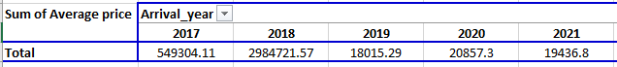
The average cost of a hotel room has fluctuated widely over the past five years, telling an interesting story about the industry's dynamics. The years between 2017 and 2021 tell a story of diverging tendencies that shed light on economic and market upheavals as well as prospective shifts in consumer behavior.

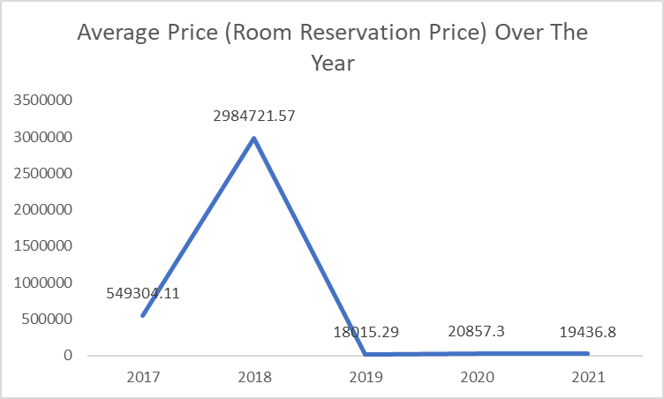

2017: The baseline is set
In 2017, the average price of a room in a hotel was $549,304.11 dollars. This first piece of information will serve as a jumping-off point for future inquiries that will be conducted. This figure may shift depending on several factors, including the state of the economy as well as the degree of interest that people have in various tourist destinations. Without additional information, it is difficult to pinpoint the reason for the existence of this average. On the other hand, it does lay the groundwork for understanding how things will unfold in the years to come.
2018: Dramatic surge
The average cost of a hotel room reservation in 2018 was $2,984,721.57, which is a considerable increase from the average cost of a hotel room reservation in 2017. A growth of this magnitude calls for additional investigation into its root causes. A multitude of factors, such as a thriving economy, a rise in the demand for lodging, or special events like large conferences or global gatherings, could be to blame for the rise in rates. 2018 may have been a year of thriving economy, which was mirrored in the hotel industry due to the strong association between a thriving economy and increasing travel spending.
2019: The great decline
Between 2018 and 2019, the average cost of reserving a hotel room dropped by a significant amount, reaching a low of $18,015.29. This precipitous fall demands a thorough investigation. A weak economy, political upheaval, and an abundance of available lodging options are all potential reasons for this phenomenon. The sudden drop may have been a market correction in response to the exceptional increase in price that occurred in 2018, since high pricing may have contributed to a reduction in demand.
2020: A slight recovery
A room at a nice hotel in 2020 will set you back an average of $20,857.3, even though booking a room will be extraordinarily difficult due to the worldwide COVID-19 epidemic. This shows that the hospitality sector is surprisingly robust. Some facilities in the hospitality sector have adapted to meet emerging needs, like those for remote work and longer guest stays, which may explain the industry's recent revival. It's also possible that several separate variables have contributed to this uptick. Despite being below its 2018 high, the average price shows that the industry is resilient and able to adapt to new circumstances.
2021: Steady maintain
It was calculated that the average cost of booking a hotel in 2021 would be $19,436,8, indicating that the increased trend witnessed in the previous year would continue. Despite this, the cost is still far lower than the all-time high that was reached in 2018. This scenario may have been impacted by a variety of variables, some of which include the continuous unpredictability brought on by the pandemic, alterations in the preferences of tourists, and higher levels of competitiveness among suppliers of housing.
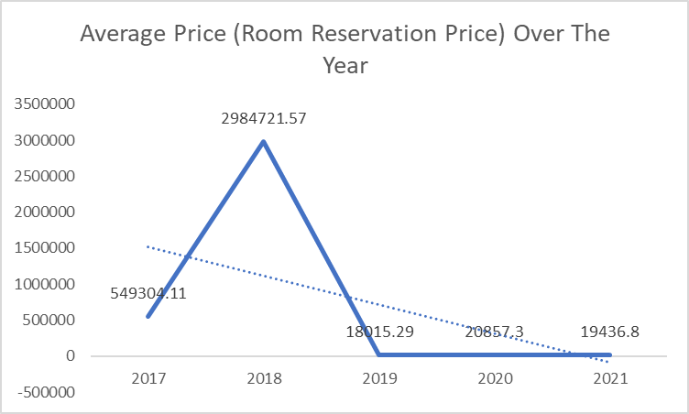
Analyzing the Trend
From this assessment of five years' worth of data, several general trends have emerged. The rise that occurred in 2018 stands out as an anomaly and may have been caused by extraordinary circumstances. The subsequent decline in 2019 is indicative of the market having corrected itself, bringing prices closer to levels that are more reasonable. Even while we have reason to be positive, the comeback in 2020 and 2021 implies a more muted image, which may be influenced by the fact that global concerns have not been solved.
These patterns are significantly influenced by both macroeconomic indices and global events, as well as the dynamics of specific industries. To conduct a comprehensive analysis, it is required to review economic statistics, tourism figures, and events that took place around the same time that these price increases were implemented. An appreciation of consumer behavior, such as the popularity of specific lodging options or the influence of online booking platforms, can provide additional insight into the trends that have been seen. This can be done by gleaning information from the observed patterns.
In conclusion, the variations in the cost of reserving a hotel between the years 2017 and 2021 serve as a microcosm for the complex interplay that exists between many economic forces, the dynamics of the sector, and the happenings on a global scale. The hotel sector can better adapt to shifting market conditions and serve the changing wants of customers when it analyses these tendencies and gains new insights because of this analysis.

PART 2
- How many students are male and female?
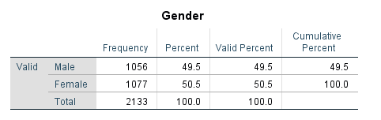
There are a total of 2,133 students enrolled in the school, with 1,056 male and 1,077 female students. It seems like there are almost the same number of males and women in this location. A pleasant and tolerant atmosphere can be inferred from the fact that the student body is evenly split between males and females. Students of both genders have equal opportunity for learning and development when there is peace and harmony in the school environment. The numerical symmetry symbolizes a dedication to achieving gender parity and a recognition of the significance of cultivating an environment in which students of both genders can flourish and make positive contributions to an inclusive and supportive academic community.
- How many students qualifies and does not qualify for reduced/free lunch?
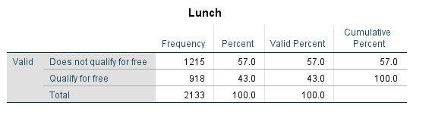
Some of the 1,215 students may come from affluent homes, as the majority do not qualify for free or reduced lunches. At the same time, 918 students are eligible for this assistance, illustrating the socioeconomic variety of the student body. We need to understand and respond to the distinct socioeconomic demands of people to close this gap and give equal educational opportunities. Students who qualify for free or reduced-price lunches should have their financial situations assessed so they can receive tailored support.

- What are the mean and median of students who qualifies and does not qualify for reduced/free lunch?
Students who do not qualify for free/reduced lunch have a mean of 21.45. Also, the median for the students who do not qualify for free/reduced lunch is 20. Students who qualify for free/reduced lunch have a mean of 24.5. Students who qualify for free/reduced lunch has a median of 22.
- Using the dataset Student_Score.csv provided in conjunction with SPSS, give a specific example of clustering (ex. K-Means Clustering). Show your workings with screenshots.
I am illustrating the clustering of pretest score and post test score.

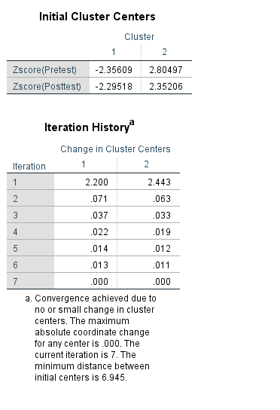

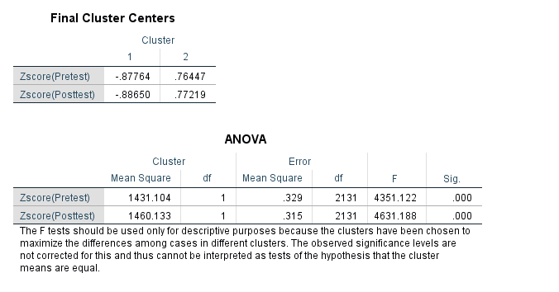
5. With real world (practical) examples, explain a minimum of the 5 most common data mining and text mining methods for each that can be used in contemporary business.
Data Mining Method
For first example, mining based on association rules is used in supermarkets to figure out the best places to put different products. By examining the purchase histories of customers, technology can understand which combinations of products are likely to be successful sellers. Using this data, retailers may be able to better arrange products such that they have the most potential for cross-selling.
For second example, the field of cybersecurity makes use of anomaly detection to investigate potentially harmful behavior on a network. To detect security breaches or cyberattacks, it is necessary to create a baseline of normal behavior, and any deviation from this baseline must cause alarms to be triggered.
For the third example, regression analysis is used in manufacturing to foretell quality issues with finished goods. Regression models can anticipate the possibility of faults by analyzing factors like manufacturing time, materials utilized, and machine performance, allowing for preventative quality control actions.
For fourth example, clustering is a common method used by retailers for dividing up their clientele. Businesses can create client cohorts with similar buying habits by analyzing customer purchase data. This is helpful for developing segmented marketing campaigns that may tailor their recommendations to each subset of customers.
For fifth example, classification is used in online commerce to prevent fraudulent activity. Using patterns like unusual spending behavior, repeated transactions in a short period of time, or out-of-the-ordinary places, a model can determine if a transaction is legal or fraudulent.
Text Mining Methods
For first example, NER is used in the healthcare industry to glean data from patient files. Entities including patient names, medical diagnoses, and treatment protocols can be recognized and categorized to allow for the extraction of structured data for analysis.
For second example, sentiment analysis is used by social networking sites to get a feel for user feedback. The marketing strategy and public image of a company are influenced by the data gleaned from user comments to gauge public opinion, spot trends, and address consumer concerns.
For the third example, text classification is used by media outlets to sort content into relevant categories. Training models to categorize news into categories like politics, sports, and entertainment helps media organizations improve content management and the user experience in news apps.
For fourth example, in academic research, the use of topic modelling is essential for carrying out detailed assessments of extensive document collections. By keeping a look out for repeating issues in academic papers, researchers have the potential to learn about new avenues that are being explored in their area.
For fifth example, text summarization is used in the legal field for the study of contracts. A lawyer can save time and increase efficiency in the legal process by using a summary to swiftly extract critical information, analyze risks, and make well-informed choices from long legal documents.

6. Discuss the advantages and disadvantages of using SPSS and Excel using relevant practical examples and present your discussions in a table.
Advantages
SPSS | EXCEL
Regression analysis, analysis of variance, and factor analysis are just some of the more complex statistical methods that can be done in SPSS (Guerrero, Guerrero & Rauscher, 2019). It has many different types of statistical analyses available. | The built-in statistical functions of Excel are sufficient for doing computations in a rapid and straightforward manner. It is useful for basic mathematics as well as the examination of rudimentary data.
SPSS's strong charting and graphing tools allow users to effectively communicate complex statistical findings through the development of a wide variety of charts. | Excel's variety of chart types makes it a good choice for simple data visualization. It's a common tool for making quick graphs and charts for presentations.
SPSS simplifies data management, even for massive datasets. Improved data quality can be achieved by its use of data cleansing, transformation, and merging. | Excel's data manipulation tools are rather basic, even though the application is excellent at managing datasets with fewer rows and columns.

Disadvantages
SPSS | EXCEL
SPSS is a popular tool for research, experimentation, and decision-making. It is one of the most widely used statistical software worldwide in the world for its attractive features (Landau & Everitt, 2018). Since SPSS is commercial software, its price may be prohibitive for individuals and startups. | MS Excel is a commonly used Microsoft Office application. It is a spreadsheet program which is used to save and analyze numerical data (Mayers, 2013). For simple spreadsheet and data processing tasks, the widespread installation and accessibility of Excel makes it a cost-effective choice.
Users who have not previously worked with statistical software could discover that the learning curve for SPSS is steeper. It's probable that getting some exercise is necessary to function at your best. | Since most people are already acquainted with the operation of spreadsheets, it should not be difficult for them to rapidly learn the fundamentals of Excel. In most cases, there is no need whatsoever for any kind of training.
When working with people who do not have SPSS installed, sharing, and collaborating on SPSS files may be more difficult than with Excel files. | Because of its widespread compatibility and ease of sharing and collaboration, Excel is often the best of choice for budget persons (Nahrstedt, 2017).

In a marketing research endeavor, for example, doing a complex regression analysis to identify variables influencing client happiness. Calculation of descriptive statistics (mean, standard deviation, etc.) based on sales data.
For the second example, in psychological research, one may simply produce a complicated visual demonstrating the correlation matrix between various variables using SPSS. In Excel, create a simple bar chart to represent monthly sales data for a formal report.
For a third example, if a small business with limited resources must undertake basic data analysis, the high cost of an SPSS license may be too expensive. Excel is a low-cost or free alternative for the company's data analysis requirements.
For a fourth example, owing to their distinct software preferences, members of a research team may find it challenging to exchange and cooperate on SPSS files. Team members may rapidly exchange and modify Excel files, allowing for easy collaboration despite differing software preferences.

CONCLUSION
The decision between SPSS and Excel is made considering the analysis's requirements, the users' knowledge and experience levels, and the project's financial limits. Excel is a more flexible and inexpensive option for simple data analysis and visualization tasks, while SPSS is better suited to complex statistical analyses. For data analysis, both are very important and useful tools. We cannot totally shift from one software to another because of their dynamic usages.

REFERENCE
Field, A. (2023). Discovering statistics using IBM SPSS statistics. sage.
Hinton, P. R., McMurray, I., & Brownlow, C. (2014). SPSS explained. Routledge.
Landau, S., & Everitt, B. S. (2018). A handbook of statistical analyses using SPSS. Chapman and Hall/CRC.
Argyrous, G. (2021). Statistics for research: With a guide to SPSS. Statistics for Research, 1-608.
Mayers, A. (2013). Introduction to statistics and SPSS in psychology.
Guerrero, H., Guerrero, R., & Rauscher. (2019). Excel data analysis. Springer International Publishing.
Billo, E. J. (2017). Excel for scientists and engineers: numerical methods. John Wiley & Sons.
Nahrstedt, H. (2017). Excel in Perfektion. Springer Fachmedien Wiesbaden.
Ose, S. O. (2016). Using Excel and Word to structure qualitative data. Journal of Applied Social Science, 10(2), 147-162.

