Pair of Clappers
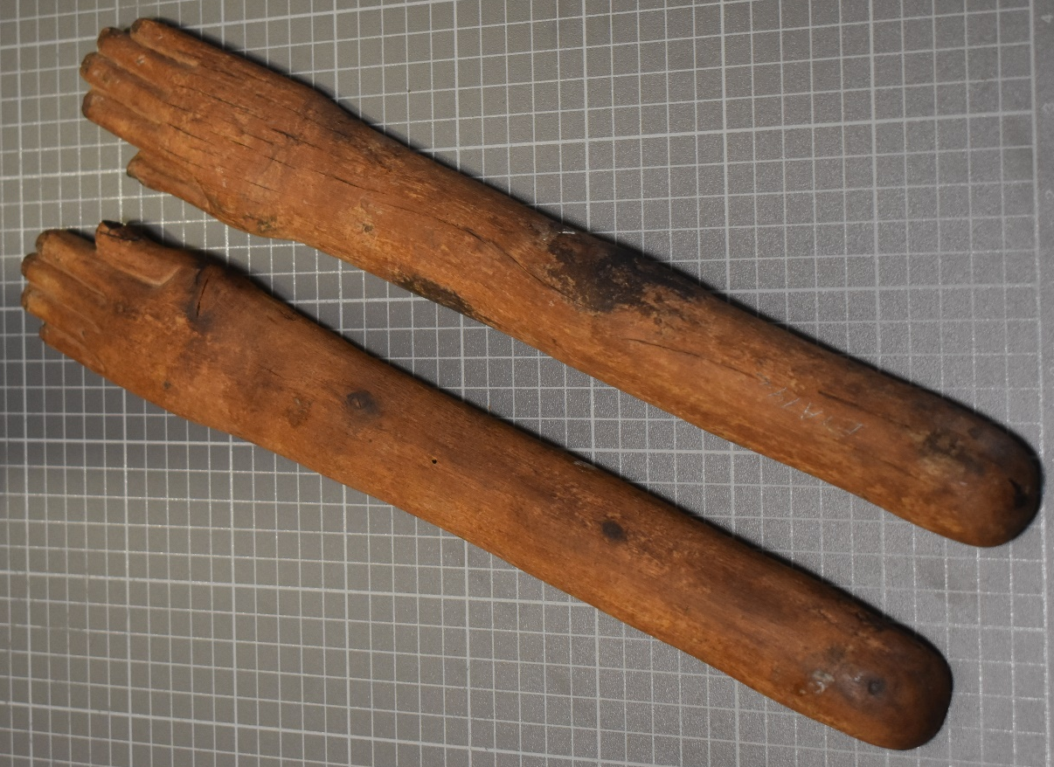
Cyfarthfa Castle, Merthyr Tydfil CCM
Object type: instrument
Material: wood
Period: 2055-1100 BC
Provenance: Egypt
Dimensions: Left Hand:
Length: 39.5cm width: 5.5cm (at widest) Circumference (arm): 9.6cm
Right Hand:
Length: 40cm width: 5.5cm (at widest) Circumference (arm): 9.5cm

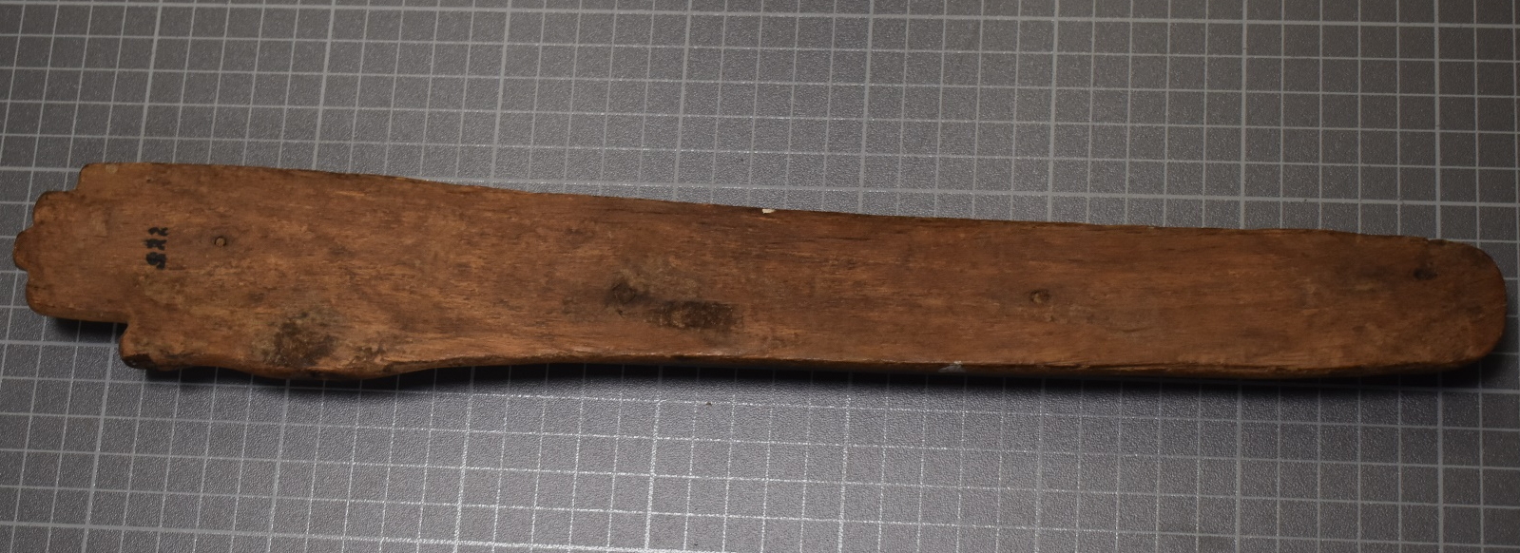
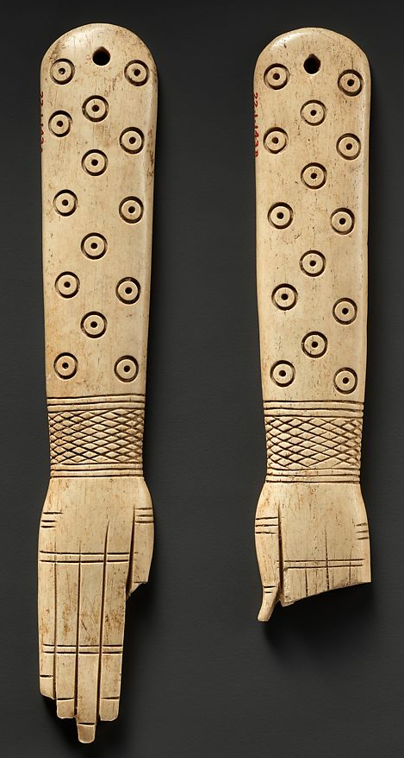
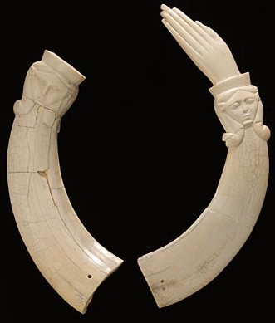
Looking at clappers from Ancient Egypt it is clear that there are a variety of sizes, shapes, and materials. Whereas the clappers from Cyfarthfa are made of wood it seems that ivory clappers are better preserved. There are a number of well-preserved hippopotami ivory clappers that are made via the halving and decorating of hippopotami tusks (figure 1). There is also a difference in importance when looking at decoration between the clappers studied here and figure 1, as the ivory tusks have a detailed carving of Hathor’s face “recognizable by her small cow ears” (Richard, 2020). The wooden clappers are of a far more basic decoration with carved hands, and indentation to show the nails. There seems to be a connection between clappers and performance purposes. In the funerary sense they may have been used in mortuary processions by Hathoric dancers (Morris,2017), moreover in the royal cemetery of Meroe, East of the Nile depicted is a scene of a funeral where there are women ‘clapping time while others carry palm staves, and throw their heads back in time to the rhythm’ (Solange, 2018. 77). Clappers were among the earliest musical instrument that the Egyptians used, there are many examples such as the decoration from the tomb walls of Khesuwer a 12th dynasty king teaching groups of women clapping and other instruments (Manniche, 1991. 123). They we used in the aforementioned ensembles of ancient Egypt and for funerary rituals, but they were also used in birthing rituals (Morris, 2017), this is due to their connection to Hathor the fertility goddess as can be seen on figure 1. A tomb in Thebes (TT 113) contains scenes of women dancers believed to be Hathoric performers and with them are musicians, some clapping to the beat (Solange, 2018. 75). It would appear suitable to state that clappers were an instrument made for ritualistic purposes, including birth, funerary processions and “parties” or large banquets and gatherings. Which means it’s intended audience would be performers of religious cults, as they were used in rituals and were to accompany dancers like the priestesses of Hathor.
(Figure 1, A pair of hippopotamus ivory clappers with detailed faces of Hathor, The Louvre, N 1479, N 1480)
On the clappers from Cyfarthfa museum, the size of both are about 40cm, which is quite large and would produce a louder sound than the smaller versions such as figure 2 which are about 17cm and 14cm, however the clappers from the Louvre in figure 1 have a height of 35cm. This shows the variety of size and that the Egyptians used for these artefacts. The incisions on the nails and thumbs look to be cut in and are below the finger level, there also seems to be small downward slices on the nails that show the level of intricacy and realism. The indentations and carving for the shape of the fingers is very clear and the dimensions are consistent. Looking at figure 1 and 2 the wooden pair from Cyfarthfa seem to be a simpler design as figure 1 has a detailed carving of Hathor and figure 2 has indentations representing where the knuckles and different bend in the fingers would be, as well as other artistic decoration all over the object. The shape of the clappers from Cyfarthfa museum use a 3D style that Egypt developed over time, as they did not look at something from one perspective, a recent term for their work is called ‘aspective’ (University College London 2002). As an archaeologist this type of 3D recording is very useful and offers a better understanding of Egyptian society, it also shows the level of craftmanship that Egypt developed. The use of hippopotami ivory in clappers tells us that they were important to the society, as it is not an easy source to acquire, moreover there is evidence of the king hunting them as a sign of courage (Stünkel, 2017). This tells us that with quite a lot of evidence of the religious and ritualistic use of clappers, Egypt invested into their religious and ritualistic rites with a lot of resources and it was of great importance.
(Figure 2, A pair of hippopotamus ivory clappers, The Met Museum, 22.1.143a, b)
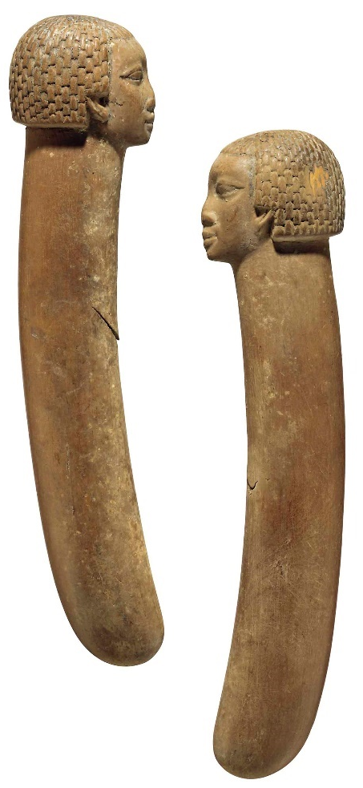
My strategy for dating this artefact will be to use relative dating, using other clappers from Ancient Egypt and nearby areas like Nubia (figure 3) looking at the design and material for similarities. In order to date this object it is important to look at other versions of the artefact, usually a museum will date other artefacts and offer information on how they dated it or where the design type appears in the timeline of the culture you are looking at. For example, according to Guichard (2020) the clappers with hands are said to first appear in Middle kingdom Egypt. However, from looking at many types the dating is very broad, figure 1 is dated between the middle kingdom all the way to the third intermediate period. Figure 2 only during the middle kingdom, which is narrower section of time. The material used is also important in the dating, figure 3 and 4 are both wooden clappers from Ancient Egypt and the surrounding area. Figure 3 and 4 are from the middle kingdom to the 18th dynasty before the Amarna period. Looking at clappers from the new Kingdom there seems to be a more streamlined design (The Met Museum, 32.5.2a, b. & Brooklyn Museum, 49.58.1-.2) with the fingers curving in towards a point, the straighter examples I have found seem to be from the middle kingdom, although according Morris (2017) straight clappers were enjoyed during the 18th dynasty. Due to the simplicity of the hands and that they started using hands in the middle kingdom I would like to state the start date during early Middle Kingdom, for the round off date I would say the Amarna period due to both the wooden material clappers being rounded off there around the 18th dynasty, so the early Amarna period maybe be where they declined.
(Figure 3, A Pair of Egyptian Wooden Clappers with Nubian heads. Christie’s: Live Auction 10372.)

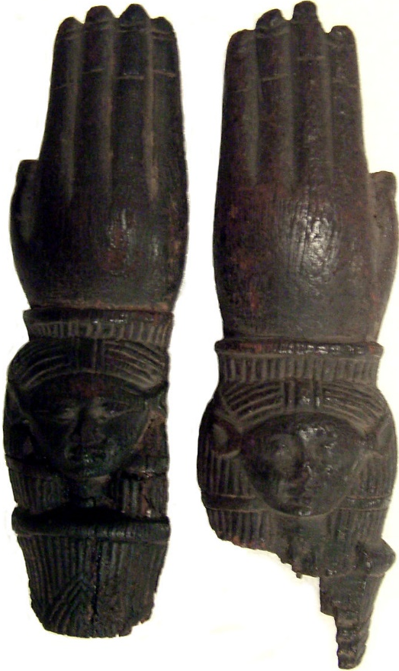

(Figure 4, A pair of wooden castanets/ clappers with detailed portraits of possibly Hathor on the wrists. The Met Museum: 89.4.1843)

Bibliography:
- Pair of Clappers. 2033-1069 BC. [Hippopotamus ivory, lower canines]. At: The Louvre: Department of Egyptian Antiquities: Objects from everyday life. N 1479, N 1480. [Online]. [Accessed 4th February 2021]. Available from: https://www.louvre.fr/en/oeuvre-notices/pair-clappers
- Guichard, S. 2021. Pair of clappers. The Louvre. Available from: https://www.louvre.fr/en/oeuvre-notices/pair-clappers [Accessed 4th February 2021]
- Manniche, L. 1991. Music and Musicians in Ancient Egypt. London: British Museum Press.
- Morris, E. 2017. MIDDLE KINGDOM CLAPPERS, DANCERS, BIRTH MAGIC, AND THE REINVENTION OF RITUAL. In: Miniaci, G. And Betro, M. And Quirked, S. (eds). Modelling the Imaginary World of Middle Kingdom Egypt (2000-1500 BC). Leuven: Peeters.
- Solange, A. 2018. Dancing for Hathor: Nubian Women in Egyptian Cultic Life. Dotawo: A Journal of Nubian Studies, 5(11): 63-90. [Online: Dancing for Hathor: Nubian Women in Egyptian Cultic Life (escholarship.org)] [Accessed: 6th February 2021]
- Pair of Clappers. 1900- 1640 BC. [Hippopotamus ivory]. At: The Met Museum: Gallery 113. 22.1.143a, b. [Online] [Accessed 6th February 2021] Available from: https://www.metmuseum.org/art/collection/search/546840
- University College London. 2002. What is Ancient Egyptian Art? Digital Egypt for Universities. Available from: https://www.ucl.ac.uk/museums-static/digitalegypt/Welcome.html [Accessed 7th February 2021]
- Stunkel, I. 2017. Hippopotami in Ancient Egypt. The Met Museum. Available from: https://www.metmuseum.org/toah/hd/hipi/hd_hipi.htm#:~:text=Ancient%20Egyptians%20were%20attacked%20by,field%20with%20their%20enormous%20appetite [Accessed 7th February 2021]
- A Pair of Egyptian Wood Clappers. 1985-1295 B.C. [wood]. At: Christie’s: Live Auction 10372. [Online]. [Accessed 7th February 2021]. Available from: https://www.christies.com/en/lot/lot-5882257
- Castanets (clappers). 1580-1090 BC. [wood]. At: The Met Museum: The Crosby Brown Collection of Musical Instruments, 1889. 89.4.1843. [Online]. [Accessed 7th February 2021]. Available from: https://www.metmuseum.org/art/collection/search/502442
- Pair of Clappers. 1353–1336 B.C. [ivory]. At: The Met Museum: Gallery 121. 32.5.2a, b. [Online] [Accessed 7th February 2021] Available from: https://www.metmuseum.org/art/collection/search/544680
- Pair of Clappers in Form of Human Hands. 1539-1190 B.C.E. [ivory]. At: The Brooklyn Museum: Egyptian Orientation Gallery, 3rd Floor. 49.58.1-.2. [Online] [Accessed 7th February 2021] Available from: https://www.brooklynmuseum.org/opencollection/objects/3538

