Everyday Life in Athens and Rome (HPHP4020)
Social hierarchies in the Graeco-Roman world
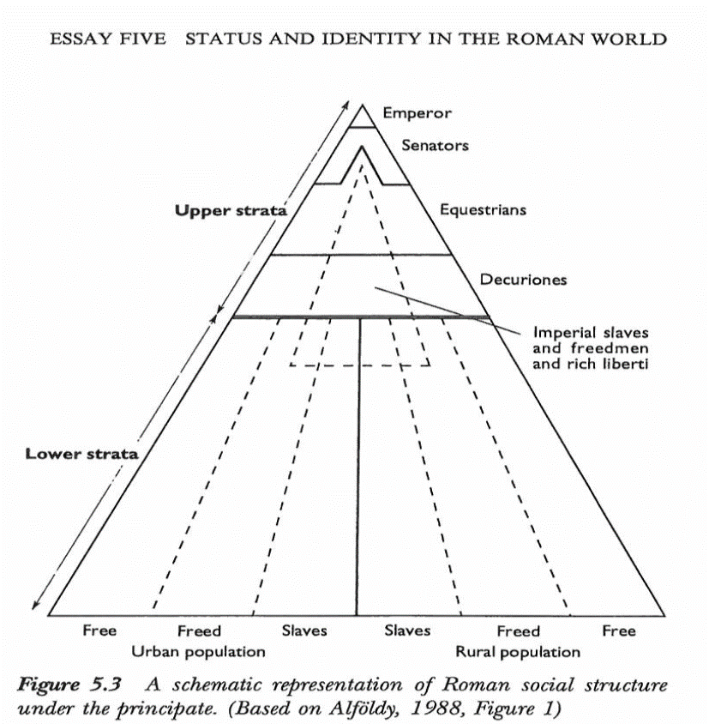

In this workshop we will consider the hierarchical structures that existed in Classical period Athens and Imperial era Rome. Such hierarchies are not abstract and fixed entities. Rather, they are made up of the myriad complex relationships that exist between individuals and groups within a society. Even if the dominant ideological framework (the views of those at the top) might express a desire for a rigid operation of such relations (people “knowing their place”), the reality often tends to be more fluid, with people moving up and down these “hierarchies” (even if in many pre-modern societies this tended to be harder). Moreover, the many complex cases could exist, where individuals defy easy placement within a given social pyramid (“exceptions proving the rule”). For instance, certain imperial freedmen within the Julio-Claudian court became extremely wealthy, and clearly had a lot of influence with certain emperors or other members of the imperial family. Members of the senatorial elite might even try to court their favour for political advancement and yet, at the same time, privately despise them as social inferiors who upset the “appropriate” social order.
Read the extracts on the following pages and consider the questions set alongside them. We will then discuss this material.

Extracts for Classical Athens

Right to be an Athenian citizen
“…in the year of Antidotus [451-450 BC], owing to the large number of the citizens an enactment was passed on the proposal of Pericles confining citizenship to persons of citizen birth on both sides [i.e., both father and mother had to be citizens of Athens in order to be born a citizen].” – Aristotle Athenian Constitution 26.3 – H Rackham (1952).

“[Pericles] was persuaded by Alcibiades and his other friends to resume his public life. When the people had apologized for their thankless treatment of him, and he had undertaken again the conduct of the state, and been elected general, he asked for a suspension of the law concerning children born out of wedlock, — a law which he himself had formerly introduced, — in order that the name and lineage of his house might not altogether expire through lack of succession. The circumstances of this law were as follows. Many years before this,​ when Pericles was at the height of his political career and had sons born in wedlock, as I have said, he proposed a law that only those should be reckoned Athenians whose parents on both sides were Athenians. And so when the king of Egypt sent a present to the people of forty thousand measures of grain, and this had to be divided up among the citizens, there was a great crop of prosecutions against citizens of illegal birth by the law of Pericles, who had up to that time escaped notice and been over­looked, and many of them also suffered at the hands of informers. As a result, a little less than 5000 were convicted and sold into slavery, and those who retained their citizenship and were deemed to be Athenians were found, as a result of this scrutiny, to be 14,040 in number. It was, accordingly, a grave matter, that the law which had been rigorously enforced against so many should now be suspended by the very man who had introduced it, and yet the calamities which Pericles was then suffering in his family life, regarded as a kind of penalty which he had paid for his arrogance and pride of old, broke down the objections of the Athenians.” – Plutarch Life of Pericles 37.1-5 – transl. B. Perrin (1916).

Why do you think such a measure to restrict who could be a citizen was taken? And why such extreme measures to enforce it?

Athenian social classes
“…he [Solon the Lawgiver, reforms in 594 BC] divided the people by assessment into four classes, as they had been divided before, Five-hundred-bushel-man [pentakosiomedimnoi = 500-bushel-men], Horseman [hippeis = the cavalrymen], Yoke-man [zeugitai = yoke-men] and Labourer [thetes = (hired) labourers], and he distributed the other offices to be held from among the Five-hundred-measure men, Cavalrymen and Yoke-men—the Nine Archons, the Treasurers, the Vendors of Contracts, the Eleven and the Paymasters, assigning each office to the several classes in proportion to the amount of their assessment; while those who were rated in the Laborer class [thetes] he admitted to the membership of the assembly and law-courts alone.” – Aristotle Athenian Constitution 7.3 – H Rackham (1952).

Why do you think such land-based class distinctions were put in place?

The (mock) rants of the “Old Oligarch” about the Athenian democracy
“But since they have decided to have it so [the Athenians have chosen to have a democratic system], I intend to point out how well they preserve their constitution and accomplish those other things for which the rest of the Greeks criticize them. First I want to say this: there the poor and the people generally are right to have more than the highborn and wealthy for the reason that it is the people who man the ships and impart strength to the city; the steersmen, the boatswains, the sub-boatswains, the look-out officers, and the shipwrights -- these are the ones who impart strength to the city far more than the hoplites, the high-born, and the good men. This being the case, it seems right for everyone to have a share in the magistracies, both allotted and elective, for anyone to be able to speak his mind if he wants to. …
And everywhere on earth the best element is opposed to democracy. For among the best people there is minimal wantonness and injustice but a maximum of scrupulous care for what is good, whereas among the people there is a maximum of ignorance, disorder, and wickedness; for poverty draws them rather to disgraceful actions, and because of a lack of money some men are uneducated and ignorant. …
For the people do not want a good government under which they themselves are slaves; they want to be free and to rule…
Now among the slaves and metics at Athens there is the greatest uncontrolled wantonness; you can't hit them there, and a slave will not stand aside for you. I shall point out why this is their local practice: if it were customary for a slave (or metic or freedman) to be struck by one who is free, you would often hit an Athenian citizen by mistake on the assumption that he was a slave. For the people there are no better dressed than the slaves and metics, nor are they any more handsome. If anyone is also startled by the fact that they let the slaves live luxuriously there and some of them sumptuously, it would be clear that even this they do for a reason. For where there is a naval power, it is necessary from financial considerations to be slaves to the slaves in order to take a portion of their earnings, and it is then necessary to let them go free. And where there are rich slaves, it is no longer profitable in such a place for my slave to fear you. In Sparta my slave would fear you; but if your slave fears me, there will be the chance that he will give over his money so as not to have to worry anymore. For this reason we have set up equality between slaves and free men, and between metics and citizens. The city needs metics in view of the many different trades and the fleet. Accordingly, then, we have reasonably set up a similar equality also for the metics.
…
Further, for oligarchic cities it is necessary to keep to alliances and oaths. If they do not abide by agreements or if injustice is done, there are the names of the few who made the agreement. But whatever agreements the populace makes can be repudiated by referring the blame to the one who spoke or took the vote, while the others declare that they were absent or did not approve of the agreement made in the full assembly” – Old Oligarch [Pseudo-Xenophon] Constitution of the Athenians 1.1-2, 5, 8, 10-12; 2.17 – transl. E. C. Merchant (1984)

Do these comments seem like parody, genuine criticism or a mixture of the two? What can we discern about (elite) social attitudes in much of the Greek world from these comments?

Extracts for Imperial era Rome

Work and “professions”
“Now in regard to trades and other means of livelihood, which ones are to be considered becoming to a gentleman and which ones are vulgar, we have been taught, in general, as follows. First, those means of livelihood are rejected as undesirable which incur people's ill-will, as those of tax-gatherers and usurers [people who lend out money at interest]. Unbecoming to a gentleman, too, and vulgar are the means of livelihood of all hired workmen whom we pay for mere manual labour, not for artistic skill; for in their case the very wage they receive is a pledge of their slavery. Vulgar we must consider those also who buy from wholesale merchants to retail immediately; for they would get no profits without a great deal of downright lying; and verily, there is no action that is meaner than misrepresentation. And all mechanics are engaged in vulgar trades; for no workshop can have anything liberal about it. Least respectable of all are those trades which cater for sensual pleasures: "Fishmongers, butchers, cooks, and poulterers, And fishermen," as Terence says. Add to these, if you please, the perfumers, dancers, and the whole corps de ballet.
But the professions in which either a higher degree of intelligence is required or from which no small benefit to society is derived — medicine and architecture, for example, and teaching — these are proper for those whose social position they become [i.e., well-to-do, skilled, non-elites]. Trade, if it is on a small scale, is to be considered vulgar; but if wholesale and on a large scale, importing large quantities from all parts of the world and distributing to many without misrepresentation, it is not to be greatly disparaged. Nay, it even seems to deserve the highest respect, if those who are engaged in it, satiated, or rather, I should say, satisfied with the fortunes they have made, make their way from the port to a country estate, as they have often made it from the sea into port. But of all the occupations by which gain is secured, none is better than agriculture, none more profitable, none more delightful, none more becoming to a freeman. But since I have discussed this quite fully in my Cato Major, you will find there the material that applies to this point.” – Cicero De Officiis 1.150-151 – transl. W. Miller (1913).

“This is the account given by others; Augustus [the first “Emperor”] himself merely writes​ that he came of an old and wealthy equestrian family, in which his own father was the first to become a senator. Marcus Antonius taunts him with his great-grandfather, saying that he was a freedman and a rope-maker from the country about Thurii, while his grandfather was a money-changer.” – Suetonius Divus Augustus 2.3 – transl. J. C. Rolfe (1913).

Why do you think certain “professions” are considered high-brow, low-brow or middling? Is there anything in Cicero’s review that surprises you?

Dress to impress
“He [the emperor Augustus] desired also to revive the ancient fashion of dress, and once when he saw in an assembly a throng of men in dark cloaks, he cried out indignantly, "Behold them Romans, lords of the world, the nation clad in the toga," and he directed the aediles never again to allow anyone to appear in the Forum or its neighbourhood except in the toga and without a cloak.” – Suetonius Divus Augustus 40.5 – transl. J. C. Rolfe (1913).

“To tell you the truth, in most of Italy, no one wears a toga unless they’re dead. Even on days of major festival when the traditional farce returns once more to the wooden stage, when the rustic infant cowers in its mother’s lap, at sight of a white gaping mask, even then you’ll see everyone, there, still dressed the same, those in the senatorial seats and those elsewhere. White tunics are quite sufficient for the highest aediles, as a garb to adorn their glorious office.” – Juvenal Satires 3.171 ff. – transl. A. S. Kline (2001).

“He had still another omen of empire: for once, when he [the future emperor Septimius Severus] was invited to an imperial banquet and came wearing a cloak, when he should have worn his toga,​ he was lent an official toga of the emperor's own.” – SHA Septimius Severus 1.7 – transl. D. Magie (1921).

Why was clothing an important means of indicating social standing?

Seating, guests and the social order
“He put a stop by special regulations to the disorderly and indiscriminate fashion of viewing the games, through exasperation at the insult to a senator, to whom no one offered a seat in a crowded house at some largely attended games in Puteoli. In consequence of this the senate decreed that, whenever any public show was given anywhere, the first row of seats should be reserved for senators; and at Rome he would not allow the envoys of the free and allied nations to sit in the orchestra, since he was informed that even freedmen were sometimes appointed. He separated the soldiery from the people. He assigned special seats to the married men of the commons, to boys under age their own section and the adjoining one to their preceptors; and he decreed that no one wearing a dark cloak should sit in the middle…​ He would not allow women to view even the gladiators except from the upper seats, though it had been the custom for men and women to sit together at such shows. Only the Vestal virgins were assigned a place to themselves, opposite the praetor's tribunal. As for the contests of the athletes, he excluded women from them so strictly, that when a contest between a pair of boxers had been called for at the games in honour of his appointment as pontifex maximus, he postponed it until early the following day, making proclamation that it was his desire that women should not come to the theatre before the fifth hour.” – Suetonius Divus Augustus 44 – transl. J. C. Rolfe (1913).

“It would be a long story - and it is of no importance - to tell you how I came to be dining - for I am no particular friend of his - with a man who thought he combined elegance with economy, but who appeared to me to be both mean and lavish, for he set the best dishes before himself and a few others and treated the rest to cheap and scrappy food. He had apportioned the wine in small decanters of three different kinds, not in order to give his guests their choice but so that they might not refuse. He had one kind for himself and us, another for his less distinguished friends - for he is a man who classifies his acquaintances - and a third for his own freedmen and those of his guests. The man who sat next to me noticed this and asked me if I approved of it. I said no. "Then how do you arrange matters?" he asked. "I set the same before all," I answered, "for I invite my friends to dine not to grade them one above the other, and those whom I have set at equal places at my board and on my couches I treat as equals in every respect." "What! even the freedmen?" he said. "Yes," I replied, "for then I regard them as my guests at table, not as freedmen." He went on: "It must cost you a lot." "Not at all," said I. "Then how do you manage it?" "It's easily done; because my freedmen do not drink the same wine as I do, but I drink the same that they do." And, by Jove, the fact is that if you keep off gluttony it is not at all ruinously expensive to entertain a number of people to the fare you have yourself.” Pliny the Younger Epistles 2.6 – transl. J.B.Firth (1900).

Why do you think social position was so clearly reflecting in the seating arraignments in these contexts?

Ancient jokes, acerbic humour and attitudes towards provincials
“Egnatius, because he has white teeth, smiles all the time… But Egnatius, you are from Spain, where it is the habit to brush your teeth with urine. So the shinier your teeth are, the more pee we know you have drunk.” – Catullus Carmina 39 – transl. P. Ripat (2014).

“A provincial was trying to sell a pot without a handle or spout. ‘Why did you cut of its appendages?’ asked someone. ‘So that it wouldn’t hear that it was going to be sold and run away.’” – a joke from The Laughter-Lover (Philogelos) – transl. P. Ripat (2014).

“An officer saw a carter driving his wagon through the marketplace, and ordered him to be blinded. But the latter protested that he was a Roman citizen, so it was against the law to blind him. Whereupon, the officer ordered his oxen to be flogged.” – a joke from The Laughter-Lover (Philogelos) – transl. P. Ripat (2014).

“His sister from Leptis [the hometown of Septimius Severus in present day Libya] once came to see him, and, since she could scarcely speak Latin, made the emperor blush for her hotly. And so, after giving the broad stripe​ [i.e., a toga normally worn by magistrates] to her son and many presents to the woman herself, he sent her home again, and also her son, who died a short time afterwards.” SHA Septimius Severus 15 – transl. D. Magie (1921).

What can these ancient jokes tell us about social attitudes and about social and legal status?

