Portfolio of Evidence

Day 1 - Saturday:

Today was an induction day into the company. I met the management team, alongside some of the store colleagues. The store manager used today to brief me on store health and safety, and also to explain to me how the pet pals workshops were run.
My first observation of a workshop was really interesting. One of the more experienced store colleagues led it, and explained to the children what birds ate, as well as how to provide them with nesting materials for the colder months. They also led a group activity in which the children made holders for nesting materials, as you can see in the photos below.

Today proved valuable as it was my first glimpse into the way in which a pet store can offer alternative education methods to children. The interactive activity kept the children’s attention, whilst the colleague explained why it was important to help wildlife, and the key ways in which they can help.
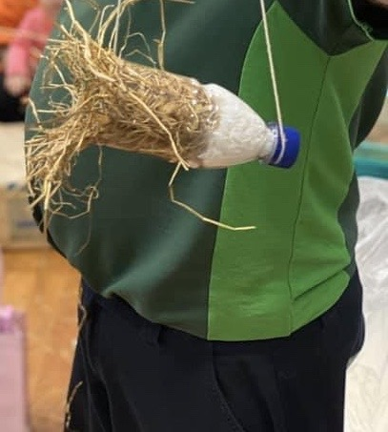
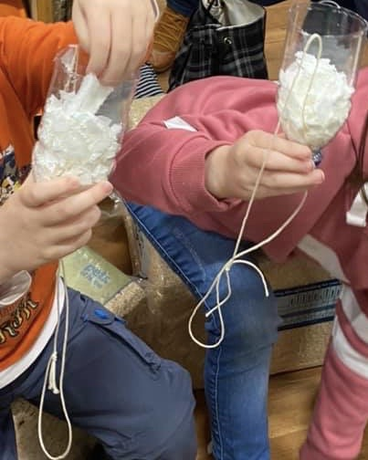
Learning about the basic health and safety practices of the store through the same training techniques the colleagues must use, was also a fantastic first insight into the methods of education used by the company.

Day 2 - Sunday:

After a brief introduction to the colleagues I did not meet yesterday, I was partnered up with one of the newer colleagues to experience first hand the types of training offered in store.
First up was fish, a subject area that becomes increasingly more complex with every step of learning. The store sell both cold water, and tropical fish. This means colleagues must know how to correctly care for both, as well as knowing which species can live together, and this that cannot. Interestingly, fish that will generally live with all species are known as community fish, meaning when customers are asking colleagues what species are best for a community tank, they are able to quickly identify them.

A guided learning experience today. One which occurred alongside a colleague still within their training period. This offered my the chance to experience first hand the depth of knowledge required by the company. It also afforded me the opportunity to examine how well this training practice of a more experienced colleague, explaining the subject to myself and the trainee, worked. In truth it can be rather boring if you are not interested in fish. It’s almost like being in a classroom, just standing up and walking a few metres down the fish tanks.

Day 3 - Monday:

Back to workshops today. This time a different colleague led the workshop. The manger likes to ensure that all colleagues have an even share of the workshops, in order to keep things fair. Today’s colleague was not as keen as Saturday’s to lead the workshop, however was able to produce one that was just as entertaining for the children attending. Instead of simply explaining about wild birds, today the colleague took a different approach, and brought out some of the store animals. This allowed the colleague to ask the children what each animal might eat, and explain some other interesting facts about the animals.

Today provided a really different aspect of learning. Whilst the format was certainly still a teacher (the colleague) telling the children what each animal ate, having the pets there to handle meant the children were far more engaged with what the colleague was saying to them. At the end of the workshop, the colleague again asked the children a few questions about what each animal ate, with most of the questions being answered correctly.

Day 4 - Tuesday:

Today was a return to the type of training that colleagues undertake. A far more hands on approach this time, as today was all about pet cleaning. Cleaning out the in store pets is a massive part of the care routines for the animals, as it keeps bacteria levels low. It also allows colleagues the opportunity to check the animals for any signs of illness, or fighting with other animals.
Animal checks are conducted using the company’s 6 point health check. This means checking the eyes, ears, teeth, nose, feet and general body condition of each animal. Whilst most points can be completed with a visual check, teeth and body condition mean handling the animal in a safe and correct manner.

A new segment of colleague training was shown to me today. Both animal cleaning, and health checks are critical development points for the colleagues.
Pet cleans were relatively simple to pick up, thanks to the demonstration from my colleague companion. However the same cannot be said for health checks. I was provided with a hands on demonstration, but being able to replicate the check was fairly difficult as the animals are not tempted to stay still for prolonged periods.

Day 5 - Wednesday:

Today was fairly similar to yesterday. I was once again helping out with pet cleans and health checks. Both tasks could easily become fairly monotonous if repeated on a daily basis. To combat this, the manage rotates the responsibility of pet cleans around the team. I enquired why I was expected to complete pet clean on consecutive days, and the manager explained that after my struggle with health checks yesterday, they wanted me to try again whilst everything was fresh, so that I could master it and move on.
This idea of modular learning was great for me, as it meant I would have complete confidence in an area before moving on to a new one.
The rest of the day was taken up with a mid point review of my placement here, and it gave me and opportunity to ask about spending more time speaking with colleagues about their training.

Day 6 - Thursday:

My request for time with colleagues was heard and I got to spend the day with my fish friend from Sunday. However today ran a little differently, and instead of simply being told about different animals, I got to read through the colleague textbook for the company. This was the first time I had seen any sort of written training from the company, and it was certainly a jarring difference to the hands on approach from my first five days.
The book is fairly large, and after reading just one chapter I can already see how it could become tedious and difficult for someone to focus on it long enough to absorb the relevant information.
To break up the dullness of reading, and also to ensure colleagues are gaining knowledge from the book, the company include tasks in each chapter that the colleagues must complete. Some of these involve walking the shop floor to find relevant items, whilst others are a demonstration of skills that must be observed by a manager.

The training textbook is a surprisingly fun method for learning. Whilst at first it could seem like a daunting read, the inclusion of various activities throughout make it a valuable resource. It allows colleagues to demonstrate their level of knowledge of both pet care, and store products.

Day 7 - Friday:

Fish Friday is not just a food thing. Today was a slightly different workshop for the children, and one I would be expected to rely on my training to complete. The company have select days used just to educate children about responsible fish care. It is a brilliant change of pace from the usual circus that’s involved with getting out the rabbits and guinea pigs for the children.
The workshop needed to be fun and engaging for the children, and using the knowledge I’d gained from Sunday and Thursday, I led the workshop, with a store colleague on hand to help me out.

Today was definitely one of the better days for seeing how alternative education can work in practice. Showing the children all the different fish and explaining some interesting facts about them kept them engaged in the information I was providing.
Combined with the chance to demonstrate what I had been learning from my own training this week, also helped to reinforce some of the information and ideals of the company.

Day 8 - Saturday (2):

Today was a particularly busy day for the store. This limited the amount of trains I was able to partake in, as there was little opportunity to free up any colleagues to train me. However, I was once again afforded the chance to lead a pet workshop, this time we were back to wildlife and the warm blooded pets.
It was a great opportunity for me to put my own spin on the workshop environment. Stealing some ideas from the colleagues I had observed over the past week, and modifying them to my own taste helped to engage the children’s attention. Whilst we did not make any nesting boxes for the children to take home, we did get a chance to talk about the smaller animals in store. The children enjoyed holding the animals and seemed to be enthralled as I explained how rats could eat almost anything.

Another great chance to reflect on what I had learnt over the past week of placement, and put it into practice.

Day 9 - Sunday (2):

My penultimate day of placement offered one of the most unique insights into the company’s training methods. A pun intended meeting called a shoal. This involves the entire store team getting together to learn about any new changes to company policy, or to review and refresh current standards.
This was something completely different to what I would expect a typical meeting to be like. The managers began by thanking everyone for their hard work over the past year, and handed out awards for various achievements. It put the entire team in a jovial mood, and seemed to ease the boredom of the next section, training.
The shoal setting gives a whole new environment for training, and it was definitely the most enjoyable experience. All colleagues are broken up into teams of three, and expected to compete against each other to complete certain tasks first. I was able to get involved in most of the activities thanks to the training I had received over the course of my placement with the team.
Admittedly being able to correctly label a diagram of a rabbit may not seem the most interesting way of demonstrating knowledge, but the added edge of competition makes it more important to get the answers down.
As well as some written exercises, there were also some practical activities, like correctly health checking a guinea pig, and being able to reassemble a fish tank filter.

This group work atmosphere definitely improves the quality of training. All of the colleagues were able to bounce ideas off each other, whilst also learning from each other. The competition element was only intended for a bit of fun, but it brought out the best of each colleague.

Day 10 - Monday (2):

My final day was a slightly sombre one. I have loved my placement here, and have learnt a lot from the entire team. The opportunity to acquire new skills and knowledge from a completely different learning environment to that which I’m used to was incredibly useful.
It has also provided me with a lot of opportunities to observe how children learn in an environment that completely contrasts to a typical classroom.

Over the course of my placement, it was obvious that children are definitely capable of learning in new, unpredictable environments. Despite the ever changing presence of dogs moving throughout the store, children attending the workshops devoted their attention to whoever was leading the workshop. Whilst it is fair to say that this is most likely due to the opportunity to hold one of the smaller pets, it definitely served as a great motivator.
However there are of course some drawbacks to learning this way. The workshops only run for 30 minutes, and in that time some children arrive late and so missed some of the information. On top of this, each colleague has their own way of hosting a workshop, meaning the way in which information is conveyed changes each time. This lack of consistency could prove a problem for long term learning.

