Materials engineering
Tomos Butterworth 2409888

Table of Contents
1.0- Abstract 2
2.0- Recent Research 2
2.1- Dry Process 2
2.2- Wet Process 3
2.3- Plastic Specification 4
2.3.1- Polyethene Terephthalate (PET) 4
2.3.2- Highly Dense Polythene (HDPE) 4
2.3.3- Polypropylene (PP). 5
3.0- Issues With Plastics in Road Construction 5
4.0- Critical Assessment of Plastics in Road Construction. 7
5.0- Conclusion. 9
6.0- Appendix. 10
7.0- References. 11

1.0- Abstract
The use of recycled plastics in road construction, such as incorporating them into the mortar, has become a growing interest in the UK over the last few years. This method represents an innovative approach to road construction, helping to reduce plastic waste and move away from the reliance on unsustainable materials. Research from the UK government found that recycled plastics could be incorporated into asphalt roads either in the form of a polymer modifier to bitumen or to coat the aggregates (GOV.UK, 2019). Early trials, mainly from Scotland, have shown that involving plastic in an asphalt mix can help the road perform equally or in some cases better than traditional road mixes, with the possibility of reducing carbon emissions by utilising recycled plastic (Barker, 2025). Further research must be undertaken into this topic before this can be incorporated into roads.

2.0- Recent Research

As a direct result of founding research from India in 2006, the Department of Transport recently initiated UK trials of a plastic road technology developed by the Scottish company MacRebur, aiming to contribute to the reuse of waste plastic and reduce the release of plastics into the environment (The Civil Engineer, 2017). This information comes from a civil engineering news article, posting unbiased information. However, this article is slightly outdated, with further research coming out prior to this article. Across the world, the use of plastic in road construction is rapidly developing. There are two main processes for incorporating plastic waste into roads: the dry method and the wet method.
2.1 Dry Process
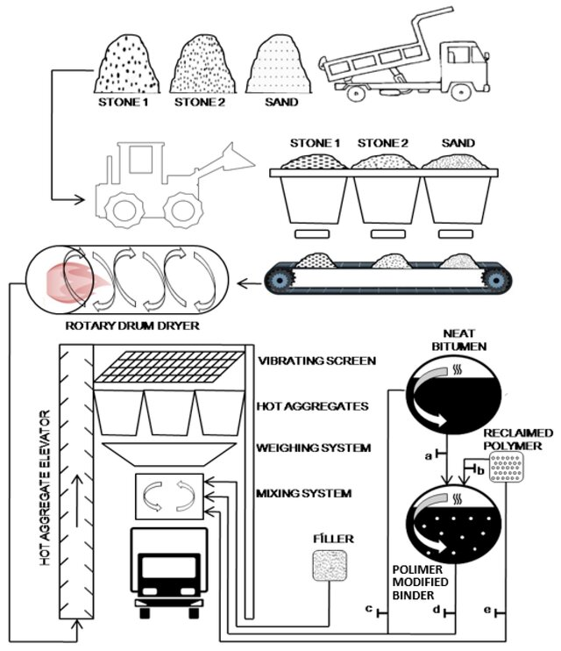
As described by Sasidharan et al. (2019), the dry process is the simplest method and can be considered more economically and environmentally friendly, while the wet process requires more advanced technology, so it is less commonly used. As this information comes from the University of Birmingham, we can assume the information is reliable. They also compile research from 5 countries, spanning 3 continents, which helps us to generalise the information to most road construction. The dry process entails shredding waste plastic and adding it to the aggregate, as shown in Figure 2 (Sasidharan et al, 2019). To ensure full coating of the aggregate, the optimal sizing for the shredded plastic is in the range of two to three millimetres (National Rural Roads Development Agency, 2019). The plastic is then added to the aggregate, which is then heated to 170 degrees Celsius, melting the plastic which coats the aggregate (Sasidharan, 2019).
Figure 1. wet and dry process (Brasileiro et al, 2019)
Recent research conducted by Hridoy et al. (2025) found that the percentage of recycled plastic in the mix that performed the best was the 3% mix, compared against 5% and 7% mixes. The 3% mix was found to have superior binding stability compared to the other percentages tested, having a Marshall stability value of 19.58 kN, compared to a conventional road mix of around 18.25 kN (Hridoy et al, 2025). This research comes from South Africa, which has a different climate from the UK, meaning the roads won’t perform the same, so they cannot be generalised to roads in the UK

2.2 Wet Process
The wet process is the more expensive and time-consuming method of adding microplastics to roads. The powdered waste plastic is added to the hot bitumen before incorporating them to the aggregates in the mix (Sasidharan, 2019). The wet method is less cost-effective as it requires specialised equipment (Dhull, 2024) to heat the mix to around 155 degrees Celsius (Sasidharan, 2019).

2.3 Plastic Specification
It is essential to choose the correct plastic type to incorporate into the mix, as each plastic type has different durability, melting points, weights, and resistance to chemicals and pollution. As described by Madhu and Gaonkar (2020), some of the best plastics for incorporation into road construction include polyethene terephthalate (PET), highly dense polyethene (HDPE), and polypropylene (PP). This source comes from the Department of Civil Engineering, Karnataka, India. As it comes from India, the information provided cannot be directly applied to road construction in the UK.

2.3.1 Polyethene Terephthalate (PET)
PET is a strong synthetic fibre that is typically used as a reinforcing agent for other materials, such as cotton, wool, and rayon (Britannica, 2025). Britannica is an online encyclopaedia with a vast catalogue of fact- checked, objective information. This article was published in November 2025, making it an up-to-date and recent piece of information. Shredded PET increases moisture resistance, coarser particles enhance bulk density, and longer PET fibres improve fracture and fatigue resistance (Usman and Kunlin, 2024).

2.3.2 Highly Dense Polythene (HDPE)
HDPE has become a very popular additive in construction over the last decade. HDPE is a light, versatile polymer, becoming popular for its strength-to-weight ratio and chemical resistance (Poly PVC, 2024). Poly PVC is a polymer supplier who have been operating since the 1980s, which helps to give validity to their information. However, as this company provides a product, there may be some bias in their information. HDPE is a very durable material which can be very beneficial to road construction, as constant use can wear down other materials, such as the aggregate (Poly PVC, 2024). Coating the aggregate in polymers such as HDPE can increase the life span of the road.

2.3.3 Polypropylene (PP).

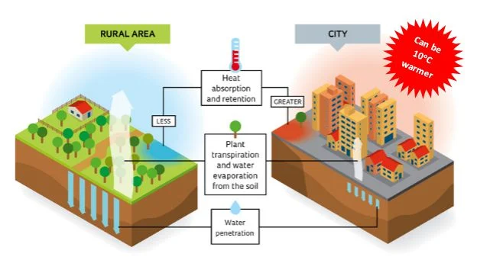
PP is a very durable and strong plastic, allowing it to withstand the constant wear and tear from traffic (Liu, 2025). China Geosynthetics are a plastic engineering expert, giving validity to their information as they have a high degree of expertise and have industry standards they must follow. However, as this company produce plastic, there may be some conflicts of interest, with a monetary incentive. PP is a very water-permeable plastic, helping to effectively drain water from the road, reducing flooding and road damage (Liu, 2025). Having permeable roads has been found to have a wide range of practical benefits. These include a reduction in runoff water quantity, which places less stress on sewerage systems (Xie et al, 2019), and can reduce a phenomenon called the heat island effect, where urban environments have a significantly higher temperature than rural areas due to human activity (Royal Meteorological Society, 2017). This information from the Royal Meteorological Society is slightly outdated, however, as they’re experts in their field, their information is reliable. PP is a highly chemically resistant material, which helps resist pollution in rainwater and enhances the long-term health of the road (Liu, 2025).
Figure 2. Heat Island Effect (Royal Meteorological Society, 2017).

3.0 Issues with Plastics in Road Construction
Whilst plastic incorporation in road construction has been revolutionary, there have been research and case studies into issues faced. One challenge for engineers is that performance varies depending on the type, proportion, and type of plastic used (Ghodrati et al, 2025). The research paper gives a concise and up-to-date overview of how waste plastics are used in road construction, referencing the information given. However, this paper discusses plastic use in road construction on a more global level, meaning the information may not fully fit in with British construction standards. Higher plastic contents have been found to lower the density of the mix and increase voids to be filled by air, decreasing the moisture resistance (Ghodrati et al, 2025).
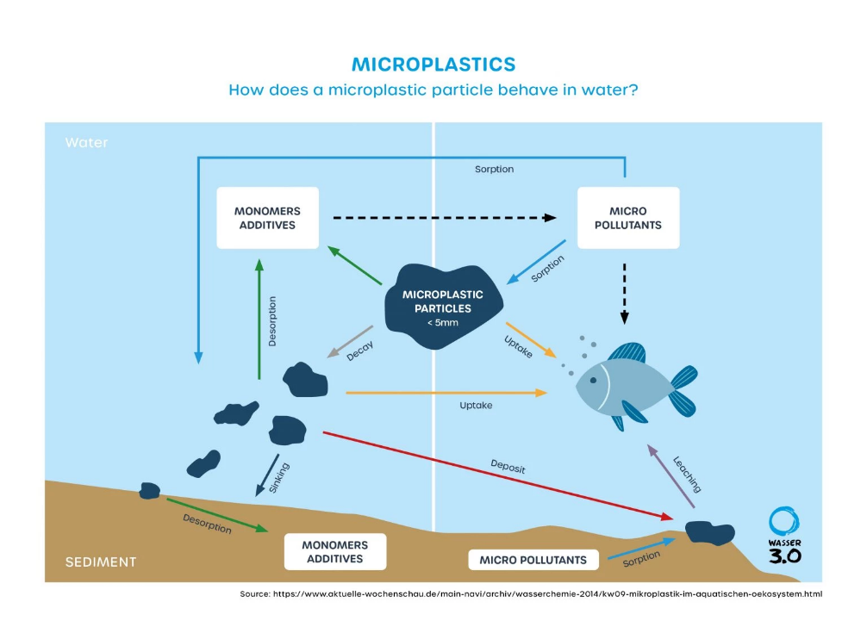
Another issue faced using microplastics in road construction is the breakdown of microplastics owing to additives, including heavy metals, which have been found to seep into soils and waterways and damage the environment (Ghodrati et al, 2025). Leachability testing (how substances, in this case, microplastics, can be released from a solid when in contact with a liquid) on roads with shredded plastic as an additive found that there was a high level of common water contaminants, such as heavy metals and nutrients, seeping out of the roads (Ghodrati et al, 2025). The presence of microplastics in water sources can significantly hinder the process of treating it for human and animal consumption, increasing costs and the need for expensive technical equipment (Strojni et al., 2025). It has been found that regular water treatment centres can only filter out around 70% of microplastics in water sources, meaning that the water seeping from the roads could be ingested by humans (Strojni et al, 2025), which has links to diseases such as cancer. This source is up to date with the listed sources of information, giving validity to the information provided. However, as this source originates from Poland, the information may not be directly applicable to UK construction and engineering.
Figure 3. Microplastics seeping into water (Wasser 3.0, n.d)

Another issue found in road construction including plastics, is the adherence of the mix. The introduction of plastics has been found to reduce the stiffness in the mix, caused by a lower cohesion (Department of Building Engineering, Tongji University, China, 2019). As this source has listed its references, the source can be seen as reliable, as it provides transparency and academic integrity. However, this source does not have its author(s) listed, so we cannot understand any personal biases. The plastic and asphalt can separate in the mix due to the differences in the molecular density and overall structure (Xu et al, 2021). Only when these molecules are similar enough to avoid separation can a proper mix be completed (Xu et al, 2021). To deal with this issue, research has found that additives along with the plastic, such as sulphur, carbon, and hydrophobic clay, can significantly increase the compatibility of the asphalt mix (Xu et al, 2021).
Another issue found is the road's performance in cold conditions, especially using the wet method of integration (Ameur et al, 2025). Including plastic into asphalt has been found to increase the long term stiffness at lower temperatures, resulting in a reduced lower temperature cracking resistance (Xu et al, 2021). Coming from an academic source, this information is reliable with its sources of information and authors listed. However, as the information originates from China, it should not be applied directly to road construction in the UK. To address this issue, waste rubber has been introduced into many mixes to help reduce the stiffness and subsequent cracking of the road surface. (Xu et al, 2021). Due to rubber's elastic properties, testing has found that mixes including waste rubber and plastic significantly outperform road mixes with plastic and rubber added individually (Xu et al, 2021).

4.0 Critical Assessment of Plastics in Road Construction.
Using waste plastic in road construction is a very practical method to reduce waste accumulation in the environment and landfills. Potholes are a significant issue in the United Kingdom due to the heavy rain, causing the most road accidents per year (Bindal, 2024). Testing in India and Sri Lanka, where rainfall isn’t dissimilar to the UK’s, found plastic-reinforced roads are effective in reducing damage with less maintenance (Bindal, 2024). Although plastic can be very practical to use in road construction, it does have some limitations. With bitumen and plastic having poor compatibility, it is common for separation to occur and ruin the mix. Retrofitting plastic roads also requires specialist equipment, staff training, and quality checking, increasing upfront and recurring costs. However, with a road less likely to succumb to damage over time, less maintenance is needed on the road, which helps reduce costs, as shown in Figure 5 (Bindal, 2024). This article focuses on how plastics can be incorporated into road construction in the UK, making it directly applicable to this report. However, it has a focus on short-term practicality instead of a focus on the long term, meaning more research needs to be undertaken.

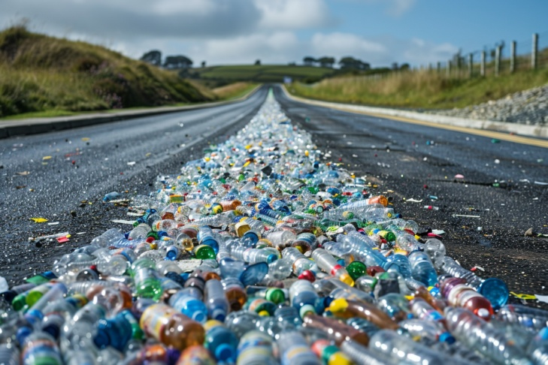
The future of road construction has a strong focus on sustainability and environmental concern. Each kilometer of roads containing shredded plastic can contain the equivalent of nearly 700,000 plastic bottles or 1.8 million plastic bags (Highways Industry, 2024). This source has a strong focus on the environmental benefits of incorporating plastic into roads, which is beneficial to this report. However, this source has a bias towards the positives and has a very short mention towards future concerns. In the UK, MacRebur of Scotland has pioneered the use of recycled plastics in road repairs in the UK, most notably a nearly 1 Kilometer stretch of the A709 in Dumfries and Galloway (Highways Industry, 2024) in 2017 (Dumfries & Galloway News, 2017). Another UK-based company, Roadfill, has developed a product called Roadworx, a product that merges recycled plastics and graphene, a form of carbon, to enhance road surfacing quality (Highways Industry, 2024). Trials in the regions of Buckinghamshire and Tayside have successfully implemented waste low-density polyethene (LDPE) and PP into roads (Highways Industry, 2024).
Figure 4. (Highways Industry, 2024).
Many experts have raised concerns over the use of plastic in construction. Even though the environmental consequences of plastics are thoroughly documented, the effect of construction plastics on the public's health has undergone less research (Smethurst, 2023). This source comes from the Royal Institute of Chartered Surveyors, meaning that they are experts in the field of construction, giving validity to the information provided. However, it doesn’t extensively explore any counterarguments or quantify the levels of risk involved, meaning readers do not get a full understanding of how dangerous these chemicals are. In a 2021 meta-analysis, more than 2,000 additives were found in construction plastics, with a quarter of these plastics containing chemicals that are classed as “EU substances of concern” due to factors such as bioaccumulation or toxicity to human and animal life (Smethurst, 2023). A similar study discovered 88% of chemicals in commonplace plastic products, including common construction plastics, can leak into the environment during their use (Smethurst, 2023). This is a concern as it can seriously affect the long-term practicality of plastics in road construction. However, many experts believe that this method of road construction is the most environmentally friendly. After the construction of a plastic-mixed road in Motherwell, Scotland, research found that these roads can reduce carbon emissions by upwards of 20% after the reduction of the oil-based bitumen (North Lanarkshire Council, 2025). This source comes from the council, meaning there are some concerns over bias, pushing a motive for their innovation. However, as this source comes from the UK, it is directly applicable to this report.

5.0 Conclusion
The incorporation of waste plastics in road construction presents an opportunity to deal with two substantial challenges faced by the UK: plastic waste environmental buildup and the durability and lifespan of roads. Laboratory and practical testing over the last eight years have found that plastic-modified roads can perform equally to conventional roads, if not better. Benefits include possible improvements in durability, water resistance, and lower maintenance. Furthermore, plastic roads have the added benefit of reducing plastic accumulation in landfills, giving practical uses for a toxic material that accumulates in the environment.
However, before widespread implementation into UK roads, further research into its environmental concerns must be conducted. Performance of the road can vary depending on the type of polymer used, quantity and method of incorporation. Health concerns also remain under-researched, especially the leaching of toxic microplastics and their chemical additives into soil and water systems, possibly accumulating in the human body. Although research has not been fully conducted regarding the risks of plastic roads, there are concerns that they may cause damage to public health. Issues with the mix have also been discovered, needing greater additives to solve the issues presented.
To conclude, plastic-modified roads are an innovative solution to issues with roads in the UK. However, this cannot be seen as a long-term solution currently. A greater amount of field research must be undertaken before widespread implementation.

6.0 Appendix
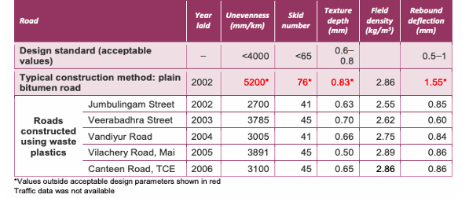
Figure 5. Roads Constructed in India Using Waste Plastic and Their Condition (Bindal, n.d)

7.0 References
Ameur. A.B, Valentin. J, Baldo. N (2025) ‘A Review on the Use of Plastic Waste as a Modifier of Asphalt Mixtures for Road Constructions’ MBDI, 6(2). Available at https://www.mdpi.com/2673-4109/6/2/17 (Accessed: 21 December 2025).
Barker. G (2025) ‘New 'homogenously mixed' recycled plastic technology trialled in UK asphalt for first time’ Highways Magazine. Available at https://www.highwaysmagazine.co.uk/news/nations-and-regions/homogenously-mixed-recycled-plastic-technology-trialled-uk-asphalt (Accessed: 21 December 2025).
Bindal. P (2024) ‘Recycling Plastics for Road Maintenance’ Schumacher Institute. Available at https://schumacherinstitute.org.uk/wp-content/uploads/2024/04/202404-Recycling-Plastics-for-Road-Maintenance-Preksha-Bindal.pdf (Accessed: 31 December 2025).
Brasileiro. L, Moreno- Navarro. F, Tauste. R, Matos. J, Rubio Gámez. C (2019) ‘Reclaimed Polymers as Asphalt Binder Modifiers for More Sustainable Roads: A Review’, Sustainability, 11(3). Available at https://www.researchgate.net/publication/330706261_Reclaimed_Polymers_as_Asphalt_Binder_Modifiers_for_More_Sustainable_Roads_A_Review (Accessed: 22 December 2025).
Britannica (2025) ‘polyethylene terephthalate’. Available at https://www.britannica.com/science/polyethylene-terephthalate (Accessed: 23 December 2025).
Department of Building Engineering, Tongji University, China (2019) ‘Performance Improvisation of Bituminous Roads using waste Plastic Material’ International Journal of Civil, Environmental and Agricultural Engineering. Available at https://sietjournals.com/index.php/ijceae/article/view/26/18 (Accessed: 31 December 2025).
Dhull. N (2024) ‘Eco-Friendly Road Construction: Using Recycled Plastics in Asphalt’ Azo Build. Available at https://www.azobuild.com/article.aspx?ArticleID=8690 (Accessed: 22 December 2025).
Dumfries & Galloway News (2017) ‘a709 to be closed while new plastic road laid for trial run’. Available at https://www.dgwgo.com/dumfries-galloway-news/new-plastic-road-laid-a709/ (Accessed: 1 January 2026).
Ghodrati. A, Mashaan. N.S, Paraskeva. T (2025) ‘Incorporating Waste Plastics into Pavement Materials: A Review of Opportunities, Risks, Environmental Implications, and Monitoring Strategies’, Applied Sciences 15(14). Available at https://www.mdpi.com/2076-3417/15/14/8112 (Accessed: 27 December 2025).
GOV.UK (2019) ‘Using Waste Plastics in Road Construction’. Available at https://www.gov.uk/research-for-development-outputs/using-waste-plastics-in-road-construction? (Accessed: 15 December 2025).
Hridoy. S.M, Haque Protyai. I, Bin Rashid. A, Sayeed. A (2025) ‘Marshall property analysis of an improved bituminous mix obtained by mixing plastic waste with bitumen’ South African Journal of Chemical Engineering. 53. Available at https://www.sciencedirect.com/science/article/pii/S102691852500037X#abs0002 (Accessed: 22 December 2025).
Highways Industry (2024) ‘Is Recycled Plastic the Future of UK Road Construction?’. Available at https://www.highwaysindustry.com/recycled-plastic-the-future-of-road-construction/ (Accessed: 1 January 2026).
Liu. J (2025) ‘Can PP Non Woven Geotextile be used in road construction?’ China Geosynthetics. Available at https://www.geosyntheticschina.com/blog/can-pp-non-woven-geotextile-be-used-in-road-construction-992789.html (Accessed: 25 December 2025).
National Rural Roads Development Agency (2019) ‘Guidelines For The Use of Plastic Waste in Rural Roads Construction’. Available at https://www.scribd.com/document/520785555/Plastic-Roads-Guidelines (Accessed: 22 December 2025).
Poly PVC (2024) ‘Innovative Applications of High-Density Polyethylene (HDPE) in Construction, Agriculture, and Industry’. Available at https://www.polypvc.com/news/Innovative-Applications-of-HighDensity-Polyethylene-HDPE-in-Construction-Agriculture-and-Industry.html (Accessed: 25 December 2025).
Royal Meteorological Society (2017) ‘Urban Heat Islands’. Available at https://www.rmets.org/metmatters/urban-heat-islands (Accessed: 26 December 2025).
Sasidharan. M, Eskandari Torbaghan. M, Burrow. M (2019) ‘Using waste plastics in road construction’ University of Birmingham. Available at https://assets.publishing.service.gov.uk/media/5d41b34040f0b60a86a5e5dc/595_Use_of_Waste_Plastics_in_Road_Construction.pdf (Accessed: 31 December 2025).
Smethurst. T (2023) ‘Why we must limit use of construction plastics’, Royal Institute of Chartered Surveyors. Available at https://ww3.rics.org/uk/en/journals/built-environment-journal/plastics-construction-materials-health.html (Accessed: 1 January 2026).
Strojni. W, Gruca-Rokosz. R, Cieśla. M (2025) ‘Microplastics in Water Resources: Threats and Challenges’, Applied Sciences, 15(8). Available at https://www.mdpi.com/2076-3417/15/8/4118#Microplastics_in_the_Aquatic_Environment (Accessed: 28 December 2025).
The Civil Engineer (2025). ‘A Scottish company turns recycled plastic waste into roads’. Available at https://www.thecivilengineer.org/news/a-scottish-company-turns-recycled-plastic-waste-into-roads (Accessed: 22 December 2025).
Usman I.U, Kunlin. M (2024) ‘Influence of Polyethylene Terephthalate (PET) utilization on the engineering properties of asphalt mixtures: A review’, Construction and Building Materials, 411. Available at https://www.sciencedirect.com/science/article/pii/S0950061823041582 (Accessed: 24 December 2025).
Wasser 3.0 (n.d) ‘Microplastics’. Available at https://wasserdreinull.de/en/knowledge/microplastics/ (Accessed: 28 December 2025).
Xie. N, Akin. M, Shi. X (2019) ‘Permeable concrete pavements: A review of environmental benefits and durability’ Journal of Cleaner Production, 210. Available at https://www.sciencedirect.com/science/article/pii/S0959652618335376#sec3 (Accessed: 26 December 2025).
Xu. F, Zhao. Y, Li. K (2021) ‘Using Waste Plastics as Asphalt Modifier: A Review’, Materials, 15(1). Available at https://www.mdpi.com/1996-1944/15/1/110 (Accessed: 31 December 2025).

