Professional Behaviours and Valuing People
Task 1
Final Word Count: 2601 words
(AC 1.1)
The fundamental purpose of being a people professional is to “champion better work and working lives” (CIPD, pp. 1, 2024). According to CIPD’s (2018) Profession Map, our purpose as people professionals is to get the best out of people by supporting organisations to create supportive roles and opportunities and to ensure working environments are delivering impactful outcomes by making respectable, impartial and inclusive working experiences. People Professionals bring value to organisations like Nexxobyte by incorporating three core steps: first, by using evidence-based practice to inform decision making; second, by being principles-led, whereby professionals go beyond policy to do what’s right; and finally, by being driven by outcomes, which focuses on the work which creates the most value for people and organisations (CIPD, 2018).
In more depth, People Professionals have a powerful impact on organisational culture, employee wellbeing, and levels of trust (CIPD, 2023a). CIPD (2015b) emphasise that People Practices should move beyond rigid procedures and instead adopt principles-based approaches that prioritise equality, transparency, and ethical decision-making. By embedding this approach, People Practices become a driver of trust, stability, and positive employee experience (CIPD, 2015b).
At Nexxobyte, it is clear that employees and leaders are dissatisfied with the inconsistent way people are being managed across teams. The diagram below highlights that this area is a top priority for improvement across HR functions, which aligns closely with Nexxobyte’s current challenges.
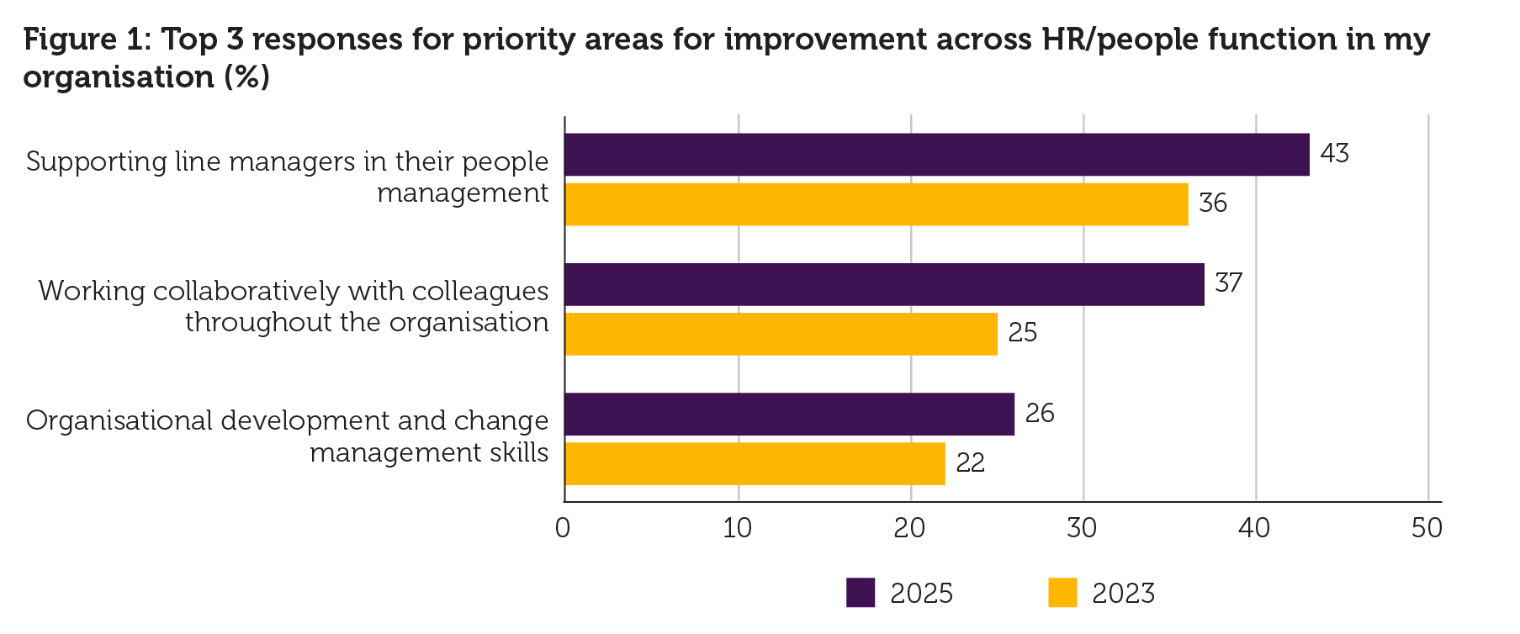

Figure 1: Top Challenges for the Profession (CIPD, pp.1, 2025a).
As the HR/L&D Advisor at Nexxobyte, I play a crucial role in addressing these gaps and shaping a healthier, more consistent culture. By being a principles-led practitioner, I can help establish fair and transparent people practices that ensure all employees are treated consistently, regardless of which team they belong to. Through an evidence-based approach, I can introduce structured processes, gather feedback, analyse trends, and use data to guide decisions that improve the employee experience. Finally, by being outcomes-driven, I can focus on interventions that genuinely add value. Such as developing line managers’ capability, improving collaboration across teams, and supporting organisational development as Nexxobyte continues to grow.
My strong influencing skills will help me guide Nexxobyte’s leaders toward consistent and fair people-centred practices. By building credibility, communicating clearly, and aligning people initiatives with business goals, I can support managers more effectively, improve trust, and shape a healthier culture that prioritises employee wellbeing and fair treatment across all teams (Page, 2022).
(AC 1.2)
Two of the ethical values that I believe will help me in my new role are fairness and equality. According to Smith and Mitchell, cited in Taylor and Woodhams (2022), ethical values are deep-rooted beliefs that influence your decision-making. Figure 2 demonstrates that employees at Nexxoybyte will experience my behaviour only, which is shaped by my underlying personal beliefs, values and attitudes (Smith and Mitchell, cited in Taylor and Woodhams, 2022). The sources highlight that these underlying drivers have a large impact on the quality of my working relationships and the way I am perceived within the workplace.
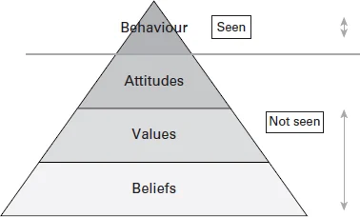

Figure 2: Beliefs, values, attitudes and behaviours (Smith and Mitchell, cited in Taylor and Woodhams, 2022).
To me, being fair involves making decisions that are consistent and transparent, which involves applying processes in the same way for everyone and ensuring that employees understand the purpose behind decisions. Equality complements this by ensuring that all individuals have access to the same opportunities, support, and standards of treatment, regardless of their background, ethnicity, role, or personal circumstances (CIPD, 2026c). Both values will show up visibly in my behaviour by promoting good work through clear, kind and calm communication, rewarding good performance, supporting fair development, and fostering constructive, inclusive relationships across the organisation (Smith and Mitchell, cited in Taylor and Woodhams, 2022).
Consistently applying fairness and equality will be central to my people practice work at Nexxobyte, especially given the issues in the case study. Employees at Nexxobyte have not received fair or equal treatment. This inconsistency has contributed to a decline in trust and affected retention. I will prioritise clear policy development and ensure these policies follow relevant employment legislation. I will also establish consistent processes that apply equally to all teams, ensuring all employees have the same clarity, expectations, and support (Acas, no date).
I will consistently lead by example by modelling these values and behaviours, demonstrating them through my everyday actions and decision-making (CIPD, 2026a). CIPD (2025a) support this and states that transmitting an organisation’s values indicates a long-term strategic dedication to building and maintaining an ethical culture. Finally, I will monitor progress to ensure these changes are embedded effectively, and I will support this by placing all managers onto appropriate managerial training to build capability and consistency (Acas, no date).
A theory I believe suits my practice is utilitarianism. It is a consequentialist ethical theory which focuses on making the best possible decision by prioritising actions that generate the greatest benefit for a large number of people (Marchington et al. 2025). Rousseau (2019) explains that this approach allows professionals to focus on outcomes that will benefit the whole workforce, ensuring decisions reflect good practice rather than individual interests. However, there are some weaknesses if this theory is not utilised appropriately, as CIPD (2015a) argues that the utilitarian approach is only effective if it genuinely produces well-being for all, and therefore, employee well-being should be monitored accurately to ensure it is positively impacting everyone.
(AC 1.3)
Communicating in an informed, clear and confident way to the management team at Nexxobyte is an essential part of my role as a L&D/HR Advisor, especially as I need to convince managers to adapt their way of working. As People Professionals, it is our role to ensure employees, stakeholders and managers are informed, engaged and aligned with Nexxobyte’s organisational goals (Harper, 2023).
To achieve this, I will need to demonstrate confidence and apply influential skills when working with the managers at Nexxobyte. Smith and Mitchell, cited in Taylor and Woodhams (2022), emphasise that having the ability to influence employees in an inclusive and ethical way is crucial; however, it requires a degree of power to do so effectively. Power of this kind can emerge from a sense of passion, supported by clarity and firmness in one’s communication (Harper, 2023). However, it is important to notice and challenge how power is being utilised at Nexxobyte to prevent managers from drifting towards dysfunctional authoritarian leadership styles of management. Professionals who support such models use power to control their subordinates through hierarchical pressures and often have a negative impact on employee well-being and retention (Pizzolitto et al, 2023). Similarly, Vahdati and Moumeni (2021) describe this approach as damaging and unethical.
Therefore, being clear involves expressing information in a concise and logical way, enabling your audience to engage and understand your expectations or instructions (CIPD, 2025b). It allows professionals to build trust and resolve conflicts, which creates a working culture that encourages openness, transparency and respect (Harper, 2023). The clearer we are as People Professionals, the less confusion there will be around organisational priorities (CIPD, 2025b).
One consequence for myself is that, if I do not communicate in an informed, clear, and confident way, I risk damaging my professional credibility and therefore negatively impacting my relationships with employees due to increased levels of misunderstanding, frustration and a lack of trust (Bahrain et al, 2023). For example, poor communication can cause levels of uncertainty due to an inaccurate relay of information, which can have a negative impact on employee well-being, motivation and performance (BFI, 2023). This, in turn, has a further negative consequence for Nexxobyte regarding the way the organisation operates. For example, Bahrain et al. (2023) state that inadequate communication might lead to ambiguous instructions or expectations, meaning employees become uncertain about their duties, deadlines and organisational objectives. This is likely to have a detrimental influence on Nexxobyte’s organisational performance, therefore, increasing workload and pressure for all employees (Tsipursky, 2023).
(AC 1.4)
Unethical workplace behaviour can range from minor offences to illegal acts that harm an organisation, its employees, customers, and wider society (CIPD, 2024a). If I had been employed at Nexxobyte as the L&D/HR Advisor at the time and was aware of these behaviours, I would have responded professionally, following ethical standards and organisational policies.
I would begin investigating the unethical behaviour demonstrated by the line manager who has been accused of approving extensive training events and conferences for his ‘favourite’ team members. I would arrange separate meetings with both administrators in an environment where they feel safe to share their understanding of the situation. I will then begin investigating and gathering factual evidence from both employees and line managers at Nexxobyte regarding what training has been approved in each department to locate patterns based on ethical and unethical decisions. Once I have carefully analysed and understood the data, I will professionally discuss my findings directly with all line managers using the Transactional Analysis (TA) approach developed by Dr Eric Berne (1961) (Budukh, 2021).
Using TA as a communication theory will support me to understand how line managers at Nexxobyte interact through three ego states: ‘Parent, Adult and Child’ (Krausz, 1986). I would use the TA approach to stay in the ‘adult’ state, allowing me to handle the favouritism and misconduct issues calmly, fairly and based on evidence, while professionally managing any defensive or emotional reactions from staff (Krausz, 1986). In more depth, I will clearly communicate and inform the importance of equality within the workplace, and I will clearly state that approving training events should be solely based on the role requirements of the job, budget considerations, and employee needs, rather than personal agendas and individual decision-making.
Regarding the illegal activity involving a former employee who used Nexxobyte’s working hours and equipment to operate his own separate business. According to CIPD (2026b), this could be perceived as a serious case of misconduct and misuse of company resources. As the HR Advisor, I would have approached this by ensuring the concern was investigated promptly and accurately, gathering evidence in line with the organisation’s disciplinary procedures. I would work closely with management to determine whether the behaviour constituted gross misconduct, and I would document all findings thoroughly. Finally, although the individual is no longer employed by the organisation, I would still review whether Nexxobyte’s organisational monitoring and unclear policies contributed to the breach and recommend improvements to prevent this recurrence (Acas, 2023).
I will make it clear to all line managers that they must follow my newly developed diversity and inclusion policy and complete the mandatory anti-discrimination training (GOV.UK, 2026). The formal training may again involve aspects of TA to clearly highlight Nexxobyte’s issues by showing how line managers’ favouritism reflects a ‘critical parent’ approach which lacks fairness and equality (Murray, 2025).
(AC 2.1)
Developing the ability to understand and interpret human behaviour is a fundamental element of effective team management (Dar and Sakthivel, 2022). Extensive research into organisational human behaviours demonstrates that employees who feel included, respected and fairly treated show significantly higher levels of motivation, commitment and effort (Young and Tong, 2025). A motivational theory that recognises this behaviour is Maslow’s Hierarchy of Needs (figure 3). It is a motivational model that separates the human needs into five levels, beginning with basic physiological needs and progressing toward higher-order psychological needs to reach one’s full potential (Maslow and Lewis, 1987). The model proposes that people can only pursue their needs at a higher level once the more fundamental needs beneath them have been effectively met (Poston, 2009).
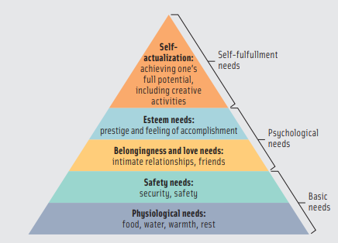

Figure 3: Maslow’s Hierarchy Pryamid (Poston, pp.348, 2009).
Putting this into consideration, employees at Nexxobyte must experience a sense of safety, belonging, recognition, and equitable treatment to increase levels of motivation and effective performance, consistent with the principles outlined in Maslow’s Hierarchy of Needs. Meaning with the development of clear ‘feel-good policies and procedures’, employees at Nexxobyte can develop a sense of safety as everyone will be treated equally and required to follow the same rules based on organisational values and culture. The Profession Map supports this, as valuing people is a core behaviour where all People Professionals are expected to treat others fairly and considerately (CIPD, 2018). Baykal (2020) argues that one benefit of doing so is that it will ensure employees are more inclined to feel satisfied and engaged with their jobs when workplace cultures are fair and inclusive.
Not only does this approach benefit humans, but businesses too, as Madero-Gomez (2022) states, human behaviours such as employees feeling safe, listened to, and treated fairly, naturally contribute to improved organisational outcomes. McKinsey’s (2020) research supports this and confirms that organisations with higher levels of inclusion and diversity often outperform their competing organisations, as their culture enables better decision making, innovation and resilience during challenging periods. Quinetta Roberson’s work further deepens this understanding by emphasising that inclusion depends on employees feeling personally appreciated and able to contribute meaningfully to organisational goals (LSE, 2018). Roberson highlights that inclusion is fundamentally about participation, contribution, and meaningful involvement in organisational work (Roberson et al, 2024). Finally, data shows well-recognised and valued employees are 45% less likely to leave within two years, and those receiving strategic, high-quality praise are 65% less likely to be job-seeking, demonstrating a powerful impact on retention and organisational stability (Yi, 2024).
(AC 2.2)
In response to several complaints regarding unfair practices in staff training, I intend to develop a fair and inclusive Staff Learning and Development Policy. To begin, it is important to base the new Staff L&D policy on CIPD’s inclusivity standards, relevant equality legislation, and the organisation’s own objectives. Starting from this foundation ensures the policy is built on strong moral principles of fairness and inclusivity (CIPD, 2025d).
The next step involves understanding and applying evidence-based practice (EBP) to critically review existing research, similar organisational policies and understand trends from reliable sources (Taylor and Woodhams, 2022). I will then gather evidence by requesting all employees at Nexxobyte to complete an interactive questionnaire to capture patterns and perceptions surrounding what is and is not working well, followed by focus groups to examine the issues in greater depth (Doran et al, 2026). This data will enable me to identify gaps with current policies at Nexxobyte and support me in understanding where additional guidelines, such as individual training budgets, may be required (CIPD, 2025d). Furthermore, CIPD (2025d) highlight the importance of ensuring that L&D policies do not create discriminatory barriers to accessing learning. Therefore, I will provide additional resources and targeted support for underrepresented groups who may require further development opportunities.
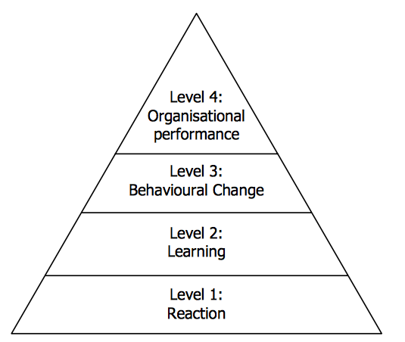
After three months of implementation, I will put clear procedures in place to check whether the new Staff L&D policy is working as intended and still supporting high levels of inclusivity. This is important, as Baska’s (2019) research showed that 70% of L&D professionals feel pressure to measure impact and often don’t know where to begin. Using the Kirkpatrick Model (figure 4) to structure my evaluation, my first step will be to request feedback on the inclusivity of the Staff L&D Policy from employees and compare this with the initial evidence gathered.

Figure 4: The Kirkpatrick Model (Kurt, 2018).
Using this model will help me assess reactions and learning (Levels 1 and 2) by examining changes in participation, engagement and outcomes across different groups within Nexxobyte (CIPD, 2025d). I will then speak with employees, line managers, senior leaders and L&D practitioners to explore behavioural changes and identify any barriers that have emerged, supporting Levels 3 and 4 of the Kirkpatrick model (CIPD, 2025d). Following the review, I will use the findings to refine the policy and develop clear actions to address any gaps or barriers highlighted by employees and managers.

Task 2
Final Word Count: 807 (Excluding Tables)
(AC 2.3)
Table 1 presents feedback from colleagues within the General Resourcing team at Hywel Dda University Health Board (HDUHB), which included one of the administrators and the recruitment advisor, alongside my own reflections as the Recruitment Officer. Together, this feedback involves informing the subsequent diagram by mapping this feedback against the seven CIPD Working Inclusively standards.
Table 1: Feedback From Colleagues Against CIPD’s Six Working Inclusively Standards
CIPD’s Working Inclusively Associate Standards | Feedback from Employees Within My Team Against CIPD’s 6 Associate Standards | My Own Reflections Against CIPD’s 6 Associate Standards
Inclusivity  Get to know people as individuals so you can work together more effectively.  How well do I get to know people as individuals to ensure we can work together more effectively? | Person 1:  Emily always takes the time to understand people's individual work styles, so that she can collaborate more smoothly and effectively with them. For example, I was very new to this recruitment team last year and Emily was so kind and understanding as she knew what it felt like to be a new employee. Emily is always so engaged with others and how they are in work and at home.  Person 2:  You get to know people by taking the time to talk to colleagues and other individuals. You are really good at understanding how people prefer to work and communicate which helps build good relationships with individuals and helps you to get to know people better. | Over my eleven months working as a Recruitment Officer at HDUHB, I have prioritised getting to know colleagues as individuals so we can work together more effectively. Drawing on my previous career as a Primary Teacher, where relationship-building was fundamental, I have applied similar principles in this role.  I have developed strong professional connections through regular 1:1 meetings, shadowing opportunities, collaborative group tasks, and active participation in team discussions. These approaches have enabled me to understand colleagues’ strengths, communication styles, and working preferences, which has enhanced collaboration, trust, and overall team productivity.
Valuing diversity  Actively seek and listen to diverse views and opinions.  How well do I actively seek and listen to diverse views and opinions? | Person 1:  Emily consistently seeks out different perspectives and listens openly to ensure everyone’s views are understood. For example, during team meetings Emily ensures everyone’s opinion has been heard before she offers her own. When she does offer guidance, it is always with our best interest at heart.  Person 2:  You will actively seek out perspectives different from your own, you listen with curiosity, not defensiveness and you use that information/perspective to shape your decisions and actions. For example, at team meetings you will encourage others to voice their opinions on topics you bring up, and you are always happy to use suggestions others bring to the table. | I recognise the importance of being an active listener rather than offering my views without first understanding others’ perspectives. As HDUHB moves away from hierarchical thinking based on banding, I strongly believe in treating everyone as equal, regardless of pay grade. Creating space for all colleagues to voice their opinions supports engagement, belonging, and shared purpose.  Feedback from colleagues highlights my strengths in team discussions, demonstrating my commitment to listening to diverse viewpoints.
Building relationships  Build purposeful working relationships with and collaborate with wider colleagues.  How well do I build purposeful working relationships and collaborate with wider colleagues? | Person 1:  Emily takes time to understand each hiring manager’s needs within the recruitment process and works closely with wider teams such as finance, to make sure every stage runs smoothly and candidates have a positive experience.  Person 2:  You build relationships by understanding what colleagues are trying to achieve, for example you will reach out early in a project to understand expectations and what the end goal is. You bring enthusiasm and a positive attitude, and you are able to adapt your communication style depending on who you are working with. | I build purposeful working relationships by collaborating closely with colleagues across the wider workforce. I work particularly well with the Nursing, Medical and Consultant teams, ensuring clear communication around recruitment procedures. Within the Nursing team, we regularly support one another by sharing vacancies during busy periods, and my involvement in the nursing onboarding process has strengthened cross-team understanding.  As I am still new to the role, I have expressed to my line manager my interest in shadowing other areas within Workforce to broaden my knowledge of different functions and further enhance my ability to collaborate effectively across the organisation. I enjoy meeting and speaking to new people so I feel like this experience would benefit my professional development further.
Sharing knowledge  Readily share your knowledge and expertise with others to solve problems.  How well do I readily share my knowledge and expertise with others to solve problems? | Person 1:  Emily readily shares her recruitment knowledge and expertise, offering practical guidance and solutions whenever challenges arise so the team can move forward confidently.  Person 2:  You will proactively share advice/information instead of waiting for someone to ask a question. You are very good at explaining the why to things, you don't just give the answer, but you'll give more context to help people understand the bigger picture. You are also great at documentation information whether it's updating QRGs or forwarding an email to everyone with useful information you have come across but feel the team would benefit from and so the team will know the answer for next time. | In my role as a recruitment officer, I actively share my knowledge and experience to support colleagues and contribute to effective problem-solving. I recognise that recruitment processes can be complex, so I make a conscious effort to explain procedures clearly, offer guidance, create step by step visual instructions and provide practical solutions when challenges occur.  I have recently created a ‘staff shoutout’ board to regularly share and celebrate best practice. By being approachable and willing to assist, I help create a collaborative environment where issues are resolved quickly and learning is continuous. I like it when my colleagues ask me for support and guidance and am always open to share my knowledge to support others around me.
Conflict resolution  Support others to resolve conflict and build trust before issues escalate.  How well do I support others to resolve conflict and build trust before escalating issues? | Person 1:  Emily supports others to resolve conflict by staying calm, listening to both sides, and helping people find common ground, which builds trust and prevents issues from needing to be escalated.  Person 2:  You are great at building the trust, the team know they can come and talk to you for advice, help with problem solving, people know you will always listen they feel comfortable raising concerns early. You also are great at understanding the root issue rather than focusing on symptoms or personalities of the conflict. You are also good at knowing when escalation is appropriate. | In my role as a recruitment officer, I recognise the importance of addressing concerns early to prevent conflict and maintain trust within the team. I make a conscious effort to remain approachable and calm, encouraging colleagues to share issues before making irrational decisions. When tensions arise, I listen carefully to each problem, clarify misunderstandings, and help colleagues find helpful solutions.
Psychological safety  Encourage others to recognise when they need help, to admit mistakes, and share concerns and ideas.  How well do I encourage others to recognise when they need help, to admit mistakes, and share concerns and ideas? | Person 1:  Emily encourages others to recognise when they need help by creating a safe, open environment where people feel comfortable admitting mistakes and sharing concerns or ideas.  Person 2:  When colleagues have been unsure about something, you encourage them to talk it through so you can solve it together, you'll also often share what you've learned from past mistakes to show that it’s normal to make mistakes which helps the team know it's ok to make mistakes and learn to from it. | I aim to create an environment where colleagues feel comfortable acknowledging when they need support, discussing mistakes, and sharing ideas openly.  I model this by being transparent about my own learning needs and demonstrating that asking for help is a strength, not a weakness. By listening without judgement and offering guidance, I help build a culture of trust and safety.

The feedback from my colleagues played a central role in shaping the focus of my review. By highlighting several strengths, it enabled me to critically evaluate how closely my day-to-day behaviours align with CIPD’s Working Inclusively standards. However, I would like to be able to understand where further growth is required, ensuring that feedback isn’t solely grounded on positive external observations.
(AC 3.1)
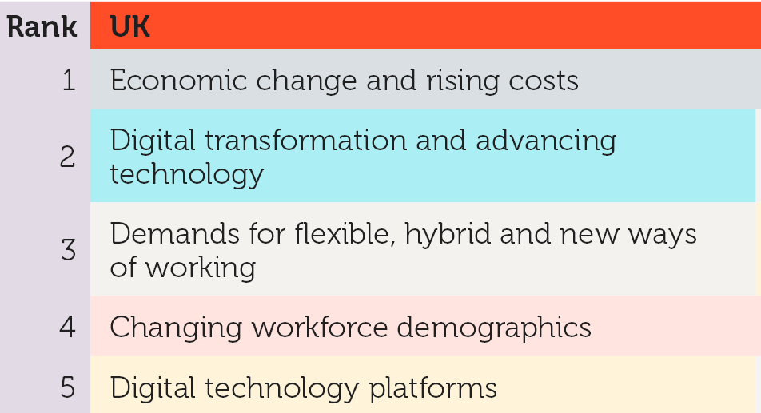
Over the past decade, the role of a recruitment advisor has evolved in many ways to adapt to shifting employee expectations, new ways of working, changes in recruitment and societal values (CIPD, 2025c). Figure 4 indicates the primary drivers of organisational change in the United Kingdom (UK), which naturally have an impact on the People Profession (Peters, 2023). The two factors that I will examine are the influence of advancing technology on the evolving role of people practitioners and the increasing organisational demands for flexible and hybrid working arrangements.

Figure 1: Top Five Drivers of Change for Organisations in the UK (Peters, pp.6, 2023).
The rapid advancement of digital technologies is significantly reshaping the role of the People Professionals within recruitment, as it is evolving at such a pace that many professionals currently lack the capacity, technological infrastructure, or skills to keep up (Wiebusch, 2025). For recruitment advisors, the increasing use of Artificial Intelligence (AI) is creating new challenges, as the CIPD (2023b) highlight that AI has substantial implications for people management, particularly when ensuring it is used safely, fairly and acceptably by all employees.
This has several implications for my CPD as a Recruitment Officer. Applicants are increasingly using AI to enhance their applications and interview responses. As a result, I am finding it more challenging to judge authenticity and to confidently advise frustrated hiring managers with next steps because there is no actual way to know whether AI has been used. This highlights a skills gap in my own practice, and therefore, I now need to develop a stronger understanding of how these tools work, the ethical risks involved, and how to support managers to deal with AI-related processes without accusing potential talent.
A second development is the growing organisational demand for flexible and hybrid working arrangements. Peters (2023) argues that hybrid working is reshaping the role of People Professionals, who must develop working practices and policies that maintain flexibility and ensure fairness across detached teams. This shift also requires practitioners to support managers who lead employees they may not regularly see (Mutebi and Hobbs, 2022). It also requires a higher level of clarity, exceptional communication and technical ability, alongside having a greater awareness of employee wellbeing (CIPD, 2024b). Research by Mutebi and Hobbs (2022) highlights that hybrid working can positively influence work–life balance, yet it also increases risks like reduced social interaction, increased loneliness, higher levels of screen time and potential negative impacts on both mental and physical health.
To conclude, this has clear implications for my professional development, particularly as hybrid working continues to evolve and has expanded significantly since COVID-19. I need to build greater confidence in supporting wellbeing, inclusion and flexible working requests, especially as my employment-law knowledge is still developing. Strengthening these areas will help me understand the relevant processes and enable me to guide and advise managers and employees effectively in line with hybrid and flexible working policies (McCartney, 2025).
(AC 3.2)
Upon reflection, and drawing on the feedback I received from colleagues, Table 2 illustrates my current strengths, weaknesses, and development needs in relation to people practice.
Table 2: Current Strengths, Weaknesses and Development Areas
Trends taken from Feedback (Q7) and Research (Q8) | Personal Assessment from Feedback (Q7) and Research (Q8) in Relation to People Practice
Strengths
Strong communicator | Being a strong communicator within my current role as a Recruitment Officer helps to build trust and enables me to support colleagues and managers with confidence and clarity. It allows me to confidently explain and direct colleagues where necessary whilst allowing others to have their opinion and be heard too which is essential when working within People Practice.
Kind, caring and empathetic | Kindness has always been my core value of mine and assessing its impact within the People Practice environment shows that it helps me build relationships, supports others wellbeing and establish trust in my team. Being able to be an active listener through showing empathy and understanding is also a key skill when working with people.
Weaknesses
Confidence in data and analytics | I currently have limited experience in interpreting and analysing complex data sets. I enjoy using Excel, but I recognise that further developing my data skills would enhance the quality of information I produce and increase my efficiency. Given the volume of data within People Practice and across Hywel Dda, strengthening my confidence in this area will enable me to contribute more effectively.
Understanding of people practice laws and regulations | As I am new to this role and with a background in Education my understanding on employment law is limited. I am interested in finding out more about legal policies and legislation and how this is actioned and utilised within workforce.
Development
Attend employment law workshops | I want to expand my employment law knowledge by attending workshops and training sessions within the CIPD and Hywel Dda. This will help me provide more informed guidance for my colleagues and will allow me to support and advise managers effectively.
Improve data skills and understanding | I intend to improve my data skills in order to generate more clear and meaningful information, improve the efficiency of my working methods, and better support my team in developing these competencies as well.

(AC 3.3)
Over the next six months, I intend to develop my data and analytical skills through a combination of online and practical learning within my role. I’ve selected this area because I want to increase my confidence and understanding when working with data. I believe it is essential for me to have a deeper understanding of patterns within recruitment and the wider organisational context. To achieve this, I will be undertaking training run by Microsoft, which has been arranged for all recruitment teams within my department at Hywel Dda. The course will enable me to develop more advanced skills in formulas, formatting, and efficiency-enhancing techniques, as well as in creating tables, charts and data sets.
Another development activity I plan to undertake is training focused on the use of AI within recruitment. My aim is to build my confidence when applying and teaching team members within the team how to utilise AI tools for tasks such as enhancing job adverts, streamlining processes, but also to deepen my understanding of the ethical and practical considerations involved in AI, as this is often a concern within recruitment, as mentioned above.
(AC 3.4)
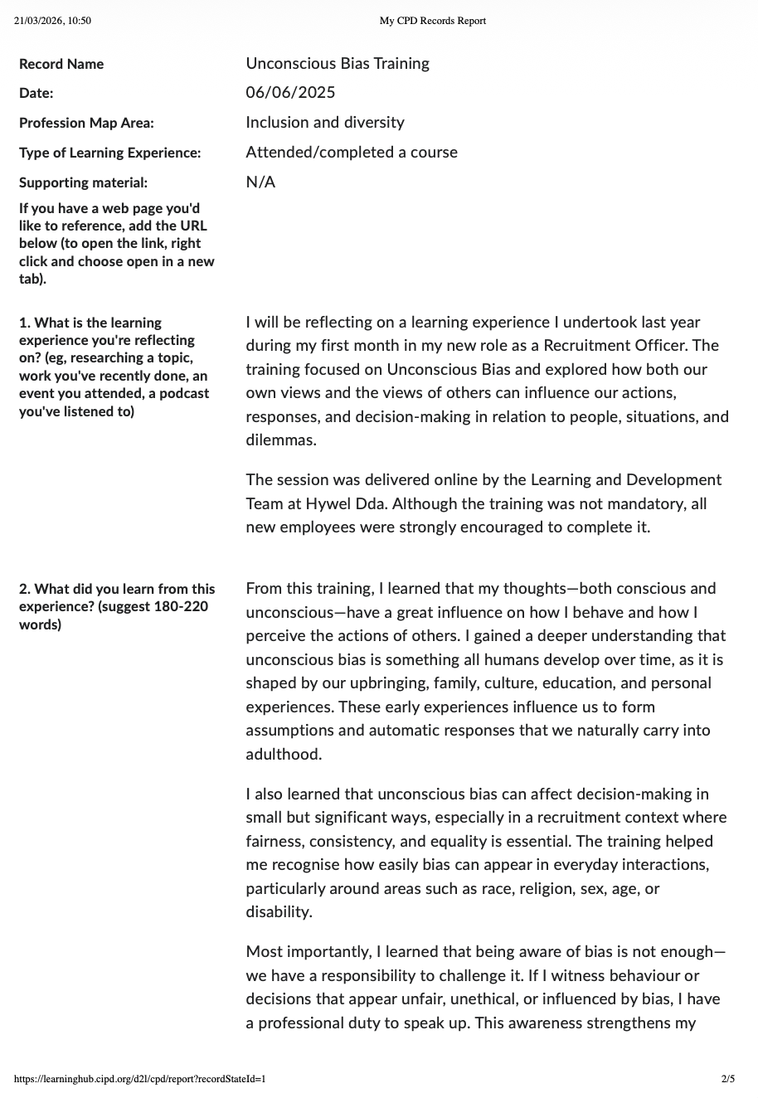
I have attached extracts from my CIPD Reflection Tool below. These reports contain self-reflections on two separate learning experiences that I have undertaken over the past year, each of which has significantly influenced my professional behaviour and performance.
Reflection 1

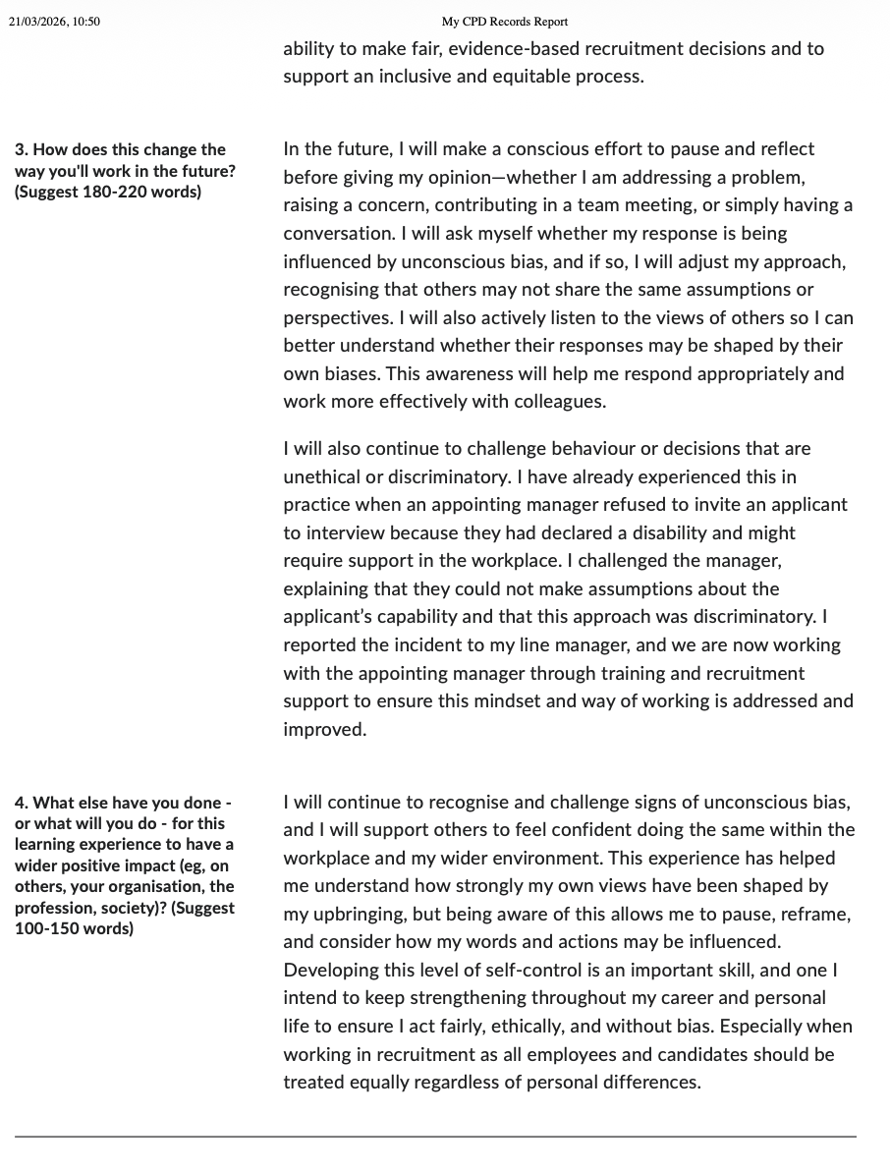

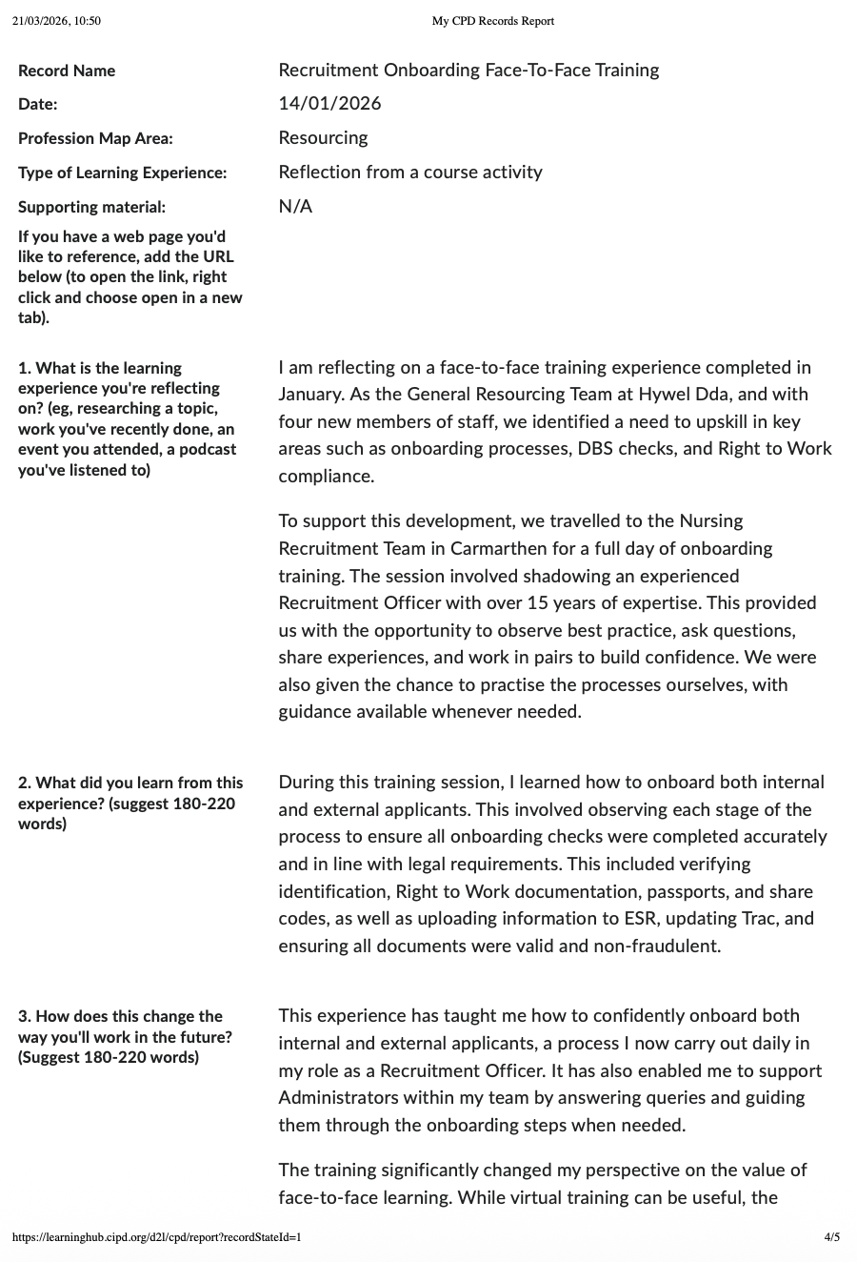
Reflection 2
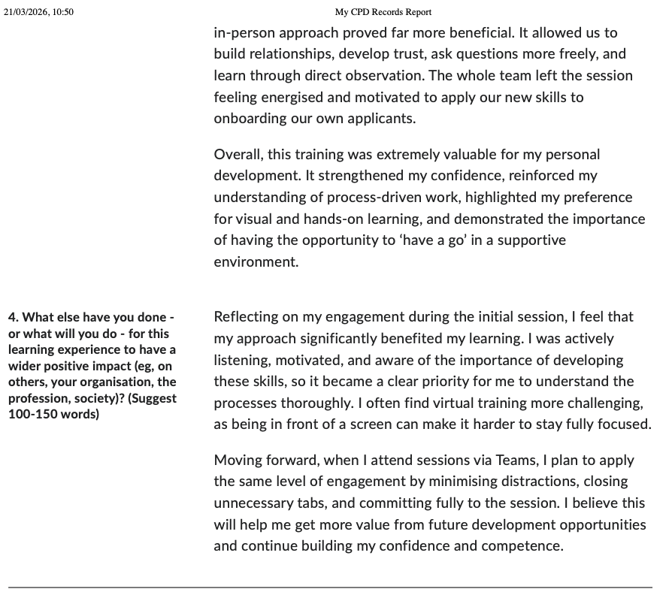

References
Acas (2023) Equality, diversity and inclusion – What are they. Available at: https://www.acas.org.uk/improving-equality-diversity-and-inclusion (Accessed: 23 February 2026).
Acas. (n.d.) Conflict Management and Leadership - Acas Training. Available at: https://www.acas.org.uk/dispute-resolution-acas-training-courses (Accessed: 2 March 2026).
Baska, M. (2019) ‘Majority of L&D professionals feel ‘growing pressure’ to measure impact’, People Management, 14 February. Available at: https://www.peoplemanagement.co.uk/article/1744738/majority-learning-development-professionals-feel-growing-pressure-measure-impact (Accessed: 23 March 2026).
Baykal, E. (2020) Handbook of research on positive organisational behaviour for improved workplace performance. Hershey, IGI Global.
Bahrain, N.K, Sakrani, S.R. and Maidin, A (2023) ‘Communication barriers in work environment: understanding impact and challenges’. International Journal of Academic Research in Business and Social Sciences, 13(11), pp.1489-1503. Available at: http://dx.doi.org/10.6007/IJARBSS/v13-i11/19498
Budukh, M. (2021) Developing and Evaluating a Training Programme for Leadership Behaviours Focusing on Psychological Theory of Transactional Analysis. Doctoral dissertation. The University of Waikato. Available at: https://researchcommons.waikato.ac.nz/server/api/core/bitstreams/5b5eb327-bf2c-4772-9577-dc7457e577c5/content (Accessed 12 March 2026)
CIPD (no date) Working inclusively standards. Available at: https://www.cipd.org/uk/the-people-profession/the-profession-map/explore-the-profession-map/core-behaviours/working-inclusively/ (Accessed: 22 March 2026).
CIPD (2015a) Ethical decision-making: Eight perspectives on workplace dilemmas. London: Chartered Institute of Personnel and Development. Available at: https://www.cipd.org/globalassets/media/comms/the-people-profession/profession-map-pdfs/ethical-decision-making-2015-eight-perspectives-on-workplace-dilemmas_tcm29-9564.pdf Accessed: 20 January 2026).
CIPD (2015b) From best to good practice HR: Developing principles for the profession. London: Chartered Institute of Personnel and Development. Available at: https://www.cipd.org/globalassets/media/comms/the-people-profession/profession-map-pdfs/pff-report-update-pffmay20_tcm29-8731.pdf
CIPD (2018) The CIPD Profession Map. Available at https://www.cipd.org/uk/the-people-profession/the-profession-map/explore-the-profession-map/ Accessed: 21 February 2026).
CIPD (2023) The importance of people management: Analysis of its impact on employees. Available at: https://www.cipd.org/uk/knowledge/reports/importance-of-people-management/ (Accessed: 21 February 2026).
CIPD (2023b) Using AI responsibly in people management. Available at: https://www.cipd.org/uk/views-and-insights/thought-leadership/insight/ai-people-management/ (Accessed: 17 March 2026).
CIPD (2024a) Ethics at work: An employer’s guide. Available at: https://www.cipd.org/uk/knowledge/guides/ethics-work-guide/ (Accessed: 23 February 2026).
CIPD (2024b) People manager guide: Supporting hybrid working. Available at: https://www.cipd.org/uk/knowledge/guides/line-manager-supporting-hybrid-working/ Accessed: 18 March 2026).
CIPD (2024c) People analytics: Guide for people professionals. Available at: https://www.cipd.org/uk/knowledge/guides/analytics-practitioner-guide/ (Accessed: 6 January 2026)
CIPD (2025a) Analysis | Recognition of the HR function in organisations. Available at: https://www.cipd.org/uk/views-and-insights/thought-leadership/insight/hr-function-organisations/ Accessed: 21 February 2026).
CIPD (2025b) Employee communication. Available at: https://www.cipd.org/uk/knowledge/factsheets/employee-communication/ (Accessed: 13 March 2026).
CIPD (2025c) Analysis: Evolution of the people profession. Available at: https://www.cipd.org/uk/views-and-insights/thought-leadership/insight/evolution-people-profession/ (Accessed: 13 March 2026).
CIPD (2025d) Learning and development strategy and policy. Available at: https://www.cipd.org/uk/knowledge/factsheets/strategy-development-factsheet/ (Accessed: 22 March 2026)
CIPD (2026a) Ethical practice and the role of people professionals. Available at: https://www.cipd.org/uk/knowledge/factsheets/ethics-role-hr-factsheet/#assessing-and-reinforcing-ethical-behaviours
CIPD (2026b) Discipline and grievance at work. Available at: https://www.cipd.org/uk/knowledge/factsheets/discipline-factsheet/ (Accessed: 02 March 2026).
CIPD (2026c) Equality, diversity and inclusion (EDI) in the workplace. Available at: https://www.cipd.org/uk/knowledge/factsheets/diversity-factsheet/ (Accessed: 02 March 2026).
Dar, S.A. and Sakthivel, P (2022). Maslow’s hierarchy of needs is still relevant in the 21st century. Journal of Learning and Educational Policy, 2(5), pp.1-9. Available at: https://doi.org/10.55529/jlep25.1.9
Doran, J., Kirby, A. and Bourke, J (2026) Survey & questionnaire design: Collecting primary data to answer research questions. Axel NEEFS.
Department for Business, Innovation and Skills (2013) The business case for equality and diversity: a survey of the academic literature. Available at: https://assets.publishing.service.gov.uk/media/5a78d762e5274a277e68fe2c/the_business_case_for_equality_and_diversity.pdf (Accessed: 22 March 2026).
GOV.UK (2026) Employers: preventing discrimination. Available at: https://www.gov.uk/employer-preventing-discrimination/discrimination-in-work (Accessed: 1 March 2026).
Harper, J (2023) Talk the talk: The importance of effective communication in HR strategy. Available at: https://www.thehrdigest.com/talk-the-talk-the-importance-of-effective-communication-in-hr-strategy/ (Accessed: 24 February 2026).
Krausz, R. R. (1986). Power and leadership in organisations. Transactional Analysis Journal, 16(2), 85-94. Available at: https://doi.org/10.1177/036215378601600202
Kurt, S. (2018) Kirkpatrick Model: Four Levels of Learning Evaluation. Available at: https://educationaltechnology.net/kirkpatrick-model-four-levels-learning-evaluation/ (Accessed: 30 January 2026).
London School of Economics and Political Science (LSE) (2018) The value of diversity and inclusion. Available at: https://www.lse.ac.uk/management/news/quinetta-roberson-091018 (Accessed 5 March 2026).
Marchington, M., Wilkinson, A., Donnelly, R., and Kynighou, A. (2020) Human Resource Management at Work: The Definitive Guide. 7th edn, CIPD, Kogan Page.
Maslow, A. and Lewis, K.J., (1987). Maslow's Hierarchy of Needs. Salenger Incorporated, 14(17), pp.987-990. Available at: https://doi.org/10.5281/zenodo.15240897 (Accessed: 03 March 2026).
McKinsey & Company (2020) Diversity Wins: How Inclusion Matters. Available at: https://www.mckinsey.com/~/media/mckinsey/featured%20insights/diversity%20and%20inclusion/diversity%20wins%20how%20inclusion%20matters/diversity-wins-how-inclusion-matters-vf.pdf (Accessed 03 March 2026).
McCartney, C. (2025) Flexible and hybrid working practices in 2025. London: Chartered Institute of Personnel and Development. Available at: https://www.cipd.org/globalassets/media/knowledge/knowledge-hub/reports/2025-pdfs/8909-flexible-working-report-web.pdf (Accessed: 8 March 2026).
Madero-Gomez, S (2022) ‘Perception of Maslow’s hierarchy of needs and its relation to human talent attraction and retention factors’. Consduria y Administration. 68 (1), 2023, 1-24 http://dx.doi.org/10.22201/fca.24488410e.2023.3416
Merlin, C (2026) ‘The legal risks of AI-driven recruitment and redundancy (and how to govern them properly)’, HRZone, 6 December. Available at: https://hrzone.com/the-legal-risks-of-ai-driven-recruitment-and-redundancy-and-how-to-govern-them-properly/ (Accessed 17 March 2026).
Mutebi, N and Hobbs, A. (2022) The impact of remote and hybrid working on workers and organisations. London: UK Parliament Post. Available at: https://researchbriefings.files.parliament.uk/documents/POST-PB-0049/POST-PB-0049.pdf (Accessed 10 March 2026).
Murray, H. (2025) Transactional Analysis Theory & Therapy: Eric Berne. Simply Psychology. Available at: https://www.simplypsychology.org/transactional-analysis-eric-berne.html (Accessed 23 February 2026).
Page, N (2022) ‘Ten tips for successful influencing’, HR Zone, June 2022. Available at: https://www.hrmagazine.co.uk/content/insights/ten-tips-for-successful-influencing (Accessed: 21 February 2026).
Pizzolitto, E., Verna, I. and Venditti, M (2023). Authoritarian leadership styles and performance: a systematic literature review and research agenda. Manag Rev, vol 73, 841–871 (2023). https://doi.org/10.1007/s11301-022-00263-y
Peters, R. (2023) People Profession 2023: UK and Ireland survey report. London: Chartered Institute of Personnel and Development
Poston, B., 2009. Maslow’s hierarchy of needs. The surgical technologist, 41(8), pp.347-353. Available at: https://www.ast.org/pdf/308.pdf (Accessed 03 March 2026).
Roberson, Q.M, Moore, O.A. and Bell, B.S (2024) An active learning approach to diversity training. Academy of Management Review, 49(2), pp.344-365. Available at: https://doi.org/10.5465/arnr.2020.0231
Taylor, S. and Woodhams, C. (2022). Studying Human Resource Management: A Guide to the study, context and practice of HR. 3rd ed. Kogan Page
Tsipursky, G. (2023) ‘Poor communication may be slowing down your team’, Harvard Business Review, 18 October. Available at: https://hbr.org/2023/10/poor-communication-may-be-slowing-down-your-team (Accessed: 24 February 2026).
Wiebusch, N. (2025) ‘The AI workplace revolution: What HR needs to know now’. HRZone, 29 May. Available at: https://hrzone.com/the-ai-workplace-revolution-three-focus-areas/ (Accessed: 13 March 2026).
Young, J. and Tong, D. (2025) CIPD Good Work Index 2025. London: Chartered Institute of Personnel and Development.
Valecha, N (2022). A study on importance of ethical responsibilities in HR management. International Journal for Global Academic & Scientific Research, 1(1), pp.13-22. Available at: https://doi.org/10.55938/ijgasr.v1i1.7
Vahdati, H. and Moumeni, M (2021). The Effect of Authoritarian Leadership on Human Resource Ostracism with Mediating role Emotional Burnout. Management Studies in Development and Evolution, 30(102), pp.97-123.
Yi,R (2024) Employee retention depends on getting recognition right. Available at: https://www.gallup.com/workplace/650174/employee-retention-depends-getting-recognition-right.aspx (Accessed 5 March 2026).

