06/02/2025

Construction materials
Framing material in high rise-buildings

Produced by Louis James (2415463)
Construction Materials (ACBA4016)
Table of Contents
Introduction 4
Case Study – Burj Khalida, Dubai 4
Framing Material Choice 4
Material Strength, Durability and Climatic Resistance 5
Environmental Conditions 5
Framing Material original process 5
Impact to local community and the environment 6
Ease of assembly and adaption 6
Case Study – National Stadium Beijing. 7
Framing Material Choice 7
Material Strength, Durability, and climatic Resistance 8
Environmental Conditions 8
Framing Material Original process 9
Impact to local community and environment 9
Ease of Assembly and adaption 9
Properties in Concrete and Steel 10
Advantages 10
Disadvantages 12
References 14

Figure List
Figure 1: Burj Khalifa structure. [online] Available at: 1301-brief-on-the-construction-planning-of-the-burj-dubai-project-dubai-uae.pdf [Accessed 28th March 2025]
Figure 2: Tension, Compression and Shear Forces. [online] Available at: Modeling Loads on Structures Using "Human Molecules” - Activity - TeachEngineering [Accessed 28th March 2025]
Figure 3: Buttressed core system [online] Available at: Burj Khalifa: The world’s tallest building – Bloggers unite [Accessed 28th March 2025]
Figure 4: National Stadium Beijing [online] Available at: 226 National Stadium – Herzog & de Meuron [Accessed 28th March 2025]
Figure 5: Exterior Structure design phase [online] Available at: 226 National Stadium – Herzog & de Meuron [Accessed 28th March 2025]
Figure 6: Exterior structure final design [online] Available at: 226 National Stadium – Herzog & de Meuron [Accessed 28th March 2025]

Introduction
In the construction industry, both concrete and steel are primarily used as a material choice for the structural frame of a building. Each material has its own characteristics that contribute to the structure's strength, durability, and longevity of the project. The following report evaluates high-rise habitable structures constructed of concrete and steel.

Case Study – Burj Khalida, Dubai
The Burj Khalifa, located in Dubai, United Arab Emirates famously known as the world’s tallest building standing at ‘828’ (Guinness World Records n,d ). The Burj Khalifa is primarily constructed with reinforced concrete in order to support the load weight of the structure. The Burj Khalifa implements a Y shaped floor plan allowing for natural use of ventilation and future possibilities of adaption.

Framing Material Choice
The primary framing material used to construct the Burj Khalifa is reinforced concrete, installed from foundation level to the 156th floor level (CTBUH Research Paper, 2008). Figure 1 visualises the amount of concrete that was installed throughout the structure, as shown concrete was installed throughout the core providing stability and greater load bearing capacity in comparison to materials such as steel (ArchEyes, 2024).
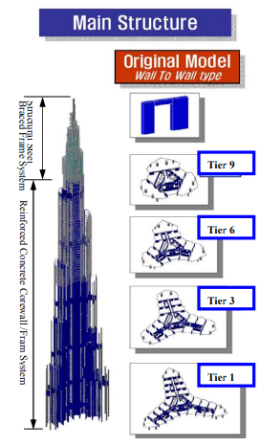
Figure 1: Burj Khalifa Structure

Due to the significant height of the Burj Khalifa natural forces such as wind will act upon the structure potentially leading to a plethora of issues. (James Aldred, 2017) stated concrete has significant benefits in terms of limiting movement, and the high strength is necessary to reduce the cross-section of vertical elements.

Material Strength, Durability and Climatic Resistance
Concrete is used in a variety of construction projects as its properties include high strength, durability, and resistance to corrosion. As interpreted from (ScienceABC, 2023) concrete is weak under tension and shear forces, yet excels under compression forces. Figure 2 gives the reader an understanding of the various forces a material will act against.
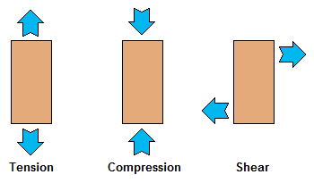
Figure 2: Tension, Compression and Shear forces.

As a result of the height of the Burj Khalifa natural forces such as gravity will act upon the structure through compression, because of this the core of the Burj Khalifa is constructed with reinforced concrete (Instron, n.d) strengthening the tensile load.
Concretes characteristics thrive under the extreme heat conditions in Dubai, as concrete has a high thermal mass. (YourHome, 2020) explains the thermal mass is the ability a building can absorb, store and release heat reducing the building's energy consumption.

Environmental Conditions
Dubai experiences a desert climate featuring extreme heat, leading to water evaporation within the concrete, as interpreted from (Nachi, n.d) most of the water mixed into the aggregates will evaporate causing shrinkage cracks. In order to minimise the likelihood of this occurring (Instron, n.d) states all pumping took place at night.
Furthermore (ACAA, n.d) explains that the concrete incorporated a mix containing fly ash in order to control peak temperatures, minimising the risk of cracks during the mass placement in the desert climate. As a result, the methods and techniques used ensured the durability and structural stability of the structure.

Framing Material original process
During the construction of the Burj Khalifa (Commercial Interior Design, 2023) provides evidence that 330,000m³ of concrete was used.
As stated from (Axtell, n.d), Concrete is a composite material, consisting of cement, which is considered the “glue” that binds all the other materials together, additionally coarse aggregates such as gravel, fine aggregates for example sand, water and finally additives. During the production process of concrete the primary ingredient is cement. As stated from (Science Museum, n.d.) cement production generates 2.5 billion tonnes of Carbon Dioxide (CO2) equivalent to 8% of the global total.

Impact to local community and the environment
The construction of the Burj Khalifa had positive and negative impacts on the local community and environment.
In a result of the projects large scale numerous jobs were created benefiting the local and nearby community (sothebysrealty, n.d) noted approximately 12,000 workers were involved in the construction of the Burj Khalifa, this led to further implications (migrant rights, n.d) stated workers toiled 12 hours days, 6 days a week on minimal pay leading to protests and strikes.
After the completion of the project, facilities inside the Burj Khalifa include hotels and residential accommodation as well as restaurants attracting tourists worldwide. On average 17 million people per year visit Dubai (Ice, n.d). Tourism is a huge factor that benefits the local economy, providing jobs for the local community reducing poverty.
The materials used to construct the structure posed environmental problems, as stated previously the manufacturing process of concrete is an energy consuming process, negatively contributing to the worlds carbon footprint, however the structure has sustainable features in order to minimise further emissions into the atmosphere (Ice, n.d) states the Burj Khalifa used solar panels, which heat more than 140,000 litres of water daily, additionally the structure includes an irrigation system that collects condensation from the air conditioning, proving 15 gallons of water yearly.

Ease of assembly and adaption
The Burj Khalifa was designed incorporating a buttressed core structural system, The structure implements a Y shaped base which was inspired by the regional desert flower Hymenocallis (Burj Khalifa, n.d), the purpose of this design was not only for aesthetic appeal but to ensure the structural stability and to ‘reduce the wind forces on the tower’ (Novak, L, 2023).
As stated from (Lueste, 2023) throughout the construction of the project, advanced construction techniques were employed during the installation of the concrete, such as reinforcing concrete and slip forming. Slip forming is the process of continuously pouring concrete without the need of formwork. The use of these techniques allowed the structure to withstand higher stress loads and reducing the overall project time phase.
As a result of the Burj Khalifa’s Y shaped floor plan modular construction was used allowing a possibility for future adaptions (Indovance Blog, 2022). as stated from (Boury, A, 2024) modular construction minimises the waste on site, Employee injuries and fatalities as a result of less members required on site during construction and increases project efficiency and overall construction period.
The design and structural system used throughout the structure allows for potential adaptions past original construction. As shown in figure 3 the buttressed core system consists of a three-winged structure attached to a central hexagon core (Berkheimer-Lubeck, C, n.d). As the structure is an open layout the internal floor spaces are provide an option for future adaptions such as office spaces, residential or hotel accommodation.
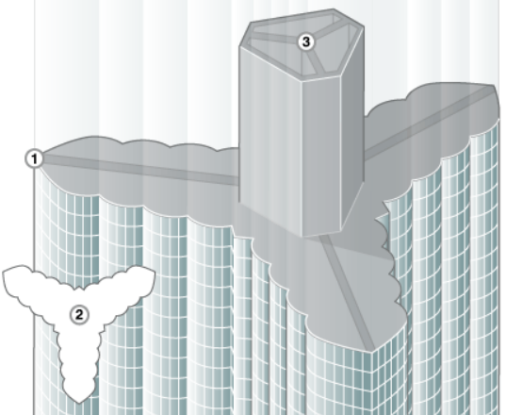
Figure 3: Buttressed Core System

The design of the Burj Khalifa incorporated sustainable practices, (Volume Zero, n.d) states the structure implements reflective glazing, therefore reducing the solar gain and improving the efficiency. Reflective windows can be reused allowing a sustainable option for other projects also there is an option to adapt the glass with electrochromic technology, this is a process in which the windows can change its transparency or tint minimising usage of artificial lighting.

Case Study – National Stadium Beijing.
The National Stadium, Beijing, China is commonly known as the ‘birds nest’, designed for the 2008 Olympics, the Stadiums designs features inspiration from natural structures and Chinese philosophy. The structures structural system is constructed with Steel providing durability and resistance to seismic activity.

Framing Material Choice
As shown in figure 4 the complex design of the National Stadium required a material able to support large spans and columns whilst curved at great hights. The National Stadium was constructed using steel framework, chosen for its high strength to weight ratio and its durability under ‘tension’ as stated from (TEVEMA Marketing, 2024).
The use of steel allowed architects Jacques Herzog and Pierre de Meuron (Irving, M, 2025) to accomplish the external lattice structure. (‌World Construction Network, 2024a) Provides evidence that the outer steel frame structure is separated by a 50ft gap from the inner concrete structure, in order to withstand earthquakes whilst ensuring the structure does not encounter potential structural failures
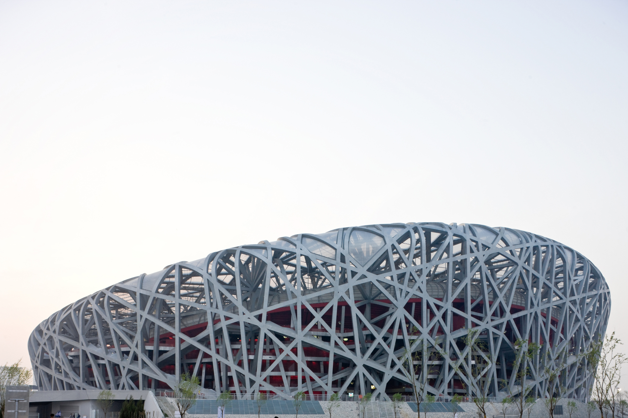
Figure 4: National Stadium Beijing

Material Strength, Durability, and climatic Resistance
According to (Build Using Steel, n.d) Steel is commonly used in high-rise construction projects for its strength and durability whilst being adaptable, which allow complex designs such as the National Stadium possible. (Tekla, n.d) states the largest span of the steel structure is more than 343 meters illustrating the strength to weight ratio steel possess.
As stated from (‌Universal College of Engineering, 2021) due to the size of the structure the foundation is as deep as 37m below ground, this led to a new grade of steel being developed ensuring the material was resistant to seismic activity.

Environmental Conditions
China’s climate varies across the country, as the National Stadium is located in Beijing, north China. This region of the country experiences summer temperatures and in the winter periods of wet weather and cold spells. (Albatros Adventure Marathons, n.d.). The design of the stadium incorporates open spaces allowing natural ventilation and comfort whilst in use in elevated temperatures (Arquitectura Viva, n,d).
As stated from (GFDRR, 2020) China lies right in the region where the Eurasian, Pacific, and Indian Ocean plates meet resulting in tectonic plate movement which cause China to suffer from frequent earthquakes.

Framing Material Original process
(Siscol, n,d) Provides evidence that the National Stadium was constructed with 42,000 tonnes of steel making it the world’s largest steel framed structure.
Steel is composed of two primary elements, Iron and Carbon and may contain other elements such as manganese and chromium which provide further strength and resistance to common issues of steel (‌cliftonsteel, n,d). Although steel is a fully recyclable material, (voestalpine Metsec, 2020) explains that the production of steel accounts for 6% of the worlds CO2 emission however in recent years the steel industry has begun to use more efficient processes reducing the amount of energy used to produce steel.

Impact to local community and environment
The construction of the National Stadium contributed to both positive and negative impacts to the local community and environment. The construction of the Stadium created thousands of jobs for the community according to (Mondoworldwide, 2011) it took 17,000 workers to construct the iconic stadium however this led to further issues, (FPIF, n,d) illustrates the unfair treatment and disregard for their welfare, the article also states workers and members of the local community where forced out of the city ahead of the Olympics. Beijing significantly benefited economically from the construction of the Stadium. (The US-China Business Council, 2008) stated that Beijing seen an increase in tourism following the completion of the National Stadium.
The production process of the framing materials used to construct the structure contributed negatively to environment however as stated from (‌Olympics, 2004) the stadium incorporated an energy saving design by using natural ventilation and lighting ensuring it meets the ‘green Olympics’ ambition to reduce pollution.

Ease of Assembly and adaption
The design of the National Stadium commonly known as the ‘birds’ nest’ due to its exterior steel lattice structure (Rethinking the future, n.d) provides evidence that the structure mimics the strength and efficiency that can be found in natural systems such as a bird’s nest. Figures 5 and 6 visualise the exterior structure and the resemblance to the nickname. As stated from (‌World Construction Network, 2024b) the stadium’s iconic design was also inspired by Chinese philosophy symbolising balance and harmony.
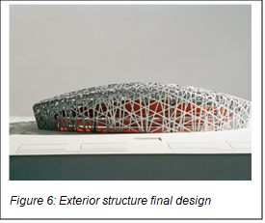
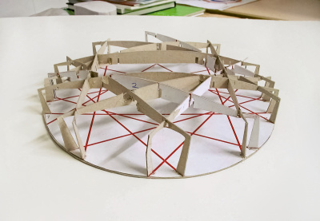
Figure 5: Exterior structure design phase

(‌Herzog & de Meuron., n.d) shown the construction of the stadium and techniques used, the outer steel frame was prefabricated in sections before it was transported to site and welded ensuring accuracy and efficiency during the installation of the frame, the use of modular construction also enhances the ease of potential disassembly for future adaptions.
After the buildings intended use for the Olympics, the stadium has been underused leading to potential adaptions to help boost attraction and ensure the structure is in use frequently. As stated from (Schindler Group, 2024) the venue hosts to large scale events, such as sports competitions and concerts. In recent years, between December and February, it transforms into the Ice and Snow Festival, However the large open spans will allow for permanent adaptions such as hotel accommodation and shopping outlets.

Properties in Concrete and Steel
The below tables provide information of the comparison between concrete and steel characteristics in build design, in construction and in life cycle and use.

Advantages
Properties of structural steel frame
In Build Design | Constructing | Life Cycle & Use
Open Frame layout – larger span distance between columns | Faster construction period – prefabricated before transported to site. | Durable & long lasting –Unaffected by rot, Moisture, Pests. Increasing lifespan if maintained.
Load bearing capacity – able to construct at greater hights. | Lightweight material – easier to transport and construct | Steel is a fully recyclable material allowing the construction to be more sustainable than concrete.
Lightweight material – Doesn't require a strong foundation | Weather conditions - Construction can take place all year round despite weather complications | Flexibility – open space – Limited number of internal supports, able to modify after original construction.
 | Minimal storage taken on site & less waste left after works completed | Dismantling & Demolition works can be completed at ease.
 | Quality control | Steel structures provide more resistance and stability under seismic resistance
 | Efficient in erection
 | Skilled Job – Less workers on site therefore lower labour costs

Properties of structural Concrete frame
In Build Design | Constructing | Life Cycle & Use
Design flexibility – Can be poured into moulds allow various design options. | Materials required to produce concrete can be sourced in most continents of the world, Minimising transport costs. | Durable & long lasting –Unaffected by rot, moisture, and Pests. Increasing lifespan if maintained.
Thermal mass – regulates temperature by reducing energy costs and improving efficiency. | Can be installed on or off-site reducing delays such as weather. | Natural Fire Resistant due to its thermal conductivity therefore does not require further protection
High strength material able to support the buildings load weight. | Concrete frames ones set provide immediate load-bearing capacity reducing the need for temporary support. | Natural water resistance –Rust & Corrosion does not occur
Lower initial cost |  | Natural soundproofing qualities due to the high density of the material

Disadvantages
Properties of structural steel frame
In Build Design | Constructing | Life Cycle & Use
High initial cost | Heavy machinery such as cranes are required during assembly | Risk of Rust & Corrosion – Needs to be treated with rust preventive coatings to minimise risk of corrosion occurring.
Thermal expansion – requires in depth calculations and designs to account for potential losses of strength | Complicated assembly – Skilled labour is required however there are less workers qualified in steel frame construction. | Unstable at height – Liable to deformation and torsion under adverse weather
Although steel is fully recyclable the production process has a negative impact on the environment. | Temperature changes can cause shrinkage and swelling – Leading to potential cracks and structural failures | Requires fire protection to minimise likelihood of failure under extreme heat.

Properties of structural Concrete frame
In Build Design | Constructing | Life Cycle & Use
Slower construction time phrase | More workers on site therefore Higher labour costs | Prone to cracks from stress therefore maintenance will be required frequently
Poor Quality control | The production process of concrete results in negative emissions polluting the environment | Reinforced concrete is prone to corrosion as a result of the steel rebar, weakening the structure
In extreme weather conditions concrete has the risk of cracking due to thermal expansion |  | Post construction concrete building is difficult to adapt compared to other materials.

References
‌ ACAA (n.d). Beneficial use case study – Burj Khalifa. [online] Available at: https://acaa-usa.org/wp-content/uploads/case-studies/CS-Burj.pdf [Accessed 17th March 2025]
Albatros Adventure Marathons (n.d.). Climate & Weather in China - Great Wall Marathon. [online] Available at: https://great-wall-marathon.com/climate-weather-china. [Accessed 25th March 2025]
Arquitectura Viva (n,d). National Stadium, Beijing - Herzog & de Meuron. [online] Available at: https://arquitecturaviva.com/works/estadio-nacional-en-pekin-6. [Accessed 21st March 2025]
ArchEyes (2024) Burj Khalifa by SOM: Engineering the World’s Tallest Skyscraper. [online] Available at: https://archeyes.com/burj-khalifa-by-som-engineering-the-worlds-tallest-skyscraper/ [Accessed 14th March 2025]
Axtell (n.d). Concrete Components. [online] Available at: https://www.axtell.co.uk/blogs/concrete-components/. [Accessed 17th March 2025]
Berkheimer-Lubeck, C. (n.d.). Burj Khalifa Overview Main Structural System Foundation Lateral Resisting System Loads. [online] Available at: https://faculty.arch.tamu.edu/anichols/courses/applied-architectural-structures/projects-631/Files/BurjKhalifa.pdf. [Accessed 18th March 2025].
Boury, A. (2024). Benefits of Modular Construction [online]. Theaccessgroup.com Available at: https://www.theaccessgroup.com/en-gb/construction/resources/benefits-of-modular-construction/. [Accessed 18th March 2025].
Burj Khalifa. (n.d). Architecture & Design. [online] Available at: https://www.burjkhalifa.ae/the-tower/architecture-design/. [Accessed 17th March 2025]
Build Using Steel. (n.d.). Why Choose Steel. [online] Available at: https://www.buildusingsteel.org/why-choose-steel/. [Accessed 21st March 2025]
‌cliftonsteel (n,d). 11 Elements Found in Steel & Why They’re There [online] Available at: https://www.cliftonsteel.com/education/11elementsfoundinsteel. [Accessed 21st March 2025]
Commercial Interior Design (2023). How the Burj Khalifa was built: design, foundations, cladding and urban myths. [online] Available at: https://www.commercialinteriordesign.com/insight/updated-how-the-burj-khalifa-was-built-including-design-foundations-cladding-and-urban-myths. [Accessed 17th March 2025]

CTBUH Research Paper (2008) Brief on the construction planning of the Burj Dubai Project, Dubai, UAE. [online] Available at: https://global.ctbuh.org/resources/papers/download/1301-brief-on-the-construction-planning-of-the-burj-dubai-project-dubai-uae.pdf [Accessed 14th March 2025]
FPIF (n,d). Beijing’s Extreme Make-over: Is it worth it? [online] Foreign Policy in Focus. Available at: https://fpif.org/beijings_extreme_make-over_is_it_worth_it/. [Accessed 22nd March 2025]
GFDRR (2020). Natural Disaster Challenges in China: Key Trends and Insights [online]. Available at: https://www.gfdrr.org/en/feature-story/natural-disaster-challenges-china-key-trends-and-insights. [Accessed 21st March 2025]
Guinness World Records (n,d ). Burj Khalifa: The tallest building in the world. [online] Available at: https://www.guinnessworldrecords.com/records/hall-of-fame/burj-khalifa-tallest-building-in-the-world. [Accessed 25th March 2025]

‌Herzog & de Meuron. (n.d.). 226 National Stadium. [online] Available at: https://www.herzogdemeuron.com/projects/226-national-stadium/. [Accessed 24th March 2025]
ice (n.d). Burj Khalifa. [online] Available at: https://www.ice.org.uk/what-is-civil-engineering/infrastructure-projects/burj-khalifa. [Accessed 17th March 2025]
Instron (n.d) The Burj Khalifa – Cast in concrete. [online] Available at: https://www.instron.com/en/-/media/literature-library/newsletter/2011/03/technotes-issue-44.pdf [Accessed 15th March 2025]
Indovance Blog (2022). Is Burj Khalifa More Than Just ‘The Tallest Building?’ [online] Available at: https://blog.indovance.com/is-burj-khalifa-more-than-just-the-tallest-building/ [Accessed 18th March 2025].
Irving, M. (2025). Beijing National Stadium. Britannica. [online] Available at: https://www.britannica.com/place/Beijing-National-Stadium. [Accessed 21st March 2025]
James Aldred (2017) Burj Khalifa – a new high for high-performance concrete.[online] Available at: https://www.researchgate.net/publication/245407762_Burj_Khalifa_-_A_new_high_for_high-_Performance_concretej [Accessed 14th March 2025]
Lueste. (2023). Burj Khalifa and the use of concrete in its construction. [online] Available at: https://lueste.com/en/blog/concrete-guide-and-best-practices-1/burj-khalifa-and-the-use-of-concrete-in-its-construction-52. [Accessed 18th March 2025]
migrant rights (n.d.). Behind the Glamorous Facade of the Burj Khalifa. [online] Available at: https://www.migrant-rights.org/2010/01/behind-the-glamorous-facade-of-the-burj-khalifa/. [Accessed 17th March 2025]
Mondoworldwide (2011). The Beijing National Stadium [online] Available at: https://www.mondoworldwide.com/emea/en/spaziomondo/olympics/project-the-beijing-national-stadium. [Accessed 22nd March 2025]
Nachi (n.d). Shrinkage Cracks in Concrete. [online] Available at: https://www.nachi.org/shrinkage-cracks-in-concrete.htm [Accessed 15th March 2025]
Novak, L. (2023). Lead Structural Engineer Shares Insights on the Burj Khalifa, the World’s Tallest Structure. [online] ICC. Available at: https://www.iccsafe.org/building-safety-journal/bsj-technical/a-tall-adventure-the-burj-khalifa-the-worlds-tallest-structure/. [Accessed 18th March 2025]
‌Olympics (2004). Beijing: National Stadium highlights ‘Green Olympics’. [online] Available at: https://www.olympics.com/ioc/news/beijing-national-stadium-highlights-green-olympics. [Accessed 22nd March 2025]
Rethinking the future (n.d). Beijing National Stadium, Beijing: A Marvel of Biomimicry in Architectural Design. [online]. Available at: https://www.re-thinkingthefuture.com/articles/beijing-national-stadium-beijing/. [Accessed 24th March 2025]
ScienceABC (2023) Why Does Concrete Have Great Compressive Strength, But Poor Tensile Strength? [online] Available at: https://www.scienceabc.com/pure-sciences/why-does-concrete-have-great-compressive-strength-but-poor-tensile-strength.html [Accessed 14th March 2025]
Science Museum. (n.d.). Building the modern world: Concrete and our environment. [online] Available at: https://www.sciencemuseum.org.uk/objects-and-stories/everyday-wonders/building-modern-world-concrete-and-our-environment#the-environmental-impact-of-concrete. [Accessed 17th March 2025]
Schindler Group. (2024). Beijing National Stadium. [online] Available at: https://group.schindler.com/en/media/stories/beijing-national-stadium-a-stadium-for-all-seasons.html. [Accessed 25th March 2025]
Siscol (n,d). The World’s Super 8 Steel Structures [online] Available at: https://www.siscol.co.in/the-worlds-super-8-steel-structures/ [Accessed 21st March 2025]
sothebysrealty (n.d.). A Deep Dive Into The Building Cost of Burj Khalifa. [online] Available at: https://sothebysrealty.ae/the-journal/cost-of-burj-khalifa/. [Accessed 17th March 2025]
Tekla (n.d.). Olympic Stadium - Bird’s Nest: Accurate modeling ensures architects’ dreams come true. [online] Available at: https://www.tekla.com/resources/steel/olympic-stadium-birds-nest. [Accessed 21st March 2025]
TEVEMA Marketing (2024). Which is Stronger: Tension or Compression? [online] Available at: https://www.tevema.com/which-is-stronger-tension-or-compression/. [Accessed 21st March 2025]
‌The US-China Business Council. (2008). The 2008 Olympics’ Impact on China [online] Available at: https://www.uschina.org/articles/the-2008-olympics-impact-on-china/. [Accessed 22nd March 2025]
‌Universal College of Engineering (2021) Beijing National Stadium. [online] Available at: Microsoft Word - august benchmark [Accessed 21st March 2025]
voestalpine Metsec. (2020). The environmental impact of steel [online] Available at: https://www.metsec.com/the-environmental-impact-of-steel/. [Accessed 22nd March 2025]
Volume Zero (n.d). Burj Khalifa: An Icon of Modern Architecture and Design. [online] Available at: https://volzero.com/news/view/burj-khalifa-an-icon-of-modern-architecture-and-design. [Accessed 18th March 2025].
‌World Construction Network. (2024). Beijing National Stadium, China. [online] Available at: https://www.worldconstructionnetwork.com/projects/national_stadium/.[Accessed 21st March 2025]
YourHome (2020) Thermal Mass. [online] Available at: https://www.yourhome.gov.au/passive-design/thermal-mass#:~:text=In%20simple%20 terms%2C%20thermal%20mass,to%20 have%20low%20thermal%20mass [Accessed 15th March 2025]

‌

