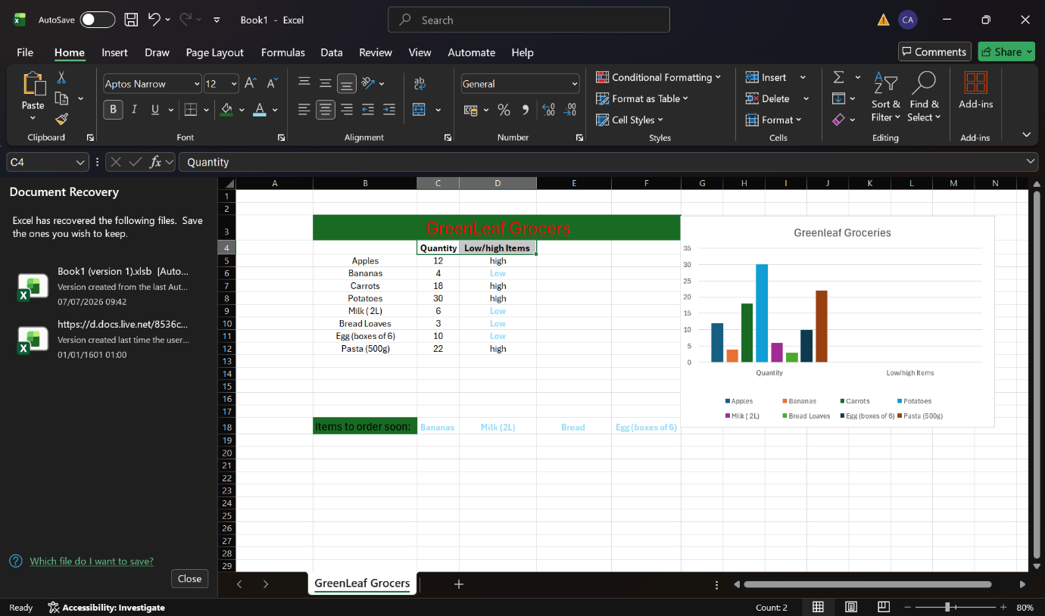
Why I choose my tool?
- I have choose excel because I can have a record of sales and is easier to manage a business.
What information I used?
- I have used data from a green leaf groceries to have a better understanding about sales.
How I create my artefact?
- I collect all the data and then I typed in to excel table.
Then I have used this simle formula: =IF(C5>10,”high”,”low”)
- After I have made a bar chart to understand wich products we sale the most
- Then I checked if everything was correct.

What changes I have made?
- I Made the topic in green and I I made bigger letters to make it more understandable.
Feedback I used:
I follow recommendations From my lecture.
Final Explanation:
- I have created this artefact in order to help a small business to have a better understanding of sales to take the best the decision.



