
Navigating Challenges: A Financial and Strategic Plan for Urban Heights Hotel


Student name: Alexandru Badea.
Student ID: 2208275.
Module name: Financial Management for the Hotel Industry
Module code: BMIH5007, BMIH5002.
Lecturer: Ernest Wavei.
Word Count: 1996
Executive Summary
The key issues being shown at Urban Heights Hotel include a general decline in its operating revenues, continuously increasing operating costs, and deteriorating customer satisfaction levels during the past three years. This report assesses the hotel’s financial position and some of the challenges it may face, for instance, intensified competition, cyclical economic risks, and rising cost. Through ratio analysis supported by trend evaluation to identify and understand the financial trends, there is an alarming decline in the profitability, liquidity, and solvency. The proposed strategic turn around includes; short term revenue enhancement strategies and organisational cost cutting, coupled with evidence based long term investments in technology, service delivery specialisation and innovation, and sustainability. They are meant to ensure that the right financial resources are available, customers’ satisfaction is achieved, and the hotel has proper and competitive positioning.

Contents
Executive Summary 1
1. Introduction 3
2. Scope and Objectives 3
3. Analysis of Financial Performance 3
3.1. Financial Statements 3
3.2. Trend Analysis 4
3.3. Revenue Trends and Implications 4
Operating Expenses and Net Income 4
3.4. Ratio Analysis 5
Profitability Ratios 5
Liquidity Ratios 6
Solvency Ratios 6
3.5. Changes in Assets, Liabilities, and Equity 6
Interest Coverage Ratio: 7
Efficiency Ratios 7
3.6. Interpretation and Implications 8
4. Key Reasons for Decline 8
5. Contemporary Industry Trends 9
6. Turnaround Strategy 10
7. Conclusion 10
7.1 Recommendations……………………………………………………………………………..…..10
References 12
Appendix: 14
Appendix A: SWOT Analysis (Turnaround Strategy) 14

Introduction
Urban Heights Hotel is a business hotel in the urban center to whose clients it provides accommodation, meals, and drinks in a bar and a venue for important events. Still, the latter may be considered one of the best-located hotels. Still, over the three years, it has had specific problems: decreasing revenues, the number of occupied rooms, and customer satisfaction (Perinotto, 2022). These problems provoke definite concerns about the hotel's future economic sustainability. This report aims to evaluate the financial perspective of Urban Heights Hotel, determine possible causes for a decrease in its profit, and provide a detailed outline of how to stabilise the situation and bring the company to a better financial state again.

Scope and Objectives
Firstly, the assessment will determine the extent to which this hotel has realised its financial goals over the past three years. This presupposes the detailed evaluation of various financial performance figures, such as revenues, operation costs, profit, losses, liquidity, and solvency. Analysing these numbers, we are able to infer the overall direction of the hotel's financial development and which aspects have improved or worsened over time (Kansakar, 2019). Some of the analytic tools that will help in the analysis include ratio analysis, trend analysis, and benchmark analysis to ensure a comprehensive view of the hotel's financial health is gained.
Secondly, it aims to establish what could be causing this decline in the hotel's profitability. This entails evaluating limited factors, such as internal and external factors, that led to the decline (Woods, 2012). We will examine unproductive workflow, poor cost control methods, and other possible organisational service deficiencies (Đikanović, 2020).

Analysis of Financial Performance

Financial Statements
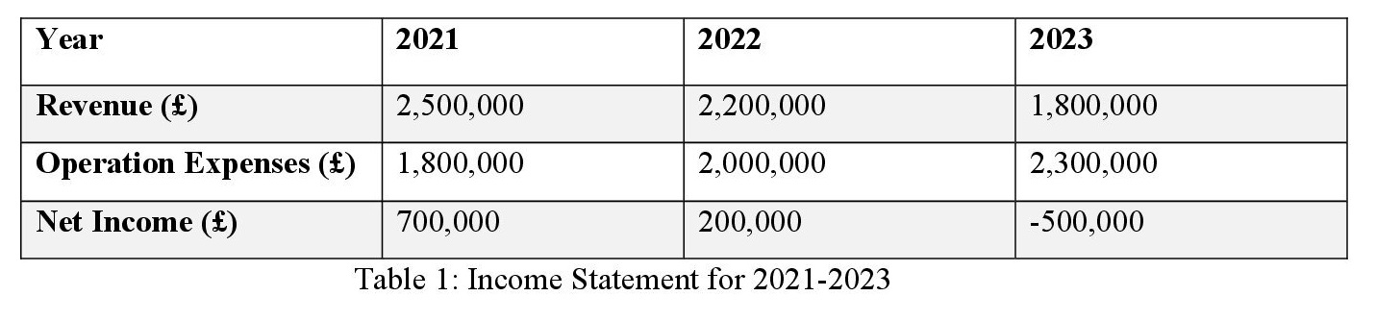

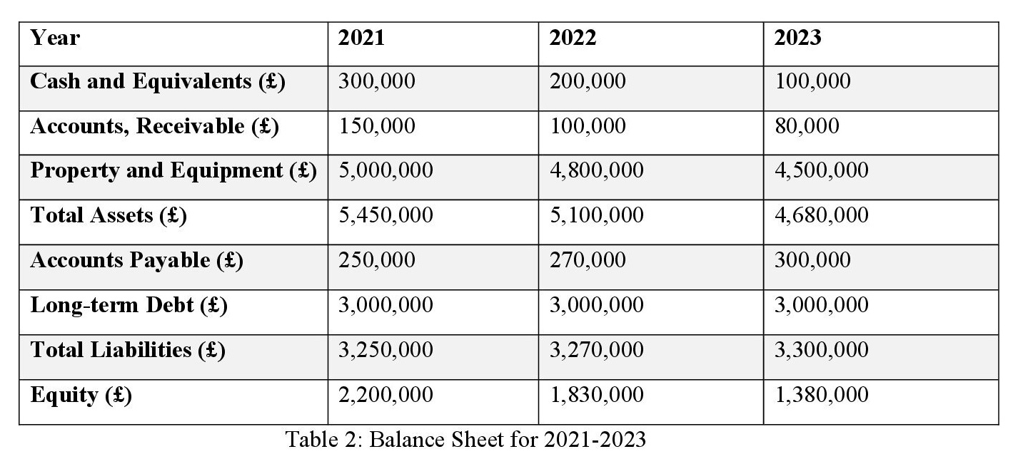

Trend Analysis
Key points identified and discussed for the financial data between the years 2021 – 2023. Taking the average of the financial ratios of Urban Heights Hotel for the last three years, one can notice that the company's financial state is deteriorating (O’Neill, 2020).

Revenue Trends and Implications
In 2021, the company produced £2,500,000 in revenues, but in 2023, it was £1,800,000, thus showing a 28% reduction in three years. This decline suggests various problems, such as reduced client base, competition, or problems associated with advertising and marketing strategies (Erdem, 2016). This has been an issue of concern since the hotel has been experiencing a continuous decline in its revenues, meaning that it cannot even afford to meet most of the operating expenses effectively, making it hard to register a healthy profitability level (Kim, 2015).

Operating Expenses and Net Income
Thus, operating expenses have grown to £ 2,300,000 in 2023 from £ 1,800,000 in 2021, which is 28% more. This loss has been attended by a decline in revenue, which has affected net income notably, as it has fallen from £700,000 in 2021 to a net loss of £500,000 in 2023. This is also a strong indication of poor cost management or a tendency to increase operating expenses in areas such as employee remuneration, energy costs, or materials used (Guillet, 2020).

Ratio Analysis

Profitability Ratios
- Gross Profit Margin:
$$Gross Profit Margin = (Revenue - Operating Expenses) / Revenue$$
2021: (2,500,000 - 1,800,000) / 2,500,000 = 0.28 (28%)
2022: (2,200,000 - 2,000,000) / 2,200,000 = 0.09 (9%)
2023: (1,800,000 - 2,300,000) / 1,800,000 = -0.28 (-28%)
- Net Profit Margin:
$$Net Profit Margin = Net Income / Revenue$$
2021: 700,000 / 2,500,000 = 0.28 (28%)
2022: 200,000 / 2,200,000 = 0.09 (9%)
2023: -500,000 / 1,800,000 = -0.28 (-28%)
- Return on Assets (ROA):
$$ROA = Net Income / Total Assets$$
2021: 700,000 / 5,450,000 = 0.13 (13%)
2022: 200,000 / 5,100,000 = 0.04 (4%)
2023: -500,000 / 4,680,000 = -0.11 (-11%)
- Return on Equity (ROE):
$$ROE = Net Income / Equity$$
2021: 700,000 / 2,200,000 = 0.32 (32%)
2022: 200,000 / 1,830,000 = 0.11 (11%)
2023: -500,000 / 1,380,000 = -0.36 (-36%)

Liquidity Ratios
- Current Ratio:
$$Current Ratio = Current Assets / Current Liabilities$$
2021: (300,000 + 150,000) / 250,000 = 1.80
2022: (200,000 + 100,000) / 270,000 = 1.11
2023: (100,000 + 80,000) / 300,000 = 0.60
- Quick Ratio:
$$Quick Ratio = (Current Assets - Inventory) / Current Liabilities$$
Note: Assuming no significant inventory, the quick Ratio remains similar to the current Ratio.
2021: (300,000 + 150,000) / 250,000 = 1.80
2022: (200,000 + 100,000) / 270,000 = 1.11
2023: (100,000 + 80,000) / 300,000 = 0.60

Solvency Ratios
- Debt to Equity Ratio:
$$Debt to Equity Ratio = Total Liabilities / Equity$$
2021: 3,250,000 / 2,200,000 = 1.48
2022: 3,270,000 / 1,830,000 = 1.79
2023: 3,300,000 / 1,380,000 = 2.39

Changes in Assets, Liabilities, and Equity
Total assets have reduced from £ 5,450 000 in 2020 to £ 4,680 000 in 2022. This has been due to a decrease in cash and cash equivalent, accounts receivable, and customers and a reduction in the value of property and equipment (Burgess, 2007).
The total liabilities were slightly higher than the previous year, standing at £3,250,000 in 2021 and increasing to £3,300,000 by 2023. The longer-term trend generally shows no declines in overall long-term debt, hinting at little debt restructuring.
Equity erodes from £2,200,000 in 2021 to £1,380,000 in 2023 due to the losses made and shrinkage in the company’s assets.

Interest Coverage Ratio:
$$This means that interest coverage ratio = EBIT / Interest Expense$$
Note: If the company failed to disclose interest expense details, interest ratio analysts cannot accurately determine this Ratio from the available statistics. A number, including an estimate or industry average, might be useful here (Sharma, 2005).

Efficiency Ratios
- Accounts Receivable Turnover:
$$Acid Test or Quick Ratio = Current Assets – Inventory / Current Liabilities$$
2021: We want to divide 2,500,000 by 150,000, so to compute the quotient, we divide 2,500,000 by 150,000, which equals 16.67
2022: 2,200,000 divided by 100,000 equals 22.00
2023: 1,800, 000 divided by 80,000 equals 22.50
- Asset Turnover:
$$Asset Turnover= Annual revenue / total asset$$
$$Asset Turnover = Net Operating Revenue / Average total assets$$
2021: 2,500,000 divided by 5,450,000 equals 0.46
2022: 2,200,000 divided by 5,100,000 equals 0.43
2023: 1,800, 000 divided by 4,680, 000 equals 0.38

Interpretation and Implications
A severe decrease in the key indicator, such as revenue, combined with high operating costs causes negative profitability, which can be illustrated by the tendency to decrease the gross and net margins and profitability indicators such as ROA and ROE (Burgess, 2003).
The current and quick ratios indicate that the hotel's liquidity is declining, below 1. They also contain information about the company's short-term solvency, which is equal to 0, which indicates that there may be problems meeting its obligations in the short term (Fairley, 2019).

Key Reasons for Decline
- Revenue Trends
Tangible and intangible assets decreased from £ 5,500,000 in 2021 to £ 500,000 in 2023 due to sales of fixed assets. Such trends that led to the decline include; rising competition, economy turns, customer changes, and other global factors which include; the Covid-19 pandemic, political conflict for example the Russia and Ukraine war (Grobelna, 2015).
- Competition
Competition from bargain lodging and other sites such as Airbnb threatens the market position of this hotel.
- Economic Downturns
Other external factors include; The occupancy in hotels was affected by the closing down of various events and restrictions on travel as a result of the COVID-19 outbreak.
- Global Events
This is due to fluctuations in geopolitical activity leading to uncertain economic environment where people are hesitant to traverse countries or indulge in non-necessities such as travel.
- Operating Expenses
This fixed cost type rose from £1,800,000 in 2021 to £2,300,000 in 2023, equivalent to a 28% uplift. Various cost drivers that may lead to the increase of the costs include; Cost of employment, cost of energy, fluctuations in supplier prices, and the high cost of meeting regulatory requirements.
- Cost-Push Inflation
From the above analysis it is seen that cost-push factors such as rising costs in labor, and energy lead to increased cost, and thus inflation which has a damaging effect on profitability (Lugosi, 2017).
- Demand Shock
By syncing a negative demand shock brought by the COVID-19 pandemic, the travel and accommodation companies saw a reduction in revenue as demand for the service dropped.

Contemporary Industry Trends
The ability to offer reservations through the Internet and the application of various information technologies, such as CRM systems, are crucial for improving customer satisfaction and organisations' productivity. Climate change awareness and ecology play a significant role in consumers' choices as more people request sustainable products and services (Enz, 2011).
Socio-economic factors play an essential role in the import of the hotel industry in the United Kingdom. Brexit, which means Britain's exit, has had severe implications, such as labor gaps and high prices for imported products (Sharma, 2006).
- Lessons from COVID-19 affect travel habits:
Travelers choose domestic destinations more often and prefer flexible conditions for travel dates and route changes. It has raised operation costs, and lower consumer purchasing power has hindered the economy (Song, 2011).

Turnaround Strategy
After applying the SWOT framework (Appendix A), I identified several issues. In order to counter them I recommend the following plan:
- Short-term Strategies:
Cost Control: This should be accompanied by initial cost control measures including discussions with suppliers to arrive at a cheaper wholesale price for the materials required as well as use of technologies that will enable the firm to reduce its electricity bills.
Marketing Initiatives: Develop promotional campaigns with specific messages and organise loyalty schemes and promotions to attract new customers and increase brand loyalty among the current customers (Vladimirovna, 2020).
Service Improvement: Training subtheme aims at training the staff of the hotel while the physical subtheme seeks to improve on physical structure of the hotel (Olsen, 1991).
- Long-term Strategies:
Digital Transformation: Technology makes it easier to seek clients, manage booking, connections, or engagements hence technology in the form of online booking systems, or customer relationship management systems, or digital marketing should be considered (Olsen, 1998).
Service Diversification: It is recommended that The Pier Salon should add wellness packages, corporation deals, and special occasion packages so that it can accommodate a larger number of customers (Viktorovna, 2018).

Conclusion
Evaluating Urban Heights Hotel, it can be observed that the organisation’s performance is characterised by a declining financial position due to a decrease in revenues and increase in costs which calls for the development of an operational strategy. The analysis focuses on key sources of strengths and threats, and feedback on the decision-making to reveal a detailed transformation plan. In the short-run, companies are employed in the cutting of costs and marketing expenses, while in the longer run, they are strategic on digital transformation, the provision of service variety, and sustainable practices. The execution of these strategies can help eradicate sources of instability in the financial environment, increase the satisfaction rate among customers, and achieve consistency. Thus, despite the existing current threats and weaknesses of Urban Heights Hotel, by utilising its strengths and opportunities it can counterbalance these threats and maintain high financial viability and competitiveness in the future.

7.1. Recommendations
To reduce expenses, implementing cost reduction initiatives like optimising supply chain management and workforce restructuring is mandatory. In order to boost revenue, the brand should invest in targeted marketing campaigns, unique membership cards and steaming hot promotions. Another one would be to upgrade the way they use their assets. Managing debt by planning better financially will keep debt-to-equity ratio optimal. If the brand manages to apply and keep these recommendations it will improve its financial health successfully.

.

References
- Burgess, C., 2003. Gender and salaries in hotel financial management: it’s still a man’s world. Women in Management Review, 18(1/2), pp.50-59.
- Burgess, C., 2007. Do hotel managers have sufficient financial skills to help them manage their areas?. International Journal of Contemporary Hospitality Management, 19(3), pp.188-200.
- Đikanović, Z. and Jakšić-Stojanović, A., 2022, May. The Implementation of New Technologies in Tourism and Hospitality Industry-Practices and Challenges. In International Conference “New Technologies, Development and Applications” (pp. 991-995). Cham: Springer International Publishing.
- Enz, C.A., Kosová, R. and Lomanno, M., 2011. The impact of terrorism and economic shocks on US hotels.
- Erdem, M. and Jiang, L., 2016. An overview of hotel revenue management research and emerging key patterns in the third millennium. Journal of Hospitality and Tourism Technology, 7(3), pp.300-312.
- Fairley, J., 2019. Turnaround Strategies in Destination Marketing Organizations. Tourist Destination Management: Instruments, Products, and Case Studies, pp.227-239.
- Grobelna, A., 2015. Intercultural challenges facing the hospitality industry. Implications for education and hospitality management. Journal of Intercultural Management, 7(3), pp.101-117.
- Guillet, B. D., 2020. An evolutionary analysis of revenue management research in hospitality and tourism: Is there a paradigm shift?. An evolutionary analysis of revenue management research in hospitality and tourism: Is there a paradigm shift?.
- Kansakar, P., Munir, A. and Shabani, N., 2019. Technology in the hospitality industry: Prospects and challenges. IEEE Consumer Electronics Magazine, 8(3), pp.60-65.
- Kim HyoJin, K.H. and Kim ByungGook, K.B., 2015. Economic impacts of the hotel industry: an input-output analysis.
- Lugosi, P. and Jameson, S., 2017. Challenges in hospitality management education: Perspectives from the United Kingdom. Journal of Hospitality and Tourism Management, 31, pp.163-172.
- O’Neill, J.W. and Ouyang, Y., 2020. Predicting lodging demand trends in the US hotel industry. Cornell Hospitality Quarterly, 61(3), pp.237-254.
- Olsen, M.D., 1991. Strategic management in the hospitality industry: a literature review. Strategic management in the hospitality industry: a literature review., pp.215-231.
- Olsen, M.D. and Roper, A., 1998. Research in strategic management in the hospitality industry. International Journal of Hospitality Management, 17(2), pp.111-124.
- Perinotto, A.R.C., Araújo, S.M., Borges, V.D.P.C., Soares, J.R.R., Cardoso, L. and Lima Santos, L., 2022. The development of the hospitality sector facing the digital challenge. Behavioral Sciences, 12(6), p.192.
- Sharma, A. and Upneja, A., 2005. Factors influencing financial performance of small hotels in Tanzania. International Journal of Contemporary Hospitality Management, 17(6), pp.504-515.
- Sharma, A., 2006. Economic impact and institutional dynamics of small hotels in Tanzania. Journal of Hospitality & Tourism Research, 30(1), pp.76-94.
- Song, H., Lin, S., Witt, S.F. and Zhang, X., 2011. Impact of financial/economic crisis on demand for hotel rooms in Hong Kong. Tourism Management, 32(1), pp.172-186.
- Konovalova, E.E., Yudina, E.V., Bushueva, I.V., Uhina, T.V. and Lebedev, K.A.E., 2018. Forming approaches to strategic management and development of tourism and hospitality industry in the regions. Journal of environmental management and tourism, 9(2), pp.241-247.
- Bokareva, E.V. and Yudina, E.V., 2020. Strategic management in the hospitality industry. Revista Turismo Estudos e Práticas-RTEP/UERN, (4), pp.1-8.
- Kalargyrou, V. and Woods, R.H., 2011. Identifying training challenges in hospitality industry: An exploratory approach. Hospitality Review, 29(1), p.1.

Appendix:

Appendix A: SWOT Analysis (Turnaround Strategy)
Strengths | Weaknesses
Prime Location: Urban Heights Hotel is well-located in an urban center, attracting both business travelers and event organizers. | High Operating Costs: Increasing operating expenses are negatively impacting profitability.
Established Brand: The hotel has an established brand and reputation in the market. | Declining Customer Satisfaction: Reduced customer satisfaction is leading to lower repeat business and negative reviews.
Comprehensive Services: Offering accommodation, meals, drinks, and event venues provides multiple revenue streams. | Limited Technological Adoption: Lagging behind in technology, such as online booking systems and CRM, affects operational efficiency and customer engagement.
Opportunities | Threats
Digital Transformation: Investing in technology for online bookings and customer relationship management can improve efficiency and customer experience. | Economic Downturns: Economic instability and reduced consumer spending can lower occupancy rates.
Market Expansion: Introducing new services, such as wellness packages and corporate deals, can attract a broader customer base. | Intense Competition: Increased competition from budget hotels and alternative accommodation platforms like Airbnb.
Sustainability Initiatives: Implementing eco-friendly practices can attract environmentally conscious travelers and reduce operational costs. | Regulatory Changes: New regulations, particularly in health and safety, can increase operational costs and require additional investments.

