ACADEMIC AND EMPLOYABILITY SKILLS
Student Name : Andrei A Cojocaru
ID Number:1818263

Executive Summary
This report is based on academic along with employability skills which is discussed in context of learners’ experience in learning through in class exercises. In this regard, tasks are divided in two in academic report and reflective report. In academic report, employability and academic skills are analysed. In reflective report, development processes of employability skills are highlighted. Certain skills are identified such as language learning, communication skill and searching ability. Additionally, time management skill and paraphrasing skills are addressed. Drawbacks are identified and recommendations are provided.

Table of contents

Task 1-Academic report 4
Introduction 4
Ideal academic skills 4
Drawbacks and gaps in learning skills 7
Recommendations 8
Conclusion 10
Task 2- Reflective report 11
Introduction 11
Performance Activities 11
Performance measurement 13
Feedbacks 13
Recommendations 15
Conclusion 16
Reference List 17
Appendices 20

Task 1-Academic report

Introduction
The current report is based on academic as well as employability skills that have been analysed through referring to published literature and in-class exercises. Academic skills play a vital role for encouraging students to be efficient learners. These skills facilitate to boost confidence for participating in academic courses, outside the classroom. These skills include note taking and critical thinking that are transferable. Hence, academic skills are significant to gain success in career.

Ideal academic skills
In order to gain success in academic skills, certain skills are important such as-
- Academic discourse
Skills of academic discourse are effective to communicate in an effective manner in presentations, discussions and debates. As stated by Bryan and Clegg (2019), this discourse has certain elements like speaking manner, intelligibility and handling audience.
- Strategies of academic text
These skills play a significant role to analyse texts of academic perspectives with greater detail.
- Academic strategies
These skills help to understand along with respond to lectures in critical way. In view of Cotronei-Baird (2019), note taking in an effective manner is beneficial skill for learning before going to higher education.
- Comprehension
This skill enhances ability for processing text, integrating acquired knowledge of learner and understanding proper meaning.
- Composition
This skill develops argumentative nature of students during class discussions. As propounded by Espelage, Rose and Polanin (2016), producing arguments coherent in nature is a major skill for students for higher education.
- Process of active learning
This skill is gaining importance among millions of students all across the globe as it assists to implement risk taking process along with improving method of critical thinking. In addition, inclusion of this skill is important as it aids in facilitating engagement among students along with sparking creative level of thinking.
- Implication of effective time management
In order to complete any work among students in an efficient manner using a planner is much more essential as it aids in analyzing time. On other point of view, time management is important in any institution as it helps to gain higher level of productivity along with managing process of business in an efficient and effective manner.
It is essential within any educational sector of business as it helps to minimise stress level along with promoting healthy workplace environment.

Figure 1: Academic skills
- Availability feedback
Feedback is estimated to be a primary key to gain success as it aids in providing clear expectations about level of performance. As stated by Griffiths et al. (2018), in addition, this academic skill is known to be most important as it aids in promoting level of loyalty among students along with improving rate of retention in long term.
Thus, based on above discussion it can be analysed that for promoting effective interaction among students these above mentioned academic are of utmost important.
- Language skills
Four types of language skills refer to be four capabilities which allow individual to comprehend as well as produce language. As stated by Cotronei-Baird (2019), these skills are significant regarding interpersonal communication in an effective and proper way. These skills involve writing, reading, speaking and listening. Listening includes initial language skill that requires to be acquired in native language. This passive or receptive skills use brains and ears in order to comprehend a language. Speaking skills are productive skills where vocal tract along with brain are utilised for producing language with help of sound.
Acquired academic and employability skills
Learner has acquired skill of paraphrasing that has helped concerned learner to rephrase a particular text in own way. As a result, student has been benefited to learn how a written text can be expressed in different manner. As stated by Hosan and Hoglund (2017), paraphrasing skills focuses on rephrasing a speech without altering the meaning of given text. In addition, specified learner has learned to summarize the meaning of a text.
This skill of summarizing helps to cut down the text to bare essentials. In view of Jackson (2016), both techniques of paraphrasing as well as summarizing are beneficial to simplify and clarify complex ideas and information.
By learning skill of paraphrasing, specified learner is benefitted to understand whether the sources are well enough for writing in own words.
Apart from paraphrasing and summarising, learner has acquired skill of reading and writing vocabulary. As propounded by Matsouka and Mihail (2016), reading vocabulary includes words that are needed to be understood at time of reading. In contrast, writing vocabulary refers to be learning words. This skill of vocabulary enhances reading skills. Furthermore, vocabulary of speaking along with listening is also enriched through this learning session.
In addition, active skills of listening have got enriched through concerned exercises along with published literature. As a result, specified learner is now able to ask questions of open ended and students are able to request further clarification to educator. Hence, learner has gained skill and ability for tackling difficult questions so that concerned learner can well understand class materials.
Specified learner was asked to go to library catalogue of institution and by using advance facility of search student was asked to collect information. In this context, educator asked learner whether a book written by McEneaney, Mike and Fenlon is accessible in university library. In this regard, particular student did not find full text of this selected book. After that, learner found four copies of book of Patric McNeil named “Research methods”.
These two incidents imply that student is trying to improve his skill of searching ability in online library. Specified pupil has learned knowledge process of choosing effective search engine. Additionally, utilizing specific key words and simplifying search terms have contributed in better searching ability of concerned pupil. Furthermore, the learner has gained skill of using quotation marks and process of removing unhelpful terms. As stated by Rabiner, Godwin and Dodge (2016), searching internet may be frustrated and in this purpose, entering relevant term is beneficial to save time in searching.
Skill of research ability is enhanced through these class exercises. In this regard, concerned educator has taken care of skill development process through checking sources and asking questions. Moving beyond surface of topic and finding relevant information with adequate patience have been acquired by learner by active cooperation of educators.
In view of Wolff and Booth (2017), research skills are beneficial as it improves locating, extracting, evaluating and organising present information. Through this skill development, learner has gained ability of intensive search, critical analysis and investigation. In addition, it grows talent to provide response to particular hypothesis and questions related to topic.
In case of citation, learner had been provided some multiple choice questions to evaluate whether concerned pupil have knowledge to cite within assignment. In maximum questions, the learner had given correct choice that implies that student was sincere in class. As a result, after completion of learning, correct answers were chosen by this pupil. In case of unavailability publication date, student was asked process of writing. Against this question, student has provided correct answer that implies student was attentive in class while teaching by educator.

Drawbacks and gaps in learning skills
Gaps in searching skills
Learner needs to be careful in identifying and developing selected topic as topic selection can be challenging. The books that have been asked to search are needed to be analysed so that student can locate materials in a faster way. Additionally, after selecting search engine, active websites are not searched properly based on content. Specified pupil has been found to be restricted in some particular, limited websites and hence, it is considered to be a major drawback.
As stated by Bryan and Clegg (2019), some popular search engines have different positive impacts such as returning greatest result variety. Certain search engines provide extensive and wider services along with results that are auto complete. Hence, searching requires to be done in keeping these factors in mind.
Learning to make reference list
Furthermore, student was asked while listing references at end of work, whether all items are needed to be kept in same list or not. In response of that question, concerned learner replied that all items should be included in same list. It reflects that learner did not list this listing process carefully. Reason behind it includes different referencing style demands different processes of listing. According to these demands, books and journals can be arranged in separate list or these items can be kept in same arrangement.
Drawback and gap in development of learning skills
Concerned student was asked to paraphrase a paragraph that was based on Mike Erwin. Against this question, it was found that student was not careful about learning language skills.
Less time in learning outside
It has been observed that student has spent less time to learn outside in every week. Apart from that, in learning outside, specified student did not avail facility of online library properly. As a result, when this student was asked to find campuses of book copies, specified learner has found very few campuses. For searching books containing “digital” in the title, concerned pupil did not find it properly.

Recommendations
This concept of employability skills that are related with academic standards are mainly based on different factors (Moore and Morton, 2017). Accordingly this type of factors that are related with these types of skills of academics and employability are recommended for different need and growth. These types of skills can be described of different types and have different utility. Thus this form of utility gives a better scope about these types of employability skills and has different types such as
Recommendation can be provided in terms of skilfully working strategy with different people, aids in different aspects of employability development of skills and growth. This growth is very much required in terms of any process of job interview and other process of communication (Messum et al. 2016). Thus this all forms of ability acts as skills of interpersonal level that helps in different tasks.
It can further be recommended that these forms of interpersonal skills are mainly based on different factors such as
- Skills of communication: It is a primary ability that is recommended in matters of employability skills (Magnell and Kolmos, 2017). This skill makes a better understanding about ideas that are based on factors of listening, speaking and sending without any flaws.
- Communication of verbal: This is a part of communications skills and is the most significant part that results in better face to face understanding. It is part of that balances various jobs situation and criteria in this employability skills.
- Communication skills of non-verbal: This is a secondary part of communication skills that offers different types of gestures and communication through languages.
- Emotional listening: This is a most recommended skill of employability that aids for better approaches and growth. Thus it has better and positive outcomes that are related to better outcomes and functional employability skills.
- Team Working: According to this process of employability skills and growth, provides a better approach to this process of working with a team and different organizations (Barton, Bates and O'Donovan, 2019).
- Decision making ideas: These forms of skills are mostly very effective and provide better concepts and identity of solutions those results in better skills solving. This unique ability helps in better utility in academic skills of employability.
Reliable and dependable are a huge recommended in this academic skills and developments. This includes different types of effective strategies; time bound management ideas and different reliability factors based on different types of skills in this employability ability of academic patterns. A unique ability of self management and regulation are very much effective in terms of task.
A learning ability is a basic option that is based in these skills of regulation of employability skills and growth (Bharathi, 2016). Thus this type of development is mainly based on factors of personal aspects that are based on personal development of employability skills. Learning is an abstract concept that always evolved and gets adopted in different advanced forms.

Conclusion
Thus based on this general approach about employability skills with academics contrast, these formats are very ironic in terms of development. These skills of employability are contrasting and typically refer to different aspects of presenting in fields of profession. Hence these employability skills are very in demand and needed for growth and improvement that are needed in academic fields and professional fields.

Task 2- Reflective report

Introduction
As per my research I found out that employability skills helps to develop individuals and it is transmittable. It requires good technical knowledge as well as knowledge of subjects. Employability based on employer's knowledge of skills and various attributes.
During the research period I have found employability skills includes many aspects such communication skills, solving problems skills, working under heavy deadline and self motivation.
I have also developed an idea about employability skills which includes key etiquette, soft skills, interpersonal and general skills and some basic intermediate skills.

Performance Activities
In this research I have given a task to search for Sir Christopher Wren in Google. Com and founded that specified person was an English astronomer, anatomist, mathematical physicist as well as geometer. Concerned person is most publicly praised architect in word of history. I also found that he had given a responsibility to develop approximately fifty two churches in London, UK (Cotronei-Baird, 2019).
While searching I explored various links which suggests my desired result. In the first link it was showing Wikipedia link which contains brief information about Sir Christopher Wren. Mentioned link contains born day and died day including his education and books. There is also mentioned his work life in brief.
During research period I have found several records which I found quite useful. Using these results I have much information about mentioned person. This gives me an overview idea about concerned person lifestyle, work ethics, and contribution to society (Pinto and Ramalheira, 2017).
My first result is very effective and very relevant to topic which was provided. I have come to know that sir wren received a big commission for his architecture. Apart from many works monuments is sir wren biggest achievements. In 1962 sir wren advised to statue of king beasts have to be removed.
In Between 1683 to 1685, mentioned person occupied for designing king’s house however that task was never completed. Sir Wren promised to complete that task within given time but it was never completed.
I have also found an interesting information about sir wren that some of youthful exercise of mentioned person has been preserved to show that sir wren received a proper grounding Latin and he also learned drawing. In 25 June 1650 Sir Wren joined Wadham College in oxford to complete graduation. The concerned person was very keen to learn Latin so sir wren started to learn Latin as well as life of Aristotle (Sotiriadou et al. 2019)
It is unimaginable that concerned person received many scientific instructions in a modern way. However concerned person became very close to John Wilkins who was warden of wad ham whose group was very small. However sir wren learned various philosophies there.
Sir Wren began to lease property to queen Annie with exchange of some money. In 19 Th century above mentioned person frequently goes to London to visit St Paul's church to visiting progression of work. On 1723 in the month of February Sir Wren’s servant found specified person dead (Griffiths et al. 2018).
Thus, it is quite clear that links which i found on google.com gave me a brief idea. It helps me to gain knowledge about Sir Christopher Wren.
During this research period when I was searching about Sir Christopher Wren I found that during first five results includes five or six types of advertisements such as various video ads such as ads from YouTube, this shows commercial video content from YouTube world .Secondly I had seen various marketing ads which includes various ecommerce websites such as Amazon , flip kart. It was showing different products from different e commerce store about discounts which was provided by them and also product details (Collet, Hine and Du Plessis, 2015).
Thirdly I have noticed various app promoting their application in google.com which includes various song applications, various money transfer applications and online quiz application which was specially designed for kids. Fourthly I have seen various reputed brands promoting their brands such as Puma, Reebok. They are showing their latest outlets which was launched recently in my locality and was given a huge discount for first 50 customers which was valid for only one day (Simatele, 2015).
Above mentioned ads were showing while researching for this given topic which I found quite irrelevant regarding Sir Christopher Wren.
During research I have also found much relevant scholarly information about Sir Chrsitopher Wren. There were many writers who wrote about concerned person. In second result it was showing scholarly articles about mentioned person. In scholarly there was various journals and popular magazines.
I have explored many information about scholarly articles which defines scholarly article is also called peer reviewed. It helps to differentiate one article from another and it helps people to find out exact result.
In scholarly there is very limited audience. In scholarly journals are mainly published by press of university. Scholarly article includes many articles based on various special topics (Scott et al. 2019).

Performance measurement
In this research I have mentioned various descriptions about how to develop students' performance. Measurement of student’s performance is measured by various methods such as organizing quiz, participation of students in classes, assigning students to various projects, various course work and in the end take exams for their overall performance. There is another way to upgrade performance of students understanding of their course.
I have also figured teachers also have some methods to measuring student’s performance. Types of methods used for development of student lies on content or task which is measured whether it is a formal evaluation or it is an informal evaluation.
I have also concluded that estimation should be real and valid by nature. In consideration of individual development of students effective estimation measure verification that a student is present to explain understanding of concepts and ability to perform any kind of task based on situations. I also decided that constructional of assessment of estimation of tools is used. Student’s performance can be estimated by formal and informal mechanism.

Feedbacks
In my view, skills of students have different aspects and different scopes those results in better approach in terms of ability of presenting and providing better results (Schnell and Rodríguez, 2017). I have observed that these students have better ability and better approach, but this type of skills can be made better. This forms of skills enhancement are be able to done such as
- Practice is a huge remedy for these types of skills enhancement and growth that are needed for their growth.
- Development of skills of language that have huge positive impacts in terms of skills improvements and better employability aspects (Bharathi, 2016). This has other positive aspects those results in betterment of internal vocabulary and skills.
- Reading and writing provides huge aspects for growth and development those results in betterment of these skills (Wilson and Zulu, 2016). This form of activity helps to create a better opportunity based on academics level and levels of employability skills.
- Communications skills are other factors that resulted in different types of enhancement for academics improvements and results in better scopes. Thus this is a basic skill that is utmost requirements for betterment of skills of employability. Hence communication skills are very important in field of employability skills and developments that are required in this field.
- Time management is another part of developments that are required in this parts of development cycles. This form of skills has different positive aspects that are based on this type of skills of employability in academics. Skills that are being followed in these categories are generally going to create a better perspective of working and task management. Thus it also gives a better idea about any tasks completed and positive outcomes. Time management skills helps to make more effective with more throughput of work and fewer flaws in work patterns.
- An ability to solve problem results in better growth with academic skills of employability. These formats of skills are very much effective in terms of tough situations and typical conditions of pattern of working cycle. This unique ability results in better approach of different types of work with better and in depth skills of solving ability.
Hence these forms of feedback are very much necessary in terms of skill enhancements and growth. As per my view these types of measurements are very much necessary that are based skills assessments of employability and their requirements.

Recommendations
The suggestion can be provided to students in terms of promoting their level of performance as it aids to improve growth in long term. Other form of recommendation can be provided as:
- Adopting positive level of mental attitude
Positive level of mental attitude is beneficial for any students in their academic life cycle as it helps them to achieve anything beyond imaginary level or power. In addition, introduction of formative assessment is another suggestion that can be granted to students as it aids in pointing out where students need to improve (Wilson and Zulu, 2016). Based on my opinion it can be analyzed that positive mental strength aids to promote learning standards.
- Proving constant level of feedback to students
Feedback in both negative and positive format is important as it aids in promoting level of loyalty among students. In my point of view, I think providing regular feedback to students in both timely and respectful manner helps to succeed in long term along with identification of key challenges.
- An innovative ideas for students
This form of ideas is used in these terms of analysis about skills and employability opportunity results in growth (Barton, Bates and O'Donovan, 2019). An innovative idea results in better opportunity and perspective that results in different ways of solving and creating paths of handling different problems. Accordingly, these types of ideas in innovative are very much effective in creating base of professionalism in terms of innovation. New ideas are very much expected in these modern fields of professionalism and their respective growth. A past experience in terms of employability results in betterment of these types of managements.
- A brief connectivity and network among students
This is a major part of development that is required in matters of opportunities and growth based on skills. There are different types of skills that are based on factors of skills and their connectivity. These forms of employment strategies are mainly done in fields of events and other forms of opportunities that are based on factor of connection and growth. This formats of have a huge effective working process that is based on factors of facts that are related to this type of development. Thus it is a better and effective working standard that results betterment of working styles. A collaboration and partnership helps in betterment of this type of connectivity patterns among students.
- Working in team management for students
This is a virtual part of skills that are required in terms of profession and employability skills. A working skill with teammates helps to make better understanding of tasks and thus results in better performances. Thus an ability of these patterns results in better approach as formats of skills and opportunity. A faster approach and exchange of information are very much better in this type of process of team management skills and opportunity.

Conclusion
According to this type of observations about performances and different activities, it has resulted in betterment of different types of skills. These types of skills based on feedback are very much effective in solving and growth of skills about employability. Thus a better approach and better feedback with positive outcome creates a betterment of skills. Thus this ability and skills plays a significant part in betterment of skills those results in betterment of different ability.

Reference List
Book
Bryan, C. and Clegg, K. eds., 2019. Innovative Assessment in Higher Education: A Handbook for Academic Practitioners. Abingdon, U.K.: Routledge.
Journals
Barton, E., Bates, E.A. and O'Donovan, R., 2019. ‘That extra sparkle’: students’ experiences of volunteering and the impact on satisfaction and employability in higher education. Journal of Further and Higher Education, 43(4), pp.453-466.
Bharathi, A.V., 2016. Communication Skills-Core of Employability Skills: Issues and Concerns. Higher Learning Research Communications, 6(4), p.n4.
Collet, C., Hine, D. and Du Plessis, K., 2015. Employability skills: perspectives from a knowledge-intensive industry. Education Training, 57(5), pp.532-559.
Cotronei-Baird, V.S., 2019. Academic hindrances in the integration of employability skills development in teaching and assessment practice. Higher Education, pp.1-21.
Espelage, D.L., Rose, C.A. and Polanin, J.R., 2016. Social-emotional learning program to promote prosocial and academic skills among middle school students with disabilities. Remedial and Special Education, 37(6), pp.323-332.
Griffiths, D.A., Inman, M., Rojas, H. and Williams, K., 2018. Transitioning student identity and sense of place: future possibilities for assessment and development of student employability skills. Studies in Higher Education, 43(5), pp.891-913.
Hosan, N.E. and Hoglund, W., 2017. Do Teacher–Child Relationship and Friendship Quality Matter for Children's School Engagement and Academic Skills?. School Psychology Review, 46(2), pp.201-218.
Jackson, D., 2016. Re-conceptualising graduate employability: The importance of pre-professional identity. Higher Education Research & Development, 35(5), pp.925-939.
Magnell, M. and Kolmos, A., 2017. Employability and work-related learning activities in higher education: how strategies differ across academic environments. Tertiary Education and Management, 23(2), pp.103-114.
Matsouka, K. and Mihail, D.M., 2016. Graduates’ employability: What do graduates and employers think?. Industry and Higher Education, 30(5), pp.321-326.
Messum, D., Wilkes, L., Peters, K. and Jackson, D., 2016. Content analysis of vacancy advertisements for employability skills: Challenges and opportunities for informing curriculum development. Journal of Teaching and Learning for Graduate Employability, 7(1), p.72.
Moore, T. and Morton, J., 2017. The myth of job readiness? Written communication, employability, and the ‘skills gap’in higher education. Studies in Higher Education, 42(3), pp.591-609.
Pinto, L.H. and Ramalheira, D.C., 2017. Perceived employability of business graduates: The effect of academic performance and extracurricular activities. Journal of Vocational Behavior, 99, pp.165-178.
Rabiner, D.L., Godwin, J. and Dodge, K.A., 2016. Predicting academic achievement and attainment: the contribution of early academic skills, attention difficulties, and social competence. School Psychology Review, 45(2), pp.250-267.
Schnell, B. and Rodríguez, N., 2017. Ivory tower vs. workplace reality: Employability and the T&I curriculum–balancing academic education and vocational requirements: a study from the employers’ perspective. The Interpreter and Translator Trainer, 11(2-3), pp.160-186.
Scott, F.J., Connell, P., Thomson, L.A. and Willison, D., 2019. Empowering students by enhancing their employability skills. Journal of Further and Higher Education, 43(5), pp.692-707.
Simatele, M., 2015. Enhancing the portability of employability skills using e-portfolios. Journal of Further and Higher Education, 39(6), pp.862-874.
Sotiriadou, P., Logan, D., Daly, A. and Guest, R., 2019. The role of authentic assessment to preserve academic integrity and promote skill development and employability. Studies in Higher Education, pp.1-17.
Wilson, M. and Zulu, S., 2016. Inter-professional Collaborative Learning for the Enhancement of Employability Skills. Delivering Excellence in Higher Education 2016.
Wolff, R. and Booth, M., 2017. Bridging the gap: Creating a new approach for assuring 21st century employability skills. Change: The Magazine of Higher Learning, 49(6), pp.51-54.

Appendices
Appendices 1(Task 1)

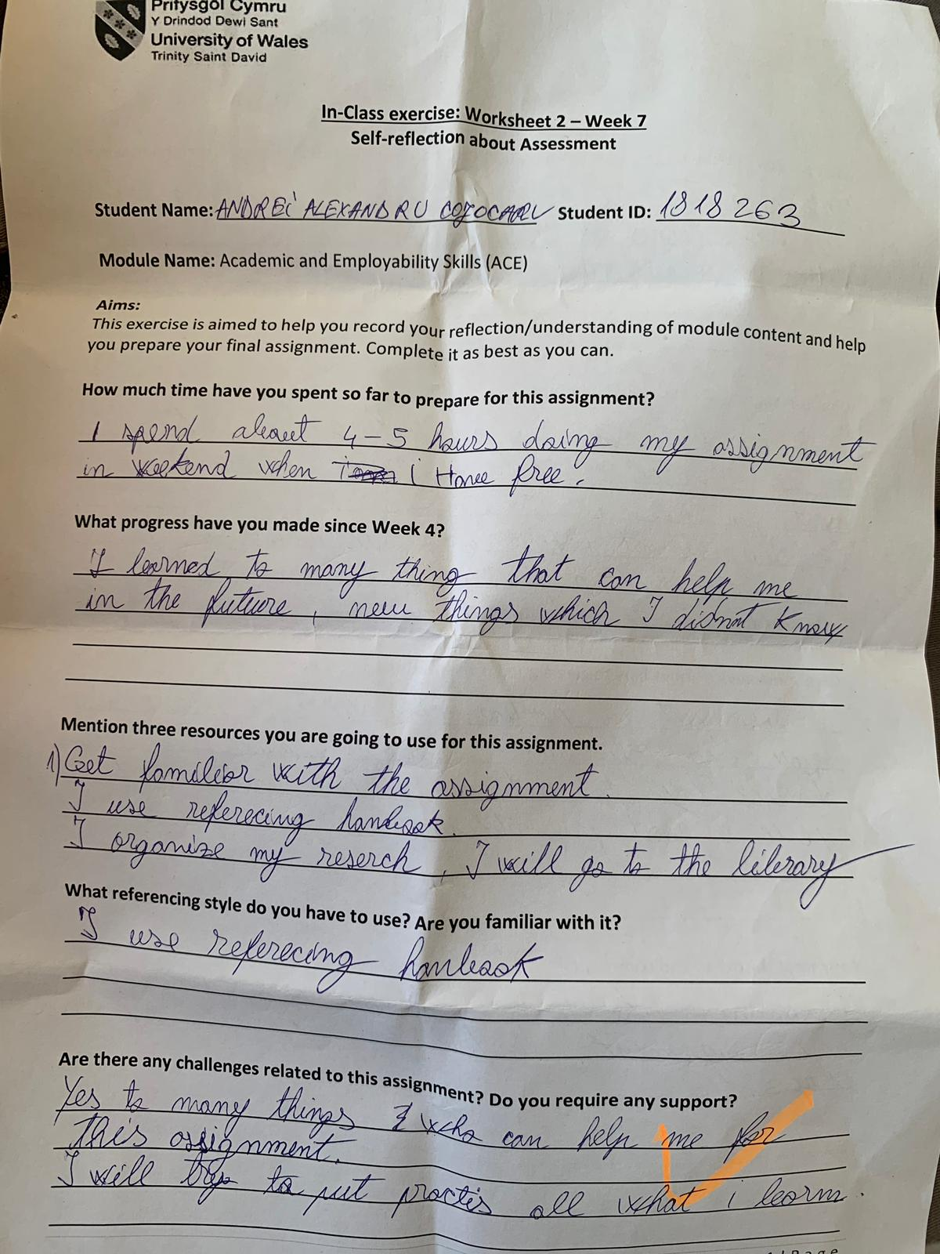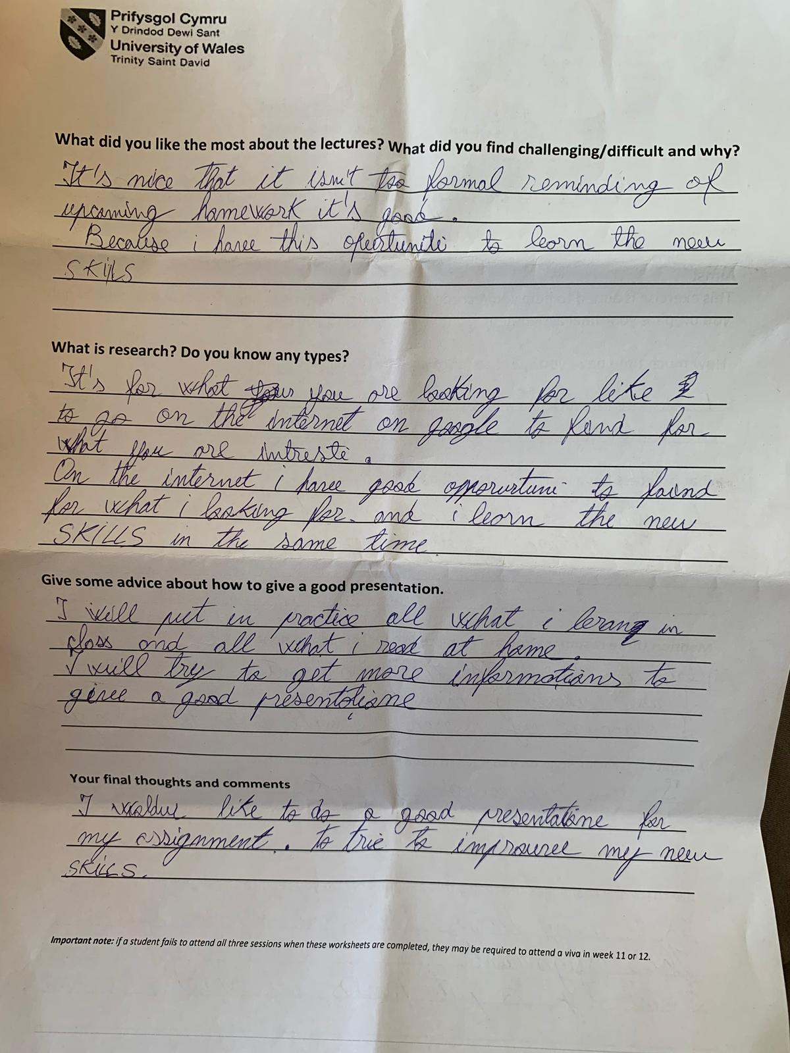
Appendices2 (Task2)

