

International Business Communications LCBB6001

~ Assessment 1 coursework ~

Strategic Cultural Approach for
Tesco's Expansion into Germany or Romania:

Module Leader: Dr Charles Nwaogwugwu
Lecturer: Dr Zainab Atta
Student: Vladimir Mihai BARA – 2110942

Table of Contents:

- Introduction – p.3
- Comparative Analysis of Germany and Romania based on Hofstede’s Dimension – p.4
- Conclusion – p.7
- References – p.8

- Introduction:
Our essay represents a report produced for Tesco's board of directors from our position as a global management consultant. Our report analyses British business communication as characterized by its formality, understatement, and reliance on established protocols. Communication tends to be indirect, where open conflict or direct confrontation is generally avoided, a style deeply rooted in British cultural norms (Hall & Hall, 1990). This subtle form of communication necessitates a high degree of cultural fluency when British firms consider international expansions, particularly in the diverse cultural landscape of the European Union (Lewis, 2006).

Tesco PLC, founded in 1919, in Hackney, London, has grown to become one of the world’s leading multinational retailers, specializing in groceries and general merchandise. With operations spanning multiple countries, Tesco is known for its commitment to localizing its operations to meet diverse customer needs, emphasizing affordability, and prioritizing customer satisfaction (Tesco Annual Report, 2021). These core attributes are integral to Tesco’s expansion strategy and must be adapted to fit new cultural contexts (Palmer, 2018).
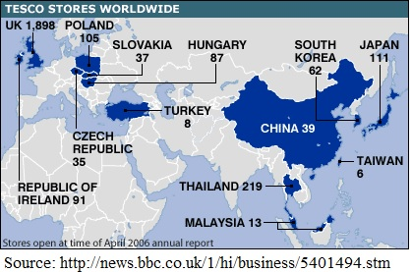
Our report aims to offer documented recommendations to Tesco's board of directors about future market orientation in Europe, based on the cultural differences between the German market and the Romanian market.
- Comparative Analysis of Germany and Romania based on Hofstede’s Dimensions:
In this part, we will analyze the German and Romanian cultures opposite to British culture, and we will illustrate with the following graph:
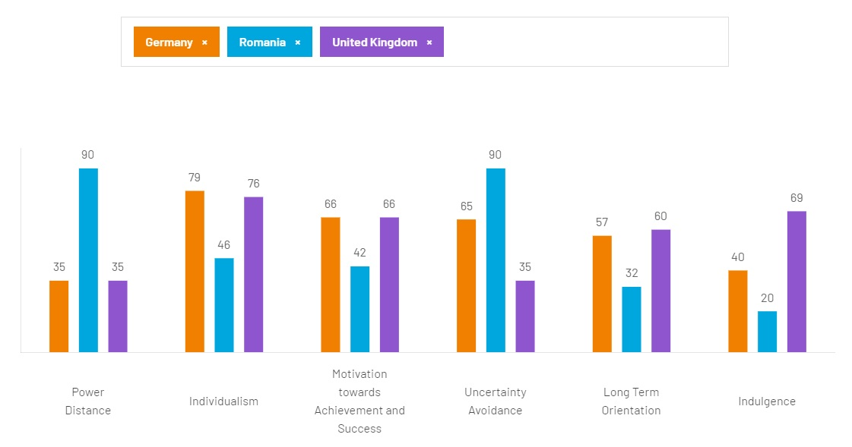
Source: https://www.hofstede-insights.com/country-comparison-tool?countries=germany%2Cromania %2Cunited+kingdom
From this graph, we can easily observe that in Romanian culture the power distance has a score of 90 “ which means that people accept a hierarchical order in which everybody has a place and which needs no further justification” (Hofstede, 2024, https://www.hofstede-insights.com/country-comparison-tool?countries=germany%2Cromani a%2Cunited+kingdom). This high score on the power distance dimension came from historic times when the communist regime in Romania, imposed by force, gave the strategic line in every aspect of life for the Romanian citizens.
Our essay will dive deeper into the cultural dimensions as described by Geert Hofstede's framework, which provides insights into the work-related values and behaviors that are influenced by national culture. This analysis helps in understanding the key cultural differences between Germany and Romania, which can significantly impact international business practices and management strategies.
2.1. German culture:
2.1.1. Power Distance (Low): Germany’s low power distance index reflects a society that values egalitarianism and co-determination. This cultural trait is evident in German business practices, where participation at all levels is encouraged, and subordinates expect to be consulted. Organizational structures are often flat, with a focus on decentralization and delegation of authority. This setting can be conducive to open discussions and innovative ideas, as employees feel valued and empowered.
2.1.2. Individualism (High): High individualism in Germany indicates a society where personal achievement and individual rights are paramount. In the workplace, this translates to a focus on personal initiatives and achievements. Employees are expected to be self-reliant and display a high degree of personal autonomy. The employment relationship is viewed as a contract based on mutual benefit, and loyalty is based more on professional opportunities than on personal relationships.
2.1.3. Motivation towards achievement and success, or one word - Masculinity (High): The high score on masculinity shows a preference for achievement, success, and competition. In the German business context, this results in a driven, result-oriented workplace where performance and outcomes are highly valued. Success is often measured through material gains and achievements, influencing workplace dynamics and managerial practices.
2.1.4. Uncertainty Avoidance (High): Germany scores high in uncertainty avoidance, indicating a society with a low tolerance for ambiguity and uncertainty. This is reflected in a well-structured organizational setting where rules and regulations are emphasized, and adherence to laws and standards is expected. Planning and precision in detail are valued in business practices, and changes are managed through meticulous risk assessment and management processes.
2.1.5. Long-term Orientation (Moderate): Amoderate score in long-term orientation suggests a balanced approach towards tradition and innovation. German society values pragmatic adaptation, where traditions are honored but innovations are not dismissed. In business, this results in a focus on long-term benefits and sustainable practices, rather than short-term gains.

2.2. Romanian culture:
2.2.1. Power distance (High): Romania’s high power distance indicates a significant level of acceptance for unequal power distribution within the society and organizations. This is manifested in hierarchical organizational structures where decisions are often centralized. Subordinates are generally expected to follow the decisions of their superiors without much room for consultation or dissent.
2.2.2. Individualism (Low): With a low score on individualism, Romania exhibits a collectivist society where group loyalty and strong relationships are emphasized. In a business setting, this translates into a focus on building strong, long-term relationships, both internally and with external business partners. The group's success is placed above individual achievements, and social networks are crucial for professional advancement.
2.2.3. Motivation towards achievement and success, or one word - Masculinity (Moderate): A moderate masculinity score suggests a balance between competitiveness and quality of life. Romanian businesses may not be as aggressively competitive as in more masculine societies. There is an appreciation for success and achievement but not at the expense of quality of life and social relationships.
2.2.4. Uncertainty Avoidance (High): Like Germany, Romania also scores high on uncertainty avoidance, indicating a preference for clear rules and structured circumstances to minimize situations of uncertainty. This leads to detailed planning and regulation in business, although it may sometimes hinder rapid innovation and flexibility.
2.2.5. Long-term Orientation (Low): Romania’s low score on long-term orientation suggests a stronger focus on the past and the present rather than the future. Traditions and established norms are held in high regard, potentially at the expense of innovative or forward-thinking practices. In business, this can manifest as a cautious approach to change and innovation, prioritizing proven methods over new solutions.
These detailed insights into the cultural dimensions of Germany and Romania highlight the critical differences and nuances that international businesses must navigate to effectively operate and manage in these countries. Understanding these cultural factors is essential for developing successful international strategies and fostering productive international collaborations.
We will an analysis of the United Kingdom's cultural dimensions, using Geert Hofstede's framework, alongside those of Germany and Romania. This comprehensive overview will provide a broader perspective on how these countries compare and contrast in terms of cultural values, especially in a business context.
2.3. United Kingdom’s cultural dimensions:
2.3.1. Power Distance (Low): Similar to Germany, the United Kingdom exhibits a low power distance. This cultural trait indicates a society that values equality and challenges authority, which is evident in the country's democratic and participative approach to decision-making in business. Managers and leaders are seen more as facilitators rather than dictators, and employees expect to be consulted and involved in decision processes.
2.3.2. Individualism (High): The UK scores very high in individualism, indicating a society that prioritizes individual autonomy and personal achievements. The business culture in the UK is characterized by a strong emphasis on individual initiative and responsibility. Employment relationships are often contractual and based on individual performance, with a significant focus on achieving personal career goals.
2.3.3. Motivation towards achievement and success, or one word - Masculinity (Moderate): The UK has a moderate score on masculinity, which suggests a balanced approach between competitiveness and quality of life. While achievement and success are important, there is also a significant emphasis on ensuring a good work-life balance. This balance influences business operations and human resource practices, such as flexible working hours and emphasis on employee welfare.
2.3.4. Uncertainty Avoidance (Moderate): The uncertainty avoidance in the UK is moderate, indicating a society that is comfortable with ambiguity and risk. This trait fosters a flexible approach to business and an openness to innovation and entrepreneurial activities. British companies tend to be more adaptive to changes and less reliant on strict rules and regulations than their counterparts in high uncertainty avoidance countries like Germany and Romania.
2.3.4. Long-term Orientation (Moderate): The UK demonstrates a moderate level of long-term orientation. This reflects a pragmatic culture that values tradition but also adapts to changing circumstances. In business, this means that while historical success and established practices are respected, there is also a willingness to innovate and explore new opportunities.
2.4. Comparative Analysis:
2.4.1. Power Distance: All three countries, Germany, the UK, and Romania, exhibit low to moderate power distance. However, Romania leans towards higher power distance, which may reflect more hierarchical organizational structures compared to Germany and the UK.
2.4.2. Individualism: Germany and the UK are similar in their high individualism, contrasting with Romania’s low score. This difference highlights a greater emphasis on personal achievement and autonomy in Germany and the UK, while Romania emphasizes community and collective success.
2.4.3. Maculinity: Germany shows a higher degree of masculinity compared to the moderate scores in the UK and Romania. This indicates a more competitive and success-oriented culture in Germany, whereas the UK and Romania might blend competitive drive with quality of life considerations more evenly.
2.4.4. Uncertainty Avoidance: Germany and Romania share high uncertainty avoidance, favoring structured approaches and risk aversion. In contrast, the UK’s moderate score suggests a more flexible and adaptable business culture, open to taking calculated risks.
2.4.5. Long-term orientation: Moderate scores across all three nations indicate a balanced approach to innovation and tradition, though specific attitudes can vary based on regional and sectoral differences.
This analysis shows distinct cultural frameworks that can impact business operations, management styles, and organizational practices.

The German market is characterized by a pragmatic and disciplined workforce. The preference for straightforwardness and precision in business aligns well with Tesco’s values of clarity and efficiency in service delivery (Brodbeck & Frese, 2007).
In Romanina, the high power distance and low individualism could pose challenges for a British company like Tesco, which is accustomed to more egalitarian and individualistic work settings. The strong uncertainty avoidance might also slow down innovative processes (Smith, 2015).

- Reference:
- Blom, H., & Meier, H. (2002). Interkulturelles Management. Herne: NWB.
- Brodbeck, F. C., & Frese, M. (2007). Societal culture and leadership in Germany. In J. S. Chhokar, F. C. Brodbeck, & R. J. House (Eds.), Culture and Leadership Across the World: The GLOBE Book of In-Depth Studies of 25 Societies. Lawrence Erlbaum Associates.
- Bürgel, H. D. (2001). Lessons from Globalization: Success Strategies for Joint Ventures in the New Europe. Berrett-Koehler.
- Deresky, H. (2017). International management. Harlow, Essex: Pearson.
- Dignen, B., McMaster, I. (2013). Collins Effective International Business Communication. London.
- Hall, E. T., & Hall, M. R. (1990). Understanding Cultural Differences. Yarmouth, ME: Intercultural Press.
- Hall, E.T. (1976). Beyond Culture. New York, NY: Anchor Books.
- Hofstede, G. (2001). Culture's Consequences: Comparing Values, Behaviors, Institutions, and Organizations Across Nations. Thousand Oaks, CA: SAGE Publications.
- Hofstede Insights. (2020). Country Comparison Tool. Retrieved from Hofstede Insights website: https://www.hofstede-insights.com/country-comparison-tool?countries=germany%2Cunited+kingdom
- Kiss, E. (2004). Communication in Eastern Europe: The Role of History, Culture, and Media in Contemporary Conflicts. Lawrence Erlbaum Associates.
- Lewis, R. D. (2006). When Cultures Collide: Leading Across Cultures. Nicholas Brealey International.
- Muller, G. (2004). Interkulturelle Kommunikation im Europäischen Kontext. SAGE.
- Palmer, A. (2018). Introduction to Marketing: Theory and Practice. Oxford University Press.
- Schneider, S. C. (2003). Managing Across Cultures. Pearson Education.
- Smith, P. B. (2015). Cultural Impact on International Relations. SAGE.
- Tesco PLC. (2021). Annual Report and Financial Statements 2021. Tesco PLC.
- Trompenaars, F., & Hampden-Turner, C. (1998). Riding the Waves of Culture: Understanding Cultural Diversity in Business. London: Nicholas Brealey Publishing.
- Weber, Max (1904). The Protestant Ethic and the Spirit of Capitalism.
- http://news.bbc.co.uk/1/hi/business/5401494.stm
- https://www.thtconsulting.com/models/7-dimensions-of-culture/

