

Applied Computing

Wales Institute of Science and Art (WISA)

Advanced Networking (ACCA5024)

Lab 2: Analyse Network Packets


n.kaliyamurthy@uwtsd.ac.uk 1

Topology
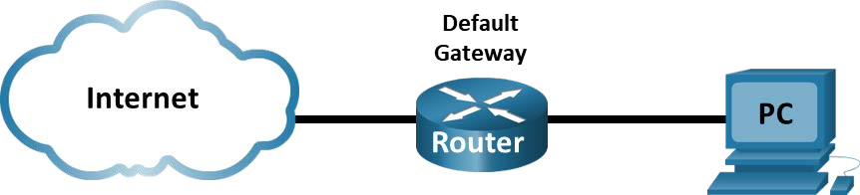
Objectives
Part 1: Capture and Analyze Local ICMP Data in Wireshark
Part 2: Capture and Analyze Remote ICMP Data in Wireshark
Part 3: Examine the Header Fields in an Ethernet II Frame
Part 4: Use Wireshark to Capture and Analyze Ethernet Frames
Background / Scenario
Wireshark is a software protocol analyzer, or "packet sniffer" application, used for network troubleshooting, analysis, software and protocol development, and education. As data streams travel back and forth over the network, the sniffer "captures" each protocol data unit (PDU) and can decode and analyze its content according to the appropriate RFC or other specifications.
Wireshark is a useful tool for anyone working with networks for data analysis and troubleshooting. When upper layer protocols communicate with each other, data flows down the Open Systems Interconnection (OSI) layers and is encapsulated into a Layer 2 frame. The frame composition is dependent on the media access type. For example, if the upper layer protocols are TCP and IP and the media access is Ethernet, then the Layer 2 frame encapsulation will be Ethernet II. This is typical for a LAN environment. When learning about Layer 2 concepts, it is helpful to analyze frame header information.
In this lab, you will use Wireshark to capture ICMP data packet IP addresses and Ethernet frame MAC addresses. You will review the fields contained in an Ethernet II frame and use Wireshark to capture and analyze Ethernet II frame header fields for local and remote traffic.
Required Resources
- 1 PC (Windows with internet access and Wireshark)
- Additional PCs on a local-area network (LAN) will be used to reply to ping requests.
Warning
Using a packet sniffer such as Wireshark may be considered a breach of the security policy of organizations. It is recommended that permission be obtained before running Wireshark for this lab. If using a packet sniffer such as Wireshark is an issue, Please contact the Lecturer.
Instructions
Prerequisite: Download and install Wireshark https://www.wireshark.org/#download

PART 1

Capture and Analyze Local ICMP Data in Wireshark
Ping another PC on the LAN and capture ICMP requests and replies in Wireshark. You will also look inside the frames captured for specific information. This analysis should help to clarify how packet headers are used to transport data to their destination.

Retrieve your PC interface addresses
For this lab, you will need to retrieve your PC IP address and its network interface card (NIC) physical address, also called the MAC address. Open a Windows command prompt.
1) In a command prompt window, enter ipconfig /all, to the IP address of your PC interface, its description, and its MAC (physical) address. C:\Users\Student> ipconfig /all

Windows IP Configuration

Host Name . . . . . . . . . . . . : DESKTOP-NB48BTC Primary Dns Suffix . . . . . . . :
Node Type . . . . . . . . . . . . : Hybrid IP Routing Enabled. . . . . . . . : No
WINS Proxy Enabled. . . . . . . . : No

Ethernet adapter Ethernet:

Connection-specific DNS Suffix . :
Description . . . . . . . . . . . : Intel(R) 82577LM Gigabit Network Connection Physical Address. . . . . . . . . :00-26-B9-DD-00-91
DHCP Enabled. . . . . . . . . . . : No
Autoconfiguration Enabled . . . . : Yes
Link-local IPv6 Address . . . . . : fe80::d809:d939:110f:1b7f%20(Preferred)
IPv4 Address. . . . . . . . . . . : 192.168.1.147(Preferred)
Subnet Mask . . . . . . . . . . . : 255.255.255.0
Default Gateway . . . . . . . . . : 192.168.1.1
<output omitted>

- Ask a team member or team members for their PC IP address and provide your PC IP address to them. Do not provide them with your MAC address at this time. Alternatively, you could use other Laptops or End devices which are
connected to your home network. (If practicing this lab from home) Close a Windows Command Prompt.
Start Wireshark and begin capturing data.
- Navigate to Wireshark. Double-click the desired interface to start the packet capture. Make sure the desired interface has traffic.
- Information will start scrolling down the top section in Wireshark. The data lines will appear in different colors based on protocol.
This information can scroll by very quickly depending on what communication is taking place between your PC and the LAN. We can apply a filter to make it easier to view and work with the data that is being captured by Wireshark.
For this lab, we are only interested in displaying ICMP (ping) PDUs. Type icmp in the Filter box at the top of Wireshark and press Enter, or click the Apply button (arrow sign) to view only ICMP (ping) PDUs.
- This filter causes all data in the top window to disappear, but you are still capturing the traffic on the interface. Navigate to a command prompt window and ping the IP address that you received from your team member. C:\> ping 192.168.1.114

Pinging 192.168.1.114 with 32 bytes of data:
Reply from 192.168.1.114: bytes=32 time<1ms TTL=128
Reply from 192.168.1.114: bytes=32 time<1ms TTL=128
Reply from 192.168.1.114: bytes=32 time<1ms TTL=128
Reply from 192.168.1.114: bytes=32 time<1ms TTL=128

Ping statistics for 192.168.1.114:
Packets: Sent = 4, Received = 4, Lost = 0 (0% loss), Approximate round trip times in milli-seconds:
Minimum = 0ms, Maximum = 0ms, Average = 0ms
Notice that you start seeing data appear in the top window of Wireshark again.
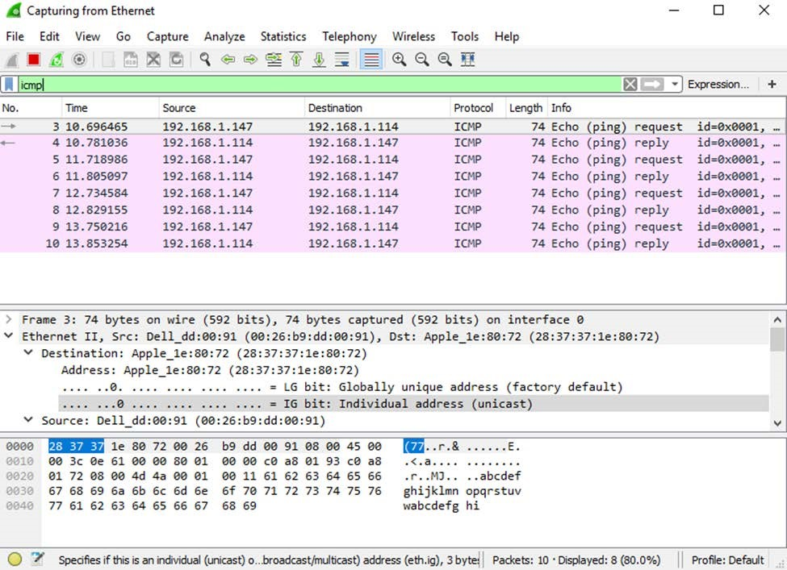

Note: If the PC of your team member does not reply to your pings, this may be because the PC firewall of the team member is blocking these requests. Please see Appendix A: Allowing ICMP Traffic Through a Firewall for information on how to allow ICMP traffic through the firewall using Windows.
- Stop capturing data by clicking the Stop Capture icon.
Examine the captured data.
Examine the data that was generated by the ping requests of your team member PC.
Wireshark data is displayed in three sections:
  - The top section displays the list of PDU frames captured with a summary of the IP packet information listed;
  - The middle section lists PDU information for the frame selected in the top part of the screen and separates a captured PDU frame by its protocol layers; 3) The bottom section displays the raw data of each layer. The raw data is displayed in both hexadecimal and decimal form.
- Click the first ICMP request PDU frames in the top section of Wireshark. Notice that the Source column has your PC IP address, and the Destination column contains the IP address of the teammate PC that you pinged.
- With this PDU frame still selected in the top section, navigate to the middle section. Click the plus sign to the left of the Ethernet II row to view the destination and source MAC addresses.
Record your reflection:

Does the source MAC address match your PC interface?
Yes

Does the destination MAC address in Wireshark match your team member MAC address? Yes

How is the MAC address of the pinged PC obtained by your PC?
The address is obtained by an ARP request which requests to find out layer addresses such as an IPV4 or a MAC address
Note: In the preceding example of a captured ICMP request, ICMP data is encapsulated inside an IPv4 packet PDU (IPv4 header) which is then encapsulated in an Ethernet II frame PDU (Ethernet II header) for transmission on the LAN.

PART 2
Capture and Analyze Remote ICMP Data in Wireshark
In Part 2, you will ping remote hosts (hosts not on the LAN) and examine the generated data from those pings. You will then determine what is different about this data from the data examined in Part 1.

Start capturing data on the interface.
- Start the data capture again.
- A window prompts you to save the previously captured data before starting another capture. It is not necessary to save this data. Click Continue without Saving.
- With the capture active, ping the following three website URLs from a Windows command prompt. 1) www.yahoo.com
  - www.cisco.com
  - www.google.com
Note: When you ping the URLs listed, notice that the Domain Name Server (DNS) translates the URL to an IP address. Note the IP address received for each URL.
- You can stop capturing data by clicking the Stop Capture icon.

Examining and analyzing the data from the remote hosts.
Review the captured data in Wireshark and examine the IP and MAC addresses of the three locations that you pinged. List the destination IP and MAC addresses for all three locations in the space provided.

Record your reflection:
IP address for www.yahoo.com:
87.248.100.215
MAC address for www.yahoo.com:
40:0d:10:73:0d:f8
IP address for www.cisco.com:
104.127.16.186
MAC address for www.cisco.com:
40:0d:10:73:0d:f8
IP address for www.google.com:
216.58.212.228
MAC address for www.google.com:
40:0d:10:73:0d:f8

What is significant about this information?
All these companies run through the same proxy therefore they have the same mac address

How does this information differ from the local ping information you received in Part 1?
This is a public IP address therefore its outside of the LAN. This means the part 1 IP address is Private while the second one is Public.

Why does Wireshark show the actual MAC address of the local hosts, but not the actual MAC address for the remote hosts?
The remote hosts mac address is not known on the local network therefore the mac address of the default gateway is used instead.

PART 3
Examine the Header Fields in an Ethernet II Frame

Examine the header fields and content in an Ethernet II frame. A Wireshark capture will be used to examine the contents in those fields.

Review the Ethernet II header field descriptions and lengths.
Preamble | Destination Address | Source Address | Frame Type | Data | FCS
8 Bytes | 6 Bytes | 6 Bytes | 2  Bytes | 46 –  1500  Bytes | 4  Bytes

Examine the network configuration of the PC.
In this example, this PC host IP address is 192.168.1.147 and the default gateway has an IP address of 192.168.1.1. C:\> ipconfig /all
Ethernet adapter Ethernet:
Connection-specific DNS Suffix . :
Description . . . . . . . . . . . : Intel(R) 82579LM Gigabit Network Connection Physical Address. . . . . . . . . : F0-1F-AF-50-FD-C8
DHCP Enabled. . . . . . . . . . . : Yes
Autoconfiguration Enabled . . . . : Yes
Link-local IPv6 Address . . . . . : fe80::58c5:45f2:7e5e:29c2%11(Preferred)
IPv4 Address. . . . . . . . . . . : 192.168.1.147(Preferred)
Subnet Mask . . . . . . . . . . . : 255.255.255.0
Lease Obtained. . . . . . . . . . : Friday, September 6, 2019 11:08:36 AM
Lease Expires . . . . . . . . . . : Saturday, September 7, 2019 11:08:36 AM
Default Gateway . . . . . . . . . : 192.168.1.1
DHCP Server . . . . . . . . . . . : 192.168.1.1
<output omitted>
Examine Ethernet frames in a Wireshark capture.
The screenshots of the Wireshark capture below shows the packets generated by a ping being issued from a PC host to its default gateway. A filter has been applied to Wireshark to view the ARP and ICMP protocols only. ARP stands for address resolution protocol. ARP is a communication protocol that is used for determining the MAC address that is associated with the IP address. The session begins with an ARP query and reply for the MAC address of the gateway router, followed by four ping requests and replies.
This screenshot highlights the frame details for an ARP request.
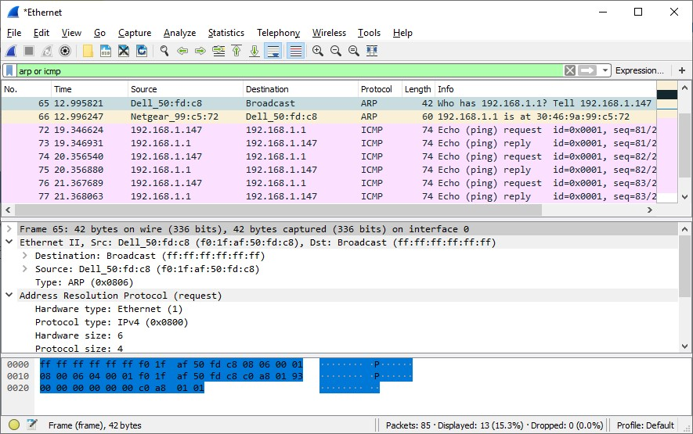
This screenshot highlights the frame details for an ARP reply.
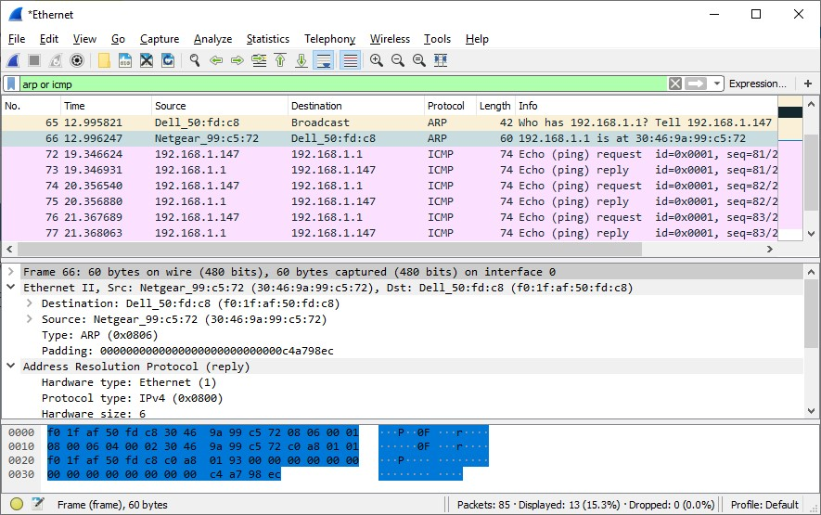

Examine the Ethernet II header contents of an ARP request.
The following table takes the first frame in the Wireshark capture and displays the data in the Ethernet II header fields.
Field | Value | Description
Preamble | Not shown in  capture | This field contains synchronizing bits, processed by the NIC hardware.
Destination  Address  Source  Address | Broadcast  (ff:ff:ff:ff:ff:ff)  Netgear_99:c5:72  (30:46:9a:99:c5:72) | Layer 2 addresses for the frame. Each address is 48 bits long, or 6 octets, expressed as 12 hexadecimal digits, 0-9,A-F.  A common format is 12:34:56:78:9A:BC.  The first six hex numbers indicate the manufacturer of the network interface card (NIC), the last six hex numbers are the serial number of the NIC.  The destination address may be a broadcast, which contains all ones, or a unicast. The source address is always unicast.
Frame Type | 0x0806 | For Ethernet II frames, this field contains a hexadecimal value that is used to indicate the type of upper-layer protocol in the data field. There are numerous upper-layer protocols supported by Ethernet II. Two common frame types are these:  Value Description  0x0800 IPv4 Protocol  0x0806 Address Resolution Protocol (ARP)
Data | ARP | Contains the encapsulated upper-level protocol. The data field is between 46 – 1,500 bytes.
FCS | Not shown in  capture | Frame Check Sequence, used by the NIC to identify errors during transmission. The value is computed by the sending device, encompassing frame addresses, type, and data field. It is verified by the receiver.

Record your reflection:
What is significant about the contents of the destination address field?
All hosts on the LAN will receive the broadcast frame. The default gateway will send a unicast reply to the host containing the MAC address of the NIC of the default gateway.

Why does the PC send out a broadcast ARP prior to sending the first ping request?
The PC needs to determine the destination before it can be sent.

What is the MAC address of the source in the first frame?
30:46:9a:99:c5:72

What is the Vendor ID (OUI) of the Source NIC in the ARP reply?
Netgear

What portion of the MAC address is the OUI?
First 3 octets

What is the NIC serial number of the source?
99:c5:72

PART 4
Use Wireshark to Capture and Analyze Ethernet Frames

Use Wireshark to capture local and remote Ethernet frames. You will then examine the information that is contained in the frame header fields.
Determine the IP address of the default gateway on your PC.
Open a command prompt window and issue the ipconfig command.

What is the IP address of the PC default gateway?
192.168.0.1

Start capturing traffic on your PC NIC.
Open Wireshark to start data capture. Observe the traffic that appears in the packet list window.

Filter Wireshark to display only ICMP traffic.
You can use the filter in Wireshark to block visibility of unwanted traffic. The filter does not block the capture of unwanted data; it only filters what you want to display on the screen. For now, only ICMP traffic is to be displayed. In the Wireshark Filter box, type icmp. The box should turn green if you typed the filter correctly. If the box is green, click Apply (the right arrow) to apply the filter.
From the command prompt window, ping the default gateway of your PC.
Open a Windows command prompt.
From the command window, ping the default gateway using the IP address that you have already recorded.

Stop capturing traffic on the NIC.

Click the Stop Capturing Packets icon to stop capturing traffic.

Examine the first Echo (ping) request in Wireshark.
The Wireshark main window is divided into three sections:
the packet list pane (top), the Packet Details pane (middle), and the Packet Bytes pane (bottom).
If you selected the correct interface for packet capturing previously, Wireshark should display the ICMP information in the packet list pane of Wireshark.
In the packet list pane (top section), click the first frame listed. You should see Echo (ping) request under the Info heading. The line should now be highlighted.
Examine the first line in the packet details pane (middle section). This line displays the length of the frame.
The second line in the packet details pane shows that it is an Ethernet II frame. The source and destination MAC addresses are also displayed

Record your reflection:
What is the MAC address of the PC NIC?
D8:3b:bf:b7:fc:af
What is the default gateway’s MAC address?
40:0d:10:73:0d:f8

You can click the greater than (>) sign at the beginning of the second line to obtain more information about the Ethernet II frame.
What type of frame is displayed?
IPv4 0x0800

The last two lines displayed in the middle section provide information about the data field of the frame. Notice that the data contains the source and destination IPv4 address information.
What is the source IP address?
192.168.0.28
What is the destination IP address?
192.168.0.1

You can click any line in the middle section to highlight that part of the frame (hex and ASCII) in the Packet Bytes pane (bottom section). Click the Internet Control Message Protocol line in the middle section and examine what is highlighted in the Packet Bytes pane
What do the last two highlighted octets spell?
hi
Click the next frame in the top section and examine an Echo reply frame. Notice that the source and destination MAC addresses have reversed, because this frame was sent from the default gateway router as a reply to the first ping.
What device and MAC address is displayed as the destination address?
Host pc = d8:3b:bf:b7:fc:af

Capture packets for a remote host.

Click the Start Capture icon to start a new Wireshark capture. You will receive a popup window asking if you would like to save the previous captured packets to a file before starting a new capture. Click Continue without Saving.
Open a Windows command prompt.
In a command prompt window, ping www.cisco.com.
Close a Windows command prompt.
Stop capturing packets. Examine the new data in the packet list pane of Wireshark.

Record your reflection:
In the first echo (ping) request frame, what are the source and destination MAC addresses?
Source:
d8:3b:bf:b7:fc:f8
Destination:
40:0d:10:73:0d:f8
What are the source and destination IP addresses contained in the data field of the frame?
Source:
192.168.0.28
Destination:
www.cisco.com 104.127.16.186
Compare these addresses to the addresses you received already. The only address that changed is the destination IP address. Why has the destination IP address changed, while the destination MAC address remained the same?
Layer 2 frames never leave the LAN. The ping has to use the default gateway MAC address for the frame destination. This then receives the packet strips it from the layer 2 frame information and creates a new header with the MAC address for the next hop continuing this process until the packet arrives at the destination IP address.

Wireshark does not display the preamble field of a frame header. What does the preamble contain?
The preamble field contains seven octets alternating in different 1010 sequences, one of these octets signals the beginning of the frame 10101011.

APPENDIX
A: Allowing ICMP Traffic through a Firewall

If the members of your team are unable to ping your PC/ or if you can’t successfully ping a device in your home network, the firewall may be blocking those requests. This appendix describes how to create a rule in the firewall to allow ping requests. It also describes how to disable the new ICMP rule after you have completed the lab.

Create a new inbound rule allowing ICMP traffic through the firewall.
Navigate to the Control Panel and click the System and Security option in the Category view.
In the System and Security window, click Windows Defender Firewall or Windows Firewall.
In the left pane of the Windows Defender Firewall or Windows Firewall window, click Advanced settings.
On the Advanced Security window, click the Inbound Rules option on the left sidebar and then click New Rule… on the right sidebar.
This launches the New Inbound Rule wizard. On the Rule Type screen, click the Custom radio button and click Next.
In the left pane, click the Protocol and Ports option and using the Protocol Type drop-down menu, select ICMPv4, and then click Next.
Verify that Any IP address for both the local and remote IP addresses are selected. Click Next to continue.
Select Allow the connection. Click Next to continue.
By default, this rule applies to all the profiles. Click Next to continue.
Name the rule with Allow ICMP Requests. Click Finish to continue. This new rule should allow your team members to receive ping replies from your PC.

Disabling or deleting the new ICMP rule.
After the lab is complete, you may want to disable or even delete the new rule you created previously. Using the Disable Rule option allows you to enable the rule again at a later date. Deleting the rule permanently deletes it from the list of inbound rules.

On the Advanced Security window, click Inbound Rules in the left pane and then locate the rule you created previously.
Right-click the ICMP rule and select Disable Rule if so desired. You may also select Delete if you want to permanently delete it. If you choose this option, you must re-create the rule again to allow ICMP replies.

