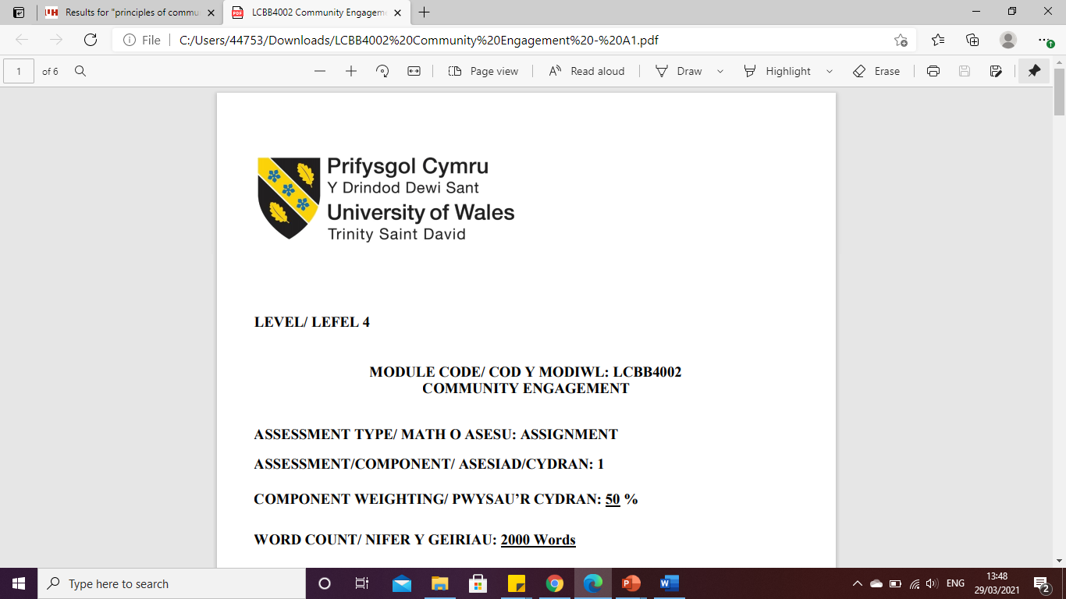

LEVEL 6

ASSIGNMENT 1- UNILEVER
MODULE CODE: LCBB6001
INTERNATIONAL BUSINESS COMMUNICATIONS

ASSESSMENT TYPE: ASSIGNMENT
ASSESSMENT/COMPONENT: 1
COMPONENT WEIGHTING: 50 %
WORD COUNT: 2 665 Words
SUBMISSION DETAILS:
Name: Cosmin Adrian Mitu
Student Number: 2021613
TABLE OF CONTENTS

1. Introduction to British business communications context 3
2. Introduction to Unilever 4
3. Theories of intercultural and international communication on the UK context 4
3.1. Hofstede cultural dimension 4
3.2. Power distance 5
3.3. Individualism 5
3.4. Masculinity 5
3.5. Uncertainty avoidance 6
3.6. Long-term orientation 6
3.7. Indulgence 6
3.8. Jandt’s theory on intercultural communication: 7
3.9. Gender identification: 7
3.10. Social class identification: 7
4. Cultural sensitivity access while doing business in the UK 8
4.1. Meetings in the UK: 8
4.2. Negotiations in the UK: 8
4.3. Time Perceptions in the UK: 8
4.4. UK meetings and Greetings: 8
5. Analysis of various communication issues experienced by the diverse workforce in the UK 9
5.1. Usage of too many channels: 9
5.2. Involvement of too many stakeholders: 9
5.3. Non-specific/accurate information flow: 9
6. Communication strategies and different recommendations to Unilever to succeed to provide a positive environment for all 9
6.1. Be clear about the company goals: 9
6.2. Monitor the work of the company: 10
6.3. Provide ongoing training: 10
7. Conclusion 10
8. Reference 11

Introduction to British business communications context
The secondary research states that business communication is mainly about personal titles, face-to-face communications, making effective contact to support business relations and language matters. The secondary research discusses the British people who are using a mix of indirect and direct communication. The practices related to British business mainly focus on day-to-day business situations and dealings. People in the UK effectively maintain face-to-face communication while doing business. While doing the introductions before the business meetings depending upon the specific situations. The perfect practice is to be effectively introduced by the third party; however, it cannot be possible. The British people mainly do the handshake while greeting one another during a new introduction and avoid it during subsequent meetings. For example, co-workers do not shake hands regularly at work. Starting to communicate with new people can be daunting for the British people due to their cultural expectations and norms. This is normally advisable to open the communication with a neutral topic like the weather or dictated by current or fast situations like asking for recommendations to drink or eat. This is an effective practice to initiate communication with open questions instead of personal viewpoints or subjective assumptions. To maintain effective business relations, the British people have to interact organically or develop, following the lead of the person to whom they are talking. The British people have to take permission while discussing sensitive subjects (Trade, 2019).
On the other hand, while doing business meetings in the UK, individuals or companies have to maintain their English language skills. While doing communication there can be a possibility of British counterparts who can speak other languages and linguistic differences can occur. Even the international language competence amongst the managers in the UK is normally poor. The characteristics have historical roots while British firms traded in maximum time with different English-speaking countries and dependencies. In this case, virtually no such requirements are there for the knowledge of different languages. In maximum British firms, their historical legacy manifests itself as the managers being reluctant to speak any language rather than English. While the capabilities of the English language are not satisfactory level then this is highly advisable to take the help of an interpreter (Trade, 2019).
In British culture, the agreement cannot be complete and final until the written contract has been formally witnessed and signed. However, this is important to ensure that every term and condition is included in the contractual document (formal). In various cases, depending on the business size or value, the contract should be subjected to approval and review by the solicitation in British contract law (Trade, 2019).

Introduction to Unilever
Unilever is a British multinational firm which has a strong commitment to corporate social responsibility. The organization is popular for their FMCG or first-moving consumer goods services. Unilever UK has more than 400 brand names in nearly 190 countries. The journey of this international company started in 1883 by launching Sunlight Soap. In 2021, the company had a £652 billion turnover and offered services to 3.4 billion people per day. The organization has 148,000 staff and offered more than 90 years of operation in Ireland and the UK. The purpose of Unilever is to make the commonplace of sustainable living. The mission of the company is to strive to do better for society and the planet. Unilever wants to act on environmental and social problems facing the globe and to enhance the lives of people with high-quality, sustainable and innovative items (Unilever PLC, 2023).

Theories of intercultural and international communication on the UK context
  - Hofstede cultural dimension
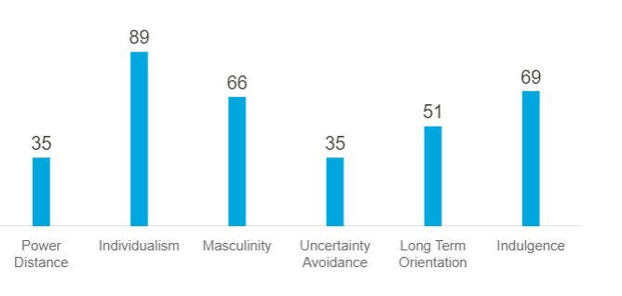
Fig 1: Hofstede’s cultural dimension of the UK
(Source: Insights, 2023)

  - Power distance
The score as per the diagram above is 35. British society is the kind of society that believes in equality and people of this kind of society think that inequality must be decreased. Interestingly, research shows that the score of the PD index is lower in Britain's higher class than all the working classes. At first, the PDI scores seem incongruent with the British class system which is historical and well-established. This culture reveals one of the major deep-rooted tensions in the culture of Britain. The tension is between the significance of rank by birth on one hand and an intrinsic belief about the birth of an individual on the other hand. In the Unilever company, the management believes that all people must be treated as equals. So, in the company power distance between all the employees is not too strong. The employees of Unilever do not ask for all the instructions of the managers and they also can easily consult and give advice for the project on which they are working together (Insights, 2023).
  - Individualism
The score of the UK in this section is 89 which means it is high and, in this dimension, the UK is battered by some commonwealth countries only. The people of British society are highly individualist and they are usually private people. These people teach their children to think about themselves at an early age to identify their special purpose in life and parents teach their children to contribute uniquely to society. Their roots of happiness go through their private fulfilment. The people from British society always value their privacy and think about themselves and achieve their personal goals. Employees of the Unilever company also believe in individualism and always seek for gaining personal success rather than the success of the company. So, the company must train its employees to perform in any group project properly to fulfil the goals of the company for success of the company (Insights, 2023).
  - Masculinity
The society of Britain is masculine as the score of the UK is 66 and which is high. Masculine society is hugely oriented toward success and driven by success. The UK society intends to value their work, competition, attainment and success of any project. The society of the UK gives less value on the impute like being modest to each other, behaving well with all and then assessing the life quality by all of these. These people of the UK intend to value their careers and they are usually comfortable revealing their ambition. In the company, Unilever male employees get the responsibility for maximum big projects as men employees are more serious about the projects of the company. The male employees do not think that the project is finished until they get their grades on the performance of their work (Insights, 2023).
  - Uncertainty avoidance
The score of the UK in this dimension is 35 and it can be considered a low score. The people of British society do not mind not knowing about the upcoming events of the future and they are happy to change their plans as per the need of the situation after getting new information. The UK is a low UAI country and the British people are happy with the ambiguous situations. In British society, there are not too many rules. These people do not make plans with proper details of their outcomes. In the Unilever company, the same thing can happen if the management does not take proper steps to tell the employees to be serious about the planning. The company has to deal with clients from all over the world so the company must take care of these situations as all societies are not the same as British society (Mindtools, 2022).
  - Long-term orientation
The score of the UK is neutral in this dimension because the score is 51. The score defines that British society accommodates the challenges of the present while still respecting the beliefs of the past. In the culture of the UK, it is usually essential to present oneself properly to be taken solemnly and these people think that compromise is a sign of showing weakness. In the Unilever company, the management and employees protect the past links while handling present challenges and future challenges. They do not compromise with any situation easily and they do not value modesty easily (Mindtools, 2022).
  - Indulgence
In this segment, the score of the UK is also high with a score of 69. The UK society is classified as an indulgent society. People in indulgent societies usually show their willingness to recognize their motives and requirements regarding the enjoyment of life and having fun. The British people have a positive attitude and they have positive thinking towards optimism. The Unilever company employees give importance to using their leisure time as they want to and spend their money as per their wish (Mindtools, 2022).

  - Jandt’s theory on intercultural communication:
With some key concepts, the author Fred E. Jandts leads his readers and provides help to his readers to properly get linked with the intercultural abilities in their experiences of life to enhance their thinking about intercultural communication (Sage, 2023).
  - Gender identification:
The debate on intercultural communication is not bounded by some restricted aspects. It also can be expressed as communication across all genders. The style of communication can be recognized by the communication style of all genders. It consults the differentiations between male and female workers in their workplace by their communication style, their use of language and their attitudes towards the management and other workers. In some countries, the governing body of any organization dispenses working powers and responsibilities to the workers that depend on the gender of the workers. In major countries, the most avoided gender in any workplace is females and females also face the gap according to payment. In the UK, branded companies follow the equality rules that are placed by the government. Also, Unilever is a respective company and they are committed to rewarding all employees as per their performance. This is a structure of the company for compensating its employees fairly (Unilever, 2020).
  - Social class identification:
Class identification is related to both social and economic class. It is described as how an individual or a group of people think about themselves in comparison with other people in the same society as per their position in the economy and society. In different cultures, the description and measurement of economic status are mostly similar but it is different for the social status. In some societies, people from elite classes think they are superior and only they have the right to get all the facilities but, in this era, people are being treated as per their performance and success. The company Unilever does not distribute the powers as per the social classification and they are committed to building an inclusive and more fair society by improving the standard of living of its employees and generating opportunities for them and preparing them for future work (Unilever PLC, 2023).

Cultural sensitivity access while doing business in the UK
  - Meetings in the UK:
The people from the UK usually like to work with a team of people they are friends with and can easily associate with them and with those people they easily can recognize. The meetings are decided before and these meetings require time. The style of meeting discussion can be unofficial but the nature of British people is task-aimed, so each member of any meeting must leave the meeting with a particular task (Expatica, 2023).
  - Negotiations in the UK:
The people of the UK are very skillful and tough negotiators. At the time of the negotiation, it is essential to stay polite and calm. Maybe the style is informal and they use a humorous tone to hide the seriousness of the issue and situation. The majority of businessmen in the UK follow a pragmatic and rational approach (Expatica, 2023).
  - Time Perceptions in the UK:
Recently British people have formalized being late for some social events such as dinner, and lunch. Companies advise their employees to be present on time for a meeting that is already scheduled. British managers generally work for longer hours and take the remaining work home (Expatica, 2023).
  - UK meetings and Greetings:
All over the UK, one of the most integral parts of usual indirect communication is humor. As a country, the UK is famous and well-known for its irony and humor. The majority of speakers who are not from the UK can often misunderstand their competitors. Euphemisms and understatements are generally used and required to be identified as a means to explain a point indirectly (Expatica, 2023).

Analysis of various communication issues experienced by the diverse workforce in the UK
  - Usage of too many channels:
Each business must choose the channels of production marketing carefully. Companies have to focus on the quality of delivered messages to the audience that is engaged. It is quite dangerous to have too many channels because for this the messaging quality will decline and the engagement of the audience may decrease and the sales may be lost. In Unilever, the management is using too many channels that are hard to follow and the company is losing the engagement of its consumers and sales are decreasing (Microsoft, 2021).
  - Involvement of too many stakeholders:
Having a diverse interest in all the projects and its result is generally a nice thing but a large scale of diverse shareholders may also pull the project group in various directions. Shareholders frequently struggle to form effective decisions from the team without cautious management. Lining up so many diverse shareholders jointly can be very challenging for all the managers and may add extra challenges for the projects. Unilever has involved too many shareholders in their company and the management of the company is facing issues and challenges with all projects (Cdc.gov, 2023).
  - Non-specific/accurate information flow:
The structure of information flow occurs when the leaders of higher management and leadership positions split instructions with all lower-level employees of any organization. In Unilever, the information flow is low, which means lower-level workers are not getting proper and accurate information about any instructions that are taken by the top management of Unilever (Siddique, 2014).

Communication strategies and different recommendations to Unilever to succeed to provide a positive environment for all
  - Be clear about the company goals:
The mission of any company must be to be the cornerstone of communications with everything else. So, all things must be cleared to the employees who are working with it. The management has to ensure that every employee must be aware of the goals that their organization is trying to fulfil to make them know the vision of the company. The company Unilever, must be transparent toward their employees and flow proper information about the goal that Unilever wants to achieve (Tariq, 2022).
  - Monitor the work of the company:
All companies have to ensure that they are continuously collecting information and feedback on the quality of products by their consumers. Also, the company has to ask the staff to measure their experiences while using the communication tools provided by the company. The company Unilever must follow these to enable itself to recognize the recent trends of the market and the impact of the changes that are made by the company on the trends (Tariq, 2022).
  - Provide ongoing training:
This is essentially significant if the system of any company is changing regularly but also essential for the new employees who are not familiar with the systems and business processes of the company. So, Unilever's aim must be to provide proper training to its employees once a year to make sure that the employees can use the company's communication system properly (Tariq, 2022).

Conclusion
The report described British Business communication. A brief introduction to British Business communication and the company Unilever is presented in the above report. Some theories are applied to measure the context. A critical evaluation of the cultural sensitivity of doing business in the UK is defined here. Some communication barriers faced by Unilever are also discussed and some strategies are provided to enable the success of Unilever.

Reference
Cdc.gov (2023) Identifying and determining involvement of stakeholders - CDC. Available at: https://www.cdc.gov/std/Program/pupestd/Identifying%20and%20Determining%20Stakeholders.pdf (Accessed: April 24, 2023).
Expatica (2023) Business culture in the United Kingdom, Expatica United Kingdom. Available at: https://www.expatica.com/uk/working/employment-basics/uk-business-culture-103182/ (Accessed: April 24, 2023).
Insights, H. (2023) United Kingdom, Hofstede Insights. Available at: https://www.hofstede-insights.com/country/the-uk/ (Accessed: April 24, 2023).
Microsoft (2021) Tech users' battle to stay in touch: Too many channels, too little time, Microsoft Research. Available at: https://www.microsoft.com/en-us/research/group/customer-insights-research/articles/tech-users-battle-to-stay-in-touch-too-many-channels-too-little-time/ (Accessed: April 24, 2023).
Mindtools (2022) Home, MindTools. Available at: https://www.mindtools.com/a1ecvyx/hofstedes-cultural-dimensions (Accessed: April 24, 2023).
Sage (2023) An introduction to intercultural communication, Sage Publications Inc. Available at: https://us.sagepub.com/en-us/nam/an-introduction-to-intercultural-communication/book267102 (Accessed: April 24, 2023).
Siddique, R. (2014) Internal Communication Problems of Unilever, prezi.com. Available at: https://prezi.com/eehvo6_tuzqg/internal-communication-problems-of-unilever/#:~:text=Usage%20of%20too%20many%20channels,Well%20structured%20communication%20methods%20used (Accessed: April 24, 2023).
Tariq, H. (2022) Council post: Five components of a successful Strategic Communications Plan, Forbes. Forbes Magazine. Available at: https://www.forbes.com/sites/forbescommunicationscouncil/2021/06/22/five-components-of-a-successful-strategic-communications-plan/?sh=4e99bb6d5813 (Accessed: April 24, 2023).
Trade, P.to (2019) Business communication, Business Culture. Available at: https://businessculture.org/northern-europe/united-kingdom-business-culture/business-communication/ (Accessed: April 24, 2023).
Unilever (2020) Unilever Gender Pay Report 2020 - assets.unilever.com. Available at: https://assets.unilever.com/files/92ui5egz/production/82bf256c66f0b5d895779abd3fb5b0b234f4f634.pdf/unilever-uk-gender-pay-gap-report-2020.pdf (Accessed: April 24, 2023).
Unilever PLC (2023) About - purpose - our company, Unilever. Unilever PLC. Available at: https://www.unilever.co.uk/our-company/ (Accessed: April 24, 2023).
Unilever PLC (2023) Unilever commits to help build a more inclusive society, Unilever. Unilever PLC. Available at: https://www.unilever.com/news/press-and-media/press-releases/2021/unilever-commits-to-help-build-a-more-inclusive-society/ (Accessed: April 24, 2023).

