NAME - BHUMIKA
STUDENT NO-2230753
MBA PROGRAM
HUMAN RESOURCE MANAGEMENT (BMMB7007)
Contents
Executive Summary 2
1.0 Introduction 3
1.1 Employee Engagement 3
2.0 Organisational Overview 4
3.0 Main Discussion 5
3.1 Priority Area: Employee Engagement 5
3.2 Current Weaknesses 5
a) Lack of transparent communication: 5
b) Insufficient recognition and rewards 5
c) Limited growth and development opportunities 6
3.3 Impact on the Organisation 6
a) Increased turnover 6
b) Lower productivity 6
c) Damaged employer brand: 6
d) Reduced customer satisfaction 6
e) Hindered innovation and collaboration: 6
f) Increased absenteeism 7
Conclusions 7
5.0 Recommendations 7
a) Improve communication 8
b) Enhance recognition and rewards 8
c) Invest in employee growth and development 8
References 10

Executive Summary
This report provides a comprehensive critical evaluation of the Human Resource Management (HRM) priority area of employee engagement within the context of ABC Limited, a UK-based retail company. Employee engagement has emerged as a crucial priority area due to its significant influence on various aspects of organizational success, including employee performance, job satisfaction, and retention. It is widely acknowledged that engaged employees are more likely to be productive, committed, and contribute proactively to achieving organizational objectives.
The primary objective of this report is to identify the current weaknesses in ABC Limited's employee engagement practices and assess the adverse impact these shortcomings have on the organization. By highlighting these concerns and offering feasible recommendations for improvement, the report aims to help ABC Limited enhance its employee engagement practices, enabling the company to better fulfill its strategic aims and gain a competitive edge in the dynamic retail landscape (SHRM, 2019).
The evaluation begins by offering a thorough analysis of the benefits of enhancing employee engagement at ABC Limited, focusing on how it could contribute to improved organizational performance, increased employee satisfaction, and a more committed workforce (Pansari, 2015). By emphasizing the importance of employee engagement in driving business success, the report demonstrates the need for ABC Limited to prioritize this HRM area. Subsequently, the report delves into the identification and discussion of the current weaknesses in the organization's employee engagement practices. The analysis uncovers several areas of concern, including insufficient communication, inadequate recognition and rewards systems, and limited opportunities for growth and development. These issues contribute to a lack of employee motivation and commitment, ultimately affecting the company's overall performance.
Furthermore, the report explores the negative consequences of these shortcomings on the organization. The analysis highlights the detrimental effects on employee turnover, productivity, and employer brand, demonstrating the pressing need for ABC Limited to address its employee engagement weaknesses. By comprehensively examining the impact of these issues, the report emphasizes the urgency for the organization to take action and implement improvements.
Finally, the report offers feasible recommendations for improving employee engagement within the specific context of ABC Limited. These suggestions include enhancing communication channels, revamping the recognition and rewards systems, and investing in employee growth and development opportunities. By implementing these recommendations, ABC Limited can create a more engaged workforce, ultimately leading to improved organizational performance and a stronger competitive position in the market.

1.0 Introduction
This report aims to critically analyze the HRM priority area of employee engagement at ABC Limited, a retail company in the UK (Sivapragasam and Raya, 2017). Employee engagement is a critical factor in organizational success, as it directly impacts productivity, retention, and overall employee well-being (Kaaviyapriya and Xavier, 2021). Engaged employees are more likely to be motivated, committed, and actively contribute to achieving organizational goals. The report will examine the benefits of enhancing employee engagement, identify existing weaknesses, and assess the impact of these weaknesses on the organization. This analysis will provide a comprehensive understanding of the current state of employee engagement at ABC Limited and provide a foundation for developing actionable recommendations for improvement.
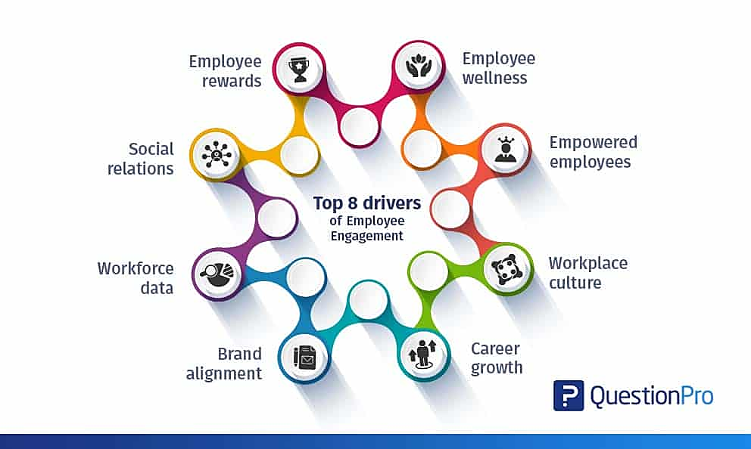

1.1 Employee Engagement
Employee engagement can be defined as the emotional and intellectual commitment employees have towards their organization, which influences their willingness to put in discretionary effort to achieve organizational goals (Shafiq and Rana, 2016). High levels of employee engagement have been linked to numerous positive outcomes, including increased productivity, improved job satisfaction, reduced turnover, and enhanced organizational performance (Lakshmi Narayanamma, Neelima and Mounika, n.d.). In the context of ABC Limited, employee engagement is crucial to maintaining a competitive edge in the ever-changing retail landscape, where companies must continuously innovate and adapt to new challenges.
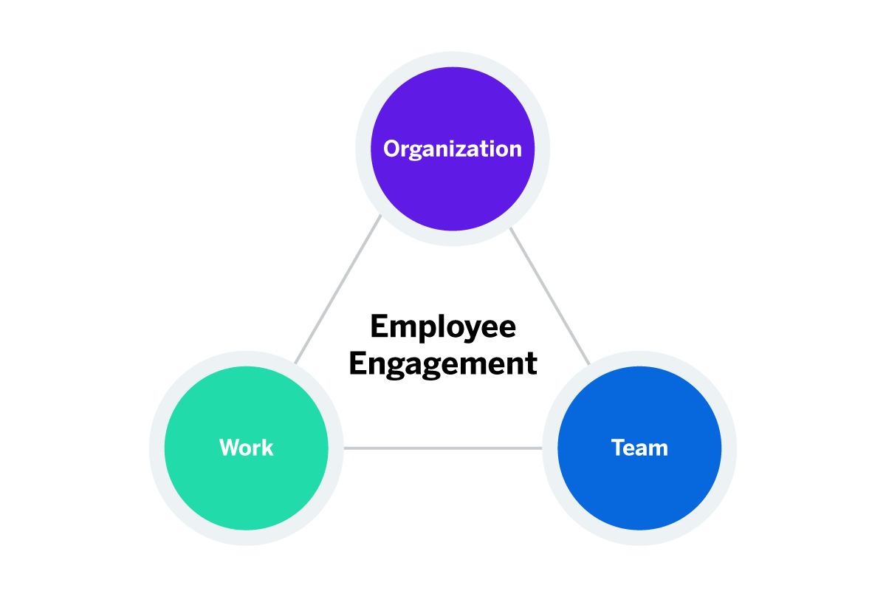

2.0 Organisational Overview
ABC Limited is a prominent UK-based retail company with a strong presence across the country, operating over 200 stores in diverse locations, ranging from bustling city centres to suburban shopping districts (Kazimoto, 2016). The company has built a solid reputation for offering quality products at competitive prices and providing exceptional customer service, which has contributed to its continued growth and success in the retail industry.
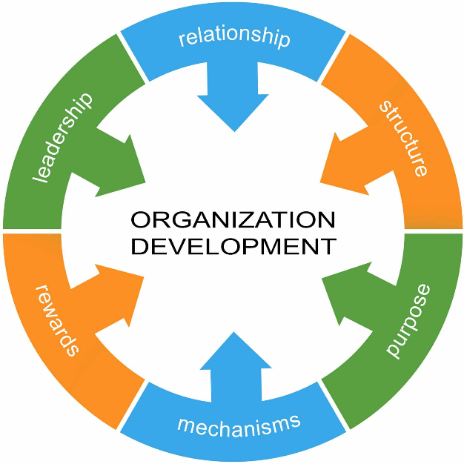
The company employs approximately 5,000 people across various roles and functions, including store staff, logistics, corporate functions, and management. This diverse workforce is an essential asset for the company, as it brings together individuals with a wide range of skills, experiences, and perspectives, fostering a culture of innovation and collaboration.
The HRM function at ABC Limited operates with a dedicated HR team that reports directly to the Human Resources Director, who is an integral member of the executive team. This reporting structure ensures that HR-related matters receive appropriate attention and strategic focus at the highest level of the organization. The HR team comprises both HR generalists and specialists, who work together to manage and support various aspects of human resource management, such as recruitment, employee relations, performance management, learning and development, compensation and benefits, and diversity and inclusion initiatives.
ABC Limited's HR function plays a vital role in developing and implementing strategies to attract, retain, and engage talent in a highly competitive retail environment. The HR team collaborates closely with business leaders and managers to ensure that the organization's human capital strategies are aligned with its overall business objectives, contributing to the company's continued success.
Given the dynamic nature of the retail industry, the HR team at ABC Limited is continuously focused on addressing the evolving needs of the business and its workforce. This includes adapting to changes in consumer preferences, technology advancements, and market trends, as well as staying abreast of relevant employment laws, regulations, and best practices in the field of human resource management.
In this context, employee engagement has emerged as a critical priority area for the HR function at ABC Limited. A highly engaged workforce is essential for driving productivity, enhancing job satisfaction, and promoting employee retention, all of which contribute to the company's overall success and competitive edge in the market. This report will examine the current state of employee engagement at ABC Limited, identify areas for improvement, and provide feasible recommendations for enhancing engagement within the organization.

3.0 Main Discussion

3.1 Priority Area: Employee Engagement
Employee engagement has been identified as a priority area for ABC Limited due to its direct influence on employee performance, satisfaction, and retention. High employee engagement levels can lead to increased productivity, reduced turnover, and improved customer satisfaction. Engaged employees tend to be more motivated, committed to their work, and contribute proactively towards achieving organizational goals. By addressing the shortcomings in employee engagement practices, ABC Limited can create a more engaged workforce, ultimately enhancing its overall performance and competitive position in the market.

3.2 Current Weaknesses
ABC Limited faces several weaknesses in its current employee engagement practices, which can be attributed to various factors, including organizational culture, communication, rewards systems, and career development opportunities. These weaknesses have a significant impact on employee motivation, satisfaction, and commitment to the organization. The following are some of the key weaknesses identified in ABC Limited's employee engagement practices:
a) Lack of transparent communication: Employees report feeling disconnected from the company's strategy and decision-making processes, leading to confusion and disengagement. Transparent communication is essential to ensure employees understand their roles, responsibilities, and the impact of their work on the organization's success. However, at ABC Limited, employees often feel that they are not adequately informed about important organizational developments, changes, and plans, resulting in a lack of clarity and a sense of disconnection from the company's objectives.
b) Insufficient recognition and rewards: ABC Limited's current rewards system does not adequately acknowledge employee achievements, leading to dissatisfaction and reduced motivation. Recognition and rewards play a crucial role in motivating employees and fostering a sense of accomplishment. Unfortunately, ABC Limited's existing recognition and rewards system is perceived as inadequate and inconsistent, leading employees to feel undervalued and demotivated.
c) Limited growth and development opportunities: Employees express concern over the lack of opportunities for career advancement and skill development, which affects their long-term commitment to the company. Continuous learning and development opportunities are essential for employee growth, satisfaction, and engagement. At ABC Limited, employees feel that there are limited opportunities for career progression and skill development, which hinders their engagement and commitment to the organization.

3.3 Impact on the Organisation
The weaknesses in ABC Limited's employee engagement practices have led to several negative outcomes that directly affect the organization's overall performance and competitive edge (Saks, 2006). Some of the key consequences include:
a) Increased turnover: Disengaged employees are more likely to seek opportunities elsewhere, resulting in higher turnover rates and associated recruitment and training costs. High turnover can be detrimental to an organization, as it not only incurs significant costs but also disrupts the continuity of operations and negatively impacts employee morale. Additionally, the loss of skilled and experienced employees can result in knowledge gaps within the organization, further affecting performance.
b) Lower productivity: Disengaged employees may be less motivated to perform at their best, leading to decreased efficiency and productivity. Low employee engagement can manifest itself in various forms, such as reduced enthusiasm, low discretionary effort, and a lack of initiative. As a result, employees may not be fully committed to their work, leading to suboptimal performance and lower productivity levels. This has a direct impact on ABC Limited's bottom line and overall organizational success.
c) Damaged employer brand: High turnover rates, low employee morale, and disengagement can harm the company's reputation, making it difficult to attract and retain top talent. A strong employer brand is crucial for attracting and retaining high-caliber employees who can drive the organization's growth and success. However, ABC Limited's weak employee engagement practices can negatively impact its employer brand, as potential candidates may perceive the company as an undesirable place to work.
d) Reduced customer satisfaction: As a retail company, ABC Limited's success heavily relies on providing exceptional customer experiences.
Disengaged employees may not exhibit the same level of dedication to customer service as engaged employees, potentially resulting in lower customer satisfaction levels. In the retail industry, customer satisfaction is a key driver of repeat business, brand loyalty, and positive word-of-mouth. Consequently, a decline in customer satisfaction due to disengaged employees can negatively impact ABC Limited's overall performance and market reputation.
e) Hindered innovation and collaboration: Engaged employees are more likely to contribute to a culture of innovation and collaboration within the organization, as they actively seek opportunities for improvement and willingly share their ideas and knowledge (Fu et al., 2022). However, in a workplace with low employee engagement, there may be a lack of enthusiasm and initiative to contribute to innovative efforts or collaborate effectively with colleagues. This can limit the organization's ability to adapt to changing market conditions, develop innovative solutions, and stay ahead of the competition.
f) Increased absenteeism: Disengaged employees are more prone to absenteeism, which can disrupt the normal functioning of the organization and put additional pressure on other employees. Frequent absences not only impact the organization's productivity but also increase the workload for other employees, potentially leading to burnout and further disengagement.
In summary, the weaknesses in ABC Limited's employee engagement practices have significant consequences for the organization, affecting its overall performance, productivity, and reputation. By addressing these weaknesses and enhancing employee engagement, ABC Limited can mitigate these negative outcomes, better fulfil its strategic aims, and gain a competitive edge in the market.

Conclusions
The analysis of ABC Limited's employee engagement practices reveals several areas of weakness, including communication, recognition and rewards, and growth and development opportunities. These shortcomings have significant implications for the organization's overall performance, productivity, and reputation. Addressing these weaknesses is crucial for creating a more engaged workforce, which in turn can contribute to the organization's strategic aims and competitive advantage.
Transparent and effective communication is a fundamental aspect of employee engagement, as it ensures that employees understand the company's goals, their role in achieving these objectives, and any changes that may impact their work. By improving communication practices, ABC Limited can foster a sense of connection and alignment between employees and the organization, ultimately enhancing engagement levels.
Recognition and rewards are another critical component of employee engagement. An effective recognition and rewards system acknowledges employees' achievements and contributions, fostering a sense of accomplishment and motivation. ABC Limited needs to review and enhance its existing rewards system to ensure that it is equitable, consistent, and adequately acknowledges employees' efforts, which will contribute to higher levels of satisfaction and engagement.
Finally, growth and development opportunities play a significant role in employee engagement, as they enable employees to enhance their skills, advance their careers, and maintain long-term commitment to the organization. By offering more opportunities for learning and development, as well as clear career progression paths, ABC Limited can improve employee satisfaction and engagement, ultimately resulting in a more committed and high-performing workforce.
In conclusion, addressing these key weaknesses in employee engagement practices is essential for ABC Limited to realize the full potential of its workforce, enhance overall performance, and maintain a competitive edge in the market. By taking targeted action to improve communication, recognition and rewards, and growth and development opportunities, the organization can create a more engaged, satisfied, and productive workforce that contributes to its long-term success.

5.0 Recommendations
To improve employee engagement at ABC Limited, the following recommendations are proposed:
a) Improve communication: Implement regular town hall meetings, employee surveys, and other communication channels to keep employees informed and engaged in company strategy and decision-making. This can be achieved by:
i) Establishing a clear communication strategy that outlines the objectives, channels, and frequency of communication, ensuring that information flows consistently and transparently throughout the organization (Sköld, 2019).
ii) Encouraging open dialogue between management and employees by creating opportunities for feedback, questions, and suggestions, such as anonymous suggestion boxes, online forums, or regular one-on-one meetings with managers.
iii) Providing regular updates on organizational performance, strategy, and changes, ensuring that employees understand how their work contributes to the company's overall success.
b) Enhance recognition and rewards: Revise the current rewards system to better acknowledge employee achievements, and establish a company-wide recognition program to celebrate success (Vantage Circle HR Blog, 2018). This can include:
i) Developing a transparent and equitable rewards system that takes into account individual performance, team contributions, and overall company success, ensuring that employees feel fairly compensated for their efforts.
ii) Introducing a peer recognition program, where employees can nominate their colleagues for awards or commendations based on their achievements, fostering a culture of appreciation and support.
iii) Celebrating success through company-wide events, newsletters, or social media, highlighting the accomplishments of individuals and teams and reinforcing the importance of their work.
c) Invest in employee growth and development: Offer comprehensive training programs, mentoring schemes, and opportunities for career advancement to support employee growth and maintain long-term commitment (Dachner et al., 2019). This can involve:
i) Conducting regular skills assessments and identifying areas for improvement, ensuring that employees receive targeted training and development opportunities to enhance their capabilities and performance.
ii) Implementing a mentoring program, where experienced employees can provide guidance and support to newer or less experienced colleagues, fostering a culture of learning and growth.
iii) Establishing clear career progression paths and promotion criteria, allowing employees to understand the steps required to advance within the organization and providing them with the motivation to develop their skills and capabilities.
These recommendations should be feasible within the resources available to ABC Limited and should be tailored to address the specific needs and challenges the company faces. Potential risks, costs, and ethical considerations must be carefully assessed and managed to ensure successful implementation. For example, the costs associated with training programs and recognition events should be weighed against the benefits of increased employee engagement, productivity, and retention. Additionally, any changes to the rewards system should be communicated transparently and fairly, ensuring that employees understand the rationale behind the changes and feel that their contributions are valued and acknowledged.
By implementing these recommendations, ABC Limited can significantly enhance employee engagement, leading to improved performance, reduced turnover, and a more positive workplace culture. Furthermore, these improvements will contribute to the organization's long-term success and competitiveness, positioning ABC Limited as an employer of choice in the retail industry.

References
Dachner, A., Ellingson, J., Noe, R. and Saxton, B. (2019). The future of employee development The future of employee development The future of employee development. [online] Available at: https://core.ac.uk/download/pdf/289197727.pdf.
Fu, X., Fu, X. (Maggie), Ghauri, P. and Hou, J. (2022). International collaboration and innovation: Evidence from a leading Chinese multinational enterprise. Journal of World Business, 57(4), p.101329.
Kaaviyapriya, K. and Xavier, P. (2021). A Study about the Factors Affecting Employee Engagement and Its Outcomes. [online] papers.ssrn.com. Available at: https://papers.ssrn.com/sol3/Delivery.cfm?abstractid=3785974 [Accessed 25 Mar. 2023].
Kazimoto, P. (2016). Employee Engagement and Organizational Performance of Retails Enterprises. American Journal of Industrial and Business Management, 06(04), pp.516–525.
Lakshmi Narayanamma, P., Neelima, S. and Mounika, K. (n.d.). Employee Engagement and Organizational Performance: A Literature Review. Journal of Positive School Psychology, [online] 2022(3), pp.3558–3563. Available at: https://www.journalppw.com/index.php/jpsp/article/download/2144/1316 [Accessed 25 Mar. 2023].
Pansari, A. (2015). Measuring the Benefits of Employee Engagement. [online] MIT Sloan Management Review. Available at: https://sloanreview.mit.edu/article/measuring-the-benefits-of-employee-engagement/.
Saks, A.M. (2006). Antecedents and consequences of employee engagement. Journal of Managerial Psychology, [online] 21(7), pp.600–619. Available at: https://doi.org/10.1108/02683940610690169.
SHRM (2019). Developing and Sustaining Employee Engagement. [online] SHRM. Available at: https://www.shrm.org/resourcesandtools/tools-and-samples/toolkits/pages/sustainingemployeeengagement.aspx.
Sivapragasam, P. and Raya, R.P. (2017). HRM and Employee Engagement Link: Mediating Role of Employee Well-being. Global Business Review, [online] 19(1), pp.147–161. Available at: https://journals.sagepub.com/doi/abs/10.1177/0972150917713369?journalCode=gbra.
Shafiq, M. and Rana, R.A. (2016). Relationship of Emotional Intelligence to Organizational Commitment of College Teachers in Pakistan. Eurasian Journal of Educational Research, 16(62), pp.1–14.
Sköld, M. (2019). Employee perspective on communication and engagement A case study in a manufacturing organisation. [online] Available at: http://ltu.diva-portal.org/smash/get/diva2:1335082/FULLTEXT01.pdf.
Vantage Circle HR Blog. (2018). 33 Employee Rewards and Recognition Ideas to Boost Engagement. [online] Available at: https://blog.vantagecircle.com/rewards-and-recognition-ideas/ [Accessed 30 Sep. 2020].

‌
‌

