Student Name - Natasha Rose-Taylor
Student number – 2328696
Tutor – Olufemi Oluranti
Changemakers: Building your personal brand for sustainable employment – BMHP5015
Component 2 – Report

Introduction
Working within the Children with Disabilities (CWD) Team requires a highly skilled, knowledgeable, and resilient practitioner capable of supporting children with complex needs and their families. This report examines the employability requirements for the Social Worker role within Birmingham Children’s Trust and evaluates how my current skills, experience, and qualifications align with these expectations. It also outlines a structured action plan to support my progression into social work, alongside strategies for building my personal brand, promoting my professional identity, and developing a strong professional network. The report aims to demonstrate my readiness and commitment to pursuing a career within children’s disability services.
Job Role and Employability Skills
The Social Worker role within Birmingham Children’s Trust’s Children with Disabilities (CWD) Team involves safeguarding, assessment, care planning, and multi-agency collaboration. The job advert highlights that practitioners are responsible for “safeguarding and promoting the welfare of children and young people” and must work closely with families and professionals to assess needs and develop care plans (Birmingham Children’s Trust, 2026). The team supports children with physical disabilities, learning disabilities, autism, and complex health needs, requiring practitioners to demonstrate specialist knowledge, strong interpersonal skills, and the ability to work sensitively with children and families experiencing significant challenges.
A key employability requirement is a recognised Social Work degree and registration with Social Work England, ensuring practitioners meet national professional standards (Social Work England, 2019). Social workers must demonstrate a thorough understanding of safeguarding legislation, including Working Together to Safeguard Children (Department for Education, 2025), which outlines statutory responsibilities for protecting children from harm. Strong assessment and analytical skills are essential, as practitioners must evaluate risk, analyse complex information, and make evidence-based decisions to ensure children’s safety and wellbeing (Trevithick, 2012). Effective communication is also vital, as social workers must build trusting relationships with children, families, and professionals, adapting their communication style to meet individual needs and ensuring that children’s voices are heard (Thompson, 2015).
Multi-agency working is a core component of the role, with practitioners expected to collaborate with health, education, police, and voluntary organisations to ensure holistic and coordinated support (NSPCC, 2023). The Professional Capabilities Framework (PCF) emphasises professionalism, ethics, critical reflection, and partnership working as essential capabilities for social workers (BASW, 2018). Personal qualities such as empathy, resilience, emotional intelligence, and cultural competence are also crucial for effective practice, particularly when supporting children with disabilities and their families (Howe, 2013). These combined skills ensure practitioners can deliver high-quality, child-centred support within a complex and demanding area of practice.
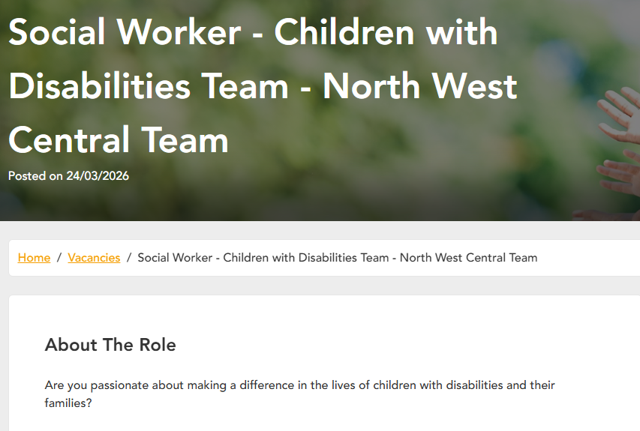
Job Advertisement - Social Worker - Children with Disabilities Team - North West Central Team in Birmingham - Birmingham Children's Trust

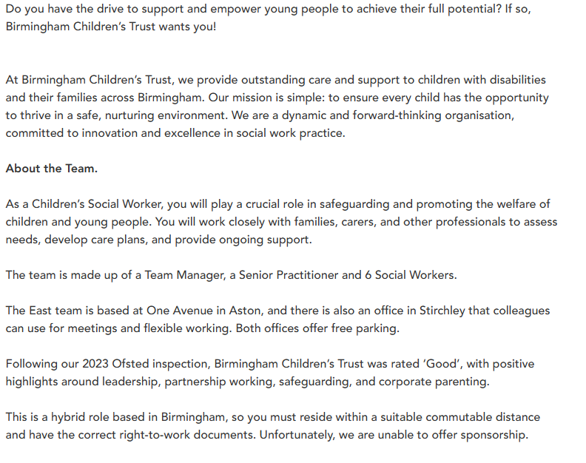

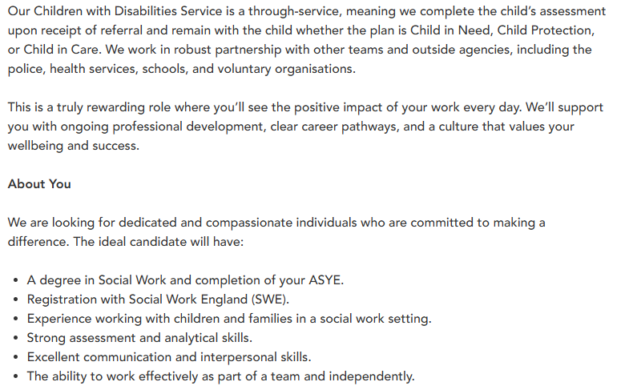
Figure 1 – Social worker job

Evaluation of My Skills
My current skills, experience, and qualifications align strongly with the requirements of the Social Worker role within the Children with Disabilities (CWD) Team. I have four years of experience working with vulnerable adults with complex needs, which has enabled me to develop strong interpersonal skills, emotional resilience, and the ability to remain calm and professional in high-pressure situations. This experience has strengthened my understanding of safeguarding, risk management, and person-centred approaches, all of which are directly transferable to social work practice (Thompson, 2015). Working in environments where individuals present with a range of cognitive, behavioural, and physical needs has also enhanced my ability to adapt quickly, think critically, and respond sensitively to challenging situations.
I also have one year of experience as a Speech and Language Therapy Assistant, where I worked closely with individuals with communication difficulties. This role required me to collaborate within a multidisciplinary team (MDT), follow therapy plans, support communication development, and contribute to assessments. MDT working is a key requirement of the CWD role, and my experience aligns closely with the collaborative nature of social work practice. Through this role, I developed a deeper understanding of communication barriers, alternative communication methods, and the importance of working holistically with families and professionals.
My communication skills are a significant strength. I hold Makaton Level 2, which enhances my ability to communicate with children and young people who use alternative communication methods. Effective communication is essential for building relationships, gathering information, and supporting children with disabilities (Thompson, 2015). I am also confident in managing challenging behaviour, using de-escalation techniques, and maintaining a trauma-informed approach, which is crucial when working with children with complex needs.
In addition to my professional experience, I have lived experience supporting my own SEND child. This has provided me with a deep understanding of autism, sensory needs, communication differences, and the challenges families face when navigating services. My Level 3 Autism qualification further strengthens my knowledge of autism spectrum conditions and inclusive practice.
Academically, I am completing a Health and Social Care degree, entering my final year in May 2026 and completing in May 2027. I am also completing my English qualification (June 2026) and Maths qualification (2027), which will allow me to meet the entry requirements for the Step Up to Social Work programme. While I have strong interpersonal and communication skills, I recognise the need to develop formal assessment skills, gain direct experience with children with disabilities, and build confidence in applying safeguarding procedures in practice.
Action Plan and Timeline
To achieve my goal of becoming a Social Worker within the Children with Disabilities (CWD) Team, I have developed a structured and realistic action plan covering the period from 2026 to 2030. This plan outlines the key steps I will take to build the qualifications, experience, and professional identity required for the role.
May 2026 – May 2027: Complete Degree & Qualifications During this period, I will complete the final year of my Health and Social Care degree. My focus will be on strengthening my academic writing, critical thinking, and understanding of safeguarding, legislation, and professional practice. I will ensure that I meet all assignment deadlines, engage fully in seminars, and use feedback to improve my academic performance. Alongside this, I will complete my English qualification by June 2026 and continue progressing through my Maths qualification, which I aim to complete in 2027. Achieving these qualifications is essential for meeting the entry requirements for Step Up to Social Work.
2026–2027: Gain Experience with Disabled Children To strengthen my application, I will seek voluntary or part-time roles within SEND schools, disability charities, respite services, or parent support groups. This will allow me to gain direct experience supporting children with disabilities, develop my understanding of their needs, and apply my communication and behaviour-management skills in a children’s setting. This experience will also help me build confidence in working with families and professionals.
2026–2027: Build Professional Identity and Portfolio I will begin developing my professional identity by creating a high-quality CV tailored to social work, compiling a portfolio of certificates, reflective logs, and CPD activities, and considering the creation of a LinkedIn profile. I will also attend Step Up to Social Work information sessions, university employability workshops, and local authority open days to expand my knowledge of the profession. During this time, I will begin gathering references from academic tutors and previous employers.
Late 2026 – Early 2027: Prepare for Step Up Application I will prepare my application by reviewing eligibility criteria, attending preparation workshops, and practising interview techniques. I will highlight my professional experience, lived experience, and academic achievements.
2027–2028/29: Complete Step Up Training If accepted, I will complete the 14-month programme, gaining supervised practice experience, developing assessment skills, and applying safeguarding procedures in real-world settings.
2029–2030: Complete ASYE and Apply for CWD Role After completing Step Up, I will undertake my ASYE year within children’s services. Once completed, I will apply for the Social Worker role within Birmingham Children’s Trust’s CWD Team.
Building My Personal Brand
A strong personal brand is essential for securing employment in social work, as it communicates who I am as a practitioner and what I can offer to children, families, and organisations. My personal brand will reflect my commitment to disability inclusion, safeguarding, and person-centred practice. I will highlight my professional experience supporting vulnerable adults, my background as a Speech and Language Therapy Assistant, and my Makaton Level 2 qualification. These experiences demonstrate my ability to communicate effectively, work collaboratively, and support individuals with complex needs. My lived experience supporting my own SEND child and my Level 3 Autism qualification further strengthen my brand by demonstrating empathy, understanding, and specialist knowledge (Howe, 2013). Together, these elements present me as a compassionate, skilled, and reflective future social worker.
To build my personal brand, I will create a professional CV that clearly outlines my skills, qualifications, and experience. I will develop a portfolio containing certificates, reflective logs, and evidence of CPD to showcase my ongoing learning. I will also consider creating a LinkedIn profile to highlight my achievements, connect with professionals, and share my journey into social work. Attending Step Up to Social Work events, university workshops, and local authority open days will further support my brand development and visibility.

Promoting My Professional Identity
Promoting my professional identity involves clearly demonstrating my values, skills, and commitment to the social work profession. A strong professional identity helps establish credibility, builds trust with service users and colleagues, and reflects my readiness to work within a complex and demanding field. I will use the Professional Capabilities Framework (BASW, 2018) and Social Work England’s Professional Standards (Social Work England, 2019) as guiding frameworks for my development, as these outline the expectations for ethical practice, professionalism, communication, and reflective learning.
I will promote my professional identity by consistently engaging in reflective practice, using supervision effectively, and maintaining professionalism in all interactions. My experience working with vulnerable adults and within multidisciplinary teams demonstrates my ability to collaborate, share information appropriately, and contribute meaningfully to assessments and support plans (NSPCC, 2023). My strong communication skills, Makaton Level 2 qualification, and experience managing challenging behaviour further reinforce my identity as a capable and adaptable future practitioner.
In addition, I will promote my professional identity through academic achievement, ongoing CPD, and participation in relevant training opportunities (Payne, 2020). Creating a LinkedIn profile, attending professional events, and engaging with social work communities will help me establish a visible, credible presence within the sector and demonstrate my commitment to continuous professional growth.
7. Building a Network for Successful Employment
Building a strong professional network is essential for securing employment in social work. Networking provides opportunities for learning, mentorship, and career progression (Burns, 2022). I will begin by connecting with lecturers, placement supervisors, and professionals I have worked with in adult services and speech and language therapy. These individuals can provide references, guidance, and insight into the social work profession.
I will also engage with professionals involved in my SEND child’s care, such as SENCOs, social workers, and therapists. These connections can offer valuable perspectives on working within children’s disability services. Attending Step Up to Social Work information sessions, university employability events, and local authority recruitment fairs will further expand my network.
Joining professional organisations such as BASW will allow me to access resources, attend conferences, and connect with practitioners across the UK. Creating a LinkedIn profile will also support networking by enabling me to connect with social workers, share my achievements, and engage with professional discussions. Building a strong network will enhance my employability and support my transition into the Children with Disabilities Team.
8. Conclusion
This report has examined the employability skills required for the Social Worker role within the Children with Disabilities Team, evaluated my current skills and experience, and outlined a structured action plan to support my progression into social work. With my professional experience, academic studies, and lived SEND experience, I am well-positioned to pursue this career path. By building my personal brand, promoting my professional identity, and developing a strong network, I will enhance my employability and prepare for future success within Birmingham Children’s Trust.

Reference list
BASW (2018). Professional Capabilities Framework (PCF). [online] BASW. Available at: https://www.basw.co.uk/professional-development/professional-capabilities-framework-pcf.
Birmingham Children's Trust (2026). Social Worker - Children with Disabilities Team - North West Central Team in Birmingham | Birmingham Children’s Trust. [online] Birmingham Children’s Trust. Available at: https://joinus.birminghamchildrenstrust.co.uk/vacancies/702/social-worker--children-with-disabilities-team--north-west-central-team.html.
Burns, P. (2022). Entrepreneurship and small business : start-up, growth and maturity. London: Macmillan Education.
Department for Education (2025). Working Together to Safeguard Children. [online] GOV.UK. Available at: https://www.gov.uk/government/publications/working-together-to-safeguard-children--2.
Grant, L. and Kinman, G. (2014). Developing resilience for social work practice. London: Palgrave.
Howe, D. (2013). Empathy : what it is and why it matters. Basingstoke, Hampshire: Palgrave Macmillan.
NSPCC (2023). Multi-agency and interdisciplinary working. [online] NSPCC. Available at: https://learning.nspcc.org.uk/child-protection-system/multi-agency-working-child-protection.
Payne, M. (2020). How to Use Social Work Theory in Practice: An Essential Guide. Bristol: Policy Press.
Social Work England (2019). Professional Standards. [online] Social Work England. Available at: https://www.socialworkengland.org.uk/standards/professional-standards/.
Thompson, N. (2015). People Skills. 4th ed. London: Palgrave.
Trevithick, P. (2012). Social work skills and knowledge: a practice handbook. 3rd ed. Maidenhead: Open University Press.

