Task description: Sh*t is F*cked Up and Bullshit
My Response: The Imperfect Circle

Concept and Theme
The reason why I chose to base the theme of my project on the idea of the ‘imperfect circle’ is because I wanted to explore the recurrent injustice associated with absence of change and the idea of history repeating itself. I therefore decided to focus the on the current Black Lives Matter protest, linking back through to the earlier Civil Rights movement as the key representation of this central theme and concept. The decision to identify the Black Lives Matter movement is due to its current prevalence in the popular consciousness since the death of George Floyd on 25 May, and that to link this in with the Civil Rights Movement is due to my own personal research interests, initially developed during History GSCE, where I focused, in particular on a comparison between the approaches of Martin Luther King and Malcolm X.
My decision to title this response ‘The Imperfect Circle’ - and have my interactive, collage poster based on circles - is in turn directly related to the 2016 song ‘Imperfect Circle’ by Jorja Smith. This conveys the never-ending circle of injustice suffered by African Americans and the idea that we as a society are ‘running round in circles like we’ve got no place to go’. Because of this I felt the song and my use of circles in the collage aligned to and amplified the theme of history repeating itself.

Research Process
I initially designed two brainstorms around the general theme of protest, recording my ideas on PowerPoint:

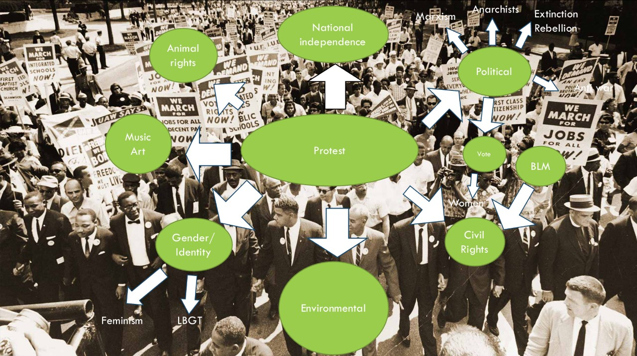

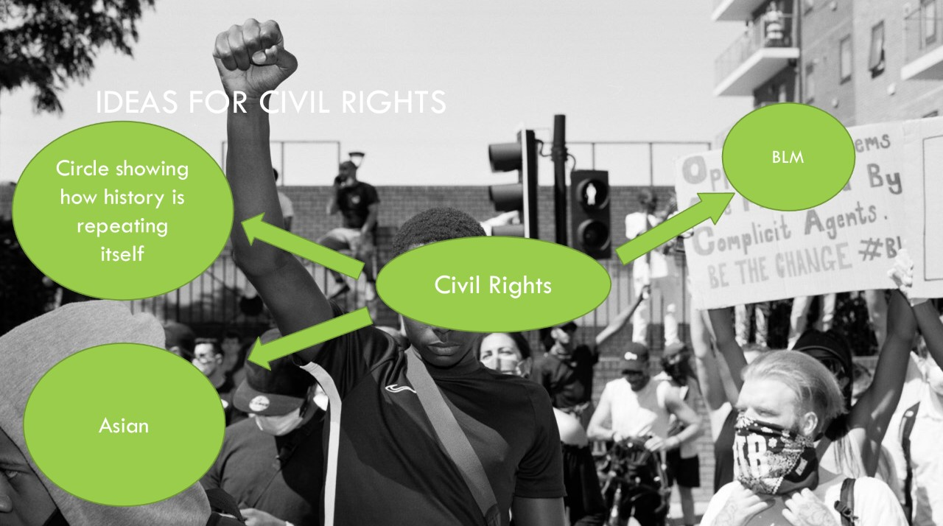

From this I then developed my specific research focus on Black Lives Matter and Civil Rights movements, in turn identifying photographers and iconic images from both periods, considering which would best offer opportunities for interactive links to contextual information or related material:

My initial research
The March on Washington for Jobs and Freedom. March on Washington
28 August 1963 by Anon 28 August 2020 by Drew Angerer

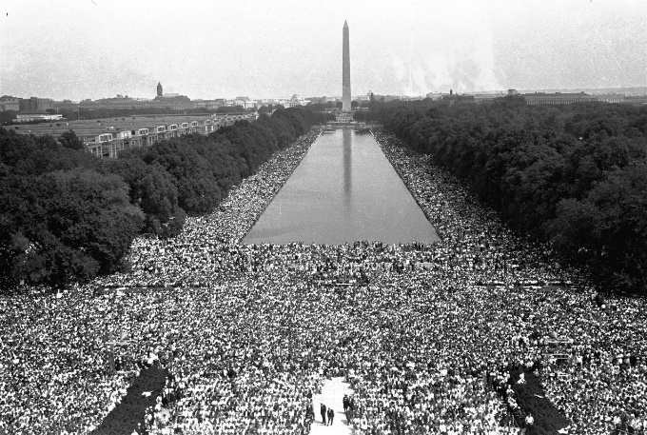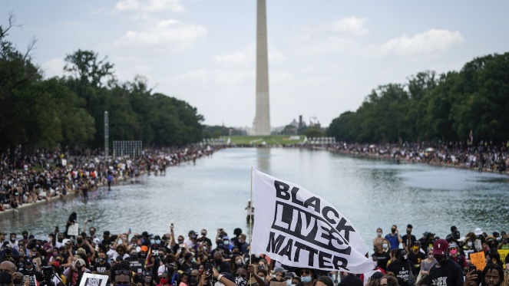

The “Black Salute” 16 October 1968 The White House, Washington DC
by John Dominis 31 May 2020 by Alex Wong Getty Images
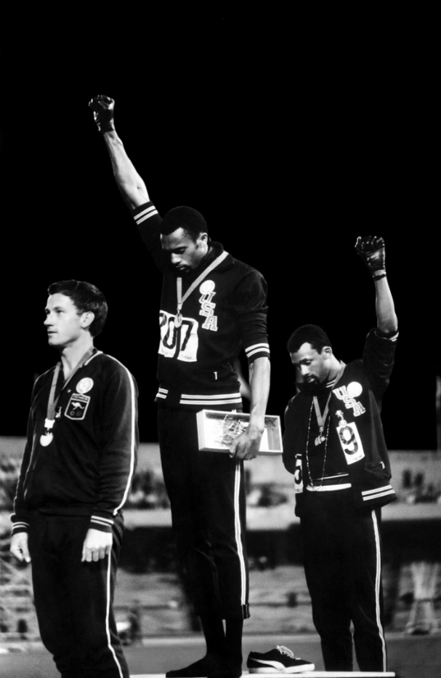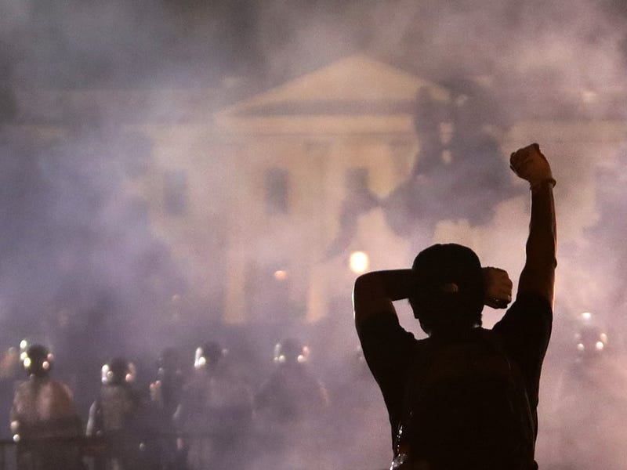

“I have a dream” speech Lynching of Thomas Shipp and Abram Smith
August 28 1963 Washington by Anon August 7 1930 by Lawrence Beitler
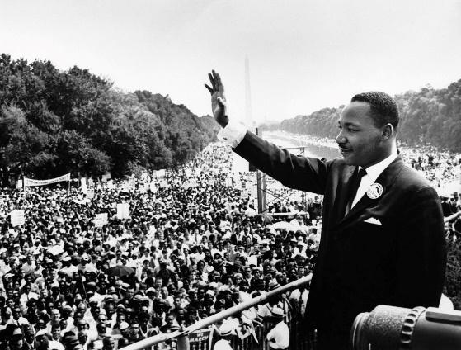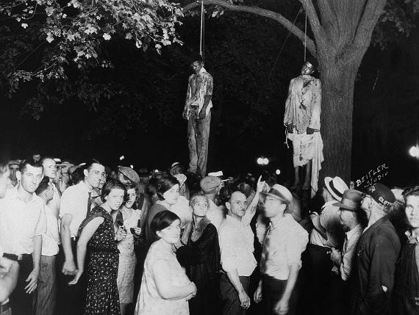

Rosa Parks “Elizabeth Ekford of Little Rock Nine”
December 1 1955 by Underwood Archives September 6 1957 by Will Count
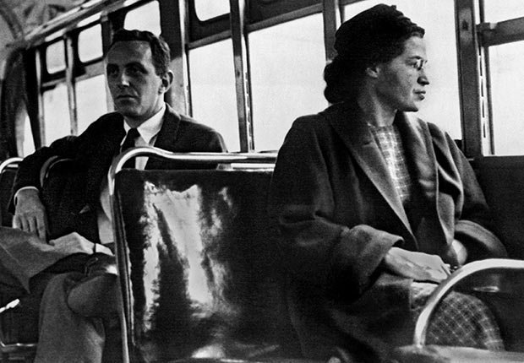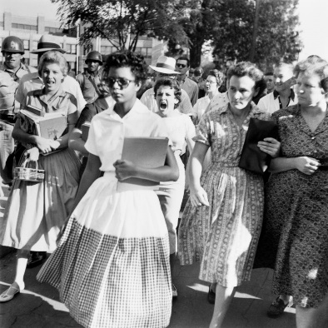
“Woman Running” July 21 1964 Front line of demonstrators during the March on
by Bettman Getty Images Washington for jobs and freedom Getty Images
28 August 1963 by Steve Schapiro
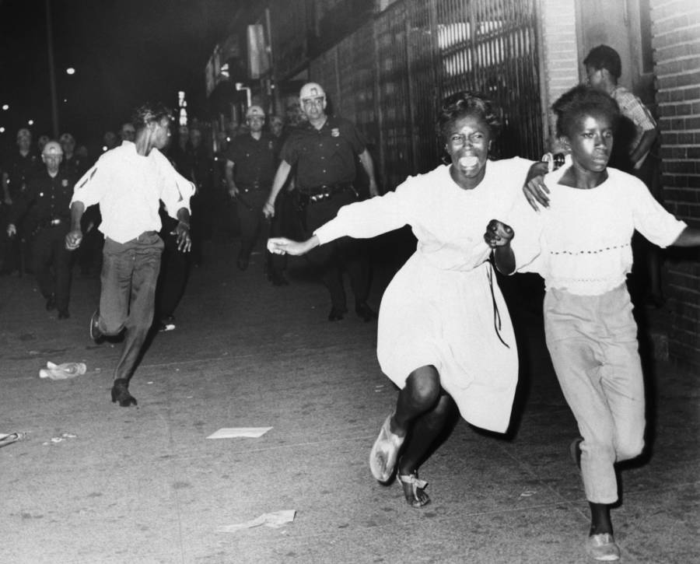
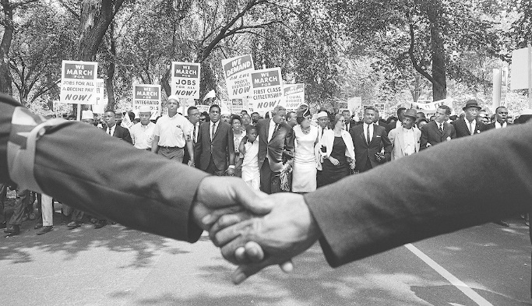

Police Dogs, held by officers
jumps at a man with torn trousers A protester wears a black beret and turtleneck,
during a nonviolent demonstration, an attire Hunter says is reminiscent of
Birmingham, Alabama 3 May 1963 ‘Revolution’ by Darrel Hunter
by Charles Moore Getty Images
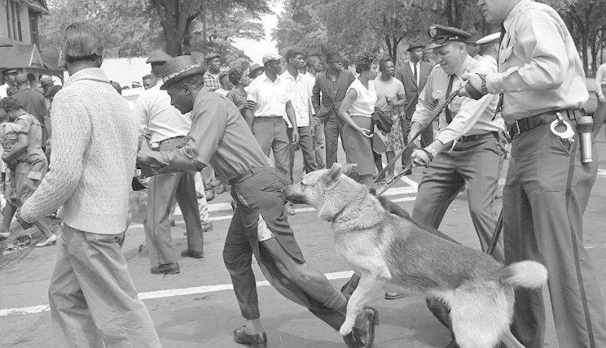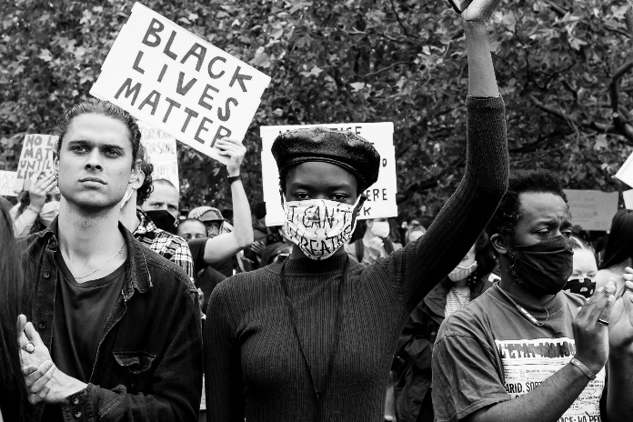

Woman raises her fist at a protest organised by Ria Foye bieng arrested in Times Sqaure New York
Build Power and Black lives matter by Alexis Hunley by Mark Clennon
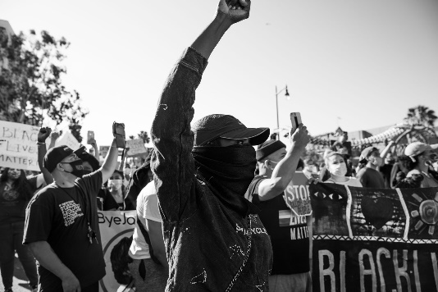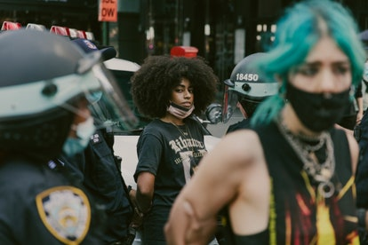
May 2020 London by Tommy Sussex 6 June 2020 Bishbane by Glenn Hunt

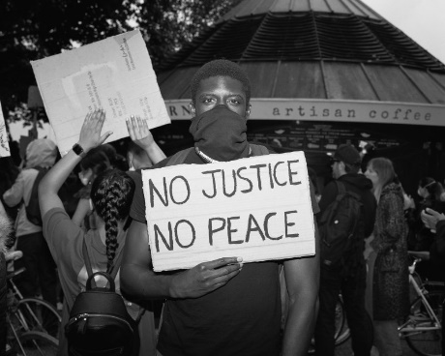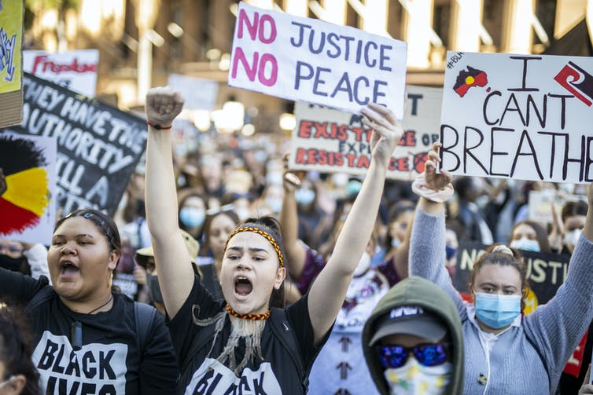

Parkers High School student Walter Malcolm X
Gordon being attacked by dogs 1963 by Photographer unknown
May 1963 by Bill Hudson
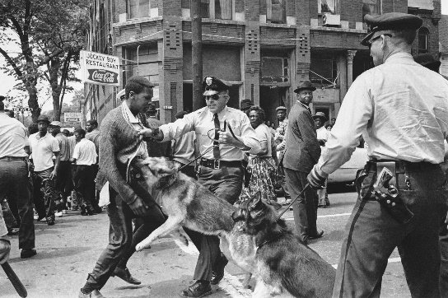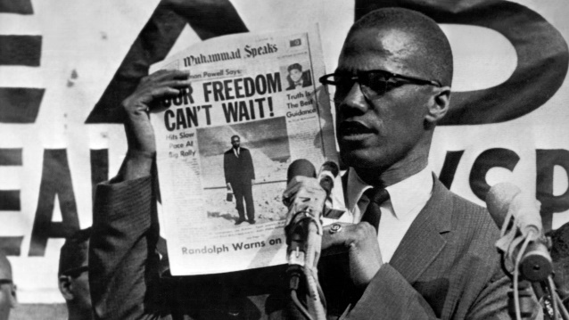

Marches in Memphis George Floyd screen grab
1968 by Builder Levy May 26 2020 by Darnella Frazier
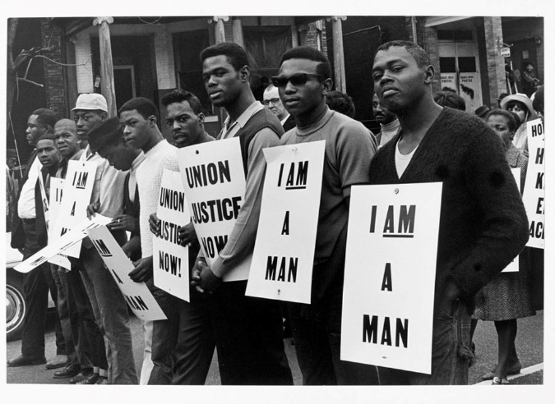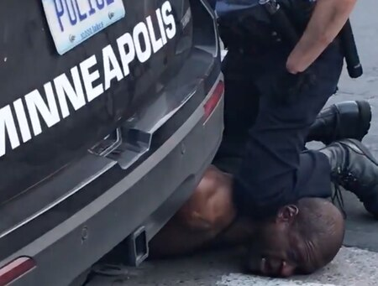

Artist research
I found Magnum photos an excellent source of photographs of the Civil Rights movement. The work of Bruce Davidson, Eve Arnold and Lennard Freed was particularly powerful. Separately I discovered the work of Dan Budnik a photojournalist who has documented social, political and cultural change in the world for the last 55 years and was at the heart of the Civil Rights movement.
I found Bill Hudson’s work on photographing the Birmingham demonstrations, where Bull Connor unleashed the police dogs on the men, women and children, simultaneously distressing, powerful and striking. I felt that this type of imagery would fit well into my theme of the ‘Imperfect circle’ and the idea of history repeating itself with the protests of today’s current Black Lives Matter movement.
Details of photo on page 5
I discovered Brandon Wells’ photographs in an article form the Guardian in May of this year. This chronicles his recording of various protests of the Black Lives Matter movement, and included photos of both peaceful and violent protest. One image in particular that stood out for me was the striking photograph of the man standing punching his fist upwards (echoing the black power salute) to the dark night sky while a building burns behind him. These types of photos, which draw similarities with both past and present, is what influences the idea of the circle theme, and that of history repeating itself.
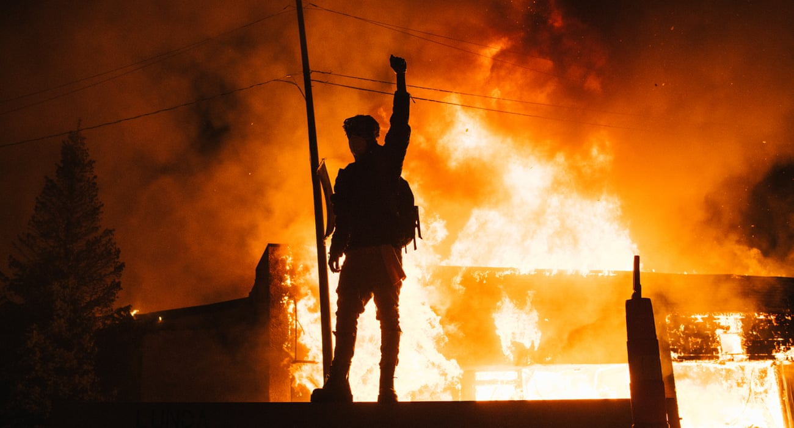
‘People in Trouble Laughing Falling to The Ground’ by Adam Broomberg and Oliver Chanarin depicts the various photos of ‘The Troubles’ which took place in Northern Ireland taken by several photographers. In the book, Broomberg and Chanarin took these images and inserted them in these circular “dots” (as shown below), which creates the effect of introducing the viewer to unseen aspects of the image. I wanted to take influence from the idea, using my circle to show different aspects and elements of the images I was using that people would otherwise not notice.
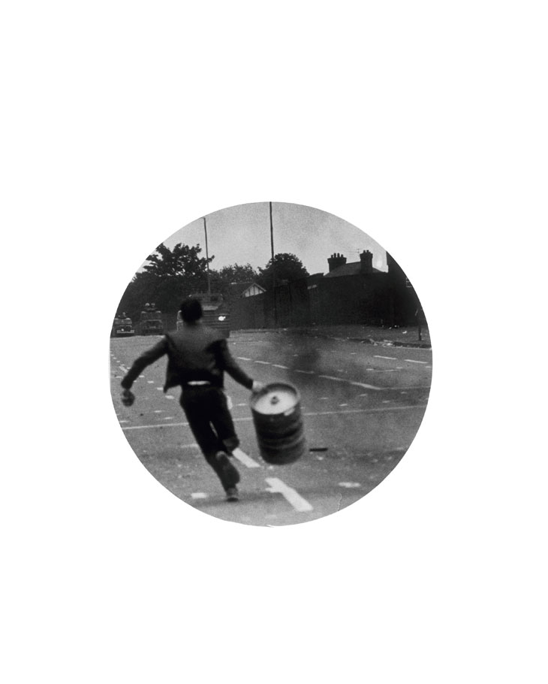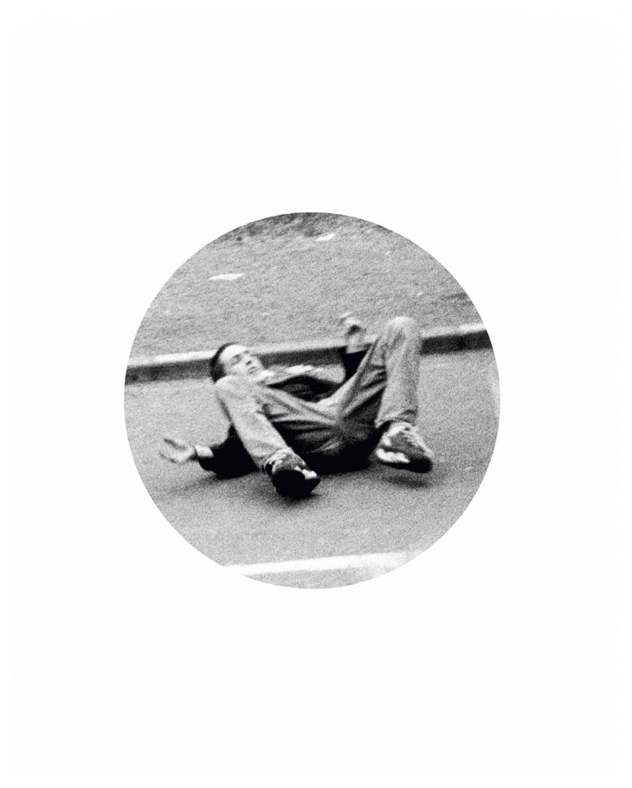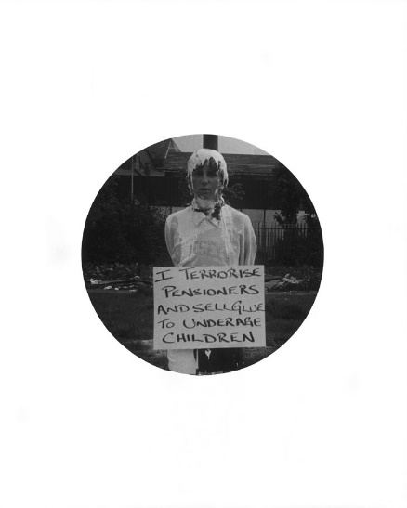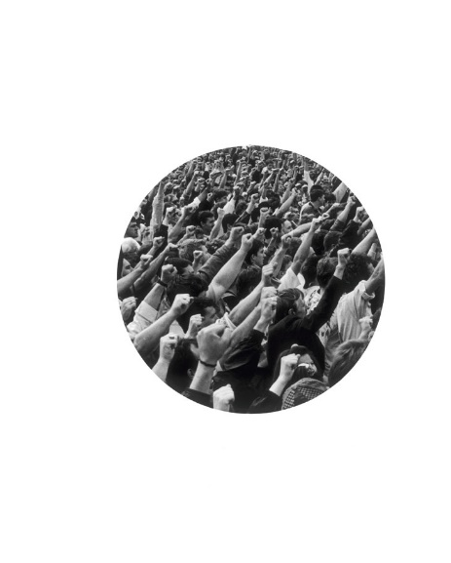
Ideas for poster 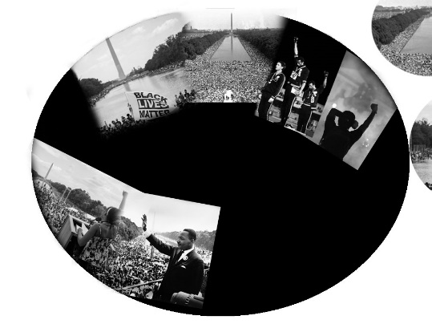
For my first attempt I initially placed images around a circular form. Clearly these needed more consideration in terms of position and scale.
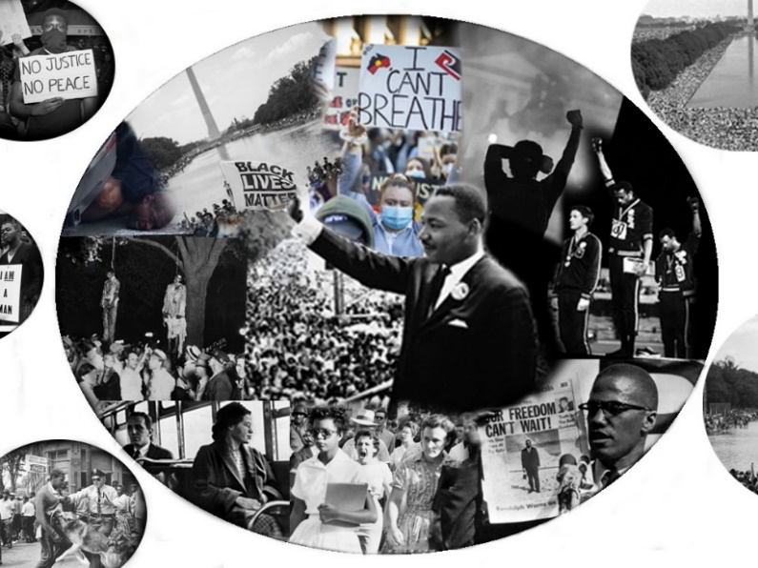
I decided to vary use of scale and reposition images to create a better flow to the composition. I also cropped the image of Martin Luther King, enlarged it, and moved him to a more central position to give him greater significance.

I decided to keep the small cropped accidental spheres surrounding the main sphere to show different images I also to left some of the current images in color to contrast past and present.
I experimented with introducing a segment in which I intended to put my title The Imperfect Circle, but I decided it detracted too much attention from the main subject matter.
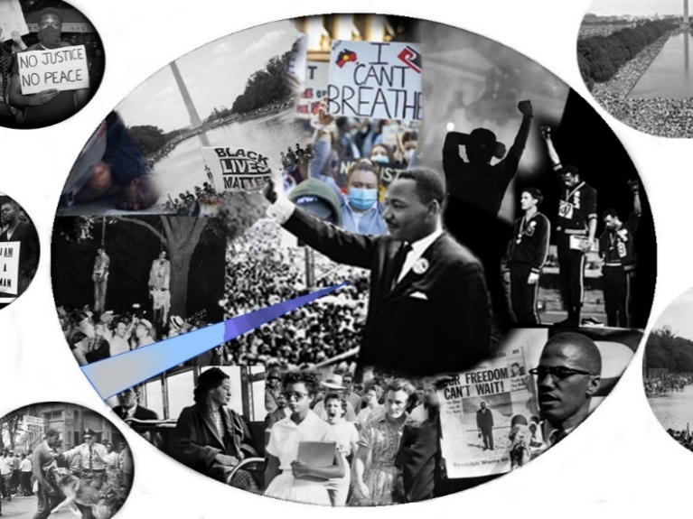

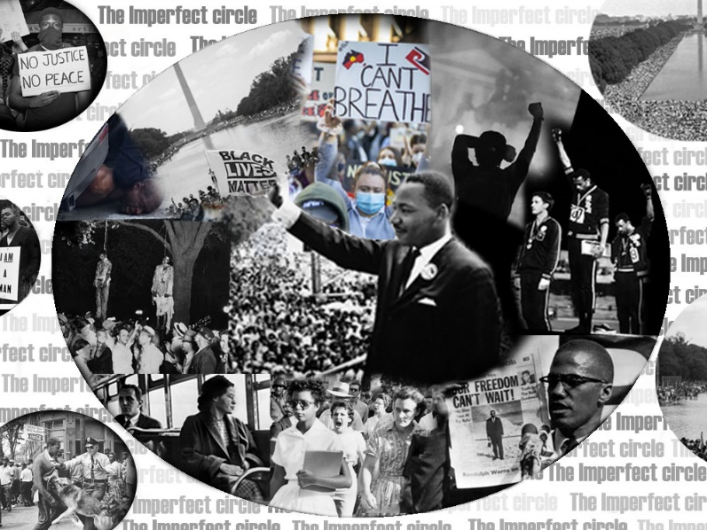
I decided to incorporate my title into the background of the image and experimented with decreasing the opacity of the font so it did not overpower the images.

Notes on GIF’s and hyperlinks.
The inclusion of the hyperlinks on the images I have used in my poster is to give further historical background to my images as well as giving the poster it’s interactive qualities. For example, I added a hyperlink to John Dominis 1968 Black Power Salute photograph that leads to a website called Time 100 photos which gives a basic summarization of the photo whilst giving a deconstruction of the signs of protest taken by Tommie Smith and John Carlos during the 1968 Mexico Olympics. I also added a GIF as one my hyperlinks. I attached a hyperlink to the photo of Martin Luther King which takes the viewer towards the GIF which shows a famous quote from Kings speech at Washington DC.

Evaluation
I feel that the combination of images link well together and that the focus of the viewer is drawn to the central figure of Martin Luther King which is what I intended. The inclusion of the accidental cropped spheres add another dimension to the work by enabling me to show more images of the both the civil rights and Black Lives matter movements. Adding the font to the background holds all of these images together and unifies them.
The quotation from the Martin Luther King speech in Washington which I have turned into a GIF adds another layer of interest and interactivity to the poster as do the hyperlinks which give further historical background to the images I have used such as the images of King, Ekford,Parks and the iconic Black Power Salute by John Dominis . This is mirrored by the “The White House Washington DC” photo from 2020 by Alex Wong.
If I had more time, I would have explored alternative compositions – maybe a spiral image? I’m not entirely certain that the written title in the background works and whether I could explore different fonts on different scales and maybe experimented with more colour.
Ideally, I would have wanted to include my own photographs rather than been completely reliant on others photographs. However, due to current situation and timeframe this has not been possible, but I could develop further in the future.

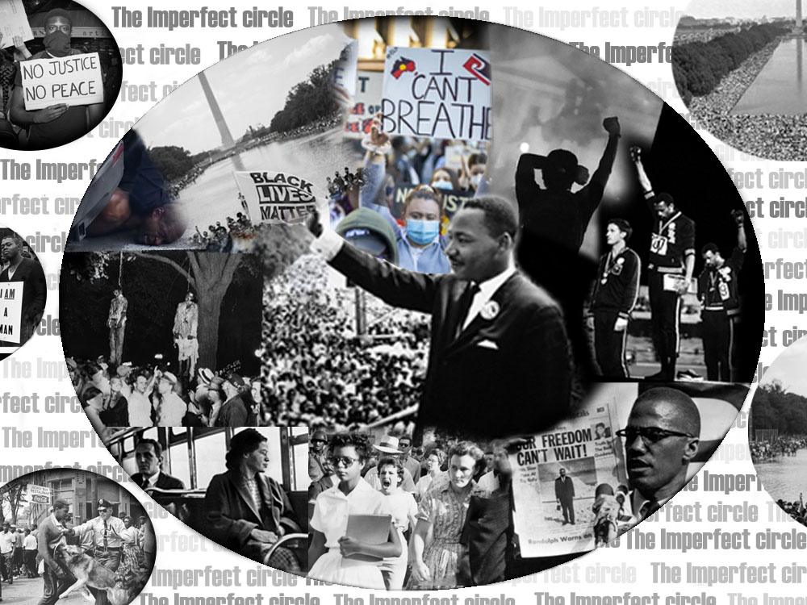

Bibliography

Bell, B., Ngala, F., Jarrus, S. and Cherry, J., 2020. Capturing The Cry For Change: Photographers On The BLM Protests. [online] the Guardian. Available at: <https://www.theguardian.com/media/2020/jun/12/capturing-the-cry-for-change-photographers-on-the-blm-protests> [Accessed 21 October 2020].

Bond-Nelms, C., 2020. Key Events During The Civil Rights Movement. [online] AARP. Available at: <https://www.aarp.org/politics-society/history/info-2018/civil-rights-events-fd.html#quest1> [Accessed 21 October 2020].

Broomberg & Chanarin. 2020. People In Trouble Laughing Pushed To The Ground (Dots) — Broomberg & Chanarin. [online] Available at: <http://www.broombergchanarin.com/kodak-1-1-25-1-1> [Accessed 21 October 2020].

Burns, K., 2020. The "Get Your Knee Off Our Necks" March On Washington In Photos. [online] Vox. Available at: <https://www.vox.com/identities/2020/8/29/21406686/get-your-knee-off-our-necks-march-on-washington-photos> [Accessed 21 October 2020].

Budnik,D., 2020. Home - Dan Budnik. [online] Available at: <http://danbudnik.com/> [Accessed 21 October 2020].

Clennon, M., 2020. 10 Black Photojournalists Give Personal Accounts From The US Protests. [online] British Vogue. Available at: <https://www.vogue.co.uk/arts-and-lifestyle/article/photojournalists-protests> [Accessed 21 October 2020].

Ehlke, G. and Richmond, T., 2020. 4 Minneapolis Police Officers Fired As FBI Investigates George Floyd’S Death. [online] pennlive. Available at: <https://www.pennlive.com/nation-world/2020/05/4-police-officers-fired-as-fbi-investigates-in-custody-death-of-man-in-south-minneapolis.html> [Accessed 21 October 2020].

Gardinier, K., 2020. March On Washington 2020: The Commitment March | WAMU. [online] WAMU. Available at: <https://wamu.org/story/20/08/27/march-on-washington-2020-the-commitment-march/> [Accessed 21 October 2020].

Garfield, L., 2020. Rosa Parks Refused To Give Up Her Bus Seat 62 Years Ago Today — Here Are 14 Facts About Her. [online] Business Insider. Available at: <https://www.businessinsider.com/rosa-parks-historical-photos-2016-2?r=US&IR=T> [Accessed 21 October 2020].

Google Arts & Culture. 2020. I Am A Man/ Union Justice Now, Martin Luther King Memorial March For Union Justice And To End Racism, Memphis, Tennessee - Builder Levy - Google Arts & Culture. [online] Available at: <https://artsandculture.google.com/asset/i-am-a-man-union-justice-now-martin-luther-king-memorial-march-for-union-justice-and-to-end-racism-memphis-tennessee-builder-levy/nwF_6Mt20boJJQ> [Accessed 21 October 2020].

Grindell, S., 2020. Photos Show How The Black Lives Matter Protests Compare To Civil Rights Demonstrations In The 1960S. [online] Insider. Available at: <https://www.insider.com/photos-compare-black-lives-matter-protests-to-civil-rights-protests-2020-6#a-man-raised-his-fist-as-he-looked-at-the-white-house-during-a-protest-for-george-floyd-on-may-31-2020-5> [Accessed 21 October 2020].

Guardian, T., 2020. Capturing The Cry For Change: Photographers On The BLM Protests. [online] the Guardian. Available at: <https://www.theguardian.com/media/2020/jun/12/capturing-the-cry-for-change-photographers-on-the-blm-protests> [Accessed 21 October 2020].

Hughes, H., 2020. Obituary: Bill Hudson, Photographer Of Civil Rights Protests, 77 | Pdnpulse. [online] PDNPulse. Available at: <https://pdnpulse.pdnonline.com/2010/06/obituary-bill-hudson-photographer-of-civil-rights-protests-77.html> [Accessed 21 October 2020].

Khan Academy. 2020. The March On Washington For Jobs And Freedom (Article) | Khan Academy. [online] Available at: <https://www.khanacademy.org/humanities/us-history/postwarera/civil-rights-movement/a/the-march-on-washington-for-jobs-and-freedom> [Accessed 21 October 2020].

Kuroski, J., 2020. Reliving The Civil Rights Movement, In 55 Powerful Photos. [online] All That's Interesting. Available at: <https://allthatsinteresting.com/civil-rights-movement-photos> [Accessed 21 October 2020].

Pasley, J., 2020. The Life And Assassination Of Malcolm X, The Controversial Civil Rights Activist Whose Death Remains A Mystery. [online] Business Insider. Available at: <https://www.businessinsider.com/how-malcolm-x-lived-died-assassinated-death-reinvestigated-2020-2?r=US&IR=T> [Accessed 21 October 2020].

Photographers, M., 2020. The Civil Rights Movement In America By Magnum Photographers. [online] Magnum Photos. Available at: <https://www.magnumphotos.com/newsroom/magnum-photographers-the-civil-rights-movement/> [Accessed 21 October 2020].

Shutterstock Editorial. 2020. Protesters Participate Black Lives Matter Rally Brisbane Editorial Stock Photo - Stock Image | Shutterstock. [online] Available at: <https://www.shutterstock.com/editorial/image-editorial/black-lives-matter-rally-in-brisbane-australia-06-jun-2020-10671366b> [Accessed 21 October 2020].

Tommysussex.com. 2020. BLM LDN 2020 — Tommy Sussex. [online] Available at: <https://tommysussex.com/BLM-LDN-2020> [Accessed 21 October 2020].

www.youtube.com, 2020. Imperfect Circle. [video] Available at:
<https://www.youtube.com/watch?v=7g1ozPfX3Kg> [Accessed 21 October 2020].

www.youtube.com, 2020. Strange Fruit Lyrics Billie Holiday. [video] Available at:
<https://www.youtube.com/watch?v=c52ElU5tQNo> [Accessed 21 October 2020].

100 Photographs | The Most Influential Images of All Time. 2020. See The Story Behind The Black Power Salute. [online] Available at: <http://100photos.time.com/photos/john-dominis-black-power-salute> [Accessed 21 October 2020].

