NOS ACCA5023
Task 2

Network and Operating Systems
Iwan Dyke

Contents
1 Part 1 Group Work 2
1.1 Understanding NTFS and Share Permissions 2
1.1.1 New Technology File System 2
1.1.2 Share Permissions 7
1.1.3 Accessing the file share/server over the network. 11
1.2 Utilising Group Policy Management Console to better facilitate network object management. 12
1.2.1 Configuring User Environment and Computer Environment 12
1.3 Routing and Packet Filtering within Core TCP/IP services and critical Failover/Redundancy Practices 20
1.3.1 Utilising ARP and Routing Tables 20
1.4 IP Filtering 28
1.4.1 Filter 1 Stopping ‘anyone’ in PrivateNet1 from Pinging the Router Firewall Service 28
1.4.2 Filter 2: Restrict Access to FTP Service on Server2 to only hosts in PrivateNet2. 29
1.4.3 Filter 3: Only allow specific hosts in PrivateNet1 to access the FTP server Server2 30
2 Observational Task 32
2.1 Enhancing Security (SOHO) 32
2.1.1 Wi-Fi 32
2.1.2 Group Policy 32
2.1.3 Backups 32
2.2 Failover Clustering 33
2.2.1 Purposes 33
2.2.2 High Availability FC 33
2.2.3 Continuous Availability FC 33
2.2.4 Cost 33
2.3 Enterprise Network Policy 34
2.3.1 Group Policy (Enterprise) 34
2.3.2 Active Directory 34
2.3.3 Data Protection Impact Assessment (DPIA) 34
2.3.4 Disaster Recovery 34
Backups are essential for larger organisations as part of the GDPR laws enforced by the UK government. Windows servers with different RAID configurations can be used depending on the specific requirements of the team. 34
2.3.5 General Data Protection Regulations (GDPR) 36
2.3.6 Organisational Role Diagram 36
2.3.7 Virtual Private Networks 37
2.4 Reflection 37
3 Bibliography 37

Figure 1 Routing model [2] 27
Figure 2 (Failover Cluster Diagram) 33
Figure 3 (RAID 0 Diagram) 34
Figure 4 (RAID 1 Diagram) 35
Figure 5 (RAID 5 Diagram) 35
Figure 6 (RAID 1+0 Diagram) 36
Figure 7 (Organisational Chart) 37

Name of the Team: Team NOSS
Team Members
Student Name | Student ID
KAREN wINDSOr | 1918576
iWAN dYKE | 1800933
cRISTIAN-sTEFAN sTANCU | 2008911
jOSHUA hArrIES | 2021807

Team Evaluation (Self Evaluate your Team)
 | Karen Windsor | Iwan Dyke |  | Cristian-Stefan Stancu |  |  | Joshua Harries
Karen Windsor |  |  | 5 |  | 5 | 5
Iwan Dyke | 5 |  |  |  | 5 | 5
Cristian-Stefan Stancu | 5 |  | 5 |  |  | 5
Joshua Harries | 5 |  | 5 |  | 5
Rate your Teams Contribution with a scale of 1 to 5 (1 No Contribution and 5 Excellent Contribution)
Add your comments on Team Evaluation: (Justify your evaluation)
Karen Windsor: Karen was instrumental in providing annotation to the practical screenshots. Karen also helped to provide the technology in which the practical work was completed on. Karen mostly worked as the coordinator of the group helping to organise everyone and move the project forward.
Cristian-Stefan Stancu: Cristian helped to review and alter the annotations which were completed by Karen ensuring the best quality of work was submitted by the group. Cristian acted as the quality control for the group checking the work submitted.
Joshua Harries: Josh aided in providing practical screenshots where evidence was missing. Certain crucial pieces of the practical work were missing evidence so Josh stepped in to provide help during the difficult sections.

Part 1 Group Work

Understanding NTFS and Share Permissions

New Technology File System
Screenshot 1 Creating confidential file.
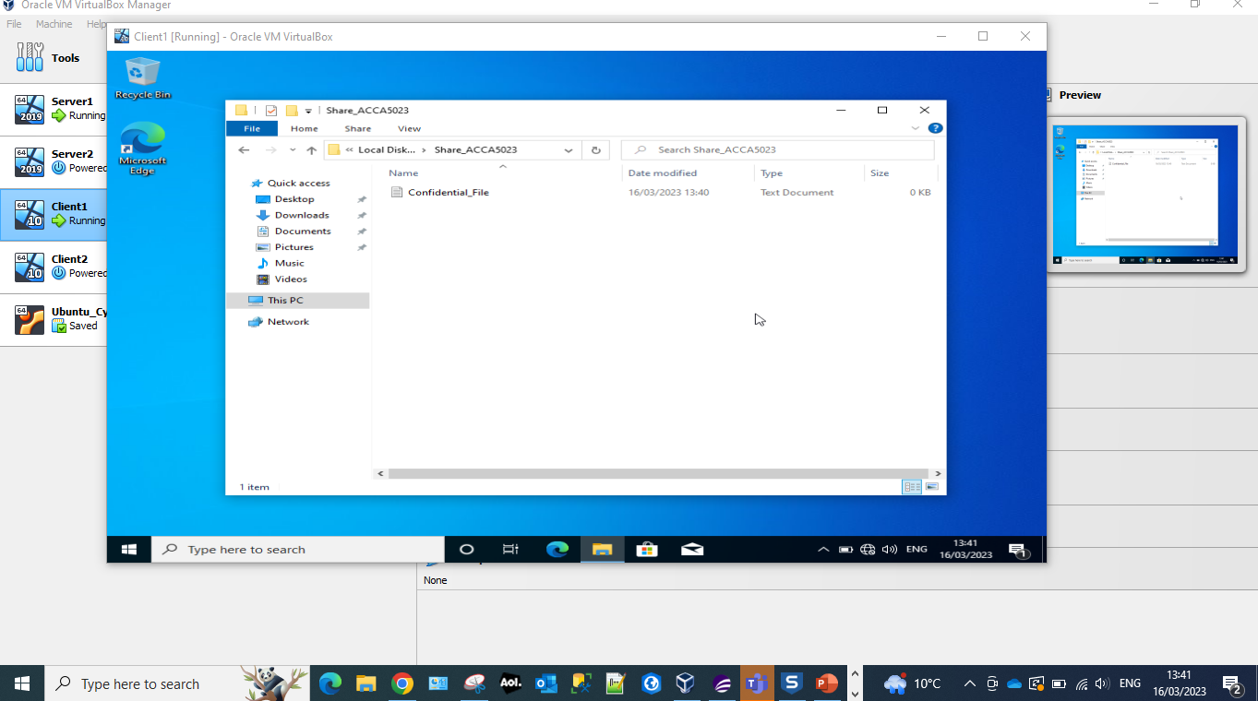
Creating a new folder called confidential_file within the folder Share_ACCA5023 of the administrator group on Client1.
Screenshot 2 Inherited permissions.
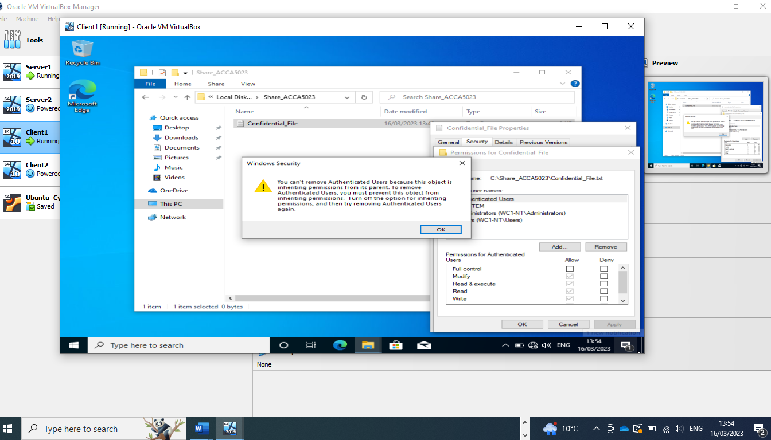
Unable to alter permissions for the user as they have inherited permissions. Inherited permissions are permissions that are given to an because it is a child of a parent object. Turning off inherited permissions is chosen as it is an easier way to restrict access to a specific sub-folder inside of a parent folder, while still allowing it to access the rest of the sub-folders within the parent folder.

Screenshot 3 Enable inheritance.
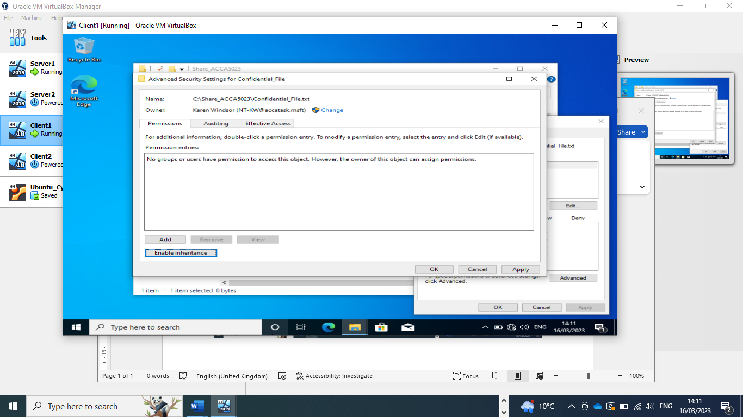
Disabling inheritance in order to set New Technology File System (NTFS) permissions.
The NTFS is a process that Windows operating systems uses for storing, organising and locating files quickly and efficiently.
Screenshot 4 Disabling Inheritance.
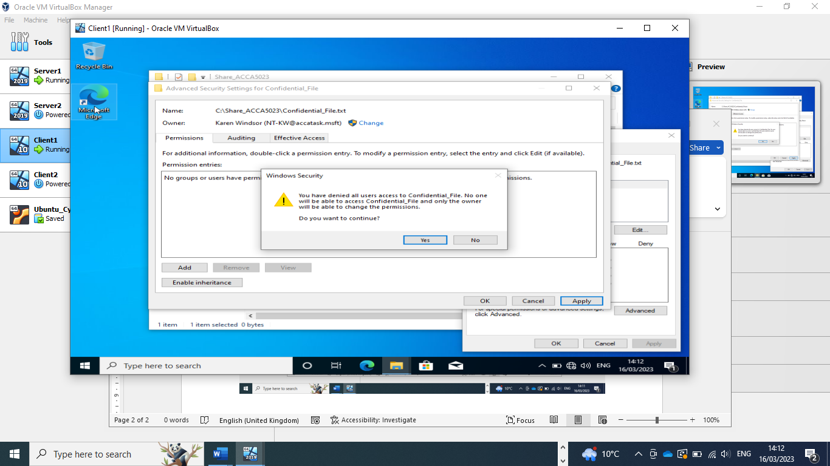
Confirmation that only the ‘owner’ has access to the Confidential_file.
When setting the ‘disable inheritance’ protocol it is important to remember that when you see a button ‘Disable inheritance’, inheritance from above is currently enabled for this folder and when button ‘Enable inheritance’ shows it means that inheritance from above is currently disabled for this folder.

Screenshot 5 Adding permissions.
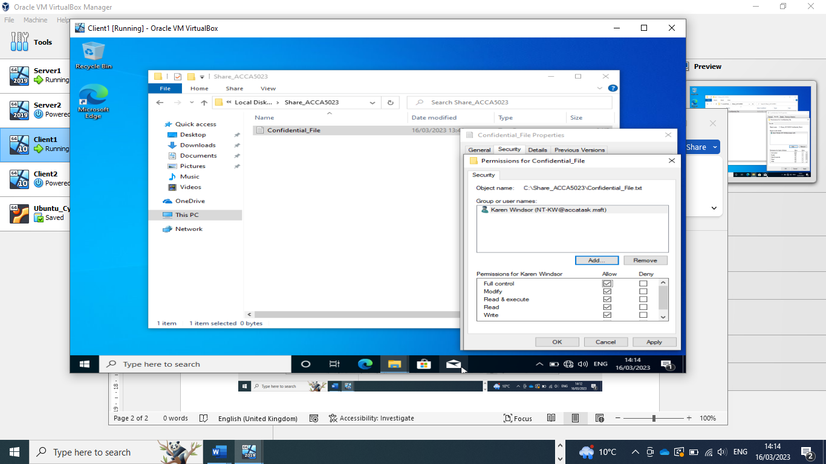
Adding full permissions to administrator user so that they have full permissions for the Confidential_file:
- Modify – Users can view and modify the Confidential_file and its permissions, including deleting and adding files to a directory or file properties to a file.
- Read & Execute – Users can run executable files, including scripts.
- Read – Users can view the Confidential_file and its properties.
- Write – Users can write to the Confidential_file.
Screenshot 6 Confirmation of permissions
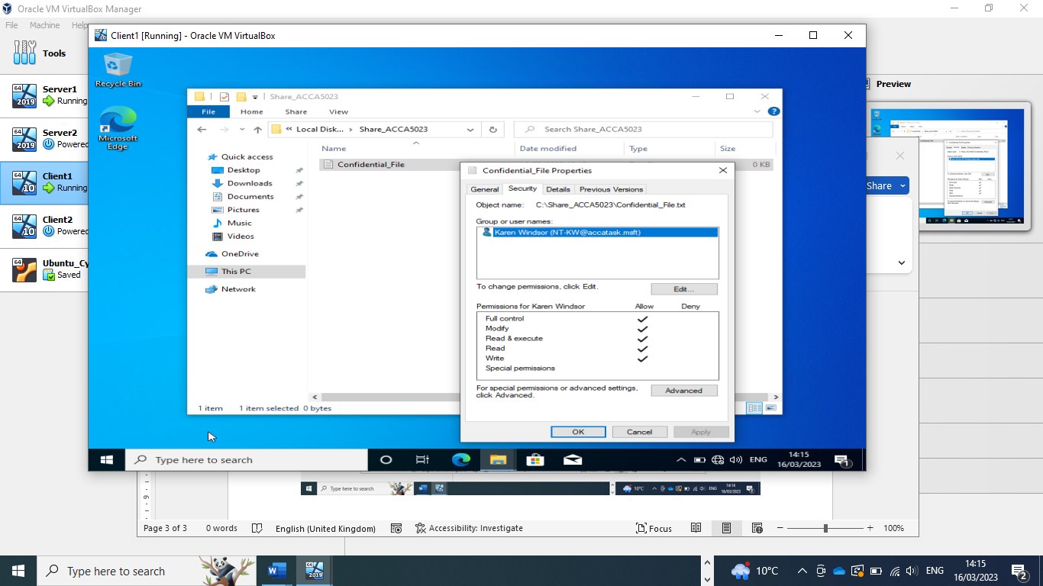
Confirmation that the administrator has full permission for the Confidential_file.

Screenshot 7 Adding permissions for another user.
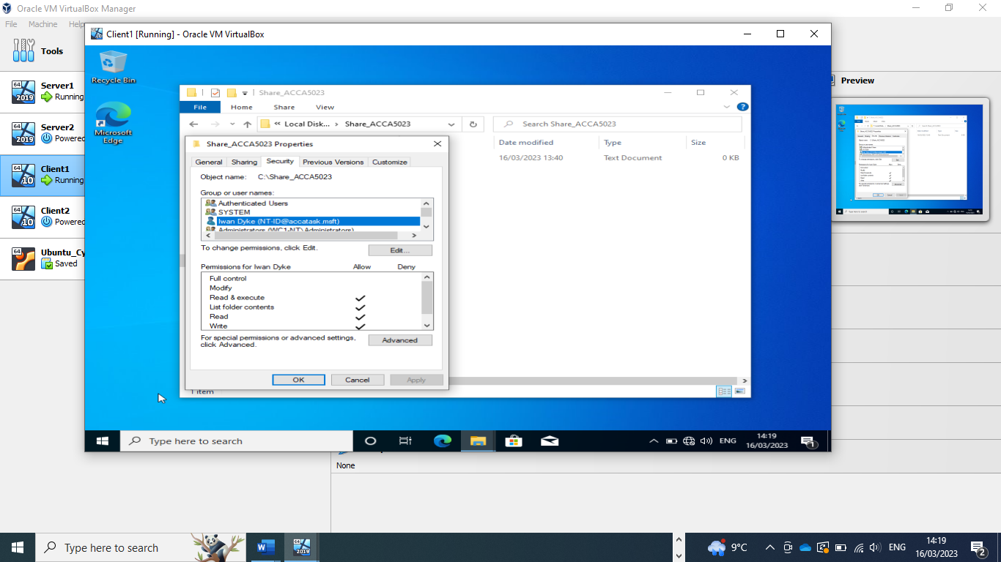
Allowing permissions to Confidential_file to secondary user but with more restrictive permissions. This user can only Read & Execute, List folder contents, Read and Write.

Screenshot 8 Adding text to file.
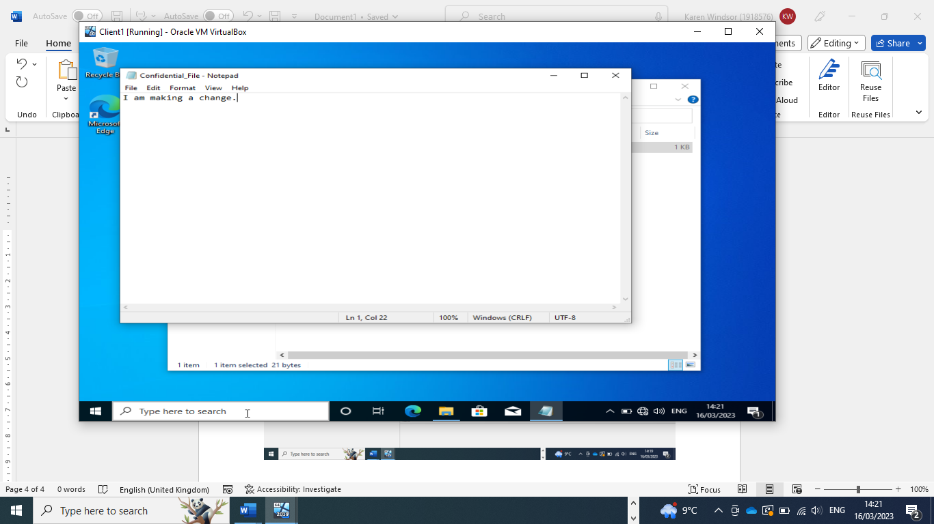
(Made a change as there is no star on the name this indicates the change has been successful)

Screenshot 9 Time Restriction
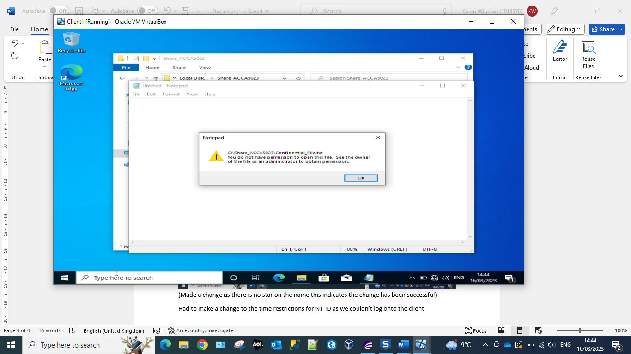
Had to make a change to the time restrictions for NT-ID as we couldn’t log onto the client as we had previously set a time restriction for logins for this user.

Share Permissions
Screenshot 10 Share Location
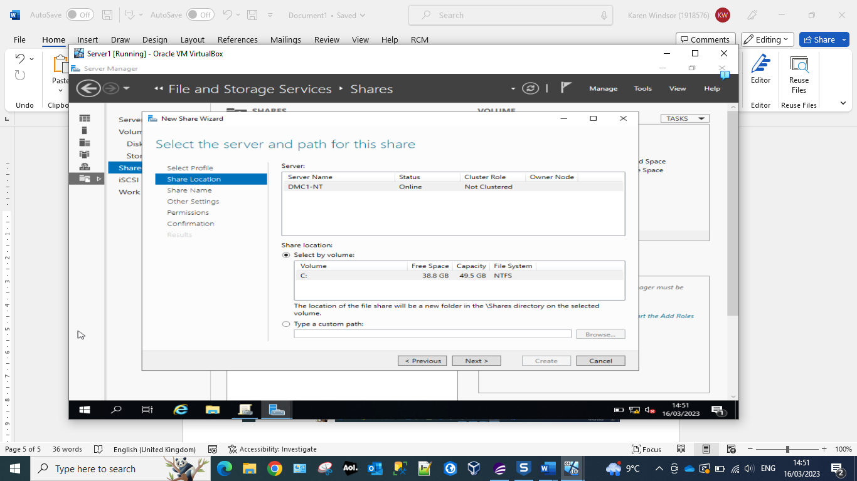
Server Message Block (SMB) protocol is a client-server communication protocol. It provides an authenticated inter-process (IPC) mechanism, and it is used to facilitate shared access to :
- Files
- Directories
- Printers
- Serial ports
- Other end device resources available on the network.

Screenshot 11 Share Name
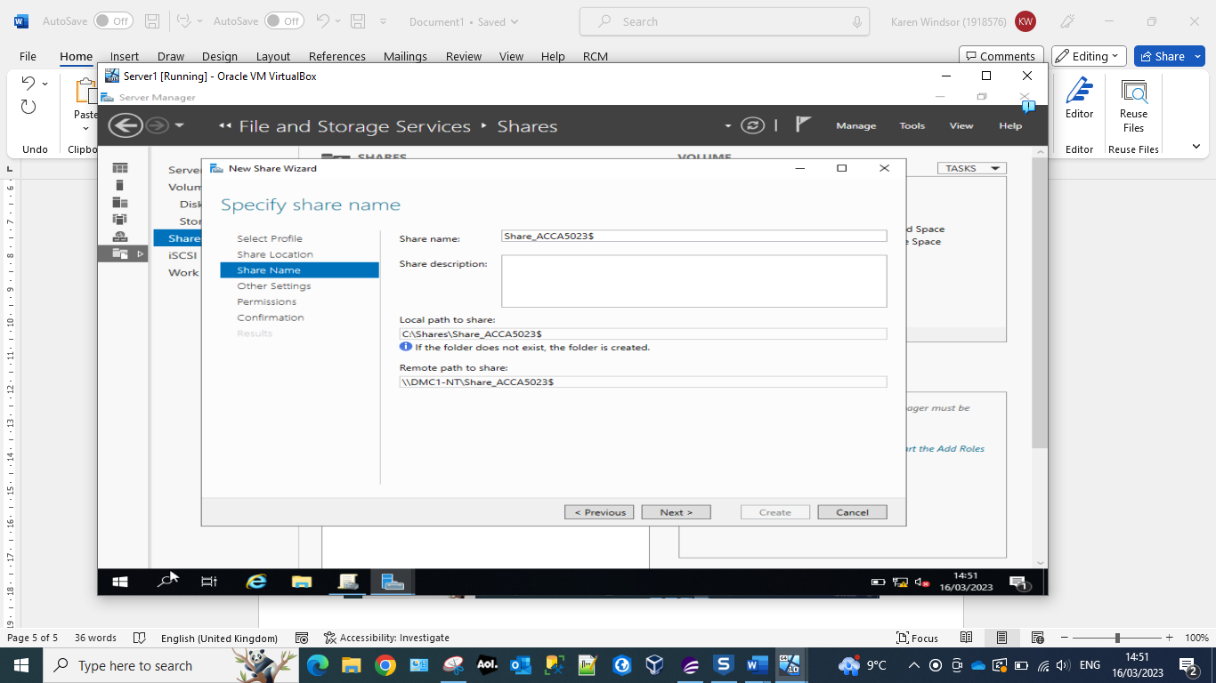
Local path for Share_ACCA5023$, which should be recorded in order to access the files over the network from a different machine or if we need to Map a network drive to the file server. Mapping a network drive means that you are planning to make a specific drive available to other users connect to a common network.

Screenshot 12 Configure Share Settings
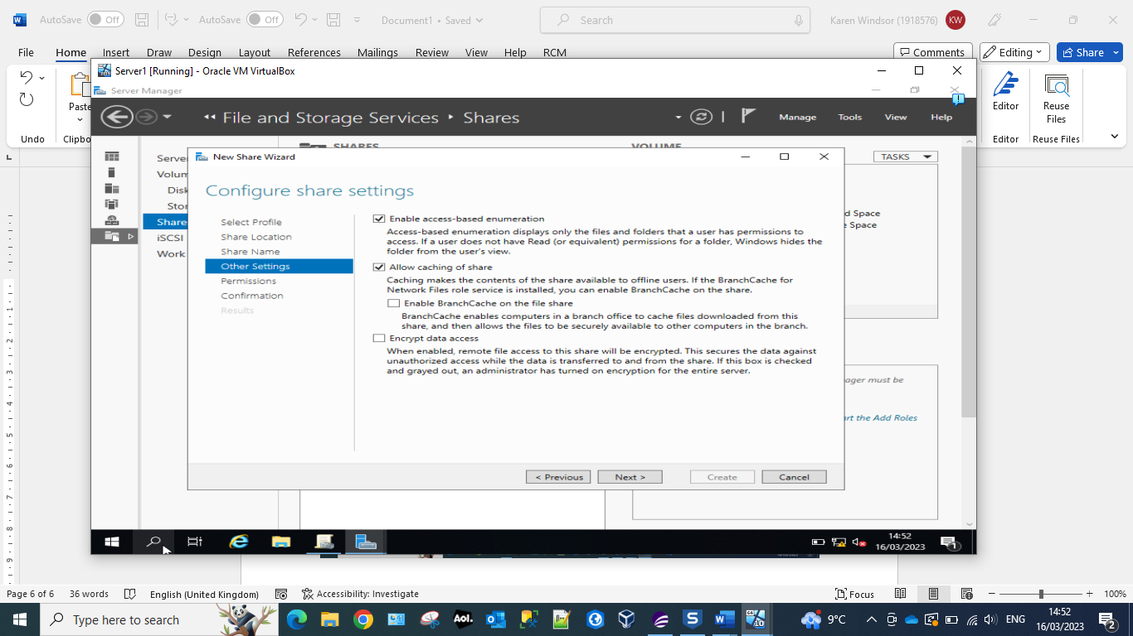
By enabling Access-Based Enumeration (ABE) it enables the user to see only a subset of files or directories to which they have access permissions when they are browsing content, versus seeing the complete of file and folders. ABE enables the comingling of files/folders utilising file access-permissions to restrict users’ visibility and access.
Allow caching of sharing permits the user to set shared files as available offline, this works by caching the files on the user’s local machine. Caching is the process of storing copies of the in a cache or temporary storage location, so that they can be accessed quickly.

Screenshot 13 New permissions
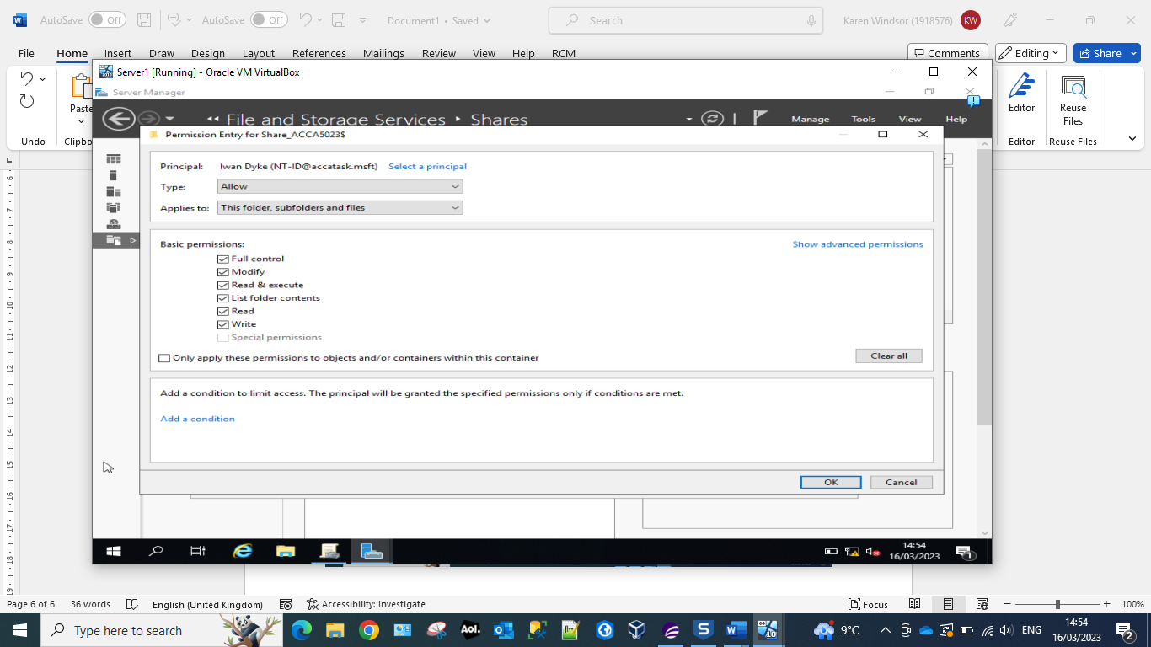
Giving full permissions to user Iwan Dyke

Screenshot 14 Specify permissions to control access.
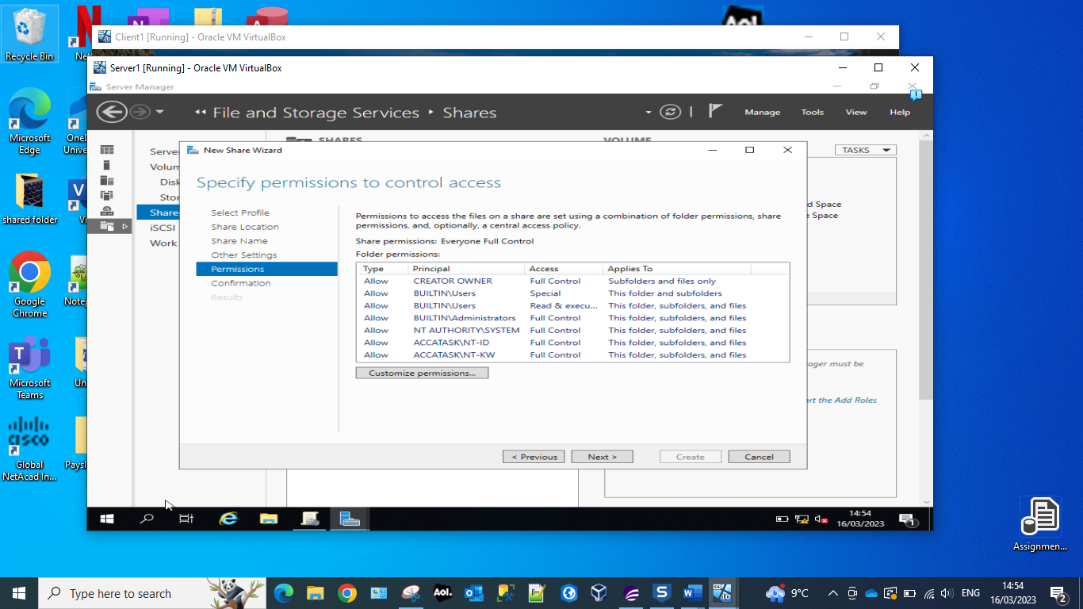
Confirmation that users NT-ID and NT-KW have ‘Full Control’ access.

Screenshot 15 Creating network file share.
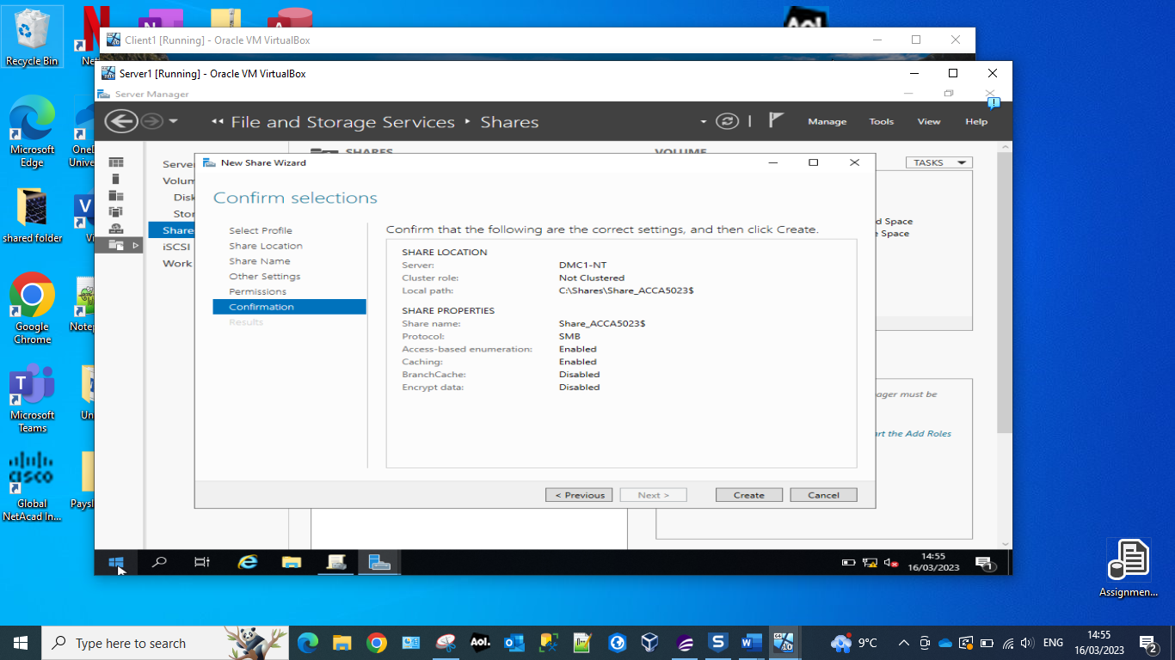
Final step of creating a network file share on the server1.
Which includes:
- Protocol SMB
- Access Based Enumeration (ABE) which allows the administrator the ability to hide files and folders from users who do not have the right permissions to access them.
- Caching is enabled per file object, and it occurs under the Cache manager. File data in the system file cache is then written to the disk at time periods that are set by the operating system.
- Branchcache has been disabled as this a intended for use by remote offices that intend to cache to a centralised location.
- Encrypt data has been disabled – this can be enabled by the administrator at a later date if they feel that this is necessary for network security.

Accessing the file share/server over the network.
Screenshot 16 Map Network Drive
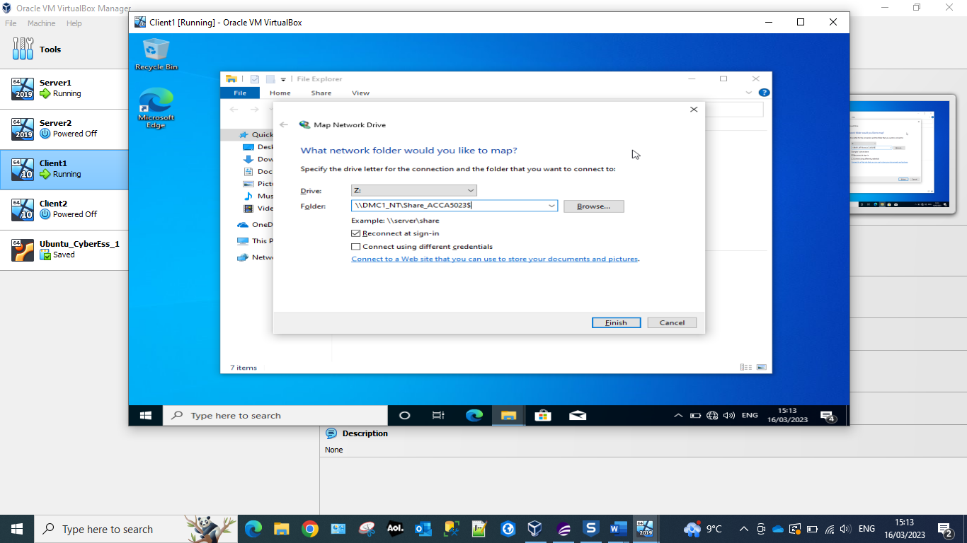
The ‘Drive letter Z’ – Drive Z is a temporary folder (Virtual Drive) from which updates are applied and where temporary file movement is organised. This allows the network share to be permanently stored on Client1, until the user disconnects from it.
The folder is the server’s name plus the full share name.

Screenshot 17 Verification of share
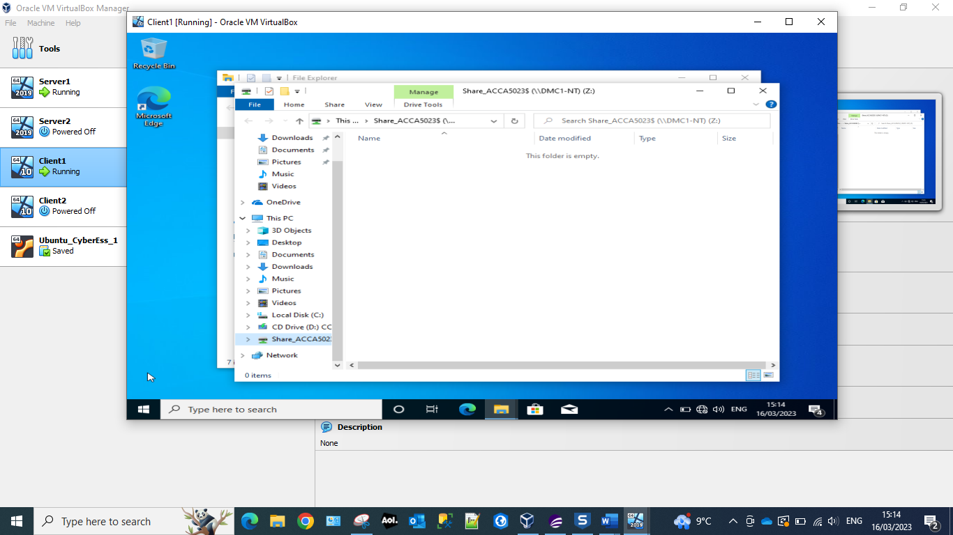
Confirmation that the drive has been mapped and that the ‘share’ can be viewed by entering the server’s name and Share_ACCA5023$

Utilising Group Policy Management Console to better facilitate network object management.

Configuring User Environment and Computer Environment
Screenshot 18 Organizational Unit
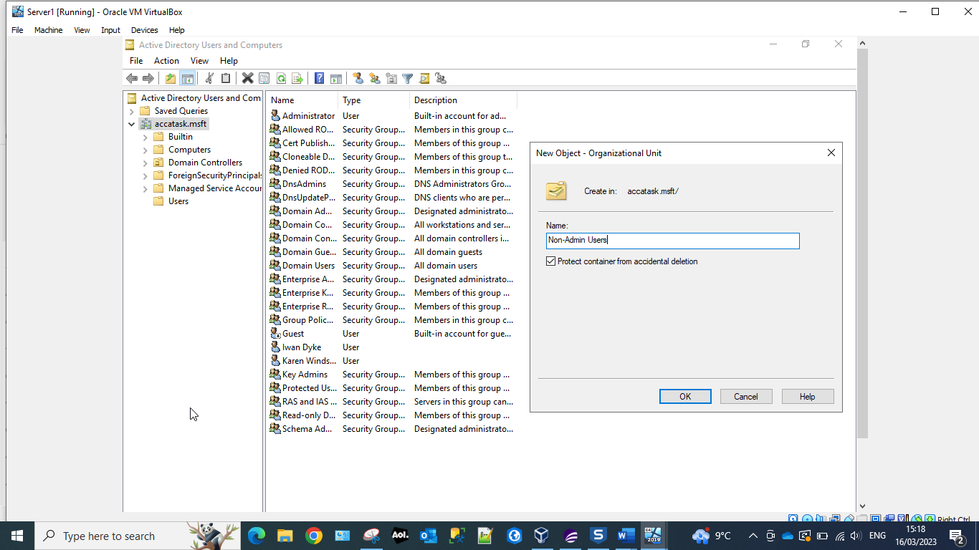
Creating Organizational Unit (OU) Non-Admin Users. An OU is a container within a Microsoft Active Directory domain which can be used to hold user, groups and computers. The above screenshot displays how the administrator would create a new OU ‘Non-Admin Users’.

Screenshot 19 No Control Panel Access
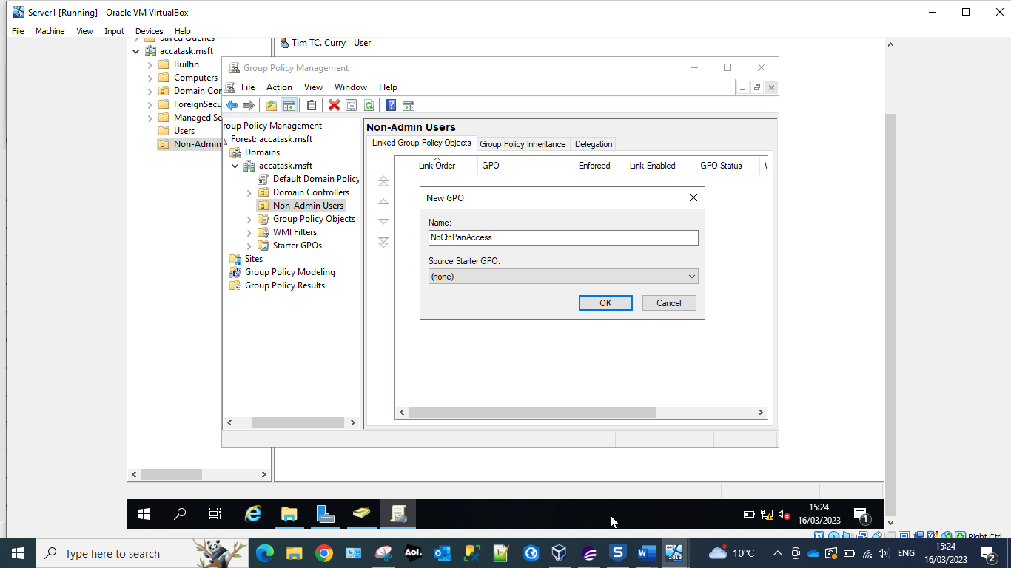
New user Tim Curry created and new Group Policy Object(GPO) within the Group Policy Management Console(GPMC). A GPO is a collection of Group Policy setting that defines what a system will look like and how it will behave for the user Tim Curry. It is created in the GPMC, which is a Microsoft Management Console that provides a graphical user-interface that enables the Active Directory administrators to manage the GPOs.

Screenshot 20 Prohibit access to Control Panel and PC settings.
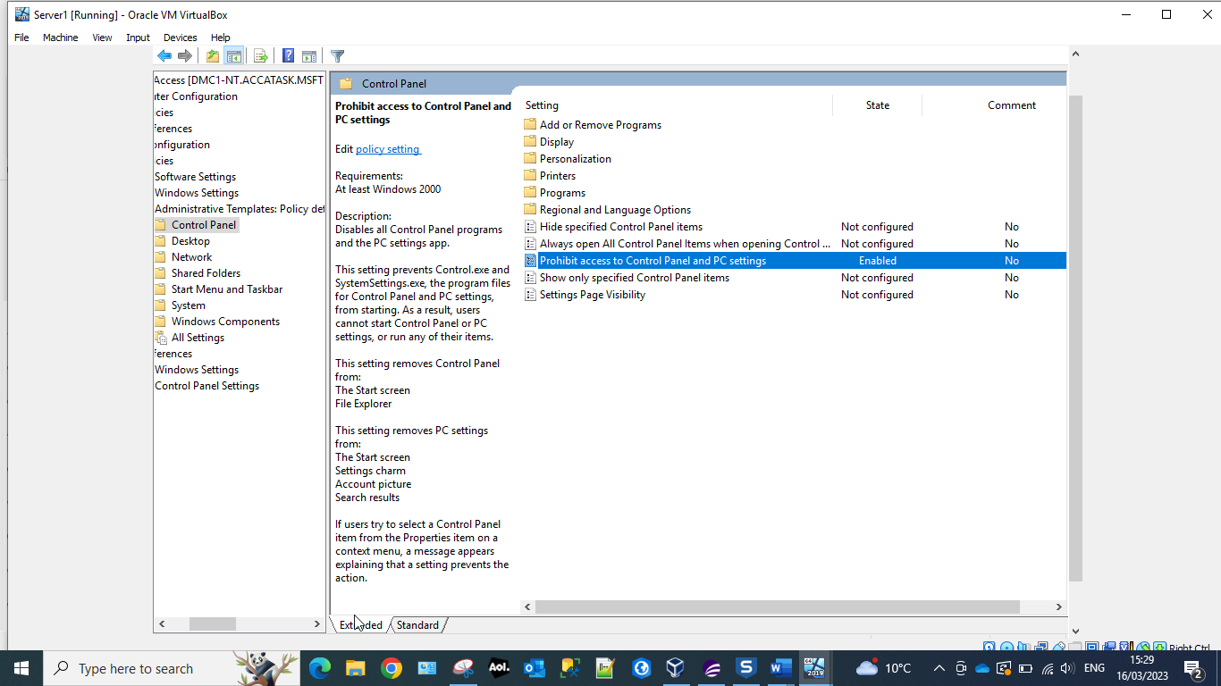
Restricting the user Tim Curry’s access to the Control Panel and PC settings. This will prevent the user from altering how the Window’s operating system looks and works. For example:
- Network and Internet functions, deleting browsing history and cookies.
- Hardware and access sound and video options.
- The ability to install/uninstall programs and well activate/deactivate Windows features.
- Modify user accounts access and change passwords.
- Modify fonts and contrasts.

Screenshot 21 Command prompt ‘Run as Administrator’.
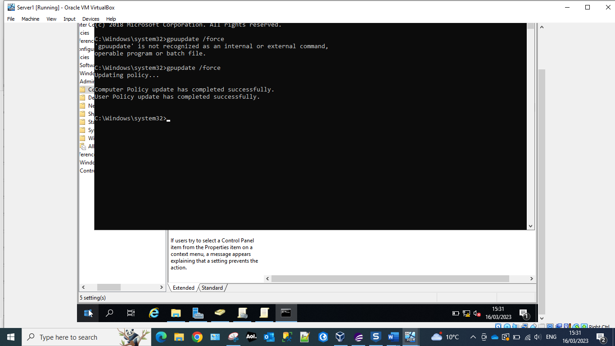
Running the command ‘gpupdate /force’ – applies all policy settings that have been changed by the administrator.
Group Policy Update – gpupdate.
By default changes in the Group Policy are not instantly applied and there is a 90 minute default wait applied. But by using the ‘force’ command we can force the update through immediately.
Screenshot 22 Confirmation of restrictions
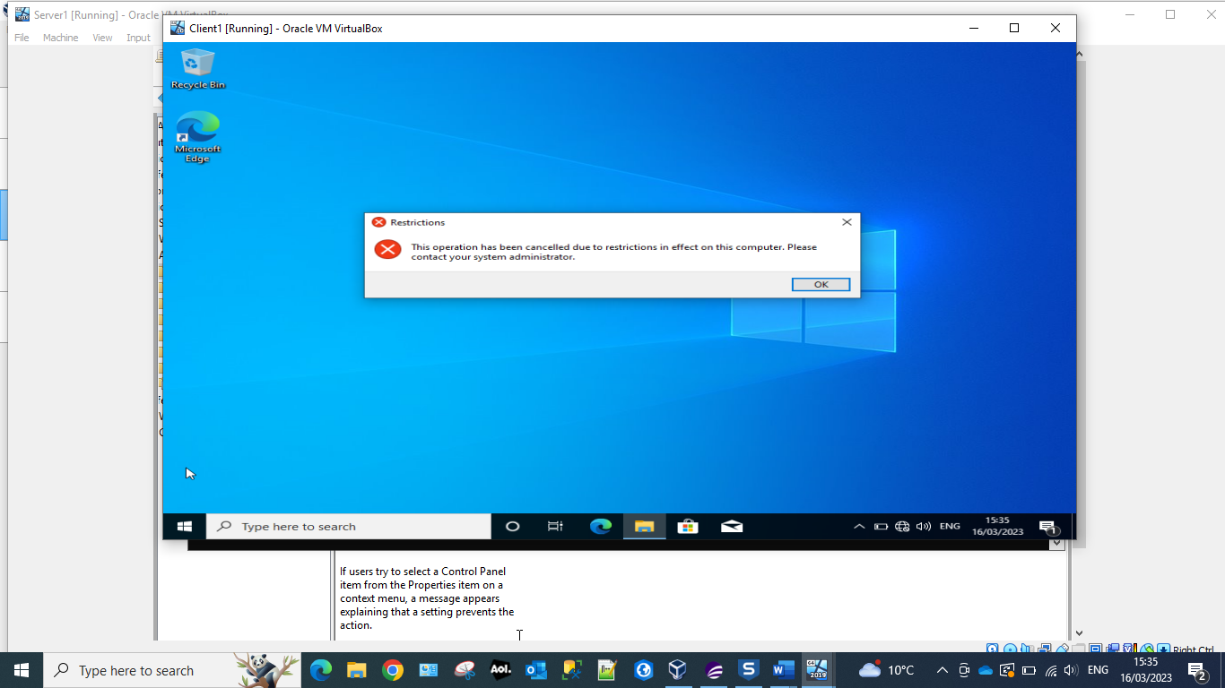
Confirmation that the user is no longer able to access the Control Panel.

Screenshot 23 Prevent access to command prompt.
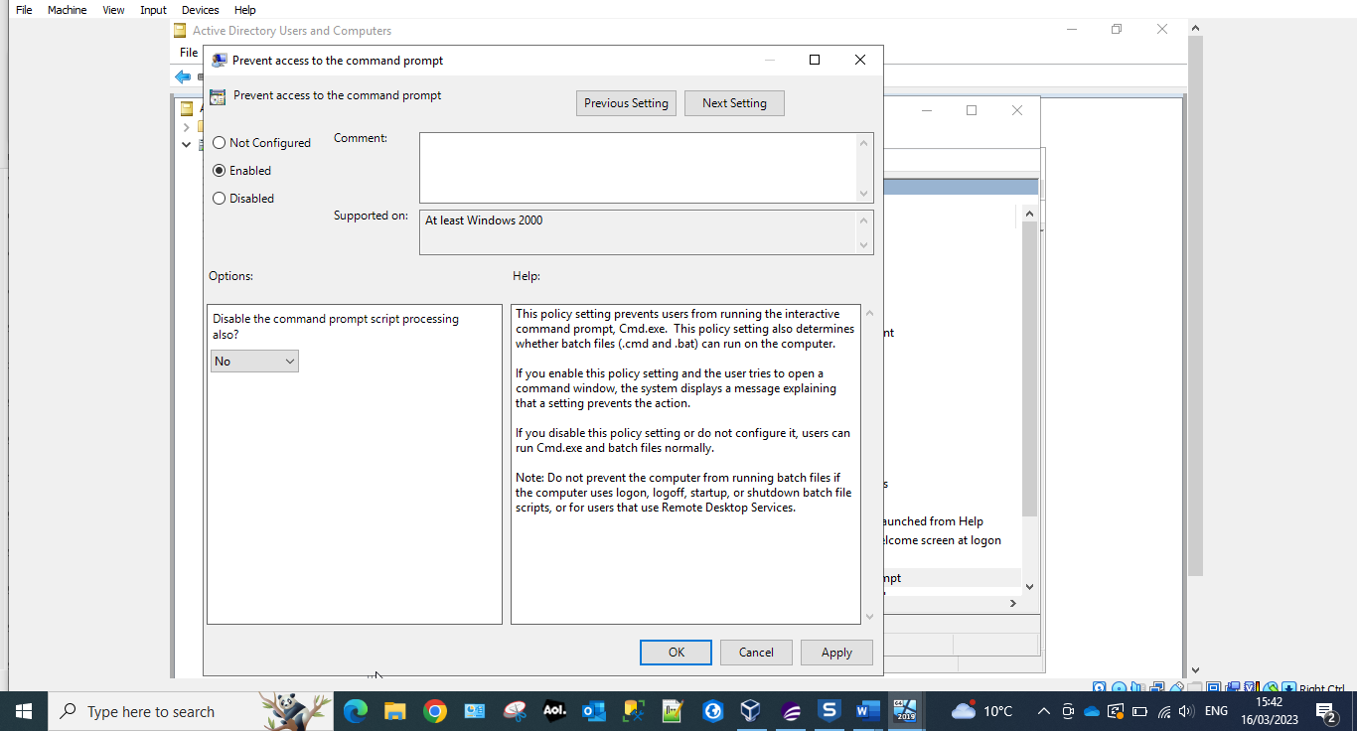
Enable the restriction to prevent the user Tim Curry access to Command Prompt. Access to the command prompt is used to prevent users who are not admins from accessing more resources than they are permitted. Such as:
- Network configurations
- Storage configurations
- Advanced file manipulation
Screenshot 24 Confirmation of no command prompt access
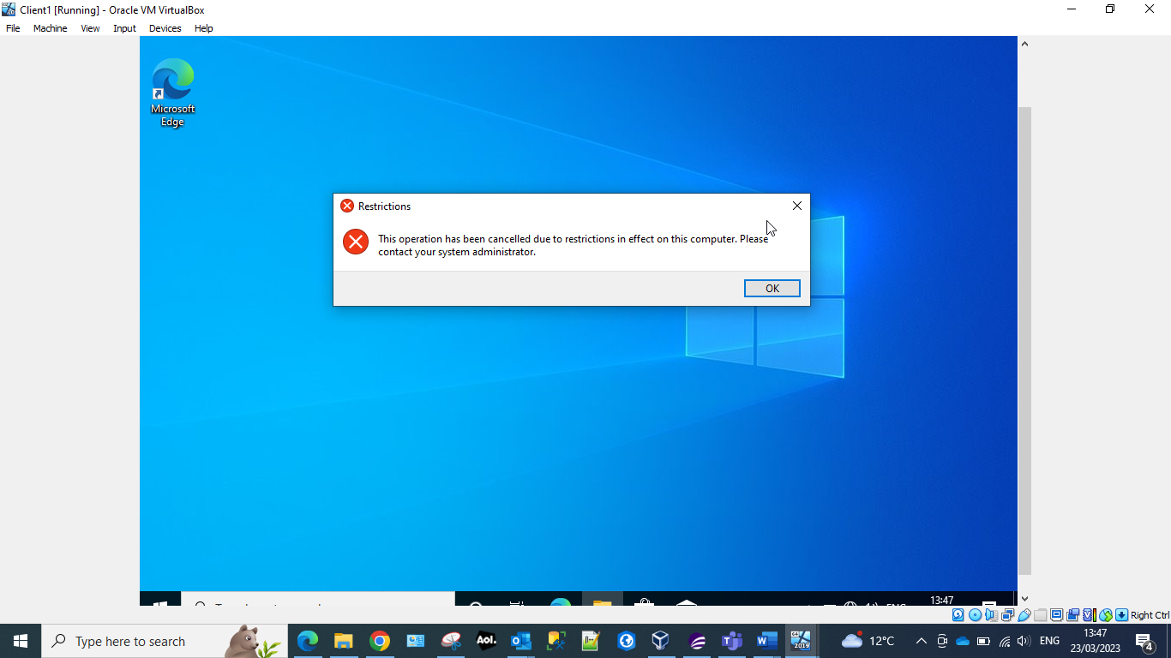
When the user attempts to access the command prompt they generate the restrictions message. That informs them that they do not have access to this function, and that if they need it they should contact their systems administrator. The systems administrator can restore this function to the user if they deem that it is necessary for the user to have this functionality in order for them to carry out specific tasks.

Screenshot 25 Removable storage access
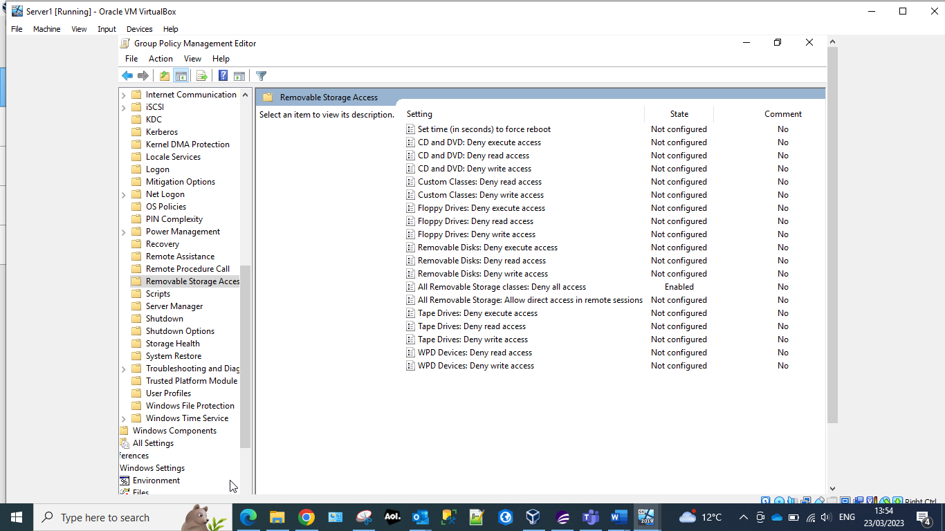
Removable storage is a risk to organisations as it is a common method of uploading viruses onto the system. To prevent this, the system administration has removed the users access to Removable Storage. As seen above this functionality has been disabled.

Screenshot 26 accatask.msft
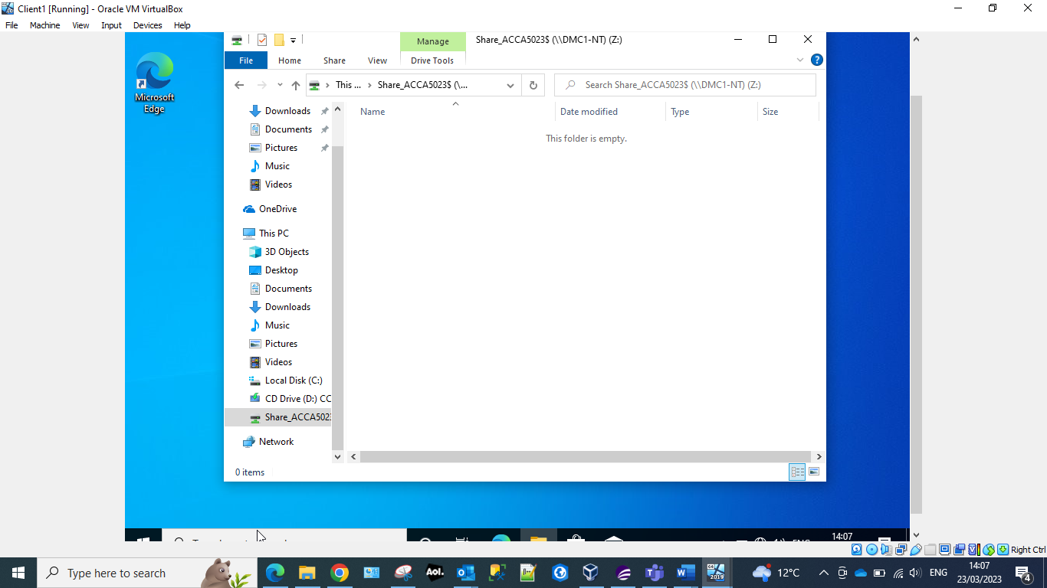
Within Active Directory the system administrator has started the process of removing the functionality from the user to install new software. This is to prevent the user for unknowingly/knowingly uploading malicious software that could attack the organisations systems.

Screenshot 27 New Organisational Unit NWClientComputers
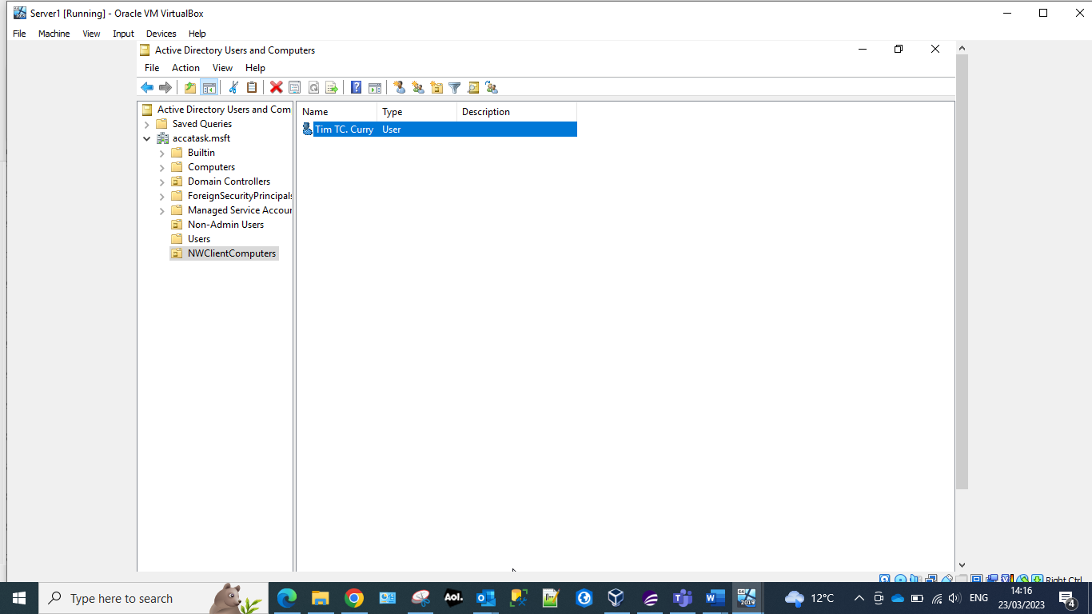
The administrator has created a new Organisational Unit within the Active Directory and has moved the Computer Object, which in this case is our user so that the administrator can configure the software installation restriction.
Screenshot 28 Prohibit User Installs
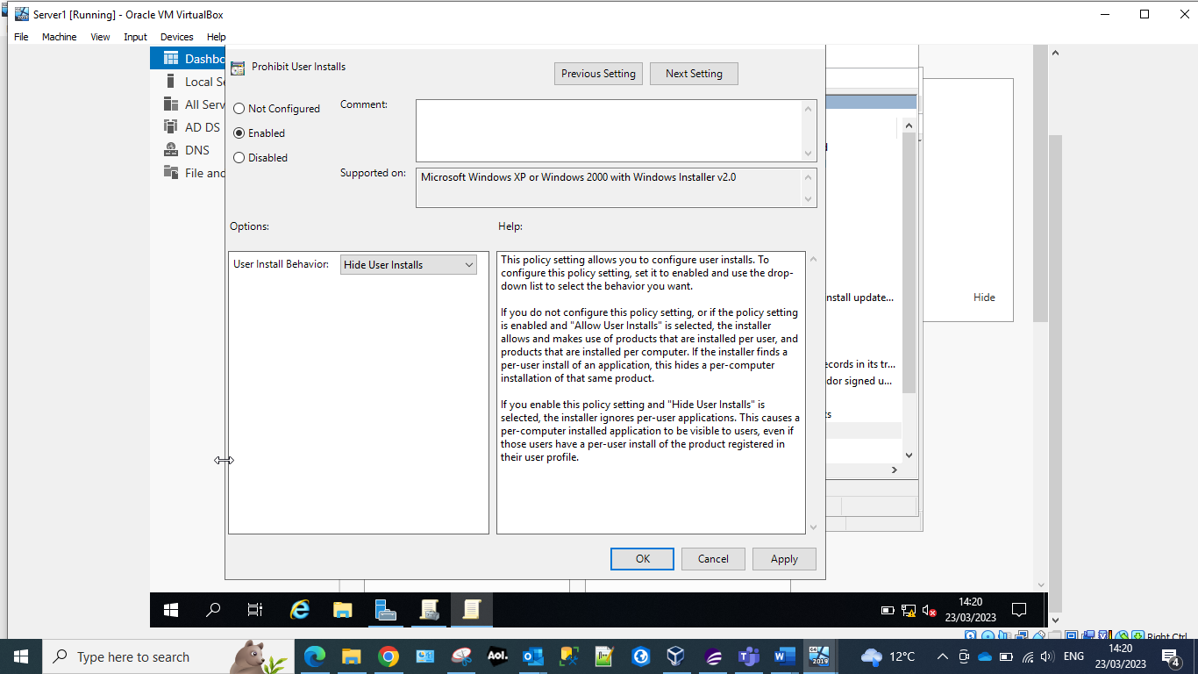
The above screen shows that the administrator has started to restrict the users access to the functionality of Software installations. To complete the configuration, they need to apply and ok the configuration.

Screenshot 29 User restriction for installation of programs
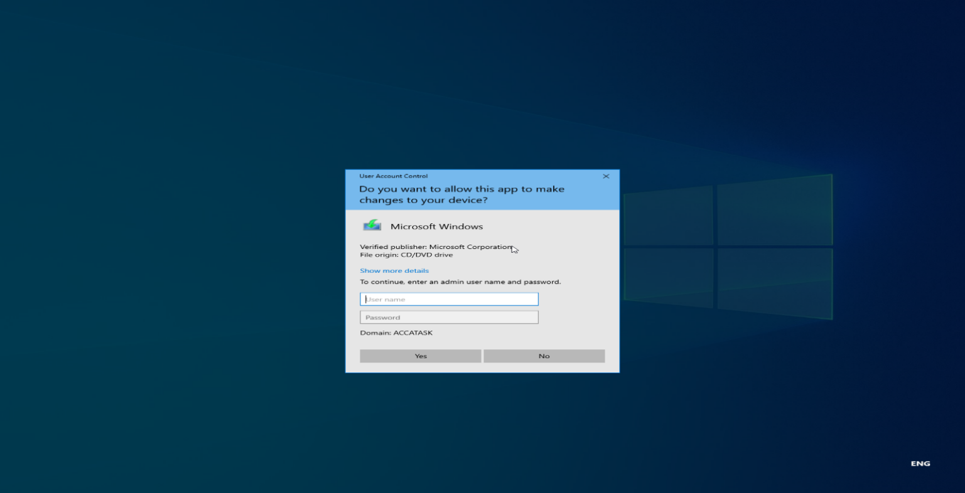
Restricting the user from being able to install programs/software prevents them from downloading malicious programs that could harm the organisations data or critical systems. System administrators are still able to install and update programs and systems, they will need to enter their own admin credentials so allow this.

Screenshot 30 Password settings
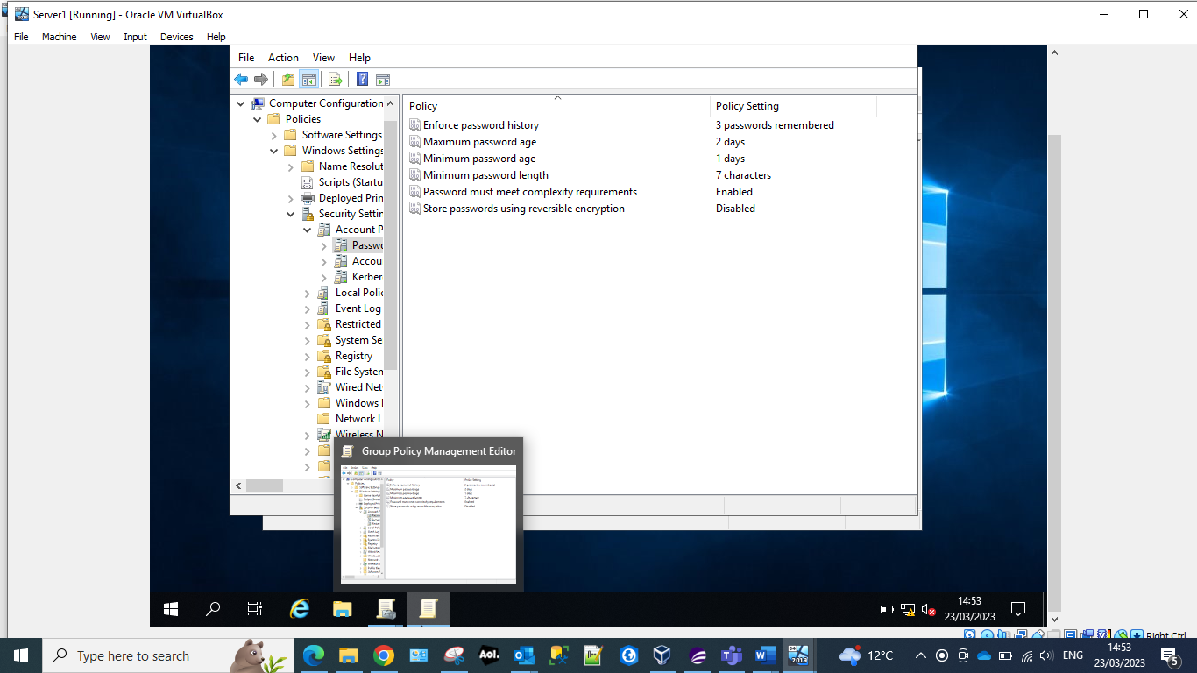
The administrator has pre-defined the setting to the password allocation for the user. Which are:
- The current password cannot be one that has been used in the last 3 previous passwords.
- The user must change the password every 2 days.
- The password must be at least one day old.
- The password must have a minimum character length of 7 characters.
- The password must meet the complexity requirements. That is containing upper case characters, lower case characters, digits 0-9 and a special character.
Screenshot 31 Password restrictions set.
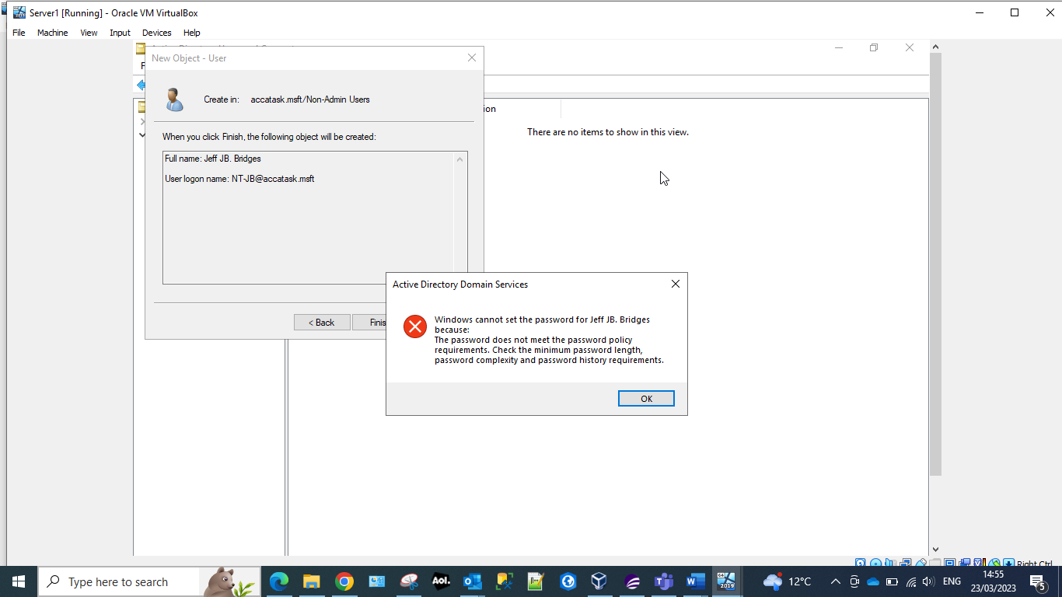
The system now forces the user to enter a password that includes all of the setting that the administrator has configured.

Routing and Packet Filtering within Core TCP/IP services and critical Failover/Redundancy Practices

Utilising ARP and Routing Tables
Screenshot 32 ARP -A command
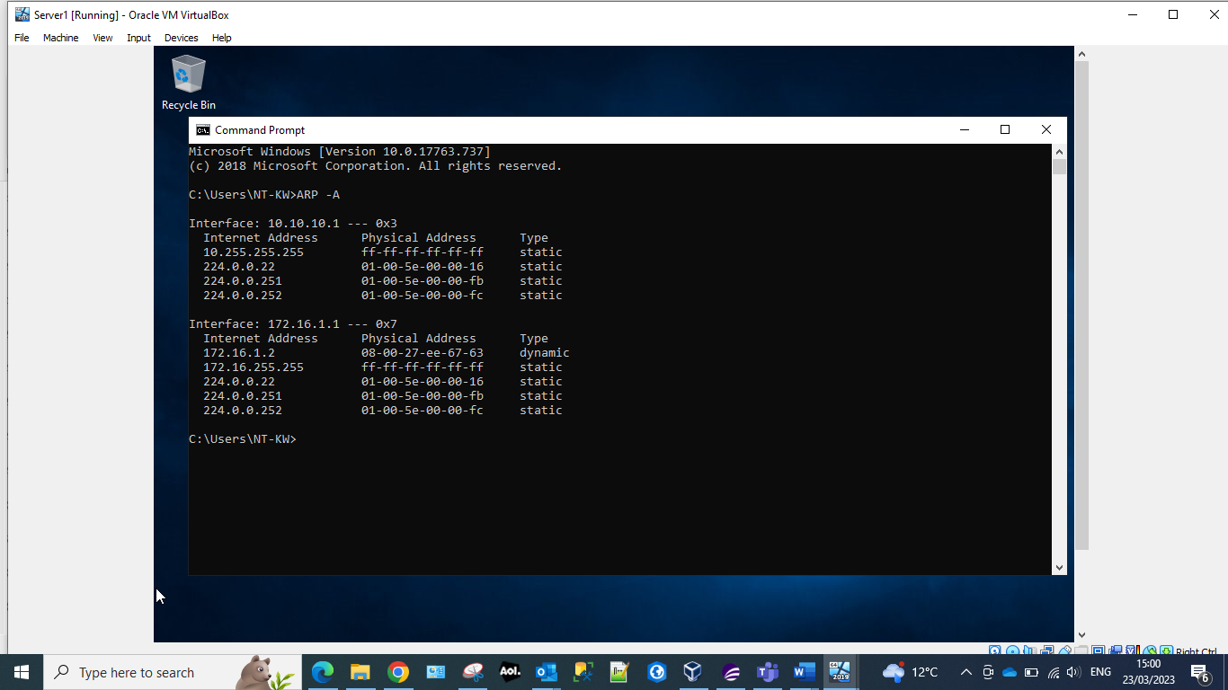
The ARP – A displays ARP (Address Resolution Protocol) data to view mappings. By entering this the administrator is able to see if the current state matches the mappings. The administrator could also use this command to troubleshoot any network connectivity issues.

Screenshot 33 route PRINT
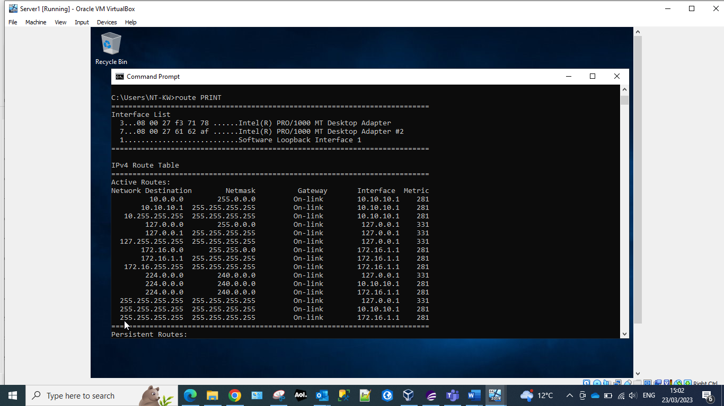
The command route PRINT allows the administrator to view the routing table.
Screenshot 34 Server Manger
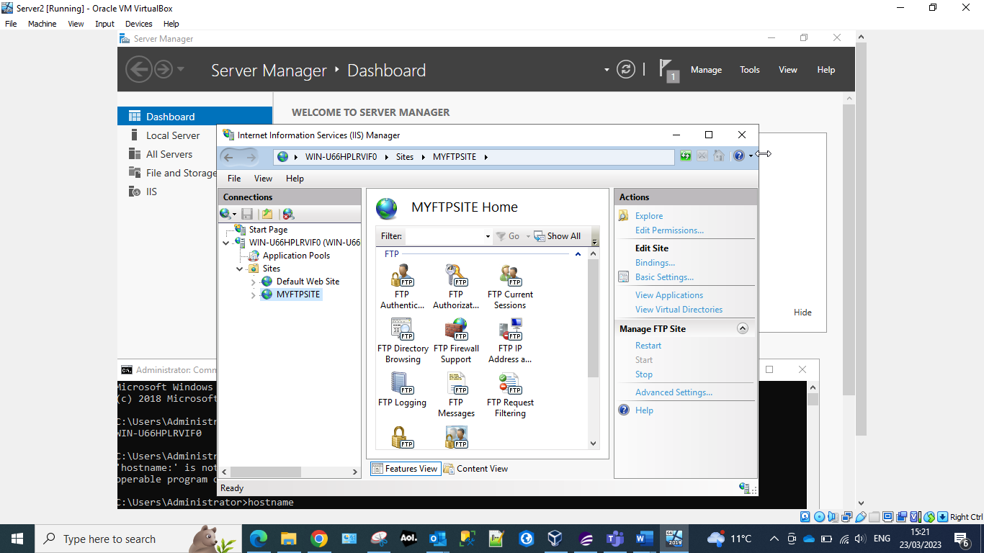
The server manager allows the administrator to monitor, start, stop or restart and configure database connections, login authentications.

Screenshot 35 MYFTPSITE
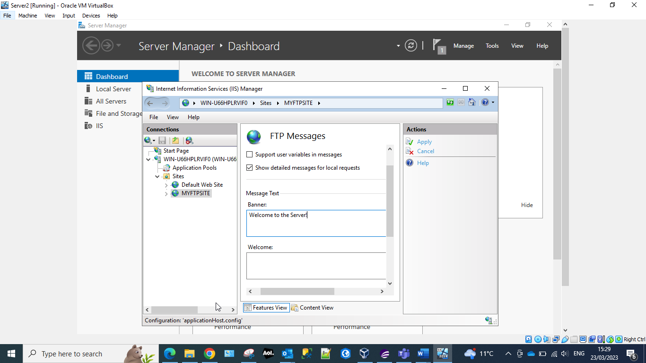
FTP (File Transfer Protocol) Server is used for transferring files across the internet. They have two functions PUT (uploading of files to the server from the client) and GET ( getting files from the server from the client). The administrator has entered a welcome message to the server banner.
Screenshot 36 MyFtupuploads folder
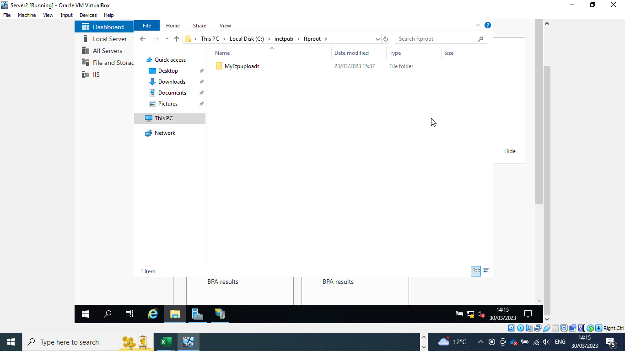
Creation of a folder to hold the ftp documents.

Screenshot 37 ftpuser23
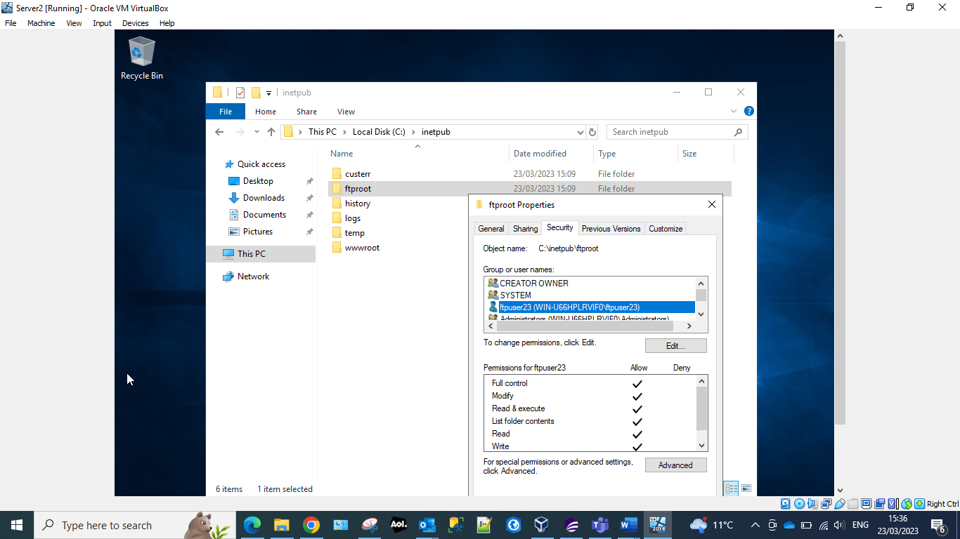
Allowing user to the FTP – domain user accounts allow for easier access and auditing for domain resources. Local user accounts are better than domain user accounts when you are trying to limit access to your domain.

Screenshot 38 Firewalls Server2
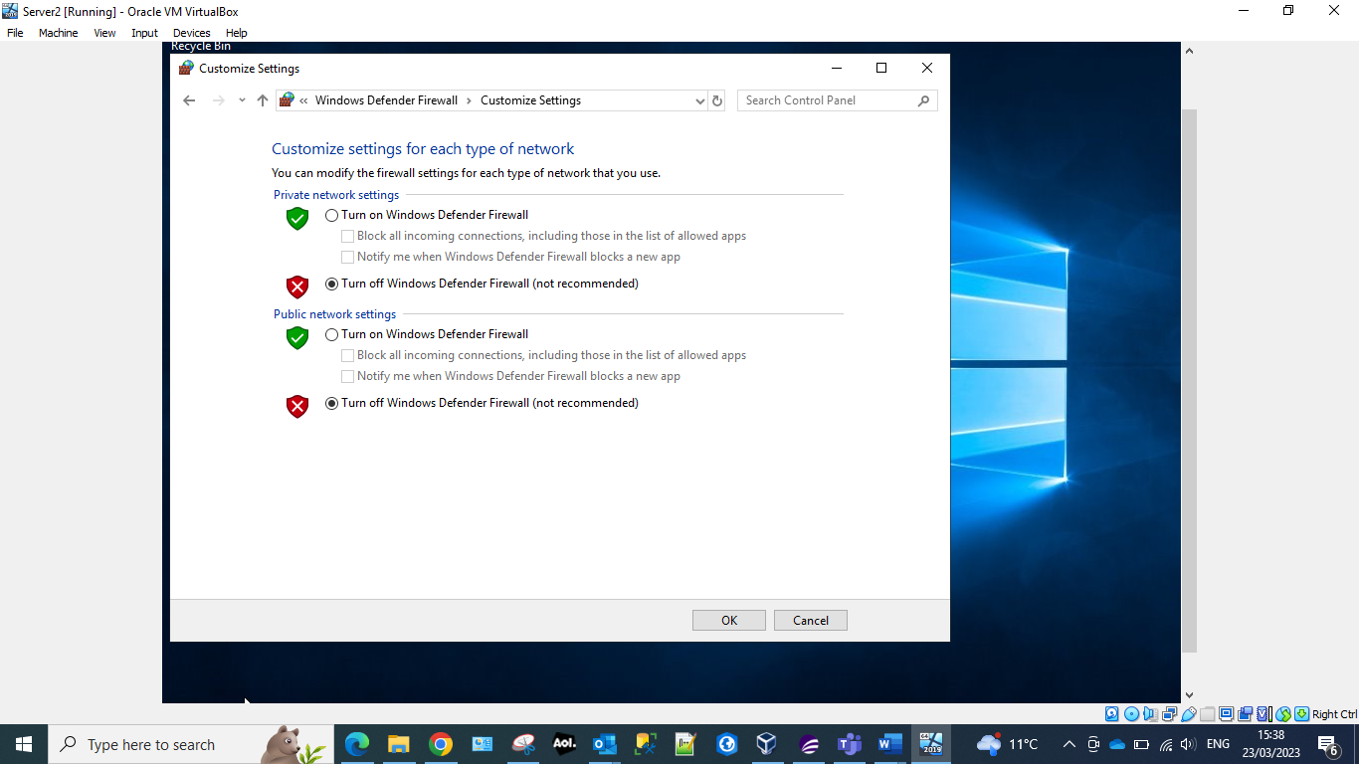
Confirming that the firewalls for Server2 have been turned off.

Screenshot 39 FTP Server
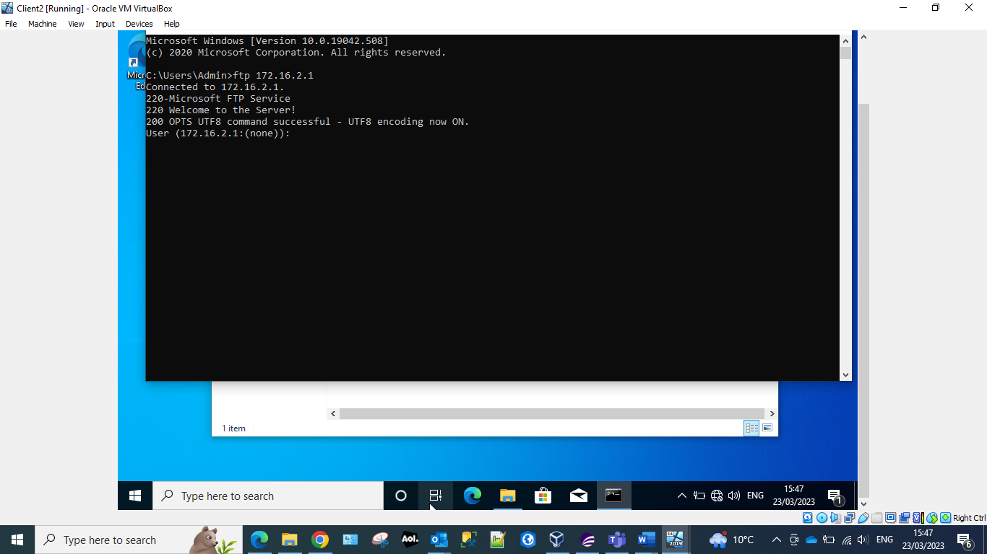
The ftp command followed by the server address – connects to ftp service.
Screenshot 40 Connecting to Server2 with ftpuser23.
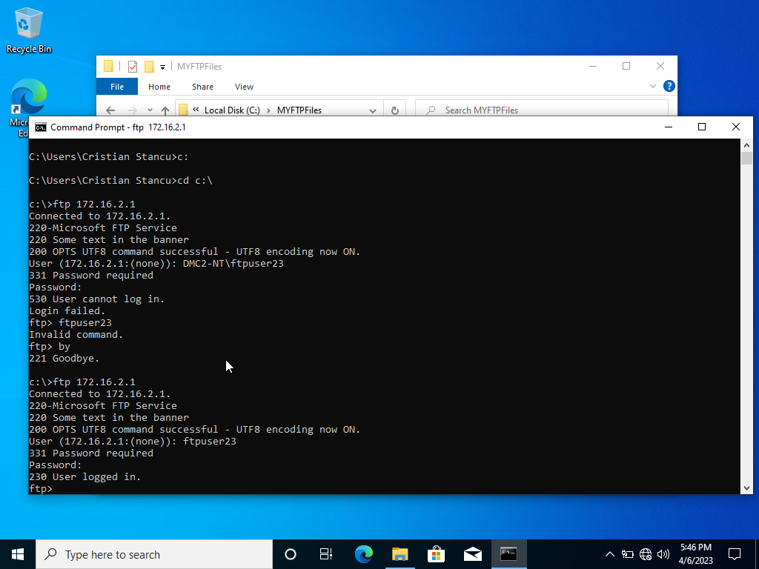
Whilst completing this task it was noted by the group that the worksheet contained several errors for this task. The FTP username doesn’t have to include the windows domain, so when we connect through FTP to Server1 (which has the computer name DMC2-NT) using the user ftpuser23, the windows domain doesn’t have to be used like DMC2-NT\ftpuser23 or accatask.msft\ftpuser23. The connection can be made using the username only: ftpuser23.

Screenshot 41 Server1 Server Manager
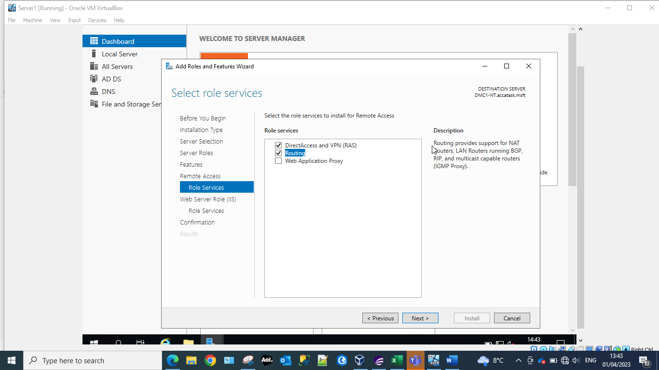
Server manager provides the administrator with an interface to Windows servers. From here the administrator can monitor and manage various aspects of the server which includes Role services. Role services allows the administrator to manager server features.

Screenshot 42 Deploy VPN and LAN routing.
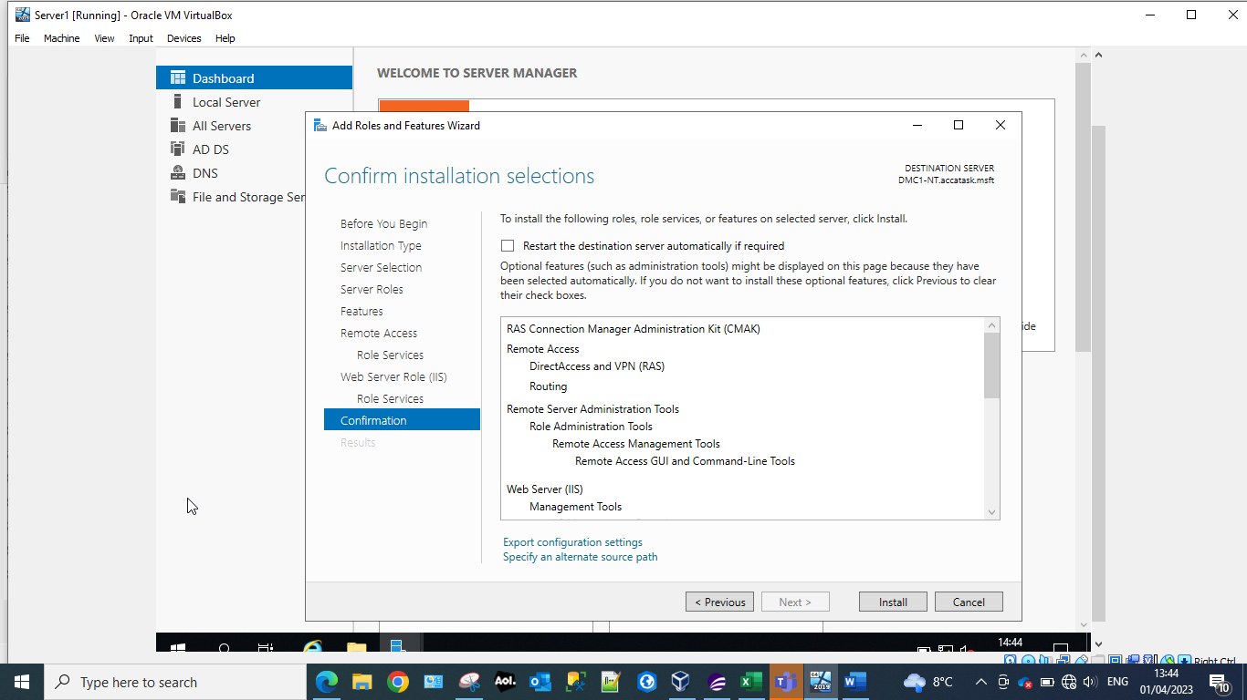
VPN deploy in role services configures the VPN role on a Windows server. It allows the provision of secure remote access to the organisations internal network. By using this the administrator can ensure that they are protecting the organisations network from malicious/unauthorised access and potential theft of data.

Screenshot 43 Routing and remote access
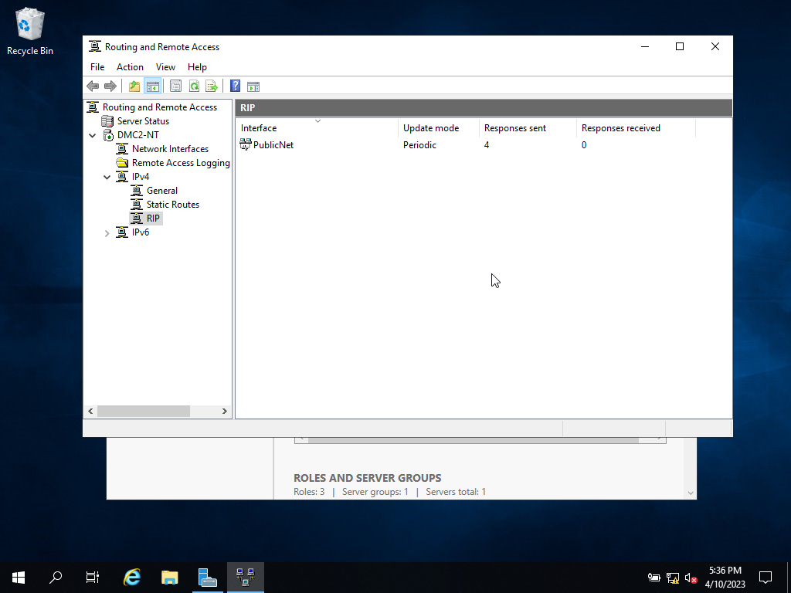
Routing and remote access completed on both Server1 and Server2 – ensuring that the PublicNet is added to the IPv4RIP.
RIP is the Routing Information Protocol and is what is known as a distance vector protocol that uses hop count as its primary metric. The RIP defines how routers should share information when moving traffic among an interconnected group of local area networks. However, according to Brush [1] that this has been replaced by Open Shortest Path First (OSPF) as the Interior Gateway Protocol in enterprise and larger, more complex networks.
Only the PublicNet interface should be present as it is the one that is announcing the routes for the server.

Screenshot 44 Ping from Server1
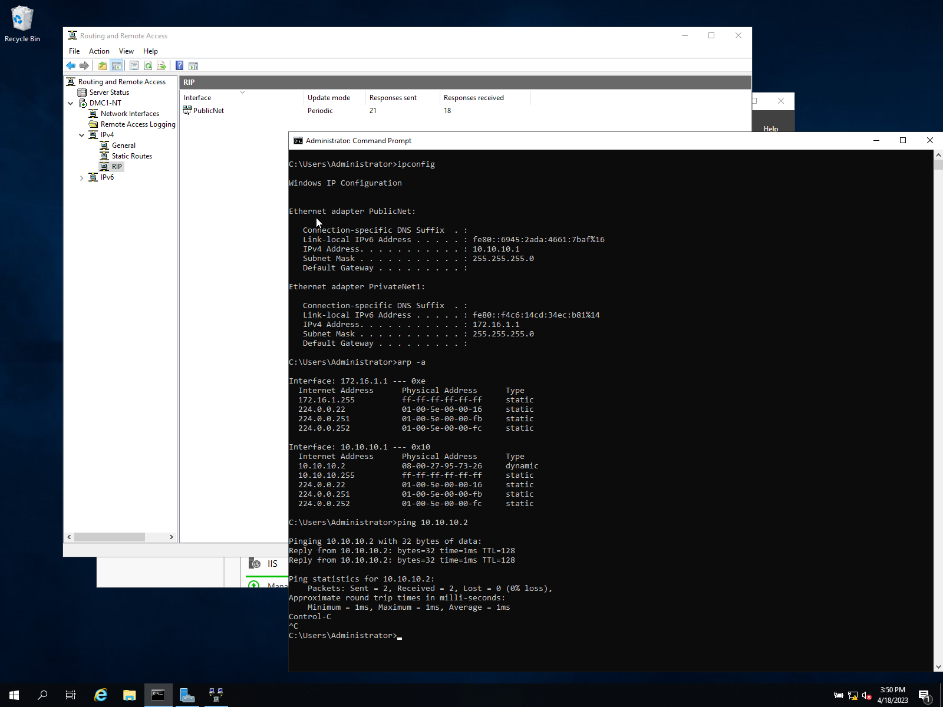
The above screenshot shows the configuration of the RIP and ping test.
The configuration for this model is similar to the figure shown below.
Figure 1 Routing model [2]
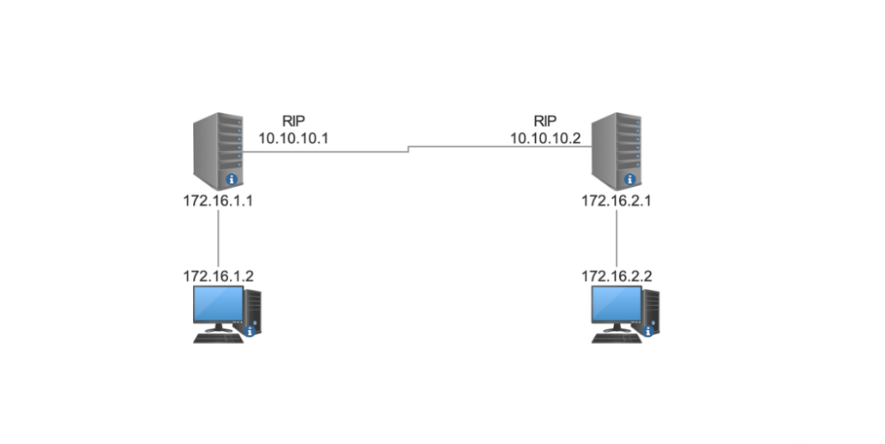
Screenshot 45 Ping Server2 from Server1
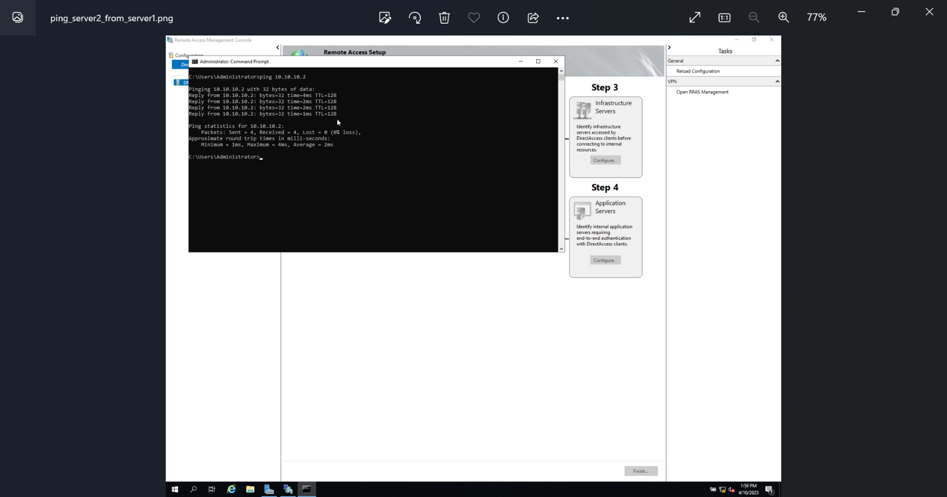

IP Filtering

Filter 1 Stopping ‘anyone’ in PrivateNet1 from Pinging the Router Firewall Service
Screenshot 46 Inbound Filters
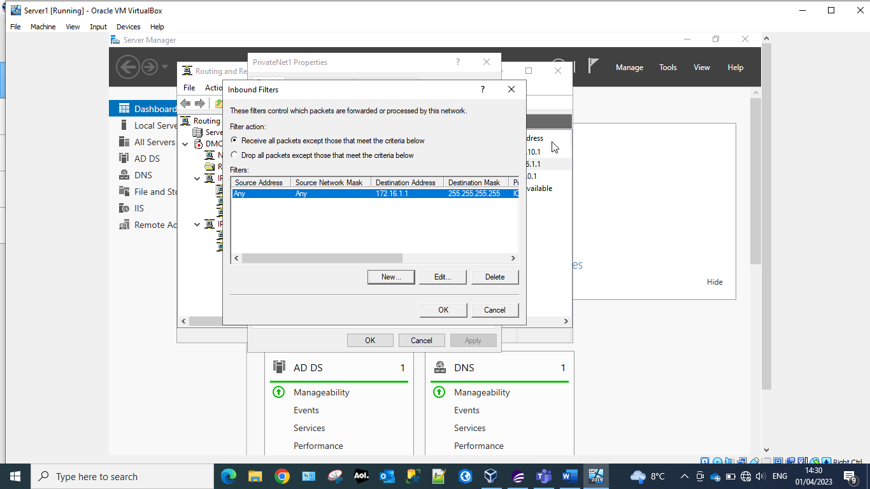
Inbound filters are a set of rules that control the incoming network traffic to the server. They form part of the Windows Firewall, which is a built-in security feature in Windows server that helps to protect the server from unauthorised access and malicious attacks.

Filter 2: Restrict Access to FTP Service on Server2 to only hosts in PrivateNet2.
Screenshot 47 Client1 can connect to ftp server.
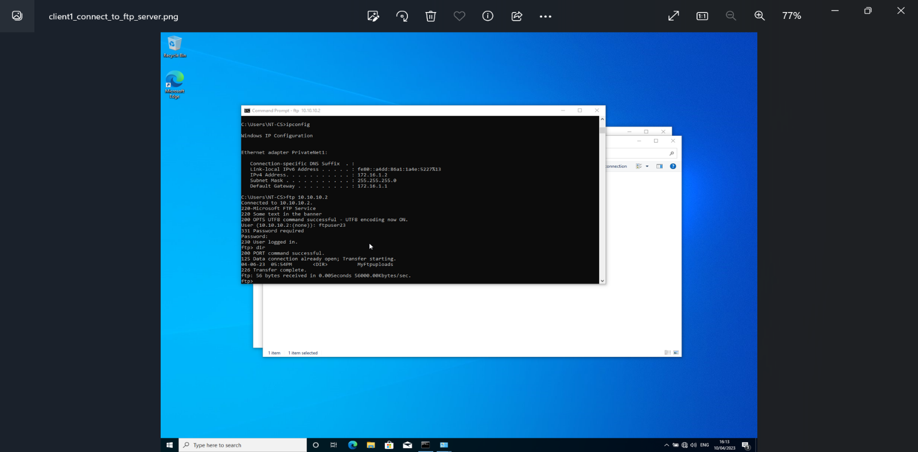
Confirmation of connection prior to the outbound filters being set.

Screenshot 48 Setting outbound filters.
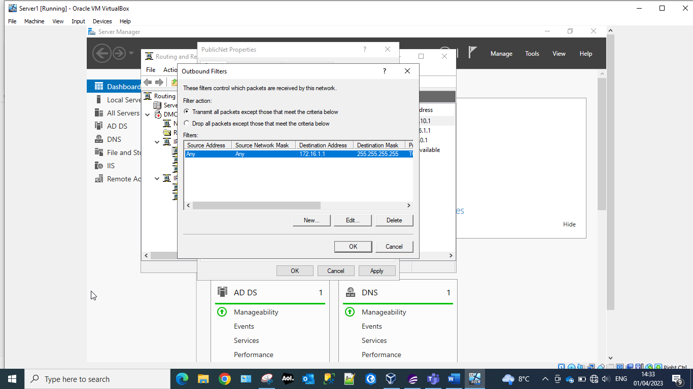
Outbound filters control the outgoing network traffic from the server. When an application or service on the server requests a network connection to a remote destination, it evaluates the connection against the outbound filters to determine if this connection is permitted or blocked. Outbound filters can be set to restrict specific types of traffic, or traffic to specific ports or to specific IP addresses. In the above screen the administrator has set an outbound filter to restrict Client1 from connect to ftp server1.
Screenshot 49 Client 1 not able to connect to ftp server1.
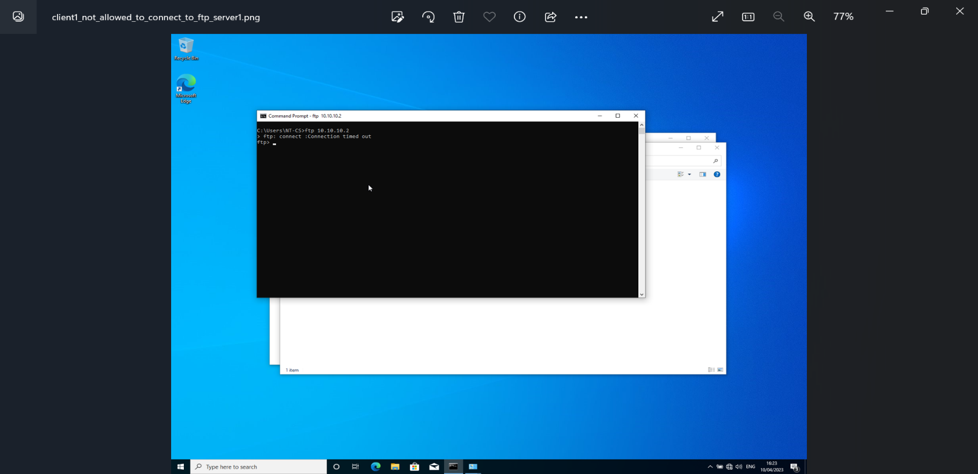
Confirmation after the outbound filter set that Client 1 can no longer connect to ftp Server1.

Filter 3: Only allow specific hosts in PrivateNet1 to access the FTP server Server2
Screenshot 50 Client 1 can connect to ftp server.
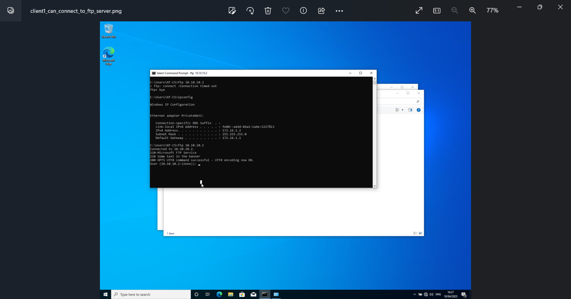
Confirmation that prior to the administrator setting the inbound filters Client1 can connect to ftp server.

Screenshot 51 inbound filter
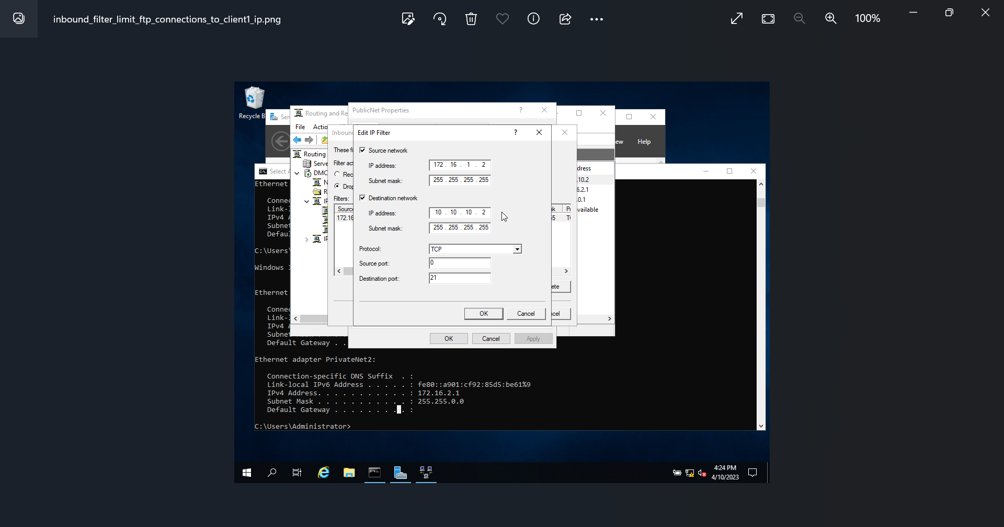
The administrator has set an inbound filter to limiting the access to the FTP server.

Screenshot 52 Server1 cannot connect to ftp server.
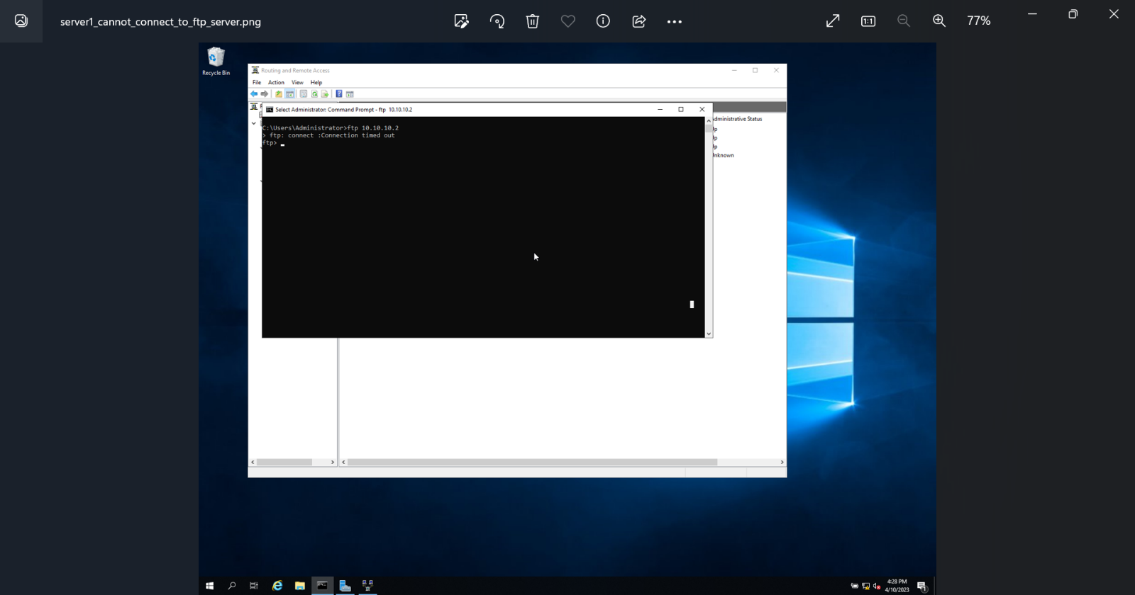
Confirmation that the inbound filters that the administrator has set now work – Server1 now cannot connect to the FTP server.

Observational Task

Enhancing Security (SOHO)
When considering enhancing security in a home network or small office there are a few considerations which can be made.

Wi-Fi
Standard Wi-Fi configurations can be easily infiltrated by people with malicious intent. It is best practice to alter the passwords for both connecting to the Wi-Fi and the administrator’s password. Depending on the use of a home network or small office environment it may benefit security to whitelist devices which would need access to the network. On a larger scale this can quickly become unmanageable, but it is a very secure method of protecting networks.

Group Policy
Group policy is a method of applying security or computer policies to a group of devices within a network. As stated in the online book Windows Group Policy troubleshooting [1]. These policies can lock down computers to protect them from external threats. To protect the computer locking down certain actions such as running certain .exe files installers and accessing the control panel. This protects the user from accidentally installing something which could be harmful to the device.
It also allows for administrators to manage all devices and users from the same administrative device. Auto lock timers can be added to devices so that networks aren't left unlocked and vulnerable.

Backups
Backups ensure that data and files can be recovered in the event of a disaster. Backups have been stated as the last line of defence by Thomas and Galligher [2]. There are multiple methods of backups for small offices which can be used. A small network attached storage device (NAS) can be used to store backups of data or documents with a “plug and play” limited setup.
A windows server can be used although this can be quite expensive and have a difficult setup different RAID systems could be used as a disaster recovery method.

Failover Clustering
Failover clustering is a method of allowing end users to continue using applications and services if a server fails. While this may not be useful in a home network, for an enterprise level network this sort of technology could be imperative to essential running of a business or organisation.
Figure 2 (Failover Cluster Diagram)

Purposes
Failover Clustering is a method of providing continuous/high availability services which can handle failures and still provide a service with little or no downtime. The backup server will absorb the workload or in some cases take over completely. These failover servers can either be set up as physical servers or as VMs.

High Availability FC
Independent servers share data and resources throughout a system. High availability clusters monitor each server on the system checking the health and connection. One server will always be active while at least one will be passive. In a two-node structure if one server detects the other has gone down it will assume the role as the primary active server [3]. When scaled up to multiple servers some can be used as management servers to deal with the changeover.

Continuous Availability FC
The distinction of a CAFC is that it has multiple systems which use the same single copy of a computer operating system commands issued by one system are executed on all other systems. The redundancy model used on CA is called 2N and requires an exact formatted copy of the computer system. Continuous availability systems can detect and replace many different component failures:
- Hard Drives
- Processing Units
- I/O subsystems
- Power Supply Units
- Networking Components

Cost
Failover Clusters require a secondary server to be set up. This means doubling the cost for maintenance of the systems. It would also be beneficial as per the failover cluster diagram above to have a shared cluster storage technology. This means that the software or application would have a quicker recovery time as the data would not need to be recovered. It would also save on storage space of mirroring data across two servers.

Enterprise Network Policy
When dealing with an enterprise level network, policies need to be introduced to protect the data and devices connected.

Group Policy (Enterprise)
As already stated, group policy is an essential tool for larger networks as it allows for administrators to apply rules to multiple users or devices at once.

Active Directory
Active directory is another tool which is essential in an enterprise level network. It means that users can be assigned to groups which apply a level of security to all contained users. These groups can be created for all standard users with more groups which can give more specific permissions [4]. For example, everyone in an organisation can be assigned to a standard group to give access to intranet and shared drives, but more specific groups can be created for sensitive data or developers' permissions.

Data Protection Impact Assessment (DPIA)
DPIAs are a documentation method of standardising and assessing risk when it comes to accessing data [5]. These forms should be filled out with the reasons the data needs to be accessed and the methods the data will be stored. This can be checked by the information protection officer (IPO) and security recommendations can be made to ensure the highest level of security and auditing.

Disaster Recovery

Failover Clustering (Enterprise)
Failover clustering is a method of allowing end users to continue using applications and services if a server fails. While this may not be useful in a home network, for an enterprise level network this sort of technology could be imperative to essential running of a business or organisation. I have discussed this in detail above.

Backups

Backups are essential for larger organisations as part of the GDPR laws enforced by the UK government. Windows servers with different RAID configurations can be used depending on the specific requirements of the team.
- RAID 0: Is a collection of disks across different drives it provides lots of storage capacities but has no disaster recovery.
Figure 3 (RAID 0 Diagram)
- RAID 1: Splits the disks between two drives. One drive would store the data and the second drive would be a mirror. This would half the storage amount but would provide data redundancy in the event of a disaster.
Figure 4 (RAID 1 Diagram)
- RAID 5: Uses a parity method to allow for maximum data storage while keeping differential data in one of the drives. This means that the data can be recovered but takes longer. This method has the best balance of storage capability and data redundancy.

Figure 5 (RAID 5 Diagram)
- RAID 10: This setting combines RAID 1 + 0. This setting gives all the benefits of RAID 1 and RAID 0 without all the disadvantages. The advantages include faster read and write speeds, high redundancy and easy recovery.
Figure 6 (RAID 1+0 Diagram)

General Data Protection Regulations (GDPR)
GDPR is a set of regulations which are enforced by the UK government. These regulations were intended to protect the citizens of the UKs personal and private data. Ensuring that their personal data is secured and can be owned and controlled by them. There are certain principles which the regulations aim to enforce:
- Accountability
- Storage Limitation
- Integrity and Confidentiality
- Accuracy
- Purpose Limitation
- Data Minimisation
- Lawfulness, Fairness and Transparency

Organisational Role Diagram
Data and information systems at an enterprise level require many teams to manage digital security effectively. GDPR is such a vast set of regulations that to enforce them at a large organisational level a team should be employed to regulate the architecture.
Security management and architecture is also a large undertaking at an enterprise level. Hundreds of different systems and data management tools can be used at an enterprise level and connecting them for data analysis requires an understanding of the systems and APIs, connectors, or ports.
All security and information related teams should report to a Chief Information Officer, it is the responsibility of this person to report all data related incidents to the ICO and associated regulators.
Figure 7 (Organisational Chart)

Virtual Private Networks
Virtual Private Networks or VPNs encrypt data as they pass over the internet. In the modern working world where hybrid working is prevalent in almost every large organisation as stated in this paper by R. Venkateswaran [6]. Encrypting the data to stop malicious actors from accessing or altering the data from the network to the devices.

Reflection
The topics covered in this paper are essential to understanding and working in the modern digital era. Understanding of potential threats and active methods of being able to protect devices and networks is essential. Using active directory to control multiple users and devices on a network is imperative to sustaining security and compliance across larger networks. As the users or devices on the network gets larger the use of trees (one or more domains) and forests (a set of trees) is imperative otherwise it can quickly overwhelm.
The use of VPNs is common practice in the modern digital era and provides essential security and protection to organisations data. Virtual machines can also provide a secondary layer of protection in an architecture stopping issues from affecting multiple systems and can be contained to that layer.
Passwords and access control can be used to limit the possible attack vector. Principle of least privilege should be used across the architecture limiting access to unnecessary data. In conclusion there are multiple technologies and processes that need to be implemented to maintain secure and reliable systems.

Bibliography
[1] “Windows Group Policy troubleshooting,” Google Books. [Online]. Available: https://www.google.co.uk/books/edition/Windows_Group_Policy_Troubleshooting/AhBuDQAAQBAJ?hl=en&gbpv=1&dq=windows%2Bgroup%2Bpolicy&pg=PR8&printsec=frontcover. [Accessed: 05-May-2023].
[2] J. Thomas and G. Galligher, “Improving backup system evaluations in information security risk assessments to combat ransomware,” SSRN, 04-Jan-2018. [Online]. Available: https://papers.ssrn.com/sol3/papers.cfm?abstract_id=3095629. [Accessed: 05-May-2023].
[3] N. V. ., “Cost effective failover clustering,” International Journal of Research in Engineering and Technology, vol. 03, no. 03, pp. 218–220, 2014.
[4] “Active directory,” Google Books. [Online]. Available: https://www.google.co.uk/books/edition/Active_Directory/exlzxcsE-7QC?hl=en&gbpv=1&dq=windows%2Bactive%2Bdirectory&pg=PR5&printsec=frontcover. [Accessed: 05-May-2023].
[5] S. B. Pasha, “The controller's role in determining 'high risk' and Data Protection Impact Assessment (DPIA) in developing Digital Smart City,” Taylor & Francis. [Online]. Available: https://www.tandfonline.com/doi/full/10.1080/13600834.2020.1790092. [Accessed: 05-May-2023].
[6] R. Venkateswaran, “Virtual private networks | IEEE Journals & Magazine | IEEE Xplore,” IEEEXplore. [Online]. Available: https://ieeexplore.ieee.org/abstract/document/913204/. [Accessed: 05-May-2023].

