Student ID | Final mark | Lecture  attendance (%) | Tutorial  attendance (%) | Monthly  study hours
1 | 34 | 40 | 35 | 23
2 | 44 | 38 | 36 | 25
3 | 46 | 70 | 40 | 30
4 | 46 | 57 | 30 | 20
5 | 52 | 70 | 65 | 48
6 | 52 | 84 | 70 | 32
7 | 52 | 66 | 60 | 41
8 | 54 | 64 | 66 | 58
9 | 55 | 68 | 60 | 54
10 | 55 | 65 | 50 | 66
11 | 57 | 60 | 80 | 34
12 | 60 | 86 | 75 | 74
13 | 61 | 85 | 90 | 70
14 | 62 | 78 | 60 | 56
15 | 63 | 70 | 76 | 64
16 | 66 | 95 | 76 | 55
17 | 68 | 70 | 55 | 48
18 | 68 | 80 | 85 | 80
19 | 73 | 90 | 90 | 70
20 | 85 | 95 | 100 | 90

One of the assumptions for Multiple Regression is that the data are normally distributed. Analysis of the data in SPSS Descriptive Statistics – Explore gives the following information:

Tests of Normality
 | Kolmogorov-Smirnovª |  |  | Shapiro-Wilk
 | Statistic | df | Sig. | Statistic | df | Sig.
mark | .110 | 20 | .200* | .982 | 20 | .952
lecture | .139 | 20 | .200* | .944 | 20 | .290
tutorial | .101 | 20 | .200* | .969 | 20 | .729
study | .113 | 20 | .200* | .967 | 20 | .699
*. This is a lower bound of the true significance.
- Lilliefors Significance Correction

It may be seen that both the KS and Shapiro-Wilks test show a significance > .05 and so the data are assumed to be normally distributed.

Scatter plot and simple linear regression – Lecture Attendance

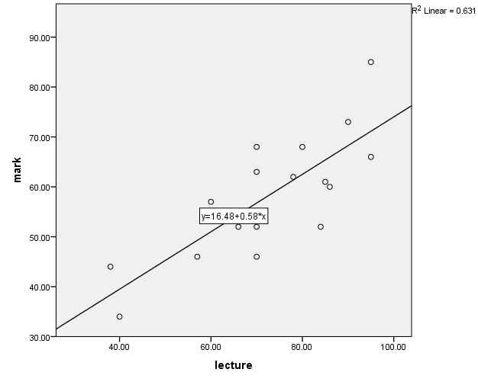

Variables Entered/Removedª
Model | Variables Entered | Variables Removed | Method
1 | lecture^{b} | . | Enter
a. Dependent Variable: mark
b. All requested variables entered.

Model Summary
Model | R | R Square | Adjusted R Square | Std. Error of the Estimate
1 | .795ª | .631 | .611 | 7.11479
a. Predictors: (Constant), lecture

ANOVAª
Model |  | Sum of Squares | df | Mean Square | F | Sig.
1 | Regression | 1561.386 | 1 | 1561.386 | 30.845 | .000^{b}
1 | Residual | 911.164 | 18 | 50.620
1 | Total | 2472.550 | 19
a. Dependent Variable: mark
b. Predictors: (Constant), lecture

Coefficientsª
Model |  | Unstandardized Coefficients |  | Standardized Coefficients | t | Sig. | 95.0% Confidence Interval for B
 |  | B | Std. Error | Beta | t | Sig. | Lower Bound | Upper Bound
1 | (Constant) | 16.484 | 7.581 |  | 2.174 | .043 | .558 | 32.411
1 | lecture | .575 | .104 | .795 | 5.554 | .000 | .358 | .793
a. Dependent Variable: mark

Scatter plot and simple linear regression – Tutorial Attendance

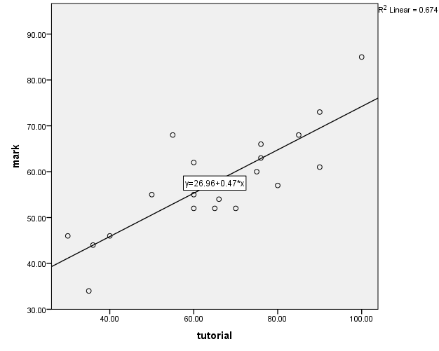

Variables Entered/Removedª
Model | Variables Entered | Variables Removed | Method
1 | tutorial^{b} | . | Enter
a. Dependent Variable: mark
b. All requested variables entered.

Model Summary
Model | R | R Square | Adjusted R Square | Std. Error of the Estimate
1 | .821ª | .674 | .655 | 6.69582
a. Predictors: (Constant), tutorial

ANOVAª
Model |  | Sum of Squares | df | Mean Square | F | Sig.
1 | Regression | 1665.537 | 1 | 1665.537 | 37.149 | .000^{b}
1 | Residual | 807.013 | 18 | 44.834
1 | Total | 2472.550 | 19
a. Dependent Variable: mark
b. Predictors: (Constant), tutorial

Coefficientsª
Model |  | Unstandardized Coefficients |  | Standardized Coefficients | t | Sig. | 95.0% Confidence Interval for B
 |  | B | Std. Error | Beta | t | Sig. | Lower Bound | Upper Bound
1 | (Constant) | 26.959 | 5.253 |  | 5.132 | .000 | 15.922 | 37.996
1 | tutorial | .473 | .078 | .821 | 6.095 | .000 | .310 | .635
a. Dependent Variable: mark

Scatter plot and simple linear regression – Study Hours

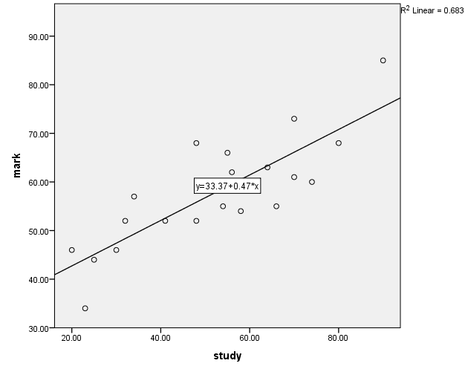

Variables Entered/Removedª
Model | Variables Entered | Variables Removed | Method
1 | study^{b} | . | Enter
a. Dependent Variable: mark
b. All requested variables entered.

Model Summary
Model | R | R Square | Adjusted R Square | Std. Error of the Estimate
1 | .827ª | .683 | .666 | 6.59627
a. Predictors: (Constant), study

ANOVAª
Model |  | Sum of Squares | df | Mean Square | F | Sig.
1 | Regression | 1689.356 | 1 | 1689.356 | 38.826 | .000^{b}
1 | Residual | 783.194 | 18 | 43.511
1 | Total | 2472.550 | 19
a. Dependent Variable: mark
b. Predictors: (Constant), study

Coefficientsª
Model |  | Unstandardized Coefficients |  | Standardized Coefficients | t | Sig. | 95.0% Confidence Interval for B
 |  | B | Std. Error | Beta | t | Sig. | Lower Bound | Upper Bound
1 | (Constant) | 33.371 | 4.166 |  | 8.010 | .000 | 24.618 | 42.124
1 | study | .468 | .075 | .827 | 6.231 | .000 | .310 | .626
a. Dependent Variable: mark

Multiple Regression – Lecture, Tutorial, Study

Variables Entered/Removedª
Model | Variables Entered | Variables Removed | Method
1 | lecture, study, tutorial^{b} | . | Enter
a. Dependent Variable: mark
b. All requested variables entered.

Model Summary
Model | R | R Square | Adjusted R Square | Std. Error of the Estimate
1 | .889ª | .790 | .750 | 5.70098
a. Predictors: (Constant), lecture, study, tutorial

ANOVAª
Model |  | Sum of Squares | df | Mean Square | F | Sig.
1 | Regression | 1952.531 | 3 | 650.844 | 20.025 | .000^{b}
1 | Residual | 520.019 | 16 | 32.501
1 | Total | 2472.550 | 19
a. Dependent Variable: mark
b. Predictors: (Constant), lecture, study, tutorial

Coefficientsª
Model |  | Unstandardized Coefficients |  | Standardized Coefficients | t | Sig. | 95.0% Confidence Interval for B
 |  | B | Std. Error | Beta | t | Sig. | Lower Bound | Upper Bound
1 | (Constant) | 20.402 | 6.201 |  | 3.290 | .005 | 7.257 | 33.547
1 | study | .226 | .109 | .400 | 2.075 | .054 | -.005 | .458
1 | tutorial | .158 | .125 | .275 | 1.263 | .225 | -.107 | .423
1 | lecture | .213 | .138 | .294 | 1.542 | .143 | -.080 | .505
a. Dependent Variable: mark

Option 1: Remove Study

Variables Entered/Removedª
Model | Variables Entered | Variables Removed | Method
1 | tutorial, lecture^{b} | . | Enter
a. Dependent Variable: mark
b. All requested variables entered.

Model Summary
Model | R | R Square | Adjusted R Square | Std. Error of the Estimate
1 | .856ª | .733 | .702 | 6.23092
a. Predictors: (Constant), tutorial, lecture

ANOVAª
Model |  | Sum of Squares | df | Mean Square | F | Sig.
1 | Regression | 1812.536 | 2 | 906.268 | 23.343 | .000^{b}
1 | Residual | 660.014 | 17 | 38.824
1 | Total | 2472.550 | 19
a. Dependent Variable: mark
b. Predictors: (Constant), tutorial, lecture

Coefficientsª
Model |  | Unstandardized Coefficients |  | Standardized Coefficients | t | Sig. | 95.0% Confidence Interval for B
 |  | B | Std. Error | Beta | t | Sig. | Lower Bound | Upper Bound
1 | (Constant) | 18.128 | 6.670 |  | 2.718 | .015 | 4.054 | 32.201
1 | lecture | .284 | .146 | .393 | 1.946 | .068 | -.024 | .592
1 | tutorial | .295 | .116 | .513 | 2.543 | .021 | .050 | .540
a. Dependent Variable: mark

Option 2: Remove Lecture

Variables Entered/Removedª
Model | Variables Entered | Variables Removed | Method
1 | study, tutorial^{b} | . | Enter
a. Dependent Variable: mark
b. All requested variables entered.

Model Summary
Model | R | R Square | Adjusted R Square | Std. Error of the Estimate
1 | .871ª | .758 | .730 | 5.92764
a. Predictors: (Constant), study, tutorial

ANOVAª
Model |  | Sum of Squares | df | Mean Square | F | Sig.
1 | Regression | 1875.222 | 2 | 937.611 | 26.684 | .000^{b}
1 | Residual | 597.328 | 17 | 35.137
1 | Total | 2472.550 | 19
a. Dependent Variable: mark
b. Predictors: (Constant), study, tutorial

Coefficientsª
Model |  | Unstandardized Coefficients |  | Standardized Coefficients | t | Sig. | 95.0% Confidence Interval for B
 |  | B | Std. Error | Beta | t | Sig. | Lower Bound | Upper Bound
1 | (Constant) | 27.025 | 4.651 |  | 5.811 | .000 | 17.213 | 36.838
1 | tutorial | .257 | .112 | .446 | 2.300 | .034 | .021 | .493
1 | study | .268 | .110 | .474 | 2.443 | .026 | .037 | .500
a. Dependent Variable: mark

Option 3: Remove Tutorial

Variables Entered/Removedª
Model | Variables Entered | Variables Removed | Method
1 | lecture, study^{b} | . | Enter
a. Dependent Variable: mark
b. All requested variables entered.

Model Summary
Model | R | R Square | Adjusted R Square | Std. Error of the Estimate
1 | .877ª | .769 | .742 | 5.79986
a. Predictors: (Constant), lecture, study

ANOVAª
Model |  | Sum of Squares | df | Mean Square | F | Sig.
1 | Regression | 1900.697 | 2 | 950.348 | 28.252 | .000^{b}
1 | Residual | 571.853 | 17 | 33.638
1 | Total | 2472.550 | 19
a. Dependent Variable: mark
b. Predictors: (Constant), lecture, study

Coefficientsª
Model |  | Unstandardized Coefficients |  | Standardized Coefficients | t | Sig. | 95.0% Confidence Interval for B
 |  | B | Std. Error | Beta | t | Sig. | Lower Bound | Upper Bound
1 | (Constant) | 20.500 | 6.308 |  | 3.250 | .005 | 7.192 | 33.808
1 | study | .299 | .094 | .529 | 3.176 | .006 | .100 | .498
1 | lecture | .302 | .121 | .417 | 2.507 | .023 | .048 | .556
a. Dependent Variable: mark

A multiple regression was run to predict marks from three variables, lecture attendance, tutorial attendance and study time. The R² value for model variants are:
Model | R²
Lecture | .631
Tutorial | .674
Study | .683
Lecture + Tutorial + Study | .709
Lecture + Tutorial | .733
Tutorial + Study | .758
Lecture + Study | .769

The best fit is presented by Lecture + Study with an R² value of .769
These variables statistically significantly predicted marks, F(2, 17) = 28.252, p < .000, R² = .769. Both variables added statistically significantly to the prediction, p < .05.
The general form of the equation to predict marks from study time and lecture attendance is
Marks = 20.500 + (0.299 x Study Time) + (0.302 x Lecture Attendance)

Example (Student No 7) =
20.500 + (0.299 x 41) + (0.302 X 66)
20.500 + 12.259 + 19.932
52.691
Actual (from table) = 52

Student ID | Mark | Lecture | Tutorial | Study | Final mark | LTS | LT | ST | LS
1 | 34 | 40 | 35 | 23 | 34 | 39.7 | 39.8 | 37.1 | 39.5
2 | 44 | 38 | 36 | 25 | 44 | 39.8 | 39.5 | 37.8 | 39.5
3 | 46 | 70 | 40 | 30 | 46 | 48.4 | 49.8 | 39.5 | 50.6
4 | 46 | 57 | 30 | 20 | 46 | 41.8 | 43.2 | 35.7 | 43.7
5 | 52 | 70 | 65 | 48 | 52 | 56.4 | 57.2 | 47.2 | 56.0
6 | 52 | 84 | 70 | 32 | 52 | 56.6 | 62.6 | 43.4 | 55.4
7 | 52 | 66 | 60 | 41 | 52 | 53.2 | 54.6 | 44.7 | 52.7
8 | 54 | 64 | 66 | 58 | 54 | 57.6 | 55.8 | 50.0 | 57.2
9 | 55 | 68 | 60 | 54 | 55 | 56.6 | 55.1 | 48.2 | 57.2
10 | 55 | 65 | 50 | 66 | 55 | 57.1 | 51.3 | 50.3 | 59.9
11 | 57 | 60 | 80 | 34 | 57 | 53.5 | 58.8 | 45.1 | 48.8
12 | 60 | 86 | 75 | 74 | 60 | 67.3 | 64.7 | 55.3 | 68.6
13 | 61 | 85 | 90 | 70 | 61 | 68.5 | 68.8 | 55.9 | 67.1
14 | 62 | 78 | 60 | 56 | 62 | 59.2 | 58.0 | 48.8 | 60.8
15 | 63 | 70 | 76 | 64 | 63 | 61.8 | 60.4 | 52.7 | 60.8
16 | 66 | 95 | 76 | 55 | 66 | 65.1 | 67.5 | 50.3 | 65.6
17 | 68 | 70 | 55 | 48 | 68 | 54.9 | 54.2 | 46.0 | 56.0
18 | 68 | 80 | 85 | 80 | 68 | 69.0 | 65.9 | 58.0 | 68.6
19 | 73 | 90 | 90 | 70 | 73 | 69.6 | 70.2 | 55.9 | 68.6
20 | 85 | 95 | 100 | 90 | 85 | 76.8 | 74.6 | 62.3 | 76.1

EXCEL Version

SUMMARY OUTPUT
Regression Statistics
Multiple R | 0.795
R Square | 0.631
Adjusted R Square | 0.611
Standard Error | 7.115
Observations | 20
ANOVA
 | df | SS | MS | F | Significance F
Regression | 1 | 1561.386452 | 1561.386452 | 30.84512783 | 0.000
Residual | 18 | 911.1635485 | 50.62019714
Total | 19 | 2472.55
 | Coefficients | Standard Error | t Stat | P-value | Lower 95% | Upper 95% | Lower 95.0% | Upper 95.0%
Intercept | 16.484 | 7.581 | 2.174 | 0.043 | 0.558 | 32.411 | 0.558 | 32.411
Lecture | 0.575 | 0.104 | 5.554 | 0.000 | 0.358 | 0.793 | 0.358 | 0.793

SUMMARY OUTPUT
Regression Statistics
Multiple R | 0.821
R Square | 0.674
Adjusted R Square | 0.655
Standard Error | 6.696
Observations | 20
ANOVA
 | df | SS | MS | F | Significance F
Regression | 1 | 1665.537 | 1665.537 | 37.149 | 0.000
Residual | 18 | 807.013 | 44.834
Total | 19 | 2472.55
 | Coefficients | Standard Error | t Stat | P-value | Lower 95% | Upper 95% | Lower 95.0% | Upper 95.0%
Intercept | 26.959 | 5.253 | 5.132 | 0.000 | 15.922 | 37.996 | 15.922 | 37.996
Tutorial | 0.473 | 0.078 | 6.095 | 0.000 | 0.310 | 0.635 | 0.310 | 0.635

SUMMARY OUTPUT
Regression Statistics
Multiple R | 0.827
R Square | 0.683
Adjusted R Square | 0.666
Standard Error | 6.596
Observations | 20
ANOVA
 | df | SS | MS | F | Significance F
Regression | 1 | 1689.356 | 1689.356 | 38.826 | 0.000
Residual | 18 | 783.194 | 43.511
Total | 19 | 2472.55
 | Coefficients | Standard Error | t Stat | P-value | Lower 95% | Upper 95% | Lower 95.0% | Upper 95.0%
Intercept | 33.371 | 4.166 | 8.010 | 0.000 | 24.618 | 42.124 | 24.618 | 42.124
Study | 0.468 | 0.075 | 6.231 | 0.000 | 0.310 | 0.626 | 0.310 | 0.626

Lecture, Tutorial and Study

SUMMARY OUTPUT
Regression Statistics
Multiple R | 0.889
R Square | 0.790
Adjusted R Square | 0.750
Standard Error | 5.701
Observations | 20
ANOVA
 | df | SS | MS | F | Significance F
Regression | 3 | 1952.531 | 650.844 | 20.025 | 0.000
Residual | 16 | 520.019 | 32.501
Total | 19 | 2472.55
 | Coefficients | Standard Error | t Stat | P-value | Lower 95% | Upper 95% | Lower 95.0% | Upper 95.0%
Intercept | 20.402 | 6.201 | 3.290 | 0.005 | 7.257 | 33.547 | 7.257 | 33.547
Lecture | 0.213 | 0.138 | 1.542 | 0.143 | -0.080 | 0.505 | -0.080 | 0.505
Tutorial | 0.158 | 0.125 | 1.263 | 0.225 | -0.107 | 0.423 | -0.107 | 0.423
Study | 0.226 | 0.109 | 2.075 | 0.054 | -0.005 | 0.458 | -0.005 | 0.458

Remove Study
SUMMARY OUTPUT
Regression Statistics
Multiple R | 0.856
R Square | 0.733
Adjusted R Square | 0.702
Standard Error | 6.231
Observations | 20
ANOVA
 | df | SS | MS | F | Significance F
Regression | 2 | 1812.536 | 906.268 | 23.343 | 0.000
Residual | 17 | 660.014 | 38.824
Total | 19 | 2472.55
 | Coefficients | Standard Error | t Stat | P-value | Lower 95% | Upper 95% | Lower 95.0% | Upper 95.0%
Intercept | 18.128 | 6.670 | 2.718 | 0.015 | 4.054 | 32.201 | 4.054 | 32.201
Lecture | 0.284 | 0.146 | 1.946 | 0.068 | -0.024 | 0.592 | -0.024 | 0.592
Tutorial | 0.295 | 0.116 | 2.543 | 0.021 | 0.050 | 0.540 | 0.050 | 0.540

Remove Lecture
SUMMARY OUTPUT
Regression Statistics
Multiple R | 0.871
R Square | 0.758
Adjusted R Square | 0.730
Standard Error | 5.928
Observations | 20
ANOVA
 | df | SS | MS | F | Significance F
Regression | 2 | 1875.222 | 937.611 | 26.684 | 0.000
Residual | 17 | 597.328 | 35.137
Total | 19 | 2472.55
 | Coefficients | Standard Error | t Stat | P-value | Lower 95% | Upper 95% | Lower 95.0% | Upper 95.0%
Intercept | 27.025 | 4.651 | 5.811 | 0.000 | 17.213 | 36.838 | 17.213 | 36.838
Tutorial | 0.257 | 0.112 | 2.300 | 0.034 | 0.021 | 0.493 | 0.021 | 0.493
Study | 0.268 | 0.110 | 2.443 | 0.026 | 0.037 | 0.500 | 0.037 | 0.500

Remove Tutorial
SUMMARY OUTPUT
Regression Statistics
Multiple R | 0.877
R Square | 0.769
Adjusted R Square | 0.742
Standard Error | 5.800
Observations | 20
ANOVA
 | df | SS | MS | F | Significance F
Regression | 2 | 1900.697 | 950.348 | 28.252 | 0.000
Residual | 17 | 571.853 | 33.638
Total | 19 | 2472.55
 | Coefficients | Standard Error | t Stat | P-value | Lower 95% | Upper 95% | Lower 95.0% | Upper 95.0%
Intercept | 20.500 | 6.308 | 3.250 | 0.005 | 7.192 | 33.808 | 7.192 | 33.808
Lecture | 0.302 | 0.121 | 2.507 | 0.023 | 0.048 | 0.556 | 0.048 | 0.556
Study | 0.299 | 0.094 | 3.176 | 0.006 | 0.100 | 0.498 | 0.100 | 0.498

Model | R²
Lecture | .631
Tutorial | .674
Study | .683
Lecture + Tutorial + Study | .709
Lecture + Tutorial | .733
Tutorial + Study | .758
Lecture + Study | .769

The best fit is presented by Lecture + Study with an R² value of .769
These variables statistically significantly predicted marks, F(2, 17) = 28.252, p < .000, R² = .769. Both variables added statistically significantly to the prediction, p < .05.
The general form of the equation to predict marks from study time and lecture attendance is
Marks = 20.500 + (0.299 x Study Time) + (0.302 x Lecture Attendance)
Example (Student No 7) =
20.500 + (0.299 x 41) + (0.302 X 66)
20.500 + 12.259 + 19.932
52.691
Actual (from table) = 52

Student ID | Mark | Lecture | Tutorial | Study | Final mark | LTS | LT | ST | LS
1 | 34 | 40 | 35 | 23 | 34 | 39.7 | 39.8 | 37.1 | 39.5
2 | 44 | 38 | 36 | 25 | 44 | 39.8 | 39.5 | 37.8 | 39.5
3 | 46 | 70 | 40 | 30 | 46 | 48.4 | 49.8 | 39.5 | 50.6
4 | 46 | 57 | 30 | 20 | 46 | 41.8 | 43.2 | 35.7 | 43.7
5 | 52 | 70 | 65 | 48 | 52 | 56.4 | 57.2 | 47.2 | 56.0
6 | 52 | 84 | 70 | 32 | 52 | 56.6 | 62.6 | 43.4 | 55.4
7 | 52 | 66 | 60 | 41 | 52 | 53.2 | 54.6 | 44.7 | 52.7
8 | 54 | 64 | 66 | 58 | 54 | 57.6 | 55.8 | 50.0 | 57.2
9 | 55 | 68 | 60 | 54 | 55 | 56.6 | 55.1 | 48.2 | 57.2
10 | 55 | 65 | 50 | 66 | 55 | 57.1 | 51.3 | 50.3 | 59.9
11 | 57 | 60 | 80 | 34 | 57 | 53.5 | 58.8 | 45.1 | 48.8
12 | 60 | 86 | 75 | 74 | 60 | 67.3 | 64.7 | 55.3 | 68.6
13 | 61 | 85 | 90 | 70 | 61 | 68.5 | 68.8 | 55.9 | 67.1
14 | 62 | 78 | 60 | 56 | 62 | 59.2 | 58.0 | 48.8 | 60.8
15 | 63 | 70 | 76 | 64 | 63 | 61.8 | 60.4 | 52.7 | 60.8
16 | 66 | 95 | 76 | 55 | 66 | 65.1 | 67.5 | 50.3 | 65.6
17 | 68 | 70 | 55 | 48 | 68 | 54.9 | 54.2 | 46.0 | 56.0
18 | 68 | 80 | 85 | 80 | 68 | 69.0 | 65.9 | 58.0 | 68.6
19 | 73 | 90 | 90 | 70 | 73 | 69.6 | 70.2 | 55.9 | 68.6
20 | 85 | 95 | 100 | 90 | 85 | 76.8 | 74.6 | 62.3 | 76.1

