Social and Ethical Marketing Issues for contemporary business

By Jordan Hitchcock (1808395)

Introduction
Marketing is the “activities undertaken by a company to promote the buying or selling of a product or service.” (Twin, A. 2019) Many businesses sell good products, many compete with each other in the same markets but what is the deciding factor upon which company a customer decides to purchase from? What issues do contemporary businesses face when marketing their products? This essay will look at the social and ethical marketing issues that businesses face and will provide relevant industry examples and use of theorist views to further support the argument.

History of Marketing
A significant component of any business is the way they market themselves and how well they do it. The expansion of marketing departments and the realisation of the importance of them began shortly after the industrial revolution in 1760. The industrial revolution was the birth of mass production, before this time trade was “direct, using a barter system, exchanging goods for other goods.” (BPP Publishing, 1995) As a result of factories and mass production, society became capable of producing a surplus of goods which then resulted in the exchange of goods for money. As the number of towns increased, individuals became more dependent on purchasing goods rather than producing them and markets became geographically separated. “When buyers lived some distance from producers, it became necessary for producers to find out what products buyers wanted and what product attributes were desired.” (BPP Publishing, 1995) Along with the development of markets and rise in sellers, it became necessary for businesses to market their products in order to compete successfully.

Modern Marketing
The UK Chartered Institute of Marketing refer to marketing as “the management process responsible for identifying, anticipating and satisfying customer requirements profitably.” (CIM, 2020) The definition provided by the CIM has been condemned in the past as it looks at profitability when marketing is also a massive aspect of charities and non-profit organisations, however the idea of marketing is discussed thoroughly and this is found to be one of the most widely used definitions. Since its introduction in the late 1700s, the methods of marketing have changed a lot and now, businesses invest large sums of money into the marketing departments to develop their own brand. “The average allocation usually ranges between 9-12% of the annual budget.” (Morrow, S. 2009)

There are many different types orientation that a company chooses to base its marketing upon. The adoption of which method used is to be decided by each business that market their product however there are orientations which are better suited to certain environments. The book ‘Essentials of Marketing’ by Jim Blythe and Jane Martin considers the marketing concept and the different methods of marketing. The earliest form of marketing was production orientation marketing. “The attitude among manufacturers was that getting the production right was all that mattered.” (Blythe, J., Marting, J. 2016) During this time, marketing was no where near as advanced as it is today and not a lot was known when trying to attract people to buy products. Similarly to the production orientation method of marketing is the product orientation method. Product orientation can be described as “the orientation of the company’s sole focus on products alone.” (MBA, 2019) Different individuals have different preferences and needs however many manufacturers believed that a generalised product could be made which would attract a larger audience. As a result of this method, customers might not always receive products that fully cover their needs and they could possibly result in paying more money for features of a product which they will not need to use. One famous example of a product orientated company would be Ford. The Ford Model T was the first mass produced car that middle- class families were able to afford however when they were first introduced they were only sold in black. The Model T was in a monopolistic market and therefore competition was minimal. If customers wanted an easier method of transport, they had the Model T and it was black. This product orientated approach was believed to be because “it dried faster and was more efficient and cheaper to produce.” (Jennings, K. 2014) It is clear this method was better suited to Ford as 15 million Model T’s were sold, this record being beaten by the Volkswagen Beetle in the 1970s.

Additionally, another method of marketing would be sales orientation marketing. The logic behind sales orientation marketing is that by “making a superior product or service at the right price…you can persuade people to buy whatever you’re selling.” (Quain, S. 2019) Although this might work for initial sales, retention of customers can be lower as after the first purchase, customers might feel as if they have been conned and will not trust the company for future purchases.

The most modern and arguably most important method of marketing would be the customer orientation approach. “Modern marketers take the view that the customers are intelligent enough to know what the need and can recognise value for money when they see it” (Blythe, J., Martin, J. 2016) The customer orientation is the basis of the marketing concept. A customer orientated approach to marketing is by far the hardest to implement and most expensive as the production, sales and after sales care are all tailored to the customer and their needs are prioritised.

Social Marketing
A common misconception of marketing is that you are always being sold a product/ service and the aim of the company is profit, in many cases this is true however “social marketing is an approach used to develop activities aimed at changing or maintaining people’s behaviour for the benefit of individuals and society as a whole” (NSMC, 2019) The idea of social marketing began in 1951 when Dr Weibe asked a simple question, “Why can’t you sell brotherhood and rational thinking like you can sell soap? (Weibe, G.D. 1951) Weibe proposed that marketing can be done in a socially responsible manner and it can aid to improve the quality of life for individuals by sharing a message.

One example of social marketing could be “NASA has found that the ozone hole was bigger than ever this year, almost 13 times as large as it was in 1982.” (U.S News & World Report) This simple sentence is a frightening statistic which has been used to make individuals realise the issues we face because of global warming and the hope is to cause them to consider ways in which they could live more sustainably and environmentally friendly.

The theorist, author, consultant and professor known as The Father of Modern Marketing, Philip Kotler has carried out extensive research and written many books on his marketing theories. In his book, Social Marketing: Improving the Quality of Life, Kotler defines social marketing as “the use of marketing principles and techniques to influence a target audience to voluntarily accept, reject, modify or abandon a behaviour or the benefit of individuals, groups, or society as a whole.” (Kotler, P. Roberto, N. Lee, N. 2002) This advanced definition is very similar to the one stated by NSMC and it covers social marketing fully. Social marketing uses the same principles as other types of marketing however is selling a change in lifestyle/ habits rather than a product or service.

The image below is an example of social marketing. The idea of this poster is simple, it shows social media logos as balloons tied to a silhouette of a human with the text ‘Warning! Can become addictive’ in large then a statistic of the correlation between social media usage and suicide rates. (Image gathered from https://www.behance.net/gallery/69142661/Social-Media-Addiction-Campaign )
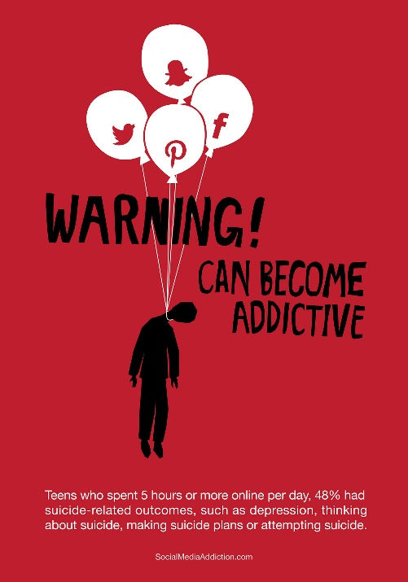
The poster is very simple yet hard hitting, it conveys the message that high usage of social media can increase the likelihood of suicide and the image can cause the consumer to feel a certain way, this can motivate a change in behaviour to decrease the amount of time spent using social media. The consumer however, isn’t being told not to use social media or to even cut down, instead they are warned of the risks and nothing more, this psychology is more likely to enact change as the consumer doesn’t feel forced- which would make them want to do the opposite.

Another example of a social marketing campaign would be would be the smoke outside campaign created by the Scottish Government. A poster was created showing an innocent looking child wearing a t-shirt with tar filled lungs. Again, there is a large text saying ‘For your kids’ sake, take it right outside.’ The image is the key aspect of the poster, it stands out massively and would really make any one who sees the poster think twice about smoking inside and potentially causing harm to their children. The poster is aiming to change the smoking habits of adults with children, it is not telling them to stop smoking, however to just not do it in front of their children which would damage their health. (Image below gathered from https://www.pinterest.co.uk/pin/169799848425850881/?lp=true )
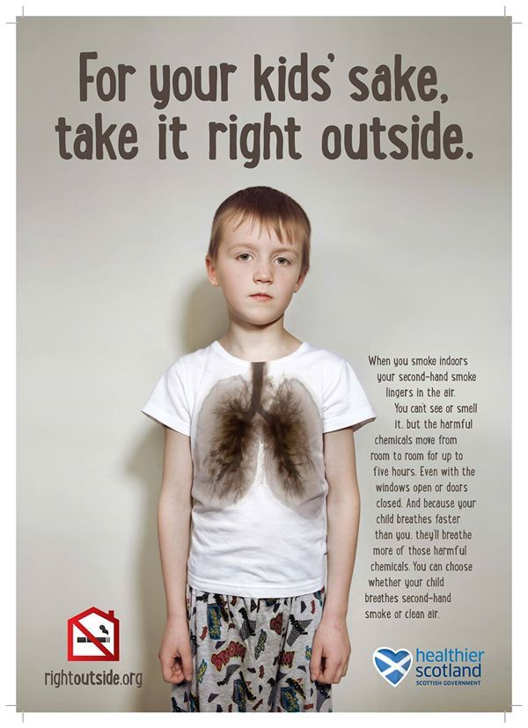

The Marketing Mix
In the 1950’s, advertising professor at Harvard, Neil Borden “popularized the idea of the marketing mix- and the concepts that would later be known primarily as the four P’s”(Twin, A. 2019) Since the marketing mix was introduced in the 1950s, it has been adapted over time and has been extended to the 7 P’s of the marketing mix.

The image below shows all of the components of the 7 P’s. (Gathered from https://marketingmix.co.uk/)
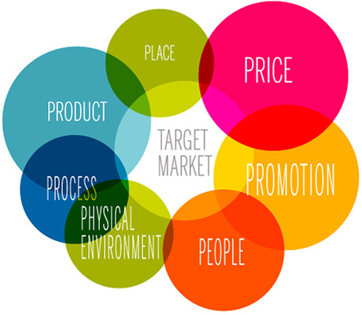

The Marketing Mix is a very important concept to understand as a business and it is something which must be analysed closely in order to see a successful business. “It has been said many times in business that if you don’t know your target market well enough and figured out exactly what they want, you’ll commit entrepreneurial suicide and the business will inevitably fail.” (MarketingMix.com, 2019) The more commonly known 4P’s focuses on putting the right product in the right place at the right time and at the right price. Although this is simply put, if the 4P’s are carried out accurately to suit the target audience then a business is much more likely to make sales over a product that has no target market.

Marketing Ethics
There are many ethical issues which a company may face when advertising. Companies want to make their products look as appealing as possible however this can sometimes lead to deceptive and unethical marketing. One example of an unethical marketing campaign would be for Camels cigarettes in the 1950s. The poster shows an image of a doctor smoking a cigarette with the caption “More doctors smoke Camels than any other cigarette.” This is seen as unethical as society are often reminded how detrimental to ones health smoking can be, also society could think that if a doctor is smoking then it is perfectly fine for them to do the same.

Another common theme for companies to use is the use of focus groups. “The main purpose of focus groups is to get the consumers’ opinions, beliefs, or perceptions about a product/ service.” (Ali, A. 2019) Sometimes members of focus groups could feel pressured into saying that they like the product or also sample sizes can be very small so the true feedback doesn’t account for the general population, but a much smaller percentage.

Finally, deception is used very often in marketing by making a product appear better than what it actually is. Very commonly with food marketing, a product can be marketed to sound healthy and beneficial to the human body however it might not always be the case and it could be encouraging individuals to take up bad habits by drinking too much sugary fruit juices for example. Similarly, fast food restaurants have been found to use fake items of food in their advertisements in order to make them look more appealing, again this is deception and can be considered unethical as it gives a false idea to the customer of what they are actually purchasing.

Marketing Issues
When designing a marketing concept or a marketing mix for a company, there are countless issues which could occur, internally and externally to the business. One issue which could occur is not satisfying essential stakeholders to the campaign or business. If stakeholders aren’t satisfied/ their needs aren’t met then the marketing would not have been done effectively as people who should be satisfied, aren’t. One method which is used to plan for this is the Stakeholder Theory. The first noted individual to define the stakeholder theory was theorist Ian Mitroff in his 1983 book, Stakeholders of the Organizational Mind. Other theorists such as R. Edward Freeman and Thomas Donaldson have all contributed massively to the stakeholder theory. In his book, Strategic Management: A Stakeholder Approach, Freeman “identifies and models stakeholder groups within a corporation , describing and recommending ways to manage their interests and determine who really counts from the perspective of the company.” (Blackburn, M. 2019) Stakeholder theory suggests that if a business wants to be successful them they bust seek to maximize value for it’s stakeholders. A stakeholder analysis can be held in order to identify relevant stakeholders and the stakeholder matrix could be used to further identify the stakeholders and their influence on the business.
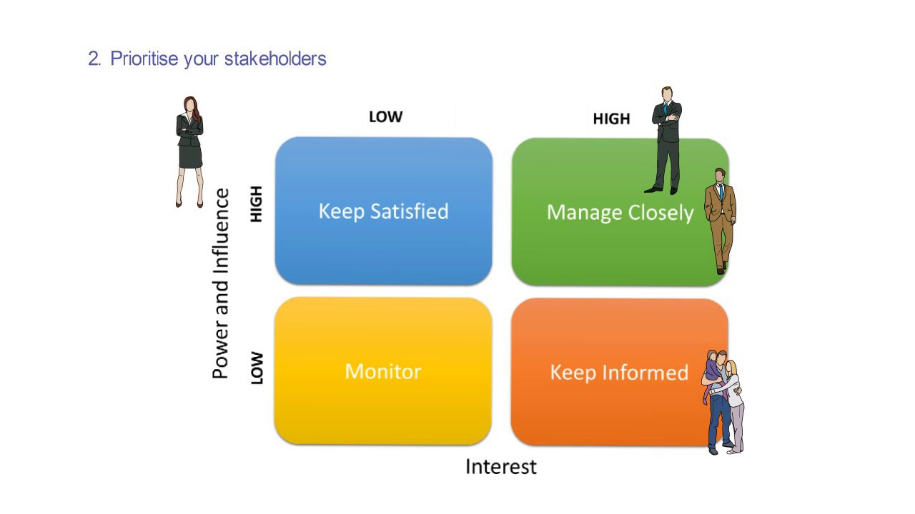

The image above shows the stakeholder matrix. The stakeholder matrix is a step taken within a stakeholder analysis and it looks to prioritize the stakeholders to a particular campaign. With regards to a social marketing campaign, the stakeholders which would be managed closely would usually be the target audience of the advert for example, with a smoke outside advert it would be directed towards parents who smoke. Planning a stakeholder analysis and knowing who to target is very useful when designing a campaign as you can always relate the campaign to each stakeholder. It is important to understand the needs of the stakeholder and know the best ways to engage with them, by laying out a clean plan it is easier to focus on what needs to be achieved.

Conclusion
All businesses need to market themselves. Successful marketing can build a trusted and reliable brand image which allows a company to become more recognised and successful. Consumers purchase from companies they trust, good marketing and a good product range can provide this image for a company. The correct marketing of a product/ message can be the deciding factor on whether or not it will be a successful campaign and therefore making the marketing an essential component which needs to be gotten right. A full in depth analysis of stakeholders needs to take place in order to ensure that the stakeholder needs are met. Many issues can occur when marketing which are very relevant to the company. The sooner that the issues are addressed, the sooner they can be overcome.

References
- Online article by Twin, A. Jun 25th, 2019. Investopedia Marketing Gathered from https://www.investopedia.com/terms/m/marketing.asp at 14:52 on 14/01/20
- Business Basics by BPP Publishing, First Edition May 1995. Published by BPP Publishing Limited, Chapter 1.1 The Marketing Concept, History of Marketing Page 1
- Online article by The Chartered Institute of Marketing, 2020. What is Marketing? Accessed at 16:16 on 14/01/20 from https://www.cim.co.uk/qualifications/get-into-marketing/
- Online article by Morrow, S. December 2009. Cost of Marketing: What is the Average Budget? Accessed at 16:10 on 14/01/20 from https://www.legalzoom.com/articles/cost-of-marketing-what-is-the-average-budget
- Essentials of Marketing Sixth Edition by Blythe, J & Martin, J First edition published in 1998, sixth edition published in 2016 by Pearson. Chapter 1. What do Marketers do? The development of the marketing concept page 5.
- Online article by MBASkool, 2019. Product Orientation accessed on 14/01/20 at 23:13 from https://www.mbaskool.com/business-concepts/marketing-and-strategy-terms/8381-product-orientation.html
- Online article by Jennings, K. 2014. Did the Model T Ford Only Come in Black? Accessed on 14/01/220 at 23:34 from https://www.woot.com/blog/post/the-debunker-did-the-model-t-ford-only-come-in-black
- Online article by Quain, S. from Chron.com. Janurary 31, 2019. Accessed on 15/01/20 at 00:13 from https://smallbusiness.chron.com/difference-between-market-orientation-sales-orientation-25893.html
- Business Basics by BPP Publishing, First Edition May 1995. Published by BPP Publishing Limited, Chapter 1.1 The Marketing Concept, History of Marketing Page 6
- Online article from NSMC, 2019. What is Social Marketing? Accessed at 13:03 on 15/01/20 from https://www.thensmc.com/content/what-social-marketing-1
- Wiebe, G. D. (1951) Merchandising commodities and citizenship on television. Public Opinion Quarterly 15 (4), 679
- U.S News & World Report, (October 30,2000), p.14
- Social Marketing: Improving the Quality of Life by Kotler, P. Roberto, N. Lee, N. 2002. Second edition. Published by Sage Publications. Chapter 1 Defining Social Marketing page 5.
- Online article Fang, L 2019. Behance.net Social Media Addiction Campaign Accessed on 15/01/20 Available from https://www.behance.net/gallery/69142661/Social-Media-Addiction-Campaign
- Online article Blackburn, M. Mar 5, 2019. What Is Stakeholder Theory? Accessed at 21:59 on 15/01/2019 available from https://www.projectmanager.com/blog/what-is-stakeholder-theory
- Youtube video uploaded by ProAction Development CIC May 31, 2017. Stakeholder Analysis Image gathered from https://www.youtube.com/watch?v=LFHlal9fwkU taken at 2:28
- Online article Ali, A, 2019. Ethical Issues in Marketing Accessed at 23:09 on 15/01/20 Available from https://content.personalfinancelab.com/finance-knowledge/marketing/ethical-issues-marketing/
- Online article by MarketingMix.com, 2019. The Marketing Mix 4P’s and 7P’s Explained Accessed at 23:31 on 15/01/20 Available from https://marketingmix.co.uk/

