Inserting Repeating Regions
Repeating regions provide much of the power of data-driven web sites in Dreamweaver. A repeating region tells Dreamweaver to insert code for scrolling through and displaying a list of records. For example, if we want to create a page that lists the information for all our clients, we need only create a simple table with one row (or two, if we want to include header information), drag the fields containing our client information into the columns, and then create a repeating region. Dreamweaver automatically inserts code that displays the client information in our database, inserting a row into the table for each record.
To see how this works:
- Create a new page, or open an existing one. We’re using our clientdetail.asp page.
- On the Common tab of the Insert bar, click the Table button to insert a table.
- In the Table dialog, specify one row and the number of columns you need to accommodate each of the fields you want to display. We’re also entering a caption for the table (“Clients”). Click OK.
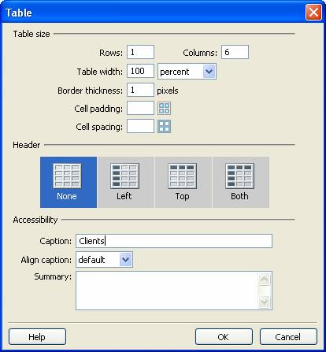
- Drag each field from the Bindings tab of the Application panel into a table column. When you finish, you should have something like this:
- Next, select the table row containing the fields by clicking the <tr> tag on the tag inspector:
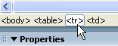
- With the row containing the fields selected, click the plus button on the Server Behaviors tab of the Application panel and select Repeat Region.
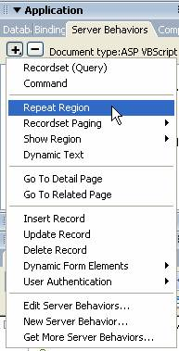
- In the Repeat Region dialog, confirm that Dreamweaver has selected the correct recordset. (This won’t be a problem if you only have one.)
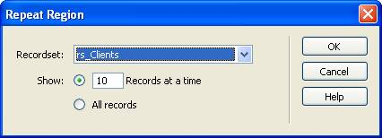
- Select whether to show a certain number of records at a time or all records at once.
- Click OK.
The repeating region is added to the row, indicated by a dark grey border and a tab that says “Repeat”.
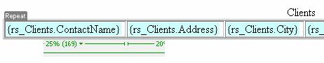
- Preview the page to see how the table is populated with the data:
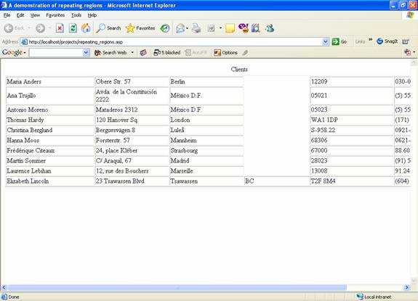

Inserting Dynamic Tables
Repeating regions are good for single fields you want to repeat, but for the example we just used, we could have more easily added an entire repeating table:
- To use the same page, delete the Repeat Region server behavior from the Server Behaviors tab of the Application panel, and then delete the table you created.
- Open the Insert menu and select Application Objects, then Dynamic Data, and then Dynamic Table:
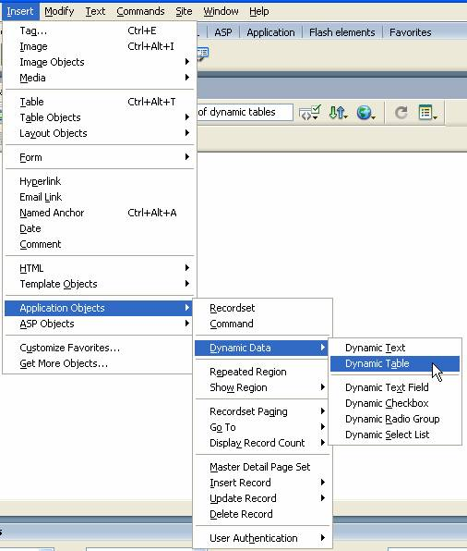
- In the Dynamic Table dialog, confirm the information and click OK.
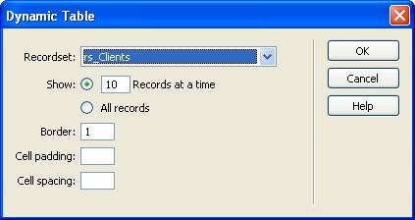
Dreamweaver automatically creates a table for you with the appropriate number of rows, as well as column headings. You can edit the column headings as necessary and delete any columns you don’t want to use.
- Preview the page to see the data:
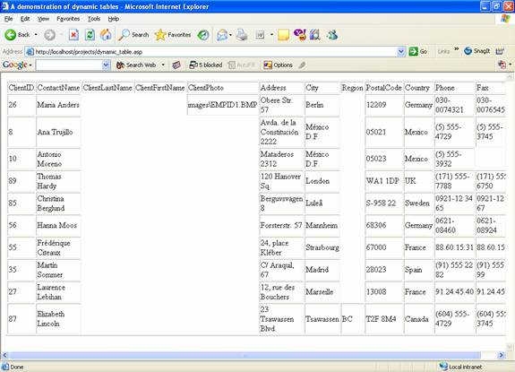
Obviously, this is an extremely quick and easy way to build an entire table full of data.
The dynamic table appears in the Server Behaviors tab of the Application panel as a repeating region and a number of dynamic text fields. If you want to modify a property of the repeating table—to show 10 records at a time, for example, you can select the Repeat Region behavior on the panel and then modify the properties using the Property Inspector.
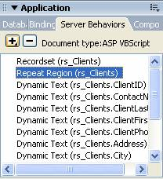
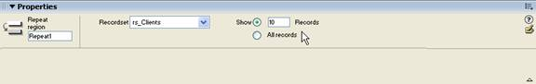
It doesn’t do you much good to show only a few records at a time if you don’t include a means for allowing users to scroll from page to page in the list. Fortunately, Dreamweaver makes this easy, too:
- Position your cursor below the table you created.
- From the Insert menu, select Application Objects, then Recordset Paging, and then Recordset Navigation Bar.
- In the Recordset Navigation Bar, specify whether you want the navigation links to be text or images. For images, Dreamweaver uses arrows by default.
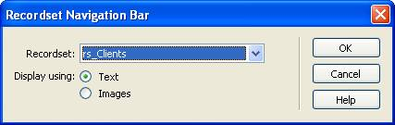
- Click OK.
Dreamweaver inserts the navigation bar:
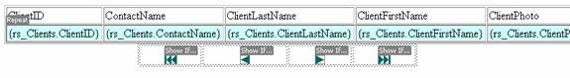
Preview your page and test the Next and Previous buttons, as well as the Beginning and End buttons.
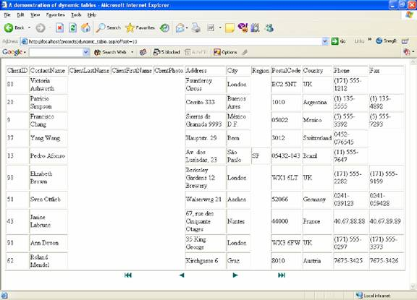
You can also display a record count that shows the user where he or she is in the list of data:
- Position your cursor below the navigation bar.
- From the Insert menu, select Application Objects, then Display Record Count, and then Recordset Navigation Status.
- In the Recordset Navigation Status dialog, confirm the recordset and click OK.
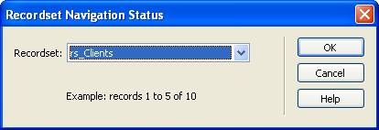
Dreamweaver inserts the text and fields “Records X to X of X”:
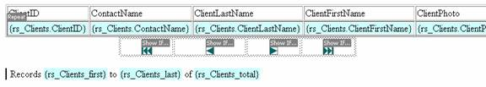
Preview the page and scroll the records, watching how this text changes:


