University of Wales Trinity St David

Design of a Specialist Automatic Control System

ACMA5001 – Control & Automation

BEng Energy & Environment Engineering

Rob Goodson

By Antony Wingate (1904205)

Table of Contents
2. Table of Contents 2
3. Table of Figures 3
Abstract 4
Introduction 5
Automation 6
Components 7
Controller 7
Fluid flow control 7
Temperature control 7
Lighting control 8
Auto feeder 8
Water level 8
Parameter measurement 8
Redundancy 8
Auto dosing pump 8
Cleanliness and environmental 9
Protein skimmer 9
Limitations 9
Power supply of actuators 10
Distributed control system 11
Hydraulic power supply 13
Design 14
Reservoirs 14
Sump 15
Sump to aquarium 15
Feeder 15
Aquarium tank 15
Alarms 16
Regulations 17
Conclusion 18
Bibliography 19

Table of Figures

Figure 1 Butterfly valve with pneumatic actuator (avkvalves, 2021) 7
Figure 2 DCS component flow chart 11
Figure 3 PLC process logic flowchart 12
Figure 4 Circuit diagram of automated aquarium system 14

Abstract

This report looks at the requirements for the company to design a specialist automated aquarium to suit the needs of a marine conservation organisation. The range of variables to be manipulated by an automated system are considered, with insight into what components are required to ensure proper functioning of the system. Following these considerations, a suitable design was produced. The specific type of power supply to be used for the valve actuators and for the system as a whole was critiqued.

Introduction

Due to increasing levels of pollution and environmental contamination, marine life is currently suffering to a greater extent than in previous decades, resulting in an increase in the number of endangered species (Todd, Ong and Chou, 2010). To help preserve these species, specialist equipment is needed to simulate the environment of marine life in the wild (Bakare, Kour, Akter and Iji, 2020). Marine life can be highly sensitive, and consequently minimal changes in the environment can cause significant complications (Saberioon and Cisar, 2016). For certain species in need of conservation, an automated aquarium would offer a potential solution. Whereas a manual aquarium would require a lot of time and money spent to ensure the environment is kept at the required temperature, pH level, light level, and cleanliness level, an automated system would require less input. Within the last decade, advancements in the field of automated technology have made this a more accessible solution for problems of this nature. An automated system would allow all variables to be controlled at a high level of accuracy, whilst reducing labour costs and reducing the possibility of human error (Obrien, 2015).

Components

An automated aquarium system requires more components to correctly function and be self-regulating when compared to a manual system (Parinam, 2019). These include sensors and actuators connected to a main controller that can communicate and automatically control each variable. The system selected was a closed-loop control system, the components of which are considered below.

Controller

Arguably the most important part of an automated system, the controller is essentially the brains of the system. It repeats a programmed cycle, where each assigned parameter is measured via sensors and transducers, compared to a set-point, and then activates the corresponding actuator if any parameter is outside the specified limit (Africa et al., 2017). It will cause valves to open and close or water pumps to turn on and off, controlling the flow of water.
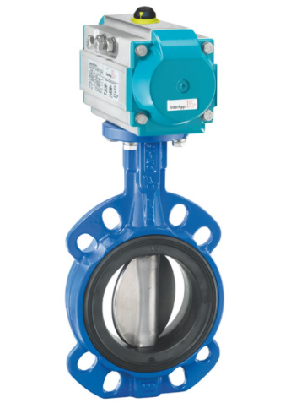
Figure 1 Butterfly valve with pneumatic actuator (avkvalves, 2021)

Fluid flow control

For this system, butterfly valves with electrical or pneumatic actuators will be used. They have a compact structure, small operating torque and can operate in most conditions (Greenfield, 2012). For the fluid control valve, an actuator with infinite positions should be used, rather than a finite on/off position.

Temperature control

The system must be able to regulate water temperature within a certain parameter. This can be achieved by using a temperature sensor that will send an alert when the high and low temperature limits are exceeded. This will then either activate a heating element to warm the water in the balancing tank, increasing the temperature of the aquarium, or activate a chiller unit, which will lower the temperature. The chiller should not be located within close proximity to the aquarium, as the chiller unit produces heat during operation, which will heat the aquarium, in turn increasing the water temperature, creating an infinite loop.

Lighting control

LED lights with ramp control would be used, as they allow the aquarium to be programmed to simulate day and night cycles.

Auto feeder

A chilled unit that is programmable to distribute liquid food, such as phytoplankton, will be used.

Water level

An auto top-off system (ATO) will be used to maintain a constant water level in the system. This can be achieved by using low level and high level water sensors. When the water level reaches the minimum level, it will activate the ATO and water will be added to the system.

Parameter measurement

Various sensors for pH, calcium, magnesium, salinity, nitrates, and phosphates, etc, will be needed. These sensors will relay signals back to the control unit and activate the relevant actuators, which will increase these variables accordingly.

Redundancy

Although most components have their own sensors built in (e.g. a heater will have its own thermostat), these can fail which will have catastrophic effects on the aquarium (Paletta, 2017). Therefore, there is a requirement for stand-alone sensors and alarms for the various components, acting as a backup if any failures were to occur.

Auto-dosing pump

A dosing pump allows the automatic supply of alkaline substances, calcium, and magnesium, among other nutrients. It allows smaller doses to be added more frequently than with a manual system, reducing parameter swings throughout the day. An auto-dosing pump also allows for automatic water changes. This can be carried out by setting the specific volume of water that should be replaced per day or per week.

Cleanliness and environmental

A Reverse Osmosis Deionized water pump will be used to remove nearly all impurities from the water, ensuring safe conditions for the marine life. An ultraviolet lamp can also be used on the supply pipe to further reduce any bacteria from entering the aquarium.

Protein skimmer

A protein skimmer will be used to remove uneaten food and fish waste, resulting in cleaner water and fewer water changes (Farnsworth, n.d.).

Limitations

Although most components of the aquarium can be automated, there are certain parts which are not suitable for automation. When filters become dirty, they will require replacing or cleaning manually as this is not possible to automate. Alarms can be used to ensure filters are changed at the appropriate interval.

Power supply of actuators

There are two viable options for the power supply of the valve actuators in this system, electrical and pneumatic. The size of the system will determine which is more suitable.

Electric – Actuators powered by an electric motor are more suitable for smaller systems, as they cannot produce as much power as a pneumatically actuated valve (Greenfield, 2012). Electrical components should not be used in an aquatic environment unless they carry the correct certification. Although in this system design the actuators are not located within the water, there is still a potential risk if leakages were to occur.

Pneumatic - In larger systems higher volumes of water are involved, resulting in higher pressures on actuators. Pneumatically driven actuators offer much higher force than electrical motors, and would therefore be more suitable (Baker, 2019). A system with pneumatic actuators would add complexity to the system, requiring a compressor and additional control devices to control the system. Pneumatic actuators operate at higher speeds than electrical actuators, although this would not be a priority for this system. Maintenance and operating costs can be high compared to other methods. If actuators were to be submerged, they would need to be waterproof, using durable seals to create an airtight system. However, in this particular system design they will not be submerged. Pneumatic actuators have a safety spring system, whereby the actuator will return to a safety point if a failure occurs, whereas a failed electrical actuator will remain in the same position. Due to the aquarium being salt water, all components should be resistant to corrosion.
This system is based on all components being powered by electrical motors, as it negates the need for separate power supplies that are required with other methods.

Distributed control system

Due to the nature and requirements of this control system, a Distributed Control System (DCS) allows the control of all applications in the system whilst enabling data to be collected and stored for research purposes.

In figure 2, a flow chart of all the components of this DCS is shown. All sensors are connected to a Programmable Logic Controller (PLC) and any data that is measured is sent to the PLC. Once the PLC receives the data, it will process it and upon detection of any parameter limits having been exceeded, it will send a wireless signal to the relevant actuator.
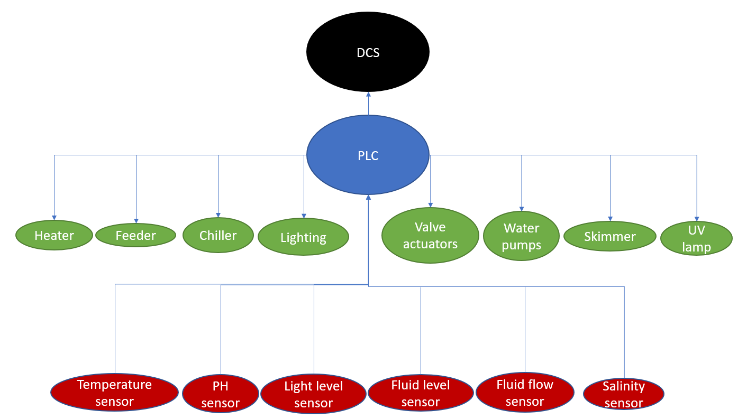
The PLC sends all data to the DCS via wireless communication, where it can be monitored and stored.
Figure 2 DCS component flow chart

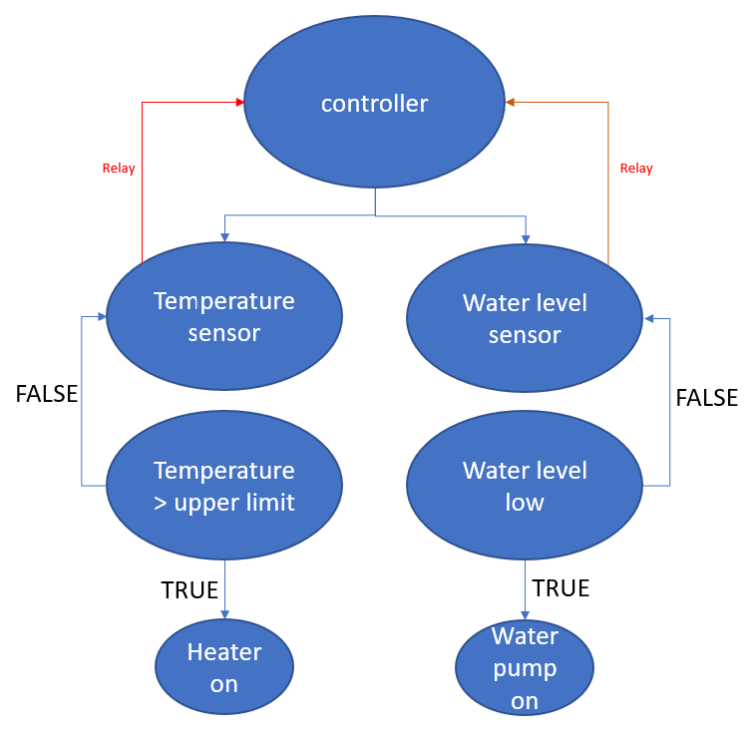
Figure 3 is a flow chart which shows two examples of the process by which the PLC controls variables, in this case water level and temperature. This is known as a closed-loop control system or a feedback control system, as it is self-correcting.
Figure 3 PLC process logic flowchart

Hydraulic power supply

Hydraulic systems are most suited to heavy lifting applications due to providing higher forces. Hydraulic systems are also larger and more complicated, requiring increased maintenance. Power delivery from a hydraulic system is harsher and harder to control than a pneumatic or electrical system. Hydraulic fluid is toxic and poses high environmental risk to marine life if any leaks were to occur. Therefore, for this system hydraulic power supply is not recommended (King, 2020).

Design

The specific requirements of a marine aquarium were conisidered, and figure 4 shows the design produced for an automated salt water aquarium.
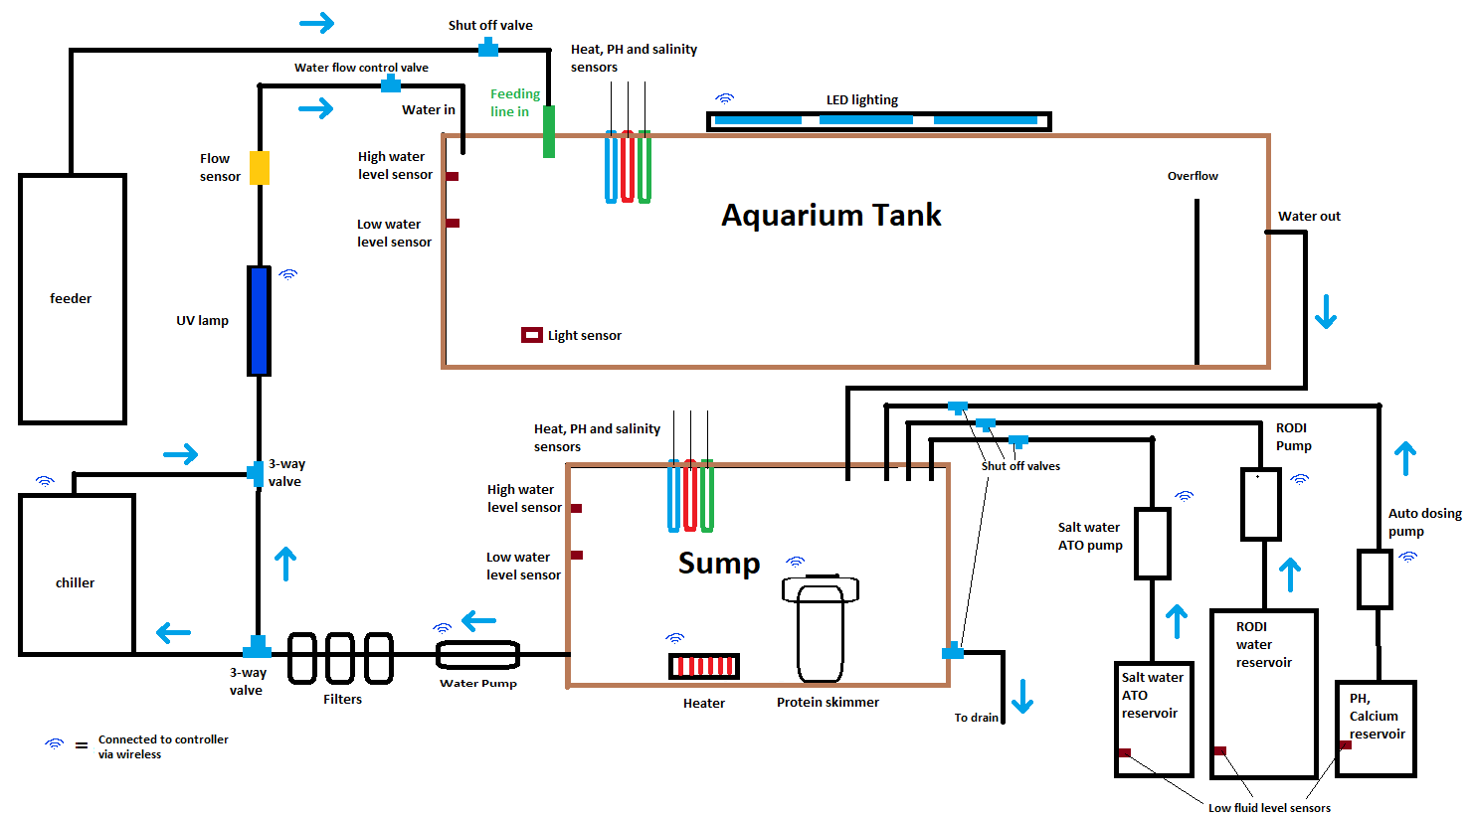
Figure 4 Circuit diagram of automated aquarium system

Reservoirs

There are 3 reservoirs connected to the sump, each containing fluids that are periodically added to the sump. Each reservoir uses its own pump that is connected to the controller via wireless connection, so each liquid can be added individually when required. Each pipe connecting the reservoirs to the main sump have shut-off valves attached. If for any reason a pump were to malfunction or get stuck in the ‘on’ position, these valves can be shut off to stop flow to the sump. The salt water ATO keeps the sump topped up with water.

Sump

The sump contains the heater and protein skimmer. The heater will be turned on and off by the controller. The protein skimmer is used to remove organic substances from the water before they break down into toxic substances. The sump has a draining pipe with a shut-off valve in case of emergency. It is also controlled by the main control unit. The sump requires a high and low water level sensor to keep the tank at optimum operating capacity. Optical sensors have been used here. All sensors are wired to the control unit. The decision was made to have wired rather than wireless connection due to there being less margin for error.

Sump to aquarium

From the sump, the main water pump sends water through the filters. The chiller unit is on a separate loop connected via 3-way valves. When the temperature of the aquarium needs to be reduced, the valve actuators will receive a signal from the control unit and the chiller will be incorporated into the loop. The chiller will also be activated by the control unit wirelessly. The water will then pass under an ultraviolet lamp (UV), which remains on constantly, but can also be controlled wirelessly by the control unit. The UV lamp kills any organisms that have not been removed by the filters. The water will then pass through a flow sensor, which will allow the water flow rate to be recorded by the control unit, and the water control valve located after the sensor will either open or close to increase or decrease flow. The water then enters the aquarium.

Feeder

This design uses a separate refrigerated feeder to supply the aquarium with liquid food, such as phytoplankton. It is controlled wirelessly via the control unit, which programs the frequency at which food is supplied to the tank. It has its own separate pump built in. The pipe to the aquarium from the feeder has a shut-off valve incorporated, ensuring supply can be shut off if the feeder were to malfunction.

Aquarium tank

The aquarium tank has various sensors to ensure the parameters of the water are constantly kept at the correct levels. There is LED lighting, which is controlled via the main control unit. A light sensor provides the control unit with light level readings. There are high and low water level sensors to ensure that the water level does not fluctuate, or, in case of the water pump failing, overflows. However, the tank has an overflow built in to avoid this. The water is finally gravity fed back to the sump, where it will repeat the cycle.

Alarms

The PLC has set parameters for each variable. When a parameter limit is exceeded, it will trigger an alarm wirelessly. Devices such as phones can also be notified when alarms are triggered.

Regulations

The system must comply with all relevant legislation, including the following regulations and standards

​​Electricity at Work Regulations (1989) – Covers all aspects of the use of electricity within a workplace. Duty holders must have the system constructed in a way that prevents danger, maintain the system to prevent danger, and carry out work on electrical systems in a way that prevents danger (Healthy Working Lives - Electrical safety legislation, 2019)
PUWER: Provision and Use of Work Equipment Regulations – PUWER contains 37 regulations. Regulation 18, control systems, is particularly relevant here. (Provision and Use of Work Equipment Regulations 1998 (PUWER), 2018)

BS EN 60204-1 covers electrical safety requirements of equipment, which covers computer-controlled equipment and systems for machines.

BS EN 62061 This standard gives best practice recommendations related to the design, integration and validation of the system safety equipment for machines.

Conclusion

As automation technology continues to improve, many applications and systems are becoming automated. An autonomous aquarium allows more precise control over system variables, resulting in an environment that is as close to a species’ natural habitat as possible. There are many more devices needed to make a system autonomous compared to a manual system. Increased measuring devices reduces the risk of incorrect measurements for parameters such as pH and calcium. The various methods of power supply to actuators were considered, and the most appropriate suggested, based on the requirements of an automated system. Although an automated system has reduced user error, if any component were to malfunction, there is the potential for complete tank failure. In view of this, it is of utmost importance that the automated system has backup components present in all areas. The control unit must be able to process multiple data inputs and outputs from sensors and to actuators at all times for the system to operate efficiently. For this project, the design produced meets the customer’s requirement to nurture endangered species.

Bibliography

Africa, A., Aguilar, J., Lim, C., Pacheco, P. and Rodrin, S., 2017. Automated aquaculture system that regulates Ph, temperature and ammonia. 2017IEEE 9th International Conference on Humanoid, Nanotechnology, Information Technology, Communication and Control, Environment and Management (HNICEM),.
avkvalves, 2021. AVK CENTRIC WAFER BUTTERFLY VALVE. [image] Available at: <https://www.avkvalves.eu/en/product-finder/butterfly-valves/centric-butterfly-valves-with-loose-liner/820-00-011> [Accessed 6 December 2021].
Bakare, A., Kour, G., Akter, M. and Iji, P., 2020. Impact of climate change on sustainable livestock production and existence of wildlife and marine species in the South Pacific island countries: a review. International Journal of Biometeorology, 64(8), pp.1409-1421.
Baker, M., 2019. Hydraulic vs. Pneumatic vs. Electric Actuators | Differences. [online] York PMH. Available at: <https://yorkpmh.com/resources/hydraulic-vs-pneumatic-vs-electric-actuators/> [Accessed 10 December 2021].
Farnsworth, R., n.d. What Is A Sump? - Filtration and Refugiums For Your Aquarium. [online] Bulkreefsupply.com. Available at: <https://www.bulkreefsupply.com/content/post/md-2016-04-what-is-a-sump> [Accessed 10 December 2021].
Greenfield, D., 2012. How to Decide Between Pneumatic and Electric Actuators. [online] Automation World. Available at: <https://www.automationworld.com/products/motion/article/13307480/how-to-decide-between-pneumatic-and-electric-actuators> [Accessed 8 December 2021].
Healthyworkinglives.scot. 2019. Healthy Working Lives - Electricity - Electrical safety legislation. [online] Available at: <https://www.healthyworkinglives.scot/workplace-guidance/safety/electricity/Pages/electrical-safety-legislation.aspx> [Accessed 11 December 2021].
Hse.gov.uk. 2018. Provision and Use of Work Equipment Regulations 1998 (PUWER). [online] Available at: <https://www.hse.gov.uk/work-equipment-machinery/puwer.htm> [Accessed 9 December 2021].
King, R., 2020. Hydraulics Vs. Pneumatics - Which Is Better? - Rowse. [online] Rowse.co.uk. Available at: <https://www.rowse.co.uk/blog/post/hydraulics-vs-pneumatics> [Accessed 13 December 2021].
Obrien, T., 2015. Controls: Automated or Manual - Is One Better?. [online] Schellman & Company. Available at: <https://www.schellman.com/blog/2015/10/automated-or-manual-controls/> [Accessed 9 December 2021].
Paletta, M., 2017. Safeguarding Your Aquarium With Redundant Design | Reef Builders | The Reef and Saltwater Aquarium Blog. [online] Reef Builders | The Reef and Saltwater Aquarium Blog. Available at: <https://reefbuilders.com/2017/02/18/redundancy/> [Accessed 10 December 2021].
Parinam, H., 2019. Difference between automatic and manual type system. [online] Mechanical Education. Available at: <http://www.mechanicaleducation.com/2019/03/Automatic-and-manual-control-system.html> [Accessed 10 December 2021].
Saberioon, M. and Cisar, P., 2016. Automated multiple fish tracking in three-Dimension using a Structured Light Sensor. Computers and Electronics in Agriculture, 121, pp.215-221.
Todd, P., Ong, X. and Chou, L., 2010. Impacts of pollution on marine life in Southeast Asia. Biodiversity and Conservation, 19(4), pp.1063-1082.

