

Student Name: Misbah Hafeez

Student ID: 2427255

Module Name: Strategic Management

Module Code: LCMB7003

Lecturer’s Name: Jayalakshmi Gopalkrishnan

Executive Summary

This modern global business environment is characterised by unending volatility and systemic risk, which has placed Strategic Agility as the organisation of great urgency and critical business capability to succeed in business model innovation. This analytical report presents the ZARA Organisational Expansion Plan to explore high potential but underexploited Pakistani market as the flagship of Inditex Group. The strategic threat is to counter the severe Political Uncertainties and Economic Uncertainty and position itself as a high-end product in a world full of strong local textile players and a high level of influence of a counterfeit market.
The analysis demonstrates that the success of ZARA depends on Staged Hybrid Market Entry model, which is designed in the way of risk mitigation. It will use Vertically Integrated Quick Response (QR) system at ZARA to reduce the currency and inventory risks, coupled with a local franchise partner to find its way through the most complex regulatory and infrastructural environment. Most importantly, the strategy defines how to transform the ethical management of ZARA supply chain into a Sustainability-Oriented Innovation (SOI), which offers Sustained Competitive Advantage based on the brand trust and established authenticity among digital, post-millennial generation in Pakistan. The enormous potential is already proven by the approximate size of the apparel market of about 13.5 billion.

Table of Contents
Executive Summary 2
Introduction 5
1. Section 1: Selection of Organisation and Target Market 5
1.1. Chosen organization: ZARA (Inditex Group). 5
1.1.1. Financial and Operational Capacity (FY2024-2025) 6
1.2. Target Markets: Pakistan 7
1.3. Rational for the Decision 7
2. Section 2: Comprehensive Strategic Analysis 9
2.1. Macro-Environmental Analysis: PESTEL Framework 9
2.1.1. Political and legal factors 9
2.1.2. Economic Factors 10
2.1.3. Socio-Cultural Factors 10
2.1.4. Technological Factors 10
2.1.5. Environmental Factors 11
2.2. Competitive Analysis: Porter’s Five Forces Model (FFM) 11
2.2.1. Competitive Rivalry: High 11
2.2.2. Bargaining Power of Buyers: High. 12
2.2.3. Threat of New Entrants: Medium. 12
2.2.4. Supplier Bargaining Power: Low. 12
2.2.5. Threat of Substitute Products: Very High. 13
2.3. Performance analysis: SWOT 13
Insights and Strategic Implications 14
3. Section 3: Strategy Development and Formulation 15
3.1. Strategic Direction and Rationale 15
3.2. Strategic Model: Ansoff Matrix. 15
3.3. Market entry strategy: staged Hybrid Model. 15
3.3.1. Phase 1 (Years 1-2): Digital WOS + Franchise Pilot 16
3.3.2. Phase 2 (Years 3+): Control Consolidation 17
3.4. Competitive Positioning: Porter’s Generic Strategies 17
3.5. Strategic Fit and Capability Assessment (VRIO) 17
3.6. Strategy Implementation Components 18
3.6.1. Stream 1: Sustainability-Oriented Innovation (SOI) 18
3.6.2. Stream 2: Innovative E-commerce and Phygital Integration 20
3.7. Risk Analysis and Mitigation 20
4. Section 4: Performance Evaluation Framework 20
4.1. The Balanced Scorecard Framework 20
4.2. Triple Bottom Line (TBL) Integration 21
4.3. Monitoring and Mechanisms of Governance 22
4.4. Critical Evaluation of the BSC 22
5. Conclusion and Future Outlook 24
References 25

Introduction
The strategic imperative and context address the circumstances affecting an organisation by highlighting how its strategic plans primarily influence the environment of the business.
The fashion industry in the world in the present decade is also pursuing scalable growth configurations beyond the Western markets that are already developed (McKinsey & Company, 2024). Pakistan is the fifth most populous nation in the world; this means that Pakistan is a critical white-space opportunity. This market offers a huge and young aspirational consumer segment of more than 64% of the population that does not have a well-known and traditional presence of international fast fashion (Waris, 2025).
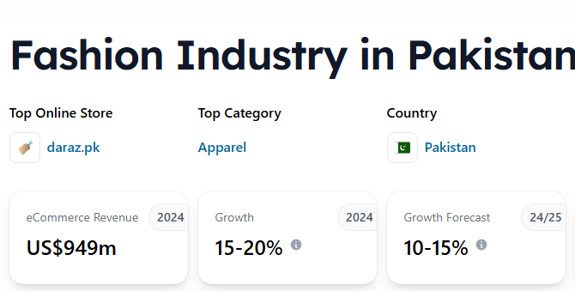
Figure 1: Overview of Pakistan fashion e-commerce industry (Waris, 2025)
The strategic dilemma is the pioneering restructuring of the ZARA main business model to address the institutional weaknesses of the host country. The plan should be informed by the fact that, high level of competition advantage cannot be separated by inseparable performance and innovation (Farida and Setiawan, 2022, p. 163). The goal is to deploy and infer the inimitable resources of ZARA to establish a defensible market position in Pakistan particularly in responding to the geopolitical and economic volatility.

Section 1: Selection of Organisation and Target Market

Chosen organization: ZARA (Inditex Group).
ZARA is chosen because of its operation model that is not matched anywhere in the globe, finance and agile strategies that is uniquely suited to risk mitigation in emerging markets.

Financial and Operational Capacity (FY2024-2025)
This is a risky venture, but the financial stability of the Inditex Group supports ZARA in establishing such a venture:

In the year 2024, Inditex reported a strong Gross Margin of 57.8% and Net Income that is higher than 5.9 billion (Inditex, 2024). This has the much needed capital buffer, which will absorb the anticipated initial operating losses and high Foreign Exchange (FX) volatility with the Pakistani Rupee (PKR).
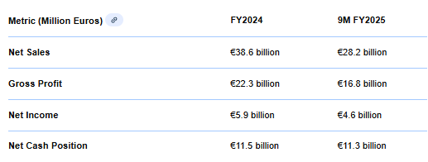
Figure 2: (Inditex, 2024)
The specific capital will be the allocation of 1.8 billion towards global technology, logistics and optimization of the online platform that will be invested in in 2025 during the strategy of proposal of "E-commerce First" (Inditex, 2024). This will finance the use of the latest systems that are required to have a market that is logistically complicated (Saira et al., 2025, pp. 501-514).
It takes strategic agility (Doz & Kosonen, 2008) to go from design-to-store within less than four weeks, the rapidity of which is the main core of ZARA’s SCA strategy to very swiftly test the localised reactions to trends without being overly exposed to inventory levels, a key defence mechanism tool in the face of sudden alterations in policies or economic declines (Mueller-Saegebrecht and Walter, 2025).
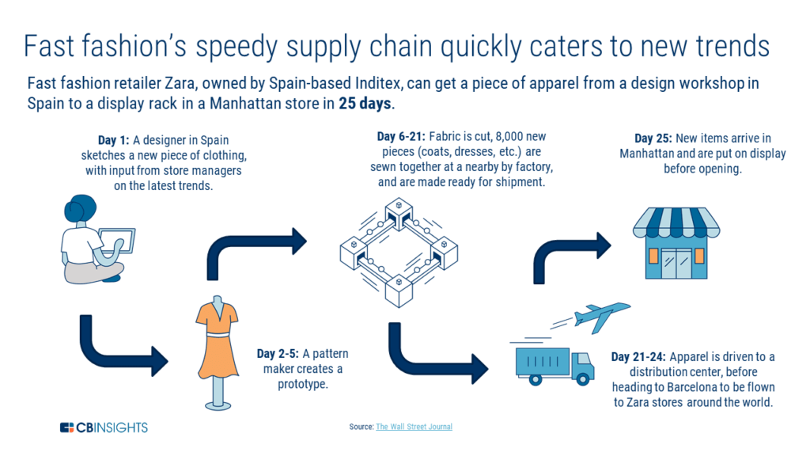
Figure 3: (Mueller-Saegebrecht and Walter, 2025)

Target Markets: Pakistan
The target market is Pakistan since the country has market gaps and the target demographics that fit perfectly with the high-value proposition of ZARA.

Rational for the Decision
Strategic Consideration | Pakistani Market Characteristics (Quantified & Specific) | Link to Zara’s Strategy
Market Scale | Apparel and footwear retail projected at approx. $13.5 billion (Statista, 2024). High population density in Tier-I cities (Karachi, Lahore) ensures high sales density for initial physical stores (see figure 4). | This justifies the required €1.8 billion global investment in technology and logistics platforms necessary for servicing this scale.
Digital Adoption | E-commerce penetration is accelerating, characterized by innovative solutions like mobile wallets (Digital Pakistan Foundation, 2024) (see figure 5) and rapid growth of digitally engaged youth (Daniyal et al., 2025, pp. 188-205). | Validates the E-commerce First strategy, allowing Zara to leverage the "Innovative Role of E-commerce" (Saira et al., 2025, p. 501).
Supply Chain Proximity | Pakistan is a global textile producer (Husain et al., 2024, pp. 33-58), providing deep, established vertical manufacturing capacity. | Zara implement a strategic pivot to local sourcing hubs, mitigating high import duties and currency risk by reducing reliance on Euro-denominated imports.
Aspirational Gap | The market lacks an undisputed premium fast-fashion status symbol. Local brands (like Khaadi) dominate the ethnic segment, creating a void in the international masstige Western wear segment (Karandaaz, 2024; Waris, 2025). | Zara can position itself in the Luxury-Aspirational Segment (Wresearch, 2025), utilizing its brand image to command a price premium justifiable by authenticity.

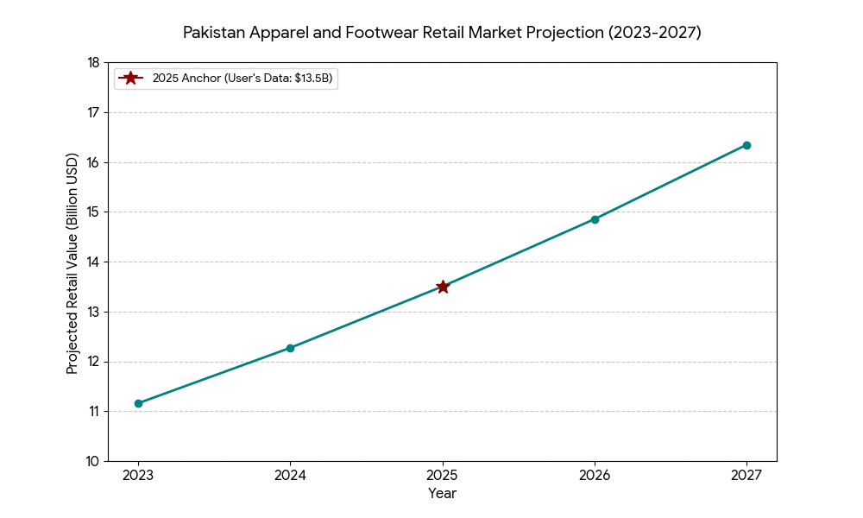
Figure 4: Projected value of the Apparel and Footwear retail market in Pakistan for 2025.
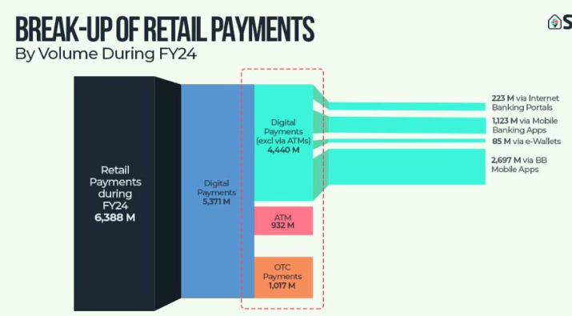
Figure 5: (Digital Pakistan Foundation, 2024)

Section 2: Comprehensive Strategic Analysis

Macro-Environmental Analysis: PESTEL Framework
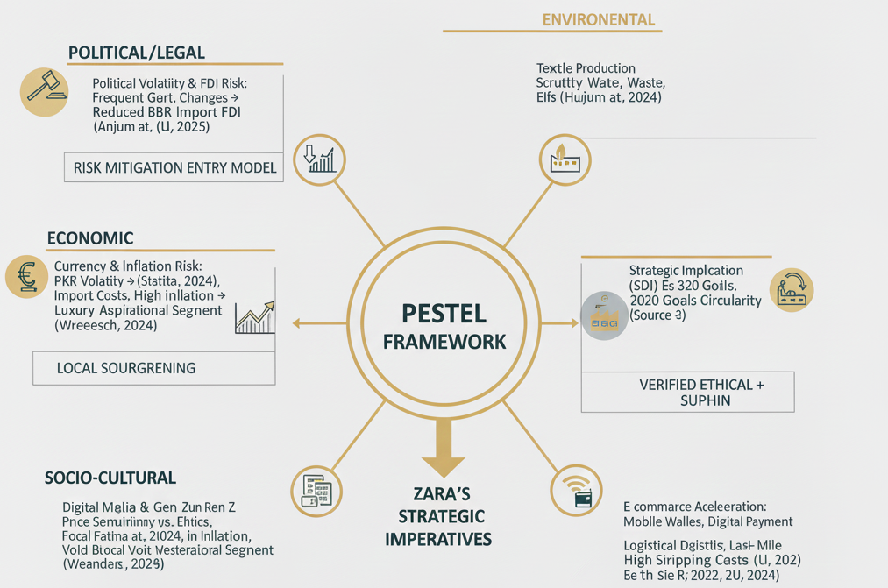

Political and legal factors
The most direct obstacle is the long-term political instability. Anjum et al. (2024, p. 1885) comes out clearly with the establishment that political uncertainty, that is, the frequent changes in the form of the government and the policies, goes hand in hand with a significant decrease in the Foreign Direct Investment (FDI) flows. This underscores the intense necessity of an admission model that is to be organised so that it lowers risks as opposed to capital congestion.
Financial transactions across borders are confronted with regulatory challenges that are determined by the State Bank of Pakistan (SBP). SBP requires special paperwork and screen cheques to the foreign financial transactions, which directly affect the pace and performance of the digital clearance of payment transactions on an e-commerce model (Li, 2025). Moreover, importer fees and taxes are also constantly unpredictably revised by the Federal Board of Revenue (FBR), which directly increases the ultimate retail cost of the imported product by Zara, complicating the approach of assessing the brand as a value proposition.

Economic Factors
The biggest economic limitation has been the unstable nature of the Pakistani Rupee (PKR) that has experienced some of the worst depreciation periods. Naeem and Butt (2024) verify that aggressive currency devaluating in favour of a stronger Dinar will raise the Euro equivalent of importing retail goods prices at a serious risk to the standard-profit margins of Zara and will force the latter to implement mandatory hedging strategies.
Although the entire apparel industry is estimated to be as high as 13.5 billion (Statista, 2024), acute inflation would influence consumer willingness to spend their money on luxury. Zara competes in the Luxury-Aspirational segment because the cost of imports is quite high (Wresearch, 2025). This will require drastic cost-control via sourcing locally to sustain a competitive level of prices as required because of the macro-level of economic stabilisation advocated by the World Bank (2025).

Socio-Cultural Factors
The digital media consumption patterns affecting the post-millennials (Gen Z) of the population (larger than 64 percent) are so deep that consumption affect Pakistan directly. According to Fatima et al. (2024, pp. 867-885), one of the factors that affect the green purchase behaviour and choices of consumption is digital engagement. Nonetheless, the cost-sensitivity limits this ethical consciousness to a high extent (Ahmed & Khan, 2025). This contradiction requires Zara to offer an easily available high quality that is compensated by proven morality (Theocharis and Tsekouropoulos, 2025, p. 4124).
Local textile organisations are overcrowding the market. To gain cultural relevance, Zara needs to cut straight against domestic dominance of such brands as Khaadi (Karandaaz, 2024) by launching localised Fusion Wear and Modest Capsule Collections. Aspirational value of the genuine Western brand is strong, and Zara can benefit in competition with the home-grown replacements, if cultural sensitivity is observed.

Technological Factors
The digital economy in Pakistan is rapidly developing and according to Digital Pakistan Foundation (2024), the use of mobile wallets and online payments has grown swiftly in the country. This confirms that there is the possibility of an E-commerce First approach, which uses the Innovative Role of E-commerce to apply to the fashion industry (Saira et al., 2025, p. 501).
The digital expansion is very poor even with the last-mile infrastructure. Li (2025) emphasises important "Logistics Management Delays" throughout the supply chain, which leads to expensive shipping rates and delay in warehouse products out of Tier-I cities.
The high-control technological systems applied by Zara to RFID to monitor the real-time inventory and SINT (Integrated Stock Management System) should be clearly implemented in the local distribution hubs. This technology plays a crucial role in breaking operational opaqueness, as well as authentication of the products as a required protection against counterfeits (The Express Tribune, 2024).

Environmental Factors
Pakistan is a significant producer of textiles in the global market, which is validated by Husain, et al. (2024, pp. 33-58) who provide the dynamics of production and consumption in detail. This industry is often subjected to international criticism due to excessive use of water, clothes pollution, and quality labour practises.
The worldwide Cirkularity, 2030 Goals set by Zara which incorporating 100 percent lower impact fibres should be used as a Sustainability-Oriented Innovation (SOI) (Chudasama & Matta, 2025). Such a clear adherence to rigorous monitoring of supply chains (in the specific dish of textile in Pakistan) distinguishes the factor of Zara as the verified and high-quality ethical option (Neumann et al., 2021, pp. 571-590), which directly opposes the ethical perception of its low ethical standard of local and unverified production.

Competitive Analysis: Porter’s Five Forces Model (FFM)

Competitive Rivalry: High
The level of competitive rivalry on the apparel market of Pakistan is quite high and multi-layered due to the high fragmentation and the threat of the counterfeit operations. Dominating the market are large local textile powerhouses (Khaadi, Nishat Linen, and Gul Ahmed) with enormous size, physical networks, and resonance with the culture in the highly active ethnic wear and fusion wear market segments (Waris, 2025; Karandaaz, 2024). These are local players that dominate the channels of distribution and local supply chains (Raza & Sohail, 2023). Moreover, there is a hyper-aggressive competitor in the shape of ubiquitous, high-quality fits, which, in fact, proposes the ubiquity of the Zara at unquestionable low costs, compelling Zara to compete not just on the style, but in Authenticity and Quality Checking (The Express Tribune, 2024).

Bargaining Power of Buyers: High.
The market structure of the buyer segment, especially the digitally aware Gen Z, has a high bargaining power because of the economic and market factors combination. Buyers are very sensitive to the high prices charged on imported goods and this is increased by the extreme price sensitivity that is further aggravated by the volatility of the national economy (Anjum et al., 2024). Consumers have many options of native alternative and online markets (Fatima et al., 2024). Unless the perceived premium value of an authentic, internationally branded product is proven to be high, consumers are ready to switch. The threat of substitution is especially high since the introduction of online thrift and resale stores, cashing in on the Gen Z movement of Mindful Consumption (Panda & Nair, 2025), are an alternative, third, ethical, and cost-effective option to traditional stores.

Threat of New Entrants: Medium.
This is because the cost to a foreign company in developing a large physical retail base is still rare, which is mainly caused by capital-intensive mandates to access prime urban real estate and overcome high levels of political and regulatory risk (Anjum et al., 2024). Nevertheless, the barrier to digital entrants is medium and declining at a fast rate. Productive digital marketing may be used to discover new segments of the market using innovative approaches that can be used to enter Pakistan's increasingly digitalized economy rapidly by an e-commerce player that is local or regional (Saira et al., 2025). This medium barrier also implies that Zara needs to jumpstart its entry to beat the competition in the dominant digital positioning.

Supplier Bargaining Power: Low.
This is one of the essential strategic competencies of Zara. Since Pakistan is also one of the largest manufacturing bases of textile in the world (Husain et al., 2024, pp. 33-58), the vast global purchasing capacity enables Zara to avail of the pre-established supply chain capacity as a tremendously favourable supplier. Zara sets strictly clearly on its requirements regarding quality, pricing, and, most importantly, ethical and environmental responsibility, unlike its domestic rivals, which means that the power of suppliers is comparatively lower, which ensures higher expectations of the quality of the inventory. This control over terms and staying in control of the quality of input is a tactical firewall against the competitors that depend on burst purchases.

Threat of Substitute Products: Very High.
The threat of substitutes is extremely high, which is based on three different and strong forces that endanger the premium price positioning of Zara. To start with, the abundance of fake products (The Express Tribune, 2024) suggests the same styles at no additional cost burden of importation. Secondly, the local ethnic clothes are deeply rooted within the culture of Pakistan and lead to high seasonal consumer spending that Zara needs to offset by performing strong localization (Fusion Edits). Third, a quality and desirable, appealing, and ethical threat is offered by the shifting digitally conscious Gen Z to digitally aware fashion consumers in the form of rising platforms-based on used fashion items (Panda & Nair, 2025). The combined effect of these forces requires Zara to respond with the quality of the products and their authenticity.
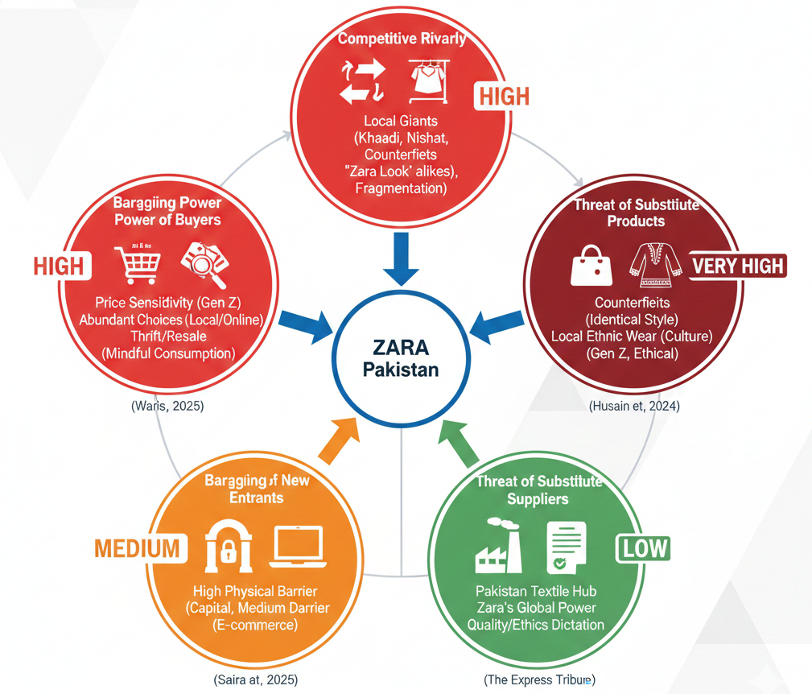

Performance analysis: SWOT

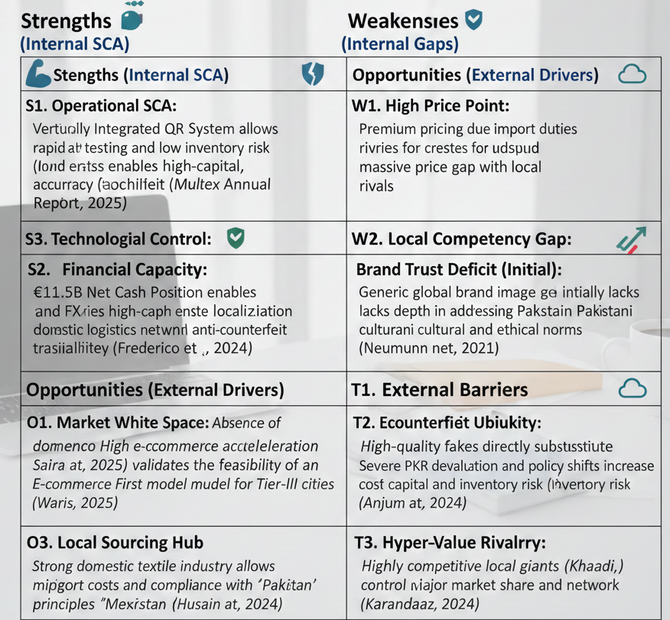

Insights and Strategic Implications
The analysis of the strategy proves that the huge market opportunity (O1) is conditional on the ability to reduce the existential threats of the Economic Volatility (T2) and Counterfeit Substitution (T1). The approach adopted by Zara must be, then, that of Digital-Ethical Differentiation whereby the previously unimitability QR System (S1) and Technological Control (S3) would be applied directly to respond to the internal weaknesses (W1, W2). The key strategic driver that must be used to reach the aspirational Gen Z cohort is the transition to a Sustainability-Oriented Innovation (SOI) strategy, as an SCA, relying on the compliance framework (S3, E). This establishes the requirement of this high-control, digital- first strategy which is specified in the next section.

Section 3: Strategy Development and Formulation
The external and internal analysis has validated that the Pakistani market is a high-risk and high-reward market characterised by instability, crumbled logistics, and the level of competition, which will require a strategic agility (Mueller-Saegebrecht and Walter, 2025, pp. 407-428).

Strategic Direction and Rationale
The spell strategy is referred to as High-Control Digital Market Development. The justification is two-fold: on the one hand, the undisputed need to significantly reduce risks associated with the large intensity of PKR volatility (Anjum et al., 2024), which demands complete operational control and low exposure to inventory (QR system). Second, the opportunities offered by the large youth market (64% under 30) in terms of the differentiation strategy founded on the verified authenticity, which is the direct response to the counterfeit threat ubiquitous (The Express Tribune, 2024). The strategy does not compete in terms of price, which is a losing offer to hyper-value competitors such as Khaadi.

Strategic Model: Ansoff Matrix.
The Zara strategy falls mainly under Market Development (existing product, new geography), where Product Development is a necessary ingredient to make sure that the product is locally relevant:
Market Development (Primary Strategy): Intensively expand urban youth segment markets in Pakistan, which have a vibrant market of the core international product of fast-fashion Zara. This is done through an enforced deployment of E-commerce First to maximise the 75 per cent DCS objective (Saira et al., 2025) and to minimise the use of the expensive physical store (Inditex Annual Report, 2024, p. 76).
Product Development (Supporting Strategy): Invest R&D hours in culturally aligned culturally influenced straddling culturally pertinent Zara Pakistan Edits -fusion collections and festive collections. Such localised product strategy immediately overcomes the Very High Threat of Substitute Products of local ethnic wear with a high aspirational, accessible premium product.

Market entry strategy: staged Hybrid Model.
The plan uses a Hybrid Model to strike a balance between the necessity of operational control and the required risk aspects and geopolitical and economic volatility (Anjum et al., 2024).
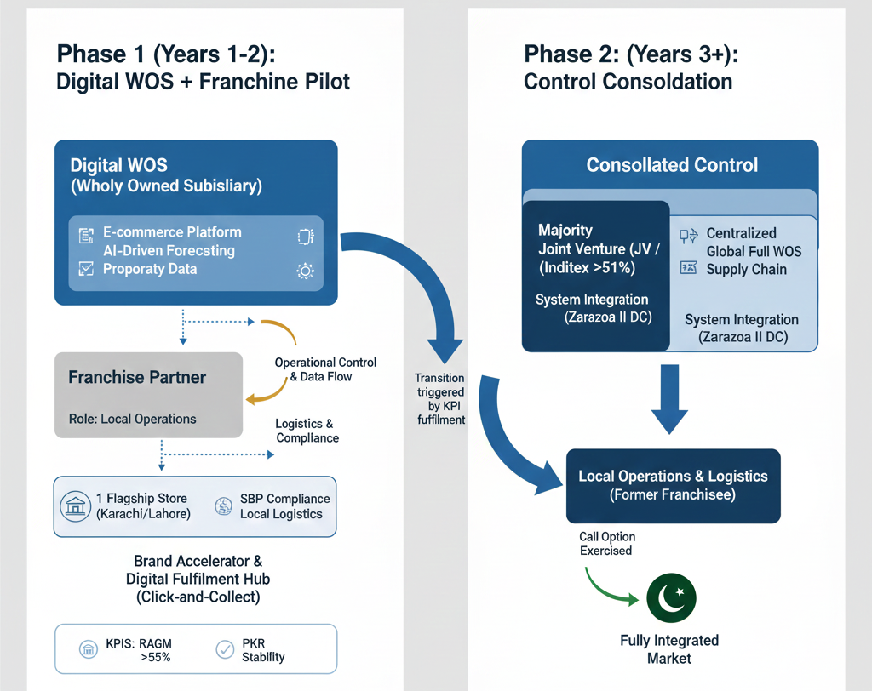
Figure 6: staged Hybrid Model

Phase 1 (Years 1-2): Digital WOS + Franchise Pilot
The basic framework will be the creation of a Digital WOS (Wholly Owned Subsidiary) which owns all the core assets of VRIO, the E-commerce Platform and AI-Driven Forecasting. It is structured according to the global Policy on Internal Reporting Channels (Inditex Annual Report, 2024, p. 305) of Zara and secures the proprietary data and digital standards are controlled by the Inditex (Saira et al., 2025, pp. 501-514). This is performed locally by a dedicated Franchise Partner since the Franchisee Role of the partner is purely focused on the unpredictable requirements of the SBP (State Bank of Pakistan) and to deliver logistics (Li, 2025). Its physical location is confined to one relatively high-end Flagship Store at a Tier-I location (e.g., Karachi or Lahore). This store operates mostly like a Brand Accelerator and essential Digital Fulfilment Hub, focused on the 48-hour Click-and-Collect, not standard volume sales, which is also one of the components of the global Inditex store optimization and digitalisation programme (Inditex Annual Report, 2024, p. 76).

Phase 2 (Years 3+): Control Consolidation
This transition occurs when the predetermined stability KPIs have been met, i.e., the Risk-Adjusted Gross Margin (RAGM) exceeds 55% and quantifiable stabilisation of the PKR (World Bank, 2025). Zara will subsequently have an exercisable call option (Inditex Annual Report, 2024, p. 28) to buy a majority Joint Venture (JV) (e.g. 51%+) or full WOS control. This consolidation of operation will be critical in assimilating the local market into the centralised global supply chain with the systems connected with the new distribution centre of Zaragoza II scheduled for summer 2025 (H1 2025 Results, p. 4).

Competitive Positioning: Porter’s Generic Strategies
The positioning of Zara is distinguished by Differentiation Focus. Instead of focusing on the digitally native segment of Gen Z in Tier-I/II cities, the strategy does not target the Cost Leadership quadrant (which is dominated by Khaadi and Nishat Linen). Differentiation is done by the following uncommon characteristics:
Authenticity (SOI): Providing checked, non-modification products, founded on legal, moral sourcing.
Technological Convenience: ensuring a smooth digital-physical presence, utilising RFID/SINT to speed it up (Zara, 2023).
Speed and Trend Authority: The QR system provides speedy delivery of global trends and localised Fusion Edits (Mueller-Saegebrecht and Walter, 2025).

Strategic Fit and Capability Assessment (VRIO)
The VRIO framework strictly verifies that the SCA implemented by Zara is proprietary and working which is the background of the risks mitigation against the macroeconomic volatility indicated by Anjum et al. (2024).
The Vertically Integrated Quick Response (QR) System is an immense Sustained Competitive Advantage (SCA) in its Inimitable Operational Speed. It is critical because this ability helps to reduce the exposure of the inventory to a rapid and excessive PKR devaluation (Naeem & Butt, 2024). The agility of the QR system is such that the Localised Fusion Edits in small batches can be rolled out by Zara within a matter of weeks, something impossible with long-established local competitors, such as Khaadi, who lack flexibility due to the scale of their production cycle (Zara, 2023). This flexibility is a direct process involved in ensuring high profitability, indicating the fact that the Group FY2024 Gross Margin of 57.8 remains high throughout the Group (Inditex Annual Report, 2024, p. 18, 77).
The Sustained Competitive Advantage (SCA), which involves Non-Substitutable Security and insight of its operations, is also the Omnichannel Technology (RFID/SINT). The obligatory usage of proprietary RFID tags accompanied by the SINT (INTEGRer Stock Management System, Inditex Annual Report, 2024, p. 28, 331) is clearly essential to sustain the Inventory Accuracy of 99.9% and ensure the High-value inventory is not compromised by the logistical obscurity and operational losses that are inherent to the Pakistanese distributions channels (Li, 2025, doi: 10.69565/jems.v4i1.408 A high volume of the threat is counterfeits, as this technology offers the needed security (The Express Tribune, 2024) by making the provenance of any garment be digitally verifiable.
Global Financial Capital of Zara gives Temporary Competitive Advantage. The Net Income of FY2024 in Inditex is 5,866 million (Inditex Annual Report, 2024, p. 18) and Net Financial Position of 11,495 million Euro (Inditex Annual Report, 2024, p. 22) provides the necessary liquidity to cover start-up operational expenses, do the intricate establishment of the local sourcing centre (Husain et al., 2024), and operate complicated FX hedges. Such capital power is supported by the international pledge of 1.8 billion of ordinary capital expenditure that it must spend in 2025 to integrate technology and optimise the physical space (H1 2025 Results, p. 4).
They are the Ethical Systems (Join Life), which is an opportunity to change Strategy Necessity into an SCA through a Sustainability-Oriented Innovation (SOI) (Chudasama and Matta, 2025). A deep, long-term Trust Advantage of strong 100 percent ethical worker standards applied to work in the Pakistani textile sector by Zara may distinguish the company between generic production of the textile locally, where verification of the sourcing of ethical working conditions is still frequently non-existent (Neumann et al., 2021, p. 571).

Strategy Implementation Components
The strategy of Zara is that of Differentiated Focus using its SCA to create authenticity and digital convenience in hand over competitors at a local level.

Stream 1: Sustainability-Oriented Innovation (SOI)
This stream makes ethics a fundamental competitive differentiator with a direct focus on the Gen Z paradox (Fatima et al., 2024).
The Verified Authenticity Guarantee is enacted on the mobile application with the RFID/QR code (SCA). It is an online verification that connects the garment with the information on certified material composition and ethical compliance audit and provides a traceable counter-narrative to counterfeits (The Express Tribune, 2024; Theocharis and Tsekouropoulos, 2025, p. 4124).
The Local Ethical Sourcing Initiative stipulates that at least 20 percent of the collection manufactured under the specificity of Pakistan (Fusion Wear) is to be sourced by local textile manufacturers that are verified and audited (Husain et al., 2024, pp. 33-58). This promise, on which its ethical labour conduct policies are sold 100 percent obedience to Inditex (Inditex Sustainability Report, 2025, p. 254), is a physical demonstration of altruism and integrity (Neumann et al., 2021, p. 571).
The Circular Economy Engagement will entail the piloting of the Garment Collection Programme (GCP) within the Karachi flagship store, wherein consumers have in-app digital incentives (e.g. 10% vouchers) to participate. This is in line with Mindful Consumption (Panda & Nair, 2025) of Gen Z and translates to the global Inditex policy of circularity, or the vision of having 100% lower-impact fibres by 2030 (Inditex Annual Report, 2024, p. 144).
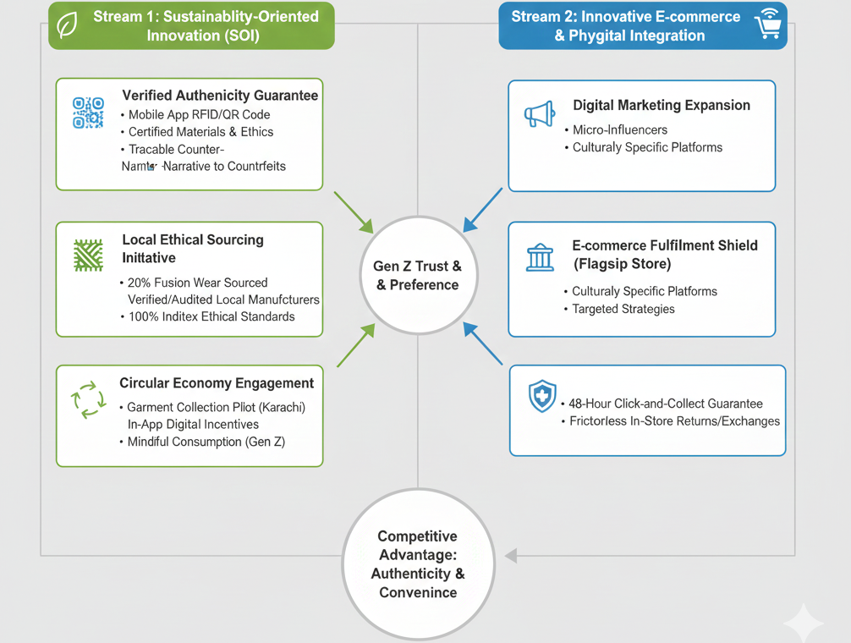
Figure 7: Sustainability-Oriented Innovation (SOI)

Stream 2: Innovative E-commerce and Phygital Integration
The digital expansion will be scaled with the help of the Innovative Marketing Strategies (Daniyal et al., 2025, pp. 188-205) and the attention to the micro-influencers and culturally specific platforms, which are essential to the growing digital economy in Pakistan (Saira et al., 2025).
The flagship store offers the E-commerce Fulfilment Shield (Li, 2025). This protection promises: Firstly, there is guaranteed 48-hour Click-and-Collect at the hub in the metropolitan centres. Secondly, Frictionless In-Storereturns/Exchanges with online purchases that will specifically target the consumer hesitation of unverified remote delivery.

Risk Analysis and Mitigation
The entry is defined by high systemic risk, requiring mandatory mitigation strategies:
Risk Source (Specific) | Severity | Mitigation Tactic (Specific)
Political Instability (FDI Risk) | High | Hybrid Model (Franchise Pilot): Offloads regulatory navigation and high capital cost to the local partner (Anjum et al., 2024).
Currency Volatility (PKR) | High | Local Sourcing Hub & FX Hedging: Reduces import dependence; QR system minimizes high-cost inventory exposure (Naeem & Butt, 2024).
Counterfeit Substitution (T1) | Very High | Verified Authenticity Guarantee: Uses RFID/QR codes and SOI messaging to confirm provenance and quality (The Express Tribune, 2024).
Logistical Deficits (Li, 2025) | Medium | E-commerce Fulfillment Shield: Flagship store acts as a high-tech fulfillment hub; uses local partner logistics expertise.
Brand Trust Deficit (W3) | Medium | Local Ethical Sourcing & ATI KPI: Explicitly markets 100% ethical compliance and measures positive social sentiment (Fatima et al., 2024).

Section 4: Performance Evaluation Framework

The Balanced Scorecard Framework
It suggests a very customised Balanced Scorecard (BSC), which aligns with the high-risk, SOI-oriented strategy, and guarantees that the goal of the performance measurement of supply chains in the industry 4.0 era is met (Frederico et al., 2021, p. 789). The flexibility is sufficient in this method to be able to innovate the business model (Mueller-Saegebrecht and Walter, 2025).
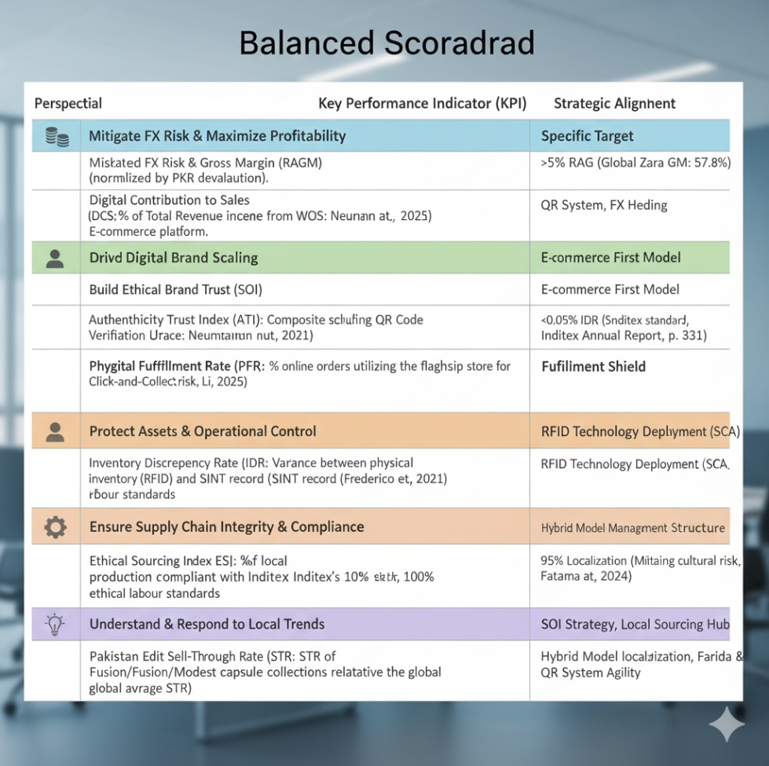
Figure 8: Balanced Scorecard (BSC)

Triple Bottom Line (TBL) Integration
The BSC model is specifically modified to integrate the Triple Bottom Line (TBL) standards (People, Planet, Profit) and shifts the perspective on the strategy, which is being not a close financial order but a comprehensive evaluation of the long-term value generation.
Profit (Economic Viability): This is constitution mainly by the Financial Perspective (RAGM, DCS). Through its target RAGM, it would help to focus economic profits on a structural (not just superficial) profits swept away by currency risk by aligning the returns of shareholders with discipline in the operation of the business (Tawse & Tabesh, 2023).
People (Social Equity): This is ingrained in the Customer and Learning and Growth Perspectives. Some KPIs are Authenticity Trust Index (ATI), which tests social acceptance and transparency, and Digital Competency and Localization KPI, which presupposes that the expansion should provide the chances to high-skilled domestic talents instead of importing all the expertise (Fatima et al., 2024).
Planet (Environmental Stewardship): This is strictly dealt with in the Internal Processes perspective by the Ethical Sourcing Index (ESI) and by proxy through the SOI strategy. The quantifiable evidence of the reduction of the negative environmental and labour effects in the cluster of the Pakistani textile industry, which meets the environmental responsibility of the TBL, is the Achievement of 100% ESI Compliance target (Husain et al., 2024; Inditex Sustainability Report, 2025, p. 254).

Monitoring and Mechanisms of Governance
The monitoring of BSC is implemented through the strong, specific governance system guaranteeing the responsibility of both financial and non-financial indicators:
Financial and Asset Control Oversight: The Audit and Compliance Committee is obliged to control the Financial Perspective and Internal Processes KPIs (RAGM, DCS, IDR). The committee cheques quarterly asset security (IDR) and financial risk management reports and makes sure that the technological SCA (RFID/SINT) is successfully applied (Frederico et al., 2021).
Sustainability & Brand Trust Oversight: The Customer and Internal Processes KPIs (ATI, ESI, PFR, STR) are required to be managed by the Sustainability Committee. This special governance framework can make sure to prioritise these ethical and cultural aspects of the SOI strategy and investigate the effectiveness of the authenticity claims and localization initiative in direct form (Tawse & Tabesh, 2023).

Critical Evaluation of the BSC
The BSC tailored to the strategic theme of Securing Digital Control and Sustainable Brand Authenticity is the ideal performance measurement tool in Zara entry into Pakistan which is highly ambitious and full of risk. The crucial value of the BSC whose value has been reaffirmed by Tawse and Tabesh (2023, pp. 123-132) is shifting the managerial concern of the short-term financial performance that is easy to manage to the long-term characteristics of sustainable growth which, in this market, is non-financial.
The Financial Perspective sternly countermeasures the volatility which is extreme in the Pakistani economy. The Risk-Adjusted Gross Margin (RAGM) is a clear directive that includes the reduction of currency risk by modifying the gross margin of 57.8% (Inditex Annual Report, 2024, p. 77) for PKR depreciation. This is far different with nominal measures that can be easily distorted by high inflation hence how such accountability is related to macro environment stability. Also, Digital Contribution to Sales (DCS) goal of 75% will also give a figure of how successful the overall digital strategy has succeeded and will also ensure that the total money invested in the global platforms (H1 2025 Results, 2025) would translate into local sales channels that can be scaled as projected by Saira et al. (2025).
Customer Perspective is chosen to get a direct fusion with the Sustainability-Oriented Innovation (SOI) strategy. The counterfeits represent a single greatest threat to competition and are directly addressed with the help of Authenticity Trust Index (ATI) (The Express Tribune, 2024). The ATI will measure the optimality of turning ethical policy into a trusted brand differentiator by utilising customer sentiment measurements and measuring the in-app usage of its QR Code Verification Feature against the threat of high-volume fakes (Neumann et al., 2021, p. 578; Theocharis and Tsekouropoulos, 2025, p. 4124). At the same time, Phygital Fulfilment Rate (PFR) serves as an indicator of the efficiency of the E-commerce Fulfilment Shield that is monitored to ensure the adoption of the 45% PFR target to ensure the physical infrastructure overcome logistical barriers (Li, 2025).
The Internal Processes Perspective would be charged with the responsibility of protecting the proprietary VRIO SCA of Zara. The high-level asset protection policy is realised into a daily, auditable metric of the RFID/SINT system performance against endemic corruption and logistical mistakes, which is expressed as the Inventory Discrepancy Rate (IDR) at the level of less than 0.05% (Frederico et al., 2021, p. 798). Importantly, Ethical Sourcing Index (ESI) level of 100 percent local sourcing compliance facilitates the ethical commitment to quantifiable standards to guarantee that the Zara Pakistan Ethical Hub presents verifiable standards as evidence to prove the SOI claim (Husain et al., 2024; Chudasama and Matta, 2025).
The future resiliency and strategic flexibility of the local operation is rooted in the Learning & Growth Perspective (Mueller -Saegebrecht and Walter, 2025). The 95percent Digital Competency Localization benchmark is crucial in the need to guarantee cultural resonance and local market intelligence, which alleviates the intense cultural risks identified by Fatima et al. (2024). Similarly, the high >75% Pakistan Edit Sell-Through Rate (STR) is confirmation of the flexibility and market acumen of the latest and newly formed localization and design team, connecting the training and trend vision directly with business achievement (Farida and Setiawan, 2022).
The first weakness is the original inability to have an effective base of market-specific measures (ATI, RAGM, ESI). The success of the BSC in Phase 1 is very dependent on the number of resources allocated to gathering initial data (e.g., independent ethical audit, consumer sentiment survey) in the first 6 12 months to set achievable targets and proper methodologies of measuring them. The inability to accomplish such a level of accuracy may compromise the entire strategic review irrespective of operational performance. Moreover, the Hybrid Entry Model is complex; even though the IDR protects the assets of Inditex, the BSC should be strong enough to lay responsibility downwards between the WOS Digital spine and the logistical implementation of the Franchisee.

Conclusion and Future Outlook
This is an elaborated Organisational Expansion Plan, which is evidence-based strategic roadmap of Zara entering the white-space Pakistani market. A Staged Hybrid Entry Model is the best approach to handle the excessive political and economic instability (Anjum et al., 2024, 2025; World Bank, 2025), which is the balance between the need of Zara to have high operational control and the ability to execute operations locally.
QR Speed and RFID Technology. This operational excellence needs to be developed in correlation with a differentiated approach of Sustainability-Oriented Innovation. Combining advanced E-commerce First market access (Saira et al., 2025) with open verification of ethical sourcing (ESI), Zara will be able to successfully mitigate the allege threat of counterfeits and achieve the loyal brand following of young but highly engaged aspirational population of Pakistan (Fatima et al., 2024). The Balanced Scorecard is rigorous, so it offers the agility needed to keep track to realign this execution and be able to convert the high strategic risks into verifiable, quantifiable returns that can be sustained.

References
Anjum, S., Farooq, M.U., Batool, A. and Kazmi, S.J., 2024. The Effects of Political Instability on Foreign Direct Investment (FDI) in Pakistan. Social Science Review Archives, 2(2), pp.1879-1892.
Chudasama, D.D. and Matta, A., 2025. Sustainability-Oriented Innovation as a Sustained Competitive Advantage Within Fashion Industry: A Study of Scandinavian Slow Fashion Companies.
Daniyal, S.M., Ahmed, A., Zeb, S.S., Butt, M.A. and Saeed, F., 2025. Innovative Marketing Strategies for E-Commerce Enterprises in the Context of Pakistan's Evolving Digital Economy. The Critical Review of Social Sciences Studies, 3(4), pp.188-205.
Digital Pakistan Foundation (2024). How Are Digital Wallets Changing Customer Behavior? | SMART. [online] SMART | SME Mastery and Readiness Training. Available at: https://www.smart.houseofpakistan.com/digital-wallets-in-pakistan/ [Accessed 3 Dec. 2025].
Farida, I. and Setiawan, D., 2022. Business strategies and competitive advantage: the role of performance and innovation. Journal of open innovation: Technology, market, and complexity, 8(3), p.163.
Fatima, M., Ahmed, Q.M. and Paracha, O., 2024. Examining sustainable consumption patterns through green purchase behavior and digital media engagement: a case of Pakistan’s postmillennials. foresight, 26(5), pp.867-885.
Frederico, G.F., Garza-Reyes, J.A., Kumar, A. and Kumar, V., 2021. Performance measurement for supply chains in the Industry 4.0 era: a balanced scorecard approach. International journal of productivity and performance management, 70(4), pp.789-807.
Group, W.B. (2025). PAKISTAN: Staying the Course on Implementing Structural Reforms Critical to Turn Economic Stabilization into Sustained, Inclusive Growth, says World Bank. [online] World Bank. Available at: https://www.worldbank.org/en/news/press-release/2025/04/23/pakistan-structural-reforms-needed-to-turn-economic-stabilization-into-sustained-inclusive-growth-says-world-bank.
Husain, M.D., Farooq, S., Siddiqui, M.O.R. and Khan, D.R., 2024. Textile dynamics in Pakistan: Unraveling the threads of production, consumption, and global competitiveness. In Consumption and Production in the Textile and Garment Industry: A Comparative Study Among Asian Countries (pp. 33-58). Singapore: Springer Nature Singapore.
Inditex (2024). INDITEX GROUP ANNUAL REPORT 2024. [online] Available at: https://www.inditex.com/itxcomweb/api/media/604197b9-50de-4f4f-ab84-c1e379cb3fd0/Inditex_Group_Annual_Report_2024.pdf?t=1741989136588.
Inditex (2025). Interim Half Year 2025 Results. [online] Available at: https://www.inditex.com/itxcomweb/api/media/54e3b24c-b22d-49f2-8746-4b64c9fb347a/1H2025Results.pdf?t=1757482386751.
Karandaaz (2024). Khaadi: Sustainable Growth Through Clear Organizational Leadership Case Study on. [online] Available at: https://picg.org.pk/wp-content/uploads/2024/10/Khaadi-case-study.pdf.
Li, J. (2025). Logistics Management in Cross-Border E-commerce: Opportunity and Regulatory Challenges. Journal of Excellence in Management Sciences, 4(1). doi:https://doi.org/10.69565/jems.v4i1.408.
McKinsey & Company (2024). The State of Fashion 2025: Challenges at every turn. [online] McKinsey. Available at: https://www.mckinsey.com/industries/retail/our-insights/state-of-fashion.
Mueller‐Saegebrecht, S. and Walter, A.T., 2025. Strategic Agility—An Urgent Capability for Successful Business Model Innovation? A Conceptual Process Model and Theoretical Framework. Strategic Change, 34(3), pp.407-428.
Neumann, H.L., Martinez, L.M. and Martinez, L.F., 2021. Sustainability efforts in the fast fashion industry: consumer perception, trust and purchase intention. Sustainability Accounting, Management and Policy Journal, 12(3), pp.571-590.
Panda, R. and Nair, J., 2025. Mindful Consumption of Used Fashion Apparel Among Gen Z on Online Thrift Stores: A Grounded Theory Perspective. Cureus Journals, 2(1).
Saira, S., Iqbal, N., Majeed, A., Zainab, S.A., Kenji, I., Reyes, F.E. and Shah, A., 2025. The Innovative Role of E-commerce for the Fashion Industry in Pakistan. In Integrating Big Data and IoT for Enhanced Decision-Making Systems in Business: Volume 2 (pp. 501-514). Cham: Springer Nature Switzerland.
Statista (2024). Fashion - Pakistan | Statista Market Forecast. [online] Statista. Available at: https://www.statista.com/outlook/emo/fashion/pakistan?srsltid=AfmBOop48wQch-FKcrvYhpcjvqZe7Ra5snaLUCI2yxvZY2V8HSAv-LZi [Accessed 3 Dec. 2025].
Tawse, A. and Tabesh, P., 2023. Thirty years with the balanced scorecard: What we have learned. Business Horizons, 66(1), pp.123-132.
Theocharis, D. and Tsekouropoulos, G., 2025. Sustainable consumption and branding for Gen Z: How brand dimensions influence consumer behavior and adoption of newly launched technological products. Sustainability, 17(9), p.4124.
Wang, M., Yang, E., Praneeth Yendamuri, Zehner, D. and Houliston, C. (2025). Asia-Pacific Consumer Products Report 2025. [online] Bain. Available at: https://www.bain.com/insights/asia-pacific-consumer-products-report-2025/.
Wresearch (2025). Pakistan Luxury Fashion Market (2025-2031) | Trends & Segmentation. [online] 6wresearch.com. Available at: https://www.6wresearch.com/industry-report/pakistan-luxury-fashion-market [Accessed 3 Dec. 2025].

