
problem solving and decision making (bmsk4004_card)
Ripara begum 1709528

December 5, 2018
University of Wales Trinity Saint David

Executive Summary

The purpose of this report is to analyse the different tools used to identify a problem in an organisation and the impact it has.by using various tools to identify them such as fishbone analysis and mend low’s matrix we can get the root cause of the problem before using strategies to solve the issues. In the report it shows what are stakeholders in a businesses, who they are internal, external stakeholders. Also to investigate Brexit issues how they impact businesses such as the airline industry, Ryan air as a company the problems their facing as a company, their stockholders the report highlights different tools to use to identify problems in an organisation to solve the issues faced. There are alternative traveling methods such as trains and coach, by sea they could be a cheaper option than flying. There are many benefit of using analysis tools to make decisions, and assess the impact of alternative solutions in an organisation. Also looked at fishbone analysis of Ryanair and a. PESTLE frame work of Ryanair.

Contents
Executive Summary 1
Introduction 3
Conclusion 8
Reference List 9

Introduction

Problem solving methods
By learning to describe a problem its nature, scope and impact and gather and interpret information to solve a problem. Learning problem solving techniques and strategies help effectively handle the challenges according to project-management-skills (2018). Also to solve a problem evaluate monitor and review the implementation and communicate decisions. Problem solving is a key component of continuous systematic improvement (Morgan D. Jones, 1998).
Fishbone analysis
Fishbone is a tool used to allow businesses identify any weakness or problems an organisation has. The diagram of the fishbone is also known as Ishikawa diagram to identify the cause and effect help to visually see all causes and effects leading up to the problem called the ‘’root cause analysis’ according to systems 2win (2018).
Mend low’s matrix according to bizzledizzle (2018).
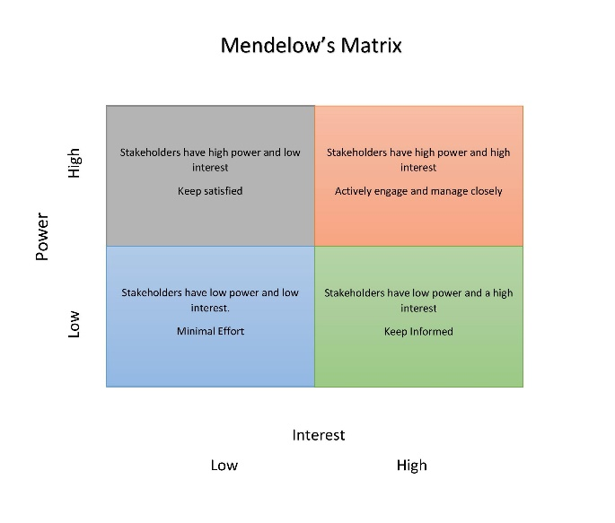
Mend low matrix suggest that stakeholders may be positioned on a matrix whose axes are power led lie the ability of the stakeholder to disrupt the activities of the organisation. According oxford college of marketing (2018) the mend low’s matrix is used to analysis the stakeholder groups based on power and interest in organisation. Some stakeholders will hold more power than others, and some stakeholders have more interest. Directors are likely to have high interest and power in the organisation were as the government will have more power to implement rules and regulations but less interest. High power, less interested people keep satisfied, low power, high interest people keep informed, low power, less interested people keep monitor to check the levels of interest or power change (Oxford College of marketing, 2018).

Main body

The impact brexit on business airlines and the wider aviation industry.
Airlines industry is international by nature and the sector most desperately waiting for arrangements to be set after brexit. The question all airline are asking is what brexit means for the aviation industry and the outcomes according to IG (2018). According to IG (2018) the UK’s aviation industry evolved through the European Union (EU) more than ever, making brexit a very real threat for Airline industry on both sides of the channel. The airlines have developed through EU laws and accessed markets, it means the UK have to strike a deal with EU to retain its current state it’s in. otherwise the UK will have to create a new regulatory framework from scratch, which will be a huge task and cost the UK thousands to ensure that flights in and out of the UK continue after brexit.
The implications of brexit has already had occurred after the results the dramatic drop in sterling the pound has managed to recover strengthening against the dollar, but stays below pre-referendum levels. British holidaymakers spending power reduced trips become more expensive. The other issue-US open skies re the foreign ownership requirements are a standard feature of most international aviation deals will apply to British airlines running routes to US when the UK falls out of the EU-US open skies agreement on a no flight disruption and no shareholder problems (financial times, 2018). According to international airport review (2018) the potential impact occurring maybe a seamless end-to-end journey where your face is your passport to the aviation digital transformation, the rules of cross border trade, those UK flying to EU trading with customers across EU new outer borders and those currently holding EASA regulatory approvals. All the changes may impact of brexit on aviation entitles and other relevant UK Government proposals, any change will have an impact comes both risk and opportunity, while brexit brings uncertainty and potential harm to UK businesses, aviation ability to trade will be heavily influenced by higher level, political issues.

Business description
Ryanair DAC is an Irish low cost airline founded in 1984, headquartered in swords, Dublin, Ireland, with its primary operational bases at Dublin and London Stansted airports (Ryanair, 2018). Ryanair is Europe’s number one airline carrying over 130 customers on a daily bases, with 2,000 flights across 86 bases according to Ryanair (2018). According to google Ryanair is named the most popular on the web for 2003 by google to be the most searched travel website in Europe. Ryanair entered the market with 80 % low airfares as compared to other airline. Also according to world airline awards (2018) Ryan air is one of the low-cost airline in Europe.
Ryanair offers the lowest possible fare to passengers, this has been managed by minimizing cost effectively, but emphasizes on safety and security of passengers. The airline being number one in European discounted airline and had been benefited by emergence of ‘’open skies’’ deregulation across the continent. Ryan air have taken advantage by utilizing its resources keeping low cost, increased capacity of planes, short turnarounds by maximizing utilization of its aircrafts and aggressive fuel hedging (Ryanair, 2018). According to market screener (2018) Ryanair holding plc was founded on June 5, 1996 and there headquartered in Dublin, Ireland. The number of employees working for them is 14,583 people, mangers are Michael O’Leary his the chief executive officer & executive director, David Bonderman is independent executive chairman, peter Brendan Bellew is chief operating officer, Neil Sorahan is chief financial officer, John Hurley is chief technology officer, Kyron McLaughlin is senior independent non-executive director, Julie O’Neill, Louise phelan, Richard Alexander Milliken, Michael cawley are all independent non-executive directors according to market screener (2018).
The current problems at Ryan air
According to BBC News (2018) Ryan air cancelled 190, or about 8% of its scheduled flights in September 2018, in strike actions being taken in Spain, Belgium, Holland, Portugal, Italy and Germany by staff and pilots walk out. According to Air help (2018) strike are taking place because Ryanair has failed to deliver practical solutions to ongoing requests from Ryan air staff for better working conditions. The other problems in Ryan Air Company is passengers flights were being cancelled because of the strikes taken place. While EU laws are in place to ensure customers were supposed to get compensation when flights are cancelled or delayed but Ryan air is refusing to pay them according to Air help (2018). Also according to BBC News (2018) staff claim Ryanair are creating insecurity for them, blocking access to state benefits in their home country. Employee’s receiving pay using Irish bank accounts are affecting their credit rating in their home country. Ryan air other problem is over booked seats and flight delays for customers flying with Ryan air.
Alternative transport methods of traveling
According to Inc. (2018) there are other ways of traveling to the destination you want to go to, for example train, car by driving down to the destination may even get there at the same of time it would’ve taken to fly, it take similar time by the time you have done all the security checks. Coach is another alternative to traveling some companies are offering low-cost traveling stress free. Also travel by cruise ships is also a great option via ferries or short cruises according to pretty wild world (2017) there are some countries where reaching by ship is more economical option.
This is a fishbone diagram of Ryanair Hannah Williams’s business blog (2017).

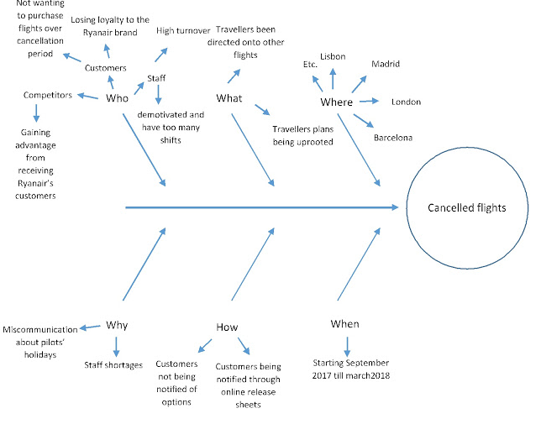
One of the problem faced at Ryanair is suddenly cancelled fights they had summer carrying a huge number of customers in one season. The result of that was too many pilots taking holidays at the same time, leaving a shortage of staff working. The effect of this is overworked staff there not happy in the working conditions doing too many hours. This could be why the employees at Ryan air have a problem in shortage of staff in the organisation. The people that are affected by the cancelations are the main three stakeholders these include staff, customers and competitors been affected in couple of ways. Staff which are left are being overworked compensating for shortage of staff trying to keep as many flights on schedule as possible, they are not receiving any extra benefits for the extra work their doing for the organisation. Resulting in further staff decreasing for the organisation high rate of shortage of employees put more pressure to the company. The other stakeholder which will be affected will be customers, who have been misleading passengers on how to claim cancellation fees for re-routing their fights. This created uncertainness in customers travel plans, customers will lose faith in there company when booking with them in the future. The customers and staff have both had a negative repercussions from the organisation, but however the next stakeholder the competitors have an advantage from this by re-routing the fights onto other fights customers are flying with competitors resulting in them getting a full fights from different company like EasyJet and jet 2, gaining their custom and loyalty this will effect Ryan air having so many unsatisfied customers according to BBC one (2018).
Stakeholder analysis
What are stakeholders in a business stakeholders is any person, organization, social groups, or society at large, or interest in the business. Stakeholders can be internal or external to the organisation according to study Com (2018). In the business, stakeholders have an important interest in the organisation and its activities which are affected both by a business or affect a business according to higher bite size (2014). They can be owners/shareholders who are interested in how much profit the business makes, which is shared between them. Mangers they are concerned about salary getting promotion prospects and potential benefits they will receive in the long-term, the employees who work for them to earn high wages and keep working for them long-term, customers who buy the products/services from the business at reasonable prices. Suppliers are people who want them to buy their products to keep on running the business with loyal contacts and deals, banks who pay and use facilities want to be paid on time. Governments who want organisations to pay taxes on time. Internal stakeholders are people within the business for example owners and employees, external stakeholders are people or groups outside the organisation like the community. The three categories of stakeholders are internal, external and people connected to the business they are the most important stakeholders according to destination-innovation (2018).
The stakeholders that have been identified at Ryan air which have been put in three categories they all have a part in the operation of the business.
Internal stakeholders | External stakeholders | Connected to the business
Air Host | Other airline | Customers
Passengers | Communities | Staff
Air traffic control | Security | Cleaners
pilot | Travel agent | Cabin crew
 | Pressure groups | Duty free

The internal stakeholders are people who already committed to the organisation have a high interest for the company. External stakeholders are people who are effected by the organisation it’s important to get perspectives of both groups (non-profit inclusiveness, 2018). According to key differences (2015) business exists in a wide environment that may affect the organisation directly and indirectly, every organization has stakeholders regardless of businesses size, nature, structure and purpose. Stakeholders can be anyone who has a influence in the organisations activities in the business environment.
The current situation at Ryan air the impact on stakeholders.
According to flight global (2017) Ryanair jumped 10% more in sales, even after flight cancellations their growing still despite on-going challenges that have suspended its planned expansion. To date Ryan air has warned investors its full year’s profit be lower than last year, due to recent industrial action its profits be 12% lower (BBC News, 2018). Ryanair suffering profit lose due to higher oil prices, higher costs associated with EU flight compensation rules and weaker fares due to recent strikes. Ryan air are still in fare of further unnecessary strikes repeating. Ryan air will refund or re-accommodate on other fights as they wise for cancelled flights (Ryanair, 2018). Disputes among employees to get recognise unions finally agreed at the end of 2017.

PESTLE Analysis framework
The PESTLE Analysis tool is used to analysis and monitor the macro environmental factors influencing an organisation’s strategy. Pestle stands for political, economic, social, technology, environmental and legal all these factors need to be analysed in order to run the organisation now and in the future which change all the time according to professional academy (2018). The political factor which is facing Ryan air is brexit changing ‘open skies’ policy’s May restricts air traffic between UK and EU countries. Economic factor Ryanair face is that in case recession occurs in the UK, low-cost airlines earning potential in the UK market will decline due to brexit outcome uncertainty. The social factor is Ryanair is a low-cost airlines middle class have affordable income to travel multiple short-trips each year, in contrast to previous generation travellers, millennials expect a high level of customer service without paying a premium and generally value airlines that offer advanced technological solutions. Technological factors are the social changes occurring in the airline industry, only those airline will survive that are able to integrate digital channels into their distribution and marketing strategies the desire remain constantly connected with social media in the environment. The environmental factor as heat waves being frequent which rise above aircraft maximum ground operations, airlines need to find alternative strategy to adjust to climate change even Ryanair is using modern fuel efficient aircraft fleet, regarding contribution to carbon emissions. Legal factor are legal challenges around the brexit referendum uncertainty of the UK, the details about the future aviation laws governing UK flights are unknown between UK and EU any restrictions that could reduce the demand for air travel between UK and EU ( business teacher (2017).

Conclusion

To conclude problem solving methods, is important to learn the nature, scope, impact and gather information to solve a problem. Learning techniques and strategies help handle the challenges ahead (project-management-skills, 2018). Fishbone is also a tool used to identify problems in an organisation has, the Ishikawa diagram identifies the root cause (systems 2win, 2018). The mend low’s matrix help understand the stakeholders ability in an organisation and power, interest they have relating to the company (oxford college of marketing, 2018). By looking at different stakeholders in Ryanair we can identify who are the main stakeholders in there organisation that are affected by the impact of the changes in the environment (Ryanair, 2018). Also we have identified the problems there will be facing using the PESTLE Analysation with the issues already the company are faced with also looked at the way Brexit has had an impact on businesses such as Ryanair. From the report also conclude that there are other mains of transport that can be used to travel other than flying may be a cheaper option (pretty world wild, 2018).

Reference List
Air help, (20118). Ryanair strike summer 2018 [online] https://www.airhelp.com/en-gb/blog/ryanair-strike Accessed on 20, October, 2018.
BBC News, (2018). Ryanair warns strikes will hit profits [online] https://www.bbc.co.uk/news/business-45704269 Accessed on 15, October, 2018.
BBC News,(2018). Disruption at Stansted following storms led to delays and cancellations [online] https://www.bbc.co.uk/news/uk-england-essex-45019843 Accessed on 19, November, 2018.
BBC News, (2018). Ryanair will not pay compensation for cancelled flights [online] https://www.bbc.co.uk/news/uk-england-essex-45038019 Accessed on 19, November, 2018.
Bizzle dizzle, (2016). Mendlow’smatrix [online] https://www.bizzleddizzle.com/up-content/upload/2016/02/mendelows_matrix.jpg Accessed on 20, November, 2018.
Business teacher, (2018). Ryanair PESTEL Analysis [online] https://www.businessteacher.org.uk/pestel/ryanair.php Accessed on 27, November, 2018.
Destination-innovation(2018).who are company’s most important stakeholders [online] http://www.destination-innovation.com/who-are-a-companys-most-important-stakeholers
Accessed on 21, November, 2018.
Financial times, (2018). Financial times on Ryanair [online]https://www.ft.com/content/eda609a6-f2f2-11 Accessed on 19,November,2018.
Flight global, (2018). Analysis Ryanair still among biggest despite capping growth [online] https://www.flightglobal.com/news/articles/ Accessed on 23, November, 2018.
Hannah williamsnu business, (2017). Problem visualisation for business [online] https://www.hannahwilliamsnubusinessblogsport.com/2017/10/problem-visualisation-for-business-html Accessed on 22, November, 2018.
Pretty wild world,(2018). Are you tired of flying here are 5 alternative ways to travel the world [online] https://www.prettywildworld.com/alternative-ways-to-travel-the-world Accessed on 23, November, 2018.
Professional academy, (2o18). Marketing theories – PESTEL Analysis [online] https://www.professionalacademy.com Accessed on 24, November, 2018.
INC, (2018). How will Brexit impact airlines and the wider aviation industry [online] https://www.ig.com/uk/news-and-trade-ideas/share-news/how-will-brexit-impact-airlines-and-the Accessed on 22, November, 2018.
International airport review, (2018). UK exit from the EU and its impact on the UK aviation industry [online] https://www.internationalairportreview.com/article/75237/brexit-and-aviation Accessed on 24, November, 2018.
Key differences, (2015). Difference between internal and external stakeholders [online] https://www.keydifferences.com/difference-between-internal-and-external-stakeholders.html Accessed on 24, November, 2018.
Market screener, (2018). Ryanair holdings plc company: shareholders, managers, and business summary [online] https://wwwm.marketscreener.com/ryanair Accessed on 24, November, 2018.
Non-profit inclusive, (2018). Identifying internal and external stakeholders [online] https://www.nonprofitinclusiveness.org/identifying-internal-and-external-stakeholder Accessed on 23, November, 2018.
Global News, (2018).Ryanair news, videos and articles [online] https://globalnews.ca/tag/ryanair Accessed on 21, November, 2018.
Morgan D. Jones, (1998). The thinker’s: 14 powerful techniques for problem solving, England: Crown Business.
System 2win, (2018). Root cause analysis tools [online] https://www.systems2win.com Accessed on 24, November, 2018.
Study. Com, (2018).
Oxford College of marketing, (2018). What is mend low’s matrix and how is it useful [online] https://www.blog.oxfordcollegeofmarketing.com/2018/04/23 Accessed on 20, November, 2018.
Ryanair, (2018). Official Ryanair website [online] https://www.Ryanair.com/gb/en Accessed on 19, October, 2018.
World airline awards, (2018). World’s best low-cost airline 2018 [online] https://www.worldairlineawards.com Accessed on 20, November, 2018.

