

Assessment 1 – Reading Task Template
PART 1: Upload your photo of your A3 in-class notes here:
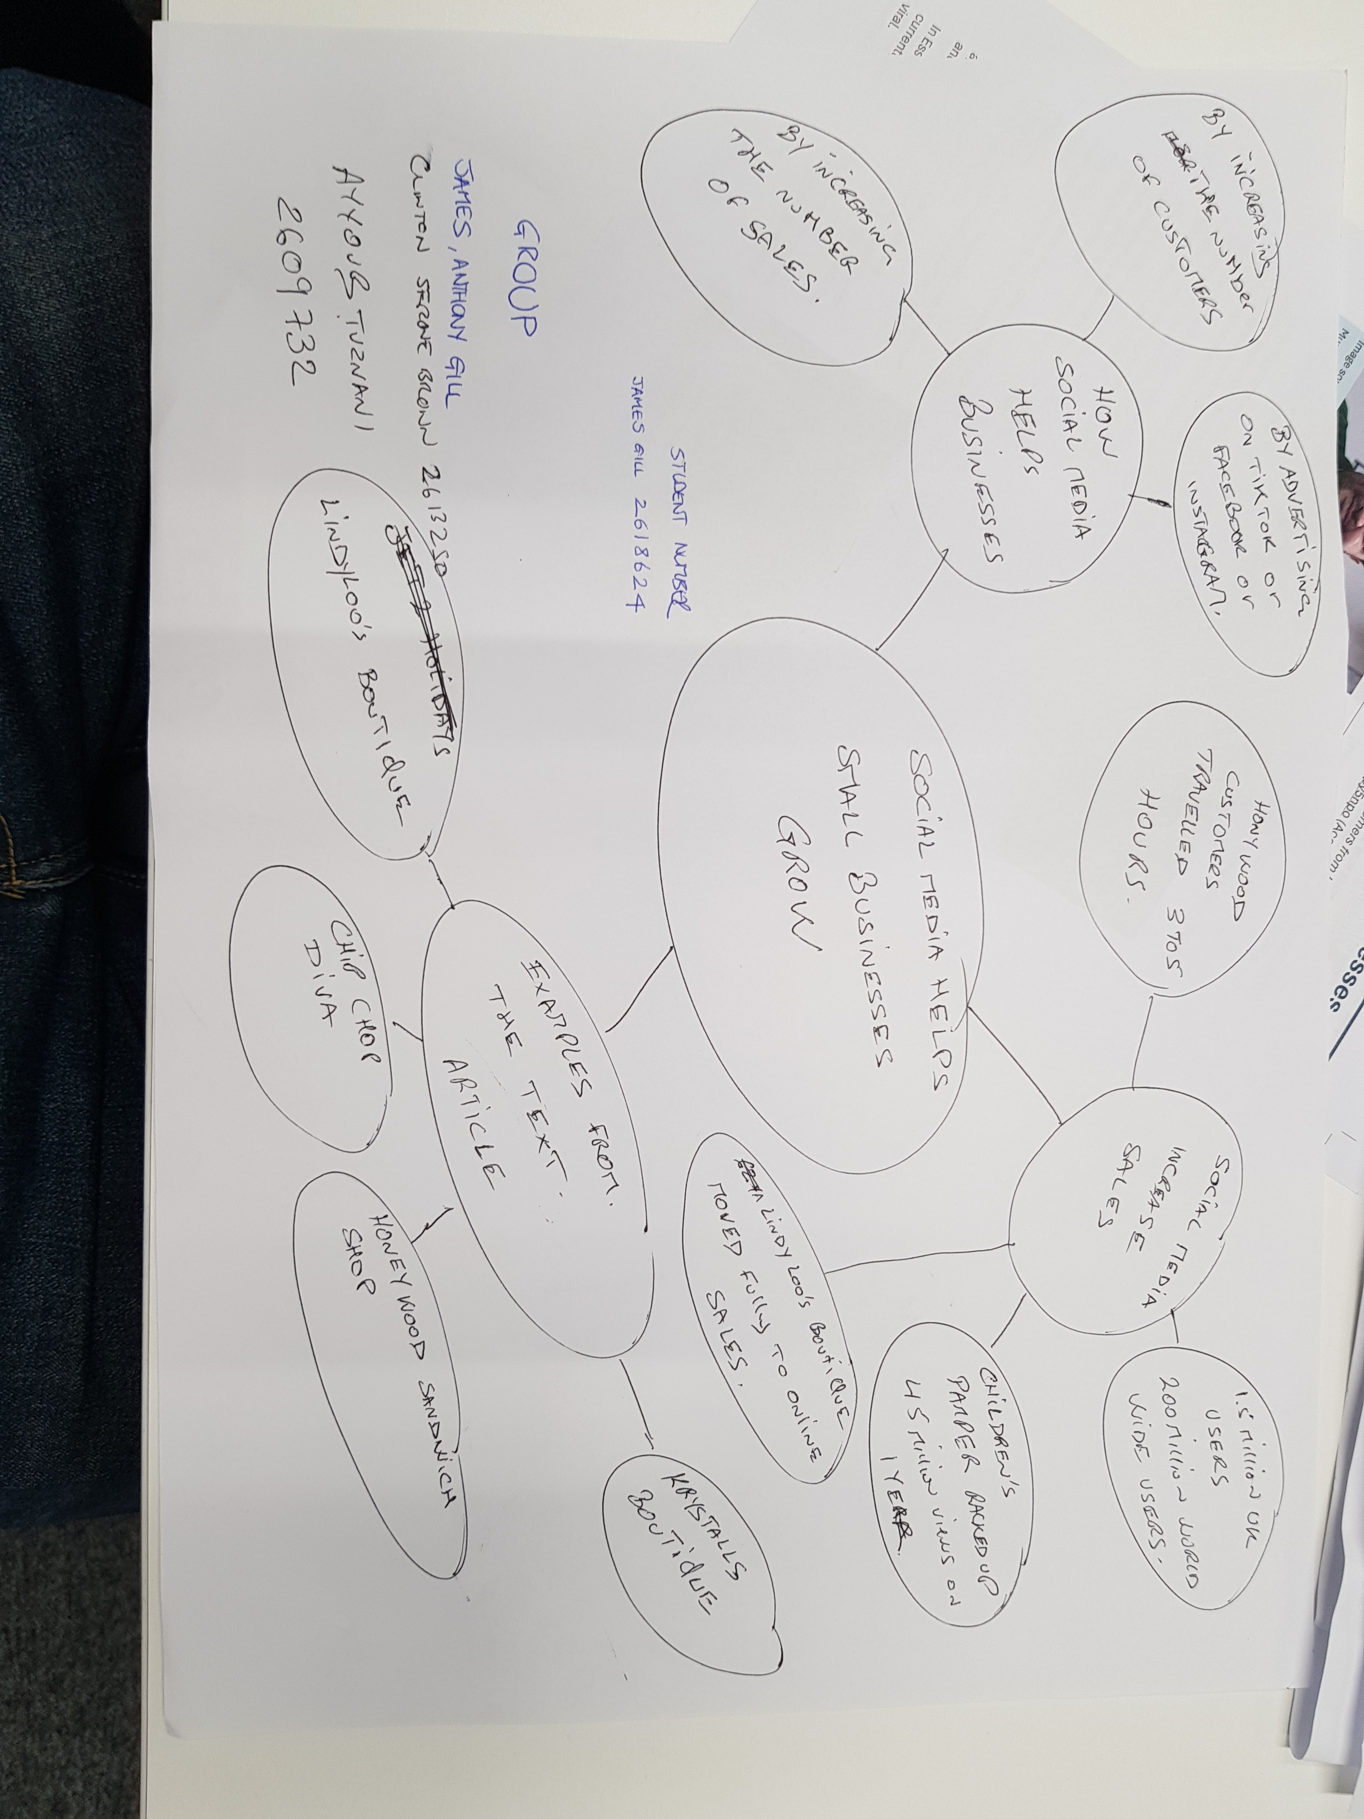

PART 2:
- Answer every question below in 1-3 full sentences.
- Use your own words. Do not use generative AI to answer these questions.
- Include a specific detail from the text when asked.
REMINDER
- The main idea is the overall message of the whole text.
- A key point helps to explain the main idea.
- A specific detail or example from the text shows that the key point is true.

- What is the main idea of the whole text?

- Social media helps small business to generate more income profits

- What is one key point that supports the main idea, and which specific example from the text shows this?

- 62-year-old has moved the business fully online and ship outfits across uk and even to Australia.

- Lindy Hunter-better known online as Lindy Loo - runs an online clothing business based in Epping

- What is a different key point that supports the main idea, and which specific example from the text shows this?

- Honywood sandwich shop customers travelling for three hours to buy the chiken burger after customers posting videos on tik tok platform.

- Honywood sandwich shop is tucked away on an industrial estate in basildon.

- Which part of the text do you think is most important, and why?
- Social media platforms such as Tiktok and Instagram have made it easier then ever to get noticed by the world .How does it feel when your business is at the centre of a viral trend?

- The first paragraph that talk about the whole subject and gives you an idea about the text information

Reflection:
- What did you find difficult in this task (including in-class components), and why was it difficult?
- I think the most difficult in this task is when you want to get the key point information.

- Because you may get confused by the key point information and the examples

- What helped you with this difficulty, and how did it help you?

- I think focusing about the key point information help to understand the text and then you choose the examples as you want to complete the task.
- It's help me to understand business text information and the key point of business succes.

