A stress-strain ballistic impact study

Physics - L4 OME

C. Morris (2025753)

May 2023

Abstract

The following report uses Abaqus software to confirm that when brass and aluminum are used as a projectile, they are capable of penetrating a steel target plate. Also discussed are the different effects velocity can make on a projectile and its target armor, looking at stress and strain as well as velocity-time graphs.

Table of Contents

Title Page
Abstract
Table of Contents

- Introduction……………………………………………………………………………………………4

- Initial Simulations…………………………………………………………………………………….4

- Simulation Parameters………………………………………………………………………………5

- Simulation Analysis………………………………………………………………………………….5

  - Varying Velocities……………………………………………………………………………….6

  - Brass Projectile………………………………………………………………………………….6

  - Time-Velocity Graph…………………………………………………………………………….7

- Limitations …………………………………………………………………………………………….8

- Conclusion…………………………………………………………………………………………….8

- References…………………………………………………………………………………………….9

- Appendices……………………………………………………………………………………………10

- Introduction

The following report looks at high speed ballistic impacts, “a ballistic impact is a study that analysis material damage caused by the impact of projectiles/bullets”. [1] This has been simulated on the modeling software ABAQUS. The simulations created are to show the results of a potential target defeating projectile impacting upon armor and its effects. This case study will compare and contrast the effects different projectile velocities make on targets made of varied materials. Stress, strain and strain-rate will be used as a key measurement to find possible failure points and weaknesses, other material characteristic changes that have also been touched upon, including adding Johnson-cook damage to the simulation and having a finer mesh on the target plate are included. The addition of velocity and time graphs are also used to help gain a better understanding of how the projectile reacts under different speeds. By changing the velocity, the author is hoping to ascertain a V50 ballistic limit for the shape and material used, according to the U.S Department of justice “V50 ballistic limit is the velocity at which a specific projectile (bullet) is expected to penetrate the armor half of the time” [2]

- Initial simulations

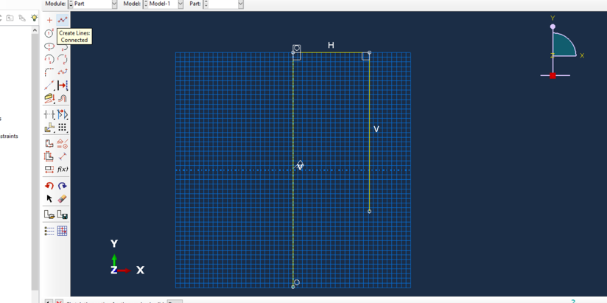
The first step to creating an impact simulation was to input the desired parameters into ABAQUS, 3ds.com states “Abaqus is truly a general-purpose finite element-based software package.” [3] Using Abaqus it was possible to draw out the required projectile and target plate to a specific dimension, shown in the screenshot below. Once the parts are designed each are assigned as a certain material, for the initial simulations the projectile was given the properties of aluminum and the armor (target plate) the properties of steel. To finish the simulation, the parts need to be meshed, positioned in the correct way, and be given a velocity with a direction of travel using the interaction module. To begin with a velocity of 800 ms-1 was used and a standoff of ten centimeters.
The results of the first test can been seen below.

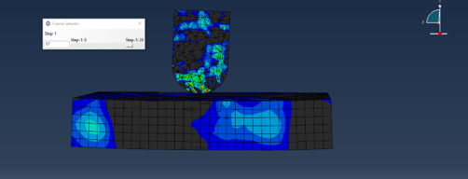
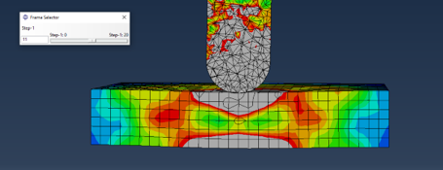

These first simulations show a high amount of stress applied to the target plate (shown in grey) on the point of impact and the opposite side of the armor, this could mean a potential failure point. “Stress is the ratio of applied force F to a cross section area - defined as "force per unit area" [4] To try and understand the interactions between the two objects other parameters where needed to gain a greater understanding of the physics involved.

- Simulation Parameters

To gain a greater understanding of the forces being applied to the plate and armor other parameters need to be included, adding Johnson-cook damage will help to create a more detailed and comprehensive insight into the ballistic impact. “The Johnson-Cook (JC) (Johnson & Cook, 1985) constitutive model is the most widely used constitutive model in predicting the flow stress behavior because of its simplicity with fewer number of material constants” [5].

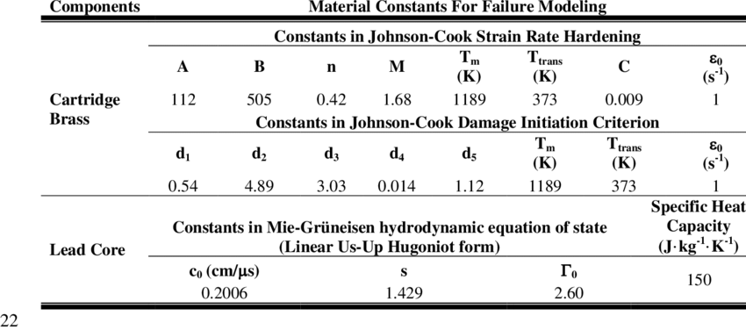
Below is a copy of the Johnson-cook parameters used for the brass projectile [6], tables with the data used for the aluminum projectile and the steel plate can been seen in appendices under A1 and A2.

To help analyze whether the projectile will penetrate the armor more than fifty percent of the time (V50 ballistic limit) the simulations have been run at various velocities. Using Abaqus this can be done by editing the pre-defined velocity field under V2. The different speeds used are 500, 1000, 1500, 2000, 3000 and 4000 meters per second.

The final parameter change was to create a finer mesh on the target plate, this can be achieved by editing your part under the mesh module in Abaqus. “a finer mesh produces more accurate results. The smaller elements in a finer mesh can more accurately capture stress gradients across the element.” [7]

- Simulation Analysis
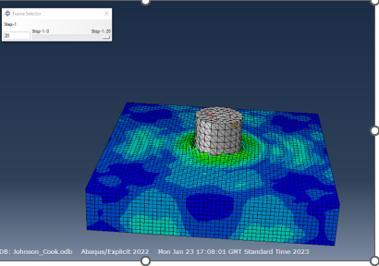
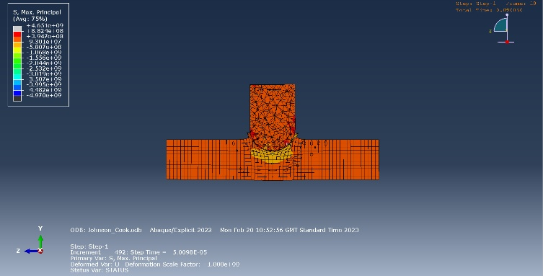
Once all of the parameters have been defined and inputted into Abaqus the simulations can be run and compared. The initial and most simple parameters were changed for the next round of simulations, adding Johnson-cook damage to the target plate but maintaining the velocity at 800 meters per second. The results (shown below) show a clear penetration of the steel armor plate as well as a high amount of stress centered around the target area. Figure A3 in appendices show fragmentation splintering away from the base of the armor plate along with a much higher circle of stress created. Using these simulations, we can ascertain that V50 will be achieved, at 800 meters per second the aluminum projectile will penetrate the armor plate. After this it was decided the application of Johnson-cook would also be applied to the projectile to gain a greater understanding of how both objects interact.

4.1 Varying Velocities

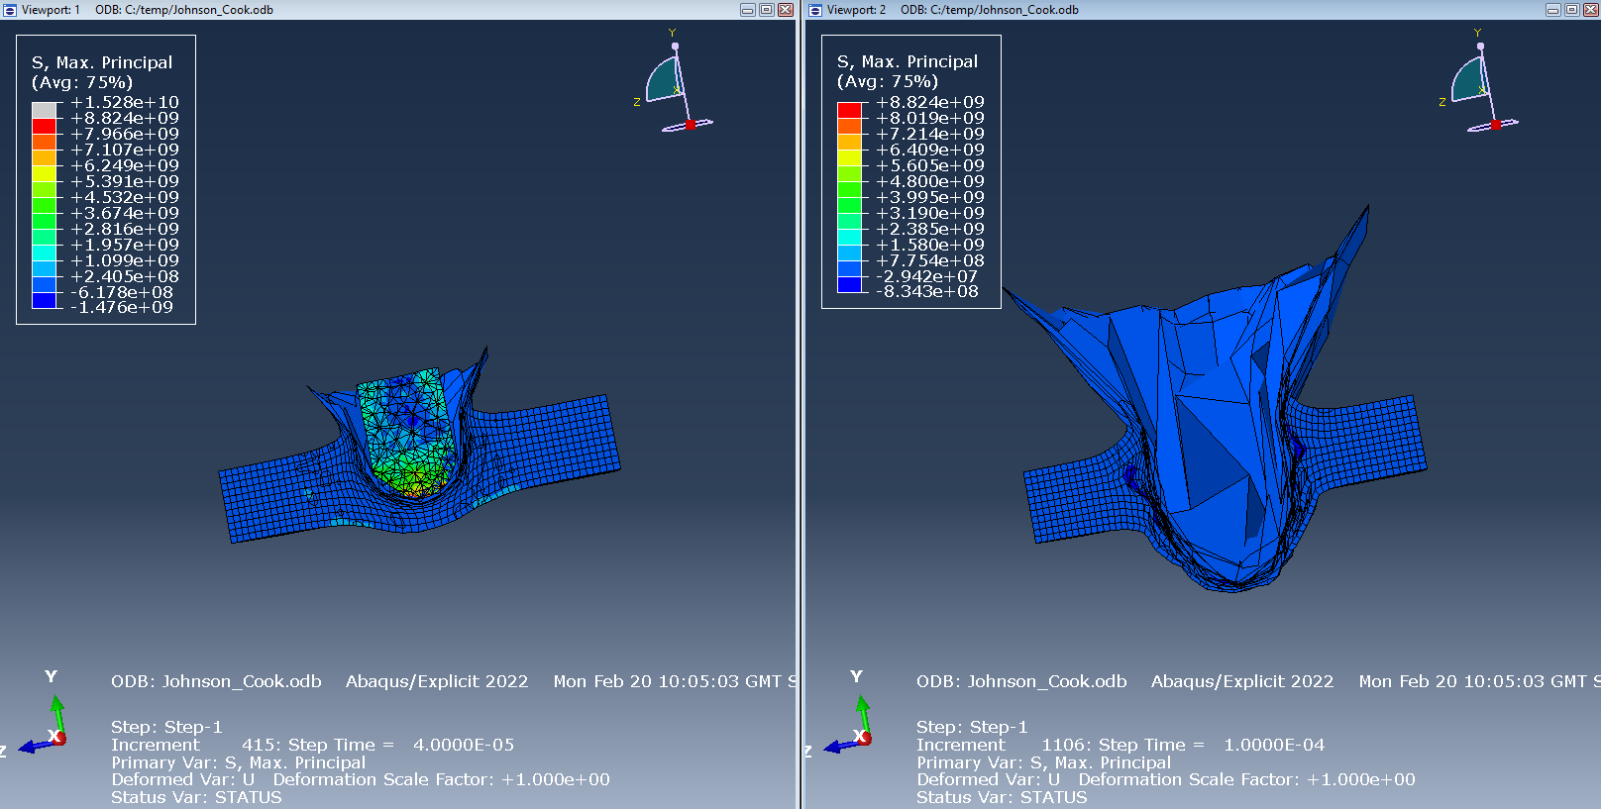
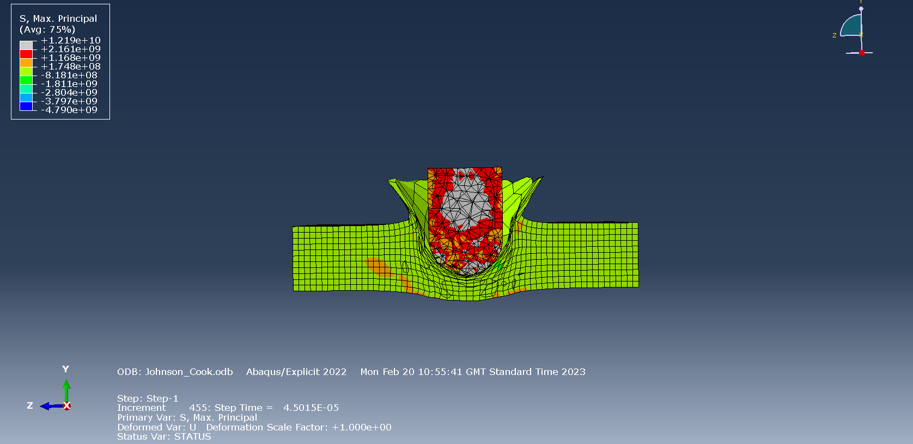
The next stage of the simulations was to compare how each plate reacted under different velocities. The simulation picture to the right shows an impact of 1500 meters per second. The first thing noticed is the higher amount of stress and strain applied to the plate and the projectile. A clear damage evolution can be seen, “The damage evolution definition defines how the material degrades after one or more damage initiation criteria are met.” [8] The simulation step shown in appendix A4 gives a clearer picture of how the bullet is penetrating the armor plate and is asserting plastic strain upon it, Bijus.com defines plastic strain as “The deformation is irreversible, and it stays even after the removal of the applied forces. Example, bending of steel rods.” [9] As apposed to elastic strain which is when an object is deformed by a force but will return it its original form once the force is no longer applied. The velocity was once again increased to 2000 meters per second, the below snapshot shows a greater deformation of the target plate as well as a far more dramatic evolution of damage, due to the limitations of the users Abaqus knowledge the simulations finished before full penetration of the target could be confirmed.

4.2 Brass Projectile

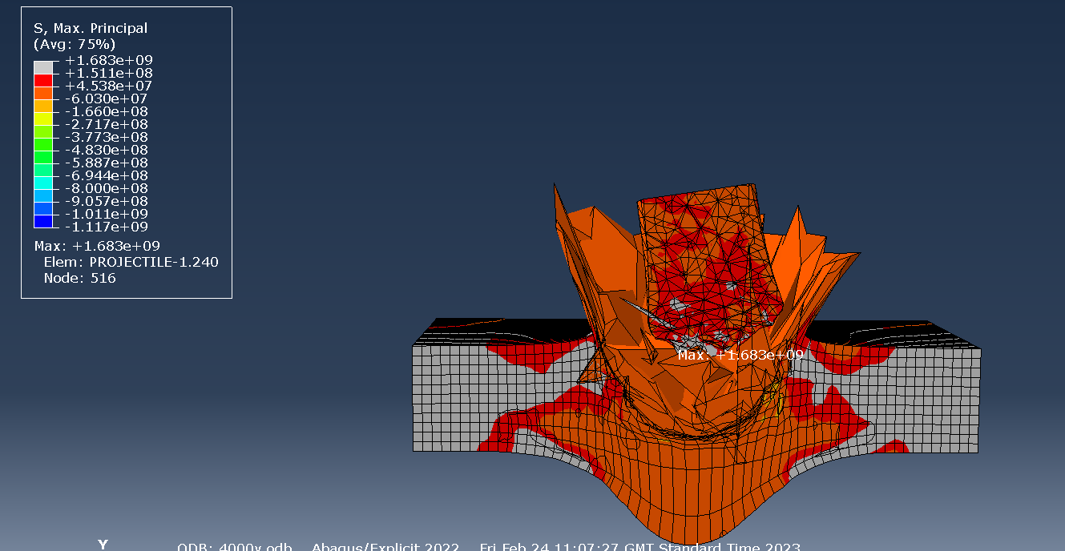
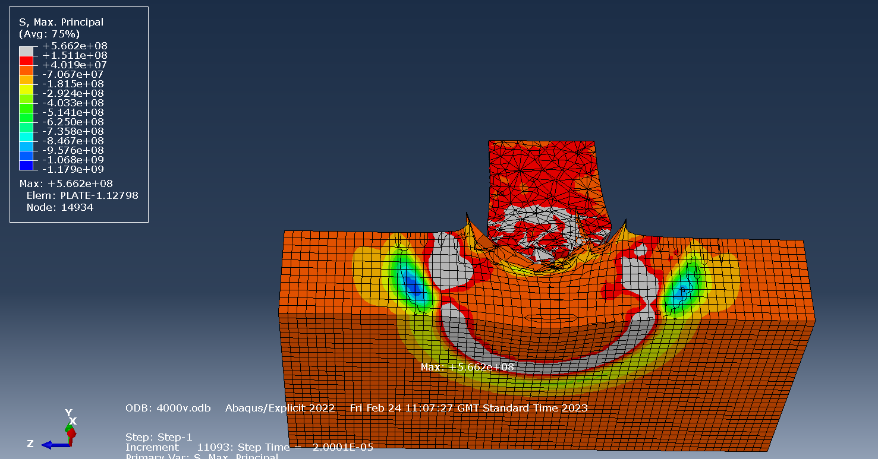
After comparing various projectile velocities, the projectile material was changed to brass, this was to try and gain a greater understanding of how different materials would react to the applied stress, strain forces applied to it. The picture shown to the right shows a high deformation of the projectile as well as the plate, high stress can be seen within the impact sight and as you travel to the outside of the plate it increases. When looking at this simulation a few steps back (shown below) a high stress ring can be monitored traveling from the impact site outward at a high speed, this could indicate a potential stress crack/failure of the target plate. Other examples of this phenomenon can be seen in the appendices (A5 and A6).

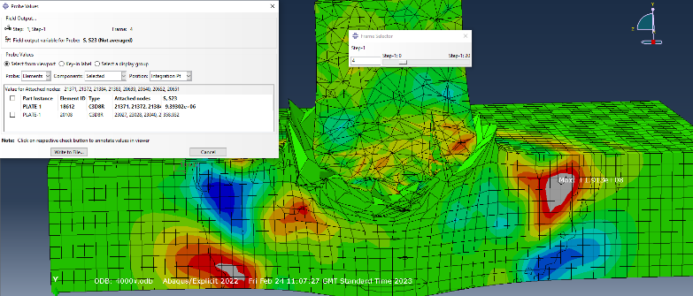
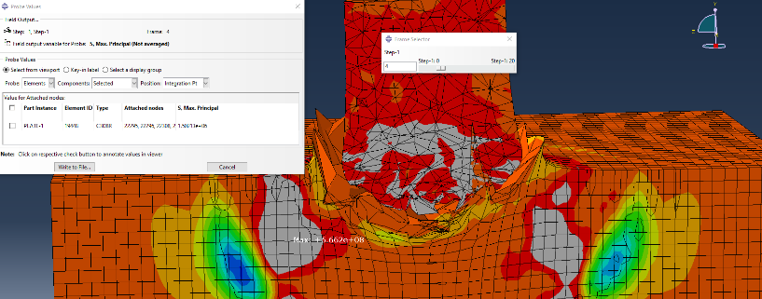
Using the probe value tool in Abaqus it is possible to take a closer look at what forces are acting on the objects. The picture located to the right shows low stress at the point of impact, however the picture below shows a high amount of strain at the point of impact. Using this we can assume that the steel plate is more likely to fail under strain rather than stress failure.

4.3 Velocity-time graphs

The final Abaqus tool used to compare and the results of impact are velocity-time graphs. Below they are shown in the order of 1500, 2000 and 3000 meters per second.

1500 mps 2000 mps

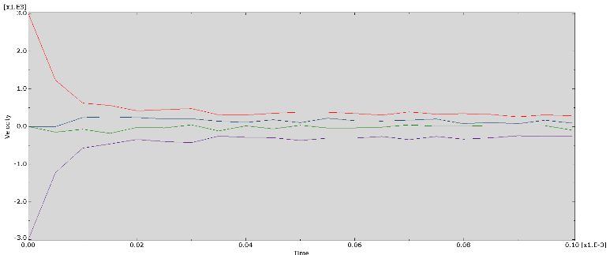
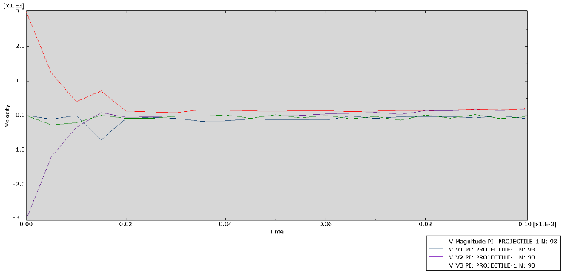

3000 mps

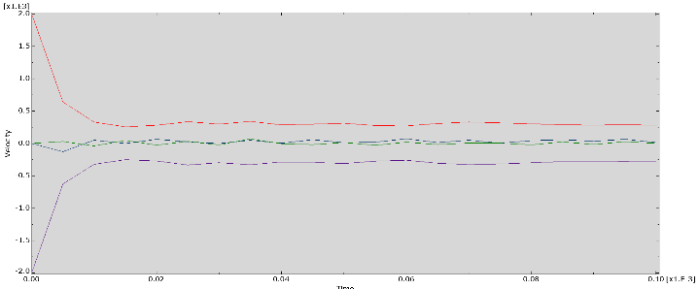

Comparing the graphs, it is clear to see that the object will maintain a higher speed though the target the higher its initial velocity. When the projectile hit the armor a 1500 meters per second a small spike can be seen indicating a quick increase and decrease of speed. This cannot be seen on the other velocity graphs.

- Limitations

The main limitation of computer simulations are it’s creation in an “ideal world”, real life factors that would have an impact on the forces of our simulation such as gravity, weather (wind, rain) and air resistance cannot be simulated. These forces could have a significant effect on the simulation results. It can be difficult when changing the material of an object, having to rely on academic papers to find the inputs for your desired material can be time consuming and sometimes fruitless. Oregon State University states “The main limitation is that Abaqus SE only supports structural models up to 1,000 nodes.” [10] This can have an effect on the amount of detail you can put into your simulations, limiting how fine your mesh can be or how long your simulation will run, large amounts of data can mean a long wait for your simulation to be completed.

7. Conclusion

In conclusion this report has confirmed when aluminum or brass is used as a projectile it is able to penetrate a steel target plate, this was confirmed by using ballistic simulations on Abaqus and meets the V50 requirement. Looking at various velocities of the same projectile it was shown that the resulting forces would differ massively having adverse effects on the armor. Depending on the forces being generated I can be shown if an object will fail under shear or elastic stress/strain. Although it has its limitations Abaqus is a good way to simulate ballistic problems to gain initial results before having them created in the real world.

References

[1] | A. R. P. T. M. N. M. R. R. a. F. B. L. Faiz Haidr Ahmad Alwan, "Assessment of ballisgtic impact damage on aluminum and magnesium alloys against high velocity bullets by dynamic FE simulations," Mechanical Behavior of Materials, vol. 1, no. 1, p. 2.2, 2022.
[2] | D. E. Frank, "Ballistic Tests of Used Soft Body Armor," Ballistic Tests of Used Soft Body Armor, p. September, 1986.
[3] | "Why Abaqus?," 3ds.com, 1 January 2003. [Online]. Available: https://www.3ds.com/products-services/simulia/products/abaqus/. [Accessed 5 May 2023].
[4] | E. t. box, "Stress, Strain and Young's Modulus," Engineering tool box, [Online]. Available: https://www.engineeringtoolbox.com/stress-strain-d_950.html. [Accessed 6 May 2023].
[5] | A. S. Sandeep Pandre, "Experimental and numerical investigation of deformation behavior of dual phase steel at elevated temperatures using various constitutive models," Experimental and numerical investigation of deformation behavior of dual phase steel at elevated temperatures using various constitutive models, p. Chapter 3.3.2.1, 2022.
[6] | K. Ming, Effect of helmet liner systems and impact directions on severity of head injuries sustained in ballistic impacts:, Medical & Biological Engineering & Computing, 2016.
[7] | simutechgroup, "What is Meshing?," simutechgroup, 2023. [Online]. Available: https://simutechgroup.com/why-is-meshing-important-for-fea-fluid-simulations/#:~:text=Mesh%20Density,stress%20gradients%20across%20the%20element.. [Accessed 8 May 2023].
[8] | W. U. i. S. Louis, "Defining Damage," no. 6.6, p. 12.8.3, 2020.
[9] | Byju's.com, "Plastic Deformation," [Online]. Available: https://byjus.com/physics/plastic-deformation/#:~:text=Elastic%20Deformation%20%E2%80%93%20The%20deformation%20caused,removal%20of%20the%20applied%20forces.. [Accessed 11 May 2023].
[10] | O. s. univercity, "Abaqus Student Edition," Oregon Univercity, [Online]. Available: https://it.engineering.oregonstate.edu/abaqus-student-edition. [Accessed 2023 5 12].

Appendices

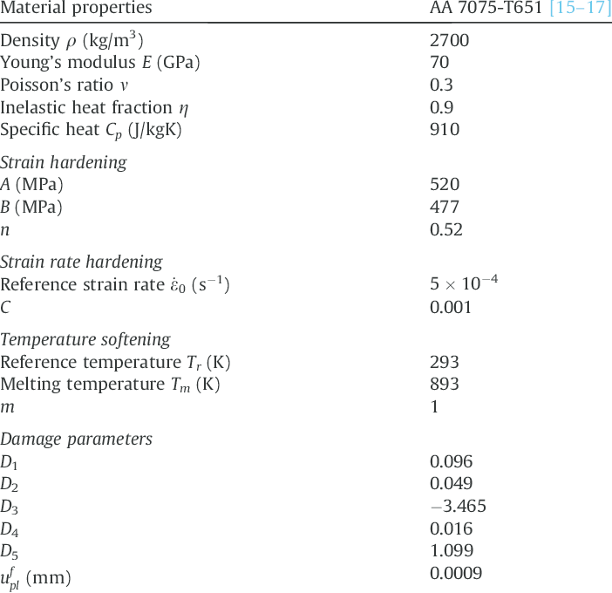
A1.

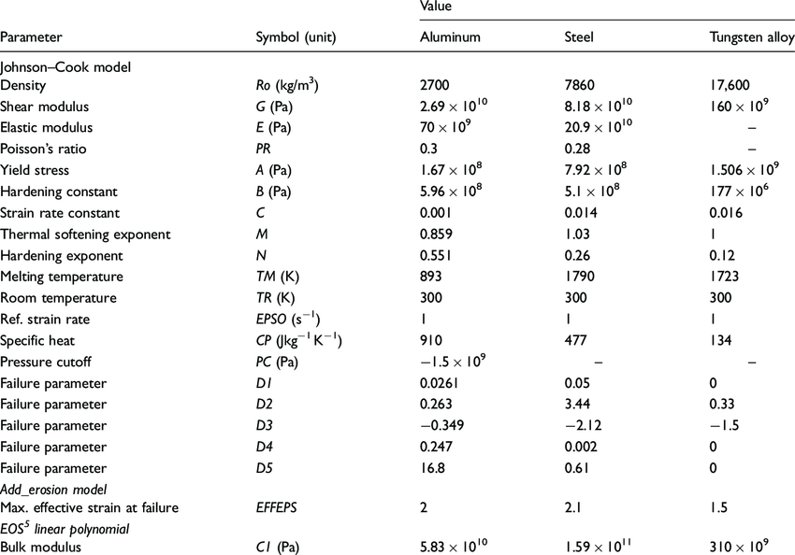
A2.

A3.

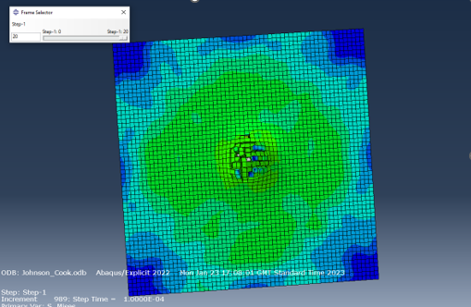

A4.

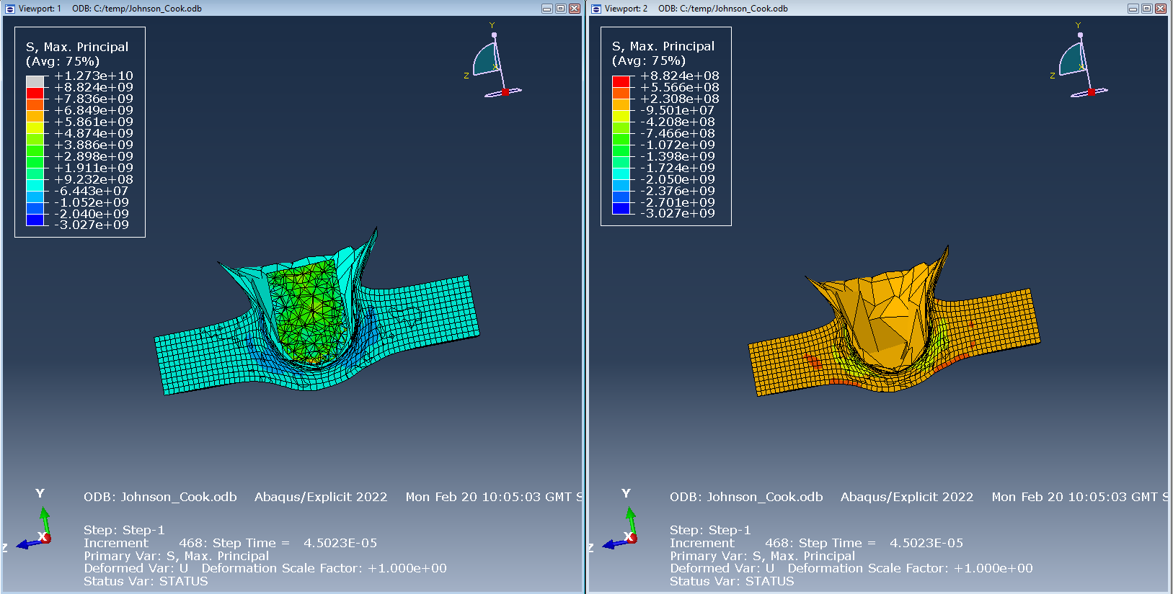

A5.

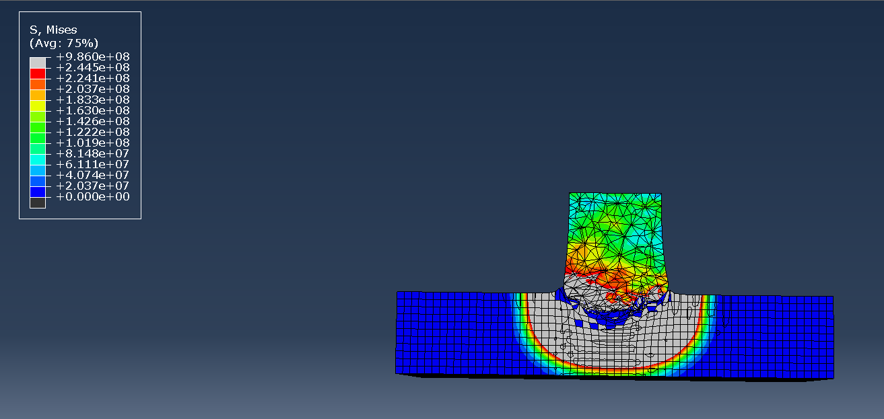

A6.



