
Practical Taguchi Trials – Systems Engineering
Arun Sherlock
15/04/2026
—
ACDA-5021
—
D. Holley & J. Steen

Contents
1. Abstract 3
2. Introduction & Objective 3
1.1 – Objective 3
2.2 – Introduction to the Taguchi Method of Experimentation 3
3. Methodology & Apparatus 4
2.1 Variables 4
2.2 Apparatus 4
2.3 Taguchi Array 5
2.4 Method 5
4. Results 6
3.1 - Results 6
4.2 – Verification 6
5. Discussion 7
5.1 – Variable Influence 7
5.2 – Verification 7
5.3 – Variation & Noise 7
6. Conclusion 7
7. Reflection 7
8. References 8

Abstract

Introduction & Objective

1.1 – Objective
A tasking has been assigned to determine the range of a catapult depending upon its setup, essentially to predict the range at which a projectile shall land when fired. To determine the ranges, a Taguchi methodology shall be utilized to reduce the number of individual experiments required and provide a reasonable estimation of the performance.
The catapult has several control variables: front band position, band anchor position, arm stop position & pull back length. The effect of these shall be considered, along with the variation potentially imparted by the operator by comparing use with two separate operators.

– Introduction to the Taguchi Method of Experimentation
The Taguchi Method of experiments was proposed by Genichi Taguchi, it provides a method which utilizes experimental and statistical analysis to implement quality control at design phase [1]. It allows the isolation and testing of variables in complex systems, with the aim of finding an optimum configuration with minimal experimentation [2]. The Taguchi methodology analyses matrices of independent variables, to find out their importance in the effect of a dependent variable [2], essentially considering the effect of change, for example in a chemical process the effect of output from the variation of chemical purity of a feedstock.
The method may be to support the definition of tolerances in product or process, via experimentation the effect of input variation on output variable can be analysed [3]. This can further be utilised to define critical elements- those which would have a major impact on safety or quality of a product or process and are of upmost importance to monitor or improve where necessary [4].
Mathematically, the methodology compares a number of variables in an orthogonally balanced matrix (whereby one variable does not influence the response of another) which provides a reliable estimation of the overall effect on the system, and the relevance of each variable in terms of the amount of change [2].

Methodology & Apparatus

2.1 Variables
The independent variables are the band anchor stop position, the band front position, the arm stop position, the operator & the pull back position (detailed on figure two). The dependent variable is the distance travelled by the projectile at first impact (defined as the point at which the ball first impacts the ground). Figure one describes these variables.
Variable No. | Type | Description
1 | Independent | Band Anchor Position
2 | Independent | Band Front Position
3 | Independent | Arm Stop Position
4 | Independent | Pull Back Distance
5 | Independent | Operator
6 | Dependent | Distance Travelled by Projectile
Figure 1 – Experiment Variables

2.2 Apparatus
The catapult is shown in figure two below, which also details the adjustments which can be made during this study. A small rubber ball is provided as the projectile, which sits within the cup on the arm. Measurements are made using a measuring tape, which runs from the front of the catapult along the firing line. Video is taken during trials, to capture the landing point accurately for measurement.
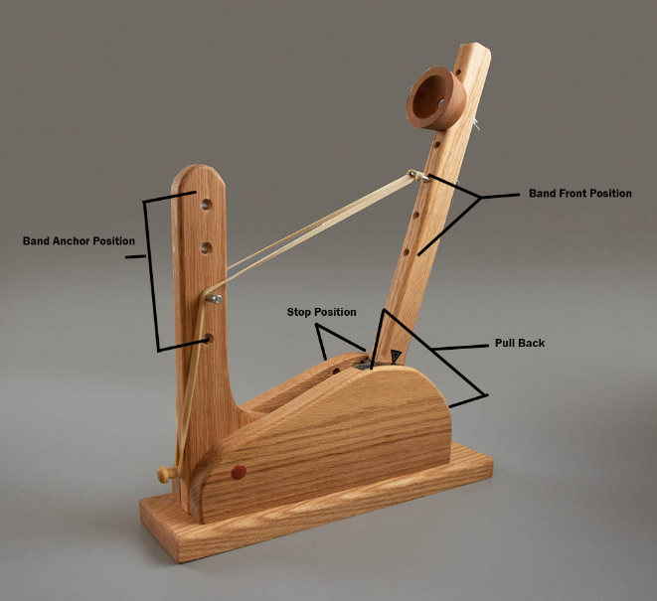
Figure 2 – Catapult with variables marked [5].

2.3 Taguchi Array
For this study, an L8 array (2^7) is used, this table is provided in Taguchi’s quality handbook [6], and provides the baseline for the calculations, it has been constructed so that the statistics are orthogonal. Each row describes an experimental setup, with settings for each described on two levels (1 or 2). These shall correspond to two different settings on the populated area, where the levels are defined as the actual value which corresponds to catapult setup. The approach reduces the number of experiments, while maintaining a reasonable estimation of the impact of each independent variable. The arrays are shown in figure three below. Interactions “1,2” and “2,4” are not used in this investigation, so a one two level is used in the populated array, so that this does not influence the results.
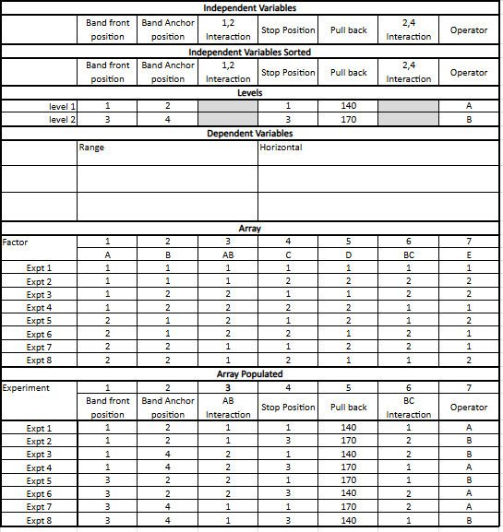
Figure 3 – Array Setup

2.4 Method
Each experiment is then carried out in accordance with the settings shown in the populated array, and distance captured by recording the point at which the projectile first lands. Once all experiments have been carried out, a validation is then carried out, where several experiments utilising the two independent variables identified as having the largest influence, while all others are not changed. The midpoint of these results is calculated, and a final experiment carried out firing at the midpoint setting of the catapult, if the recorded value is the same as the calculated midpoint, the verification is achieved.

Results

3.1 - Results
The range results for each experiment are shown in the yellow column in figure four. These are then compared to each other using equations predetermined by Taguchi [6] to provide the operability of the independent variables.
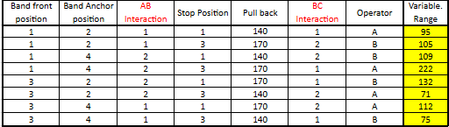
Figure 4 – Range Results
These calculations provide graphical data which represents the influence of each variable upon the result, where the line of the graph is steeper the variable had a greater influence and vice-versa. Figure five shows these results, where it was determined that the front band position, and pull back position had the largest influence.
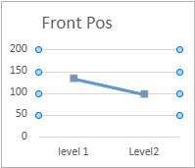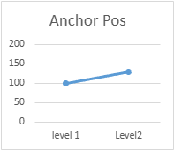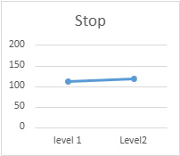
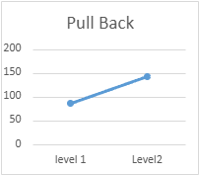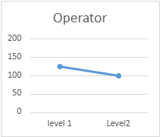
Figure 5 – Influence of Independent variables.

– Verification
Based upon the results of the main experiment, the main influence was from the catapult front position & pull back position, therefore these are used for the verification. Figure six below shows the experiments undertaken for the verification, with the results shown in yellow cells. The calculated midpoint based upon these was 158.375cm. A firing was undertaken at midpoint settings on the catapult, which produced a result of 158cm, verifying the results.
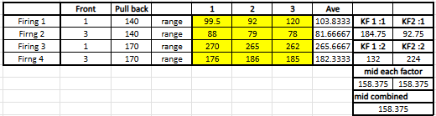
Figure 6 – Verification experiments

Discussion

5.1 – Variable Influence
As mentioned in section four, the two variables with the greatest influence are the front band position and pull back position, these were followed up by the anchor position and the operator. Finally, the arm stop position had the lowest influence on the overall range.

– Verification
The verification experiments calculated that the expected range at the midpoint should be 158.375 cm, the achieved range was 158 cm, with a variation of plus or minus 2 cm across four shots. This result proves that the experiment was run with a reasonable precision, and that the influence of the variables can be calculated to provide an expected range.

– Variation & Noise
In terms of noise, a few potential noises were identified during the experiments: the speed of release, the method of release and the degradation of the elastic band. The speed of release relates to the method of release – depending on the way the catapult was released, the acceleration of the arm will vary, which would impact the results. This could be improved by the addition of a holding and release mechanism in the catapult. In terms of the degradation of the elastic band, when band anchor & band front position are at the extremes & the catapult is used, the band may exceed its elastic limit. This would result in the degradation of the band over several firings, resulting in a decrease in its potential energy, and thus a decrease in the range.
In terms of variation, the impact of the operator was much greater than expected, which is likely due to some of the noises discussed above. Implementation of a system to release the catapult would reduce the noises, and result in a system which is less open to operator influence.

Conclusion
In conclusion, this experiment provides an insight into the methodology and theory behind the implementation of Taguchi trials, which may be utilized for several reasons. In terms of the results, a good quality of results was found based upon the accuracy of the verification.
In future, it would be beneficial to run these experiments at a greater level of detail using a larger array, to gain a better range of data, as well as implementing the improvements discussed in section 5.3 to improve the catapult. Further investigations could include signal to noise ratio analysis, to better understand the noises which could impact the results also.

Reflection
In reflection, this experiment proved to be successful, providing a good accuracy of results. The team worked effectively and supported each other where some did not fully understand the concept initially to achieve success.

References

[1] | S. Sanjay and M. Guha, “Optimization of Binder Jetting Using Taguchi Method,” Journal of Materials, vol. 69, no. 3, pp. 491-497, 2017.
[2] | J. W. Moffett, P. Fennell, C. M. Harmeling, D. Sheehan and A. Bleier, “The Taguchi approach to large-scale experimental designs: A powerful and efficient tool for advanced marketing theory and practice,” Journal of the Academy of Marketing Science, vol. 53, no. 1, pp. 949 - 954, 2025.
[3] | B. K. Rout and R. K. Mittal, “Tolerance design of robot parameters using Taguchi method,” Elsvier, Rajaasthan, 2005.
[4] | Six Sigma, “Understanding the Importance of Critical to Quality in Business,” Six Sigma, 18 09 2024. [Online]. Available: https://www.6sigma.us/six-sigma-in-focus/critical-to-quality-ctq/. [Accessed 12 04 2026].
[5] | Lean Games, “Lean Games,” Six Sigma, 01 01 2026. [Online]. Available: https://leangames.co.uk/product/the-lean-six-sigma-catapult-kit-with-flight-case/. [Accessed 15 04 2026].
[6] | G. Taguchi, S. Chowdhury and Y. Wu, Taguchi's Quality Engineering Handbook, Livionia: John Wiley & Sons, Inc., 2005.

