Question 1
A) IC1 is configured as an integrator. This op-amp configuration performs the mathematical operation of integration. The output responds to the changes of the input voltage over time, as it will produce on output voltage that is proportional to the integral of the input voltage.
B) IC2 is configured as a non-inverting amplifier. Feedback control can be achieved by applying a voltage output signal back into the inverting pin via the R1 and R2 voltage divider network, which produces negative feedback. This configuration produces good stability, low output impedance, and a very high input impedance.
C) The diode type device is a photodiode. This operates by light generating current proportional to the light intensity of the PN Junction depletion region. The diode will detect the volume of light, which will then feedback to the rest of the circuit to determine how much light the has been. In turn with the UV filter, it will filter out, and purify the light being received by the photodiode.
D) The cost of the system will increase, depending on the complexity of the system. As the complexity increases, so does the cost.
The installation also required more space, as there are more components to consider.
Once analogue is in place, there is no way to upgrade to digital. A new system would need to be implemented.
There is also no security when it comes to transmitting data.

Question 2
A) The CPU (Central Processing Unit) is the brains behind the operation. It allows everything to communicate with each other, and processes all the incoming data, for system to carry out the next set of commands.
The RAM (Random Access Memory) allows bits and data to be stored, and then recalled later. As it is only an 8-bit system, only 8 bits and be called at a time.
The EEPROM is where the program will be stored. This will contain on the commands that the system is required to take out.
The watchdog timer monitors the system and the program to ensure that it doesn’t get stuck or lost in its program. If this is the case, then watchdog timer will reset the system, so the program can start again, and end the cycle of the program getting stuck.
The temperature sensor will simply monitor the temperature of the system, to ensure its not getting to hot.
The TX and RX ultrasonic transducers will send ‘waves’ back and forth each other. The clock gate will then monitor how long it takes for the waves to reach each other. If the waves take too long, it will identify too much C02 in the air, which in turn will trigger the alarm.
B) 16-bit data bus.
C) 13 pins would be used to access 8Kb of RAM.
D) 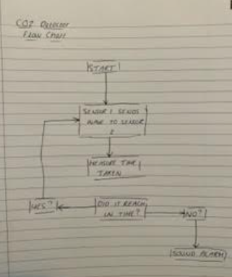
E) The most important criteria to start with would be cost. There would be no point to introduce a microprocessor to reduce cost, if the microprocessor costs more than the current components, unless it would vastly improve the system.
Secondly, ensuring that all the current parameters are met with a microprocessor. For example, the clock speed that the current system is running at, and the ability to run multiple functions at one time. Also, the amount of RAM and ROM available. The designer wouldn’t want to reduce the amount of memory available, but also wouldn’t want to over pay for too much memory.
Finally, the software available should also be taken in consideration. Software such as compilers, assemblers and simulators could have a big impact on how user friendly the system is to setup.

Question 3

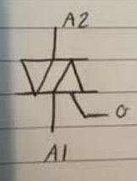
- Phase angle control when using a thyristor is designed to control the AC power across a load.
The AC power can be controlled by reducing or increasing the RMS value of the voltage appearing across the load. This is controlled by varying the angle of the TRIAC gate signal.

- The zero-crossing point refers to the point at which the sign of a mathematical function changes. For example, this could be positive to negative.
This is an important function for systems that send digital data over AC circuits, such as AC model trains for example.
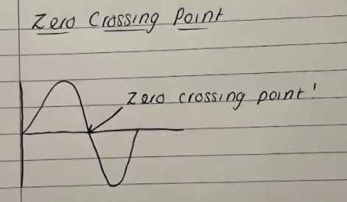
This method can also be used to process speech and estimate the fundamental frequency of speech.
In systems such as digital audio players, where an amplifier with digitally controlled gain will be applied to an input signal, will result in non-zero output signals when the gain amplifier is switched between its gain settings. This will result in identifiable and audible sounds coming from the audio player.
The reason for using zero-crossing points is so no interference is generated when switching electrical power, as it will be switched at the point of no current.
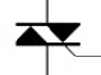
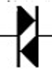
- This semi-conductor component is a TRIAC, which can be identified by the ‘Gate’.

The other semi-conductor component is a DIAC.

This circuit depends on phase control. The variable resistor is the main controller in this dimmer circuit. The capacitor C2 in circuit will get charge from the main supply. The variable reistsor and the DIAC will be used to control the brightness of the lower level, whilst R2 and C3 are used to reduce interfrence.

The light dimmer functions by changing the duty cycle of the AC voltage applied to the lights that are required to be controlled.
Light dimmers would typically be built with a thyristor. The fixed time for when the thyristor is activated in respect to the zero-crossing point will determine the power level. When the thyristor is activated, it will keep directing until the current passing through passes zero. The phase can be changed when the TRIAC gets activated, which in turn changes the duty cycle, which in turns changes the brightness of the light.

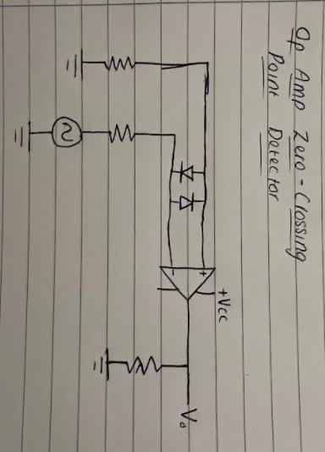
D) The input signal is connected to the inverting terminal whilst the non-inverting terminal is grounded through the resistors.
It is essentially a voltage comparator, that when the input crosses the zero of reference voltage, the output changes.

