Action points:
1. Read the learning outcomes in order to fully answer the question.
2. Proofread your work.
3. Use new theories and combine them with the old.

This essay has been constructed to explore some of the possible issues that arise for children and young people in regard to their mental health and wellbeing. During this assignment, national and school-based policies will be looked at, as well as theorists focusing on mental health and wellbeing such Bronfenbrenner’s Bioecological Model and Maslow’s Hierarchy of Needs. To help view certain strategies and programmes that are being used, occasionally a local school setting shall be referenced, further known as School A. A brief overview of the school according to their latest Estyn report (2018), School A had approximately 360 pupils registered between the ages of three and eleven. Within the number of pupils attending, thirty seven percent are in receipt of free school meals, which was well above the national average for Wales which is nineteen percent. Also above the national average is the number of children who identify as having an Additional Learning Need (ALN), School A has a figure of twenty nine percent, whereas the national average stood at twenty one percent. School A stands amongst a very diverse community, showing forty five percent of children have English as an Additional Language (EAL), with approximately thirty home languages being spoken amongst the families attending. School A is situated in a deprived area of a city in South Wales.
The National Health Service (NHS) undertook a study in 2017, on the rise of mental health amongst children and young people, their studies portrayed an increase over time in the prevalence of mental health disorders in children and young people between the ages of five and fifteen years old, (the age-group covered on all surveys in this series). It showed a rise from 9.7% in 1999 and 10.1% in 2004, to 11.2% in 2017. With these figures dramatically rising, it is no surprise that not only health professionals, teachers and even the general population are showing concern, Her Royal Highness (HRH) the Duchess of Cambridge Kate Middleton has been involved in the fight towards help for children and young peoples mental health and wellbeing. In a blog she composed as guest editor for the Huffington Post (2016), she describes ‘a child’s mental health is just as important as their physical health and deserves the same quality of support’. HRH went on to add that for some time parents showed embarrassment when discussing mental health issues of their children, afraid of the stigma, and the possibilities of detrimental future hopes.
The World Health Organisation (WHO), define mental health by:
Mental health is an integral and essential component of health. Health is a state of complete physical, mental and social well-being and not merely the absence of disease or infirmity. An important implication of this definition is that mental health is more than just the absence of mental disorders or disabilities. Mental health is a state of well-being in which an individual realizes his or her own abilities, can cope with the normal stresses of life, can work productively and is able to contribute to his or her community. Mental health is fundamental to our collective and individual ability as humans to think, emote, interact with each other, earn a living and enjoy life. On this basis, the promotion, protection and restoration of mental health can be regarded as a vital concern of individuals, communities and societies throughout the world.
With this definition being made, it further portrays the fundamental importance of mental health amongst adults and children alike. With the statistics heightening rapidly with children and young people suffering with mental health conditions and wellbeing issues, the wider picture needs to be viewed. There are varied reasons or explanations why certain children may encounter issues with their own mental health and wellbeing. The Mental Health Foundation in the UK have listed in their online article (2016), some of the reasonings and also some different types of mental health conditions that children could then develop. One of the risk factors labelled is that “having a parent who has had mental health problems, problems with alcohol or has been in trouble with the law.” (Mental Health Foundation, 2016.) This is also an ongoing issue in Britain, which is having a contagion effect for the nation’s children. According to data transferred from a number of national surveys that were taken in Wales in 2016, shows there were nearly five thousand ‘children in need’ registered with local authority children’s services due to parental substance misuse including both alcohol and drug use. The term children in need include those who are likely to have their health significantly impaired or are unlikely to maintain a reasonable standard of health and development without the provision of local authority children’s services (Houses of Parliament, 2018). Children who had parents suffering from alcohol and/or substance misuse, were more at risk of suffering mental health issues, or being at risk of being part of the Adverse Childhood Experiences (ACE’s) issues in the future. Adverse Childhood Experiences are described as traumatic events, particularly those in early childhood that significantly affect the health and wellbeing of people in Wales, the rest of the UK and the world (Ace Aware Wales, 2021). According to the study produced for Public Health Wales in 2015, exposures to Ace’s can alter a child or young persons brain development, as well as changing the development of their immunological and hormonal systems, and those with a greater exposure are at further risk to develop health harming issues and antisocial behaviours. (Public Health Wales, 2015, Page 3.) Findings show also that preventions in Wales, will not only improve early years experiences for the children born in Wales, but could further help reduce numbers of people experiencing health harming disorders helping reduce the strain felt by the Welsh NHS. Since interviewing two thousand participants in 2015, pioneering national policies and programmes have been created which will aim to identify and intervene with the children and young people who need the support, better equip parents with skills to avoid ACE’s and encourage development of social and emotional wellbeing (2015, P.20).
Similarly to a figure used to show the effect stages of ACE’s (see appendices) is Maslow’s hierarchy of needs triangle. With the Public Health Wales figure showing the domino theory between experiencing ACE’s and the negative health conditions or behaviours that can follow on. Abraham Maslow (1908-1970) is the theorist behind the ‘Hierarchy of Needs’ model, which some view as his most famous piece of work. He suggests that an individual’s response to their learning can change and be dominated at any time by what needs priority (Bates, 2019, P.66). The model has been divided into two phases, whilst the lower order is more to do with the individuals physical and psychological aspects of life and learning, Maslow argues that the upper tier of needs can not be achieved without the lower needs being met first. In relation to Maslow’s model and children in education, a child or young person’s basic survival needs, food, warmth and rest, alongside their psychological needs, stability and organisation, need to be achieved before a child can fully focus on the planned curriculum for the day ahead. With this in mind, breakfast clubs were created. Autumn 2014 marked the tenth anniversary of the Free Breakfast in Primary Schools scheme for Wales. Children having a healthy breakfast may help to improve the child or young person’s health and concentration, hopefully this then may progress to help them to learn better withing their classroom setting (WAG, 2015).
Another factor which could contribute to a poorer mental health within children and young people, is current climates and the world around them, more recently Covid-19, a global pandemic. The children and young people currently of a school age, have had all routines they have known through education changed in a very short period of time, schools closed, education turned to online resources and they had to spend more time than ever before at home, isolated from friends, family and the outside world. NHS England (2020), who conducted the study in children’s mental health in 2017, created a follow up study to coincide with the first wave of the pandemic, the results portrayed that rates of probable mental disorders have further increased since 2017. In 2020, one in six (16.0%) children aged between five and sixteen years old were identified as having a probable mental health disorder, increasing from one in nine (10.8%) in 2017 with the increase being evident in both boys and girls. Young Minds organisation, a child and young person’s mental health charity, contacted two thousand children and young people to gain information on their mental health during the pandemic and the return to schools after the sudden closures (2020). The statistics shown in their report produced a number of key findings, fifty eight percent of the participants all may have experienced some mental health issues before the pandemic, this rose to sixty nine percent when schools were re-opened. Only fifteen percent agreed that there was enough information and support available for their mental health at their current schools while fifty eight percent disagreed. Schools are not necessarily to blame, the times were unprecedented, and something nobody had ever experienced before to know the best way to handle the situations unfolding before the world. School A initially in the first wave and lockdown, as well as the online learning, schools were open for the children of key workers as emergency childcare, and for the children classed as vulnerable whether that was by the school or by the local authority. Out of a pupil list of three hundred and fifty, these strict criteria given by authorities meant that less than thirty children qualified for the childcare, meaning more pupils staying at home, safe from the virus, but were they really the safest places for a minority of our children? Sion Barry, business editor for Business Live, reported in July 2020, that according to UK Government statistics, 378,400 people had been put on the furlough scheme in Wales, totalling twenty nine percent of the Welsh workforce, they were now at home. This would of added to the stress of a pandemic for families, being out of work, low finances, children at home all day. The NSPCC have agreed that risks were higher during the lockdown for children, due to parents and caregivers being home with added stress, plus restrictions in normal safeguarding measures (Romanou and Belton, 2020). School A, as well as other schools across the country, saw an increase in children being classed as vulnerable after the schools reopened after the initial closures. The proximity that these families endure daily, can be related back to Urie Bronfenbrenner’s bioecological model. Bob Bates (2019, P.194), describes Bronfenbrenner’s Ecological Systems Theory (EST) as an emphasis between the balance of nature and nurture, or heredity and environment. To help visualise the model, he places the child at the centre of concentric circles, those illustrating the different factors which can influence the individual at the centre. The immediate circle replicates the child’s microsystem, the direct influence, their family and friends. Any discomforts or issues that arise within this system can negatively impact the next layer or the mesosystem, the broader surroundings and direct influences on the child or young persons development, such as education and healthcare. The following circles illustrate the exosystem, the macrosystem and the chronosystem, all indirect influences which possibly effect the individual. This EST directly links to Maslow’s hierarchy of needs, with both the first layers, or lower tier relating to a child’s physical and psychological needs, and both theorists believing the environment around the child has a large part to play in their development, positive relationships, nurture is needed to help each individual child and young person positively interact in day-to-day activities and promote healthy wellbeing within. To add to stressors for families and children attending schools, the current death rate due to Covid-19 in Wales as of December 2020 stands at 4,651 (Duffy, 2021). The grief that the deaths caused families, will add to existing mental health issues, also causing new depression and anxiety symptoms. School A during the first wave and lockdown, issued a training course, Cruse Bereavement Training, which staff, if it was needed, would have the necessary skills to help support the child or young person find coping strategies to help process the grief, but ultimately give them someone to talk to about emotions being felt.
To help promote wellbeing and support mental health in the classroom setting, School A amongst other schools, are enrolled in a programme called Thrive. The Thrive programme describes itself as:
Thrive provides the tools, skills and insights needed to help children become more emotionally resilient. As a result of implementing the Thrive Approach, children and young people are better placed to engage with their learning and with life (2021).
School A has specifically trained members of staff who will take children into calmer, designated areas of the school, those who are identified as needing support, where they undertake specific tasks to improve their emotional wellbeing. During weekly Planning Preparation and Assessments (PPA) for teachers, the teaching assistants (TA’s) in class will participate in Thrive activities with the class they are covering. They are usually arts and crafts based and encourage children to talk about emotions whilst creating their craft.
The Welsh Assembly Government (WAG) created the document ‘Thinking positively. Emotional health and well-being in schools and Early Years settings.’ in the summer of 2010, to help give guidance to schools and education settings on promoting healthy wellbeing amongst their pupils. They list a vast number of benefits for not only the teaching and learning aspects of schooling, but also behaviour, attendance and staff recruitment (WAG, 2010, P.3). WAG base their policy on the United Nations Convention on the Rights of the Child (UNCRC) Every Child Matters Act, although they view and aim to deliver all of the articles from the UNCRC, they focus on these four articles, and their promises for them:
“Article 6: All children have the right to life. Governments should ensure that children survive and develop healthily.
Article 19: Governments should ensure that children are properly cared for, and protect them from violence, abuse and neglect by their parents, or anyone else who looks after them.
Article 23: Children who have any kind of disability should have special care and support, so that they can lead full and independent lives.
Article 39: Children who have been neglected or abused should receive special help to restore their self-respect.” (WAG, 2010, P.4.)

Both theorists previously mentioned in this document, Maslow and Bronfenbrenner, their models and theories can be related to the WAG policy and the UNCRC articles of Children’s rights, the common ground between them all is the wellbeing being the foremost important issue to immediately rectify, the microsystem, the physical and psychological tiers that need to be addressed before a child or young person can confidently carry out day to day routines and activities.
In conclusion, the issues and matters discussed prior throughout the document, need attention still. It is obvious with the policies provided, and statistics shown from national studies that children’s mental health is increasing but even with the work and guidelines produced to help, it is not something that will disappear rapidly, more work and support will be needed. During a global pandemic, support has been halted due to new work and social distancing guidelines, but this support is needed more now than ever before. When the world is safe again, our children and young people will need our safety, guidance and support immediately to help themselves and future generations. Vikram Patel, Indian scientist conveyed this quote, which everybody needs to hear, we can all help.
“There is no health without mental health; mental health is too important to be left to the professionals alone, and mental health is everyone’s business.”

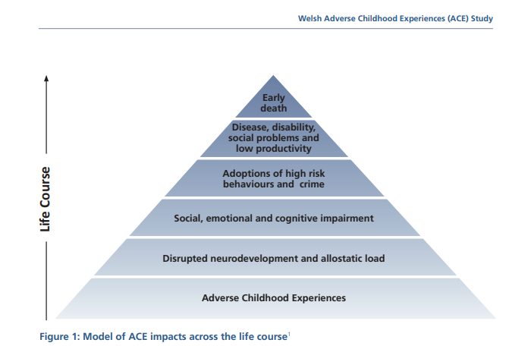
Appendices.

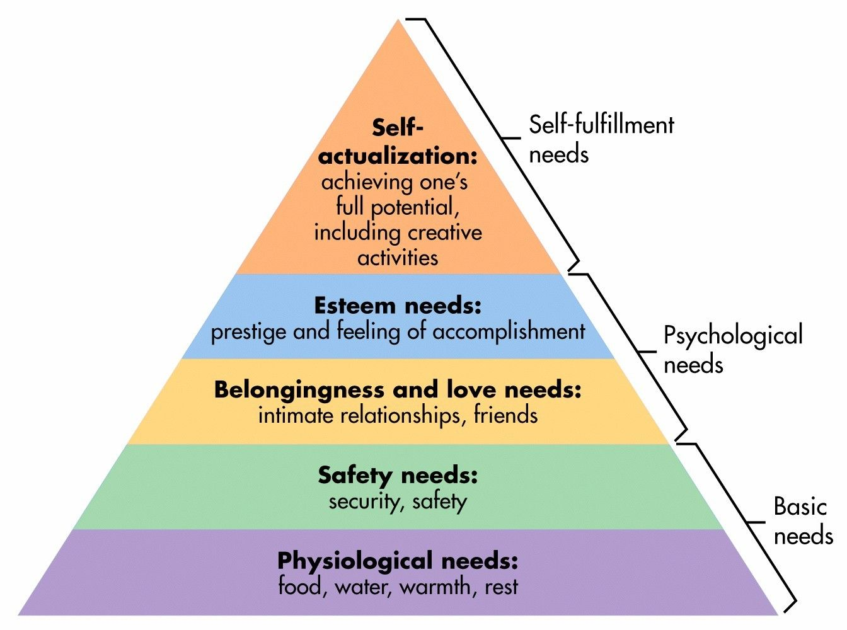
Reference List.
Ace Aware. (2021), Together, Wales can tackle ACEs. Join the movement!. Available at: https://www.aceawarewales.com/welcome. (Accessed: 10th January 2021).
Barry, S. (2020), How many people in Wales have been furloughed? Available at: https://www.business-live.co.uk/economic-development/how-many-people-wales-been-18599417. (Accessed: 10th January 2021).
Bates, B. (2019) P.194, Learning Theories Simplified. Second Edition. London: Sage Publications.
Bates, B. (2019) P.66, Learning Theories Simplified. Second Edition. London: Sage Publications.
Duffy, S. (2021), Covid-19 in Wales: What do the stats tell us? Available at: https://www.bbc.co.uk/news/uk-wales-52380643. (Accessed: 10th January 2021).
Estyn (2018), Website withheld to remain anonymous.
Houses of Parliament (2018), Parental Alcohol Misuse and Children.
Available at: file:///C:/Users/victo/Downloads/POST-PN-0570.pdf. (Accessed: 10th January 2021).
Mental Health Foundation (2016), Children and young people. Available at: https://www.mentalhealth.org.uk/a-to-z/c/children-and-young-people#:~:text=The%20emotional%20wellbeing%20of%20children,well%2Drounded%2C%20healthy%20adults. (Accessed: 10th January 2021).
Middleton, K. (2017), Let's Make a Real Difference for an Entire Generation of Young Children. Available at: https://www.huffingtonpost.co.uk/her-royal-highness-the-duchess-of-cambridge/lets-make-a-real-difference-for-young-children_b_9246336.html?guccounter=1. (Accessed: 10th January 2021).
NHS (2017), Mental Health of Children and Young People in England 2017. Available at: https://digital.nhs.uk/data-and-information/publications/statistical/mental-health-of-children-and-young-people-in-england/2017/2017#key-facts. (Accessed: 10th January 2021).
NHS (2020), Mental Health of Children and Young People in England, 2020: Wave 1 follow up to the 2017 survey. Available at: https://digital.nhs.uk/data-and-information/publications/statistical/mental-health-of-children-and-young-people-in-england/2020-wave-1-follow-up. (Accessed: 10th January 2021).
NSPCC (2020), Social isolation and the risk of child abuse during and after the coronavirus pandemic. Available at: https://learning.nspcc.org.uk/research-resources/2020/social-isolation-risk-child-abuse-during-and-after-coronavirus-pandemic. (Accessed: 10th January 2021).
Public Health Wales (2015), Adverse Childhood Experiences and their impact on health-harming behaviours in the Welsh adult population. Available at: https://phw.nhs.wales/files/aces/aces-and-their-impact-on-health-harming-behaviours-in-the-welsh-adult-population-pdf/. (Accessed: 10th January 2021).
Romanou, E. and Belton, E. (2020), Isolated and struggling: social isolation and the risk of child maltreatment, in lockdown and beyond. London: NSPCC.
Thrive (2021), About us. Available at: https://www.thriveapproach.com/about-thrive/about-us/. (Accessed: 10th January 2021).
WAG (2010), Thinking positively. Emotional health and well-being in schools and Early Years settings. Available at: https://gov.wales/sites/default/files/publications/2018-12/thinking-positively-emotional-health-and-well-being-in-schools-and-early-years-settings.pdf. (Accessed: 10th January 2021).
WAG (2015), Free Breakfast in Primary Schools. Available at: https://gov.wales/sites/default/files/publications/2018-03/free-breakfast-in-primary-schools.pdf. (Accessed: 10th January 2021).
WHO (2018), Mental health: strengthening our response. Available at: https://www.who.int/news-room/fact-sheets/detail/mental-health-strengthening-our-response. (Accessed: 10th January 2021).
Young Minds (2020), Coronavirus: Impact on young people with mental health needs.
Available at: https://youngminds.org.uk/media/4119/youngminds-survey-with-young-people-returning-to-school-coronavirus-report-autumn-report.pdf. (Accessed: 10th January 2021).

