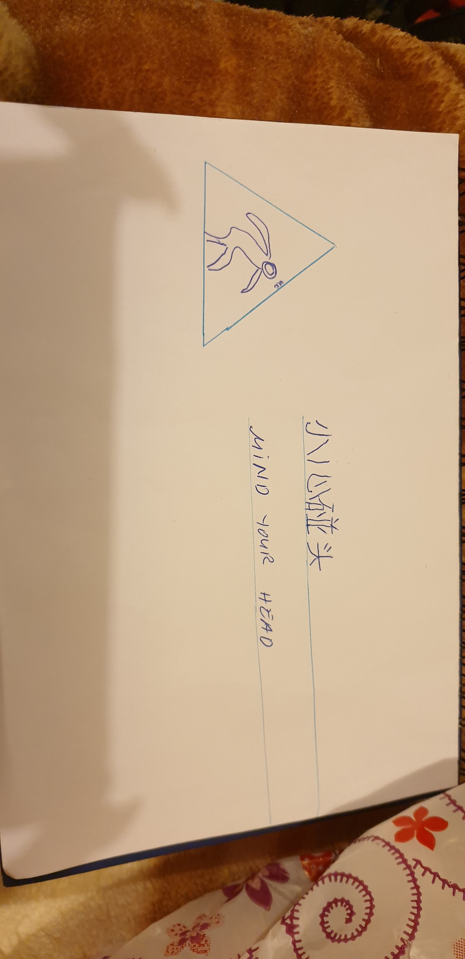
I'm writing this text because the websites turnin asks me to write 20 words to submit my assignment thanks alot for reading this useless text but is here just to make up the 20 unneeded words that the website has. THANKS FOR READING THIS USELESS TEXT!

