
Skills for the Workplace
Module Assignment Submission
Student Name: | Jemma Rees
Student Number: | 2008032
Module No: | BMSK4002
Module Title: | Effective Team Working and Communication  Part 2

Statement of Confirmation of Authenticity
By the act of making this submission, the student declares that this is the work of the student named above. The work has not, in whole or in part, been knowingly presented elsewhere for assessment, or where assessment has been built on a previous assessment, this has been identified. Where materials have been used from other sources it has been properly acknowledged. If this statement is untrue, the student acknowledges that an assessment offence has been committed.
Attention is drawn to the plagiarism and unfair practice policies of both the University and of ILM.

Table of Contents
Part 2 Communication 3
1.0 Effectiveness of Workplace Communication 3
1.1 Communication Cycle 3
1.2 Communication in the workplace 6
1.3 Personal Experiences of workplace communication 7
1.4 Active Listening 7
2.0 8
2.1 Assessing Own Communication Skills 8
2.2 Gap Analysis 9
2.3 PDP 10
References 11
Appendix A 13
Presentation Feedback 13
Evaluation 14
Appendix B 15
Appendix C 16

Part 2 Communication

1.0 Effectiveness of Workplace Communication

1.1 Communication Cycle

Effective communication is perhaps the most critical workplace skill. (Moriarty, 2010). Communication is the ability to send information, to receive and most importantly, to understand information, Skills You Need (2018). A well-known and well-resourced model is 'The Shannon and Weaver Model' (1949); this model later became known as 'Mother of all models' (Businesstopia, 2018).
The Shannon and Weaver model (1949), simply put, is a message sent by a preferred method to a destination via a suitable channel. However, external factors such as noise could skew the message, resulting in the misunderstanding of the received message. Feedback is a necessary component to be used by the receiver to gain clarity of the original message.
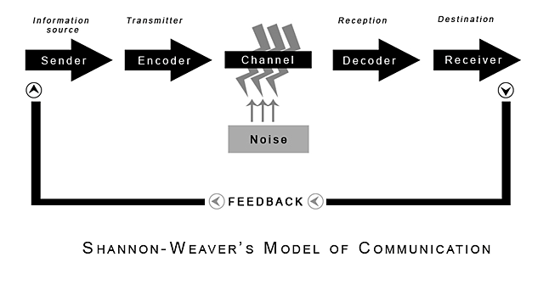
(Shannon and Weaver, 1949)
To better understand the communication process, imagine an employee arrives at work, their manager needs to make them aware of a critical unscheduled meeting that has just been arranged.
The manager calls from one side of the office to the other where the employee has just entered, "Urgent meeting at 10:15 am in room 11".
- The sender (information source) is the brain of the manager
- The mouth is the encoder (transmitter) that encodes the message to English
- The air (office space) between the manager and the employee is the channel
- The employees' ear is the decoder (reception)
- the employees brain the receiver (destination)
Imagine the interference in the channel (the office) is the conversation of colleagues, telephone calls, shuffling of paperwork and is called noise. (Businesstopia, 2018)
Due to the interference in the channel (noise), the message received by the employee is "Meet me for 10 in room 15 at 11".
If the employee is not prepared to give feedback, the message has been received but not understood correctly, perhaps leading to a disappointed manager and personal frustration. It is essential to understand why the employee may not be willing to give feedback. Maybe the manager is unapproachable and unreceptive to questions and thinks it is the employees' fault for not listening.
If the work environment is inclusive and encouraging, the employee is likely to be confident in supplying feedback. They can clarify the specific details of the message, ensuring that they attend the correct meeting room at the right time; they could also gain more information as to the purpose of the meeting and whom else is attending.
A poorly received message may have been impacted by noise. Kobiruzzaman (2019) writes that communication noise is present in all communication forms, whether face-to-face, written, visual or auditory. There are five basic types of noise depicted below.
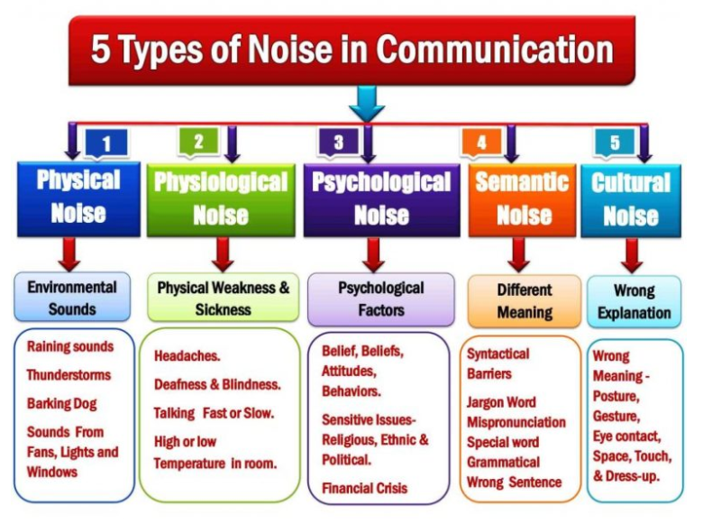
Communication Noise- 5 Types of Noise in Communication (newsmoor, 2019)
An article by Moriarty (2010) provides a guide to ensuring effective interpersonal communication. The article's main points advise that being understood is likely to be the biggest challenge, especially when giving feedback. Possible reasons for misinterpretation include but are not limited to:
  - Culture
  - Education
  - Gender
  - Age
  - Health
  - Status
  - Confidence
  - Life experiences
These barriers are further impacted by personal judgements and motives coupled with body language. Interestingly verbal communication accounts for approximately 38% of communication, with 55% of communication portrayed through facial expressions and body language. Moriarty (2010) concludes that understanding one's intent before communicating can assist the receiver in understanding the message. Be aware of the language used, the use of 'I' promotes inclusion and tells the receiver how you feel. In contrast, the word 'you' can be seen as accusatory. The use of clear and concise language will aid the receiver in their understanding. However, do not assume that they have understood; ask for confirmation.
Another critical factor in effective communication is the channel by which the communication is sent. An article by Jouany and Martic, (2020) states that there are six main types of communication channels and that these can be further divided into two groups. Firstly, communication channels by formality and secondly, communication channels by modes. Briefly, these comprise of:
Formality
Formal
Policies and procedures of an organisation, disseminated by way of business plans, annual reports, and company-wide communications.
Informal
Also used to communicate business information but in a more relaxed method such as impromptu conversations in the office.
Un-Official
This refers to communications between employees that do not relate to business matters.
Mode
Digital
Electronic communication such as e-mail, company intranet, this could also include customised online programmes. - Jouany and Martic, (2020) suggest that e-mail is the most frequent method.
Face-to-face
This method of communication is much more personal and allows necessary human interaction, we read body language intuitively, and without this, the message can be misinterpreted.
Written
Possibly the least common method in recent years; however, on occasion, it is necessary to write and post communications, perhaps for official documents that require a wet signature.

1.2 Communication in the workplace

An article by Juneja (2015) states, ' Communication is directly proportional to the choice of words or its content'. She continues, communication is information from the sender to the recipient without consideration as to the content or if it has been understood; however, effective communication is sent and received as the sender intends.
This can be further supported by Peter Blenkinsop (2010) and his Communication Cycle.
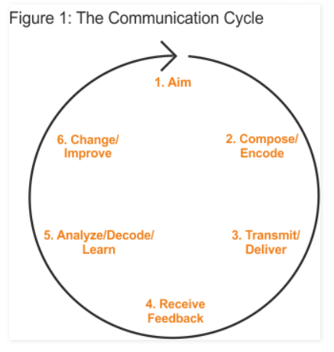 Peter Blenkinsop (2010)
Unlike 'The Shannon and Weaver Model' (1949), which can be seen as misleading due to its mathematical basis (Course Hero Inc, 2016). Blenkinsop (2010) encourages a deeper understanding of communication by considering six key steps and by continuously asking, Why? What? Who? And How? Due to the cyclical nature of this process, the user will continuously learn, via feedback, as to how effectively their communication has been received and how it could be improved in future.

1.3 Personal Experiences of workplace communication

Public sector companies tend to have already implemented robust communication methods and regularly seek feedback to improve and monitor the successful exchange of information. Fredriksson and Pallas, (2018). However, within all organisations, there are uncontrollable variants. Therefore, you cannot blindly attribute communication methods to all situations.
In my personal experience, workplace communication is never straightforward. I feel that this is a common situation in our workplaces by narcissistic managers. Once such experience only happened a few years ago. Our team were called into a telephone meeting, and the manager explained a new process that we were expected to follow. The information was not clear and contradictory. I wanted to understand the process better and the motivation that led to this new procedure. I also tried to explain that there were several daily situations where this would not be possible or practical.
Unfortunately, the manager was not receptive to feedback and mistook my questions as a challenge of authority. The final response from the manager was, "just do it". The entire team were left frustrated and confused. I decided to e-mail the manager after the call to explain my confusion and that the reason I asked so many questions was to understand better the procedure to ensure I was correctly carrying out my duties. Not only was the e-mail ignored, but my line manager received a telephone call advising that I had behaved in an unacceptable way and that if I did this again, I would receive a verbal warning.
I believe that had the conversation taken place face-to-face, this misunderstanding may have never happened. Due to the lack of non-verbal communication, such as facial expressions and body language, the manager was unable to understand my intent. Also, had the manager responded to my e-mail or spoken to me again privately, we may have been able to work through the misunderstanding. However, it was left unresolved. The manager seemed preoccupied with being right and in charge above ensuring that the correct message had been received.
For communication methods to be successful within the workplace, it would be beneficial for the manager to explain to the team the process and to be receptive to feedback; without this, it is not effective communication.

1.4 Active Listening

Indeed (2021) states that active listening is a 'soft skill' and is an essential component of effective communication. The article goes on to state that active listening requires that the listener gives their undivided attention to the speaker, and through practising empathy, the listener will be able to focus on the feelings and needs of the speaker without getting distracted. Part of this process enables the listener to correctly read the speaker's body language and understand non-verbal communication.

These include:
- Body language
- Eye movements
- Tone of voice
Active listening provides a deeper connection to the speaker and ultimately a deeper understanding to facilitate effective communication. It is important to clarify any points that are not fully understood, and this could be done by paraphrasing what has been said.

2.0

2.1 Assessing Own Communication Skills

To assess my own communication skills, I completed two online tests; the first one was created by MindTools (2021) called 'The Communication Quiz' (Appendix C). My score is 55; this indicates that I am capable of communicating but that I sometimes experience problems. The online test provides further information with suggestions as to how I could improve. One suggestion is that I consider my approach and focus on receiving messages effectively as well as sending them. I agree with this overall; I am a confident communicator and feel that I usually make myself understood. However, I think that sometimes I may rush into sending an e-mail or voicing my opinion before I have carefully considered all aspects. Due to poor self-esteem, I also overthink feedback, and I am inclined to interpret the received message as negative.
The second online test called 'Interpersonal Skills Self-Assessment' has been created by Skills You Need (2021) (Appendix C). I scored 70%; this score suggests that my interpersonal skills are 'about average'. It continues to state that I have a 'basic grasp' of these skills but that there is more I can do to improve. Suggestions include practice and development of interpersonal skills to further enhance relationships.
I was surprised to receive this feedback as I think I am empathic and understanding. I utilise these skills whilst actively listening; this helps when considering the viewpoints of others. However, upon reflection, I understand that there are certain areas where I am lacking.
Interpersonal skills, simply put, are the behaviours and tactics used to effectively interact with others (Tarver, 2021). I now realise that confidence is one of these behaviours, an area where I can sometimes be lacking. Another area I need to practice is conflict; I am very uncomfortable with conflict due to historic personal circumstances. I am keen to learn how to overcome this.

2.2 Gap Analysis

After receiving presentation evaluations from my peers, I collated the data into one document (Appendix A). Then, after reflecting upon my communication skills, I performed a gap analysis to identify areas that require further development.
Objective | Current Position | Deficiency | Action
What do I want to do? | What can I already do? | What am I lacking? | How do I fix this?
Learn how to successfully manage conflict without it affecting me emotionally. | I am very good at avoiding conflict due to the emotional effect.  I can be diplomatic to avoid potential conflict. | The ability to understand that conflict can be necessary and that it is not personal. | I will practice viewing these situations objectively to better understand how they are beneficial to communication.
Gain confidence in public speaking. | I can speak publicly and can present myself as professional. | I lack emotion and personality in my delivery. | I will practice public speaking to gain confidence in myself and my abilities.
Learn how to correctly interpret feedback. | I am happy to receive feedback, and I can identify the key points. | The ability to view the feedback objectively and to not take negative feedback personally. | I need to review feedback and break it down into more manageable sections to fully understand the message. Also, to seek clarity where I do not understand.

2.3 PDP

To further analyse my communication skills, I completed a personal development plan (PDP). I employed the use of the S.M.A.R.T method (Doran, 1981) (Appendix B) to aid in this process. In addition, I have reflected upon and evaluated the presentation feedback forms in Appendix A.
Objectives | Tasks | Success Criteria | Time Frame | Resources
List your Goals | What do you need to do to achieve these goals? | How will you identify your success? | When do they need to be done by? | Who or what do you need to help you?
To manage conflict without it impacting me emotionally. | I need to learn and research conflict management in a professional environment. | When I have achieved a greater understanding of conflict and its place in the workplace, I would also like to gain a CPD certification. | Either before I enter a management position or by the end of my degree (2023) | Continued studying with a course such as Online Conflict Management Training Course  provided by High Speed Training, (2021)
To gain confidence in public speaking. | I need to practice public speaking in a variety of situations. | When I no longer feel anxious in these situations and my mind is clear on what I am doing. | Either before I enter a management position or by the end of my degree (2023) | I will practice recording myself and listening back to see if I can identify areas for improvement. I will also ask peers for feedback.
Correctly interpret feedback. | I need to take my time when considering feedback and ask for clarity when I do not understand to avoid misinterpretation. | When I can receive feedback and not automatically look for a negative connotation, I will have succeeded. | Six months | To support this, I will need further study into interpersonal communication, and I will research this topic online, consulting academic resources.

References

Blenkinsop, P. (2010) The Communication Cycle. [online] Available at: http://manyana-education.blogspot.com/2010/10/communication-cycle.html (Accessed: 23 May 2021)
Businesstopia (2018) Shannon and Weaver Model Of Communication - Businesstopia [Online]. Available at https://www.businesstopia.net/communication/shannon-and-weaver-model-communication (Accessed 23 May 2021).
Course Hero Inc (2016) The weaknesses of the Shannon and Weavers communication... [Online]. Available at https://www.coursehero.com/file/p1dsq44/The-weaknesses-of-the-Shannon-and-Weavers-communication-model-is-it-can-be/#:~:text=The%20weaknesses%20of%20the%20Shannon%20and%20Weaver’s%20communication%20model%20is,group%20communication%20and%20mass%20communication. (Accessed 26 May 2021).
Doran, G. T. (1981). There's a S.M.A.R.T. Way to Write Management's Goals and Objectives. Management Review, 70, 35-36.
Fredriksson, M. and Pallas, J. (2018) "Public Sector Communication," ResearchGate, unknown pp. 1–11 [Online]. DOI: 10.1002/9781119010722.iesc0141 (Accessed 26 May 2021).
High Speed Training (2021) Online Conflict Management Training Course [Online]. Available at https://www.highspeedtraining.co.uk/business-skills/conflict-management-training-course.aspx (Accessed 25 May 2021).
Indeed (2021) How to Improve Your Active Listening Skills [Online]. Available at https://uk.indeed.com/career-advice/career-development/active-listening-skills (Accessed 27 May 2021).
Jouany, V. and Martic, K. (2020) Top Communication Channels to Consider for Your Business [Blog] 8 Oct. Available at https://blog.smarp.com/top-communication-channels-to-consider-for-your-business (Accessed 24 May 2021).
Juneja, P. (2015) Difference between Communication and Effective Communication [Online]. Available at https://www.managementstudyguide.com/difference-communication-and-effective-communication.htm (Accessed 20 May 2021).
Kobiruzzaman, M. M. (2019) Communication Noise, 5 Types of Noise in Communication Barriers [Online]. Available at https://newsmoor.com/communication-noise-5-types-of-noise-in-communication-barriers/ (Accessed 20 May 2021).
MindTools (2021) How good are your communication skills? [online] Available at: https://www.mindtools.com/pages/article/newCS_99.htm (Accessed 20 May 2021).
Moriarty, M. (2010) workplace misunderstandings Archives - Path to Change [Online]. Available at https://pathtochange.com/tag/workplace-misunderstandings/ (Accessed 20 May 2021).
Newsmoor (2019) Communication Noise, 5 Types of Noise in Communication Barriers [Online]. Available at https://newsmoor.com/communication-noise-5-types-of-noise-in-communication-barriers/ (Accessed 24 May 2021).
Shannon, C. and Weaver, W. (1949) The Mathematical Theory of Communication. Urbana: University of Illinois Press. (Weaver, 1949)
Skills You Need (2018) Communication Skills | SkillsYouNeed [Online]. Available at https://www.skillsyouneed.com/ips/communication-skills.html (Accessed 23 May 2021).
Skills You Need (2021) Interpersonal Skills Self-Assessment. [online] Available at: https://www.skillsyouneed.com/ls/index.php/343479 (Accessed: 24 May 2021)
Tarver, E. (2021) Why Everyone Needs Strong Interpersonal Skills [Online]. Available at https://www.investopedia.com/terms/i/interpersonal-skills.asp (Accessed 24 May 2021).
Think Marketing (2012) Planning for new objectives? Here is how to create SMART goals [Online]. Available at https://thinkmarketingmagazine.com/how-to-create-smart-goals/ (Accessed 24 May 2021).

Appendix A

Presentation Feedback
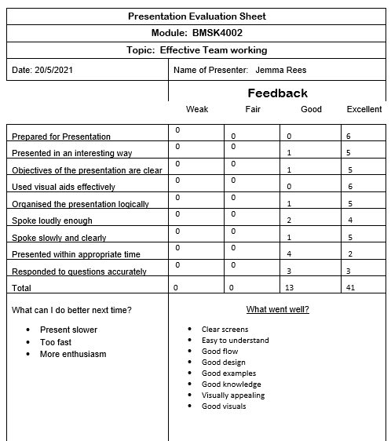

Evaluation
After collating the data from the presentation evaluation forms, I was pleased that all responses were either good or excellent. I worked hard to create my presentation and would have been disappointed to receive weak or fair responses.
I decided to total the responses into percentages to allow a clear overview. 24% thought that elements of the presentation were good, and 76% thought that elements were excellent.
Evaluation Criteria | Weak | Fair | Good | Excellent
Prepared for Presentation | 0 | 0 | 0 | 6
Presented in an interesting way | 0 | 0 | 1 | 5
Objectives of the presentation are clear | 0 | 0 | 1 | 5
Used visual aids effectively | 0 | 0 | 0 | 6
Organised the presentation logically | 0 | 0 | 1 | 5
Spoke loudly enough | 0 | 0 | 2 | 4
Spoke slowly and clearly | 0 | 0 | 1 | 5
Presented within appropriate time | 0 | 0 | 4 | 2
Responded to questions accurately | 0 | 0 | 3 | 3
Total | 0% | 0% | 24% | 76%

I have broken this down further into a visually appealing Pie chart showing the percentages of responses.

The data suggests, the main point for improvement is the length of the presentation. When rehearsing my presentation, I took care to speak slowly and clearly and using a timer, and I was confident that the presentation would last for between 9 1/2 minutes to 10 minutes. However, when presenting live, I panicked and could feel myself speaking faster towards the end. I believe this is partially due to the fact that I could not see a clock.
Overall, the presentation was well-received, with the majority (76%) finding it easy to understand, with clear visual aids and a good flow. I am pleased with the outcome and that my peers think I am knowledgeable, and that I provided good examples to support the models and theories presented.

Appendix B
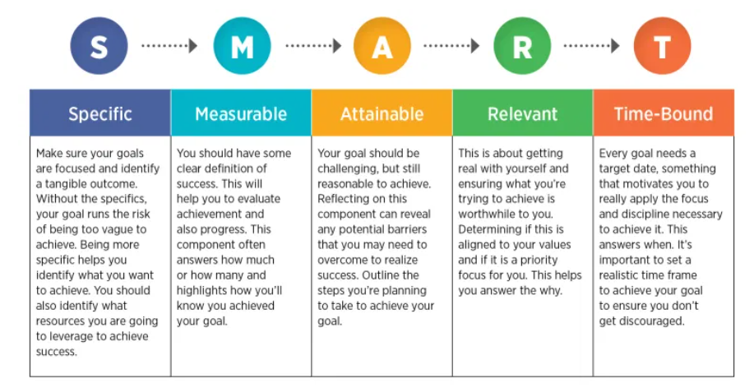
Source: Think Marketing, (2012)

Appendix C

'The Communication Quiz'
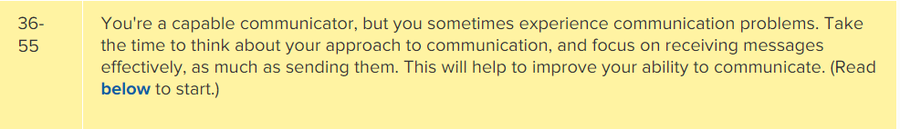
MindTools (2021)

'Interpersonal Skills Self-Assessment'
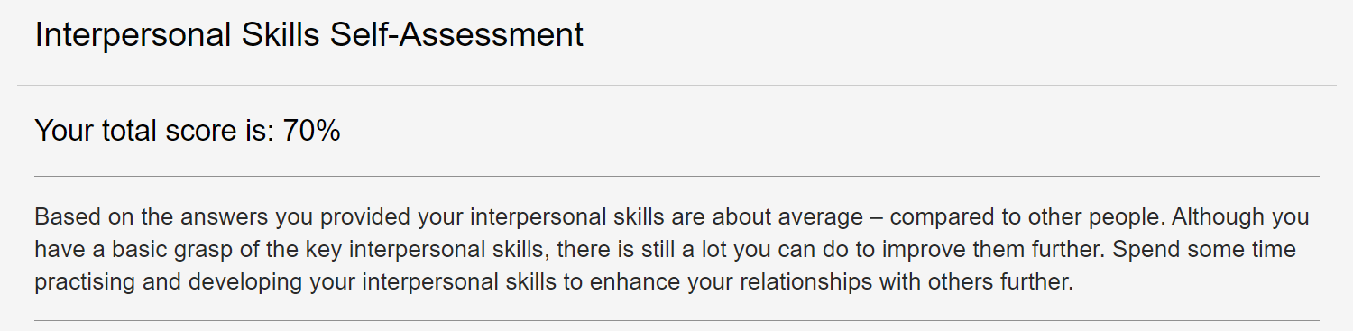
Skills You Need (2021)

