
Work based project assignment
Project Title A Comparison between pre Covid-19 agreed budgets against actual current costs and how to effectively value engineer to omit losses.


Amy Davies
Student ID - 2117453

Contents
1.0 Chapter 1 Introduction 1
1.1 Introduction 1
1.2 Abstract 1
1.3 Research Background 1
1.4 Aims and objectives 2
1.5 Hypothesis 2
1.6 Conclusion 2
2.0 Chapter 2 Literature Review 2
2.1 Introduction 2
2.2 Price movements in construction materials and plant hire, UK: 2019-2021 2
Figure 1 – Construction output prices 3
Figure 2 – Construction output 4
2.3 Construction delays and material shortages due to Covid-19 4
2.4 How value engineering is used in construction projects 4
2.5 Conclusion 4
3.0 Chapter 3 Research Methodology 5

  - Chapter 1 Introduction
  - Introduction
In this chapter the author will introduce the subject in which she has chosen to complete her research and report on. The author will also give a brief introduction and background into her own experiences on the subject.
  - Abstract
This assignment will research the cost increases that have shocked the construction industry in the aftermath of Covid-19, by comparing a budget that was set out pre Covid-19 with works commencing post cost increase. Further investigations will be undertaken to understand the reasons for the cost increases, subsequently helping the author understand the best methods for cost engineering.
  - Research Background
The author is currently working on a small renovation project consisting of a full internal refurb, new substructure and superstructure works for an extension. The original feasibility study and budget bill of quantities (BOQ) was carried out pre Covid-19, please see appendix A. Due to a delay in purchasing the project and the effects of Covid-19 there have been astronomical price increases across the industry effecting the profit margin for said project.
Due to the profit margin being affected the author is researching the best methods of reducing costs and value engineering.
  - Aims and objectives
The authors aims and objectives are set out in the bullet points below –
- To understand where the cost increases are greatest and why?
- To understand how value engineering is utilised on a construction project.
- Best methods of value engineering and cost reductions.

  - Hypothesis
The author believes that the greatest cost increases have risen from procuring materials from overseas, due to the travel restrictions imposed by Covid-19, along with foreign governments restricting workplace numbers due to social distancing.
  - Conclusion
The author has set out specific criteria to base her research on, in order to gather the correct information required to fully research and report on the aims and objectives set out in 1.4. By setting these specific aims and objectives it will aid the author in ascertaining the reasons for the price increases that have been seen throughout the industry and research the best methods of reducing costs. It is the authors aim to find a connection between price increases and restrictions imposed due to Covid-19.

2.0 Chapter 2 Literature Review

2.1 Introduction
In this chapter the author will illustrate and analyse the available literature surrounding her chosen research. The author will highlight any reoccurring issues and themes in connection with the price increases in the construction industry. The purpose of the literature review is to ascertain data and information from other professionals and organisations that have highlighted such issues. The author will research and analyse further literature in order to critically analyse best methods of practice to reduce costs on a construction project.

2.2 Price movements in construction materials and plant hire, UK: 2019-2021
The office for national statistics publicised on 20th October 2021 a brief overview of the price movements that have occurred in the construction industry in the UK and their causes. Emilia D’Silva-Parker highlights the main points as:
- Producer price inflation continuingly causing an upward push on prices in construction.
- High demand for construction inputs due to an ever-increasing requirement for construction output subsequently increasing costs.
- Global price trends such as iron and copper are increasing construction input prices for example there was a 97% price increase in iron ore in July 2021 when compared with the previous year.
- Disruptions on a global supply chain affecting the price and availability of construction resources.
Figure 1 shows a table highlighting the output prices from June 2015 to June 2021. The annual rate for price increases in June 2021 was 3.8%. These price increases have been continuous since December 2019 however as shown in figure 2 below construction output has fallen consecutively for 3 months by 1.3%, you can also see in figure 2 the peak of the fall in construction output was between March and July 2020 which coincides with the first lockdown restrictions imposed due to Covid-19.
Emilia D’Silva-Parker also highlights that due to Covid-19 material supply chain issues and shipping costs have been effected due to the lack of capacity in Chinese ports.

Figure 1 – Construction output prices
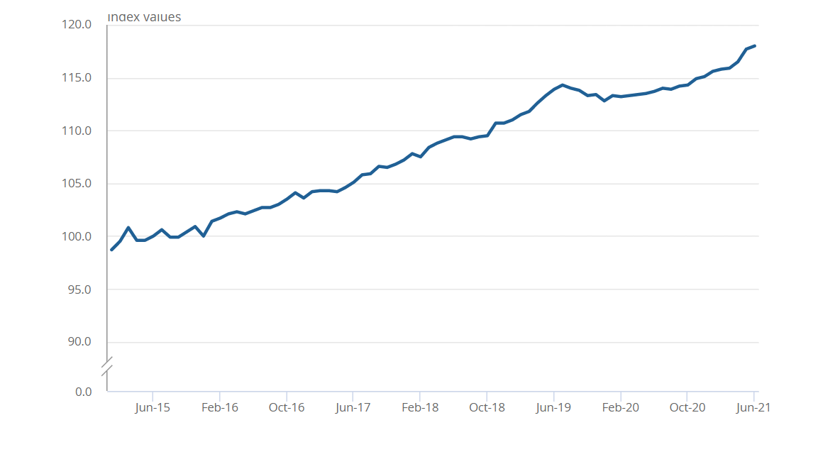
Office for national statistic 2021

Figure 2 – Construction output
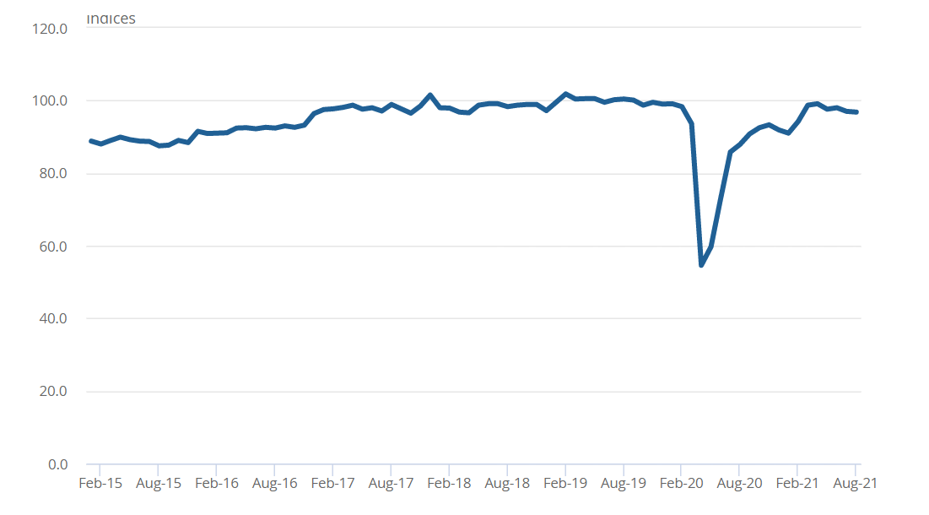Office for national statistic 2021

2.3 Construction delays and material shortages due to Covid-19
Simon Dunkling (June 2021) illustrated the connection between resource shortage and Covid-19 highlighting one of the most notable factors is the surge of construction projects since the easing of lockdown resulting in a high demand for materials. He also discusses that the Construction Leadership Council have recently issued a warning that key construction materials such as cement, timber, electrical components and paints are all in short supply. He quotes:
“With demand increasing across the globe and the UK importing many of its raw materials, not only is demand out striping supply but prices of materials are also rising.”
Simon Dunkling discusses the need for provisions within contracts that allow for price increases on materials, plant, and labour in order to mitigate potential losses due to the volatile market.

2.4 How value engineering is used in construction projects
In order to provide clear and detailed analysis on the best methods to meet a construction projects goals, value engineering is used. Value engineering is not all about cutting costs however gives all parties confidence that the maximum performance and highest values are utilised whilst assuring the most cost-effective manner, Lee Thomas (March 2019)
Value engineering is defined as
“…a conscious and explicit set of discipline procedures designed to seek out optimal value for both initial and long-term investment.” National institute for building sciences (2016)

2.5 Conclusion
Upon completion of the literature review it was concluded by the author that there is a continuous similarity and theme between the price increases of materials and the shortage due to the affects of Covid-19. Due to the continuous strict regulations imposed by governments around the world that have had an affect on manufacturing materials subsequently reducing the availability of said materials in the UK and driving up prices. The author has also discovered that there are ways of improving the project through value engineering.

3.0 Chapter 3 Research Methodology
The author has decided to use quantitative research in order to gain a greater understanding of construction professionals in the industry by handing out surveys and carrying out structured interviews. She has decided on this method due to the time scale and the fact that it is easier to control.

