

Postgraduate/Distance Learning
Assignment coversheet & feedback form

THIS SHEET MUST BE THE FIRST PAGE OF THE ASSIGNMENT YOU ARE SUBMITTING (DO NOT SEND AS A SEPARATE FILE)

For completion by the student:
Student Name: Camille Bates

Student University Email: 1806482@student.uwtsd.ac.uk
Module code: HPCA7008  Module title: Heavenly Discourses | Student ID number:  1806482 |  |  | Educational support needs:  Yes/No  No
Assignment title: Sky Journal Essay

Assignment due date: 24th August, 2020
This assignment is for the 1st 2nd 3rd 4th X 5th 6th module of the degree
I confirm that this is my original work and that I have adhered to the University policy on plagiarism.
Signed : Camille Bates
Email submission:if you are submitting this form via email, please tick this box
(as a substitute for your signature) to confirm that you agree to the above declaration.
Assignment Mark
1st Marker’s Provisional mark
2nd Marker’s/Moderator’s provisional mark
External Examiner’s mark (if relevant)
Final Mark

NB. All marks are provisional until confirmed by the Final Examination Board.

For completion by Marker 1 :
Comments:

Marker’s signature: |  |  | Date:
For completion by Marker 2/Moderator:

Comments:

Marker’s Signature: |  | Date:
External Examiner’s comments (if relevant)

External Examiner’s Signature: |  | Date:

Word Count: 3123
Sky Journal – Camille Bates #1806482
The Sun in Winter Under Southern Skies
Introduction
The aim of this research is to observe the sky at sunrise and sunset, and record my thoughts and feelings. Psychological research by Sylvia Kämpfer and Michael Mutz has suggested that people feel happier on days when the sun is shining. Tim Ingold has proposed there may be a difference between thinking about the weather as opposed to thinking outdoors in the weather. Izabela Żolnowska has suggested everyday language has used metaphors of the sun and weather to express ideas. This research will compare my Sky Journal observations to the lyrics of songs, and to psychological research investigating the types of emotions and feelings expressed about the sun and weather. The research will investigate three themes: sunshine and happiness ; connectedness to nature - a phenomenological experience; weather and the patterns in nature. The research will take place in Sydney, Australia, in the winter of 2020, in June and July.

Literature Review
Alexandra Harris has suggested that unlike Victorian society where people protected themselves from the sun, early in the twentieth century people began to embrace the sun, and sunbathing became popular. Harris has described this desire to develop a tan as the new ‘solar culture’. Furthermore, Harris has noted even the warnings of skin cancer due to exposure to the sun have been unable to reverse ‘the craze for bronzing’ which is still practiced in the early twenty first century.

Psychological studies have looked at the association between sunshine and weather in relation to positive emotions. Kämpfer and Mutz have suggested people feel happier on days when the sun is shining, and they have called this the ‘sunshine effect’. Holli-Anne Passmore and Andrew J. Howell have suggested that humans have an innate affinity with the natural world. Further, they have suggested that people find comfort in the patterns and order of nature. F. Stephan Mayer et al., have argued ‘people need to feel a sense of belonging to something larger than themselves’, and time spent in nature can provide this sense of belonging.

Izabela Żolnowska has argued elements of nature such as the sun and weather are used as metaphors in everyday language to aid in the comprehension of ideas. In addition, Żolnowska has argued these metaphors are easily understood as they have an experiential basis: the sun and sunshine are represented as happiness, or describe someone we love who brings happiness into our life; in contrast rain is represented as unhappiness or misfortune. When expressing ideas about nature, Tim Ingold has proposed that there may be a difference between thinking about the weather as opposed to thinking while being in the weather. In addition, Ingold has argued much of what we write about the weather has been ‘imaginatively remodelled’, as most of our writing about the outdoors has been written indoors. When we are outdoors, Ingold is of the view that all the changes in the air or ‘fluxes of the medium’, which we experience as sunshine, rain, mist, frost and so on, are inconceivable when we write about them indoors. When describing nature, D. Vandenberg has suggested that poets and painters are ‘born phenomenologists’, and while we all have that ability, poets and painters understand how to express their insights using words and images.

The purpose of this research is to compare my observations of the sun and weather to the lyrics of songs, and investigate if my observations of the sun and weather are similar to those of songwriters. In addition, I will also compare and contrast my findings to psychological research that has suggested people feel happier when they are in the sunshine, and develop a feeling of connectedness with nature by being outdoors.

Methodology
This research will be a record of my observations of the sky from Sunday 21st June to Sunday 26th July, recorded in a hand written Sky Journal. Due to work commitments the sky observations will take place at sunrise and sunset. The sunrises will be observed at Collaroy Beach in Sydney, and the sunsets will be observed in Chatswood, a suburb of Sydney. Photographs will be taken every day to document my observations. The Sky Journal will be based on a phenomenological approach. Thomas Groenewald has suggested the researcher should describe the phenomenon as accurately as possible, and avoid a structured framework. In addition, Vandenberg has suggested the researcher should assume the phenomena ‘have something to say’. Monique Hennink, Inge Hutter and Ajay Bailey have suggested, when keeping a field diary or taking notes during a research project, it is important to be aware of reflexivity as it can impact the notes that are collected. Particular areas of consideration are personal bias, and personal background which may reflect on the analysis. I have a personal preference for summer and sunny days, and will need to be aware of this preference during my observations.

Discussion
This research project is based on a hand written Sky Journal in which I recorded my daily thoughts and experiences as I observed the sky at sunrise and sunset. All the observations were made outside during periods of sunshine, cloudy skies and rain. Three themes emerged from the research: sunshine and happiness; connectedness to nature - a phenomenological experience; weather and the patterns in nature.
Sunshine and Happiness
I began writing my Sky Journal on the winter solstice on Sunday 21st June as I thought the day had special significance (Fig. 1).
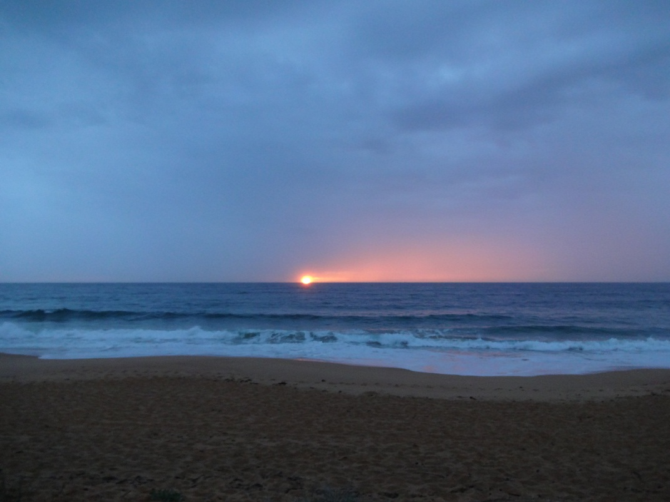
Figure 1. Sunrise. Collaroy Beach, Sunday 21st June, 2020, 7:01 am. Photo: Camille Bates

The sunrise on Sunday morning 5th July, however, felt far more significant, and I wrote in my Sky Journal:
‘I am standing on Collaroy Beach, and it is 6:15 am. I am alone on the
beach with no one else in sight. A strong wind is blowing
from the south, and I feel really cold. If I was waiting for a bus I would
be miserable. But today I am waiting for the sun. I have made a special
effort to get up early, and drive to the beach to watch the sunrise which is
something I rarely do. The sun arrived on time at 7:00am. The sunlight
is blinding as it glistens and bounces off the water (Fig. 2). The view is
stunning and I feel happy. I feel alive. I feel like jumping for joy’.


Figure 2. Sunrise. Collaroy Beach, Sunday 5th July, 2020, 7:06 am. Photo: Camille Bates

As suggested by Vandenberg, on 5th July I could have been called a phenomenologist having described a sunrise. However, the lyrics of the song Sunshine on My Shoulders by John Denver expressed the effects of sunshine far more eloquently:
Sunshine on my shoulders makes me happy
Sunshine in my eyes can make me cry
Sunshine on the water looks so lovely
Sunshine almost always makes me high.
The lyrics of John Denver described my thoughts and feelings more clearly than the words I wrote as I watched the sunrise. Sunshine did make me feel happy and high. My observations and feelings have also provided an insight into the research by Kämpfer and Mutz who have suggested there is a ‘sunshine effect’, a feeling of increased happiness in response to spending time in the sunshine. It is difficult to describe a sunrise or the beauty of the sky in words. Vandenberg has suggested poets and painters are ‘born phenomenologists’ as they understand how to express their insights through words and images. I suggest songwriters also understand, and through their lyrics they can capture their unique insights.

The sun and happiness is a common theme found in song lyrics. Żolnowska has suggested our everyday language makes use of metaphors about the sun and weather, where one type of human experience is associated with another to clarify an idea. Żolnowska has suggested that the sun and sunshine are represented as happiness or used to describe someone we love who brings happiness into our life. Sunshine is used as a metaphor for happiness in the song You are My Sunshine:
You are my sunshine, my only sunshine
You make me happy when skies are gray.
However, the sun is not always presented as sunshine and happiness. This is the case in the song I Hate The Sun:
Do you think of me
In the summer eve
Days without you are not fun
God I hate the sun.
In I Hate The Sun, the sun is not represented as happiness, the sun is a reminder of a lost love, and happy times now gone.

By way of contrast, Żolnowska has suggested the rain or rainy days are seen as unhappiness or misfortune. The song Raining in My Heart has used rain as a metaphor for the loss of love:
The weatherman says clear today
He doesn’t know you’ve gone away
And it’s raining, raining in my heart.
However, the rain is not always associated with unhappiness. Rain is seen as happiness in the song It’s Raining Men, where the lyrics explain that Mother Nature, a single woman, went to heaven and ‘rearranged the sky’, so that every single woman could find a partner. The chorus of the song praises the success of Mother Nature:
It’s raining men! Hallelujah!
It’s raining men! Amen!
The lyrics of songs use the sun and weather to represent happiness and sadness. In the appropriate context, the sun and weather can be seen as beneficial or detrimental. Songwriters are creative and gifted in delivering their message, whether the sun is used to represent happiness or sadness.

Connectedness to nature – a phenomenological experience
After observing the sun for three weeks, I realised that every day I was looking forward to the sunrise and the sunset. My days had become defined by the cycle of the sun. On Sunday 12th July I wrote in my Sky Journal:
‘waiting for the sun is like waiting for someone you love at the airport. You have an
arrival time, and you are looking forward to seeing your loved one again’.
I wrote a poem as I waited in the cold for the sun to rise:
I wait alone in the early morning twilight,
For my faithful friend to end the night.
He will be here soon, he always comes,
My heart is racing as I greet him, my friend the sun.
From a reflexive perspective, I considered the words ‘my friend the sun’, and wrote in my Sky Journal:
‘How pretentious to call the sun my friend’.
I wondered if I had taken the feeling of familiarity with the sun too far, yet with just one ‘Google’ search on my mobile phone there it was, a song called My Friend the Sun. The song used rain as a metaphor for difficult periods that people experience in their lives, but the sun was used as a metaphor for hope and better times ahead:
Though my friend the sun looks well on the run
He’s there in the distance, if you care to see, see.
In the song My Friend the Sun, the sun represented a promise of hope. If the person could hang in through the difficult times, the sun would follow the rain.

Izabela Żolnowska has suggested we use the sun and the weather as metaphors to express feelings as they have an experiential basis, and are therefore easily understood. However, in a reflexive assessment of my field notes, as suggested by Hennink, Hutter, and Bailey to assess for personal bias, I formed the view the sun as my friend represented more than an experiential metaphor, it had a deeper meaning. Research by Mayer et al., has found that when people spent time in nature it led to feeling connected to nature. Mayer et al., also suggested the connectedness led to a sense of belonging to something larger than oneself. Spending time in nature may take one back to their human roots, as suggested by Passmore and Howell, where humans have an innate affinity with the natural world.

That I was inspired to write a poem surprised me as I have not done so since I was in school. The research of Ingold has suggested much of what is written about the weather, sunshine and rain has not been written outdoors, but ‘imaginatively remodelled’ while indoors. Furthermore, Ingold proposed there may be a difference between thinking about the weather, as opposed to thinking while in the weather. I find this idea of Ingold appealing, as I may have written the poem not only from feeling connected to nature, but through my experience of writing outdoors ‘in’ nature. Perhaps it rose from the phenomenological approach of writing my Sky Journal outside every day, observing the reliability, and permanence of the daily cycle of the sun. My thoughts were freed, released from my work of analysing pages of numbers.

Weather and the patterns in nature
Keeping a Sky Journal and observing the sunset every day has highlighted the daily changes in the sky and the weather. I wrote in my Sky Journal on Monday 13th July:
‘There is a stillness at sunset that is not present during the day. The temperature
drops. The cold sets in, and I can feel the dampness in the air. The clouds make
spectacular patterns as the rays of the sun penetrate the clouds. The sky
each day is almost indescribable’.
On Friday 3rd July it looked as if there was a tornado in the sky (Fig. 3).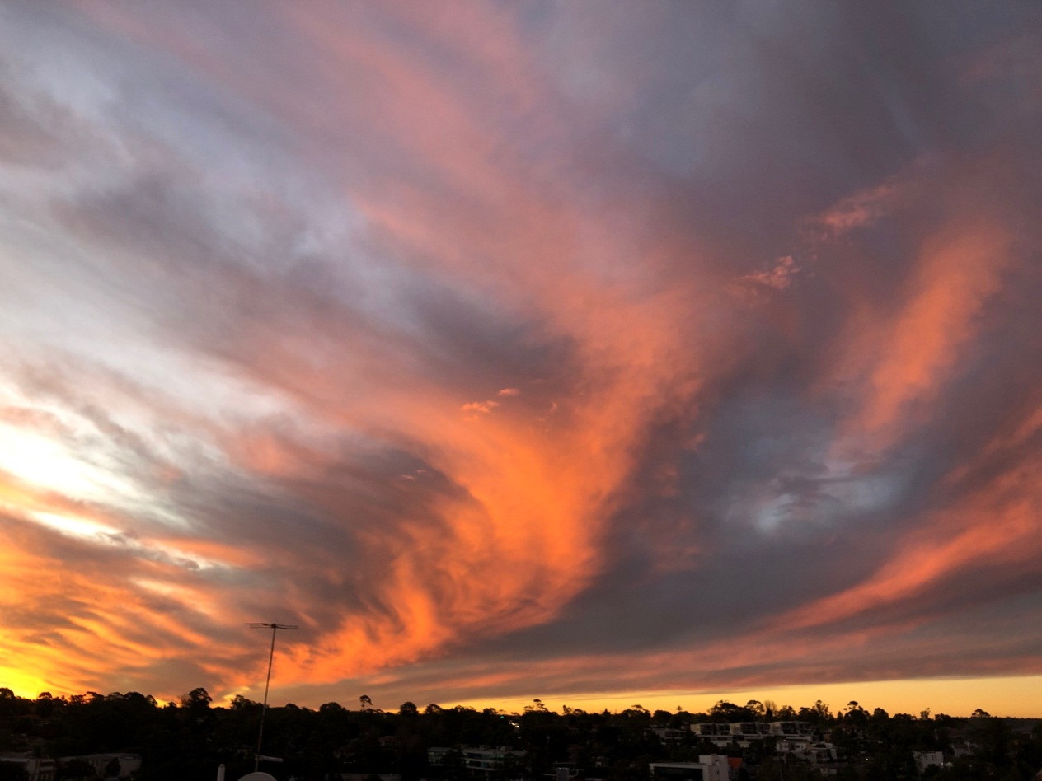
Figure 3. Tornado in the Sky. Chatswood, Friday 3rd July, 2020, 5:08 pm. Photo: Camille Bates.

On Monday 6th July the sun and clouds produced a sky of golden clouds (Fig. 4).
Figure 4. Golden Clouds. Chatswood, Monday 6th July, 2020, 4:57 pm. Photo: Camille Bates
On Friday 17th July, the sky looked like it was on fire (Fig. 5).

Figure 5. Fire in the Sky. Chatswood, Friday 17th July, 2020, 5:10 pm. Photo: Camille Bates

The fiery sky reminded me of the song by Gilbert and Sullivan, The Sun Whose Rays, which described the glory of the sun:
But fierce and bold, in fiery gold,
He glories all effulgent.

Ingold has suggested when we are outdoors we can feel the changes in the air or what he has termed as ‘fluxes of the medium’ such as rain, sunshine, wind and so on, which are not conceivable when we are indoors. My experiences outdoors were in line with Ingold’s suggestion. I could feel the stillness, and the dampness in the air, which are not conceivable indoors or even in a photograph. You must be outdoors to appreciate the full experience of the phenomenon.

Alexandra Harris has suggested, unlike Victorian society where people protected themselves from the sun, in the twentieth century people began to embrace the sun, and a new ‘solar culture’ was born. People began to spend hours in the sunshine to develop a tan, and in the twenty first century even the fear of skin cancer has been unable to reverse ‘the craze of bronzing’. In my teenage years, I was part of the ‘solar culture’, but today I have heeded the warnings of sun cancer, but I still long for the warmth of the sun. I wrote in my Sky Journal on Sunday 19th July at 6:30 am standing on Collaroy beach:
‘I wish I was writing this Sky Journal in summer. I dislike winter. My fingers are
numb. The wind is blowing, and it feels like ice. I feel as though I am dressed for the
Antarctic, yet the cold wind penetrates the multiple layers of my clothing. I feel cold.
Just forty two days to go to make it to the 1st of September, and the promise of
warmer weather to come. The good thing is I have no doubt it will start to get
warmer from September, it always does. The sun eventually rises above the
clouds in all its glory, but the air remains cold’ (Fig. 6).


Figure 6. Sunrise. Collaroy Beach, Sunday 19th July, 2020, 7:23 am. Photo: Camille Bates.

The changing of the seasons and the promise of warmer days is evident in a song by The Beatles called Here Comes the Sun:
Little darling
It’s been a long cold lonely winter
Little darling
It feels like years since it’s been here
Here comes the sun, doo-doo-doo-doo
Here comes the sun
And I say, it’s all right.
The appreciation of the cycle of the sun is also acknowledged in the song Sunrise, Sunset:
Sunrise, Sunset
Sunrise, Sunset
Swiftly fly the years
One season following another
Laiden with happiness and tears.
Passmore and Howell have suggested that people find comfort in the patterns and order of nature. The promise of summer after the winter is an acknowledgement of the cycle of the seasons. The patterns of nature, and the permanency of the patterns is comforting in contrast to our ever changing lives which can be ‘laiden with happiness and tears’. In the phenomenological approach to research, Vandenberg has suggested the researcher must assume the phenomena ‘have something to say’. Reading my Sky Journal the words have suggested it is a Winter Journal, and it would have been quite different if I had written it in summer. But there is comfort in the permanency of the seasons, and knowing that the summer will return.

Conclusion
The aim of this research project was to observe the sun and weather for a minimum of one month, and record my observations in a Sky Journal. I then compared my observations to the lyrics of songs, and to psychological research related to positive emotions associated with being in nature, to investigate if there were any similarities with my observations. In line with psychological research, I did feel happy watching the sunrise. I could relate to the lyrics of Sunshine on My Shoulders as they expressed the happiness I felt watching sunlight on the water. The lyrics of songs have commonly used metaphors of the sun for happiness, and the rain for unhappiness as suggested by Żolnowska. But to songwriters, the meanings were interchangeable depending on the context. After spending time in nature, I began to feel connected to the cycles of nature, and was amazed how little time it took to feel connected. The only way to truly appreciate the changes in the air is to be outdoors. The phenomenological approach to my Sky Journal has provided insight into the benefits of spending time in nature, and has demonstrated how one’s thinking can change in the outdoors as proposed by Ingold. My thoughts were less structured compared to analysing numerical data at work, and were freed to write a poem. Rather than a Sky Journal, I feel this is my Winter Journal, and in the summer-time I will repeat the exercise.

Bibliography
PRIMARY SOURCES
Authorship unknown, You are My Sunshine, Jimmy Davis purchased song rights from
Paul Rice, 1939. First recording Pine Ridge Boys, 1939, Bluebird Records.
Bates, Camille, Sky Journal, field notes recorded 21st June, 2020 – 26th July, 2020,
Sydney, Australia.
Bryant, Felice, and Boudleaux Bryant, music and lyrics, Raining in My Heart,
recorded by Buddy Holly, 1959, Coral # 9-62074.
Chapman, Roger, and Charlie Whitney, music and lyrics, My Friend the Sun, recorded
by Family, 1972, Reprise (UK), United Artists (USA).
Denver, John, lyrics, John Denver, Mike Taylor, and Dick Kniss, music,
Sunshine on My Shoulders, recorded by John Denver, 1971, RCA Records.
Gilbert, William, lyrics, and Arthur Sullivan, music, ‘The Sun Whose Rays’, in Mikado,
opera score, London, 1885, cited in The Authentic Gilbert & Sullivan Songbook,
(New York: Dover Publications, Inc., 1977).
Harrison, George, music and lyrics, Here comes the Sun, recorded by The Beatles,
1969, Apple.
Jickling, Sarah, music and lyrics, I Hate the Sun, recorded by The Oh Wells, 2011,
The Oh Wells Music/Activeminds,
http://theohwells.bandcamp.com/album/not-that-girl-from-transformers,
[accessed July 19, 2020].
Shaffer, Paul, and Paul Jabara, music and lyrics, It’s Raining Men, recorded by
The Weather Girls, 1982, Columbia Records and CBS Records International.

SECONDARY SOURCES
Groenewald, Thomas, ‘A Phenomenological Research Design Illustrated’,
International Journal of Qualitative Methods, 3 (2004), 42-55.
Harris, Alexandra, Weatherland: Writers & Artists Under English Skies,
(London: Thames & Hudson, 2015).
Hennink, Monique, Inge Hutter, and Ajay Bailey, Qualitative Research Methods,
(London: Sage Publications Ltd, 2015).
Ingold, Tim, ‘Earth, Sky, Wind, and Weather’, The Journal of the Royal Anthropological Institute, 13 (2007), S19-S38.
Kämpfer, Sylvia, and Michael Mutz, ‘On the Sunny Side of Life: Sunshine Effects
on Life Satisfaction’, Social Indicators Research, 110 (2013), 579-595.
Mayer, F. Stephan, Cynthia McPherson Frantz, Emma Bruehlman-Senecal, and
Kyffin Dolliver, ‘Why is Nature Beneficial? The Role of Connectedness to Nature,
Environment and Behaviour, 41(2009), 607-643.
Passmore, Holli-Anne, and Andrew J. Howell, ‘Eco-Existential Positive Psychology:
Experiences in Nature, Existential Anxieties, and Well-Being’, The
Humanistic Psychologist, 42 (2014), 370-388.
Vandenberg, D., ‘Phenomenological research in the study of education’, in
Phenomenology & Education Discourse, ed. by D. Vandenberg, (Johannesburg:
Heinemann, 1997), cited in Groenewald, Thomas, ‘A Phenomenological Research
Design Illustrated’, International Journal of Qualitative Methods, 3 (2004), 42-55.

Sylvia Kämpfer and Michael Mutz, ‘On the Sunny Side of Life: Sunshine Effects on Life Satisfaction’, Social Indicators Research, 110 (2013), 579-595, (p. 579).
Tim Ingold, ‘Earth, Sky, Wind, and Weather’, The Journal of the Royal Anthropological Institute, 13 (2007), S19-S38 (p. S29).
Izabela Żolnowska, ‘Weather as the source domain for metaphorical expressions’, The Journal of the Philosophical–Interdisciplinary Vanguard, 2 (2011), 165-179 (p. 166).
Alexandra Harris, Weatherland: Writers and Artists under English Skies, (London: Thames & Hudson, 2015), p. 336.
Alexandra Harris, Weatherland, p. 337.
Sylvia Kämpfer and Michael Mutz, ‘On the Sunny Side of Life’, p. 579.
Holli-Anne Passmore and Andrew J. Howell, ‘Eco-Existential Positive Psychology: Experiences in Nature, Existential Anxieties, and Well-Being’, The Humanistic Psychologist, 42 (2014), 370-388 (p. 370).
Holli-Anne Passmore and Andrew J. Howell, ‘Eco-Existential Positive Psychology’, p. 376.
F. Stephan Mayer et al., ‘Why is Nature Beneficial?’, The Role of Connectedness to Nature’, Environment and Behaviour, 41 (2009), 607-643 ( p. 635).
Izabela Żolnowska, ‘Weather as the source domain for metaphorical expressions’, p. 165-166.
Izabela Żolnowksa, ‘Weather as the source domain for metaphorical expressions’, p. 165 and 175.
Tim Ingold, ‘Earth, Sky, Wind, and Weather’, p. S29.
Tim Ingold, ‘Earth, Sky, Wind, and Weather’, p. S32.
Tim Ingold, ‘Earth, Sky, Wind, and Weather’, p. S32.
D.Vandenberg, ‘Phenomenological research in the study of education’, in Phenomenology & Education Discourse, ed. by D. Vandenberg, ( Johannesburg: Heinemann, 1997), cited in Thomas Groenewald, ‘A Phenomenological Research Design Illustrated’, International Journal of Qualitative Methods, 3 (2004), 42-55 (p. 44).
Thomas Groenewald, ‘A Phenomenological Research Design Illustrated’, International Journal of Qualitative Methods, 3 (2004), 42-55 (p. 44).
D.Vandenberg, ‘Phenomenological research in the study of education’, in Phenomenology & Education Discourse, ed. by D. Vandenberg, ( Johannesburg: Heinemann, 1997), cited in Thomas Groenewald, ‘A Phenomenological Research Design Illustrated’, International Journal of Qualitative Methods, 3 (2004), 42-55 (p. 44).
Monique Hennink, Inge Hutter, and Ajay Bailey, Qualitative Research Methods, (London: Sage Publications Ltd, 2015), p. 20.
Monique Hennink, Inge Hutter, and Ajay Bailey, Qualitative Research Methods, p. 20.
John Denver, lyrics, John Denver, Mike Taylor, and Dick Kniss, music, Sunshine on My Shoulders, recorded by John Denver, 1971, RCA Records.
John Denver, lyrics, John Denver, Mike Taylor, and Dick Kniss, music, Sunshine on My Shoulders, recorded by John Denver, 1971, RCA Records.
Sylvia Kämpfer amd Michael Mutz, ‘On the Sunny Side of Life’, p. 579.
Izabela Żolnowska, ‘Weather as the source domain for metaphorical expressions’, p. 166.
Izabela Żolnowska, ‘Weather as the source domain for metaphorical expressions’, p. 176.
Authorship unknown, You are My Sunshine, Jimmy Davis purchased song rights from Paul Rice, 1939. First recording, Pine Ridge Boys, 1939, Bluebird Records.
Sarah Jickling, lyrics and music, I Hate The Sun, recorded by The Oh Wells, 2011, The Oh Wells Music/Activeminds, http://theohwells.bandcamp.com/album/not-that-girl-from-transformers, [accessed July 19, 2020].
Izabela Żolnowska, ‘Weather as the source domain for metaphorical expressions’, p. 175.
Felice Bryant and Boudleaux Bryant, music and lyrics, Raining in My Heart, recorded by Buddy Holly,1959, Coral #9-62074.
Paul Shaffer and Paul Jabara, music and lyrics, It’s Raining Men, recorded by The Weather Girls, 1982, Columbia Records, and CBS Records International.
Paul Shaffer and Paul Jabara, music and lyrics, It’s Raining Men, recorded by The Weather Girls, 1982, Columbia Records, and CBS Records International.
Roger Chapman and Charlie Whitney, music and lyrics, My Friend the Sun, recorded by Family, 1972, Reprise (UK), United Artists (USA).
Roger Chapman and Charlie Whitney, music and lyrics, My Friend the Sun, recorded by Family, 1972, Reprise (UK), United Artists (USA).
Izabela Żolnowska, ‘Weather as the source domain for metaphorical expressions’, p. 165.
Monique Hennink, Inge Hutter, and Ajay Bailey, Qualitative Research Methods, p. 20.
F. Stephan Mayer et al., ‘Why is Nature Beneficial?, p. 628
F. Stephan Mayer et al., ‘Why is Nature Beneficial?, p. 635.
Holli-Anne Passmore, and Andrew J. Howell, ‘Eco-Existential Positive Psychology’, p. 370.
Tim Ingold, ‘Earth, Sky, Wind, and Weather’, p. S32.
Tim Ingold, ‘Earth, Sky, Wind, and Weather’, p. S29.
William Gilbert, lyrics and Arthur Sullivan, music, ‘The Sun Whose Rays’ in Mikado, opera score, London, 1885, in The Authentic Gilbert & Sullivan Songbook, (New York: Dover Publications, Inc., 1977), p. 243.
Tim Ingold, ‘Earth, Sky, Wind, and Weather’, S32.
Alexandra Harris, Weatherland, p. 336.
Alexandra Harris, Weatherland, p. 337.
George Harrison, music and lyrics, Here Comes the Sun, recorded by The Beatles, 1969, Apple.
Sheldon Harnick, lyrics, and Jerry Bock, music, ‘Sunrise, Sunset’, in Fiddler on the Roof, musical score, 1964.
Holli-Anne Passmore and Andrew J. Howell, ‘Eco-Existential Positive Psychology’, p. 376.
Sheldon Harnick, lyrics, and Jerry Bock, music, ‘Sunrise, Sunset’, in Fiddler on the Roof, musical score, 1964.
D. Vandenberg, ‘ Phenomenological research in the study of education’, in Phenomenology & Education Discourse, ed. by D. Vandenberg, (Johanesburg: Heinemann, 1997), cited in Thomas Groenewald, ‘A Phenomenological Research Design Illustrated’, International Journal of Qualitative Methods, 3 (2004), 42-55 (p. 44).
John Denver, lyrics, John Denver, Mike Taylor, and Dick Kniss, Music, Sunshine on My Shoulders, recorded by John Denver, 1971, RCA Records.
Izabela Żolnowska, ‘Weather as the source domain for metaphorical expressions’. P. 176.
Tim Ingold, ‘Earth, Sky, Wind, and Weather’, p. S29.

