Tale of Two Dragons:

EVALUATIVE Report

Ruth Heneghan P148310
Course: Creative Computer Game Design
Module: Creative Venture 2: Realisation
Lecturers: Richard Morgan & Jessica LaCombe
Word Count: 4436

Decleration
All work is written by Ruth Heneghan and anything that isn’t has been correctly referenced with the Harvard referencing System.
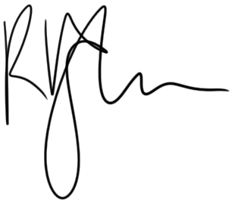
RUTH HENEGHAN
06/05/2019

Contents
Executive Summary 4
Review of Research Methodology and Methods 5
Project Planning 5
3D Sculpts and Retopology 5
Texturing 8
The Engine 8
Review of Creative/Business Strategy 10
As a Project 10
As a Market Competitor 10
Further Development 11
Critical Appraisal of the Final Proposition 12
Problems with Time Management 12
Skeletons and Rigging 13
In the Engine 13
Future Trajectories 15
Short-Term 15
Long-Term 15
Market Competitors 15
Mechanics 16
Future of Publishing 16
References 17
Bibliography 18
Appendices 19

Executive Summary
This report consists a summary of the work that was completed to create the Tale of Two Dragons art target.
This project, to be completed by a single-member team, will consist of creating a small environment within the Unreal Engine using assets modelled, textured, and rigged for this specific task. The environment will consist of three islands, upon which there will be an individual scene depicting the two main characters interacting with the environment.
This report details the work done to complete this target, the difficulties met due to poor time management, what this project could be used for in future endeavours, and how it an be developed further for those purposes. It also provides examples of how these advancements can be made, such as what kind of team would be best moving forward, how best to acquire an audience and possible funding, and possibilities of expanding from one platform to another.
There are also details on the strengths and weaknesses of this project, how specific research was found to help in difficult situations and how each task was completed, as well as the ease or hardships of these tasks.
This art target was to be an example or a taster of what the idea could be like in a fully-realised game, if a proper team and proper funding could be gained. With this project as a stepping stone, whether to build upon it or simply use it as a pre-production example, it is hoped that the full game could more easily take form, along with the help of the previously created ten-page game design document.
It is also hoped that this art target, coupled with a well-structured marketing plan, could help build an audience during production. This will hopefully help with funding in the ways of an online fundraising campaign, where the audience can interact with the team and the game before it is release.

Review of Research Methodology and Methods
This project consisted of a great deal of tasks completed in a short amount of time, which ultimately led to a lack of finishing touches near the end.

Project Planning
At the beginning an art target was envisioned, consisting of three islands decorated with static environmental meshes, and three characters posed in stationary positions on these three islands, with background music to compliment the scene. A timeline was projected on how this would be completed, with allegedly appropriate times delegated to each one to finish within the proposed time frame. (See appendix: figure 1)
Upon revision of the timeline animations were proposed to be added to the scene, using the ‘animation retargeting (different skeletons)’ available within Unreal Engine 4. This allows the transferal of animations from one skeletal mesh to another by aligning the ‘rig’ of two skeletal meshes in Unreal and matching skeletal bones between the two. Rigs can be set up within Unreal, but initially only a humanoid rig is available as default. Time had not been allocated to learn this information at a soon enough date in the project, and therefore could not be completed. (See appendix: figure 2)
A provisional plan was created as a contingency in case any problems arose. These tasks are usually covered by multiple people in one team so organising them to be undertaken by one person in this time span requires careful planning. Experience from past projects was taken into consideration during this planning stage, where two player characters were modelled and retopologised within three to four weeks.

3D Sculpts and Retopology
To begin, methods of sculpting thinner materials such as clothing, hair, and wing membrane were researched. The main question was whether to use double sided planes or create thin meshes to mimic the effect of each of these parts: articles from 80 Level (Realistic vs Stylised: Technique Overview and Game Characters: Modelling, Clothes, Materials) and Guide to Building a 3D Character by Elizabet Heikkilä were reviewed for advice on how best to proceed.
Though Guide to Building a 3D Character was focused on modelling a low poly character in Blender, knowledge on good edge flow and additional polys for deformation were included and proved to be helpful during retopology. It also describes the benefits of realistic versus stylised characters in regards to rendering times, discussing why reducing details such as fingers into ‘mitten’-like features helps reduce poly count, and other modelling tips. This was useful for creating a stylised, relatively low poly character for this art target, as this was the intended style from the beginning.
This also ties in with advice from the 80 Level article Realistic vs Stylised, where the author discusses the benefits and downsides of using either style—or rather, compares it more to a scale, dependant on the power and development of graphical capabilities at the time. The games Overwatch (Blizzard Entertainment, 2016) and Journey (Thatgamecompany, 2012) are both considered stylised with different levels of overexaggerated details, but clearly do not share a similar style. The article discusses the importance of exaggerating the correct details so as to get the point of the scene across, without losing important aspects in unnecessary focus.
This leads into the environment of the art target, as a limited number of set pieces will be created to try and get across the idea of a full and interesting layout. This is particularly important with a reduced team size and a narrow time frame in which to finish.
After reviewing these articles and studies it was decided that the clothing would be created as a separate mesh, extruded from the base mesh of the body in ZBrush. This allowed the separate pieces of clothing to follow the shape of the body, and from there they would be moulded with the move brush to loosen their shape as suggested in the article Game Characters: Modelling, Clothes Materials.
In this article the writer used the Marvellous Designer program to create hyper-detailed clothing for their character, which is positioned more on the realistic side of the scale of realistic versus stylised despite still being stylised. While they use Marvellous Designer to create the complex folds and drapes of the clothes for this character they still used Zbrush for finer details, such as correcting any incorrectly overlapping folds. The player character for this art target does not have such levels of details and therefore Marvellous Designer was not necessary, but the tips for shaping the clothes were still useful.
Another decision was the use of planes versus mesh for creating the hair for the player character. A popular yet difficult suggestion was the use of ‘hair cards’, and the tutorial on 3D Artist Online was reviewed as a possible tutorial. However, hair cards are frequently used for more detailed, ‘realistic’ hair that will be affected by physics, and for a simple art target project this was deemed too time consuming in comparison to creating a mesh in ZBrush that would match the rest of the model.
The task of placing and shaping individual pieces of ‘hair’ was still used as in the tutorial on 3D Artist, though this did not go beyond making a single textured mesh for the human character’s hair.

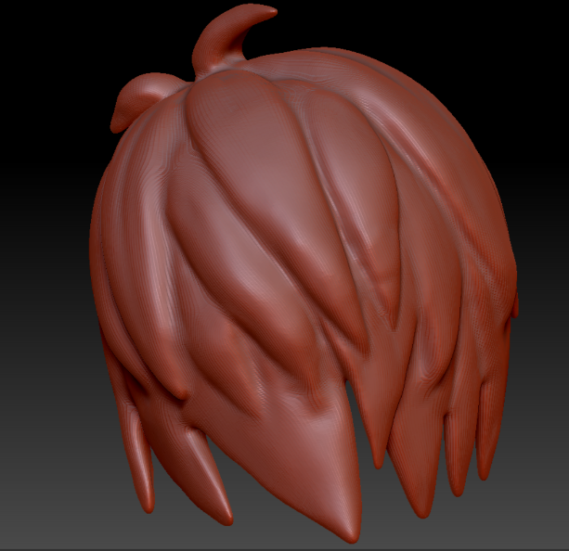
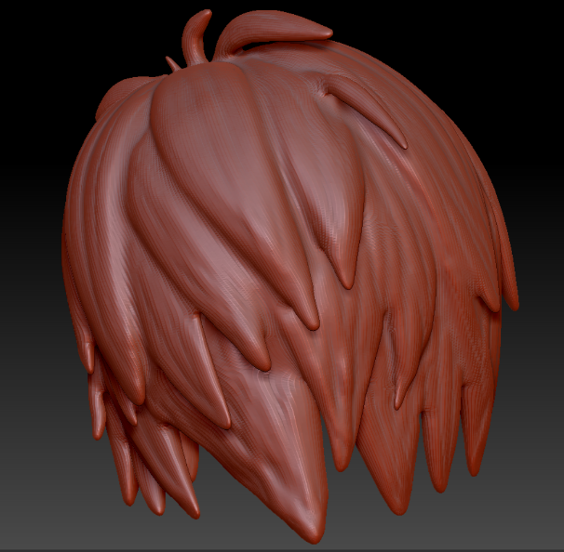
Old hair model (left) and new, less-details hair model (right)
A single mesh also made it easier to modify any problematic details during retopology, which did eventually occur regarding clean edge loops.
A thin mesh was used to create the dragon’s wing membrane as well, following Jesse Sandifer’s Dragon Workshop tutorial. This allowed more control over the overall shape of the wing, from thin at the widest, outermost point to becoming thicker closer to the joints at the top and along the individual ‘finger bones’ that make up the frame of the wing. This was closer to the desired style initially outlined in the concept art.
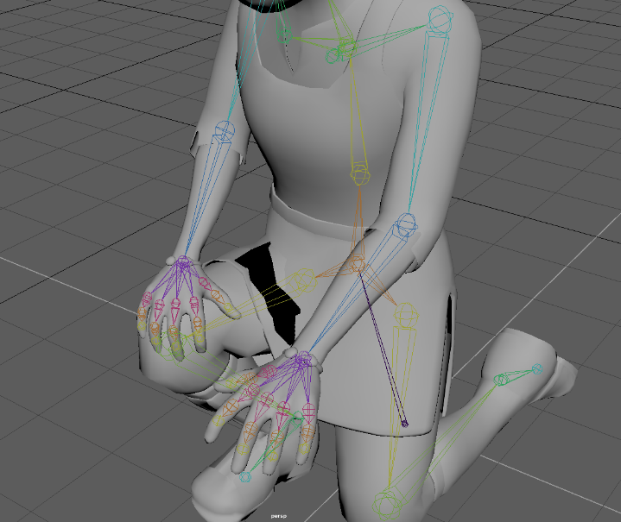
But while creating it from a thin mesh was a common suggestion, creating it from a double-sided plane would have ultimately worked better, upon review. During weight painting and rigging deformation on the wings became difficult to mimic, and eventually came out looking jagged and stiff. Similarly, the thin mesh for the human character’s clothes looked good as a static mesh, but during the retopology and weight painting of these areas of the model it was difficult to correctly assign polys to certain locations. This becomes the clearest when posing the character using the rig, as the lower part of the tunic occasionally clips through her leg, and the two layers of the mesh do not deform correctly.
An example of poor weight painting around the leg

The animation rigs for both characters were created by following tutorials provided by the university, which were aimed at beginners and easy to understand. Once again, as this was a single-person project under time constraints, and this was the first attempt at creating both a basic human skeleton and a unique skeleton for the dragon.

Texturing
To texture the meshes Substance Painter will be used, along with detail refinement and normal map corrections due to baking to be done in Photoshop. These are programs that have been used in previous projects and are both industry standards.
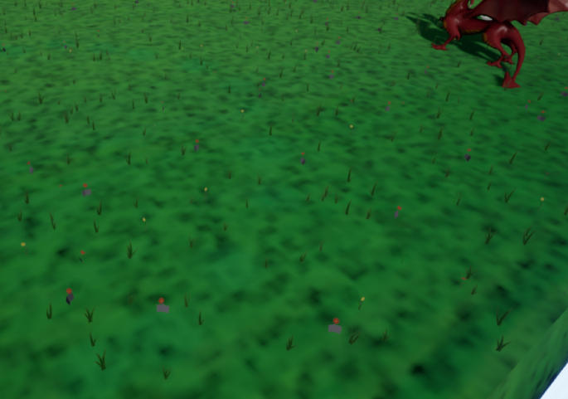
Unreal Engine 4 is the engine of choice, once again for the sake of familiarity with its interface, namely the blueprinting capability. Within the engine three islands have been created, which became the focal point of each scene, and were created using a singular large mesh. The landscape tool was considered, but further research showed that this would require the creation of many supplemental meshes to attach along with it, such as around the straight edges and to disguise it from underneath. Creating a mesh suited the time frame more succinctly, and it was easily textured in Substance Painter and Photoshop. Unfortunately, the creation of a large mesh led to a stretched material, resulting in low quality details across its surface. The grass texture appeared as nothing more than a pixelated blur, even with the largest texture map available to Substance Painter (the experimental 8k texture maps).
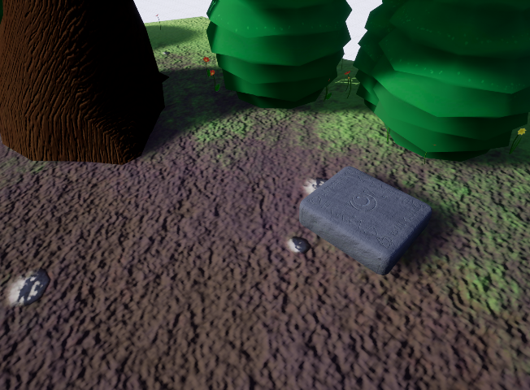
The smallest island (left) compared to the largest island (right)

The Engine
To view the scenes a camera blueprint was created that could be positioned to rotate around a central point. This centre was positioned on the human character, making her the focal point in each environment as she interacts with them. Since this is an art target for the intended game, no gameplay was implemented, but some interactivity was available through the pressing of the 1 to 3 buttons on the keyboard, which cycled the camera through the three islands after a brief introduction screen. More control of the camera was planned to allow the viewer a chance to get a closer look or to manually position the camera (a pre-determined amount), to bring some intractability to the project. Interactivity is an integral part of video games, as discussed in the article by a contributing author to the website The Artifice, titled Story Telling and Interactivity in Video Gaming. Allowing the viewer some control over the camera can help them feel more involved and offer a taste of interactivity. Due to time constraints, this was not implemented.

Review of Creative/Business Strategy

As a Project
As this was a single person project in a short time span, what was created was close to what was envisioned. Interactivity was lacking and it took a step back into being a static art target, but it has a good feel for how the game could look.
With some development and corrections this project could be shown as a proof of concept to try and acquire provisional publishers or backers. It contains the two main characters and how they interact with each other, and the world they will inhabit: from here, it will be possible to explain how the project can develop with a good visual aid, and maybe even to develop upon.
Incorporating gameplay even as basic as movement, both walking and flight, would be possible to showcase in a short development time. This allows a small development team to work on an already started project file with a number of assets already created, and can be used as an early prototype while a demo of sorts is created at the same time.
The style of the game—bold colours and exaggerated, stylised shapes—will help this game appeal to the primary target audience originally intended: 12 to 16-year olds. The models and textures will need refinement to improve their quality, particularly in this early stage where there is no interactivity to draw in an audience. Relying on the visuals of the game idea is its best option at this point, and therefore improving these will be important.

As a Market Competitor
The games that this will rival, such as the Spyro series and The Legend of Zelda series, are long running and already have dedicated fanbases. Breaking into the genre and gaining an audience will be difficult without good visuals.
In a report on the current market the game Anthem was discussed as possible competition, but has since been released and been met with poor audience reception and reviews. As detailed in the article on Kotaku by Jason Schreier, titled How Bioware’s Anthem Went Wrong, poor team management and pre-production planning led to a game that felt unfinished on release and ultimately led to the lowest score any game by the studio Bioware has received (on the review site Metacritic).
When developing this project into a full-fledged game it will be important to make sure that timescales are adhered to. One of the main points that is brought up is how Anthem was announced in 2012, but that pre-production was ongoing until 2018, with some mechanics still being finalised in the final few months before release. Having a solid image already in place for Tale of Two Dragons, hopefully an extended pre-production can be avoided, and the release time line outlined in the market strategy will still be possible.
Many mechanics and design choices were already outlined in the ten-page design document created for the Tale of Two Dragons project. During the first few months the mechanics and other details can be refined from this document, but no drastic changes can take place once those key points are locked down. ‘Feature creep’ is a term often coined for this and needs to be avoided for a project to continue on track.

Further Development
If production were to develop further for this project, a team of at least five people would need to be gathered to cover each aspect of development without overloading any one person with too much work (3D artist, animator, narrative designer, texture artist, and engine application or technical artist). It will be possible to gather any interested team members with this prototype, especially after some work to refine it. This ties back in with the point above, where correcting some textures and improving scene composition will make this a useful tool in not only starting an interest in the target audience but also in gathering together a team to fully develop it into a game.
As development continues, with this art target prototype as a starting point, the audience can be kept intrigued by a steady series of updates similarly to how some indie companies currently run their fundraising campaigns. The 2D side-scrolling game Lunafon: Tales of the Moon Oak, currently running a campaign on Kickstarter, is maintaining a website that shows their constant updates as they move forward. With this they manage to keep their audience interested, as shown by the ever-present responses to their posted updates, and are working up towards their target funds.
Another Kickstarter campaign that has gone on to be a successful game is Shovel Knight, which followed the same pattern of updates and keeping their audience involved. This culminated in the inclusion of some of their benefactors being rewarded with a ‘hall of fame’ of sorts, where their portraits are shown in-game.
With future additions planned similarly to the Shovel Knight game in the form of downloadable content, growing a large audience and maintaining it is an important step. Keeping the audience involved adds another level of interactivity, in a way, in that when they show their interest and connect with the development team during production they are rewarded with more content, encouraging more interaction and eventually leading to the release of the game. Many larger game companies, such as Bioware’s parent company EA, don’t release information such as this even after release. One such comment for EA’s handling of Anthem was the lack of updates given to their target audience during pre-production, and a lack of interaction from this audience may have restricted the feedback necessary to help improve the game before release. Even now Yacht Club Games, the studio behind Shovel Knight, maintain constant updates with their audience about upcoming releases on their website and social media, even after the game had sold over two million copies back in Spring 2018.
Adhering to a well-structured time line of tasks, as well as maintaining a good reputation with the target audience, is a good strategy to take moving forward with this prototype.

Critical Appraisal of the Final Proposition

Problems with Time Management
Following the project plan outlined in the Gantt chart at the beginning of the project more closely would have helped benefit the project, but some tasks would have been cut down or cut completely regardless of how well time management had been.
The character models are good, but too much time was spent creating them that created a knock back effect that was felt until the end of the project, and many other tasks suffered as a consequence. For a short project and a static art target such as this highly detailed sculpts were unnecessary, but otherwise managed to bring a better quality to the project by means of bright and detailed textures.
These minor details may have been unnecessary but certainly helped with the creation of the textures, adding some extra depth to them that may have otherwise not been achieved with simple low poly models. This shows particularly well on the dragon with its armour, where the plates themselves were sculpted onto the body back in ZBrush. The same effect would’ve been difficult to achieve with a bump map in Substance Painter.
Similarly, the hair for the human character benefited from extra detailing, by means of some added texture during the sculpting process. Coupled with the painted texture it has achieved a good look, and is by far the best part of her model.
The hair also caused problems during retopology for the same reason, requiring that some additional details be removed to allow for better edge flow, as mentioned above.
Additionally, using planes to create her clothes would have been beneficial during the rigging and posing process, as the creation of her skeleton did not account for the problems the tunic would cause with clipping. Being separated from the main body whilst also being so close led to problems with weight painting, which would need to be corrected going forward.
These detailed sculpts caused problems during retopology due to the thinner portions of their meshes. Particularly low poly sections early in the task would often attach to the incorrect side of the mesh, which became particularly obvious whenever the retopology was smoothed, and could only be managed with the addition of more polys in the case of the dragon’s wing membrane. This worked out better in the end a higher poly count was necessary for proper deformation in the wings if they’re stretched, but made early retopology a problem. Taking this into account with future projects will be important to maintain a timely project, either by creating a flat mesh (as opposed to the gently curved wings of the dragon) or possibly using a plane instead.
Initially the human character’s cloak was removed due to fears of incorrect weight painting, but upon review this was an unnecessary change. Additional skeletal bones in the cloak for control would have solved any skinning issues that caused concern, and would have helped maintain an interesting character design for the human character. This was due to a lack of research and understanding; it can be added back in and properly rigged for future iterations.

Skeletons and Rigging
Though rigs were created for both characters, the animation retargeting planned for them in Unreal could not be completed due to poor task relegation and time management. Reviewing information for this process in the Unreal documentation shows a simple process for the human character, where Unreal has a human rig available as standard for retargeting between humanoid characters. Creating a custom rig for the dragon would have taken more time than was available, and therefore this task was not completed. It can be tested in later iterations.
When baking the high poly textures onto the low poly models, issues with ‘shadows’ appeared when baking all parts of the human mesh. This was solved by baking each part individually, though was a cumbersome task when corrections had to be made to the model and the mesh had to be re-imported for texturing, such as when the cloak was removed.
The creation of many environmental textures was helped by the usage of Substance Share, where custom materials are uploaded for free use in Substance Painter. This helped bring some tasks back on track for time.

In the Engine
When creating scenes in Unreal, though the environments were set up with ease with the use of the foliage brush within the engine, not enough time was spent in scene composition. Lighting was not properly set up, and due to a problem with certain meshes in use with the foliage brush a proper lighting build could not be completed, which was also detrimental to the project. Reviewing some of the inspiration for this art target and project, such as films produced by Studio Ghibli and games such as The Legend of Zelda: The Breath of the Wild, could help with creating more compelling scenes. This includes more creativity with the camera, as opposed to a single rotating camera around a specific point. Creating suspense for the viewer with timed reveals through specific use of the camera could also greatly change the feel of the scene.
Adding sound and animations, both for the characters and the environment, could greatly help the appeal and feeling of the project, once again adding depth to an otherwise static scene. Even basic animation loops, such as of the characters examining their environments, will have a great affect on the art target. Along with this, adding particle effects such as insects, or movement effects such as wind, will add some character to the scene, as evidenced in games such as The Legend of Zelda: The Wind Waker.
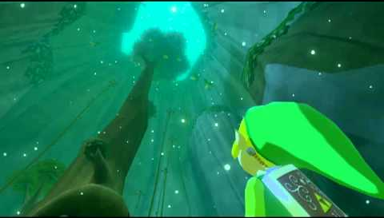
The Legend of Zelda: Wind Waker, Nintendo, 2002

Future Trajectories

Short-Term
First and foremost, work would begin on implementing all the points above to turn the project from an art target into a small playable demo. Adding walking or flight or both would greatly help the impact of the artefact, as well as other small animations and additional sound effects in the environment.
This art target was envisioned as a first step since the beginning, something that can be shown to prospective audiences to gauge their reaction on a project with this style. As mentioned above adjustments need to be made before this step is taken, but from there a small team of people can be gathered to turn this project into the playable demo.
With the adjoining ten-page document created for this project, creating enough of the game world to create a playable demo will not be difficult.
Looking into the future, creating an alpha from this will take a few extra months and additional members to the team, but this will allow a greater audience participation and the beginning of adjustments to create an enjoyable game. During the alpha stages additional assets will be created, and from here more areas can be created to begin the expansion of the narrative.
From here, with many necessary assets created early on, a playable beta version of the game could be created within the following months. Though larger islands would take on their own image and personality, once these locations with their four distinct styles are created smaller islands can be created using the same assets, which will reduce the amount of unique assets needed to create each area.

Long-Term
With as work is being finished on the main portion of the game, additional content will be created during and after release, to assure that the audience will be given more to play around the time sales begin to slow down. Additional content such as this can help maintain the audience until the release of the team’s next game.

Market Competitors
Games such as this, where exploring an unknown world to find its secrets, are already popular on the market (referring back to The Legend of Zelda: Breath of the Wild, and also mentioning games such as Yonder: The Cloud Catcher Chronicles and the Spyro series of games). Though these games exist there still aren’t many that focus and expand on Welsh and Celtic history: some are beginning to emerge, such as Lunafon: Tales of The Moon Oak which takes inspiration from Celtic mythology, but there is still a large gap in the market. Expanding the story to include Celtic-Irish themes as well as Celtic-Welsh can expend the prospective audience, and will be factored in to future renditions of the narrative.
An important trait for the gameplay to develop, particularly during the early development stages, is intuitive and easy to learn controls. The Spyro series, aimed at a similar target age group, has a very simple playstyle: the way the player moves on the ground is almost identical to how they move in the air, the only difference being the perpetual motion of flight. A button can be pressed to gradually raise the player higher in the air during flight, but otherwise movement is straightforward.

Mechanics
The importance of the game is being an intuitive adventure to experience, so that the narrative can be enjoyed alongside the mechanics without one dragging down the other. There are methods of flight control that work in other games, which do not need to be reinvented for this game. Any changes to mechanics will be implemented only upon discussion from an audience majority.
As mentioned above, a focus on Welsh and Celtic history and mythology is the main narrative goal for this game, but upon comparison of Celtic-Welsh and Celtic-Irish mythology it’s clear there are many cross overs and ties between them. Creating a world that brings focus to Irish history and mythology, and possibly even Scottish mythology, is a possible way of both expanding the narrative even further for more places to explore, as well as expanding the prospective audience. Pixar’s Brave, a film based in Scottish mythology, was the twelfth highest grossing film of the year it came out: gaining the interest of fans of this film will greatly benefit the growth of Tale of Two Dragons, though the time that has passed since its release will result in many of those fans no longer being a part of the target age and audience this game is aimed at.

Future of Publishing
In regard to production and publishing, it would be preferable to find a team externally and work on the game within a personally set time frame. After experiencing the pressure of an encroaching deadline, or self-inflicted crunch time, it is desirable that the team be able to work on the game without the pressure of a large company bearing down. Avoiding the circumstances that fell on Bioware’s Anthem is a priority, and as such fundraising personally through a campaign such as Kickstarter, similarly to Shovel Knight, will be the best option. This will require the additional work of maintaining a constant series of updates to maintain audience interest, and making sure that what is being produced stays within their interests.
Once the game is released onto the online Steam, or possibly the Epic store, the original plan of releasing onto the Nintendo Switch (or their latest console at the time of release) can be started. Since Nintendo do not consider publishing a game on the Switch unless the company has already released a game, starting on Steam (or Epic) will help fulfil this requirement and allow the game and company to expand.

References
Aava, K. (2017). Realistic vs. Stylized: Technique Overview. [online] 80 Level. Available at: https://80.lv/articles/realistic-vs-stylized-technique-overview/ [Accessed 6 May 2019].
Epic Games Forums. (2010). Floating Island. [online] Available at: https://forums.epicgames.com/udk/udk-development/level-design-and-creation/197321-floating-island [Accessed 6 May 2019].
Heikkila, E. (2017). A Guide to Building a 3D Game Character. [online] Theseus.fi. Available at: https://www.theseus.fi/bitstream/handle/10024/133905/Heikkila_Elisabet.pdf?sequence=1&isAllowed=y [Accessed 6 May 2019].
Holmes, S. (2016). How do I create real-time hair for games? | 3D Artist - Animation, Models, Inspiration & Advice | 3DArtist Magazine. [online] 3dartistonline.com. Available at: https://www.3dartistonline.com/news/2015/04/how-do-i-create-real-time-hair-for-games/ [Accessed 6 May 2019].
Nintendo. (2002) The Legend of Zelda: Wind Waker [DISC] Gamecube. Japan: Nintendo.
Sandifer, J. (n.d.). Jesse Sandifer. [online] Gumroad. Available at: https://gumroad.com/jessesandifer [Accessed 6 May 2019].
Schreier, J. (2019). How Bioware's Anthem Went Wrong. [online] Kotaku.com. Available at: https://kotaku.com/how-biowares-anthem-went-wrong-1833731964 [Accessed 6 May 2019].
The-artifice.com. (2017). Story Telling and Interactivity in Video Gaming | The Artifice. [online] Available at: https://the-artifice.com/video-gaming-story-telling-interactivity/ [Accessed 6 May 2019].
Wizeorrek, T. (2017). Game Characters: Modeling, Clothes, Materials. [online] 80 Level. Available at: https://80.lv/articles/game-characters-modeling-clothes-materials/ [Accessed 6 May 2019].
Yachtclubgames.com. (2018). Two Million Copies of Shovel Knight Sold!! | Yacht Club Games. [online] Available at: https://yachtclubgames.com/2018/04/two-million-copies-of-shovel-knight-sold/ [Accessed 6 May 2019].

Bibliography

Lunafon. (2019). Home | Lunafon. [online] Available at: https://www.lunafon.com/ [Accessed 6 May 2019].
Yachtclubgames.com. (2019). Yacht Club Games. [online] Available at: https://yachtclubgames.com/ [Accessed 6 May 2019].
YouTube. (2017). UE4 Floating Island Project. [online] Available at: https://www.youtube.com/watch?v=RCKQktjnVNg [Accessed 6 May 2019].
YouTube. (2018). UE4 fantasy level design part 5 | Floating Islands and arrangement. [online] Available at: https://www.youtube.com/watch?v=iLEYdkZOncs [Accessed 6 May 2019].

Appendices
Figure 1: Original Gantt Chart
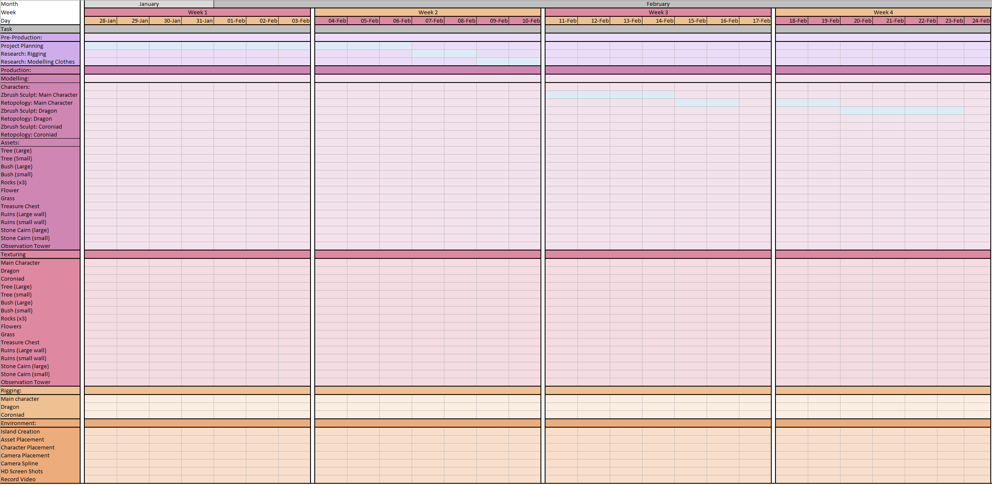
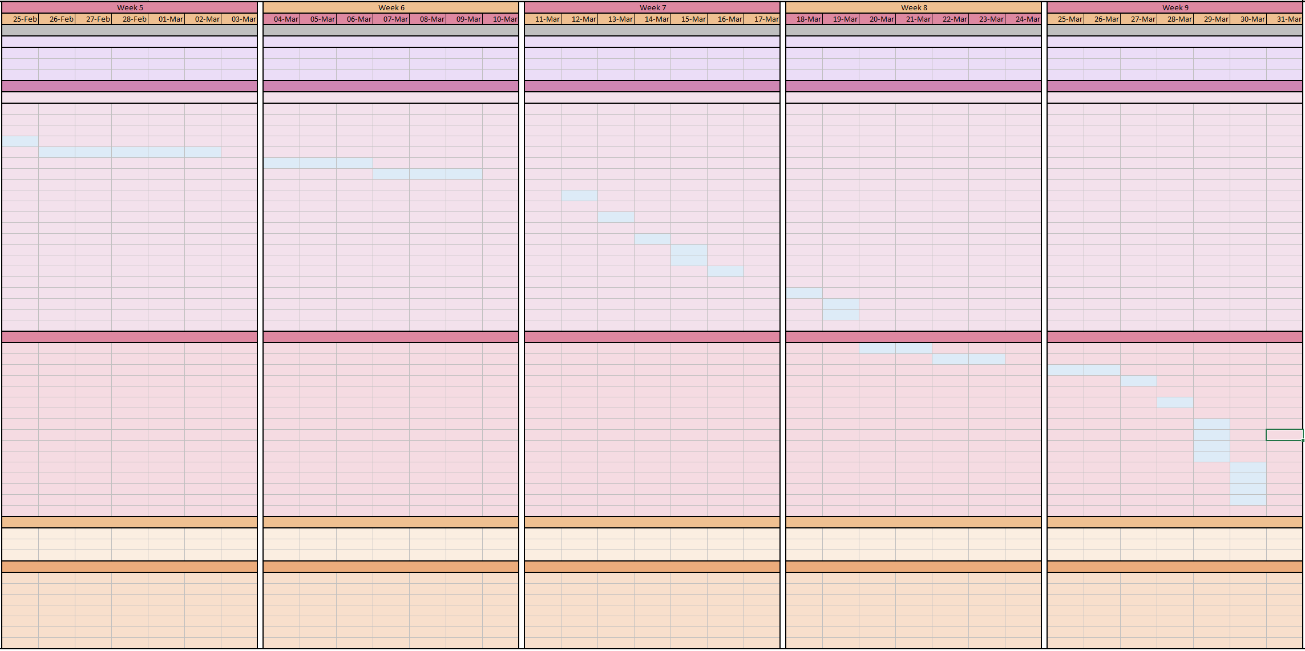
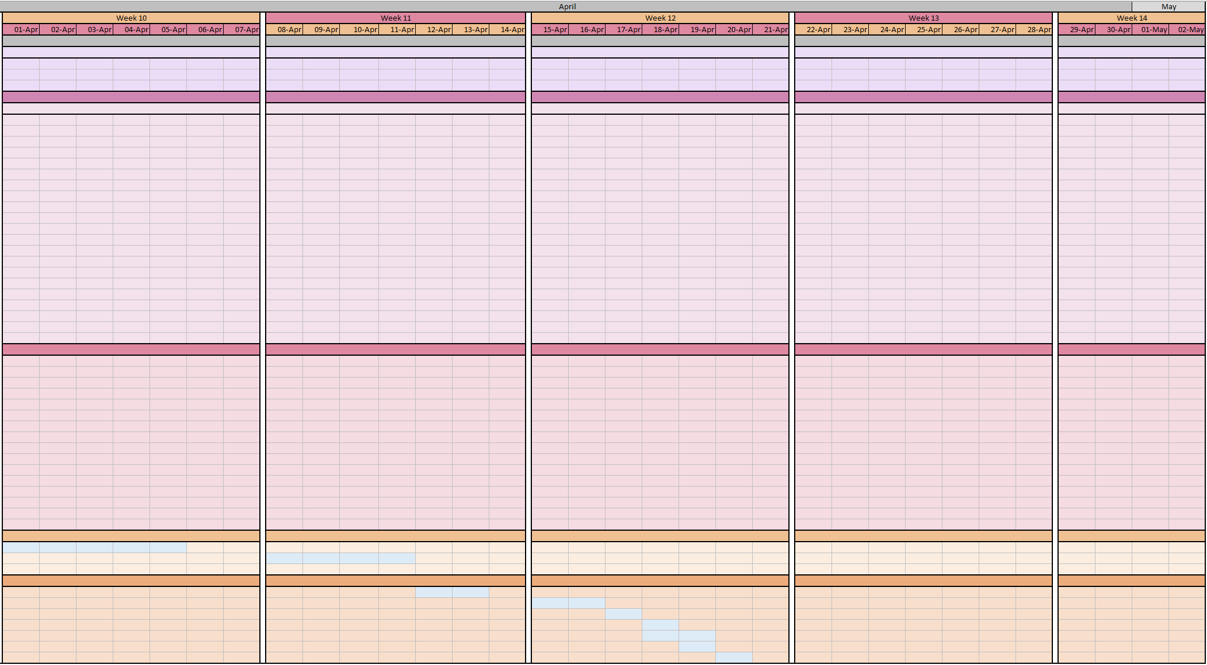
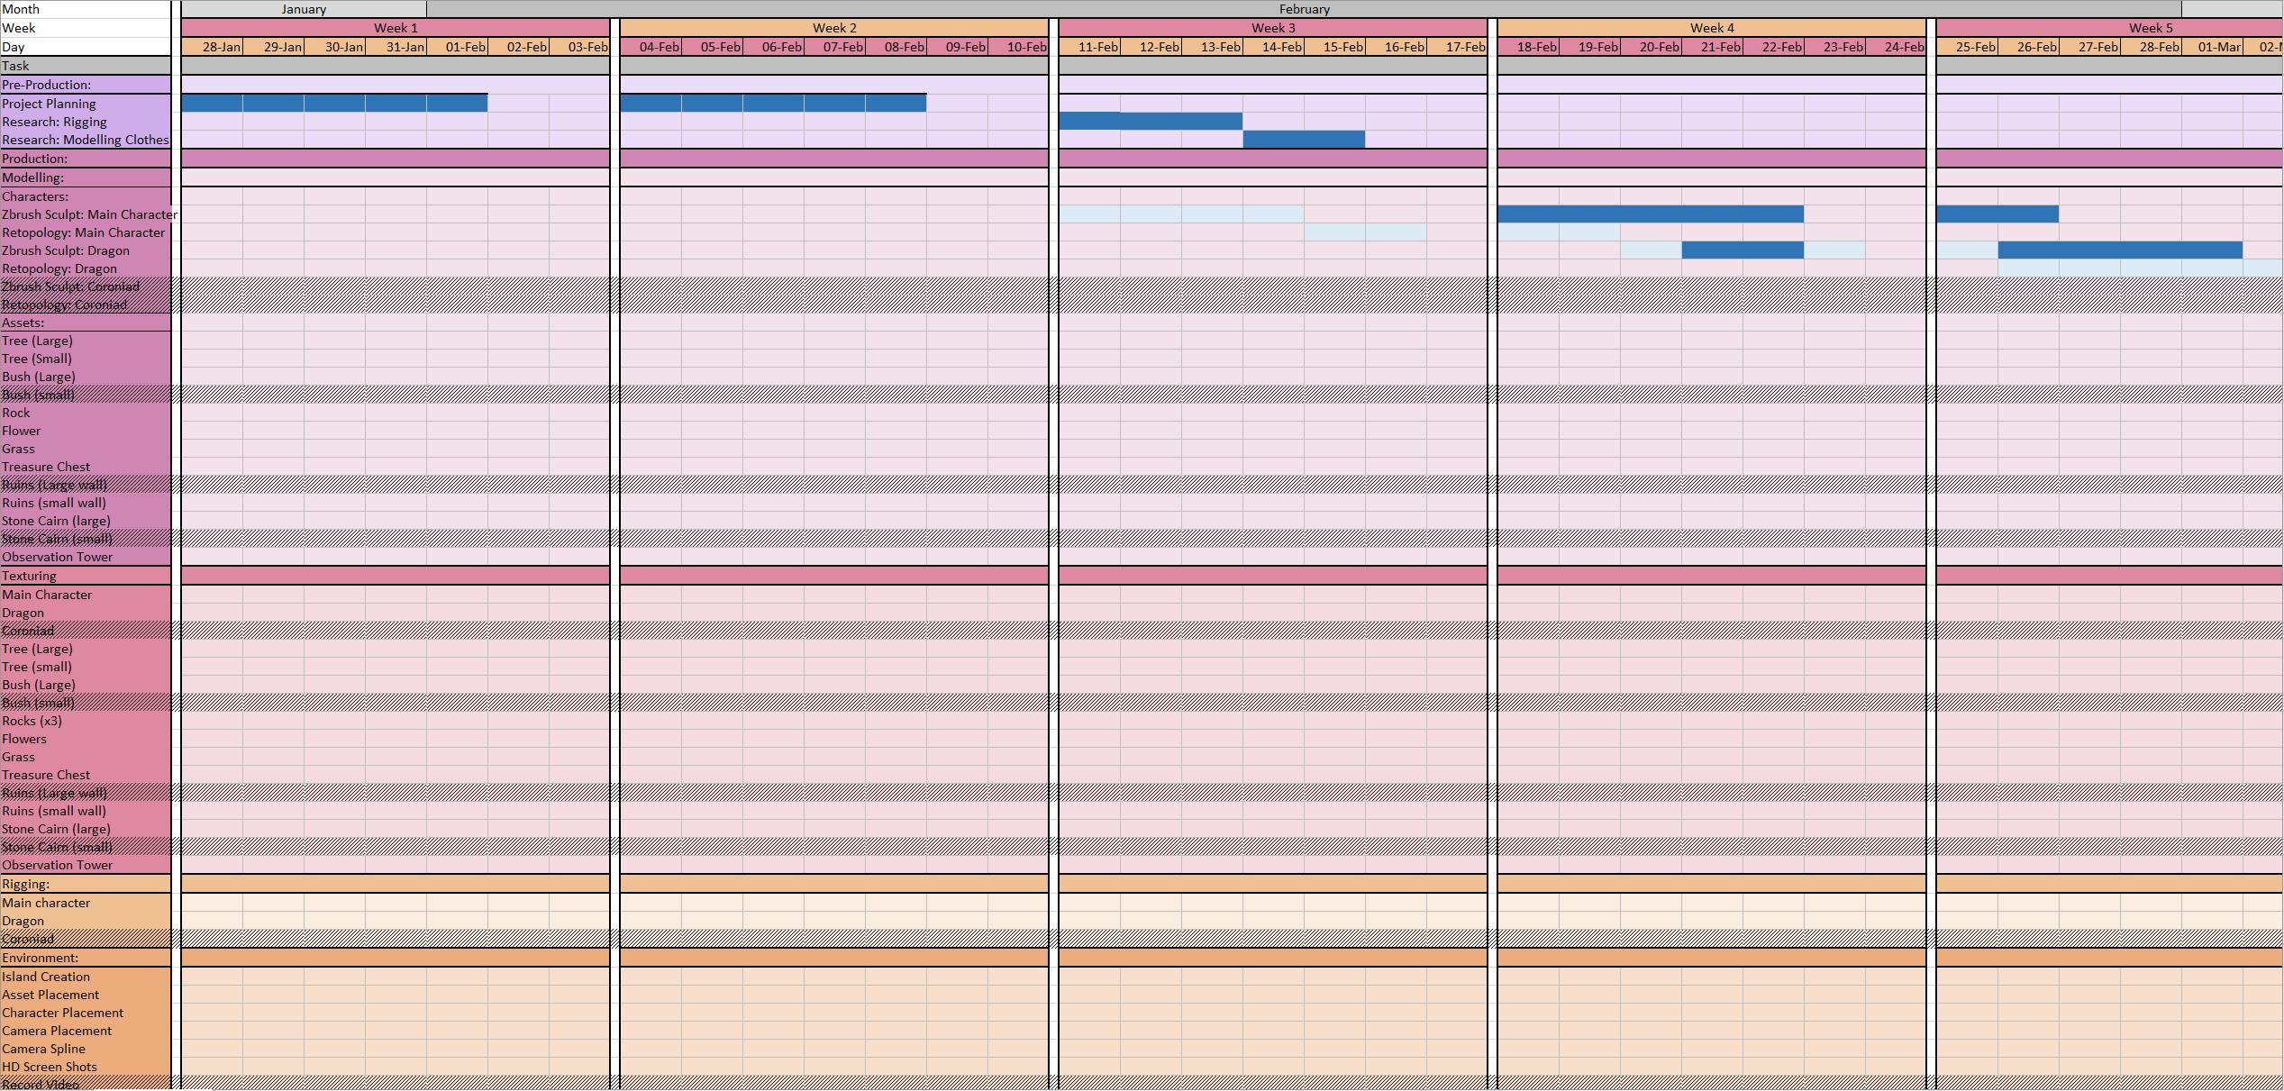
Figure 2: Back-up Gantt Chart


