Developing Professional Practice

Report Title: Personal and Professional e-portfolio (PPP)

Name: Lisa Davies

CIPD Membership
Number: 48699101

Date: 16th November 2017

Word count (max 2600 words)

I declare that this assignment is my own work and that any information obtained from books and other sources have been appropriately referenced.

Signed: Lisa Davies

Date: 16th November 2017

Table of Contents

- INTRODUCTION

1.1 The following report will demonstrate my knowledge and understanding of what defines an efficient and effective HR professional and will also explain the importance of group dynamics and methods of conflict resolution. The report will also look at my own personal development plan in order for me to identify my own personal skills audit and learning needs and be able to set clear objectives for areas of improvement.

- ACTIVITY 1

2.1 Evaluate what it means to be an HR Professional
Taylor and Woodhams (2016, p75) cite that a professional “makes proficient use of expert or specialist knowledge, exercises autonomous thought and judgement and makes a voluntary commitment to a set of principle”. Whilst this quote affirms what professionalism is, the majority of UK HR workers strive to become a member of a professional body i.e. CIPD (Chartered Institute of Professional Development). By being a member of a professional body i.e. CIPD this provides the necessary tools to ensure that knowledge, practical skills and competency is continuously updated and that CIPD’s Code of Conduct is followed. All CIPD members must commit to maintaining and upholding the standards and behaviours set i.e. Professional Competence and Behaviour, Ethical Standards and Integrity, Representative of the Profession and Stewardship, as cited by Taylor and Woodhams (2016, p76).
Being a HR professional is not just about demonstrating knowledge and skills and behaviours but knowing how and when to apply that expertise is paramount. It is important to be a skilled influencer as the ability to influence across an organisation, to gain the necessary commitment will get the best results! Also, to be curious demonstrates that you are interested in what’s going on in the organisation by continually looking for improved ways to work individually and collectively.

Working as HR Officer at Family Housing Association, the HR team endeavour to be the role model of the organisation. This is achieved by upholding and delivering the Association’s values, mission and policies, whilst adapting to issues and making informed decisions in our day to day work through advising and consulting as business partners.

The strategic objectives of the HR team are built around the long term vision of the organisation. This enables the team to work in partnership with other departments to help meet the challenges faced and deliver collaboratively the aims of the organisation in the short and long term at every level, as defined in the CIPD Profession Map.

2.2 CIPD’s Profession Map

The CIPD HR Profession Map was launched in 2009, to enable HR professionals to focus on their individual development needs throughout their career. The map provides a view on how a HR department works and how it adds value to the organisation. It was designed to support HR professionals at every stage of their HR journey and sets out the global standards for HR. The flexible framework has been devised for career development in view of the fact that HR roles and career progression vary.

Figure 1 – The CIPD Profession Map
The map set out in Figure 1 (Taylor and Woodhams 2016) highlights the ten professional areas, eight behaviours and four bands of competency that make up the CIPD’s Profession Map.

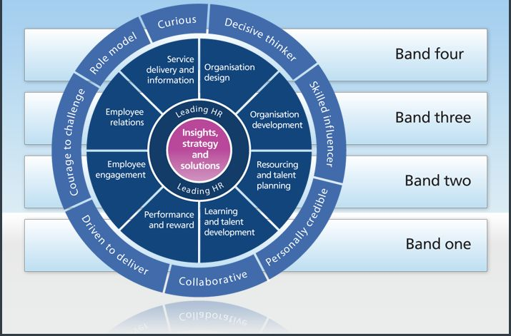

There are 3 key elements to the map:

Professional areas  describes in detail what is needed to be done and what knowledge is required for each area of the HR profession at four bands of professional competence | Behaviours – describes in detail how a HR professional needs to carry out their role | Bands and Definitions – The 4 bands provide a clear direction to development, planning and activities to enable HR professionals to progress in their HR journey, as there will be numerous challenges to be faced when developing from one band to another.
- Organisation Design  Organisation Development  Resourcing and Talent Planning  Learning and Development  Performance and Rewards  Employee Engagement  Employee Relations  Service Delivery and Information | - Curious  - Decisive Thinker  - Skilled Influencer  - Personally Credible  - Collaborative  - Driven to Deliver  - Courage to Challenge  Role Model | - Band 1 - Delivering Fundamentals  - Band 2 - Adviser/issues led  - Band 3 - Consultant/Co-operative partner  - Band 4 - Leadership colleague/coach

2.3 Core Professional Areas

There are 2 core areas to the profession map and should be implemented by all HR professionals.

- Insights, Strategy and Solutions – knowledge, behaviours and skills required to underpin the understanding of business needs and use these insights to develop strategies and solutions to meet organisation requirements. | - Leading HR – to enable individuals to act as confident, respected leaders, ensuring that contribution to the HR function is maximised by developing, supporting and measuring others across the business.  S

3.0 ACTIVITY 2

3.1 Group Dynamics

Group dynamics is the study of individual behaviours that can vary depending on individuals' current or prospective connections to a group. It shows the way groups or individuals act to changing situations. It is important that HR Professionals are aware that dynamics of group environments are affected by a number of different factors. These include: (See Figure 2)

Figure 2: Group Dynamics
Nature of individuals in the group
Structure of group or team

Leadership
Power and status issues
Communication processes

One of the most influential studies in this area is Bruce Tuckman’s (1965) as shown in Figure 3. Tuckman introduced the four stage model called ‘Tuckman’s Stages for a group:
Figure 3: Tuckman’s 1965 Performing Team (Business Balls 2017)
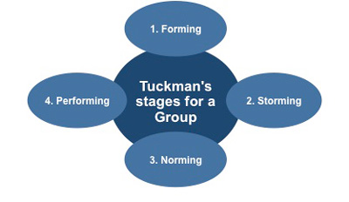
Tuckman felt that “all phases are necessary and inevitable in order for teams to grow, to face up to challenges, to tackle problems, to find solutions, to plan work, and to deliver results. Each phase is required in order for a team to tackle problems, face challenges, grow, find solutions, plan work and deliver results”, as shown in Table 1.
Table 1: Examples of behaviours found at each stage of Tuckman’s 1965 Performing Team Development Model (Business Balls 2017)
Stages of Tuckman’s  Theory | Behaviour at each stage  of Tuckman’s Theory
Forming | - Highly dependent on leader for guidance  - Leader must be prepared to answer lots of questions on objectives  - Ignored Processes
Storming | - Decisions don’t come easily within group  - Team members vie for position  - Conflicts are likely to occur
Norming | - Team starts to form  - Roles and responsibilities become clearer  - Group decisions made
Performing | - More strategically aware  - Clear direction  - Shares vision

3.2 Conflict Resolution Methods
A key role in HR management is the ability to manage any type of conflict that emerges, as conflict within the workplace is inevitable. Conflicts are usually due to a combination of factors i.e. personalities, needs and expectations. However, the most important factor is the ability to deal with issues in a calm and professional manner.
The HR Department regularly acts as mediator between employees and managers. It’s HR’s responsibility to respond quickly to any conflict that arises. There are many complaints that require conflict resolution i.e. unfair treatment and disputes between colleagues. HR will always try to offer solutions and compromises.
There have been numerous studies released which enable individuals to know how they would react and measure an individual’s behaviour in conflict situations. The Thomas-Kilmann model was designed to illustrate the options when handling conflict, as shown in Figure 4.

Figure 4: The Thomas-Kilmann Model
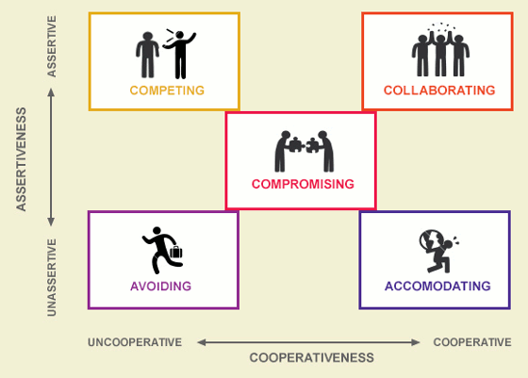
These models do not just inform individuals of their own behaviours but also inform organisations about “typical” behaviour’s of team members, which could help in conflict resolution.
According to Ohlendorf, A (2001) “avoiding dealing with conflict is a withdrawn style of conflict resolution. This is used where it is apparent that a win cannot be achieved”.
3.2.1 Examples of Conflict Resolution Methods
Working for a large organisation, it is inevitable that there will be conflict situations. I have previously resolved a situation by using the following conflict resolution methods:
- Active Listening Skills
According to Mindtools (2017) “Listening is one of the most important skills you can have. How well you listen has a major impact on job effectiveness, and on the quality of your relationships with others. By using active listening to help resolve a problem, you are able to understand the nature of the conflict of all involved.
- Problem Solving
By using problem solving techniques you are able to aim for a win-win outcome by using compromise which in turn could solve problems in a quick and effective timescale, causing less disruption to all involved.
3.2.2 Active Listening Skills Problem Solving – used in HR Conflict
The use of using both active listening and problem-solving skills have recently been used when I had to deal with an informal grievance between two members of staff who were both extremely strong characters. Employee (x) made a complaint about employee (y) stating that (x) was very loud in the office, constantly talked over people and was causing low morale in the office.
I arranged an informal meeting between (x) and (y) to get them both talking and to explain the issues raised. I encouraged (x) and (y) to let each other speak without interrupting each other and by me using acting listening skills I was able to understand the key problems from both involved. I also used problem solving techniques by asking how they were feeling, what was the problem and what could be done to resolve the situation. Both involved were provided with the opportunity to explain how they felt and both took numerous points on board, acknowledging that their own behaviours displayed played a big part in the dynamics of the team. They both agreed that if a situation arose like this again they would speak to each before the problem escalated.
The outcome of the meeting was a success and resulted in a win-win situation.

As shown in Figure 5 as part of this assignment I have completed an assessment of three professional areas, Performance and Reward, Resource and Talent Planning and Employee Relations. This will help me with my Continuous Development Plan (CDP) at Family Housing Association by providing me with the knowledge and tools to progress in my HR journey. CPD is extremely important as it enables individuals to develop which in turn, ensures ‘Best Practice’.

The light areas are areas that I am interested in developing within my HR Officer role. These areas are included in my PDP plan.

Figure 2 –

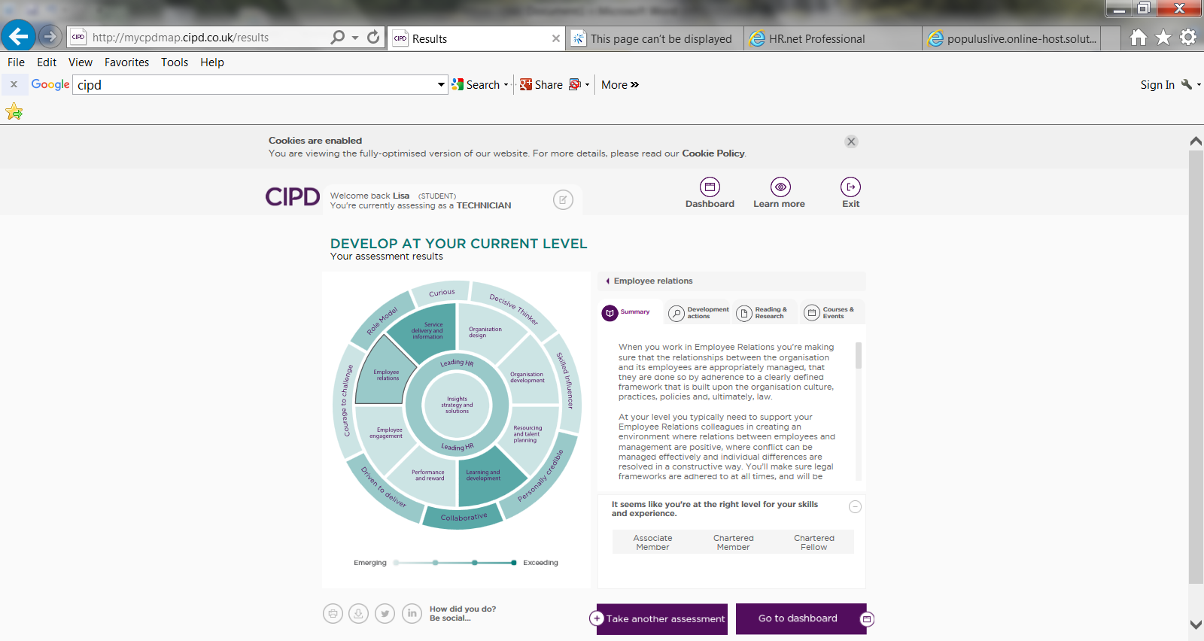

3.0 ACTIVITY 3

3.1 Project Management

Project Management skills are critical for HR professionals, as Project Management forms a large part of many HR projects, ranging from training and policy changes, restructuring of the organisation, or the planning of the Christmas party!

HR Professionals must possess the skills to manage projects. The volume of projects that HR professionals might be required to manage will vary considerably.

Ohlendorf, A (2001) indicates that there are five phases of Project Management - see Figure 5.

Figure 5 – Five Phases of Project Management
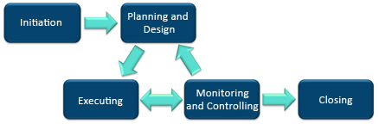

Successful Project Management also relies on proven processes and techniques.

Whilst it is evident that due to challenges highlighted by the CIPD, HR professionals now need to adapt with the changing business environment. For this reason, tools and techniques used in Project Management are now being used by HR professionals in HR focussed projects. There are software tools which can help chart progress e.g. Critical Path Method (CPM) - see Figure 6.

Figure 6 – Critical Path Method
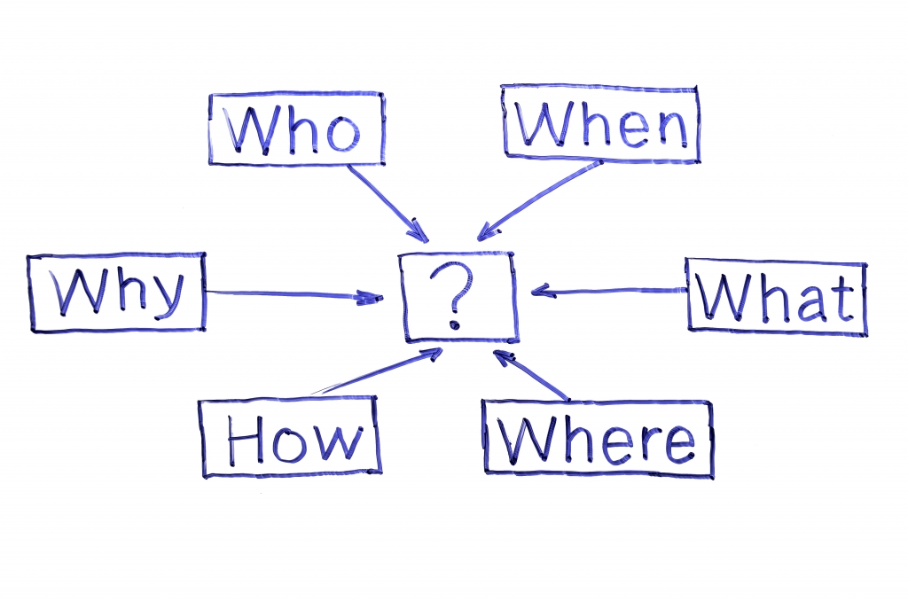
What is clear is that strategies need to be implemented by management and leadership is required to ensure projects are completed on time.

There are many problem-solving methods including Five Why Methodology. This is a system of asking “why” five times until the root cause of the problem is uncovered. It is important to apply critical thinking principles during use of this method in order to eliminate irrelevant assumptions and logic traps. Also, Kepner-Tregoe Decision Analysis produced a rational system based on unbiased decisions. It is also a structured analysis for gathering information, prioritising and evaluating data. There are four steps to this analysis, situation appraisal, problem analysis, decision analysis and potential problem analysis. The overall aim is to minimise the risk of problems.
It is important to follow project management techniques to ensure that the project goes to plan. Therefore, ensure objectives are set, resources are identified, timescales are adhered to and the project is monitored.

3.2 Influenced, Persuaded and Negotiated

Due to staff engagement reducing at Family Housing Association, we have engaged in the Best Companies 2017 process. The outcomes we hope to achieve through this process is to understand how staff honestly feel about working for Family Housing Association, finding opportunities for improvement and gaining the knowledge and tools to make it happen, support staff to become happier and more productive in their role, try to improve staff retention and create a workplace of choice.

I was heavily involved in the implementation of Best Companies 2017 and followed the Critical Path Method (CPM). I found this an extremely simple method to use.

- Who:
All permanent members of staff except staff on maternity leave and long-term sickness absence

- What:
Engage in the Best Companies 2017 process

- When:
Process commenced April 2017
, Data entry August 2017
Launch e-mail sent / posters distributed across organisation September 2017 (as shown in Screenshot 1 - dashboard confirms survey set up correctly)
Survey distributed October 2017
Reminder communication sent October 2017
Process closed November 2017

Screenshot 1 - Dashboard
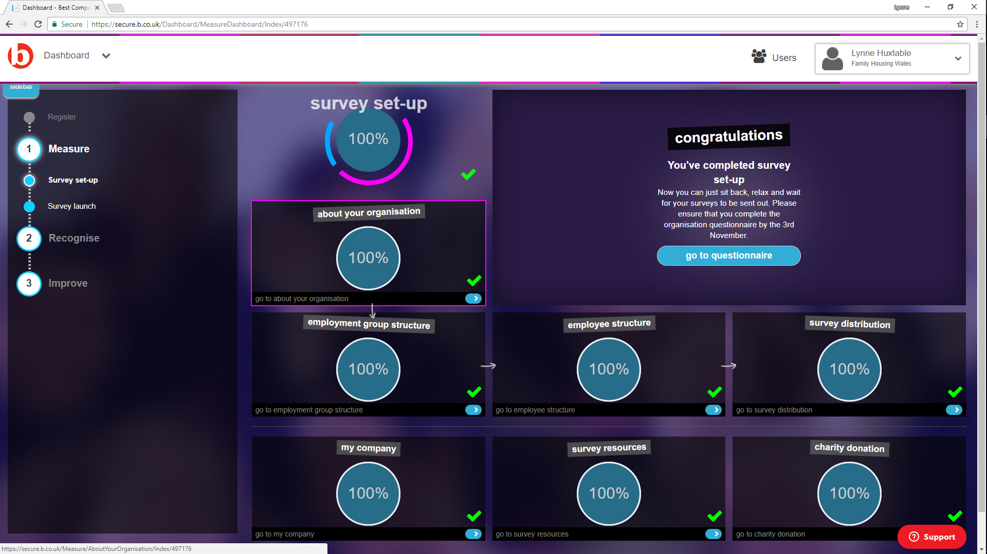

- Why:
Staff engagement has reduced at Family Housing Association. Therefore, we have engaged in the Best Companies 2017 process to hopefully understand how staff honestly feel about working for the organisation and how we can make improvements.

- How:
All office based staff sent survey electronically
Estates team – paper copies circulated

One problem encountered during the project was that staff did not feel confident that the process remained anonymous, which impacted on number of returned surveys. To analyse this further I requested a progress report from Best Companies, as shown in screenshot 2, which provided details of response rates. To try and resolve the problem and increase returns, I used my influencing skills by contacting managers and team leaders to encourage their staff to complete and return the surveys by reinforcing the fact that the process remained completely anonymous. By using this technique, response rates increased slightly.

Screenshot 2 - Overview
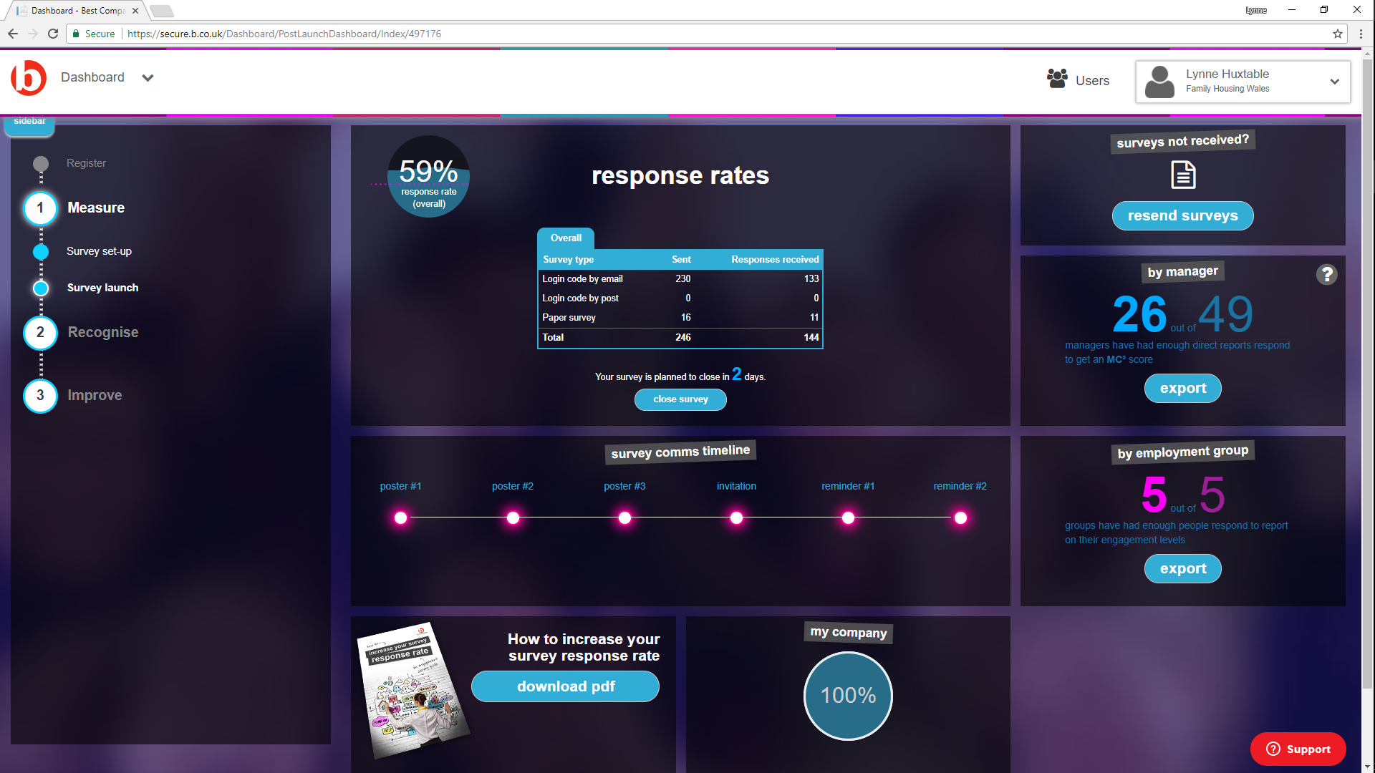

5.0 ACTIVITY 4

5.1 Self-Assessment of HR Professional Practice

As part of this assignment, using the CIPD Profession Map, I completed an assessment of one professional area Employee Relations. The reason for choosing this area is that I am currently working within Band 1 and would like to develop to Band 2 to enable me to work with managers to help implement
practices to improve employee engagement and to manage conflict effectively.

The assessment identified three areas for development as shown in table 4

table 4 – Employee Relations Competent Areas and Knowledge Gaps

Competent Areas | Knowledge Gaps
- Providing advice, training and support to encourage a positive working environment  Methods for communicating employee policies and procedures | Employment law  Monitoring HR activity to ensure compliance with employee relation  Providing accurate advice  Providing accurate advice and advice about policies and procedures

Honey and Mumford

To enable me to effectively continue with my Continued Professional Development, I undertook a Honey and Mumford 1986 questionnaire, in order to provide me with an idea of my preferred learning style. The results of the questionnaire (see attached Appendix 1 – Honey and Mumford) was that my learning style was a ‘Reflector’. Reflectors usually like to stand back, observe and are usually cautious. Van Vilet (2013) suggests that Reflectors like to listen in meetings and observe before making their decisions.

I totally agree with the results of the questionnaire and by recognising my learning style I am now able to progress with my development, looking at learning
opportunities that I will benefit from. As shown in Table 5 - Methods Showing Advantages/Disadvantages of different learning styles:

Table 5 – Advantages/Disadvantages of different learning styles
Method | Advantages | Disadvantages
On the job training | Real life  Low cost  Tailored to individual needs | Could learn bad habits  Could be put off due to other priorities  May deem a risk due to lack of structure
Reading | Gain broader knowledge of topic  Lots of choice | Lack of engagement  Need to self-motivate
Conference | Networking  Learn something new  Get inspiration | Distance  Can be expensive

Reflective Practice

Schon (1983) believes that “reflection in action distinguishes the truly outstanding professional”.
In HR there is a constant need to answer questions in a professional, accountable and credible manner. Gibbs Reflective Cycle (figure 8) clearly describe the main components of reflection:

Figure 8 – Gibbs Reflective Cycle (CIPD, 2016)



Reflective practice should be used daily by professionals turning every experience into a learning opportunity. By being reflective you should read around relevant subject, ask others how they do things and why, watch what is happening around you, have views and learn to value time spent thinking about work. A key tool used in reflective practice is to use a learning log to record entries of learning and development plans. Entries should be brief including what was learnt, actions to take and anything else significant. This enables reflection on each experience which may lead to a revised plan of action as you go along.

