University of Wales Trinity Saint David
Motorsport
Assignment 1
Alexandros Griffiths
2403677
Motorsport Engineering BEng
08/12/24
Engineering Science
1459 Words

Contents
Introduction 1
Experimental Procedure 1
Results 3
Analysis 7
Conclusion 10
Evaluation 11
Further Work 11
References 11

Introduction

During this experiment, you test different metals by stretching them using a tensile tester. From this you can calculate its stress and strain properties. In this report it outlines the carried-out experiment, the results, the analysis of the data and how you can improve on the experiment.

Experimental Procedure

To carry out the experiment, you first measure the materials you will test, the cross-sectional area and the length using a micrometre. In this experiment it consisted of Steel, PVC, Aluminium and Duralumin.
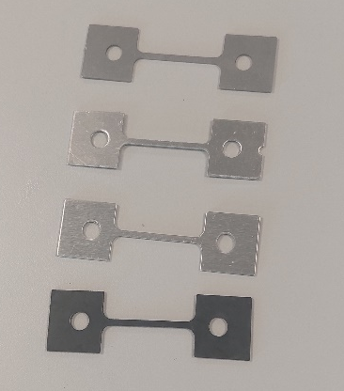
Next you load the first material into tensile tester then zero the gauge when the material is at rest. It is best if there is one person turning the crank and one is reading the gauge as the gauge changes values as the person stops rotating the crank.
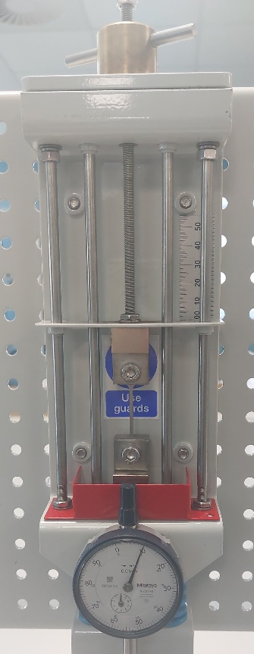
Rotating the crank two notches, you will take down the reading on the gauge until you have reached 5 full rotations of the crank, then you will switch to taking down a reading every full rotation until you reach 10 full rotations then it will move to every 10 full rotations and at that point the material would’ve snapped.
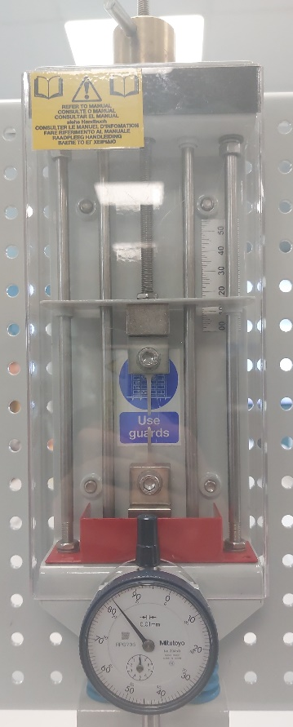
Once snapped you will take out the material and measure its new length. At this point you will have filled out the dial indicator column on the table and then you can use equations to fill out the rest. During the experiment you will need to follow the correct safety regulations which include wearing safety goggles and having the guard in place to stop any debris.

Results

Steel:
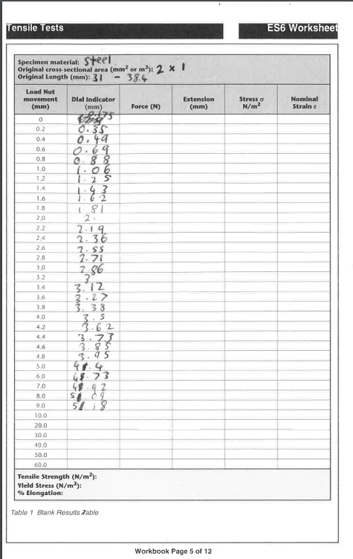

Aluminium:
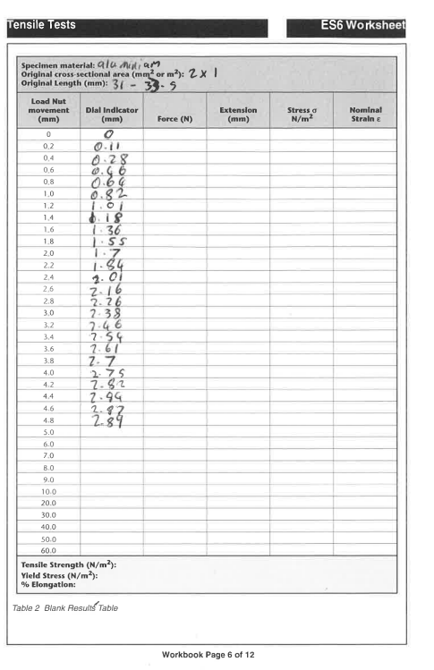

Duralumin:
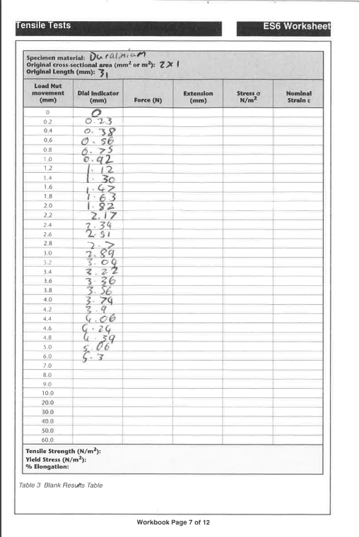

PVC:
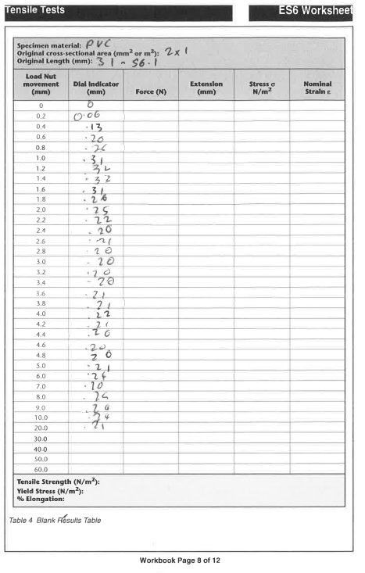

Analysis

Steel:
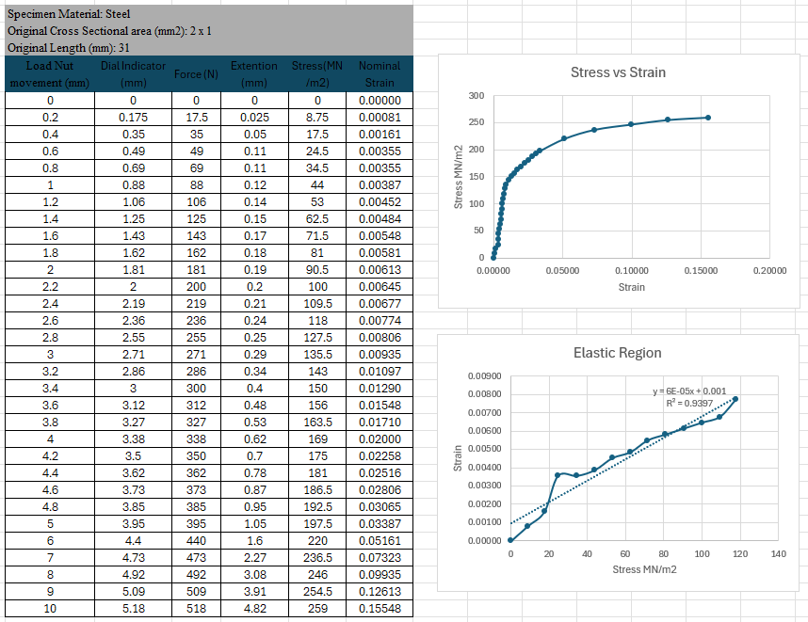
Elongation = 38.4 – 31
Elongation = 7.4 mm
%Elongation = (7.4 / 31)*100
%Elongation = 23.87%
Aluminium:
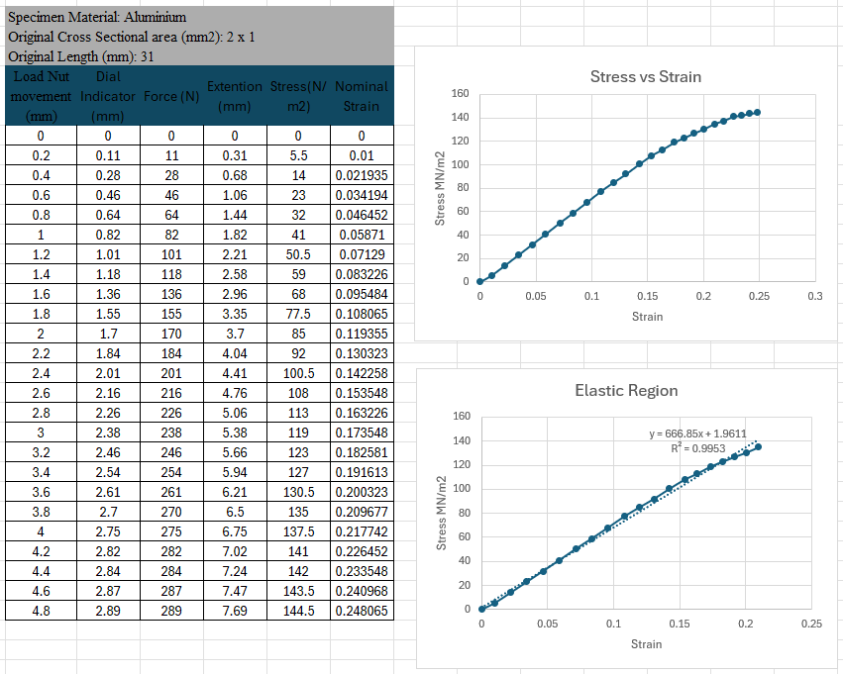
Elongation = 33.5 – 31
Elongation = 2.5 mm
%Elongation = (2.5 / 31)*100
%Elongation = 8.06%

Duralumin:
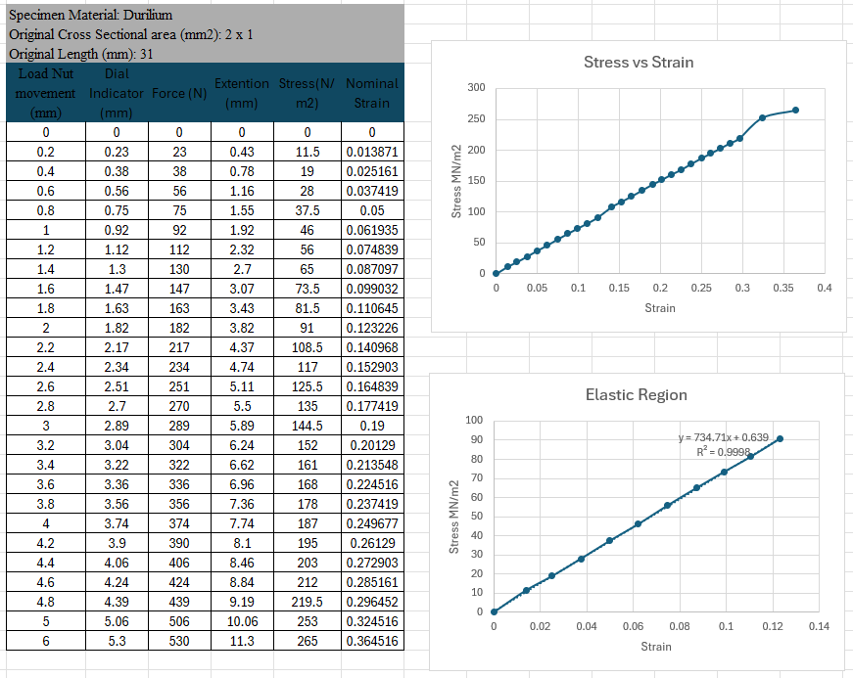
Elongation = 38.7 – 31
Elongation = 7.7 mm
%Elongation = (7.7 / 31)*100
%Elongation = 24.83%

PVC:
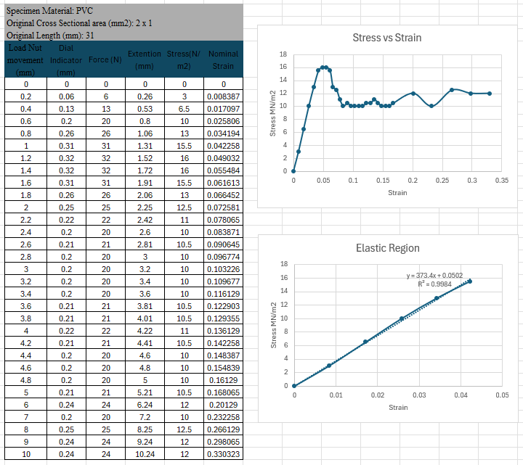
Elongation = 56.1 – 31
Elongation = 25.1 mm
%Elongation = (25.1/ 31)*100
%Elongation = 80.96%

These results include the reading you get from the test and the properties you get from the material by working them out, there is also graphed results so you can visualise the elastic and plastic regions.

To calculate the force: Dial Indicator Reading (mm) * 100
To calculate extension: Extension (mm) = Number of Turns of Force Control (mm) - Dial Indicator Reading (mm)
To calculate the stress: Force (N) / Cross Sectional Area
To calculate the strain: Change in Length (mm) / Original Length (mm)
To calculate elongation: Final Length – Original Length

Conclusion
Steel:
The tensile stress of steel is around 600 MPa and the yield stress is around 200 – 300. In the graph, there is a defined difference between the elastic and plastic regions so it is easy to pick out the yield point, were the force is 271 and the cross sectional area being 2mm^2 , this makes the yield stress 135.5 MPa. A bit lower than the standard but close.

For the tensile stress, you would take the highest point on the graph and use that but on the graph, the highest point is were is snapped so something went wrong. Using this highest point, where the force is 518N and the area 2mm^2, the stress would come out as 259MPa. This is wrong as the tensile stress of steel is around 600 so it was either the material that had a defect or human error. To improve, you could do the test multiple times to lower the possibility of bad data.

Aluminium:
Depending on the type of Aluminium, the tensile stress can range from 200 to 500 MPa and the yield stress can range from 100 to 300 in common types of aluminium. In the graph, There isn’t a defined curve so it is hard to find the yield point but it was chosen where the force is 270 N and the area is 2mm^2, this makes the yield stress 135 MPa which is within the correct range.

Same with the steel graph, the maximum stress was where the material snapped so something went wrong. Working it out anyway the force was 289N and the area was 2mm^2 which makes the stress 144 MPa. This is close to the yield stress which isn’t uncommon for aluminium but if you observe the graph, it doesn’t look correct, so this number is not representative to the true tensile strength.

Duralumin:
Being a alloy of aluminium it would have similar properties which it does, its tensile stress is around 500 – 600 MPa and its yield stress is around 160 MPa. Looking at the graph, it has the same problem as aluminium as there is little to no curve, but the yield point was taken when the force was 182 N and the area is 2mm^2. This makes the yield stress to be 91 MPa which is close to the expected value.

Same problem on the tensile stress, as the max stress on the graph is where it snapped. The force at the maximum value was 530 and with the area being 2mm^2, the tensile stress is 265 which is much lower than expected.

PVC:
PVC is very dependent on temperature, especially when you test such a thin sample. But at room temperature, the yield stress is around 50 – 60 MPa and the tensile stress is around 40 – 50 MPa. Quite dissimilar to the other materials as PVC is very elastic and ductile. Looking at the graph it is all over the place due to the equipment that was being used. There is a defined elastic region and at the point of yield, the force was 31 N and the area was 2mm^2 so the yield stress is 15.5 MPa. Much lower than expected but that is due to the temperature it was being tested at.

On this graph, the maximum stress is not where the material breaks which is good. The force at maximum stress was 32 N and the area being 2mm^2, the tensile stress is 16 MPa. This number is very close to the yield stress but that is normal.

Evaluation

The test was very limited as you could only test the materials once but we kept the same people turning the crank and watching the gauge so the results would be consistent. If we switched the people every test, one person could read the gauge slightly differently to the rest. Another way to keep the test fair is to test the materials at the same temperature, the best you could do with the equipment you are given was to test the materials quickly and to keep an eye on the temperature with a thermostat.

Further Work

If you were given unlimited time and resources, you could make the experiment much more accurate and void of any human error. For example, you could use an electronic tensile tester that automatically stretches the material and takes reading from the material, this would make the test so much more accurate as during the test it takes one person to turn the crank and one person to read the gauge and that’s two factors for human error. You could also test multiple of the same material and get the mean values to reduce external factors of the tests such as the temperature of the room, this applies heavily to the PVC as temperature affects the tensile strength of the PVC even if there is a few degrees difference so testing it multiple times either in the same temperature or a wide range of temperatures will get rid of that factor.

Another practice you could do is to not vary the intervals of where you take readings. In the experiment, it went from every .2 of a full rotation to every full rotation to every 10 rotations. This is not good for the accuracy of the experiment but was done due to the lack of time for the experiment.

References
1. N/A
2. N/A
3. N/A
‌4. N/A
5. 5.1. AZoM.com. (2013). Stainless Steel - Grade 302 (UNS S30200). [online] Available at: https://www.azom.com/article.aspx?ArticleID=8197.
5.2. AZoM (2005). Aluminium - Specifications, Properties, Classifications and Classes. [online] azom.com. Available at: https://www.azom.com/article.aspx?ArticleID=2863.
5.3. Stella Mechanics. (2024). Characteristics of A7075 Aluminum Alloy (Super Duralumin) - Stella Mechanics. [online] Available at: https://stellamechanics.com/blog/a7075/ [Accessed 8 Dec. 2024].
5.4. Technical Data Sheet GEHR PVC-U. (n.d.). Available at: https://en.gehr.de/wp-content/uploads/2021/11/GEHR-PVC-U-technical-datasheet.pdf.
6. N/A
7. 7.1. Rahman, M. (1992). A Study Of The Effect Of Temperature On Failure Behavior Of Locally Manufactured PVC Pipes. p.78. Figure 5.15. Effect of Temperature on Ductile Failure.
‌

