Jemmesha Larman
Assignment 1
Dale Clarke
BMSW4002
Cohort 11, Group 7

Introduction

The aim of this report is to explore how students can develop an effective team and the effects that having one can have. The clear definition of an ‘effective team’ is the capacity that a team has to accomplish its goals or objectives which have been designated by a person of authority or an organisation. There are a number of building blocks that an effective team will have in place such as the following: clear objectives, balanced roles, effective processes, good communication, appropriate leadership, support, trust, openness, mutual co-operation, individual development and sound inter group relationships.

Working effectively as a team is vital as it ultimately dictates the outcome of the project being worked on regardless of how smart each team member is individually. Each team member needs to be aware of the strengths and weaknesses of the other team members so that they can work in a wag which supports all team members and doesn’t leave anyone left feeling unsupported/singled out. Effective teams are the foundation of every successful company/project. Organisations/companies without teams that work well together are more likely to struggle with even the simplest of tasks. Where as teams that do work together effectively have much more increased productivity rates, better efficiency and can facilitate the completion of products.

Overview

In developing a team it is vital that team members go in with the mindset of ‘we’ rather than ‘I’. Regardless of how good your own work is if your team members level of work is not matching then you as a team will not succeed. You need to also be open to this ideas of your team members. When one idea is introduced it allows other team members to build on it, allowing it to become viable. An increased contribution from all team members high tens the chances of a successful implementation. Studies have shown that effective team work has been a key factor in for progress, evolution and the survival of humanity (Ashley pm. Kawham, 2017, page 267).

One model of team development is Tuckman’s FSNP model. Bruce Tuchman published his model in 1965. It was developed in order to illustrate the sequential stages of group development. He was of the opinion that all all phases needed to be put in place to enable the team to grow and reach the highest possible level of effectiveness. In 1977 he decided to join efforts with Mary Ann Jenson whom added the fifth stage to his model which is ‘adjourning’, this stage occurs when the team completes the current project. To date this is the most popular model although some researches suggest their own alternatives and modifications.

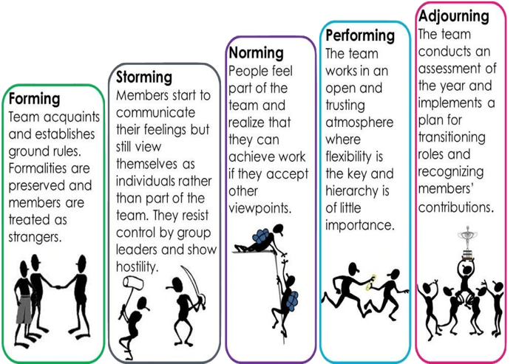
Tuckman’s FSNP model-
Models and team development

The team development model that could be considered could be the Tuckman’s FSNP model. It is understandable that a few conflicts/issues will arise with students coming from different backgrounds as many different perspectives will be getting put forward. But the recommended development model takes the possibility of conflict arising into consideration and actually plans out how to get to a point of resolution and then actually moving forward from this to focus on the actual task. This team model was formed in order to get a new team to perform more effectively (Outlife, 2019, page 1).

The Tuckman’s development model will most likely be the best development model for this team as it acknowledges the fact that groups don’t always start off being properly formed and fully functioning but Tuckman suggests that it is easier for teams to grow through fully defined stages. This includes their creation, cohesion and task focused teams.

The stages that are used are incorporated need to be sustained from when the team is formed until the point in which the team is no longer needed/has completed the given task.

It is important to complete all stages as doing so plays a very important part of ensuring that the team is high functioning and effective. Most people find it helpful that the stages rhyme as it makes them easier to remember (Colleen Condon, 2019, page 1).

There are other team development models that are available to be used but would most likely not have the same effectiveness as Tuckman’s model. Another team development model that is commonly used is the rocket team performance model. This model is designed I. Order to boost the performance of a team that is already performing well and therefore doesn’t have a plan for conflict resolution like the other model, because of this it would big work as effectively as before any tasks were undertaken the first that that would need to be don’t would be to resolve any issues with in the team resultantly allowing if to work more effectively.

Team roles

It is imperative that designated roles are given when working in a team setting. Everyone needs to know their role as well as being able to carry out their role successfully. There are also different skills that the team must possess as a whole to ensure they stay at maximum productivity. There are many different opinions on the number of roles that are needed within a team in order to make it successful, this report will explore two. The first one is Belbin’s team roles, this states that you should have a resource investigator, a team worker, a co-ordinator, a plant, a monitor evaluator, a specialist, a shaper and an implementer (Belbin associates, 2021, page 1). Another one states that only four team roles are required: a leader, a facilitator a coach and a member.

It is important that teams try their best to get through any challenges they might face as doing so allows them to grow as a team. Ensuring that team members spend a lot of time together, not just in the work setting ensures that positive relationships are built. When applying the Tuckman team development process to your team scenario it is likely that your team will have a increased chance of completing the object successfully with a high performance. The team will also be more trusting and supportive. This will allow the jobs to be completely faster and in a more effective way.

It is very important to consider team roles when recruiting new staff as you need to ensure that the potential employees will fit well into the team and will be able to properly execute their given role and positively contribute to the team. It would be wise to state to the candidate what was expected of so it cited he identified whether or not they would be suited to the role.

Discussion

Advantages-
There are many advantages of working in a team rather than individually, thus report will be exploring some of them. Firstly, working as a team facilitates the generation of ideas as well as creative thinking. By incorporating multiple people that are many more perspectives being put forward which can result in a greater number of ideas being combined and perhaps being better than they would be if one individual were to have to come up with everything alone.

Another advantage is that team work improves the rate of productivity and most commonly brings about better results. Scientists have found that working in groups Very commonly inspires the team members to work harder (Loop Team, 2021, page 1). According to scientists this is due to the fact that when surrounded by other people team members often feel the pressure to ensure that they perform/deliver. It is very common in businesses to follow a process called the Z process. In order to best make use of this tool it is imperative to identify all the roles within a team and manage them properly. This needs to be done by making sure the right people have been put in the roles that are best suited to their strengths.

Working in a team setting also encourages innovation. Working in a team allows more
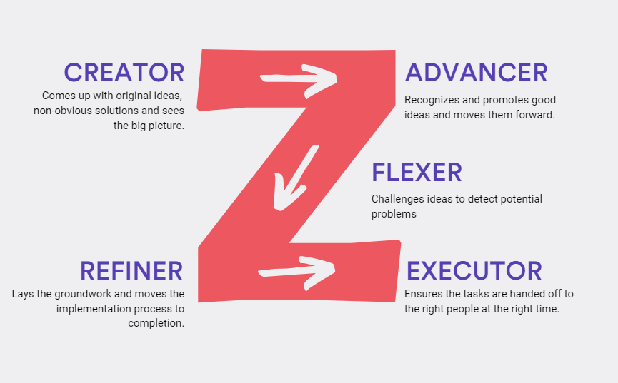
innovative and creative solutions to be thought of compared to the ones that someone might think of if they were working alone. Mr. Azoury stated that diversity plays a very important part in problem solving. He believes that when you put a bunch of diverse people together to solve an issue they will come up with a number of different solutions. Having sessions in which teams brainstorm together will most definitely lead to better solutions that someone provably couldn’t come up with all alone. Bouncing ideas off of each also allows employees to gain confidence in regards to ideas that could been deemed as out of the ordinary. When people work alone they are more likely to present ideas that they deem as safe.

Disadvantages-
This report will now explore the impact that working in effectively as a team can have. Ineffective teams can cause a lot of toxicity to build up. There are 12 qualities that infective teams possess, thus report will look at some of them. Firstly, team members that are not very driven and are not fully focused on reaching the end goal. No matter how determined certain team members are if everyone is not putting in effort and properly carrying out their role the end goal will not be able to be reached.

Secondly, a lack of openness and trust. If team members are overly guarded they will not be shoe to properly carry out tasks together. Sometimes people perceive openness as yielding to someone or giving your competitor an advantage. When this arises within a team, team members do not share enough ideas with one another. This is not good as successful teams need to be open with one another and able to bounce ideas off of one another freely.

Thirdly, if the team is unorganised and people don’t really properly understand what their roles are. It is important that within your team you feel a sense of community, failing to break down that initial awkwardness and form a good relationship with your team members will result in a loss of synergy. To avoid this team members could try to sometimes meet up outside of the work setting. A loss in synergy could lead to a highly unfocused team that will most definitely struggle to complete their project to a high enough standard.

Conclusion

This report was created in order to explore the importance as well as the impact that working as a team can have on an overall project. Working in a team, when done properly, can hugely increase success rate as well as allowing multiple perspectives to be put forward that might not have been explored if someone was working individually. Working as a team allows a number of different skill sets to be put to use and increasing the quality of the work that is produced.

In regards to the presented scenario this report exploited multiple ways in which the presented issue can be combated. Due to the fact that team work is so essential there are many different team development models that can be followed in order to try and improve the team moral and ensure that even the list fevered teams are able to work well together. An example of the team development model that could be used in this scenario is the Tuckman’s TSNP model. It works to combat any initial conflicts and thereafter working towards reaching the actual goals of f the team.

