DS 1 Template

My Screenshots/Photos
- Please add 4–6 screenshots or photos of your digital life.
- You can use your phone or laptop.
- For each screenshot, write one or two sentences explaining what it shows. Screenshot/Photo 1
- 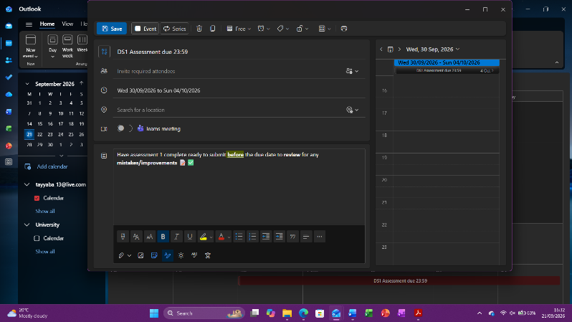

- 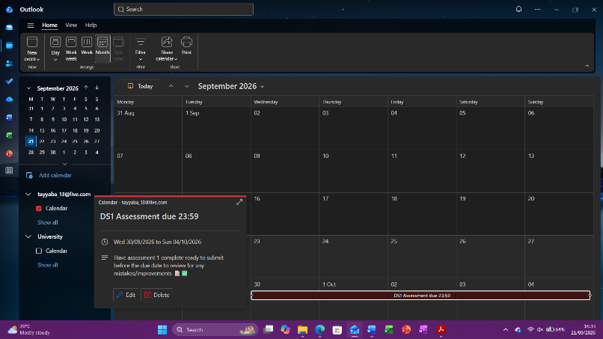
- This image displays the outlook calendar, which I use to plan all my events/reminders regarding university, work or any other event which can be accessed on any device.

Screenshot/Photo 2
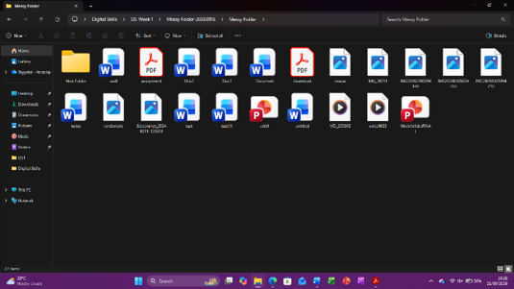
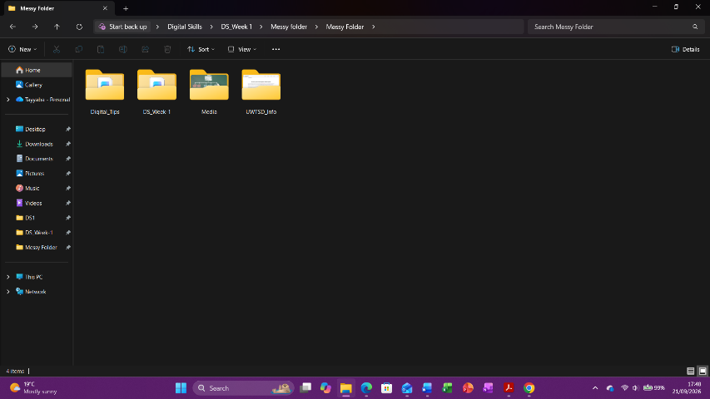
This is an example of file organisation from week 1 class, which is useful in everyday life and in a business. I have shown how I have made it concise and easily accessible.

Screenshot/Photo 3
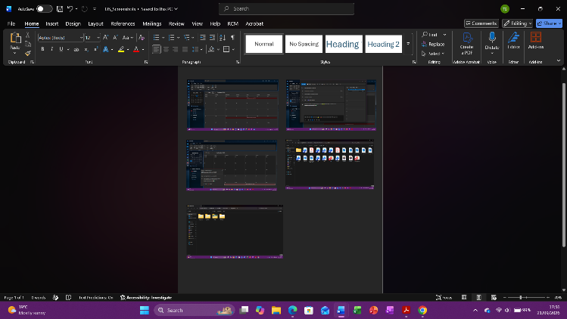
I can use word and other Microsoft applications comfortably to create a document, save images, make leaflets, posters, presentation slides etc.

Screenshot/Photo 4
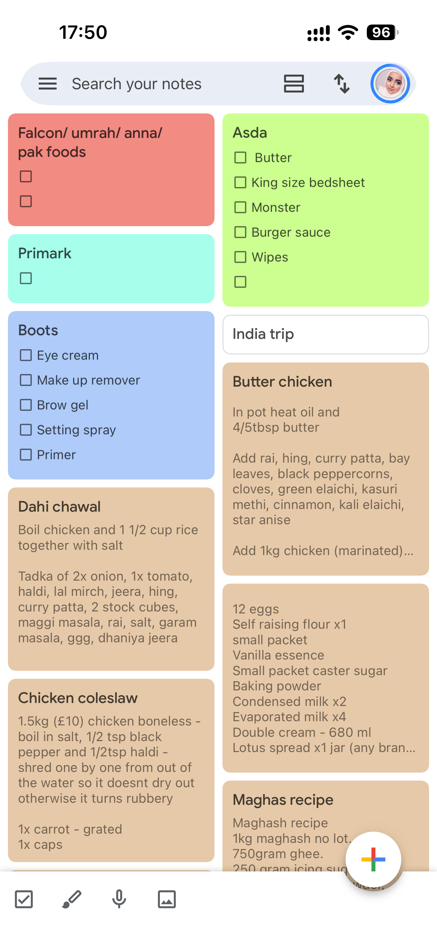
I use Google Keep on my phone to make separate lists for groceries or recipes etc, which is accessible in one place; so it’s easy to access and are colour coded to differentiate them.

Screenshot/Photo 5
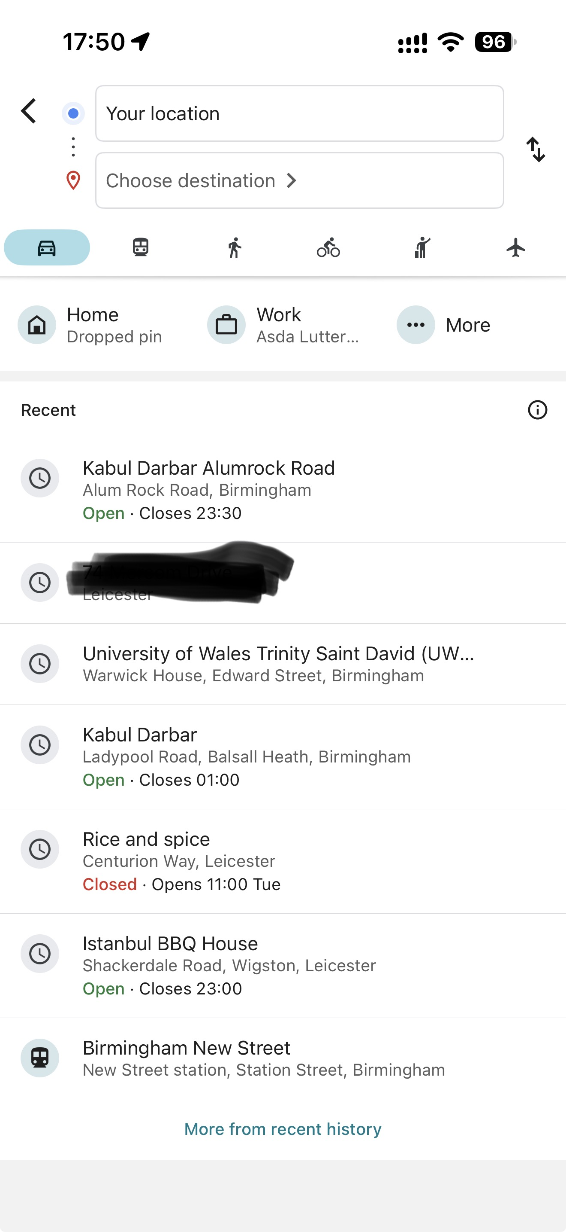
I use Google Maps daily to plan the best route, check traffic, check opening times, distances etc. it allows me to pre-plan journeys as well which helps with time management.

Screenshot/Photo 6
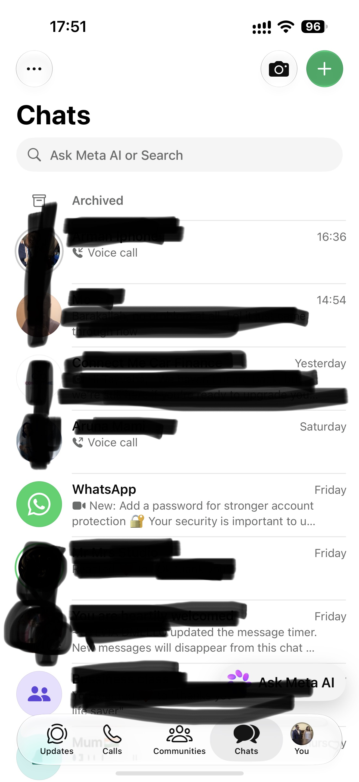
I use WhatsApp daily to communicate via video, audio call or just messaging. Also to create story, send images, videos, documents, sharing links or live location.

My Short Reflection
- Write 5–8 simple sentences about your digital life.
- You can use the sentence starters below if helpful.
I use all these digital tools regularly to aid me with my daily, work, and university life. It can be accessed on all devices, so I can have same information available on phone or laptop. As I use them on a regular basis, I am confident in using the applications and features.
I would like to improve on pushing myself to use the applications to the maximum benefit they have to offer me, as I get nervous assuming I am not sure how to go about it. Digital skills are important, as everything has become technological in all aspects of life. I hope this module helps build my confidence back into showing my full potential I have to offer and that I am making the most of what there is offered in all the applications we need to use. This will transfer into work life as it can show them what I can use confidently and efficiently.

Sentence starters
- I use digital tools to …
- I feel confident when I …
- I want to improve …
- I often use these tools: …
- I sometimes feel nervous about …
- I hope this module will help me …
- Digital skills are important for me because …
You can write more if you want.

Submission Checklist
Before you submit, please check:
​​​ ☐ I added 4–6 screenshots
☐ I wrote short sentences for each screenshot
☐ I wrote my short reflection
☐ My work is my own
☐ My file opens correctly
​​☐ My file opens correctly

