EFFECTIVE TEAM WORKING AND COMMUNICATION
CLASS CODE: BMSW4002_LON
TERM II

TASK: GROUP PRESENTATION

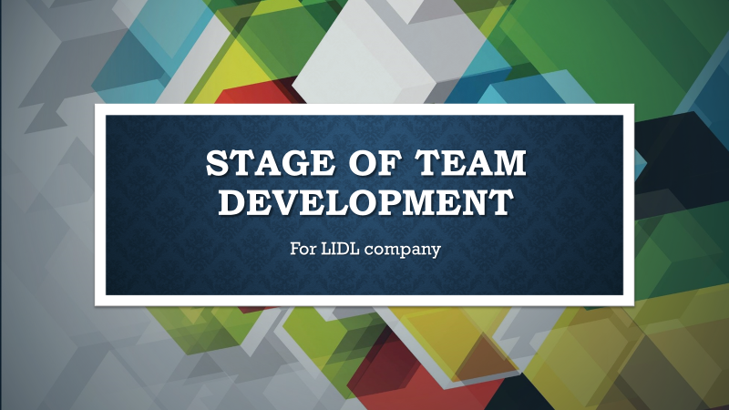

STUDENT NAME: IOANA CADERE
STUDENT ID: 1909479
LECTURER NAME: HUSAM HELMI
Good afternoon. My name is Ioana and I will speak about the stages of team development and the steps to be followed to form a reliable team.
Within this term, our requirement is to prepare a group presentation outlining the steps and considerations that need to be taken to introduce effective teamwork into the company.
According to Morgan (2017), a team is ‘a number of individuals working as one to achieve a particular goal to which they are mutually committed’.
Due to the impediments imposed by this global pandemic and the fact that we are locked in houses we will no longer be able to support the oral presentation in the class in front of an audience and for this reason we will summarize this form of presentation for this term.

STAGE OF TEAM DEVELOPMENT

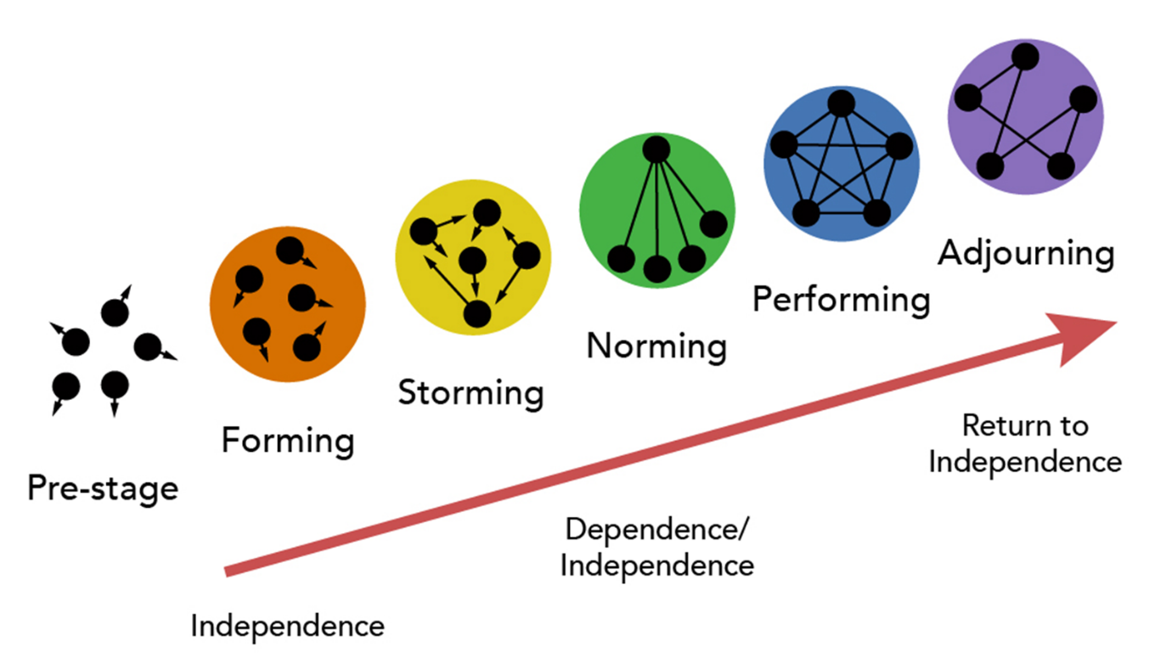
Source of photo: www.bing.com

Psychologist Bruce Tuckman said, in 1965, that each team goes through 5 stages of development: training, storm, standardization, performance and postponement. The stages start at the first meeting of the team and end at the end of the project. Each member of the group is properly appointed and plays a vital role in building a high functioning team (Toggl, no date).

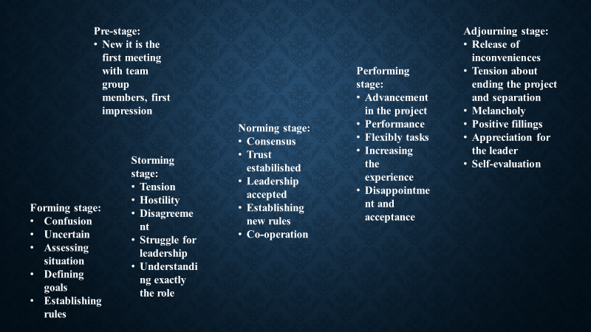

Each stage is it important and you must go through all of them to be able to train yourself completely and to perfect the team. Here I will explain the most important actions that must be implemented at each of them:
PRE-STAGE:
- Now the first eye contact between team members takes place.
FORMING:
- Now is the first face-to-face meeting
- Each member introduces himself and talks about his skills, knowledges and experiences
- Discussions about team norms for working together
- They are presented with the project and the already existing plans
- Information on how they can help develop the project
- Discussion about team roles and responsibilities
STORMING:
- They begin to realize that teamwork is not working if someone don’t join
- Understanding their roles
- Small struggles for leadership status will arise
NORMING:
- They will come to an agreement
- They will gain mutual trust
- They will choose and accept a leader
- New rules will be established, and cooperation will begin
- The team member becoming friends
PERFORMING:
- Now they are supporting each other and relaying at the team likes one
- Everyone is highly motivated to finish the project well as a true team
- They can brainstorm more effectively to solve and manage the problems
ADLOURNING:
- It is the end of the project when improvements can be seen
- The team is surrounded by positive feelings
- They will miss each other
- It is the best time to self-evaluate
Failure to follow these steps decreases the company's excellent customer service and this is not desirable, so each new member must go through all these steps.

IT WAS A PLEASURE FOR ME!


REFERENCES:
Morgan, P. 2017, The Business Student’s Guide to Study and Employability, Sage Publications Ltd, London.
Source of photo, online, available on this site: www.bing.com, accessed at 16/04/2020
5 Stage of team development ,online, available at: https://toggl.com/stages-of-team-development/, by Toggl, no date. Accessed at 16/04/2020.

