BSc Health and Social Care
Protecting and Supporting Families in Health and Care (BMHP5021_BIRM)
Title: An examination and analysis of how the ‘Early Help’ system is signposted to UK families by their local authority website. (Leeds, Norfolk, and Southwark)
Name: Abrham Andom
Student Number:2414479

TABLE OF CONTENTS
Introduction 4
Explanation of the Early Help System 5
What is Early Help? 5
Aims of Early Help 5
Importance of Early Intervention and Safeguarding 5
Family-Centred and Voluntary Support 5
Multi-Agency Working 6
Meaning of Multi-Agency Working 6
Importance of Working Together 7
Benefits of Multi-Agency Working 7
Challenges of Multi-Agency Working 7
WEBSITE EVALUATION 7
Evaluation of Leeds City Council Website 7
Accessibility 7
Information Quality 8
Family Support Information 8
Multi-Agency Communication 9
Strengths and Weaknesses 9
Evaluation of Norfolk County Council Website 9
Accessibility 9
Information Quality 10
Family Support Information 10
Multi-Agency Communication 11
Strengths and Weaknesses 11
Evaluation of Southwark Council Website 11
Accessibility 11
Information Quality 11
Family Support Information 12
Multi-Agency Communication 12
Strengths and Weaknesses 12
Comparative Analysis of the Local Authority Websites 12
Accessibility and Navigation 12
Quality of Information and Inclusivity 13
Support Services and Referral Guidance 13
Conclusion 13
Recommendations 14
References 15

LIST OF FIGURES

Figure 1: NHS England guidance 7
Figure 2: Early Help information provided by Leeds City Council 9
Figure 3: Prevention and Early Help Strategy by Norfolk County Council 11

Introduction
The early Help system is a significant aspect of assisting children, youth, and families within the UK. It tries to be supportive in its earlier stages when problems can be salvaged before they increase in magnitude (Appleton et al., 2023). Parents with mental health, parenting problems, dyscalculia, education, economic, and protection issues can all be addressed by Early Help services. The local authorities mainly take part in ensuring that families can readily access these services and get the appropriate help at the right time.
The report will compare and contrast the websites of Leeds City Council, Norfolk County Council and Southwark Council. It will compare the explanation of Early Help services and other family support that each site offers. The strengths and weaknesses of each site will also be determined in the report, and the conclusion will be drawn, which local authority is offering the best and most approachable information to the families.

Explanation of the Early Help System

What is Early Help?
Early Help is assistance offered to children, youth and families when the problems have begun to surface (Department for Education, 2023a). The purpose is to provide families with the right support at the first possible stage when the issues are not that problematic. The Early Help System Guide, by the UK government, indicates that Early Help may involve parenting, mental health, school attendance, domestic abuse, housing, and financial issues.

Aims of Early Help
The primary goal of Early Help is to change the situation and support children and families in their early childhood. It aims to stop the escalation of the problems to more difficult situations, as well as minimise the intervention by social services on a statutory basis in the future.

Importance of Early Intervention and Safeguarding
An early intervention is significant as it washes away minor issues and turns them into big safeguarding issues. According to the document Working Together to Safeguard Children 2023, the responsibility of safeguarding lies with all people, and organisations have to detect some problems at the earliest stages (Department for Education, 2023b). When families are provided in a timely fashion, they will be able to minimise threats like neglect, abuse, mental health issues, and school dropout.

Family-Centred and Voluntary Support
Early Help is a family-centred approach, which means that the whole family is the subject of the support, and not individual children. Decisions as to the support that the families get are usually made by the family. Most of the time, the involvement with Early Help services is voluntary, provided that families have a choice over whether they require assistance. This strategy assists in establishing trust between families and professionals and promotes good working relationships.

Multi-Agency Working

Meaning of Multi-Agency Working
Multi-agency working means that various professionals and organisations can collaborate to assist children, young people and families. The application of this approach is relevant in the field of health and social care since, in many cases, families require the assistance of more than a single service (Bullock, 2022). Working Together to Safeguard Children 2023 claims that cooperation between the agencies is essential to preserve the safety of children and enhance their welfare.
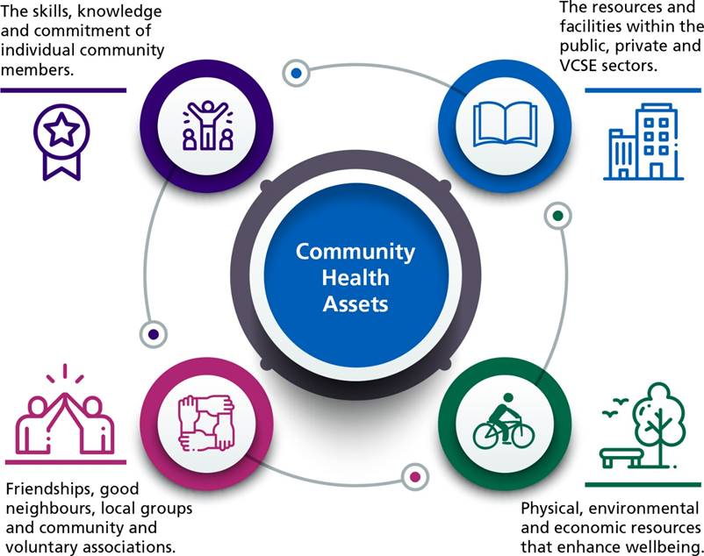
Figure 1: NHS England guidance
(Source: NHS England, 2022)

Importance of Working Together
Agencies collaborate due to the inability of any single organisation to fulfil all the needs of a family. As an illustration, a child who felt neglected might also be having issues with education, mental health or housing. The collaboration of professionals in this field can lead to the identification of issues at the initial stages and offer the appropriate support at a prompt rate.

Benefits of Multi-Agency Working
The aspect of multi-agency working that is considered to be of a big advantage is enhanced communication among services (Chambers et al., 2021). The exchange of information assists the professionals to get a better idea of the needs of families and minimise the possibility of overlooking critical issues. Families will also be in a position to obtain more planned and regular assistance as opposed to their recurrence to various agencies.

Challenges of Multi-Agency Working
Despite all the advantages of multi-agency working, it may also have challenges. The various organisations might have diverse priorities, policies and communication systems, which might make working together challenging. Sometimes, inadequate information exchange may slow assistance or mislead professionals. There can also be confidentiality and data protection concerns that could influence the information sharing.

Website evaluation

Evaluation of Leeds City Council Website

Accessibility
Early Help information can be found fairly easily, as there is a separate section of children and family services on the Leeds City Council website. The Early Help pages can be accessed by a couple of clicks from the homepage. The terms employed are generally easy to follow and comprehend by non-professional users, yet certain protective vocabulary might remain hard due to the portion of uneducated families that are less aware of social care services (Devaney and McGregor, 2022).
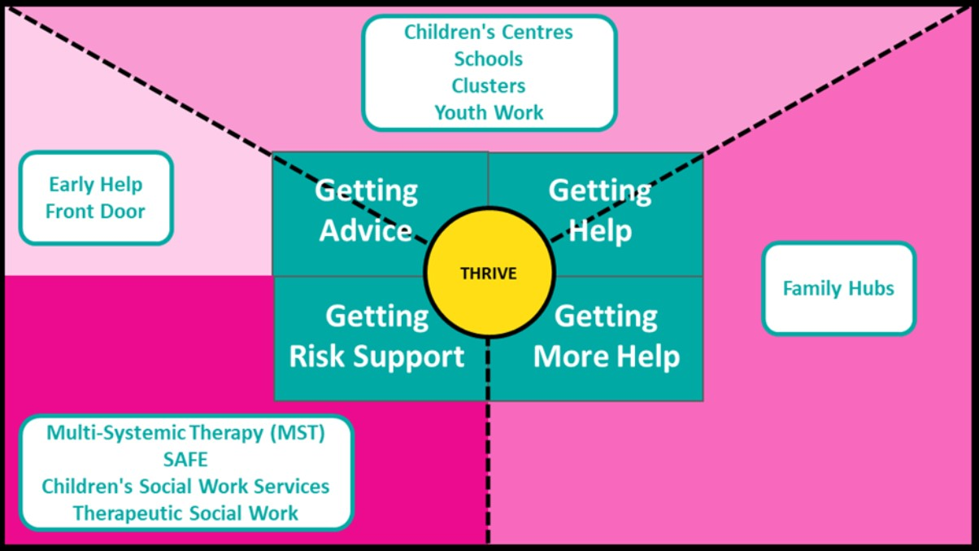
Figure 2: Early Help information provided by Leeds City Council
(Source: Leeds City Council, 2024)

Information Quality
The site provides an in-depth explanation of what early help is and how families can be helped. Contact information can be found, as well as referral information for both prospective professionals and family members. Leeds City Council gives the definition of the role of practitioners and assessment as well.

Family Support Information
The website provides information about a wide range of family support services. This covers mental health services, SEND services, domestic abuse services, parenting services, youth services and safeguarding advice (Eriksson et al., 2022). The variety of information provided is a show of great interest in helping families with special needs.

Multi-Agency Communication
The City of Leeds evidences well-working agencies in collaboration. The site mentions collaboration among schools, NHS services, protecting partnerships, social care teams, and community organisations. This echoes the concept of multi-agency that is suggested in Working Together to Safeguard Children 2023. Communication of information and aligned support is widely encouraged all over the site.

Strengths and Weaknesses
The Leeds site has a significant strength in the extensive support information about families and professionals that can be found on it. There is also clear referral guidance and available information on safeguarding on the site (McKean et al., 2022). But the text load of certain pages can present navigation problems to the user seeking easy and fast access to information.

Evaluation of Norfolk County Council Website

Accessibility
The Norfolk County Council site is well structured, where one can easily find the Early Help services. The search option works well, and the key grounds of support in the family are easily accessible. The rest of the language on the site is simple and appropriate to the layperson. It is also mobile-friendly and has accessibility features like translation services and adjustable text options.
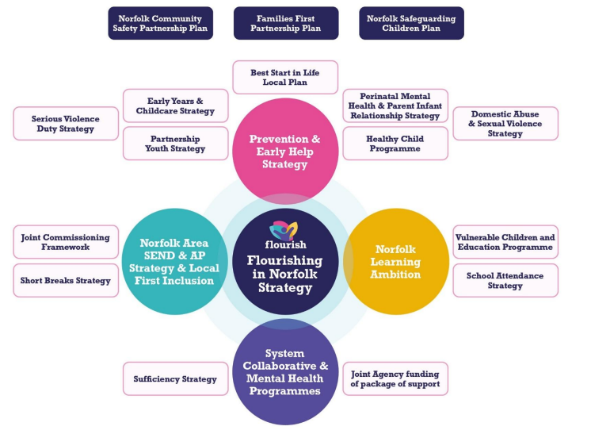
Figure 3: Prevention and Early Help Strategy by Norfolk County Council
(Source: Norfolk County Council, 2023)

Information Quality
The Norfolk County Council has a clear description of the purpose of Early Help and how families can request assistance. Referral pathways are explained in a simplified manner and make the process simple to understand for families (Offidani et al., 2022). Support services contacts are easily accessible as well. Norfolk put information in a shorter and easier-to-read form compared to some other local authority websites, making it easier to read.

Family Support Information
The site contains the data on a wide range of support services, such as emotional well-being support, SEND support, parenting advice, domestic abuse support, and protection resources. It is also the council that offers information on support for young carers and mental healthcare. The local organisations and community support groups refer families to the support groups, and this enhances accessibility to larger support networks.

Multi-Agency Communication
The Norfolk site emphasises how ineffective collaboration between social workers, schools, health professionals, and protecting agencies is. It elaborates that Early Help entails collaboration of services in order to determine and act on concerns at an early stage (Selwyn, 2022). Local safeguarding partnerships and the coordinated working of the agencies are also mentioned on the site, demonstrating a good depth of knowledge of multi-agency support.

Strengths and Weaknesses
The simplicity and user friendliness of the Norfolk site is a strength. The information is also rendered in a very simple way, and the families will find it easier to comprehend the available services and ways to refer to them. The site also offers an appropriate mix of professional advice and easy access.

Evaluation of the Southwark Council Website

Accessibility
The Southwark Council webpage has its family support and Early Help sections. Access to information is reasonably easy, but the user might have to make multiple clicks to get to certain support pages. The wording on the site is usually understandable, albeit there can be the use of professional jargon, which can hamper understanding for some users (Winter et al., 2024).

Information Quality
The Southwark Council describes the purpose of Early Help and provides information about the existing services which should be used by families. There is contact information and referral information, but some of the sections are less comprehensive than those in Leeds and Norfolk. The site provides an explanation of the responsibilities of safeguarding, as well as explains how professionals are able to assist the families.

Family Support Information
The site has details about safeguarding, mental health services, youth services, domestic abuse services, and parenting services. Liked pages can also be used to display SEND information. The Southwark Council is conscious of the needs of families in the local community. The integration of community support organisations assists in empowering the localities.

Multi-Agency Communication
Southwark Council means a partnership between social care, schools, NHS services and safeguarding boards. The site emphasises the need to have agencies collaborate to save children and provide help to needy families (Appleton et al., 2023).

Strengths and Weaknesses
The site of Southwark is a strength because it pays attention to the inclusive family support and protection of information. The website also recognises the importance of community-based support services. But very occasionally, navigation can be confusing as you find information on various pages.

Comparative Analysis of the Local Authority Websites

Accessibility and Navigation
The three local authority websites do contain all the information about the Early Help and family support services, but the accessibility and navigation vary. The Norfolk County Council offers the easiest to use and navigate one, in comparison. Experts can find information easily, and the interface is easy and understandable to non-professional users (Bullock, 2022). On the same note, information and helpful accessibility tools are also easily available on the Leeds City Council website.

Quality of Information and Inclusivity
Leeds City Council is the most comprehensive in terms of information concerning Early Help services, safeguarding responsibilities, and referral pathways. The site is very clear on how support can be accessed by professionals and families. Nevertheless, though in Leeds a lot of information is provided, the way of information presentation in Norfolk is less complex and more compact and can be easily understood by the families. Southwark also has a helpful section with support information and shows inclusivity by providing the option of translation and accessibility, but not all sections have the detailed explanation that the two other councils do.

Support Services and Referral Guidance
The three councils offer all these details of mental health support, parenting programmes, safeguarding, domestic abuse services and SEND support (Chambers et al., 2021). But Leeds has the most extensive coverage of associated support services and guidance on referral. The site highly encourages multi-agency collaboration of schools, NHS services, social care and safeguarding arrangements. In comparison, Norfolk has a better system of giving guidance on referrals in a better organised and family-friendly manner than Southwark, which offers fewer details regarding referral pathways and coordinated assistance.

Conclusion
This report analysed and compared the presentation of information about the Early Help and family support services on the Leeds City Council, Norfolk County Council and Southwark Council websites. The availability of Early Help has also been noted as being important in the report. During challenging times, families need to be able to quickly and easily access support. Leeds City Council was the only council to offer the most effective and comprehensive Early Help information of the three councils. The site provided in-depth information, excellent referral data, and the presence of multiple agents working. The most user-friendly and simple way of website design was, however, given by Norfolk County Council.

Recommendations
Despite the helpful information that is offered on all three websites, it could be improved to make it more accessible and effective. Local government can make websites easier to navigate to make it easier for families to access support services in a shorter time. Websites may also have more graphic instructions, e.g. diagrams or videos, to assist less literate or digitalising users (Devaney and McGregor, 2022). Moreover, it would be helpful to enhance translation services and accessibility tools to make sure that vulnerable families and different communities are provided with equal opportunities to access support.

References
Appleton, J.V., Bekaert, S., Hucker, J., Zlatkute, G., Paavilainen, E., Schecke, H. and Baldacchino, A. (2023) ‘A pan-European review of good practices in early intervention safeguarding practice with children, young people and families: evidence gathering to inform a multi-disciplinary training programme (the ERICA project) in preventing child abuse and neglect in seven European countries’, International Journal on Child Maltreatment: Research, Policy and Practice, 6(1), pp. 119–130. Available at: https://link.springer.com/article/10.1007/s42448-022-00132-x (Accessed: 27 May 2026).
Bullock, R. (2022) ‘Prevention and early intervention with children in need’, Adoption & Fostering, 46(2),pp.115–119.Available at:https://journals.sagepub.com/doi/abs/10.1177/03085759221100774 (Accessed: 27 May 2026).
Chambers, D., Cantrell, A. and Booth, A. (2021) Recognition of risk and prevention in safeguarding of children and young people: a mapping review and component analysis of service development interventions aimed at health and social care professionals, BMC Health Services Research, 21(1), p. 1241. Available at: https://link.springer.com/article/10.1186/s12913-021-07257-8 (Accessed: 27 May 2026).
Department for education (2023a) Early Help System Guide. London: HM Government. Available at: https://www.gov.uk/government/publications/early-help-system-guide (Accessed: 27 May 2026).
Department for education (2023b) Working Together to Safeguard Children 2023: Statutory Guidance.London:HMGovernment.Available at:https://www.gov.uk/government/publications/working-together-to-safeguard-children--2 (Accessed: 27 May 2026).
Devaney, C. and McGregor, C. (2022) ‘Protective support and supportive protection: critical reflections on safe practice and safety in supervision’, Social Sciences, 11(7), p. 312. Available at: https://www.mdpi.com/2076-0760/11/7/312 (Accessed: 27 May 2026).
Eriksson, M., Broberg, A.G., Hultmann, O., Chawinga, E. and Axberg, U. (2022) ‘Safeguarding children subjected to violence in the family: child-centered risk assessments’, International Journal of Environmental Research and Public Health, 19(21), p. 13779. Available at: https://www.mdpi.com/1660-4601/19/21/13779 (Accessed: 27 May 2026).
Leeds City Council (2024) Early Help: One Minute Guide. Available at: https://www.leeds.gov.uk/one-minute-guides/early-help (Accessed: 27 May 2026).
McKean, C., Watson, R., Charlton, J., Roulstone, S., Holme, C., Gilroy, V. and Law, J. (2022) ‘Making the most of together time: development of a Health Visitor-led intervention to support children’s early language and communication development at 2–2½-year- the old review’, Pilot and Feasibility Studies, 8(1), p. 35. Available at: https://link.springer.com/article/10.1186/s40814-022-00978-5 (Accessed: 27 May 2026).
NHS England (2022) Working in partnership with people and communities: statutory guidance. Available at: https://www.england.nhs.uk/long-read/working-in-partnership-with-people-and-communities-statutory-guidance/ (Accessed: 27 May 2026).
Norfolk County Council (2023) Prevention and Early Help Strategy. Available at: https://www.norfolk.gov.uk/media/21073/Prevention-and-Early-Help-Strategy/pdf/4gprevention-and-early-help-?__cf_chl_tk=EMFkw2anTgw2ymXMS0G7aZzLRcYRVA1O9WoXIlK8g9k-1779874027-1.0.1.1-2hCFYjGpdWyA0YpDi.eci8Nbsd1jWF7MapCAHllN90U (Accessed: 27 May 2026).
Offidani, C., Villani, A., Reale, A., Marchili, M.R., Aufiero, L.R., Moras, P. and Raponi, M. (2022) ‘Early recognition of child abuse through screening indicators at the emergency department: experience of a tertiary urban pediatric hospital’, Italian Journal of Pediatrics, 48(1), p. 32. Available at: https://link.springer.com/article/10.1186/s13052-022-01214-9 (Accessed: 27 May 2026).
Selwyn, R. (2022) ‘Early help for children and families’, Paediatrics and Child Health, 32(3), pp. 81–87. Available at: https://www.sciencedirect.com/science/article/pii/S1751722221002067 (Accessed: 27 May 2026).
Winter, K., Connolly, P., Millen, S. and Sweet, D. (2024) ‘The UNCRC and family support: a case study of the early intervention support service’, Child Care in Practice, 30(4), pp. 502–516. Available at: https://www.tandfonline.com/doi/abs/10.1080/13575279.2022.2088473 (Accessed: 27 May 2026).

