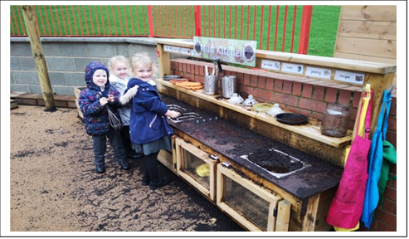
Sophie Blackadder (2008875)
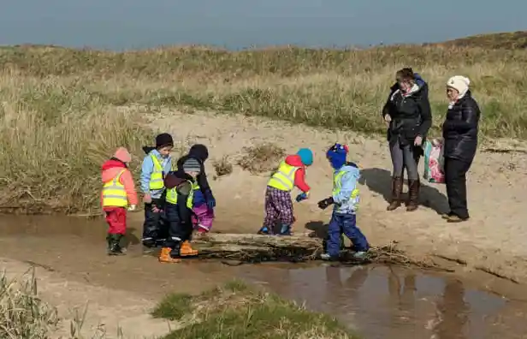

Sophie
Moving away from the traditional classroom: Outdoor Education and Learning (ECIE6001)

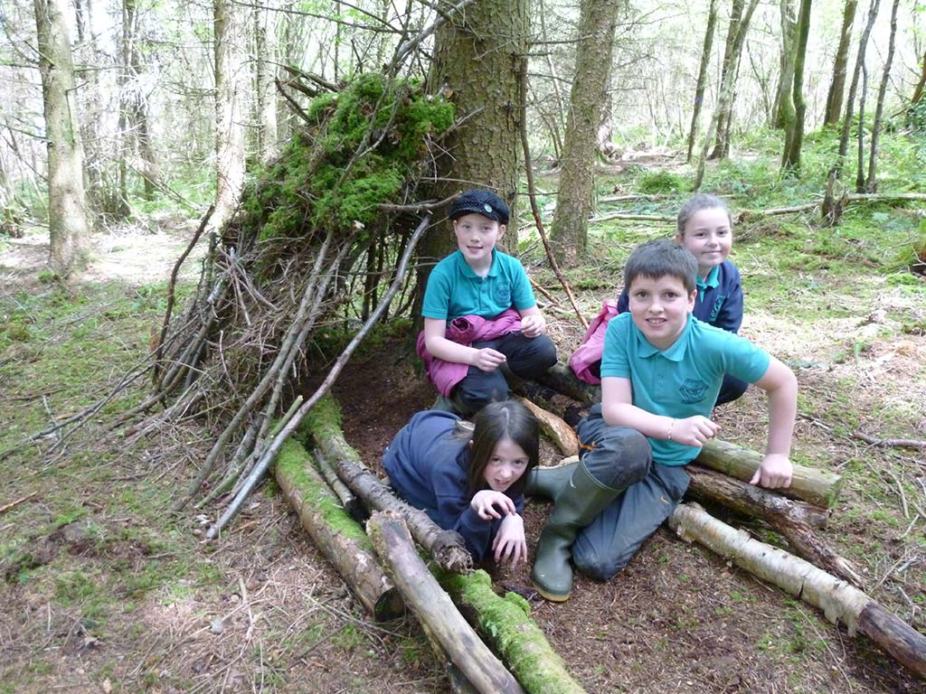
(Pentagon Play, n.d)
(Woodland Classroom, 2023)
(Kids of the Wild, 2020)

Contents

Essay ………………………………………………………………………………... Pages 2-5
References …………………………………………………………………... Pages 6-7
Flyer - Make our School Green ………………………………………………………... Page 8
References ……………………………………………………………………... Page 9
Risk Benefit Assessment ………………………………………………………… Pages 10-11
Literature Review - “The Role of Outdoor education” ………………………….. Pages 12-16
References ………………………………………………………………………...Pages 17- 20
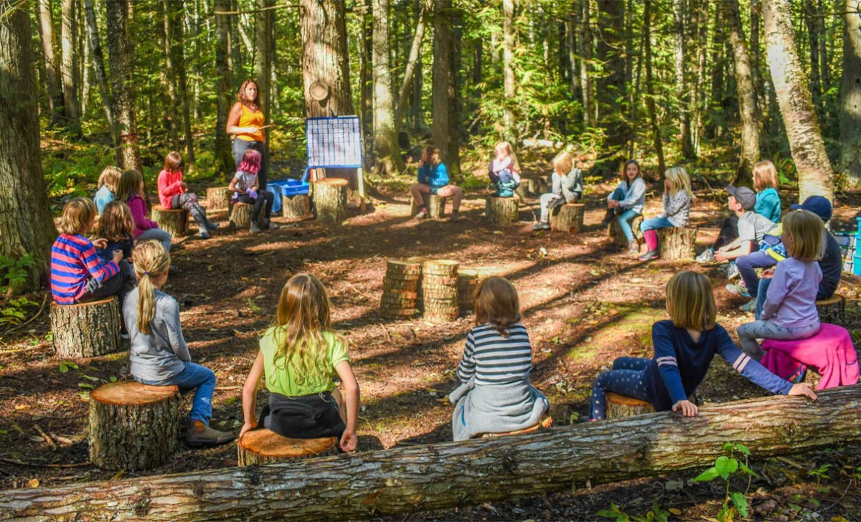
(Aamir, 2023)
Essay​​

The connection between health, wellbeing and education is well documented and it suggests that all-round healthier children have higher educational attainment. Schools are essential in providing these opportunities, that supports a child’s physical and mental health. Allowing children outside is established as one of the most important aspects in developing health, wellbeing and learning in children. From as far back as two hundred years, Froebel (1837), pedagogy believed that the outdoors and nature is where children learn best, through play and hands-on experiences (Pound, 2005). However, the term of outdoor education is hard to define and should be used as an umbrella term for the various aspects. However, Learning and Teaching Scotland (2010) suggests:
Well-constructed and well-planned outdoor learning helps develop the skills of enquiry, critical thinking, and reflection necessary for our children and young people to meet the social, economic, and environmental challenges of life in the 21st century. Outdoor learning connects children and young people with the natural world, with our built heritage and our culture and society (p.7).
The writer has chosen two outdoor learning provisions in which to compare the benefits and challenges of their outdoor education. Both based in a primary setting where the writer works, referring to the setting as school A, a nursery class in early years and Key stage 2. The writer will reflect on theories such as Montessori’s (1964) approach, Froebel (1837), theory in play, activity, and policies such as Curriculum of Wales (2022b), A Curriculum for Funded Non-maintained Nursery Settings (2022a) and Learning and Teaching Scotland (2010).
The first setting the writer has chosen to examine is an early years nursery class for children aged three to four. The writer has worked in school A for eight years, and over the past four years she has seen considerable changes to the outdoor provision. Firstly, due to an Estyn inspection which recommended improvement for outdoor learning, this led to staff movement and saw a higher-level teaching assistant with a recent master’s in education, put in place to lead the changes. Shortly after this the pandemic hit and stopped progress. However, COVID-19 did highlight the significant impact of a lack of an outdoor environment has on children’s physical health and wellbeing, especially children from disadvantaged socio-economic areas, or disadvantaged ethnic groups (Sefton, 2021). On return, school A was underway implementing the Curriculum of Wales (2022b) which recognises how outdoor pedagogies in early years has an important part to play for a holistic education. Early years settings were given clear guidance to follow, with the Curriculum for Funded Non-maintained Nursery Settings (2022a). School A has incorporated a rich and diverse outdoor environment that allows children to develop towards the four purposes, with plenty of authentic and purposeful learning opportunities.
Following in a Montessori (1964) approach where the outdoor environment is believed to be a natural extension of the classroom that reinforces sensory rich, natural, and open-ended resources. School A is fortunate to have a large outdoor provision, and with a little work and financial support, they were able to fully secure the area. This allows children to access free flow continuously, without direct adult supervision, supporting children’s independent learning, embracing, and enabling the Scandinavian approach, which is child-led and play-based encouraging children’s sense of curiosity and wonder (Winther-Lindqvist, 2017). School A’s outdoor learning environment is play based and inclusive for all learners, with a range of different provisions on offer for example a mud kitchen, construction, and water to name but a few. Additionally, the area allows for the freedom for children to be physically active and explore the natural environment, these experiences develop important life skills such as confidence, resilience, empathy, assessing risk, problem solving, making friends. Furthermore, young children develop their gross motor skills such as balance and strength, and it provides greater opportunities for schematic development, where children can make sense of the world around them (French et al. 2023). Being outside supports the Welsh curriculum “Cynefin,” the idea of connecting people with the place where they belong by engaging in the environment (Welsh Government, 2022b). As mentioned previously the outdoor environment has not always been used to its full potential, those barriers the writer considered to be initially down to a lack of expertise, experience and knowledge of outdoor learning which left teachers lacking confidence. Other concerns raised by teaching staff was the management of children, especially children with additional learning needs, planning, managing risk and the weather (Dijk-Wesselius et al. 2020). Overall, the writer considered a change in mindset was needed to progress further in outdoor learning. For example, the weather, is not an obstacle with the appropriate clothing children can access any type of weather. It is important to communicate your wet weather policy with parents. As a setting we store waterproofs, wellies and spare clothes that have been donated through the years. When it comes to risky play, children can gain lots of benefits from experiencing this type of play, so having a good understanding of what is acceptable and reasonable risk, can help to overcome practitioners and parents' anxieties (Learning Though Landscapes, 2024).
The writer has chosen to compare the early years nursery outdoor provision to the provision for learners in Key Stage 2, for ages seven to eleven. The writer has no direct experience within Key Stage 2, yet she will be analysing what she has observed within school A, and based on literature, and best practice. French et al. (2023) suggests the opportunities and expectations for outdoor learning are noticeably different from those of a younger year group, and the commitment for outdoor learning is visibly reduced, with less references made in the new Curriculum for Wales (2022b). According to Marchant et al. (2019) Key Stage 2 outdoor learning provisions can be met with barriers such as challenges to facilitate regular outdoor learning, due to curriculum demands that includes testing and evidencing of work. In addition, there are safety concerns, resources and cost, time, teacher confidence and fear of managing unwanted behaviours (French et al. 2023). However, Scotland’s Curriculum for excellence through outdoor learning (2010) suggests outdoor learning can make significant contributions to literacy, numeracy, and health and wellbeing, offering learners the chance to deepen and contextualise their understanding of subject areas, proving that the misconception about outdoor learning, that it is not just an extra-curricular activity that takes time away from real learning and can have a negative impact on attainment (Learning through Landscapes, 2023). Additionally, managing children’s behaviours like any original activity, set boundaries and expectations beforehand. In giving children responsibilities, you will find many children respond very well. In fact, older children benefit from being outdoors just as much as younger children and should be given the same opportunities to access this provision. Like children in early years, older children benefited from improved concentration, basic skills, and physical co-ordination (Thomas, n.d). Additionally, according to French et al. (2023) children in Key Stage 2 mentioned the benefits of increased lesson enjoyment, and they felt better supported in their mental health and wellbeing. Teachers also described benefits with an increase in job satisfaction, improvement in their teaching practice and professional development directly resulting in a positive impact on their own health and wellbeing.
Younger children can explore and develop a sense of ownership of their school grounds in their own time, daily. However, older children as well as exploring the school grounds, have the opportunity for more off-site field trips. From the writer's own experience all classes above nursery go on a class trip every half term that links in with their new topic. French et al. (2023) review into Wales’s outdoor provision, indicated that they were significant gaps in understanding about outdoor learning, and how it can be used to cover the curriculum, it also revealed teacher’s disinterest in trying new pedagogies, possible because of a misunderstanding of outdoor education entirely. Overcoming these barriers with additional development, that empowers practitioners in the field of outdoor education. As well as embedding meaningful pedagogies into trainee teaching through the delivery of the PGCE. There is no one definition of what is outdoor education in Welsh schools. They need to establish and update their guidelines on how and what outdoor learning can do for educational experiences, learning, as well as maintaining the wellbeing in their schools.
In conclusion, giving children regular opportunities to play outdoors, makes for happier and healthier children. By including outdoor learning and play as a regular part of teaching practice, it will ensure a positive academic, emotional, and social development outcome for life, while making connections with nature and our planet (French et al. 2023). Provision one from the writer's perspective, manages outdoor education very well, which goes hand in hand with the ethos of an early years education, being hands-on, authentic, and play-based that drives early years learning. As for the second provision, the opportunities given to children for outdoor learning is drastically reduced, which the writer feels it is across the board as children get older, and the demand of the curriculum becomes more apparent. For many practitioners’ outdoor education, can lead to doubts and concerns about its accessibility, regardless of location, school size, or socioeconomics. The writer hopes this will change overtime and practitioners can recognise the importance not only to children’s health and well-being, but to theirs too.

References

Dijk-Wesselius, J.E.V et al. (2020) Green Schoolyards as Outdoor Learning Environments: Barriers and Solutions as Experienced by Primary School Teachers. Frontiers in Psychology, 10. Available at: https://www.frontiersin.org/journals/psychology/articles/10.3389/fpsyg.2019.02919/full (Accessed: 3rd April 2024).

French, G et al. (2023) Teaching and learning in the outdoors: the current state of outdoor learning in schools in Wales. Available at: https://hwb.gov.wales/api/storage/177a33a6-7c70-4843-bb63-903e70a04154/teaching-and-learning-in-the-outdoors-the-current-state-of-outdoor-learning-in-schools-in-wales.pdf (Accessed: 3rd April 2024).

Froebel, F. (1837) Education by development. Josephine, edn, 1899. New York: D. Appleton and company.

Learning through Landscapes (2023) Teacher confidence: Why it is integral to outdoor learning. Available at: https://ltl.org.uk/news/teacher-confidence-why-integral-outdoor-learning/ (Accessed: 4th April 2024).

Learning through Landscapes (2024) 5 barriers to outdoor learning at primary school and how to overcome them | Ask Educators. Available at: https://ltl.org.uk/news/overcome-outdoor-learning-barriers-primary-school/ (Accessed: 16th April 2024).

Learning and Teaching Scotland (2010) Curriculum for excellence through outdoor learning. Available at: https://education.gov.scot/media/isxg4lb0/cfe-through-outdoor-learning.pdf (Accessed: 4th April 2024).

Marchant, E et al. (2019) Curriculum-based outdoor learning for children aged 9-11: A qualitative analysis of pupils’ and teachers’ views. Available at: https://doi.org/10.1371/journal.pone.0212242 (Accessed: 4th April 2024).

Montessori, M. (1964) The Montessori method. New York: Schocken Books.

Pound, L. (2005) How Children Learn: From Montessori to Vygotsky- Educational Theories and Approaches made easy. Routledge: London.
Sefton, C. (2021) Time for a change: outdoor learning for every child. Available at: https://www.heritagefund.org.uk/blogs/time-change-outdoor-learning-every-child (Accessed: 3rd April 2024).

Thomas, M. (n.d) The Benefits of Learning Outdoors. Available at: https://www.educators-barnardos.org.uk/resources/sp-a-the-benefits-of-learning-outdoors (Accessed: 4th April 2024).

Welsh Government (2022a) A curriculum for funded non-maintained nursery settings. Available: https://hwb.gov.wales/api/storage/b1801d78-38c3-4320-9818-d9996c21aef8/220914-a-curriculum-for-funded-non-maintained-nursery-settings.pdf (Accessed: 5th April 2024).

Welsh Government (2022b) Curriculum for Wales. Available at: https://hwb.gov.wales/curriculum-for-wales (Accessed: 5th April 2024).

Winther-Lindqvist, D.A. (2017) Nordic Social Pedagogical Approach to Early Years, Available at: 10.1007/978-3-319-42557-3_6 (Accessed: 4th April 2024).

(Britannica, 2024)

Frobel
Pound (2005)

(Formby, n.d)
(Wikimedia Common, 2023)
“No one will protect what they don’t care about, and no one will care about what they have never experienced” Sir David Attenborough
(BBC Wildlife, n.d, Online)

Improve your wellbeing by being outdoors in nature. Improve your physical health and connect with your local community.

Join our tree planting day, we wish to create a future outdoor learning environment, and a living space for our children and the local wildlife. We have been kindly donated 105 slapping trees from the Woodland trust. (Hawthorn, Rowan, Blackthorn, Silver birch, Hazel and Common oak)
So come tree planting with us! (Woodland trust, 2024)

Eco club needs your help! Join us in celebrating the United Nations International Day of Forests, 2024

Make our School Green

Tree Planting for UK Schools
To find out more contact: Call/Text Sophie 07979490505 Or Email sophienorris4@googlemail.com
(Tree Trust, 2022)
Meet us:
- At the top school field
- Saturday the 23rd March
- 9am - Noon
- Bring wellies
- Gardening gloves
- Bring refillable drinks bottle, coffee, tea, water, and small snacks available free of charge.
- Children under 14 must be accompanied by an adult

Wales Tidy will be there to help spread awareness on native trees, forest care and the importance of habitats for local biodiversity and climate change.

References

BBC Wildlife (n.d) Goal 2 - Everyone is connected to nature. Available at: https://www.bbcwildlife.org.uk/everyone-connected (Accessed: 20th April 2024).

Britannica (2024) leaf [Image]. Available at: https://www.britannica.com/science/leaf-plant-anatomy (Accessed: 10th April 2024).

Formby, P. (n.d) Hundreds of schools across the UK have planted free trees [Image]. Available at: https://www.woodlandtrust.org.uk/plant-trees/schools-and-communities/ (Accessed: 20th April 2024).

Tree Trust (2022) Generous Companies & Foundations Get Kids Planting Trees! [Image]. Available at: https://treetrust.org/kids-planting-trees/ (Accessed: 9th April 2024).

Wikimedia Common (2023) The fox and the hedgehog [Image]. Available at: https://www.linkedin.com/pulse/fox-hedgehog-marc-jadoul/ (Accessed: 20th April 2024).

Woodland trust (2024) FREE TREES FOR SCHOOLS AND COMMUNITIES. Available at: https://www.woodlandtrust.org.uk/plant-trees/schools-and-communities/ (Accessed: 20th April 2024).

RISK BENEFIT ASSESSMENT

Location / Activity: | Rock Pooling at Oxwich Bay, Gower Peninsula | Date: | 10.05.2024
Assessor: | Sophie Blackadder | Review date: | 10.04.2025

The boxes in the table below will expand as you type into them; pre-entered text is simply for illustration. You should delete irrelevant items and replace with text relevant to your circumstances.
Your overall risk rating – Low, medium, or high – is based on your judgement about whether the BENEFITS of the activity or opportunity outweigh the RISKS.

ACTIVITY | How will young people BENEFIT from this activity? | Possible hazards | Who is at risk? | PRECAUTIONS in place to reduce the risk of injury | Overall risk RATING: L/M/H
Rock pooling at Oxwich Beach for Key Stage 2, Year 4  In early Spring. | Linked to the cornerstone's topic: Blue Abyss. Are all sea creatures the same?  AOLE FOCUS  - Science and technology  AOLES COVERED  - Languages, literacy, and communication  - Science and technology  - Expressive arts  - Humanities  Children will be able to research a habitat at Oxwich Bay. Then complete a comparison study on the varied species of plants and sea life that are found within the rock pools.  Work in small groups and present back to the class their finding through a poster (complete in class time).  Children will learn about how to find and catch specimens and with a key specimens guide they will be able to identify and record their findings.  Further activities:  Microscopic rock pool life  Food chains/web  Life cycles  (Cornerstones Education Ltd, 2022) | - Uneven ground/slippery terrains – slips, trips or falls on loose or wet rocks  - Stranger danger  - Raising in water level/incoming tides  - High winds  - Sand blown/kicked in eyes  - Suffocation  - Hypothermia/ hyperthermia or sunburn  - Washed up debris/or litter  - Animals  - Drowning  - Toilets  - Waterborne diseases/ pollution  - Inappropriate footwear  - Site inspection  - Illness/injury  - Unexpected change  - Policies | Children, young people, adults | - Rocks covered in seaweed avoid. Rocks covered in barnacles can be grippy when walking slowly.  - No one to leave without permission of a supervising adult  - Check forecast including tidal times. Watch the tide when rock pooling, be aware in changes of weather conditions can speed up incoming tides. Do not go far from the beach when rock pooling and keep group together.  - Check weather forecasts, avoid going in winds above 24 mph.  - Do not throw sand and bring eye wash.  - Do not dig holes on slopes  - Take appropriate clothing: sun hats, sunscreen, and drink lots. Or wind/rain proof coat, hats, and gloves  - check empty before going in  - Do not touch jellyfish and pick up crabs correctly, behind their pincers  - Keep away from sea and do not allow in the sea at any point. Always go rock pooling on a falling tide, 1-2 hours before the low tide is best.  - Check facilities before children enter  - wash hands in clean water prior to eating if water quality is suspected cover cuts with waterproof plasters if open wounds avoid getting wet  - Always wear appropriate footwear no bare feet or open toe shoes  - Visit site in advance, check specifications talk to the landowner (if necessary) pupil to adult ratio correct  - Make sure that emergency procedures and parents' consents, emergency contact details are in place, first aid and list of allergies and health conditions.  - Provide alternative activities and routes in case of unexpected changes  - Spare clothes extra food and drinks  - Recall the Waterside Code. Set your working boundaries with football cones or other markers, agree on a muster point, and ensure all students know what to do if they get into any difficulty | Low

Literature Review
“The Role of Outdoor Education”

Outdoor education has been hard to define, as it has no one main learning objective covering many areas and many educational theories. The primary objectives that cover outdoor education can be personal and social development, experiential learning or raising awareness towards environmental concerns. According to Robbins (2015) the outdoors offers a unique learning opportunity, to gain both hard and soft skills, such as survival and shelter development, and an increase in physical activities and the promotion of good health. Children that have plenty of time outdoors will encourage physical learning, like running, jumping, and climbing, developing their gross motor skills, muscle, and bone growth, as well as promoting social interaction, developing friendships and cooperation and fine motor skills. According to Health and Care Research Wales (2024) one in six children and young people are experiencing mental health and well-being issues, such as anxiety or depression. It is well known that being outside in the fresh air, getting vitamin D, boosting serotonin, and exercising can improve you physically and mentally, having a positive effect on your mental health and wellbeing. Additionally, children are more enthusiastic and engaged with learning when outside. The connectedness they get from nature can create positive feelings, and decrease stress creating a relaxing environment (Cilingir, 2016). Outdoor learning can deepen curricular lessons, as they are able to experience things for themselves, and in a real-life. It also allows for inclusive learning; the outdoor environment can reduce feelings of anxiety for children with additional learning needs, by building their resilience and confidence (Brewer, 2016). The writer has identified two key themes of outdoor education, which she will analyse and discuss, drawing key information to help define what she believes to be the role of outdoor education. Supported with theories such as Dewey’s (1938) theory on Experience and Education, Rogers (2003) Social Learning theory, and Gardner’s (1983) theory on multi-intelligences and policies such as, the Sustainable Development Goals (2015) and The Education for Sustainable Development and Global Citizenship (2008).
The first theme the writer has chosen to analyse is the role of environmental education. As the environment on this earth is increasingly deteriorating, humans are facing some major problems, with three serious issues that need attention immediately, global warming and climate change; water pollution and ocean acidification; and loss of biodiversity (Lawson, 2019). The environment is vital for the existence of all living species that exist on our planet, all depending on it for food, water, air, and shelter. However, there are many people that are still unaware of the major crisis the planet is facing and do not realise what is good or bad for the environment, causing its continued destruction. Inevitably there needs to be an importance placed on environmental education (EE), and equally it is up to every person to protect and save the environment (Greenfield, 2022). In the 1960’s UNESCO identified a global crisis, that raised many environmental issues across the world, realising the need for change in attitudes, skills, and participation to address the awareness of global environmental problems such as biodiversity loss, food shortages, pollution, and health issues. UNESCO produced twelve principles, three goals, and five categories of EE objectives, which form a framework, that still influences EE today (Anderson and Jacobson, 2018).
Environmental education is a learning process that increases people’s knowledge and awareness about the environment and associated challenges, develops the necessary skills and expertise to address the challenges, and fosters attitudes, motivations, and commitments to make informed decisions and take responsible action, UNESCO (1978, quoted in Mubita et al, 2022, p119).
The continuous effort for global success saw the 2030 agenda for Sustainable Development Goals (SDGs) which was developed in 2015b and adopted by all United Nations Members. This provided a plan for countries to follow for the future, and prosperity for all people and the planet. The SDGs have seventeen goals. Goal four, refers to a quality education and states that children should be provided with the knowledge and skills through their education, about issues such as sustainability (United Nations, 2015a). EE range is included in curricular based requirements and activities such as, fieldwork exercises and green school initiatives (Anderson and Jacobson, 2018). Wales is one of a few countries that has implemented EE into policy, with the Education for Sustainable Development and Global Citizenship (ESDGC). The ESDGC’s agenda is about our everyday lives. It links to the environment, and focuses on issues such as climate change, resource and environmental depletion (Welsh Government, 2008). However, this is not a stand-alone subject, and the ethos should be embedded throughout a school, becoming a way of life. It combines the area of learning and experience, science and technology with the core purpose of developing an ethically informed citizen of the world (Welsh Government, 2022). This allows children to develop critical thinking skills, and an understanding of issues for themselves, to be able to challenge existing ways of thinking, and make their own mind up by considering the bigger picture (Welsh Government, 2022). Wales’s pedagogical approach towards the ESDGC is through the seven interconnected themes for example climate change, consumption and waste, and the natural environment which are linked to EE. This promotes awareness in fun and engaging ways, and schools can offer proactive approaches such as eco-friendly habits like, recycling and monitoring energy consumption through eco clubs. Additionally, it can inspire a love for nature, by developing nature reserves, or forest schools, and allowing children to get up close to wildlife, be able to grow their own food, aiding children to gain an understanding of the importance of conservation and sustainability (Desi et al. 2020). However, according to Anderson and Jacobson (2018) there are barriers to EE, from a western perspective the most common barriers can range from financial, health and safety constraints, weather, and teachers lack of confidence, time restraints and the delivery of core curriculum subjects. On the other hand, in Sweden there are no barriers to EE as it has been an integral part of their curriculum since 1969, from ecology to conservation, and it is covered across a wide range of subjects, changing lifestyles and attitudes, and promoting an environmentally conscious culture (Givetash and Banic, 2020).
The second key theme the writer has chosen to analyse as an outdoor learning experience is experiential education or “learning by doing.” Children are known as active learners, and the outdoor learning environment offers many opportunities to facilitate these direct experiences, “I hear, and I forget. I see and I remember. I do and I understand” Confucius (Quoted in Brainy Quote, 2024). Waite (2011) suggests experiential learning was first introduced in the early 20th century, by a theorist such as Dewey (1938). He believed that children would learn and develop better when experiencing and interacting with the world. This way they continuously gain new ideas, concepts and understanding. A child can then make sense of these experiences through their life and social interactions (Hargraves et al. 2023). However, much of a school’s curriculum still relies heavily on literacy knowledge, listening and memorising facts, yet with the Curriculum of Wales (2022) a move towards an authentic way of learning is delivered through engaging experiences. These experiences should provide opportunities for active learning which is rooted in real-life authentic situations. According to Kong (2021) children that actively participate in their learning, achieve higher levels of learning and better outcomes.
According to Carl Rogers (2003) experiential learning can occur when several conditions are met: there is student participation, students control and direct the learning process; activities are based upon direct interaction with nature; and self-evaluation is used to assess student learning (Gama and Fernández, n.d, p.79).
The outdoor environment has an abundance of opportunities to offer children with experiential learning, with a wide range of tactile and flexible natural resources promoting authentic, physical, and a sensory rich environment (Waite, 2011). This is important as every child learns in a different way and is unique in themselves. Outdoor education can easily promote Gardner’s (1983) multi-intelligences. He suggests there are eight distinct types of intelligences in which the outdoor environment can cater for all. For example, bodily-kinesthetic intelligence, that requires the ability of movement and are often very tactile. Naturalist intelligence, children will be very in tune with nature and their environment and interpersonal intelligence in which children enjoy relating and interacting with their peers, developing their social skills (McFarland and Adhikary, 2006).
Through experiential learning, children will actively engage in questioning, investigating, and experimenting. They gain a deeper understanding of interpersonal skills such as, collaboration, leadership and creative problem-solving. Children can engage in many areas of development, such as intellectual, emotional, social, and physical. Additionally, all the results from this learning are unique to each child and will form the basis for further learning. The learning does not stop when the task is completed. Through their observations and reflections, they can create a concrete learning outcome. Children are then able to start to form abstract ideas, based off their hands-on experiences, and applying this knowledge and understanding to real-life. Experiential learning requires practitioners to encourage children’s learning in the moment, to support them through mistakes and successes, done in an enabling environment, practitioners need to be aware of having any bias or judgments that might influence over the learning (Gass et al. 2012). However, not everyone agrees with “learning by doing,” and has been referred to as a weak method of learning, with an overreliance on figuring things out can make it harder to learn than just direct instruction. Considering if children were to find learning too hard, they simply would not bother (Young, 2021).
Overall, to define outdoor education is difficult as it depends on the sole learning outcome that you desire. However, what is evidenced through literature, it is regarded as a valuable learning tool to add depth and breadth to the curriculum, and more opportunity should be offered away from traditional classroom teaching. It offers many opportunities for children to interact with nature and gain a love of their environment, to construct ideas that will be mindful in the ways of sustaining our planet for future years to come. Outdoor education encourages healthy habits with the opportunities to physically exercise to run, jump, climb, and swing, activities that are not always possible in an indoor environment. The chance to have hands-on experiences when learning, that facilitates many different learning styles being inclusive in its nature. Lastly with the positive effects it can have on everyone’s mental health and well-being, with the restorative properties that the natural environment offers, associated with lower levels of stress and a reduction in symptoms of depression and anxiety (Pearson and Craig, 2014). Learning & Teaching Scotland (2010) suggests outdoor experiences are vital in becoming successful in learning. Children should be offered well-constructed and well-planned outdoor learning opportunities, to help develop their skills of enquiry, and critical thinking.
The writer believes as a society we are becoming increasingly disconnected from our natural environment, and within the UK nearly ninety per cent of the population lives in towns or cities (BBC, n.d). Consequently, the role of outdoor education is vitally important for our children of today. Defining the role as one of promoting environmental awareness, by changing our attitudes and values towards our planet. Additionally, to promote the health and well-being of all children, they can benefit from the inclusivity that the outdoor environment offers children, to develop their uniqueness and ways and styles of learning (Szczepanski, 2001). Furthermore, to promote an alternative, away from the traditional classroom setting, by supporting the ethos, “not all classrooms have four walls” (Martinez, 2019, Online). The outdoor environment should be viewed as somewhere where people can have fun, relax, and learn (Cilingir, 2016).

References

Aamir, S. (2023) Outdoor Education and Learning Spaces in Kindergarten: Why It Matters? [Image]. Available at: https://www.linkedin.com/pulse/outdoor-education-learning-spaces-kindergarten-why-matters-aamir/ (Accessed: 21st April 20240.

Anderson, C and Jacobson, S. (2018) ‘Barriers to environmental education: How do teachers’ perceptions in rural Ecuador fit into a global analysis?’ Environmental Education Research, 24(12), pp.1684-1696. Available at: https://doi.org/10.1080/13504622.2018.1477120 (Accessed: 1st April 2024).

BBC Wildlife (n.d) Goal 2 - Everyone is connected to nature. Available at: https://www.bbcwildlife.org.uk/everyone-connected (Accessed: 20th April 2024).

Brainy Quote (2024) Confucius Quotes. Available at: https://www.brainyquote.com/quotes/confucius_136802(Accessed: 21st April 2024).

Brewer, K. (2016) ‘Nature is the best way to nurture pupils with special educational needs’, 1st May, Guardian. Available at: https://www.theguardian.com/teacher-network/2016/may/01/nature-nurture-pupils-special-educational-needs-outdoor-education (Accessed: 21st April 2024).

Cornerstones Education Ltd (2022) Cornerstones Cwricwlwm Projects. Available at https://cornerstoneseducation.co.uk/curriculum/all-projects-welsh/ (Accessed: 2nd April 2024).

Cilingir, F. (2016) ‘Outdoor Education Perspectives: International Insights within the Field’, Environmental Science, Education. Available at: https://www.semanticscholar.org/paper/Outdoor-Education-Perspectives-%3A-International-the-Cilingir/822f3064b142fc9795daeb0d004ec2ca7c693984 (Accessed: 1st April 2024).

Desi, N et al. (2020) Environmental Conservation Education: Theory, Model, and Practice. Available at: https://www.researchgate.net/publication/350104109_Environmental_Conservation_Education_Theory_Model_and_Practice (Accessed: 29th March 2024).

Dewey, J. (1938) Experience and education. New York: Macmillan.

Gama, C. and Fernández. (n.d) ‘Do and Understand: The Effectiveness of Experiential Education,’ Experiential Education pp.74-89. Available at: file:///C:/Users/Sophie%20Blackadder/Downloads/Dialnet-DoAndUnderstand-3294512%20(3).pdf (Accessed 2nd April 2024).

Gardner, H. (1983) Frames of mind: The theory of multiple intelligences. New York: Basic Books.

Gass, M.A., Gillis, H.L., Russell, K.C. (2012) Adventure therapy: Theory, Research, and Practice. New York, NY: Routledge.

Givetash, L. and Banic, V. (2020) Sweden's environmental education is building a generation of Greta Thunberg’s. Available at: https://www.nbcnews.com/news/world/sweden-s-environmental-education-building-generation-greta-thunbergs-n1106876 (Accessed: 21st April 2024).

Greenfield, E. (2022) Need and Importance of Environmental Education. Available at: https://sigmaearth.com/need-and-importance-of-environmental-education/ (Accessed: 1st April 2024).

Hargraves, E et al. (2023) National Curriculum and Assessment in England and the continuing narrowed experiences of lower-attainers in primary schools, Journal of Curriculum Studies, 55(5), pp. 545-561. Available at: https://www.tandfonline.com/doi/full/10.1080/00220272.2023.2253455 (Accessed: 20th April 2024).

Health and Care research Wales (2024) Research in Wales making a difference to the mental health of Welsh children and young people. Available at: https://healthandcareresearchwales.org/about/news/research-wales-making-difference-mental-health-welsh-children-and-young-people (Accessed: 20th April 2024).

Kids of the Wild (2020) Beach School Rocks – Outdoor Learning at the School by the Beach [Image]. Available at: https://kidsofthewild.co.uk/2020/03/10/beach-school-outdoor-learning-education-at-the-coast-near-you/ (Accessed: 27th March 2024).

Kong, Y. (2021) ‘The Role of Experiential Learning on Students' Motivation and Classroom Engagement’, Front Psychol. 12:771272. Available at: https://www.ncbi.nlm.nih.gov/pmc/articles/PMC8569223/ (Accessed: 2nd April 2024).

Lawson, E. (2019) Three Environmental Issues and Ways to Combat Them. Available at: https://eponline.com/articles/2019/11/25/three-environmental-issues-and-ways-to-combat-them (Accessed: 1st April 2024).

Learning and Teaching Scotland (2010) Curriculum for excellence through outdoor learning. Available at: https://education.gov.scot/media/isxg4lb0/cfe-through-outdoor-learning.pdf (Accessed: 4th April 2024).

Martinez, C. (2019) "Not All Classrooms Have Four Walls" Available at: http://hdl.handle.net/10950/1900. (Accessed: 21st April 2024).

McFarland, L. and Adhikary, M. (2006) Bringing multiple intelligence outdoors. Available: https://www.researchgate.net/publication/316450861_Bringing_multiple_intelligences_outdoors (Accessed: 20th April 2024).

Mubita, K et al. (2022) Understanding Environmental Education: Conceptualization, Definitions, History and Application. Available at: https://www.researchgate.net/publication/364309087_Understanding_Environmental_Education_Conceptualization_Definitions_History_and_Application (Accessed: 1st April 2024).

Pearson, D.G., and Craig, T. (2014) ‘The great outdoors? Exploring the mental health benefits of natural environments,’ Front Psychol, (5)1178. Available at: https://www.ncbi.nlm.nih.gov/pmc/articles/PMC4204431/ (Accessed: 21st April 2024).

Pentagon Play (n.d) Mud Kitchens [Image]. Available at: https://www.pentagonplay.co.uk/products/imaginative-and-creative/mud-sand-and-water-play/mud-kitchen (Accessed: 27th March 2024).

Robbins, A. (2015) Synthesizing the Outdoor Education Literature to Create a Definition and List of Primary Objectives, (Unpublished master's thesis). University of Wyoming. Wyoming.

Szczepanski, A. (2001) WHAT IS OUTDOOR EDUCATION? The Didactic Implications of Learning on the Context of Landscape. Available at: https://www.eoe-network.eu/wp-content/uploads/2020/01/Other-Ways-of Learning.RimforsaSweden.2001.Proceedings.pdf#page=16 (Accessed: 20th April 2024).

United Nations (2015a) Ensure inclusive and equitable quality education and promote lifelong learning opportunities for all. Available at: https://sdgs.un.org/goals/goal4#targets_and_indicators (Accessed: 24th February 2024).

United Nations (2015b) THE 17 GOALS. Available at: https://sdgs.un.org/goals (Accessed: 3rd April 2024).

Waite, S. (2011) ‘Teaching and learning outside the classroom: personal values, alternative pedagogies and standards’, Education 3-13, 39(1), pp. 65–82. Doi: 10.1080/03004270903206141. (Accessed: 24th April 2024).

Welsh Government (2008) Education for Sustainable Development and Global Citizenship a Common Understanding for Schools. Available at: https://hwb.gov.wales/api/storage/eaf467e6-30fe-45c9-93ef-cb30f31f1c90/common-understanding-for-school (Accessed: 1st April 2024).

Welsh Government (2022) Curriculum for Wales. Available at: https://hwb.gov.wales/curriculum-for-wales (Accessed: 20th April 2024).

Woodland Classroom (2023) Forest School [Image]. Available at: https://woodlandclassroom.com/schools/forest-school/ (Accessed:27th March 2024).

Young, S.H. (2021) Learning by Doing: When Does it Work? When Does it Fail?. Available at: https://www.scotthyoung.com/blog/2021/11/23/learning-by-doing-deep-dive/ (Accessed: 21st April 2024).

